Software Requirements Specification
for
LETU Previewer Website
Version 1.0

Prepared by
Aisha Rigert
Colin Tompkins
Israel Terrill

Instructor: | Dr. Brent Baas
Course: | Software Engineering I
Date: | 2/12/2016

Contents
Contents ii
Revisions iii
1 Introduction 1
1.1 Document Purpose 1
1.2 Product Scope 1
1.3 Intended Audience and Document Overview 1
1.4 Definitions, Acronyms and Abbreviations 1
1.5 References and Acknowledgments 2
2 Overall Description 2
2.1 Product Perspective 2
2.2 Product Functionality 2
2.3 Users and Characteristics 2
2.4 Operating Environment 3
2.5 Design and Implementation Constraints 3
2.6 Assumptions and Dependencies 4
Appendix A – Group Log 5

Revisions
Version | Primary Author(s) | Description of Version | Date Completed
- | Aisha Rigert  Israel Terrill  Colin Tompkins | Initial release of prototype. | 2/12/2016

Introduction

Document Purpose
This document is a system requirement specification (SRS) for the initial prototype release of the LETU Previewer Website—a proposed project for Software Engineering I. The LETU Previewer Website will assist several different groups of people during their time on the LeTourneau campus in finding important information they need. This SRS includes the project’s requirements and relevant information.

Product Scope
This project is a mobile website intended to welcome visitors to campus, help their visit run more smoothly by bringing visit resources to their mobile devices, and encourage them to return by providing helpful information about the university and events. One problem visitors sometimes encounter is getting lost; thus, having a map tailored to a walking trip on campus would be helpful. Although previewers are given a folder with maps and other information, this requires the party to stay together if they want to access the folder. Having this information accessible on a mobile device gives visitors freedom to split up without fear of getting lost or being without important information. In addition, making last-minute updates to a hard-copy schedule would require reprinting pages and refilling folders; a website would allow the admissions center to easily make changes. Additionally, this software could be useful to professors unfamiliar with building layouts, new students who haven’t yet learned classroom locations, and visitors coming to campus events.

Intended Audience and Document Overview
This document is intended to communicate the details and requirements of the LETU Previewer Website prototype to four different types of readers:
- The Professor of Software Engineering I
This reader is encouraged to read all sections of the document.
- Fellow Classmate
This reader is encouraged to read all sections, focusing on sections 1.2, 2.1, 2.2, and 2.4; this will give a general understanding of the product along with some of the product details.
- The Client
This reader is encouraged to focus their attention on section 1 in order to understand the general purpose of the product. The details of the implementation are less important for the client.
- Current or Future Developer
This reader is encouraged to focus their attention on section 2 in order to understand the implementation details of the project.

Definitions, Acronyms and Abbreviations
GUI Graphical user interface
SRS System requirements specification
JSON JavaScript Object Notation
XML Extensible Markup Language

References and Acknowledgments
- M. Casimirri (n.d.). Mobile Angular UI. [Online]. Available: http://mobileangularui.com/
- M. Casimirri (n.d.). "Your first Phonegap app with Mobile Angular UI," in Mobile Angular UI. [Online]. Available: http://mobileangularui.com/blog/using-the-generator/
- T. Krotoff (2014, Apr. 1). UI-Select demo source code [Source code]. Available: https://github.com/angular-ui/ui-select/blob/3fac88cfad0ad2369c567142eadba52bdb7998b1/examples/demo.js
- V. Singhal et al. "AngularJS call scope function on route change," in StackOverflow. [Online]. Available: http://stackoverflow.com/questions/30917571/angularjs-call-scope-function-on-route-change
- A. Kim (n.d.). Ng-map. [Online]. Available: https://ngmap.github.io/
- Google, Inc. (2016). "AngularJS API Docs," in AngularJS. [Online]. Available: https://ngmap.github.io/https://ngmap.github.io/

Overall Description

Product Perspective
This web-based mobile application is a new product, originating from Software Engineering I. It will supplement the current system of paper maps and handouts. The product’s “Help” feature will be self-contained and independent of any other websites or applications. The “Schedules” and “Activities” features will be dependent on the LeTourneau website, from which information will be collected and parsed. The “Maps” feature will be dependent on Google Maps. The “Dining” feature will be dependent on both Google Maps and the Bon Appétit website. This product will interface with the LeTourneau website, Google Maps, and the Bon Appétit website via the Internet.
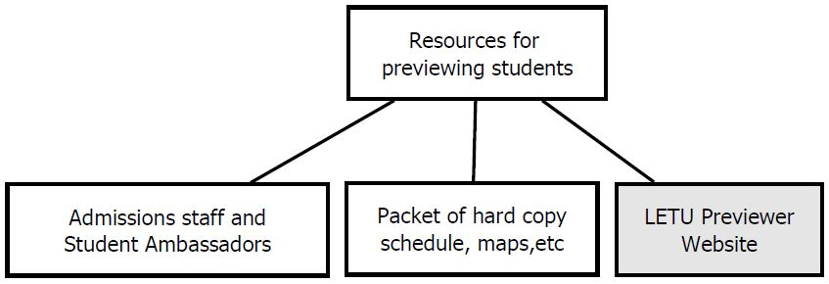

Product Functionality
The LETU Previewer Website will have five main functions:
- Maps – Allow the user to search for buildings and classrooms.
- Dining – Display the dining schedule, menu options, and locations.
- Schedule – Allow user to view the schedule for previewing events.
- Activities – List upcoming campus-wide activities.
- Help – Allow users to see frequently asked questions and view relevant contact information.

Users and Characteristics
The following are the anticipated users of the product; they are listed in order of decreasing frequency of product use.
- Previewing Students
Previewing students (along with their family members) will be the main users of the product; they are the most important to satisfy. Previewing students are expected to know very little or nothing about the school. All five of the software’s major functions will be used frequently by these users.
- New Students
New students are anticipated to use the product with decreasing frequency as the semester progresses. They are expected to know little about the school toward the beginning of the year and increasingly more as they spend time on campus. The main functions used by new students will be “Maps,” “Dining,” “Activities,” and “Help.”
- Campus Visitors
Campus visitors will use the program relatively infrequently—mainly for sporting or academic events. They will use the website perhaps a few times per month. This user is expected to care less about dining options or schedules; they typically just care about events and their locations. The main functions used by campus visitors will be “Maps,” “Activities,” and perhaps “Dining.”
- Professors
Professors are likely to use the product the least frequently—perhaps a few times towards the beginning of the semester. They are expected to use the product to determine where a particular classroom is. The only major function professors are anticipated to use is the “Maps” option.

Operating Environment
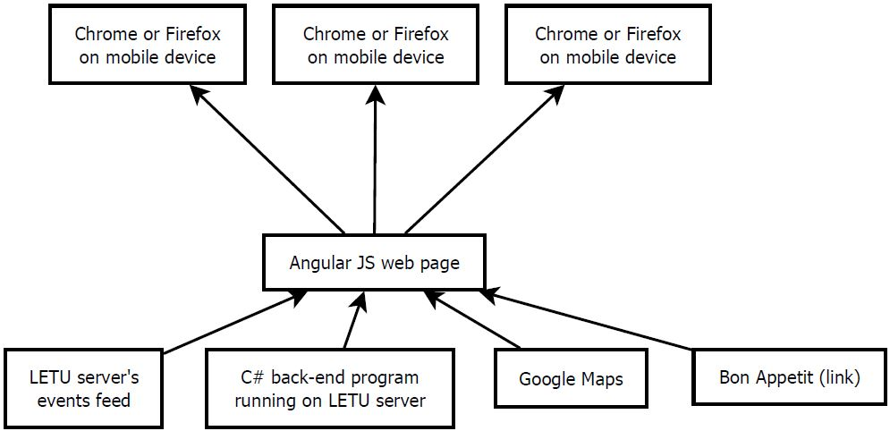
This software will be web-based. It is currently designed to run on a mobile device in either the Chrome or Firefox web browser. All mobile device operating systems (e.g. Android, iOS, Windows) will support the software. The user must have an Internet connection to use the software.

Design and Implementation Constraints
There were several different design and implementation constraints which affected the development of the prototype. The first constraint was that initially, only one team member had any experience with Angular JS (the language chosen to implement the front-end of the application). The code developed also needed to conform to Angular JS coding standards. These constraints impacted the rate of development. Another concern was screen size; the application needed to be easy to use, even on small screens. Additionally, users are expected to only access this application via a mobile device and not a personal computer (though this is possible). Both of these constraints impacted how the GUI was designed. One further constraint is that the application must be able to pull and parse JSON and/or XML from websites, limiting the languages available to implement the application’s back-end.

Assumptions and Dependencies
The application will be dependent on several websites, including Google Maps, the LeTourneau website, and the Bon Appétit website. If any of these websites are inaccessible at a given time, it could result in limited application functionality. Several major assumptions were made in regard to the application. The user is assumed to have an Internet-capable mobile device and access to the Internet. The developers assume admissions staff will provide relevant information for the “Schedule” feature. The developers assume the application will be able to pull relevant data from the LeTourneau website’s events feed. The developers assume building names and classroom locations remain constant.

Appendix A – Group Log
Project Group Meeting – February 3, 2016
Meeting called to order at 8:40 am.

Members present:
Aisha Rigert
Colin Tompkins
Israel Terrill

Reading of Agenda
Motion: To spend this meeting establishing responsibilities and project direction
Consensus reached without vote
Resolved: Agenda for the meeting on February 3, 2016 approved

Next Meeting Date
Motion: That the next team meeting will be February 5 after chapel in ASC and last no more than one hour
Vote: Motion carried
Resolved: Date, time, and location set for next team meeting

Business
- Discussion of backend responsibilities
Consensus: Back end is mostly building map search functions
- Discussion of how maps will be searchable
  - Idea: store image for each building and return appropriate one
  - Idea: database
  - Idea (selected): store coordinates in KML or XML file and place dot
  - Motion: store coordinates in XML file and place dot when loaded in GUI
Vote: Motion carried
Resolved: Map coordinate storage method
- Discussion of prototype map search scope
Consensus: Include only a few buildings/rooms now and add more later
- Choosing of project name
Consensus: LETU Previewer Website
- Discussion of SRS section-by-section:
  - Product scope – description provided by Aisha Rigert from previous prototype work
  - Languages to be used
Consensus: Angular JS for front end and C# for back end
  - Target audience/delivery
Consensus: Audience is previewers, delivery is a mobile browser (desktop later)
- Outlining of back-end and front-end responsibilities and interactions
Consensus: When user enters search text, Angular page requests map coordinates from C# back-end and displays dot at appropriate location on image
- Defining of team member responsibilities:
  - SRS – mostly Colin
  - Meeting minutes – Aisha
  - Data flow diagram – Aisha
  - Prototype (UI) –Aisha and Israel
  - Help Aisha set up AngularJS environment – Israel
Meeting adjourned at 9:35 am

Project Group Meeting – February 5, 2016
Meeting called to order at 3 pm.

Members present:
Aisha Rigert
Colin Tompkins
Israel Terrill

Reading of Agenda
Motion: To spend this meeting resolving issues and questions with the SRS
Consensus reached without vote

Business
- Discussion of SRS sections Colin is currently working on, verifying that wording and information is correct and complete
  - Revisions-- revision number and formatting
  - Document purpose
  - Product scope
  - Audience/document overview
- Should we make a C# back-end? Consensus: probably yes, because it will be more efficient than doing it all in Angular JS.

Meeting adjourned at 3:20 pm
Project Group Meeting – February 10, 2016
Meeting called to order at 8:37 am.

Members present:
Aisha Rigert
Israel Terrill
Colin Tompkins

Reading of Agenda
Motion: That the purpose of this meeting is for Colin to ask the prototyping team questions about SRS sections to make sure they are consistent with our plan and for the prototyping team to demo their work and get input.
Consensus reached without vote

Business
- Discussion of SRS sections Colin is currently working on, verifying that wording and information is correct and complete
  - List constraints: mobile's small screen size, languages we know, coding standards
  - List dependencies: mobile device with web browser, events feed from LETU, Internet access
  - Verify intended audience: client, professor, students, present and future developers
  - Verify origin and purpose of the project
  - Verify five main functions of the software
  - List which functions are dependent on outside resources such as Google Maps
  - Verify operating environment: mobile device with Chrome or Firefox browser
  - Verify expected users: previewing students, new students, visitors, professors
Should we include admissions staff who update schedule as users? Consensus: Leave the list as-is now and possibly add admissions staff later.
- Discussion of SRS items to be delegated to Aisha and Israel
  - Action item: Aisha will complete data flow diagrams on Product Perspective, Operating Environment, and Functionality.
  - Action item: Aisha and Israel will provide IEEE-formatted references used for the prototype development.
- Get input on UI and requirements specification from Dr. Baas
  - Action item: Israel will get UI input from Chris Loewer.

Meeting adjourned at 9:22 am

