ISRAEL WONDER ESELE

SID:2255540

LAB Logbook

Lab 1

import numpy as np

a = np.arange(40)

print(a)

[ 0 1 2 3 4 5 6 7 8 9 10 11 12 13 14 15 16 17 18 19 20 21 22 23

24 25 26 27 28 29 30 31 32 33 34 35 36 37 38 39]

# Reshape the array 'a' into a 2D array with 40 rows and 1 column

v = a.reshape(1,40)

print(v)

print('\n')

print(v.shape)

[[ 0 1 2 3 4 5 6 7 8 9 10 11 12 13 14 15 16 17 18 19 20 21 22 23

24 25 26 27 28 29 30 31 32 33 34 35 36 37 38 39]]

(1, 40)

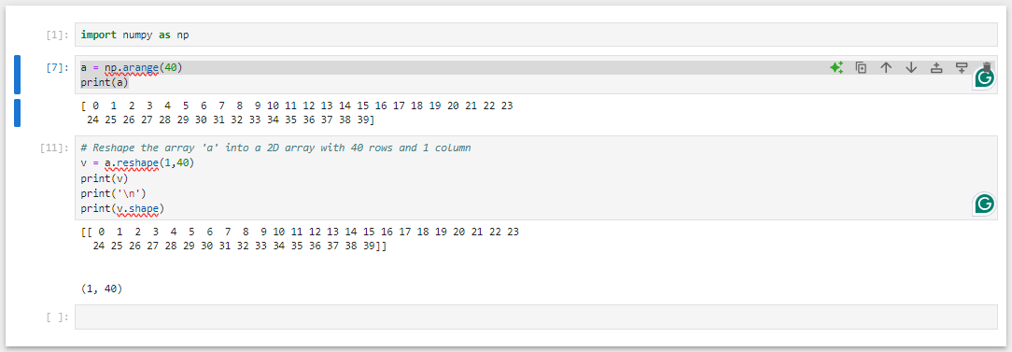

Lab 2

Lab 3

Lab 4

Lab 5

Lab 6

Lab 7

Lab 8

Lab 9

Lab 10

Lab 11

Lab 12