ISRAEL WONDER ESELE

SID:2255540

LAB Logbook

Lab 1

import numpy as np

a = np.arange(40)

print(a)

[ 0 1 2 3 4 5 6 7 8 9 10 11 12 13 14 15 16 17 18 19 20 21 22 23

24 25 26 27 28 29 30 31 32 33 34 35 36 37 38 39]

# Reshape the array 'a' into a 2D array with 40 rows and 1 column

v = a.reshape(1,40)

print(v)

print('\n')

print(v.shape)

[[ 0 1 2 3 4 5 6 7 8 9 10 11 12 13 14 15 16 17 18 19 20 21 22 23

24 25 26 27 28 29 30 31 32 33 34 35 36 37 38 39]]

(1, 40)

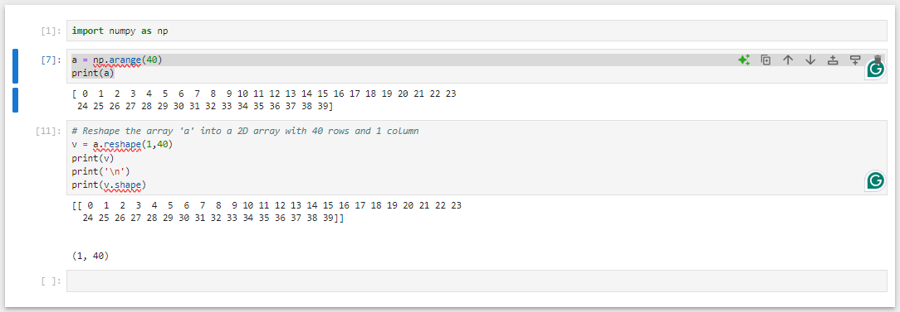

Lab 2

import pandas as pd

data = pd.read_csv('adult_data_mini.csv', header=0)

data.head()

Grouped_data = data.groupby(["relationship", "hours-per-week"])

Grouped_data.size()

data["hours-per-week"] = data["hours-per-week"] - 10

data["hours-per-week"]

Grouped_data = data.groupby(["relationship", "hours-per-week"])

Grouped_data.size()

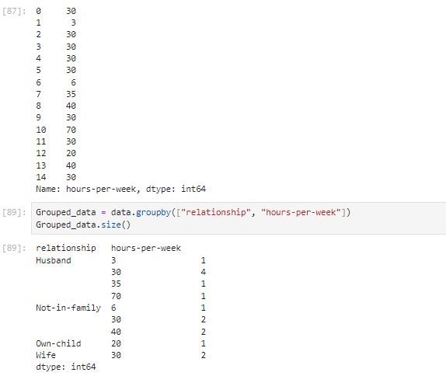

Lab 3

# SID 2255540

import pandas as pd

import numpy as np

from matplotlib import pyplot as plt

data = pd.read_csv('telecom_churn.csv')

data.head()

import seaborn as sns

%matplotlib inline

data.columns

Clr = data['Churn'].map({False: 'blue', True: 'orange'})

Clr.head()

# Set up a bicolour interaction diagram between column 0 and column 4

fig = plt.figure(figsize=(11, 5))

plt.scatter(data['Total eve calls'], data['Voice mail plan'], color = Clr);

plt.xlabel('Total eve calls');

plt.ylabel('Voice mail plan');

plt.title('Bicolour Interaction between Column 0 and Column 4')

Lab 4

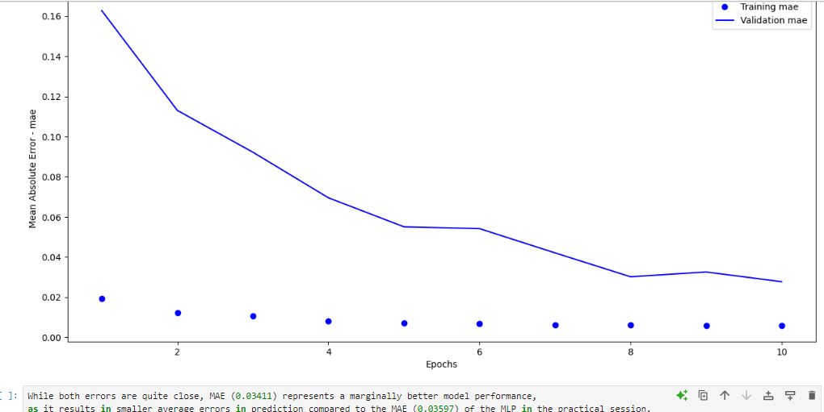

Lab 5

Lab 6

Lab 7

Lab 8

Lab 9

Lab 10

Lab 11

Lab 12