

**Green University of Bangladesh**

**Department of Computer Science and Engineering(CSE)**

**Faculty of Sciences and Engineering**

**Semester: (Summer, Year:2022), B.Sc. in CSE (Day)**

**LAB REPORT NO :10**

**Course Title:** **Structured Programming Lab**

**Course Code: CSE 104 Section: DE**

**Student Details**

|  |  |
| --- | --- |
| **Name** | **ID** |
| **Md. Israil Fakir** | **221902125** |

**Submission Date : 14-Sep-22**

**Course Teacher’s Name : Md. Parvez Hossain**

**[For Teachers use only: Don’t Write Anything inside this box]**

|  |
| --- |
| **Lab Report Status**  **Marks: ………………………………… Signature:.....................**  **Comments:.............................................. Date:..............................** |

**Problem 01:** **Write a program in C to find the maximum and minimum element in an array using pointer**

**Code:**

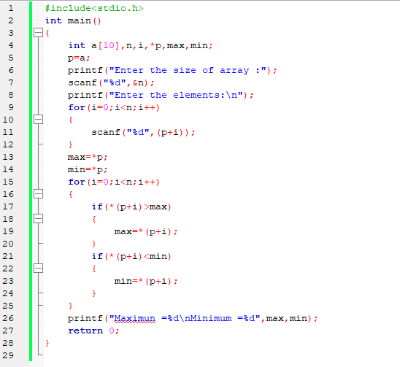

**Output:**

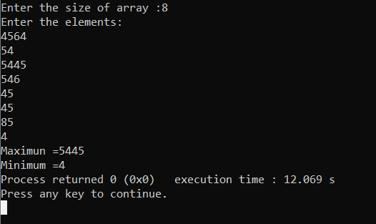

**Problem 02:** **Write a C program to convert Decimal to Binary number system pointer.**

**Code:**

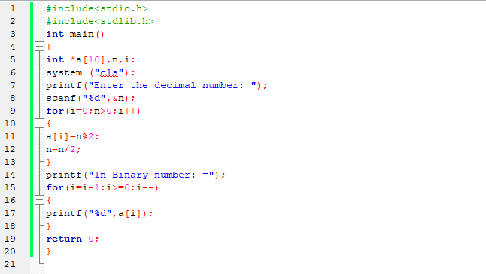

**Output:**

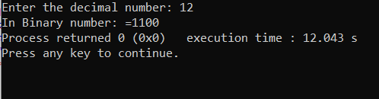

**Problem 03: Write a C program to concatenate two strings using pointers.**

**Code:**

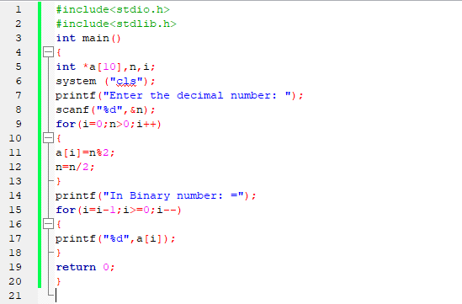

**Output:**

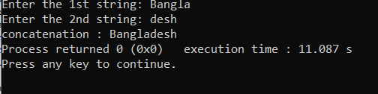

**Problem 04:** **Write a C program to add two matrix using pointers.**

**Code:**

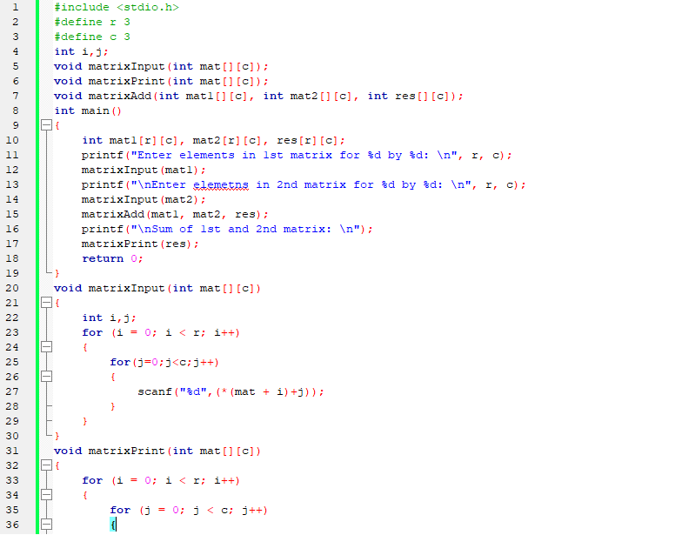

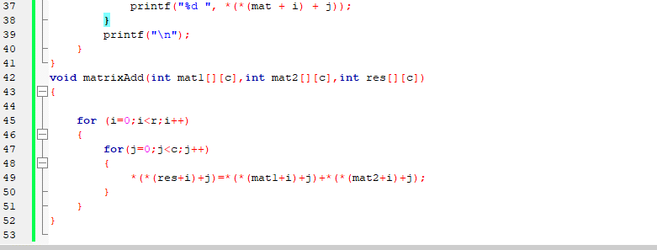

**Output:**

