

**Green University of Bangladesh**

**Department of Computer Science and Engineering(CSE)**

**Faculty of Sciences and Engineering**

**Semester: (Summer, Year:2021), B.Sc. in CSE (Day)**

**LAB REPORT NO 6**

**Course Title: Structured Programing Lab**

**Course Code: CSE 104 Section: DE**

**Student Details**

|  |  |
| --- | --- |
| **Name** | **ID** |
| **Md. Sabbir Hossain** | **221902126** |

**Lab Date : 01/08/2022**

**Submission Date : 6/08/2022**

**Course Teacher’s Name : Md. Parvez Hossain**

**[For Teachers use only: Don’t Write Anything inside this box]**

|  |
| --- |
| **Lab Report Status**  **Marks: ………………………………… Signature:.....................**  **Comments:.............................................. Date:..............................** |

**Problem 1**

**Write a C Program to Calculate mean, median and Standard Deviation.**

**Code:**

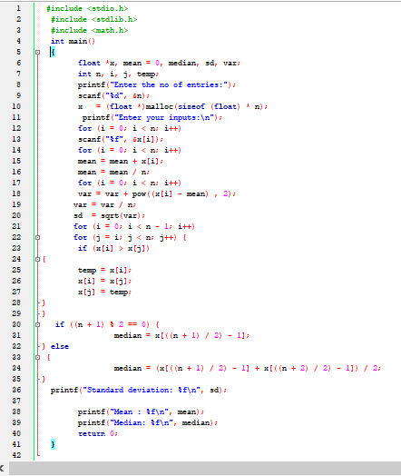

**Output:**

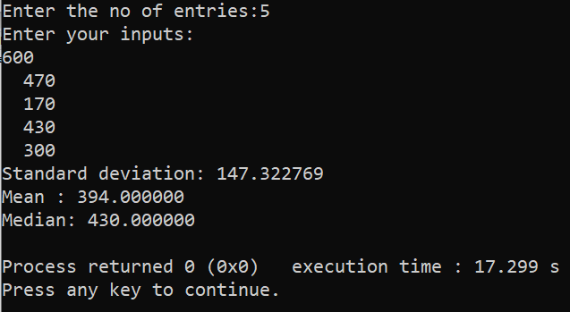

**Problem 2**

2. Write a C program to convert Decimal to Binary number system.

**Code:**

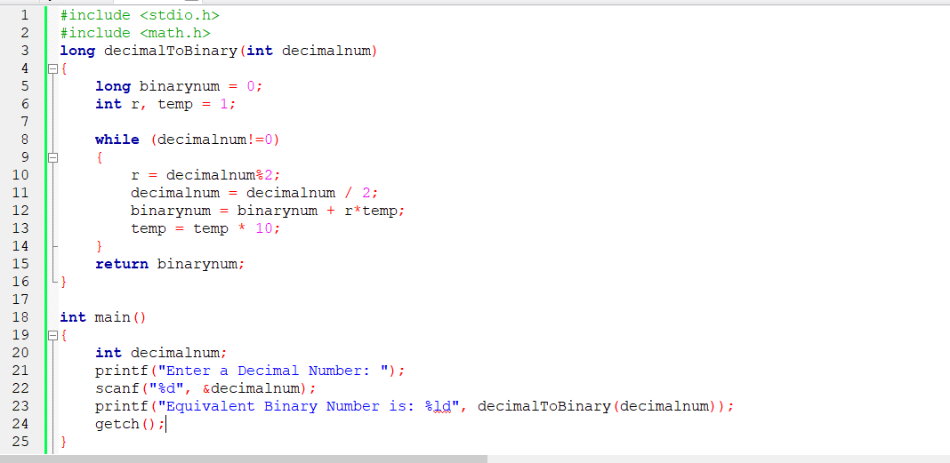

Output

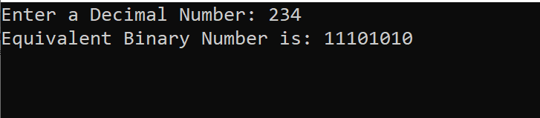

**Problem 3**

Write a C program to count frequency of each element in an array.

**Code :**

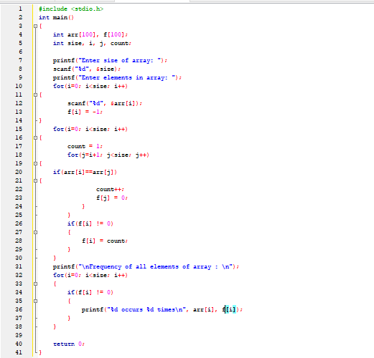

**Output:**

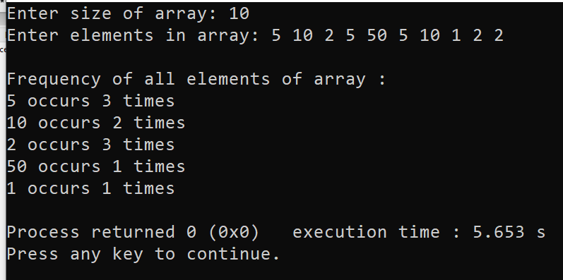

**Problem 4**

Write a C Program to Find Transpose of a Matrix.

**Code:**

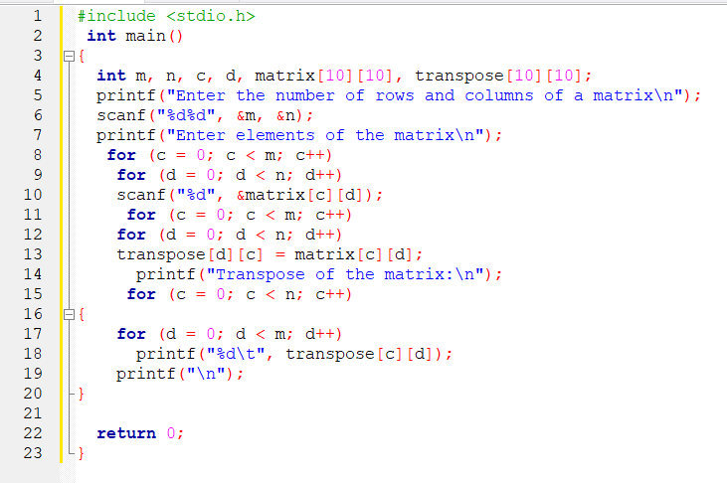

**Output:**

