

**Green University of Bangladesh**

**Department of Computer Science and Engineering(CSE)**

**Faculty of Sciences and Engineering**

**Semester: (Summer, Year:2022), B.Sc. in CSE (Day)**

**LAB REPORT NO :07**

**Course Title: Structured Programing Lab**

**Course Code: CSE 104 Section: DE**

**Student Details**

|  |  |
| --- | --- |
| **Name** | **ID** |
| **Md. Sabbir Hossain** | **221902126** |

**Lab Date : 8/08/2022**

**Submission Date : 14/08/2022**

**Course Teacher’s Name : Md. Parvez Hossain**

**[For Teachers use only: Don’t Write Anything inside this box]**

|  |
| --- |
| **Lab Report Status**  **Marks: ………………………………… Signature:.....................**  **Comments:.............................................. Date:..............................** |

**Problem 1**

**Write a C Program to convert a decimal number to an equivalent binary number using function.**

**Code:**

#include <stdio.h>

long decimalToBinary(int decimalnum)

{

long binarynum = 0;

int rem, temp = 1;

while (decimalnum!=0)

{

rem = decimalnum%2;

decimalnum = decimalnum / 2;

binarynum = binarynum + rem*temp;

temp = temp * 10;

}

return binarynum;

}

int main()

{

int decimalnum;

printf("Enter a Decimal Number: ");

scanf("%d", &decimalnum);

printf("Equivalent Binary Number is: %ld", decimalToBinary(decimalnum));

return 0;

}

**Output:**

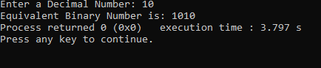

**Problem 2**

**Write a C program to create menu driven calculator that performs basic arithmetic operations (add,subtract, multiply and divide) using functions.**

**Code:**

**#include <stdio.h>**

**void main() {**

**int num1,num2,opt;**

**printf("Enter the first Integer :");**

**scanf("%d",&num1);**

**printf("Enter the second Integer :");**

**scanf("%d",&num2);**

**printf("\nInput your option :\n");**

**printf("1-Addition.\n2-Substraction.\n3-Multiplication.\n4-Division.\n5-Exit.\n");**

**scanf("%d",&opt);**

**switch(opt) {**

**case 1:**

**printf("The Addition of %d and %d is: %d\n",num1,num2,num1+num2);**

**break;**

**case 2:**

**printf("The Substraction of %d and %d is: %d\n",num1,num2,num1-num2);**

**break;**

**case 3:**

**printf("The Multiplication of %d and %d is: %d\n",num1,num2,num1*num2);**

**break;**

**case 4:**

**if(num2==0) {**

**printf("The second integer is zero. Devide by zero.\n");**

**} else {**

**printf("The Division of %d and %d is : %d\n",num1,num2,num1/num2);**

**}**

**break;**

**case 5:**

**break;**

**default:**

**printf("Input correct option\n");**

**break;**

**}**

**}**

**Output:**

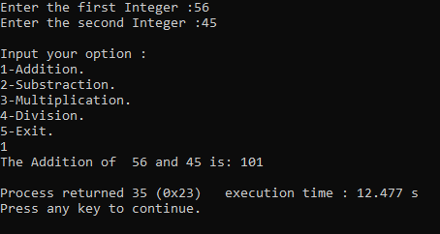

**Problem 3**

**Write a C Program to print Strong Numbers between given interval using function.**

**Code:**

**#include <stdio.h>**

**long long fact(int num);**

**void printStrongNumbers(int start, int end);**

**int main()**

**{**

**int start, end;**

**printf("Enter the lower limit to find strong number: ");**

**scanf("%d", &start);**

**printf("Enter the upper limit to find strong number: ");**

**scanf("%d", &end);**

**printf("All strong numbers between %d to %d are: \n", start, end);**

**printStrongNumbers(start, end);**

**return 0;**

**}**

**void printStrongNumbers(int start, int end)**

**{**

**long long sum;**

**int num;**

**while(start != end)**

**{**

**sum = 0;**

**num = start;**

**while(num != 0)**

**{**

**sum += fact(num % 10);**

**num /= 10;**

**}**

**if(start == sum)**

**{**

**printf("%d, ", start);**

**}**

**start++;**

**}**

**}**

**long long fact(int num)**

**{**

**if(num == 0)**

**return 1;**

**else**

**return (num * fact(num-1));**

**}**

**Problem 4**

**Write a C program to calculate sum of all digits of a number using recursion.**

**Code:**

**#include <stdio.h>**

**int sumOfDigits(int num);**

**int main()**

**{**

**int num, sum;**

**printf("Enter any number to find sum of digits: ");**

**scanf("%d", &num);**

**sum = sumOfDigits(num);**

**printf("Sum of digits of %d = %d", num, sum);**

**return 0;**

**}**

**int sumOfDigits(int num)**

**{**

**if(num == 0)**

**return 0;**

**return ((num % 10) + sumOfDigits(num / 10));**

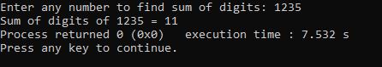**}**

**Output:**