Exploratory Data Analysis Insights
Summary Statistics
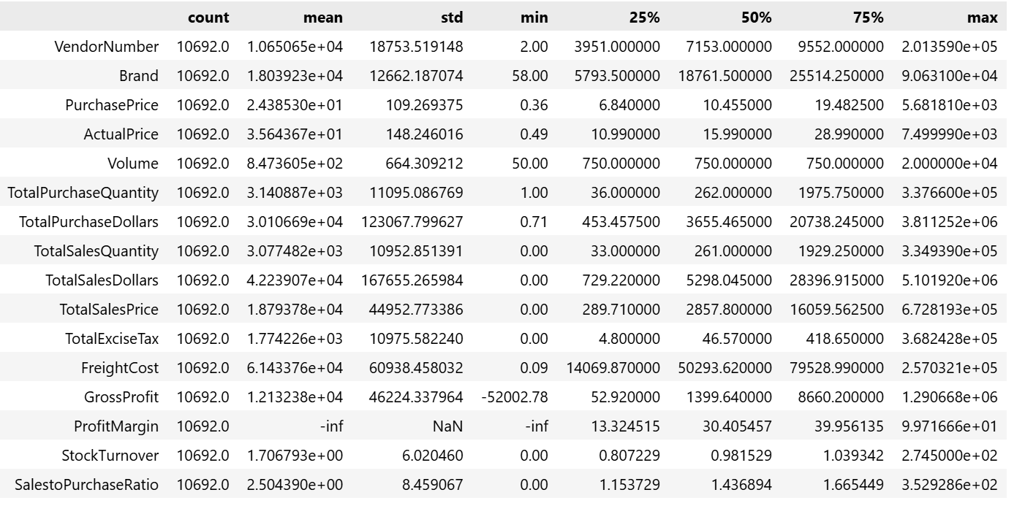

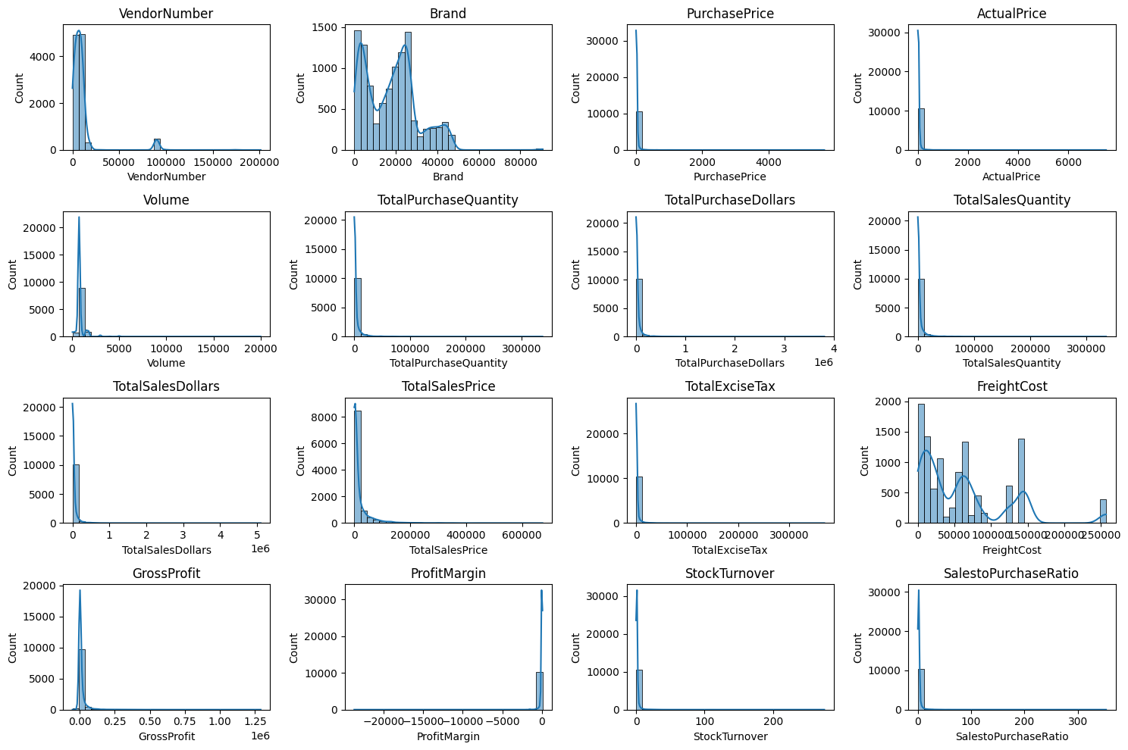
Negative and Zero Values
The summary statistics revealed several important observations regarding negative and zero values within the dataset:
Gross Profit: The minimum gross profit value is -52,002.78, indicating that certain products or transactions were sold at a loss. This may occur when products are purchased at a higher cost or sold at discounted prices below their purchase cost.
Profit Margin: The minimum profit margin is negative infinity (-∞), suggesting situations where sales revenue was either zero or lower than the associated costs. These cases require further investigation as they may indicate data quality issues or unprofitable transactions.
Total Sales Quantity and Total Sales Dollars: Both variables contain minimum values of 0, indicating that some products were purchased but never sold. Such products may represent slow-moving, obsolete, or excess inventory that ties up working capital.

Outliers Identified Through High Standard Deviation
Several variables exhibited substantial variation, indicating the presence of potential outliers and unusual business patterns:
- Purchase Price and Actual Price: The maximum values (5,681.81 and 7,499.99, respectively) are significantly higher than their average values (24.39 and 35.64). This suggests the presence of premium or high-value products within the inventory portfolio.
- Freight Cost: Freight costs vary considerably, ranging from 0.09 to 257,032.07. This large variation may indicate differences in shipment sizes, transportation methods, supplier locations, or logistics inefficiencies.
- Stock Turnover: Stock turnover ranges from 0 to 274.5, demonstrating substantial differences in inventory movement across products. A turnover value greater than 1 indicates that sales quantities exceed current purchase quantities, potentially due to inventory being fulfilled from existing stock. Conversely, low turnover values may highlight products with slow sales velocity and inventory accumulation.

Data Filtering
To enhance the reliability of the insights, we removed inconsistent data points where:
- Gross Profit ≤ 0 (to exclude transactions leading to losses).
- Profit Margin ≤ 0 (to ensure analysis focuses on profitable transactions).
- Total Sales Quantity = 0 (to eliminate inventory that was never sold).

Correlation Insights
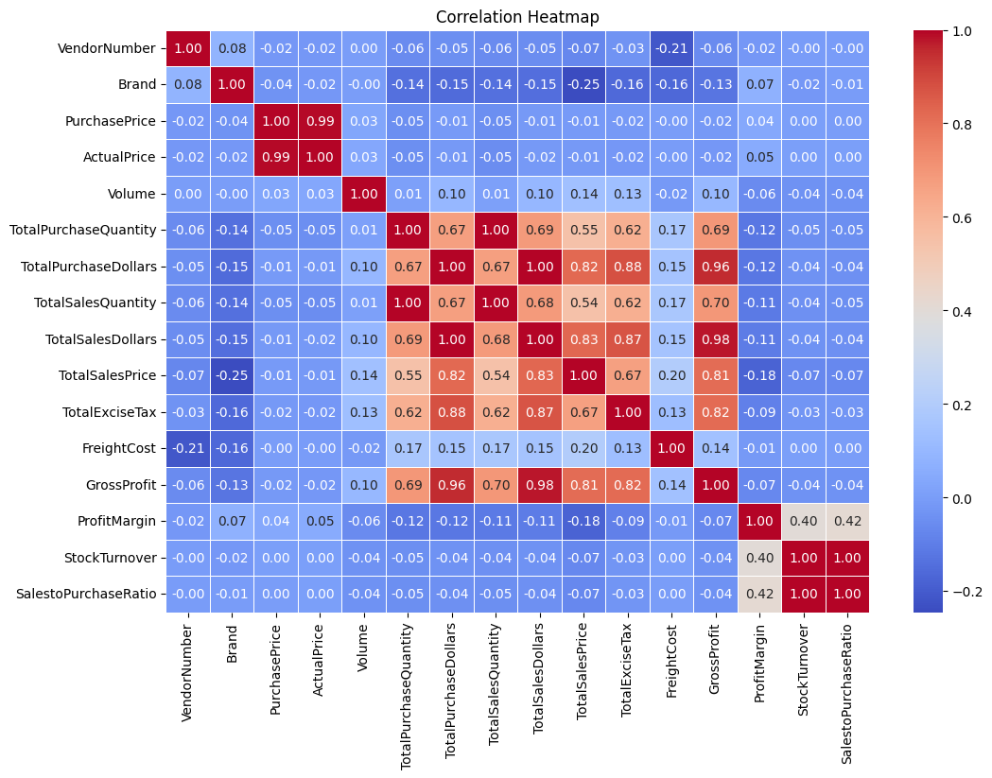
Purchase Price vs. Total Sales Dollars & Gross Profit: Weak correlation (-0.012 and -0.016), indicating that price variations do not significantly impact sales revenue or profit.
Total Purchase Quantity vs. Total Sales Quantity: Strong correlation (0.999), confirming efficient inventory turnover.
Profit Margin vs. Total Sales Price: Negative correlation (-0.179), suggesting increasing sales prices may lead to reduced margins, possibly due to competitive pricing pressures.
Stock Turnover vs. Gross Profit & Profit Margin: Weak negative correlation (-0.038 & -0.055), indicating that faster stock turnover does not necessarily equate to higher profitability.

Research Questions & Key Findings
1.Brands for Promotional or Pricing Adjustments
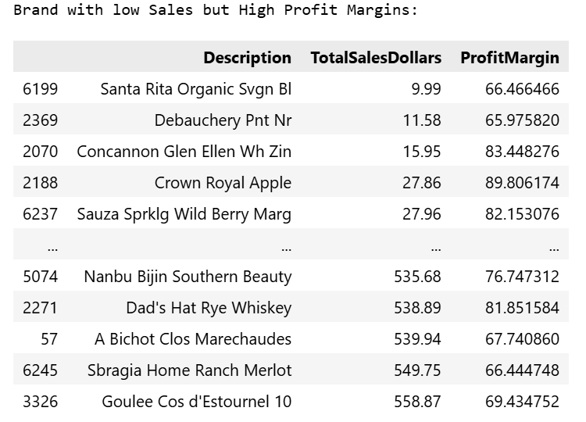
198 Brands exhibit lower sales but higher profit margins, which could benefit from targetd marketing, promotions, or price optimizations to increase volume without compromising profitability.
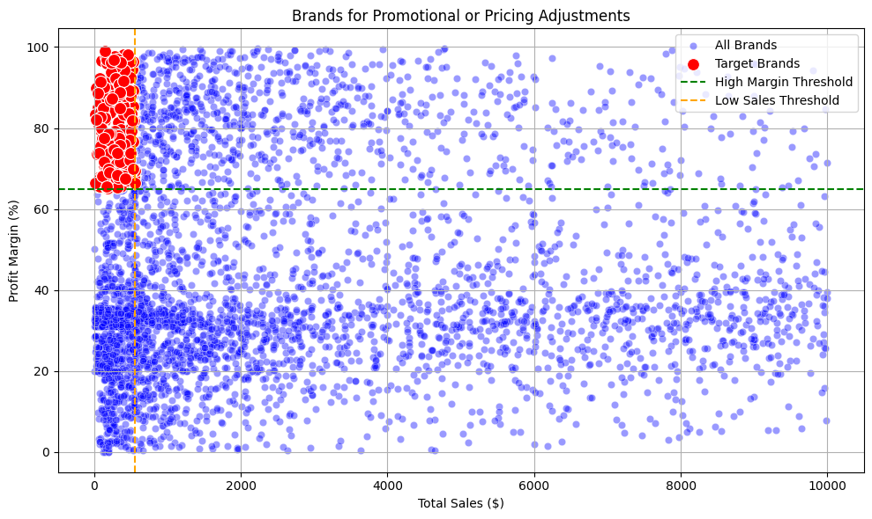
2. Top Vendors by Sales & Purchase Contribution
The top 10 vendors contribute 65.69% of total purchases, while the remaining vendors contribute only 34.31%. This over-reliance on a few vendors may introduce risks such as supply chain disruptions, indicating a need for diversification.
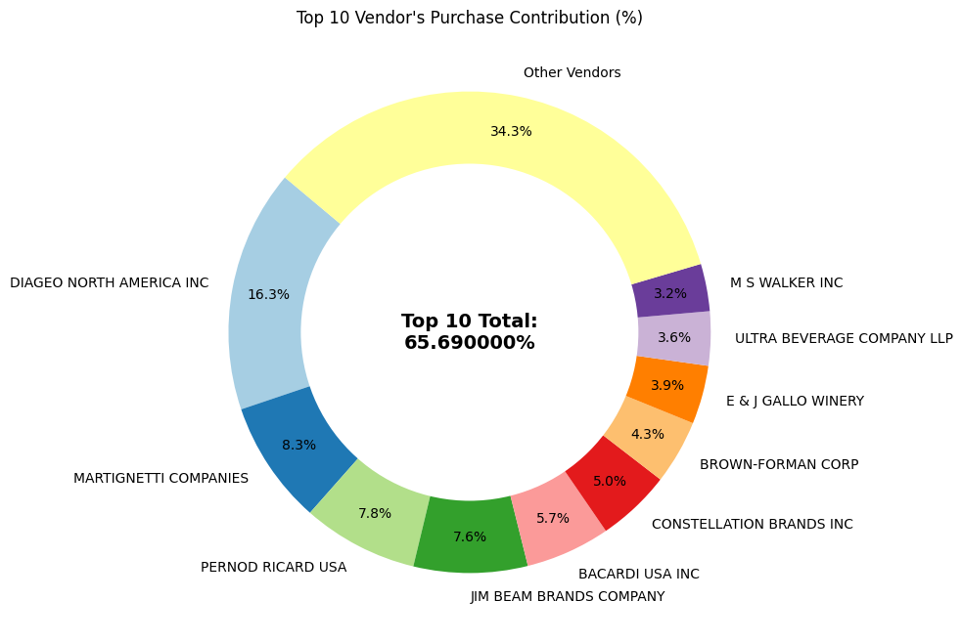
3. Impact of Bulk Purchasing on Cost Savings
Vendors buying in large quantities receive a 72% lower unit cost ($10.78 per unit vs. higher unit costs in smaller orders).
Bulk pricing strategies encourage larger orders, increasing total sales while maintaining profitability.
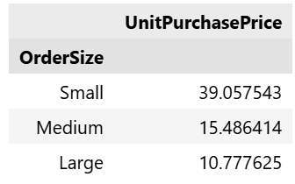

4. Identifying Vendors with Low Inventory Turnover
Total Unsold Inventory Capital: $2.71M
Slow-moving inventory increases storage costs, reduces cash flow efficiency, and affects overall profitability.
Identifying vendors with low inventory turnover enables better stock management, minimizing financial strain.
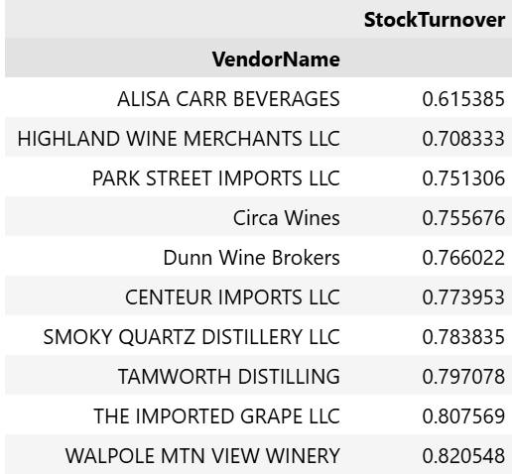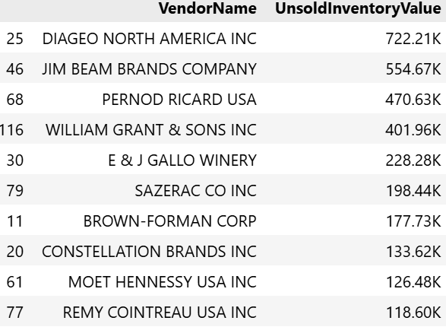

5. Profit Margin Comparison: High vs. Low-Performing
Top Vendors' Profit Margin (95% CI): (30.74%, 31.61%), Mean: 31.17% Low Vendors' Profit Margin (95% CI): (40.48%, 42.62%), Mean: 41.55%
Low-performing vendors maintain higher margins but struggle with sales volumes, indicating potential pricing inefficiencies or market reach issues.
Actionable Insights:
- Top-performing vendors: Optimize profitability by adjusting pricing, reducing operational costs, or offering bundled promotions.
- Low-performing vendors:Improve marketing efforts, optimize pricing strategies, and enhance distribution networks.
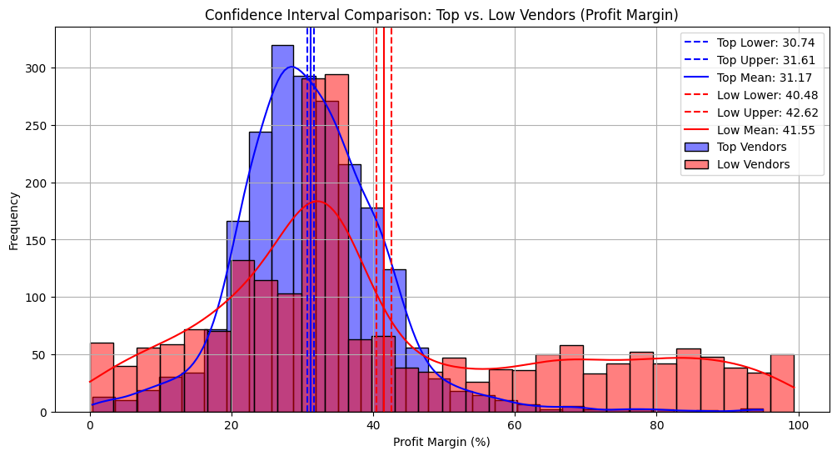
6. Statistical Validation of Profit Margin Differences
Hypothesis Testing:
- H₀ (Null Hypothesis): No significant difference in profit margins between top and low-performing vendors.
- H₁ (Alternative Hypothesis): A significant difference exists in profit margins between the two vendor groups.
Result: The null hypothesis is rejected, confirming that the two groups operate under distinctly different profitability models.
Implication: High-margin vendors may benefit from better pricing strategies, while top-selling vendors could focus on cost efficiency.
Final Recommendations
- Re-evaluate pricing for low-sales, high-margin brands to boost sales volume without sacrificing profitability.
- Diversify vendor partnerships to reduce dependency on a few suppliers and mitigate supply chain risks.
- Leverage bulk purchasing advantages to maintain competitive pricing while optimizing inventory management.
- Optimize slow-moving inventory by adjusting purchase quantities, launching clearance sales, or revising storage strategies.
- Enhance marketing and distribution strategies for low-performing vendors to drive higher sales volumes without compromising profit margins.
- By implementing these recommendations, the company can achieve sustainable profitability, mitigate risks, and enhance overall operational efficiency.

