Name: Israr Ahmad Id: 38496
Course: Artifical Intelligence

Code Screenshots & Outputs

Numbers
x = 3
print(x, type(x))
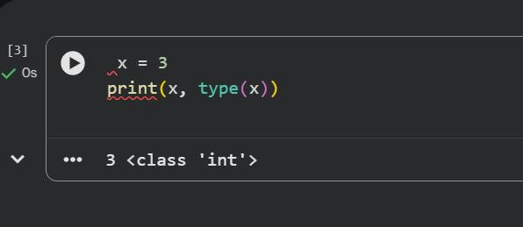

x = 3
print(x + 1) # Addition print(x - 1) # Subtraction print(x * 2) # Multiplication print(x ** 2) # Exponentiation

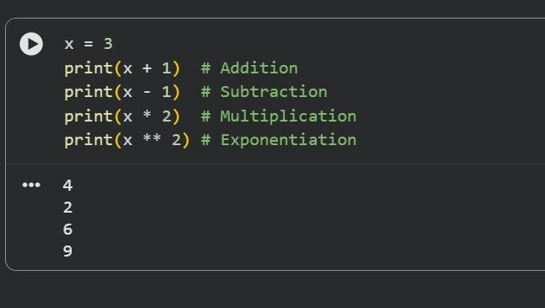
X = 3
x += 1
print(x) x *= 2 print(x)

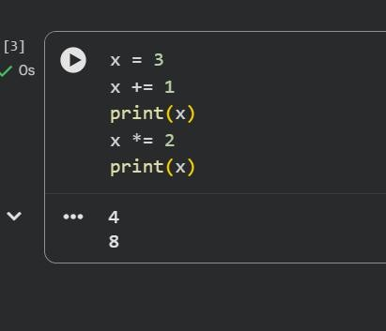

y = 2.5
print(type(y))
print(y, y + 1, y * 2, y ** 2)

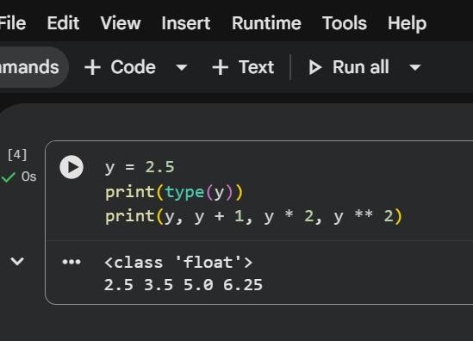

Booleans
t, f = True, False print(type(t))

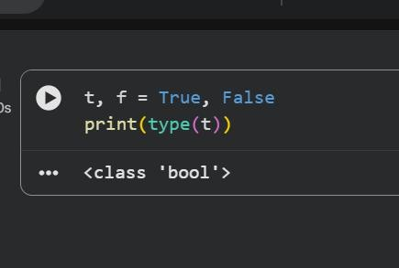

# Logical operations
print(t and f) # Logical AND print(t or f) # Logical OR print(not t) # Logical NOT print(t != f) # Logical XOR

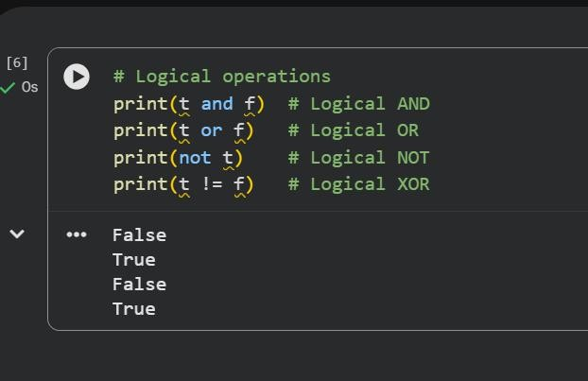

Strings
# Strings
hello = 'hello' # String literals can use single quotes world = "world" # or double quotes; it does not matter print(hello, len(hello))

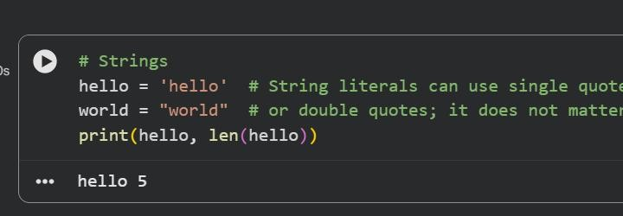
# String concatenation hw = hello + ' ' + world print(hw)

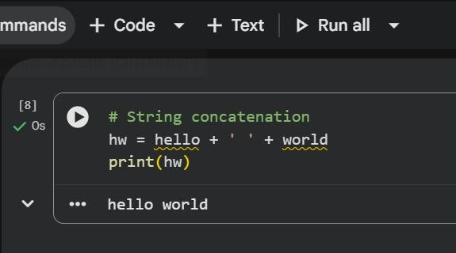

# String formatting
hw12 = '{} {} {}'.format(hello, world, 12)

print(hw12)

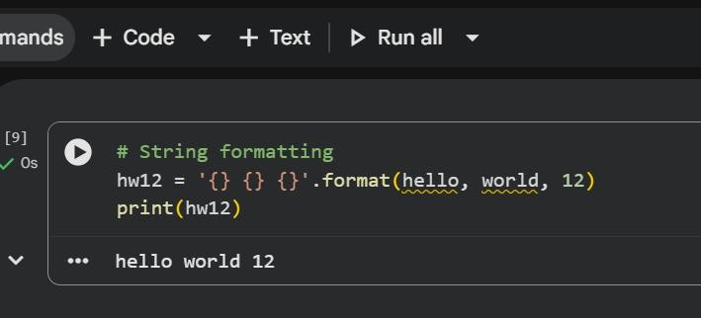

# String methods s = "hello"
print(s.capitalize()) # Capitalize a string print(s.upper()) # Convert to uppercase print(s.rjust(7)) # Right-justify with spaces print(s.center(7)) # Center with spaces print(s.replace('l', '(ell)')) # Replace substrings print(' world '.strip()) # Strip whitespace

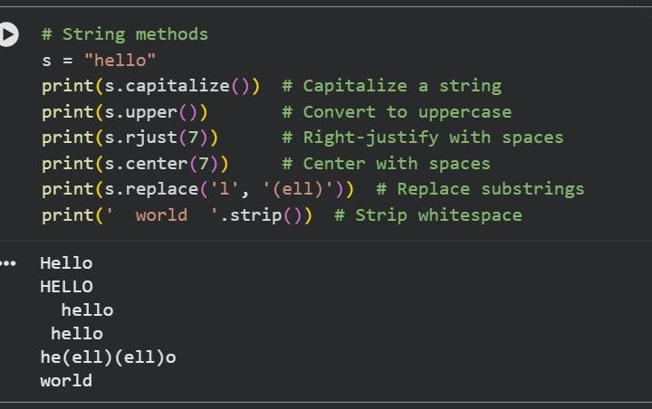
Lists
# Lists
xs = [3, 1, 2] # Create a list print(xs, xs[2])
print(xs[-1]) # Negative indices

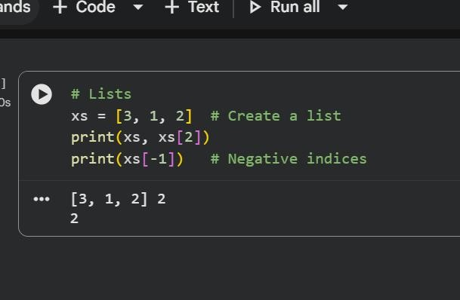

# Lists with different types xs[2] = 'foo'
print(xs)

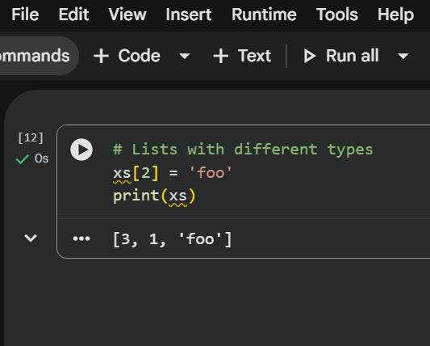

# List methods xs.append('bar') print(xs)
x = xs.pop() print(x, xs)

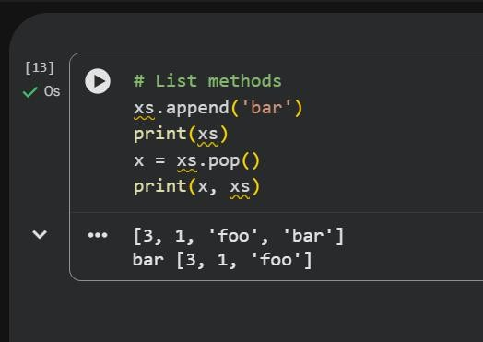

Slicing
# Slicing
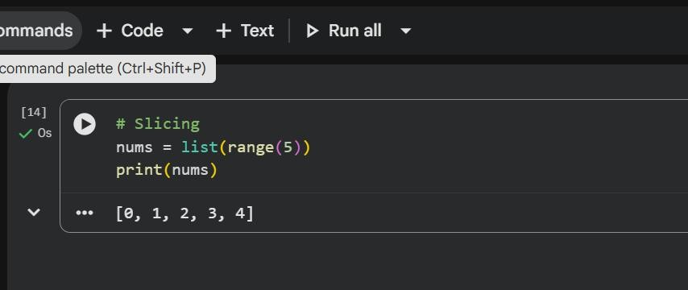
nums = list(range(5)) print(nums)

# Various slice operations
print(nums[2:4]) # Index 2 to 4 (exclusive) print(nums[2:]) # Index 2 to end print(nums[:2]) # Start to index 2 (exclusive) print(nums[:]) # Whole list
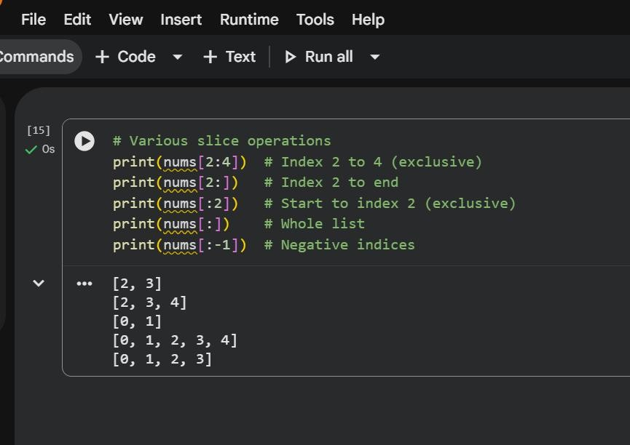
print(nums[:-1]) # Negative indices

# Slice assignment

nums[2:4] = [8, 9]
print(nums)

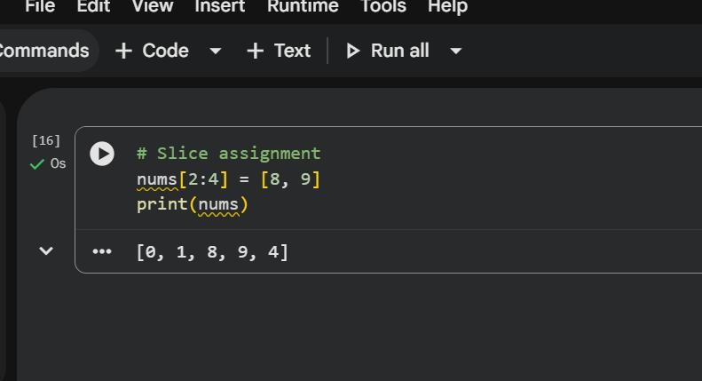

Loops

# Basic for loop
animals = ['cat', 'dog', 'monkey'] for animal in animals:
print(animal)

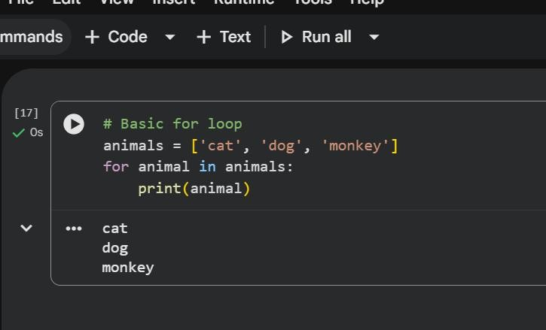

# Range with step
for i in range(0, 5, 2):
print("I am in iteration number:", i)

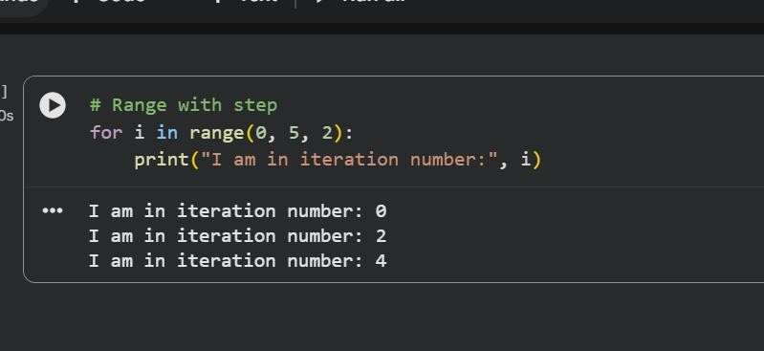

Strings
data = 'hello world' print(data[0]) print(len(data)) print(data)
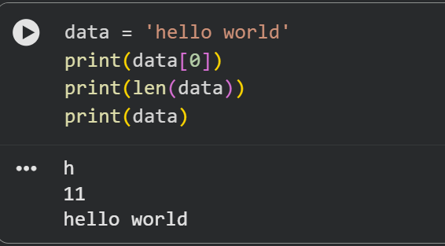

Number

Boolean
a = True

b = False
print(a, b)
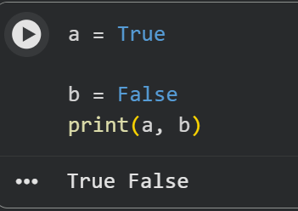

Multiple Assignment
a, b, c = 1, 2, 3

print(a, b, c)

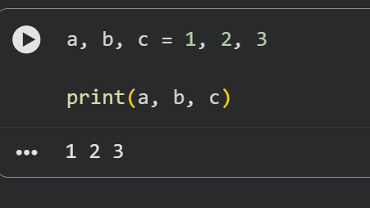

If-else Condition:

value = 99

if value >= 99: print('That is fast')
elif value > 200: print('That is too fast')
else:

print('That that is safe'
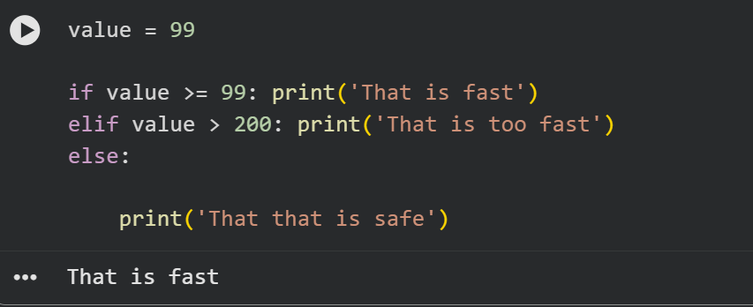

For Loops:

for i in range(10): print(i)
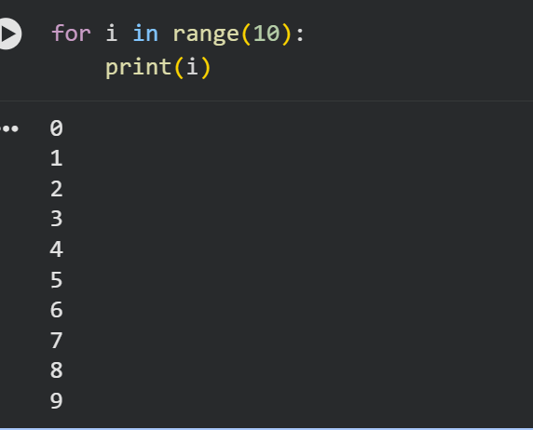

While-Loop:
i = 0

while i < 10: print(i)
i += 1

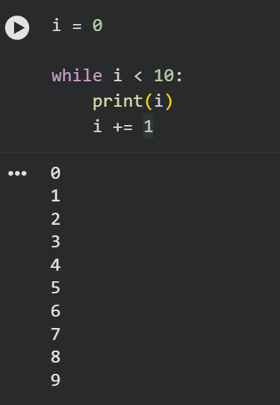

Tuple:
a = (1, 2, 3)

print(a)
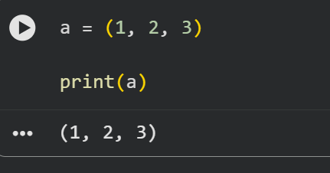

List:
mylist = [1, 2, 3]

print("Zeroth Value: %d" % mylist[0])

mylist.append(4)

print("List Length: %d" % len(mylist)) for value in mylist:
print(value)
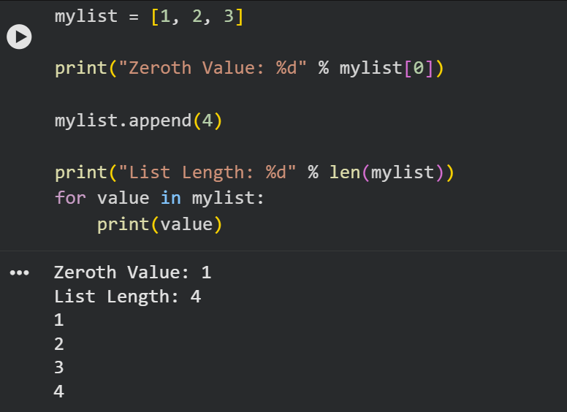

Dictionary:
mydict = {'a': 1, 'b': 2, 'c': 3} print("A value: %d" % mydict['a']) mydict['a'] = 11
print("A value: %d" % mydict['a']) print("Keys: %s" % mydict.keys()) print("Values: %s" % mydict.values()) for key in mydict.keys():
print(mydict[key])

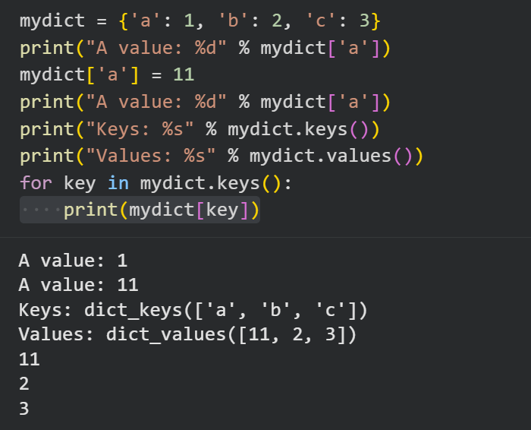

# Sum function
def mysum(x, y): return x + y

# Test sum function print(mysum(1, 3))
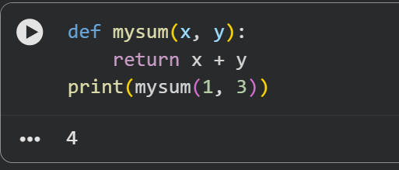

Arrays

numbers = [10, 20, 30, 40, 50]
print(f"Full list: {numbers}")
print(f"First element (index 0): {numbers[0]}")
print(f"Third element (index 2): {numbers[2]}")
print(f"Last element (index -1): {numbers[-1]}")
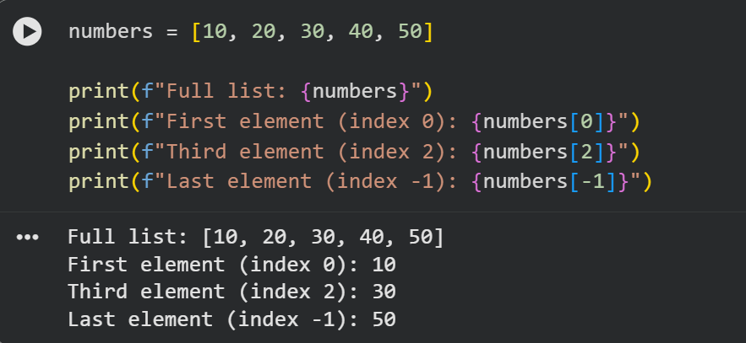

# Create a list
numbers = [5, 10, 15, 20, 25] # Calculate
sum total = 0 for num in numbers:
total = total + num
print(f"Numbers: {numbers}")
print(f"Sum: {total}")

