
PROJECT DOCUMENTATION
Melodix
Online Music & Song Streaming Website
Submitted By | [Your Name]
Roll / Enrollment No. | [Your Roll Number]
Course / Program | [Course Name]
Instructor | [Instructor Name]
Date | October 2026

1. Introduction
Melodix is a modern, responsive music website that lets visitors discover, search and listen to songs online. Music is one of the most widely used forms of digital entertainment, and listeners now expect instant access to songs, artists and playlists from any device. Melodix brings these features together in a clean, dark-themed interface that is easy to use on desktop, tablet and mobile.
This document describes the planning, design and implementation of the Melodix website, including its structure, features, user interface, database design and testing.

1.1 Objectives
- Provide a fast and attractive platform for listening to songs online.
- Allow users to search by song, artist, album or genre.
- Let registered users create playlists and save their favourite tracks.
- Offer a persistent mini-player so music continues while browsing.
- Ensure the website is fully responsive and accessible on all screen sizes.

1.2 Scope of the Project
The project covers the front-end website (HTML, CSS, JavaScript) and the supporting database for songs, artists, albums, users and playlists. In scope: browsing, searching, streaming, user registration/login and playlist management. Out of scope for this version: paid subscriptions, offline downloads and live radio.

1.3 Target Audience
User Group | Description
Music Listeners | Casual users who want to search and play songs quickly without complex steps.
Registered Members | Users who create accounts to build playlists and save favourites.
Artists / Labels | Creators who want their songs, albums and profile to reach more listeners.
Administrator | Manages songs, artists, albums, users and site content.

1.4 Problem Statement
Many music websites are cluttered with advertisements, load slowly or are hard to use on phones. Melodix solves this by providing a lightweight, distraction-free design with quick search, a persistent player and simple navigation.

2. Website Structure
The website is organised around a simple, shallow navigation tree so that any song or page can be reached in two or three clicks. The Home page links to the six main sections shown below.
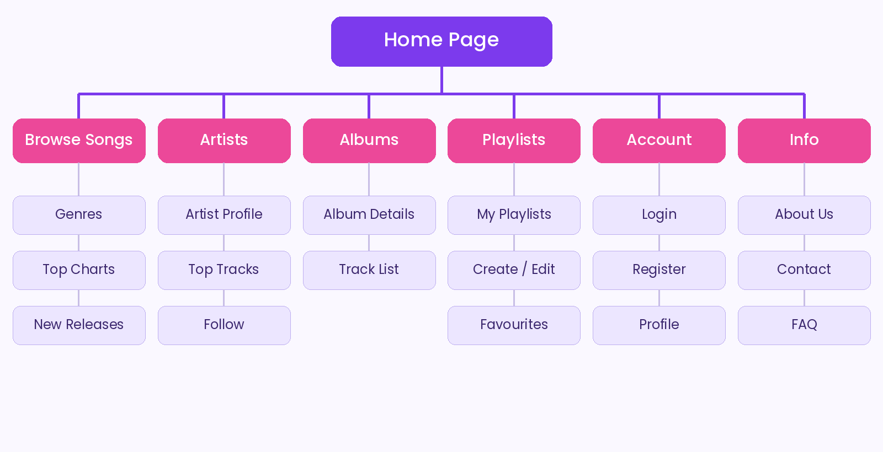
Figure 1: Sitemap of the Melodix website

2.1 Technology Stack
Layer | Technology Used
Front-end | HTML5, CSS3 (Flexbox & Grid), JavaScript (ES6), Bootstrap 5
Audio Player | HTML5 <audio> element with custom JavaScript controls
Back-end | PHP / Node.js (REST-style endpoints for songs and users)
Database | MySQL
Tools | VS Code, Git & GitHub, Figma (wireframes), XAMPP (local server)

2.2 User Flow
A typical visitor lands on the Home page, searches for a song or opens a genre, presses play, and keeps browsing while the mini-player continues in the background. A registered user can add the track to a playlist or mark it as a favourite with a single click.

2.3 Page Description
Home presents trending songs and new releases. Browse Songs lists tracks by genre and chart. Artists and Albums show profile pages with track lists. Playlists contains each user's saved collections. Account handles login, registration and profile, while the Info section provides About, Contact and FAQ pages.

3. Features and Modules
Module | Key Features
Home | Hero banner, trending songs, new releases, featured playlists.
Search | Instant search by title, artist, album or genre with suggestions.
Music Player | Play, pause, next, previous, seek bar, volume, shuffle and repeat.
Playlists | Create, rename and delete playlists; add or remove songs.
Favourites | One-click like button to save songs to a personal list.
User Accounts | Secure registration, login, logout and profile editing.
Admin Panel | Add, edit or delete songs, albums and artists; manage users.

3.1 Homepage Design
The homepage is the main entry point of the site. It includes a navigation bar with search and login, a large hero banner with a clear call to action, a row of trending tracks displayed as album-art cards, and a fixed mini-player at the bottom of the screen.
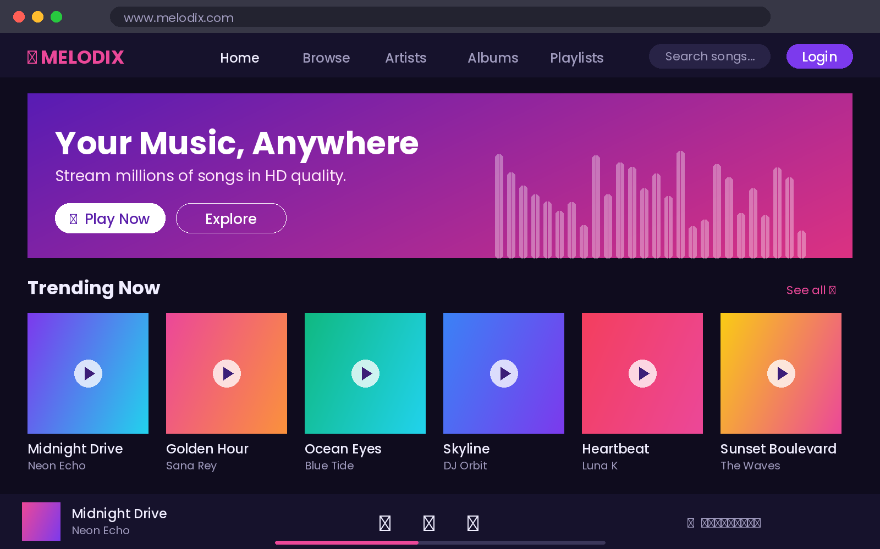
Figure 2: Homepage layout of Melodix

4. User Interface and Theme
Melodix uses a dark, music-inspired theme. Dark backgrounds reduce eye strain during long listening sessions and make colourful album artwork stand out. Violet and pink accents are used for buttons and active states, with cyan used sparingly for highlights.

Figure 3: Colour palette used across the website

4.1 Typography and Layout
- Headings: Poppins Bold; Body text: Poppins Regular (Google Fonts).
- Rounded cards and buttons (12–24 px radius) for a soft, modern look.
- 12-column responsive grid; navigation collapses to a menu icon on mobile.

4.2 Now Playing Page
The player page shows large album art, a waveform-style progress bar, playback controls and an "Up Next" queue so users always know what will play next.
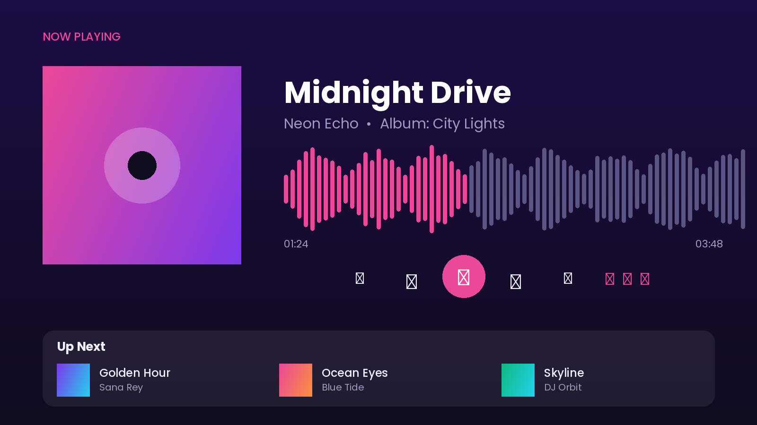
Figure 4: Now Playing page with controls and queue

5. Database Design
A relational MySQL database stores all website data. The main entities are Users, Songs, Artists, Albums and Playlists. A linking table, Playlist_Songs, resolves the many-to-many relationship between playlists and songs.
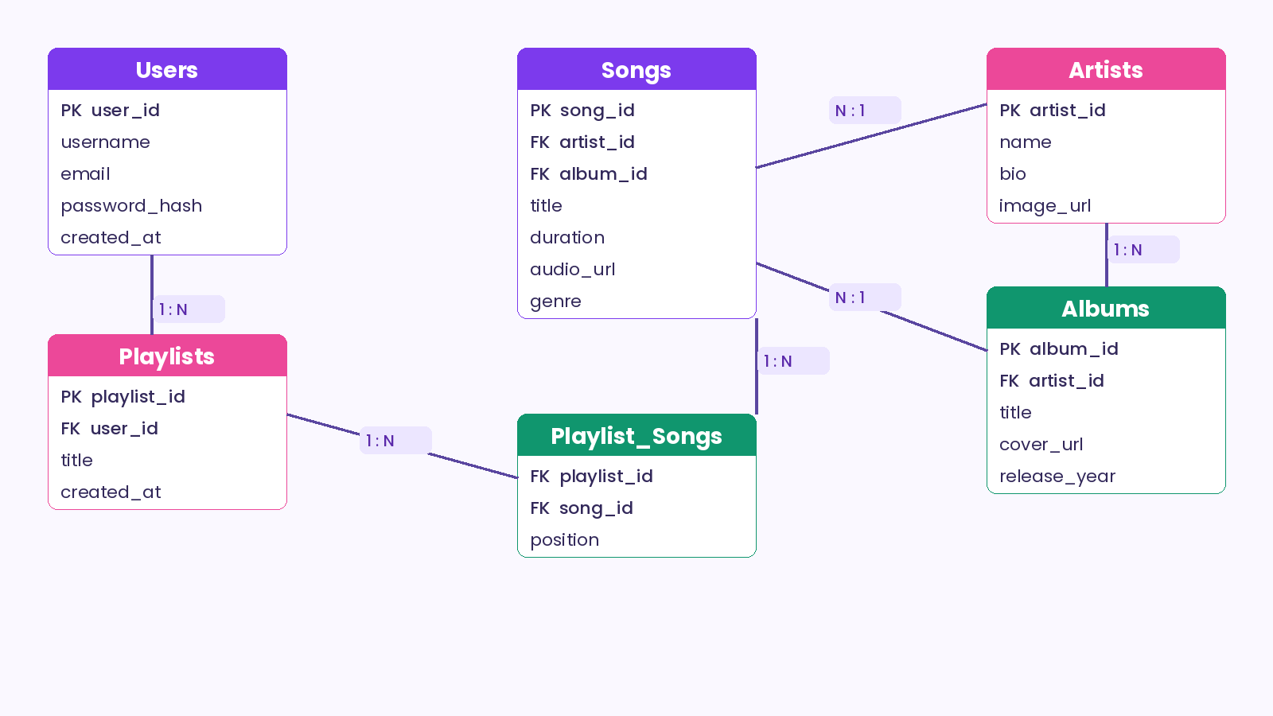
Figure 5: Entity Relationship (ER) diagram

5.1 Table Summary
Table | Purpose
Users | Stores account details: username, email and hashed password.
Artists | Stores artist name, biography and profile image.
Albums | Stores album title, cover image, release year and its artist.
Songs | Stores title, duration, genre, audio file link, artist and album.
Playlists | Stores playlists created by each user.
Playlist_Songs | Links songs to playlists and keeps their order.

6. Testing
No. | Test Case | Expected Result | Status
1 | Search for a song by name | Matching songs are displayed | Pass
2 | Click play on any song | Audio starts and player bar updates | Pass
3 | Register a new account | Account is created and user is logged in | Pass
4 | Create playlist and add song | Song appears inside the playlist | Pass
5 | Open site on mobile screen | Layout adjusts without horizontal scroll | Pass
6 | Login with wrong password | Error message is shown | Pass

6.1 Security Measures
- Passwords are stored as hashes, never as plain text.
- Form inputs are validated on both client and server to prevent SQL injection and XSS.

7. Future Enhancements
- Premium subscription plans with ad-free listening and offline downloads.
- Personalised recommendations based on listening history.
- Synchronised lyrics, social sharing and artist follow notifications.
- Native Android and iOS applications.

8. Conclusion
Melodix demonstrates a complete, user-friendly music website with a modern dark theme, simple navigation, a persistent player and a well-structured database. The project meets its objectives and provides a strong base for future features such as recommendations and mobile apps.

