

**Hand writing digit recognition based on shallow neural network**

**SCHOOL:** SCHOOL OF SOFTWARE ENGINEERING

**SUBJECT:** Deep learning

**Supervisor:** Mingkui Tan

***Grade:***

Post Graduate

***Student ID:***

201722800140

201722800100

201722800098

December 30, 2017

**Abstract:**

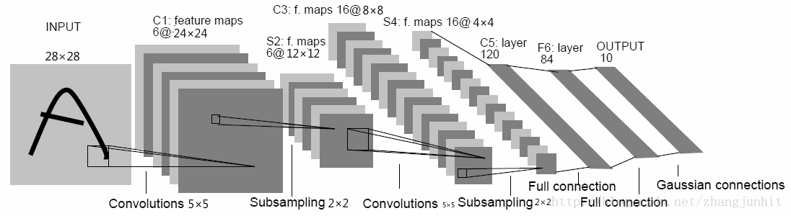

**Introduction:**

This experiment uses the MNIST dataset. The dataset contains 70,000 hand-written digital pictures (training set 60000, verification set 10000), a size of 28 * 28 pixels. Data set download, training set, validation set of operations such as reading can be done using pytorch.

**Methods and Theory:**

We use model.py to create the module LeNet5 which is inherits from nn Module, the module LeNet5 is to train the network. We use train.py to load the module LeNet5 and generate a instance “LeNet5.model” to work. After that, we use main.py to load “LeNet5.model” and use it to predict.

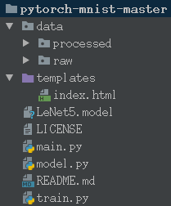

In train.py, we do that:

2.1 Load data using torch.utils.data.DataLoader, torchvision.datasets.MNIST and torchvision.transforms.

2.2 instantiation torch.optim.SGD optimizer optimizer.

2.3 instantiation LeNet5 to get network net.

2.4 put the size of the batch size data into the network for forward propagation predict target.

2.5 Use torch.nn.CrossEntropyLoss to calculate the loss of predict target and ground truth target.

2.6 Calculate the gradient using loss.backward and optimize with optimizer.step.

2.7 Calculation of recognition accuracy.

2.8 Repeat steps 2.4-2.7 until all data is placed on the network.

2.9 The number of selected training epoch, repeat the training process 2.5--2.9

2.10 Save the best model as a .pkl file

**Experiment:**

The code is in the .tar.gz file.

When I was python train.py, it works as follows, because my python is 3.5, bunt the operation f”” is used only in 3.6+,so I move the f, If you want to see it, using the .format to see in print()

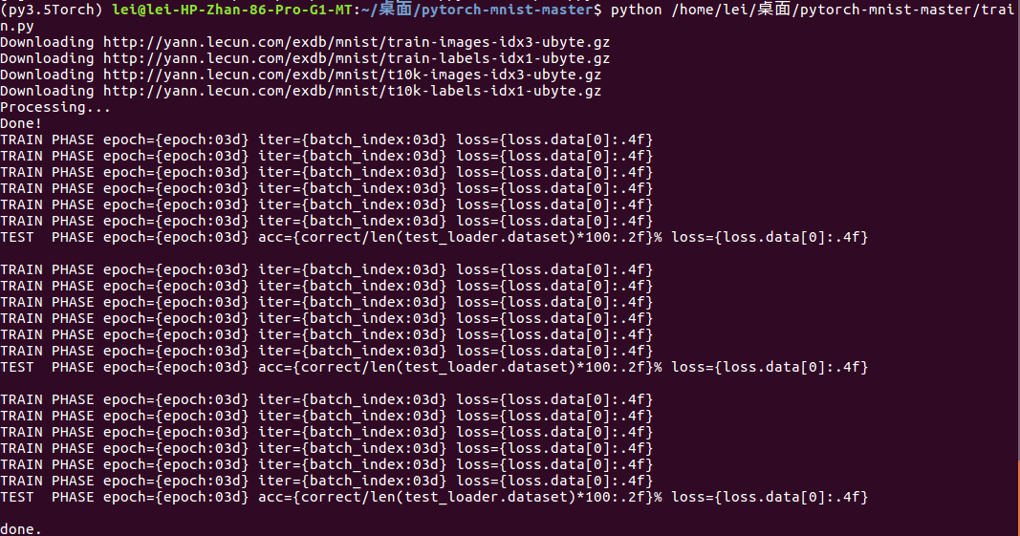

Here is the work it does, But it doesn’t perform very well.

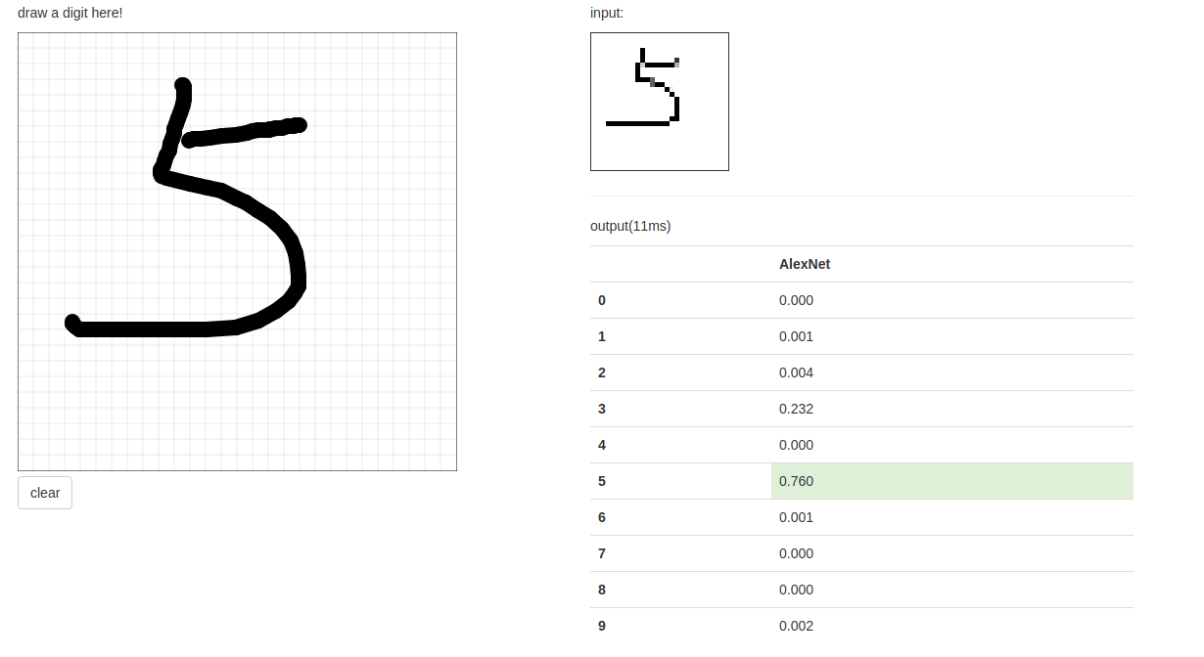

**Conclusion:**

This experiment achieved handwritten numeral recognition through the framework of Pytorch, but the test result is not good, the program is poor in robustness. Perhaps add a few hidden layer or the epoch tune larger, the effect will be better, but also prone to over-fitting. The MNIST dataset has only 70,000 samples , which is too small for analysis.