**<***FOOD COURT AUTOMATION SYSTEM***>**

A software Development Project Management report submitted

By

TUHIN, ISRAT JAHAN (14-28199-3)

Under the supervision of

**ABHIJIT BHOWMIK**

*Assistance professor (AIUB)*

**Department of Computer Science**

**Faculty of Science & Information Technology**

**American International University – Bangladesh  
 Spring16_17**

Software Project

Management Plan

For

< *FOOD COURT AUTOMATION SYSTEM* >

Version 1.0 approved

Prepared by <ISRAT>

<AIUB STUDENT Organization>

<Date created: 17-11-2017>

Table of Contents

1. Revision History………………………………………………………………………1
2. Introduction……………………………………………………………………………4
   1. Propose……………………………………………………………………………4
   2. Document convention ……………………………………………………………4
   3. Intended audience…………………………………………………………………4
   4. System scope………………………………………………………………………4
3. Overall description

2.1 System perspective…………………………………………………………………5

2.2 System function…………………………………………………………………….5

2.3 User class and characterize…………………………………………………………5

2.3.1 Customer…………………………………………………………………………6

2.4.2 Admin…………………………………………………………………………….6

2.4.3 Manager………………………………………………………………………….6

2.5 Operating Environment…………………………………………………………….. 7

3. Extended Interface requirement………………………………………………………… 7

3.1 User Interface……………………………………………………………………… 7

3.3.1 Login window……………………………………………………………………..8

3.3.2 Admin panel……………………………………………………………………….8

3.3.3 Customer panel……………………………………………………………………8

3.3.4 Manager Panel……………………………………………………………………..8

3.2 Software Interface………………………………………………………………………9

3.3 Communication Interface……………………………………………………………….9

4. System feature……………………………………………………………………………..9

4.1 Login…………………………………………………………………………………9

4.2 Admin panel…………………………………………………………………………...9

4. 3 Manager Panel

5. Other requirement………………………………………………………………………….10

5.1 Performance requirement…………………………………………………………….10

5.2 Safety Requirement…………………………………………………………………10

5.3 Security requirement………………………………………………………………….10

5.4 Documentation……………………………………………………………………….10

6. ER Diagram…………………………………………………………………………………..11

7. Class Diagram………………………………………………………………………………..12

8. Use case Diagram…………………………………………………………………………….14

9. Reference……………………………………………………………………………………..15

1. Introduction

1.1 Purpose

In the term of todays, the system of ordering in any fast food shop or any restaurant is very lengthy process. The customer have to wait a long time to get any order. This system will make the process easier and the waste of time will decrease. To add a new dimension to the food court management system, the system will work.

1.2 Document Convention

This document follows MLA Format. Bold-faced text has been used to emphasize section and sub-section headings.

1.3 Intended audience

This document is to be read by the development team, the project managers, marketing staff, testers and documentation writers, stakeholders.

1.4 System scope

The system will be operated by the customer, admin of the system and by the manager. Customer will only get the authority to create account, log-in and choosing the food, but will haven’t any authority to change anything in the features. Manager will have the authority to CRUD (Create, Read, Update and Delete) of food and calculation. Admin will have the full authority to CRUD (Create, Read, Update and Delete) of food, employee and calculation. There will have eight classes. Customer, Employee, Order, Food, Payment, Time, Table and Login class. Customer can order any food by using their account. Customer will choose a time of arrival and expect a time for being ready the given order. Customer have the flexibility of payment by the card or cash.

2. Overall Description

2.2 System Perspective

This is a wed based system which about the easier order system for customer. This system will give the flexibility to both the restaurant management and customer. This system will be helpful to reduce the gathering in restaurants or cafeteria. In this system the admin will manage all the database. Manager can author to some part of the database. Customer can use the system only for ordering or to see the features of the system.

2.3 System Functions

The whole system is about to associate the customer and management of any food court by developing many convenience things. As the system will provide flexibility to the customers in ordering easily, so customer will be more interested than previous towards the way of this system. There will be no gathering, no confusion and no waste of time for customer and management of food court.

2.4 User Classes and Characteristics

There will be three users in this system.

* Customer
* Admin
* Manager

2.4.1 Customer

Customer will only get the authority to create account, log-in and choosing the food, but will haven’t any authority to change anything in the features.

2.4.2 Admin

Admin will have the full authority to CRUD (Create, Read, Update and Delete) of food, employee and calculation.

2.4.3 Manager

Manager will have the authority to CRUD (Create, Read, Update and Delete) of food and calculation.

2.5 Operating Environment

The operating system will need any version of Windows Operating system. It can be usable from any mobile browser application. And an active internet connection is needed for communication with the database.

3. External Interface Requirements

3.1 User Interfaces

3.1.1 Login Window

This is a simple login window. User name and password fields are

Available. This is similar for Customer, Admin and Manager. After

Logging-in, it will be identified if it is the Customer, Admin or the

Manager. If anybody enter any invalid information, then it will show invalid

Identification.

3.1.2 Admin Panel

In this panel, admin will enter the identification. If it is valid then it will be logged in. If it is not, then it will show invalid. From this panel admin can modify anything.

3.1.3 Customer Panel

Customer can create and log in to the account and choose order.

3.1.4 Manager panel

In this panel, manager will enter the identification. If it is valid then it will be logged in. If it is not, then it will show invalid. From this panel manager can

Modify the food and calculate the cash.

3.2 Software Interfaces

Food court Inventory System. The quantities of food items ordered to the food court Inventory System through a programmatic interface.

3.3 Communications Interfaces

An internet connection is enough to communicate with the database server.

4. System Features

4.1 Login

There will be two separate user groups. The Admin and Manager. The Customer do not need separate accounts.

4.2 Admin Panel

The Admin should control everything from this panel.

4.3 Manager Panel

The manager can control food modification and calculation from this panel.

5. Other Requirements

5.1 Performance Requirements

The system shall accommodate 400 users during the peak usage time

window of 8:00am to 10:0am local time, with an estimated average

Session duration of 8 minutes.

5.2 Safety Requirements

No safety requirements have been identified.

5.3 Security Requirements

All network transactions that involve financial information or personally identifiable information shall be encrypted.

5.4 Documentation

All the product documentations are to be prepared and provided to the client as needed. The User Manual must be prepared in a well-structured way.

6. UML Diagram

6.1 Class Diagram

**Employee**

Employee name

Employee Id

Employee, payment

Login

User Type

User ID

User Password

If input any invalid information, then show invalid identification

Customer

Customer name

Customer Id

Password, payment

Create account ()

Login ()

Choose order ()

**Admin**

addOrder()

deleteOrde()

addCus()

delCus()

addEmp()

deleteEmp()

**Food**

Food Id

Food name

Food cost

Food type

Quantity

Order

Order Id

Time

Payment

confirmOrder()

deldetOrder()

deldetOrder()

**Admin**

addOrder()

deleteOrde()

addCus()

delCus()

**Admin**

serveOder()

**Table**

Table number

Number of sit

6.2 E-R Diagram

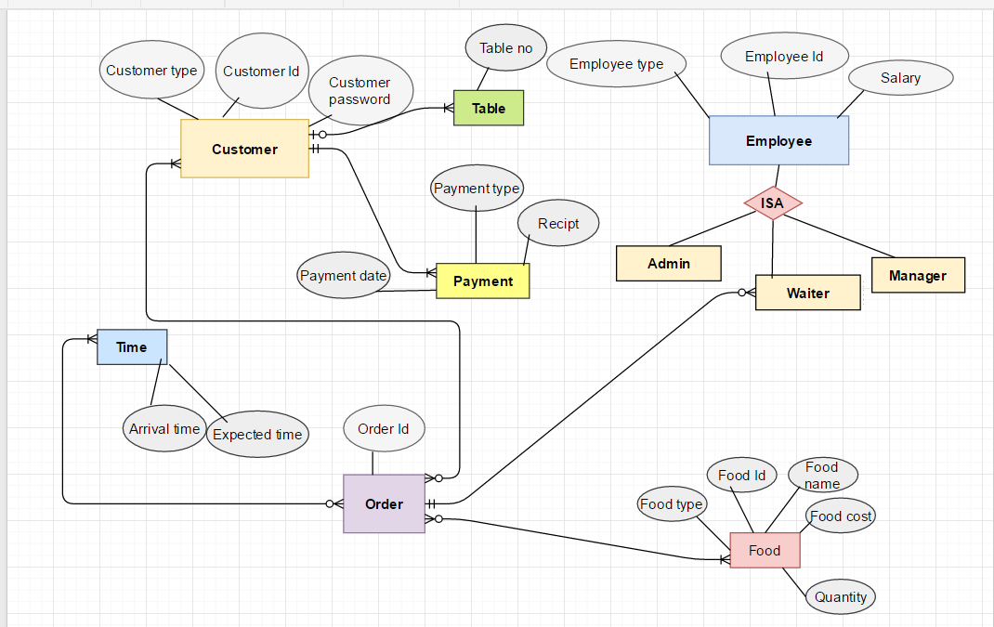

6.3 Use case Diagram

Food court Automation System

<<Extends>>

Customer

<<Include>>

Admin <<Extend>>

<<Extend>>>

< <<Extend>>

Manager <<extend>>

<<Extend>>

<<Extend>>

7. References

For preparing this document IEEE SRS Template was used.