Degradation-Aware Model Predictive Control for Off-Grid Solar Green Hydrogen Production: A Statistical Comparison with Rule-Based Energy Management
Oct 12, 2026 · @Shrabon

Short abstract for submission (send to lahby@ieee.org by 20 October 2026)
Authors: [Student author name(s), department, institution, email]; [Supervisor name, designation, department, institution, email — corresponding author] (fill in before submission)
Chapter title: Degradation-Aware Model Predictive Control for Off-Grid Solar Green Hydrogen Production: A Statistical Comparison with Rule-Based Energy Management
Target part: Part II – Intelligent Energy Management, Model Predictive Control, and Degradation-Aware Optimization
Abstract (5 sentences): The energy management system of a solar hydrogen plant decides not only how much hydrogen it delivers but also how fast its electrolyser stack degrades. This chapter compares rule-based control with a two-layer model predictive controller that solves a daily mixed-integer programme including start-up and load-dependent wear costs, for an off-grid PV–battery–PEM–hydrogen plant at a semi-arid and a humid site. Five strategies, including forecasts of different quality, are evaluated over ten weather years per site with paired non-parametric tests and bootstrap confidence intervals. Degradation-aware MPC cut annual operating cost by 8–10 % and was the best strategy in every year, while an energy-only MPC performed worse than the rules because it increased stack starts by 25–37 %. The savings survived realistic forecasts, a threefold change in start-up cost and different horizons, showing that advanced electrolyser control should be designed around stack wear rather than energy alone.

Abstract
Once a solar hydrogen plant is built, its energy management system decides how much hydrogen it delivers and how fast its electrolyser stack wears out. This chapter compares a rule-based controller with model predictive control (MPC) for an off-grid PV–battery–PEM electrolyser–hydrogen plant, using a two-layer design: a daily mixed-integer linear programme with on/off commitment, minimum load, start-up and load-dependent wear costs, and a real-time layer that follows the actual solar power. Five strategies — rule-based, energy-only MPC, and degradation-aware MPC with perfect, persistence and noisy forecasts — are evaluated over ten weather years at a semi-arid and a humid site using open NREL data. Degradation-aware MPC lowered annual operating cost by 10.3 % and 8.2 % and was the cheapest strategy in every year (Friedman p < 10⁻⁷), by running the stack a third fewer hours at higher load; an energy-only MPC was worse than the rules because it started the stack 25–37 % more often. Realistic forecasts retained 63–83 % of the saving, and the result was robust to a threefold change in start-up cost and to the prediction horizon.
Keywords: green hydrogen · model predictive control · PEM electrolyser degradation · energy management · mixed-integer linear programming · solar forecasting · statistical comparison

1 Introduction
Once a solar hydrogen plant is built, its economics are decided hour by hour by the energy management system (EMS). The EMS chooses when the electrolyser runs, at what load, when the battery charges, and how full the hydrogen tank is kept. These choices set how much hydrogen is produced, how often backup supply must be bought, and — less visibly — how fast the electrolyser stack wears out.
Stack wear is a first-order cost. A proton-exchange membrane (PEM) stack is roughly a third of the electrolyser system cost and must be replaced after several tens of thousands of operating hours [1, 2]. Degradation accelerates under frequent start–stop cycling and under high current density [3, 4], both of which are typical when an electrolyser follows variable solar power. Yet most off-grid plants are run by simple priority rules that switch the electrolyser on whenever enough power is available and ignore wear entirely.
Model predictive control (MPC) offers an alternative: at each decision point it solves an optimisation over a forecast horizon, applies the first part of the plan, and repeats [5]. MPC can include wear costs, plan around tomorrow's weather and avoid unnecessary starts. Its value, however, depends on forecast quality, on the horizon, and on the (uncertain) wear model — and studies rarely quantify these dependencies with statistical rigour across many weather years.
This chapter compares rule-based and MPC energy management for a fixed off-grid PV–battery–PEM–hydrogen plant at two climatically contrasting sites. Its contributions are:
- A two-layer degradation-aware MPC: a day-ahead mixed-integer linear programme (MILP) with on/off commitment, minimum load, start-up and load-dependent wear costs, and a real-time tracking layer that copes with forecast errors.
- A controlled comparison of five strategies — rule-based, energy-only MPC, and degradation-aware MPC with perfect, persistence and noisy forecasts — over 10 weather years per site.
- A statistical analysis with paired tests, effect sizes and bootstrap confidence intervals, plus sensitivity to the start-up cost assumption and to the prediction horizon.
- Open data and code, so every result can be reproduced and extended.
Section 2 reviews background; Section 3 presents the plant and degradation model; Section 4 the strategies; Section 5 the results; Section 6 the statistical analysis; Section 7 discusses operational trends and challenges; Section 8 concludes.

2 Background
Energy management of renewable hydrogen plants. Off-grid and hybrid hydrogen plants are commonly operated by priority (rule-based) controllers: renewable power first feeds the electrolyser up to its rating, surplus charges a battery, and the remainder is curtailed [2, 9, 17]. Rules are transparent and robust but myopic: they do not know tomorrow's weather, and they treat every hour the same regardless of wear.
Electrolyser degradation. PEM degradation arises from membrane thinning, catalyst dissolution and agglomeration, and passivation of porous transport layers [4]. Experiments show that dynamic and intermittent operation, particularly frequent shut-downs and high current densities, raise the rate of cell-voltage increase compared with steady operation [3, 4]. For system studies, degradation is often converted into an economic wear cost: the stack replacement cost is spread over its rated life, with extra cost for each start–stop cycle. The exact cost per start is uncertain and plant-specific, which is why this chapter treats it as a parameter and tests its influence.
Model predictive control. MPC repeatedly solves a finite-horizon optimal control problem from the current measured state and applies the first part of the solution [5, 6]. On/off decisions and minimum-load limits make the problem a MILP; modern solvers such as HiGHS [7], available through SciPy [8], solve the small daily problems used here in about a quarter of a second. MPC performance depends on the forecast that feeds it; day-ahead solar forecasts typically have relative errors of 20–40 % in daily energy depending on climate [18].
Statistical evaluation of controllers. Because weather varies year to year, a controller comparison on one year can mislead. Resampling methods such as the moving-block bootstrap [13] generate additional plausible years while preserving short-term persistence. Paired designs — every controller run on the same weather — allow powerful non-parametric tests such as the Wilcoxon signed-rank test [14], with effect sizes [15] and bootstrap confidence intervals [16].

3 Plant and Degradation Model

3.1 Reference plants and weather
The plant is fixed in this chapter so that only the controller changes. It supplies a constant 100 kg/day of hydrogen off-grid; any shortfall is bought in at 10 USD/kg.
Site | Climate and data | PV array (kWp) | PEM electrolyser (kW) | Li-ion battery (kWh) | H₂ tank (kg)
A | Semi-arid high desert, Colorado; NSRDB PSM3 2017 [10] | 1 780 | 906 | 600 | 224
B | Humid subtropical, North Carolina; TMY3 723170 [11] | 2 061 | 866 | 600 | 257
The battery (600 kWh, 300 kW at 0.5 C) is large enough to hold the electrolyser above its minimum load at night, so the controller has a real electrical buffer to manage. PV output is computed for a south-facing array tilted at latitude from hourly irradiance using the Erbs decomposition [19], isotropic transposition and a temperature-corrected linear model (derate 0.86, −0.4 %/°C) via pvlib [12].
Ten weather years are used per site: the observed year and nine seasonal moving-block-bootstrap years [13]. Each bootstrap year is built from 5-day blocks of observed clearness index and temperature, each block drawn from within ±15 days of its calendar position and scaled by the clear-sky profile of its target dates. Blocks keep multi-day persistence that a day-by-day resampling would destroy.

3.2 Electrolyser, battery and tank
The electrolyser runs between 10 % and 100 % of its rating. Its specific energy consumption rises linearly with load fraction l, SEC(l) = 48 + 6 l kWh/kg, plus 2.5 kWh/kg for compression. The battery has 95 % charge and discharge efficiency and a 10 % minimum state of charge; the tank starts half full and any end-of-year deficit below that level is counted as shortfall.

3.3 Degradation as a wear cost
Stack wear is expressed in money so that it can be traded against hydrogen output. The stack is assumed to be 35 % of electrolyser capital cost (1 100 USD/kW) with a life of 60 000 full-load-equivalent hours [1, 4]. The wear cost per operating hour at load fraction l and per cold start is:
c_{wear}(l) = c_h\,(0.5 + 0.5\,l), \qquad c_h = \frac{0.35\,c_{el}\,C_{el}}{60\,000\;\mathrm{h}}, \qquad c_{start} = k_s\, c_h
For site A this gives c_h = 5.81 USD/h (stack replacement 0.35 M USD). The start factor k_s, the number of full-load-equivalent hours one cold start costs, is uncertain; k_s = 10 h is the base case and k_s = 0 and 30 h are tested in Section 6. The half-fixed, half-load-proportional form reflects that wear accrues with time at voltage as well as with current density [3, 4]. These parameters are assumptions for illustration, not measured values, and should be replaced with manufacturer data in practice.

4 Energy Management Strategies
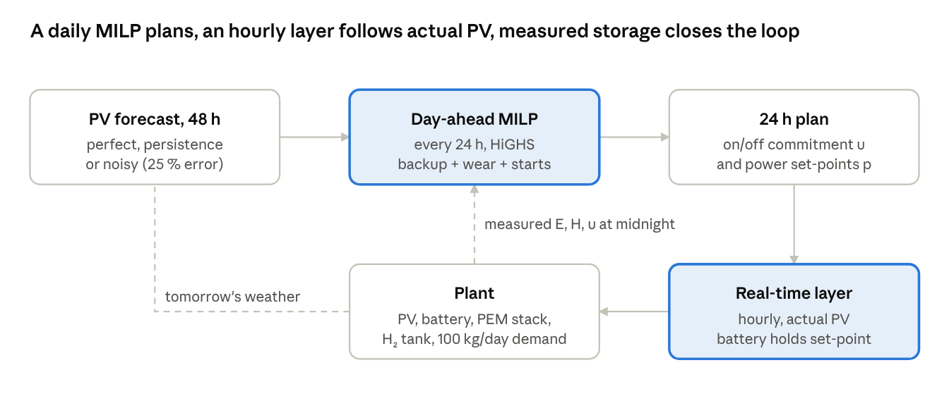
Fig. 1 · two-layer MPC architecture used in this chapter
The rule-based controller (RB) replaces the two upper boxes with a fixed priority rule; all strategies act on the same plant and weather.

4.1 Rule-based EMS (RB)
Each hour the RB controller (i) caps electrolyser power at its rating and at the power needed to fill the tank, (ii) supplies it from PV and tops up from the battery, (iii) switches it off if the available power is below minimum load, and (iv) charges the battery with leftover PV and curtails the rest. It needs no forecast.

4.2 Day-ahead MILP
Every day at midnight the MPC solves a MILP over a horizon of H = 48 hours from the measured battery energy E₀, tank level H₀ and electrolyser state u₀. Decision variables per hour t are electrolyser power p_t, on/off status u_t ∈ {0, 1}, start indicator s_t ∈ {0, 1}, battery charge c_t and discharge d_t, curtailment k_t and hydrogen shortfall σ_t; states are battery energy E_t and tank level H_t.
\min \sum_{t=0}^{H-1} \Bigl[ c_{bk}\,\sigma_t + \delta\bigl(0.5\,c_h\,u_t + 0.5\,\tfrac{c_h}{C_{el}}\,p_t + c_{start}\,s_t\bigr) \Bigr] - v_H\,H_H - v_E\,E_H
subject to, for every hour t:
\hat P^{pv}_t + d_t = p_t + c_t + k_t, \qquad 0.1\,C_{el}\,u_t \le p_t \le C_{el}\,u_t, \qquad s_t \ge u_t - u_{t-1}

E_{t+1} = E_t + \eta\,c_t - d_t/\eta, \qquad H_{t+1} = H_t + a\,p_t + b\,u_t - D + \sigma_t, \qquad 0.1\,C_b \le E_t \le C_b,\; 0 \le H_t \le C_H
The nonlinear production curve is replaced by its secant between minimum and rated load (a = 0.0175 kg/kWh, b = 0.19 kg/h for site A), which under-estimates mid-load production by at most about 4 %, so plans are slightly conservative; the plant itself is always simulated with the exact curve. Terminal values v_H = 0.9 c_bk per kg of hydrogen and the equivalent per kWh of battery energy stop the optimiser from emptying storage at the end of each horizon. The flag δ switches wear costs on (degradation-aware MPC) or off (energy-only MPC). The problem has 434 variables, 96 of them binary, and is solved with HiGHS [7] to a 1 % optimality gap with a 3 s limit.

4.3 Real-time layer
The first 24 hours of the plan are executed hour by hour against the actual PV. When the plan says "on", the electrolyser takes all available PV up to its rating (never curtailing power it could use) and draws on the battery to reach the planned set-point; if even then it cannot reach minimum load, it trips off. Leftover PV charges the battery. This two-layer design is standard in practice because a day-ahead plan is never exactly right.

4.4 Strategies and forecasts compared
Code | Strategy | Wear cost in optimisation | PV forecast
RB | Rule-based | – | none
MPC-E | Energy-only MPC | no | perfect
MPC-D | Degradation-aware MPC | yes | perfect
MPC-D-P | Degradation-aware MPC | yes | smart persistence: yesterday's clear-sky ratio × clear-sky profile
MPC-D-N | Degradation-aware MPC | yes | perfect hourly shape × lognormal daily-energy error, SD 25 %, AR(1) 0.6 across days
The perfect-forecast cases are upper bounds on what forecasting can deliver; persistence is the simplest operational forecast; the noisy case mimics a numerical weather prediction with realistic 25 % day-ahead energy error [18]. All strategies are evaluated with the same wear model, whether or not they optimise for it.

5 Results
Degradation-aware MPC is the cheapest strategy in every one of the 20 site-years; its saving comes almost entirely from lower stack wear, while hydrogen output stays within 0.1 % of the rule-based controller.
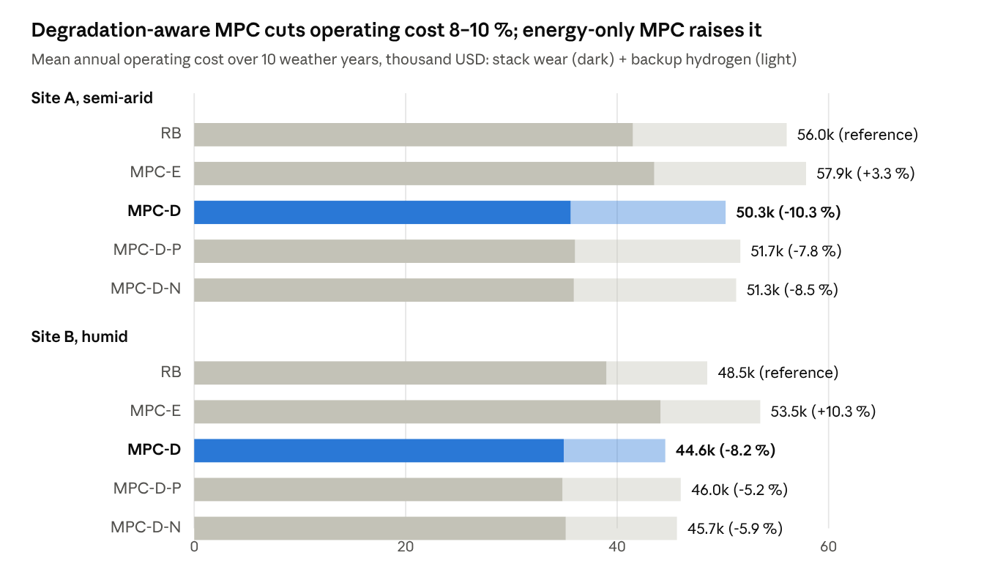
Fig. 2 · results/ch2_summary.csv · k_s = 10 h, 48 h horizon, 10 years per site

5.1 Operating indicators
Site | Strategy | H₂ produced (t/yr) | Shortfall (kg/yr) | Starts per year | Operating hours | Mean load | Wear cost (k USD/yr) | Backup cost (k USD/yr) | LCOH (USD/kg)
A | RB | 35.08 | 1 455 | 388 | 4 391 | 0.50 | 41.5 | 14.6 | 9.39
A | MPC-E | 35.10 | 1 436 | 484 | 3 119 | 0.70 | 43.5 | 14.4 | 9.44
A | MPC-D | 35.07 | 1 466 | 369 | 2 706 | 0.80 | 35.6 | 14.7 | 9.23
A | MPC-D-P | 34.96 | 1 564 | 376 | 2 725 | 0.80 | 36.0 | 15.6 | 9.27
A | MPC-D-N | 34.99 | 1 536 | 370 | 2 803 | 0.80 | 35.9 | 15.4 | 9.26
B | RB | 35.55 | 954 | 369 | 4 408 | 0.50 | 39.0 | 9.5 | 9.60
B | MPC-E | 35.56 | 944 | 504 | 3 517 | 0.60 | 44.1 | 9.4 | 9.74
B | MPC-D | 35.54 | 960 | 366 | 2 970 | 0.80 | 34.9 | 9.6 | 9.49
B | MPC-D-P | 35.38 | 1 119 | 365 | 2 955 | 0.80 | 34.8 | 11.2 | 9.53
B | MPC-D-N | 35.45 | 1 052 | 366 | 3 055 | 0.70 | 35.1 | 10.5 | 9.52
Means over 10 weather years; LCOH includes annualised capital (with the 600 kWh battery), wear, backup and water, so it is higher than in sizing studies that ignore wear.
Three mechanisms explain the ranking. First, MPC-D runs the electrolyser fewer hours at higher load: 38 % (A) and 33 % (B) fewer operating hours at a mean load of 0.8 instead of 0.5. Because a large part of wear accrues per hour at voltage, concentrating production into fewer, fuller hours, with the battery and tank absorbing the timing, cuts wear by 14 % and 10 %. Second, energy-only MPC is worse than the rules: freed from any wear penalty it chases every kilowatt-hour, starting the stack 25–37 % more often than RB, which raises wear and total operating cost by 3 % (A) and 10 % (B) for a negligible gain in hydrogen (+0.06 %). Third, forecasts cost little in hydrogen but measurably in money: with persistence or noisy forecasts, MPC-D produces 0.3–0.5 % less hydrogen because it occasionally commits the stack on days that turn out cloudy, and buys more backup; it still beats the rules.

6 Statistical Analysis
The ranking of strategies is identical in all 20 site-years, every MPC-D advantage over the rules is significant at the smallest p-value ten paired years allow, and the advantage survives realistic forecasts, a threefold change in start-up cost and a shorter horizon.

6.1 Overall ranking: Friedman test
The Friedman test ranks the five strategies by annual operating cost within each weather year and tests whether mean ranks differ. At both sites χ² = 38.7 with 4 degrees of freedom, p = 8 × 10⁻⁸. The mean ranks are identical at both sites — MPC-D 1.0, MPC-D-N 2.2, MPC-D-P 2.8, RB 4.0, MPC-E 5.0 — so MPC-D is cheapest and MPC-E most expensive in every single year.

6.2 Paired comparisons with the rule-based EMS
For each metric, the table gives the mean paired difference from RB over 10 years, a 95 % percentile bootstrap interval (5 000 resamples of years), Cohen's d_z (mean difference over its standard deviation) and the two-sided Wilcoxon signed-rank p-value. With n = 10 and all differences of one sign, the smallest possible p-value is 2/1 024 = 0.002.
Site | Comparison | Metric | Mean difference [95 % CI] | Relative | d_z | Years better | Wilcoxon p
A | MPC-D vs RB | Operating cost (USD/yr) | −5 780 [−5 945, −5 632] | −10.3 % | −22.0 | 10 / 10 | 0.002
A | MPC-D vs RB | Wear cost (USD/yr) | −5 886 [−6 058, −5 710] | −14.2 % | −20.4 | 10 / 10 | 0.002
A | MPC-D vs RB | Backup cost (USD/yr) | +106 [+37, +180] | +0.7 % | +0.86 | 3 / 10 | 0.027
A | MPC-D vs RB | Starts per year | −19.5 [−22.1, −16.9] | −5.0 % | −4.4 | 10 / 10 | 0.002
A | MPC-E vs RB | Operating cost (USD/yr) | +1 830 [+1 650, +1 990] | +3.3 % | +6.3 | 0 / 10 | 0.002
B | MPC-D vs RB | Operating cost (USD/yr) | −3 969 [−4 039, −3 899] | −8.2 % | −33.2 | 10 / 10 | 0.002
B | MPC-D vs RB | Wear cost (USD/yr) | −4 032 [−4 115, −3 948] | −10.3 % | −28.6 | 10 / 10 | 0.002
B | MPC-D vs RB | Backup cost (USD/yr) | +63 [+26, +102] | +0.7 % | +0.97 | 2 / 10 | 0.020
B | MPC-D vs RB | Starts per year | −2.9 [−3.7, −2.1] | −0.8 % | −2.3 | 10 / 10 | 0.002
B | MPC-E vs RB | Operating cost (USD/yr) | +5 015 [+4 650, +5 378] | +10.3 % | +7.9 | 0 / 10 | 0.002
The effect sizes are very large (|d_z| > 20 for operating cost) because weather affects all strategies almost equally, so the paired differences vary little from year to year. MPC-D trades a statistically detectable but tiny increase in backup purchases (+0.7 %, about 6–11 kg of hydrogen a year) for a wear saving 55–64 times larger. The LCOH reduction is 0.16 USD/kg (−1.7 %) at site A and 0.11 USD/kg (−1.1 %) at site B, again in every year.

6.3 Value of forecast quality
Site | Saving vs RB, perfect forecast | Noisy forecast (25 % daily error) | Smart persistence | Share of perfect-forecast saving kept: noisy / persistence
A | 5 780 USD/yr | 4 781 USD/yr | 4 388 USD/yr | 83 % / 76 %
B | 3 969 USD/yr | 2 868 USD/yr | 2 507 USD/yr | 72 % / 63 %
Even the crudest operational forecast keeps about two-thirds to three-quarters of the attainable saving, and all forecast variants beat RB in every year (p = 0.002). Forecast quality matters more at the humid site, where day-to-day cloud variability makes yesterday a poorer guide to tomorrow; there, a numerical weather prediction (the noisy case) is worth about 360 USD/yr more than persistence, the arid site about 390 USD/yr.

6.4 Sensitivity to the start-up cost assumption
Site | Start cost k_s (full-load hours per start) | RB operating cost (USD/yr) | MPC-D operating cost (USD/yr) | Saving | Starts RB / MPC-D | Wilcoxon p
A | 0 | 33 460 | 28 695 | 14.2 % | 388 / 464 | 0.002
A | 10 (base) | 56 039 | 50 259 | 10.3 % | 388 / 369 | 0.002
A | 30 | 101 199 | 92 686 | 8.4 % | 388 / 363 | 0.002
B | 0 | 28 023 | 24 157 | 13.8 % | 369 / 470 | 0.002
B | 10 (base) | 48 522 | 44 553 | 8.2 % | 369 / 366 | 0.002
B | 30 | 89 520 | 85 097 | 4.9 % | 369 / 363 | 0.002
The saving stays positive and significant across a threefold range of the most uncertain parameter, so the conclusion does not hinge on it. The mechanism shifts, though: when starts are free (k_s = 0), MPC-D starts the stack more often than the rules and saves by running fewer, fuller hours; when starts are expensive, it saves by avoiding starts. The relative saving shrinks as k_s grows because the roughly 360–390 starts a year that solar operation forces on any controller — one per sunny day — dominate the bill and cannot be avoided without seasonal changes in operation.

6.5 Prediction horizon
At site A (5 weather years, perfect forecast), mean annual operating cost was 52 254 USD with a 24 h horizon, 50 658 USD with 48 h and 49 708 USD with 72 h (Friedman p = 0.007). Each extra day of look-ahead is worth 1.9–3.1 %, mostly in wear, because a longer horizon lets the controller stage tank filling ahead of cloudy days instead of reacting with extra starts. The gain from 48 h to 72 h (−1.9 %) is smaller than from 24 h to 48 h (−3.1 %), showing diminishing returns even with perfect look-ahead; with real forecasts, whose error grows with lead time, the optimum horizon is likely around two days.

7 Discussion: Operational Trends and Technical Challenges
Optimising energy alone can backfire. The most counter-intuitive result is that an MPC which maximises hydrogen output without a wear term is worse than a simple rule set at both sites. A controller that squeezes out every kilowatt-hour starts the stack more often and gains almost no hydrogen (+0.06 %). Any advanced EMS for electrolysers should therefore carry an explicit wear model, even a rough one; the results hold across a threefold range of start-up cost.
Fewer, fuller hours. Degradation-aware MPC runs the electrolyser about a third fewer hours at higher load. This contradicts the common heuristic that electrolysers should always run at part load for efficiency: part-load efficiency gains (here 48.6 vs 54 kWh/kg) are outweighed when time-at-voltage dominates wear. The trade-off depends on the stack's degradation behaviour, which differs between technologies and manufacturers, so the wear model must be calibrated before deployment [3, 4].
Forecasts are useful but not decisive. Smart persistence, which needs no external data, already captures 63–76 % of the perfect-forecast saving. A commercial day-ahead forecast adds a few hundred dollars a year for a 100 kg/day plant — worthwhile at scale but not essential for a pilot. Two-day horizons capture most of the look-ahead value.
Operational trends. The two-layer architecture (day-ahead MILP plus real-time tracking) mirrors how utilities operate power plants and is compatible with digital-twin and supervisory control platforms. Daily MILPs solved in about a quarter of a second on a laptop core are easily embedded in an industrial controller. As stacks become cheaper but plants larger, wear-aware dispatch will matter more in absolute terms: scaled linearly from this plant (about 5–6 thousand USD per MW of electrolyser per year), a 100 MW plant would save roughly half a million dollars a year.
Limitations. (i) The wear model is a stylised economic proxy, not a physical degradation model, and its parameters are assumptions. (ii) The plant is sized in advance; co-optimising design and control could change the battery size. (iii) Only one observed year per site was available, extended by block bootstrap. (iv) Forecast errors are synthetic. (v) Ramp limits, thermal dynamics and cold-start times were not modelled; they would further favour fewer starts.
Future directions. Calibrating the wear model with stack voltage data, learning it online, and combining MPC with stochastic or robust formulations that hedge forecast uncertainty explicitly are natural next steps, as is replacing the MILP with a learned policy for very large plants.

8 Conclusion
This chapter compared rule-based and model predictive energy management for an off-grid solar hydrogen plant at a semi-arid and a humid site over ten weather years each. A degradation-aware, two-layer MPC — a daily mixed-integer programme with start-up and load-dependent wear costs, plus a real-time tracking layer — reduced annual operating cost by 10.3 % and 8.2 % relative to the rules, and was the cheapest strategy in every one of the 20 site-years (Friedman p = 8 × 10⁻⁸; Wilcoxon p = 0.002). It did so by running the stack about a third fewer hours at higher load, cutting wear by 10–14 % while producing the same hydrogen. An energy-only MPC without wear costs was worse than the rules, raising operating cost by 3–10 % through 25–37 % more starts. Realistic forecasts kept 63–83 % of the saving, the result held across a threefold range of start-up cost, and a two-day horizon captured most of the look-ahead value. Advanced control for electrolysers should therefore be designed around stack wear, not energy alone.
Code and data availability. All code (MILP-based MPC, simulator, statistics) and data are in the Book-Chapter-Green-Hydrogen folder of the authors' repository.

References
References are given from the authors' knowledge (no live database lookup was possible); check every entry and convert to Springer style before submission.
- IRENA (2020) Green hydrogen cost reduction: Scaling up electrolysers to meet the 1.5 °C climate goal. International Renewable Energy Agency, Abu Dhabi.
- Buttler A, Spliethoff H (2018) Current status of water electrolysis for energy storage, grid balancing and sector coupling via power-to-gas and power-to-liquids: A review. Renewable and Sustainable Energy Reviews 82:2440–2454.
- Frensch SH, Fouda-Onana F, Serre G, Thoby D, Araki SS, Krær SK (2019) Influence of the operation mode on PEM water electrolysis degradation. International Journal of Hydrogen Energy 44(57):29889–29898.
- Feng Q, Yuan XZ, Liu G, Wei B, Zhang Z, Li H, Wang H (2017) A review of proton exchange membrane water electrolysis on degradation mechanisms and mitigation strategies. Journal of Power Sources 366:33–55.
- Rawlings JB, Mayne DQ, Diehl MM (2017) Model predictive control: Theory, computation, and design, 2nd edn. Nob Hill Publishing, Madison, WI.
- Camacho EF, Bordons C (2007) Model predictive control, 2nd edn. Springer, London.
- Huangfu Q, Hall JAJ (2018) Parallelizing the dual revised simplex method. Mathematical Programming Computation 10(1):119–142.
- Virtanen P, Gommers R, Oliphant TE, et al. (2020) SciPy 1.0: Fundamental algorithms for scientific computing in Python. Nature Methods 17:261–272.
- Ulleberg Ø (2003) Modeling of advanced alkaline electrolyzers: A system simulation approach. International Journal of Hydrogen Energy 28(1):21–33.
- Sengupta M, Xie Y, Lopez A, Habte A, Maclaurin G, Shelby J (2018) The National Solar Radiation Data Base (NSRDB). Renewable and Sustainable Energy Reviews 89:51–60.
- Wilcox S, Marion W (2008) Users manual for TMY3 data sets. Technical Report NREL/TP-581-43156, National Renewable Energy Laboratory, Golden, CO.
- Holmgren WF, Hansen CW, Mikofski MA (2018) pvlib python: A python package for modeling solar energy systems. Journal of Open Source Software 3(29):884.
- Künsch HR (1989) The jackknife and the bootstrap for general stationary observations. The Annals of Statistics 17(3):1217–1241.
- Wilcoxon F (1945) Individual comparisons by ranking methods. Biometrics Bulletin 1(6):80–83.
- Cohen J (1988) Statistical power analysis for the behavioral sciences, 2nd edn. Lawrence Erlbaum, Hillsdale, NJ.
- Efron B, Tibshirani RJ (1993) An introduction to the bootstrap. Chapman & Hall, New York.
- Parra D, Valverde L, Pino FJ, Patel MK (2019) A review on the role, cost and value of hydrogen energy systems for deep decarbonisation. Renewable and Sustainable Energy Reviews 101:279–294.
- Lorenz E, Hurka J, Heinemann D, Beyer HG (2009) Irradiance forecasting for the power prediction of grid-connected photovoltaic systems. IEEE Journal of Selected Topics in Applied Earth Observations and Remote Sensing 2(1):2–10.
- Erbs DG, Klein SA, Duffie JA (1982) Estimation of the diffuse radiation fraction for hourly, daily and monthly-average global radiation. Solar Energy 28(4):293–302.

