Article

Nutrition knowledge does not translate into healthier diets in Bangladeshi households
[Author list to be confirmed with the study team. Investigators listed in the survey report: Nepal C. Dey, Md. Abdul Awal, Mahmood Parvez, Fahmida Akther, Tridib Roy Chowdhury, Sorif Hossain, Abu A. Shamim, Malay Kanti Mridha, Kaosar Afsana]
¹ BRAC James P Grant School of Public Health, BRAC University, Dhaka, Bangladesh.
² Department of Crop Botany, Bangladesh Agricultural University, Mymensingh, Bangladesh.
Correspondence: [Corresponding author name and e-mail]
Running title: Knowledge, food insecurity and diets in Bangladesh
Word counts: abstract 145; main text (introduction, results and discussion) 2445; display items: 5 figures and 1 table (placed in the text at first citation); Extended Data: 8 tables.

Abstract
Nutrition education is a mainstay of food policy in low- and middle-income countries, yet whether knowledge translates into healthier diets is rarely tested at scale. Using a nationally representative survey of 5,239 Bangladeshi households, we linked the nutrition knowledge of cooks, food purchasers and adolescents to their 24-hour diets, household food insecurity and enumerator-observed hygiene. Knowledge was low — fewer than 14% scored 60% or more — and rose with wealth, internet access and exposure to nutrition messages, but fell with food insecurity. After adjustment, knowledge was unrelated to dietary diversity (cooks: −0.01 food groups per 10-point increase; 95% confidence interval −0.07 to 0.05) and was associated with higher odds of eating discretionary foods (odds ratio 1.21; 1.11–1.31). In food-insecure households, higher knowledge accompanied lower diversity. Observed handwashing facilities tracked wealth, not knowledge. Information alone is unlikely to improve diets without making healthy food affordable.

Main
Diets are now the leading risk factor for disease worldwide, and countries undergoing rapid nutrition transition face undernutrition, overweight and diet-related non-communicable diseases (NCDs) at the same time^{1,2}. Bangladesh exemplifies this double burden. Over three decades the country has made large gains in food availability and access³, yet diets remain dominated by rice, micronutrient-rich foods are under-consumed, and inadequate feeding and hygiene practices continue to undermine child growth^{4,5}. Unsafe food compounds the problem: foodborne disease imposes a disproportionate burden in South Asia⁶, and household contamination of complementary foods has been linked to diarrhoea and poor growth among Bangladeshi children^{7,8}.
Nutrition and food-safety policy in Bangladesh, as in many low- and middle-income countries (LMICs), relies heavily on behaviour change communication (BCC). Its implicit theory of change is that closing knowledge gaps will improve food choices, preparation and hygiene. Trials show that intensive BCC can produce durable gains in infant-feeding knowledge⁹, but evidence from high-income settings suggests that nutrition knowledge is only modestly associated with dietary intake^{10,11}. Income, food prices and the wider food environment may constrain what knowledgeable consumers can actually buy and eat^{12,13}. Whether knowledge matters for diets where healthy diets are unaffordable for many¹⁴ — and whether food insecurity blunts any benefit — has not been examined at national scale. No nationally representative assessment of consumers' nutrition and food-safety knowledge exists for Bangladesh¹⁵.
Here we analyse microdata from a nationally representative survey of 5,239 households across all eight divisions of Bangladesh, conducted for the Ministry of Food and the Food and Agriculture Organization of the United Nations (FAO) in October–November 2020. The survey interviewed the household members who most directly shape diets — the person who cooks, the person who buys food, adolescents and caregivers of young children — and combined knowledge questions based on FAO guidelines¹⁶ and the World Health Organization (WHO) Five Keys to Safer Food¹⁷ with 24-hour dietary recall, the Household Food Insecurity Access Scale (HFIAS)¹⁸, measured anthropometry and enumerator observation of handwashing facilities and food storage. We ask three questions. Who lacks knowledge? Is knowledge associated with healthier diets once household resources are taken into account? And does food insecurity modify this association? We find that knowledge is low and socially patterned, but unrelated to dietary diversity, positively associated with discretionary-food consumption and, in food-insecure households, inversely associated with diversity.

Results

Sample
The analytical sample comprised 4,136 households in 198 rural and urban primary sampling units and 1,103 households in 50 slums (Extended Data Table 1). All households had a cook interview. A separate food purchaser was interviewed in 3,021 rural–urban and 407 slum households; in the remainder (27.0% and 63.1%, respectively) the cook was also the main food purchaser. We interviewed 2,281 adolescents aged 10–19 years and 607 caregivers of children aged 6–23 months. Food insecurity was common: 22.3% of rural–urban and 34.5% of slum households were moderately or severely food-insecure, and 9.8% and 16.9% were severely food-insecure. Because the slum sample was drawn and weighted separately, we analysed rural–urban and slum households separately throughout (Methods); results refer to rural–urban households unless stated.

Knowledge is low and concentrated on specific nutrients and food-safety practices
On a 0–100 scale, mean basic nutrition knowledge was 44.6 among cooks, 42.7 among food purchasers and 40.4 among adolescents, and was lower in slums (41.8, 38.5 and 35.8). Only 13.7% of cooks, 11.7% of purchasers and 11.7% of adolescents answered at least 60% of the knowledge items correctly (slums: 7.9%, 3.2% and 4.3%). Almost everyone agreed that a balanced diet is needed (95–97%), but specific, actionable knowledge was scarce (Fig. 1a). Between 79% and 84% of respondents could not name any NCD consequence of eating unhealthy foods, 55–66% could not name any vitamin A-rich food, 68–70% did not know that trans-fatty acids are harmful, and 40–48% could not name any iron-rich food. Between a third and over half had never heard of iron-deficiency anaemia, and about half did not know that shallow tubewell water is a source of arsenic.
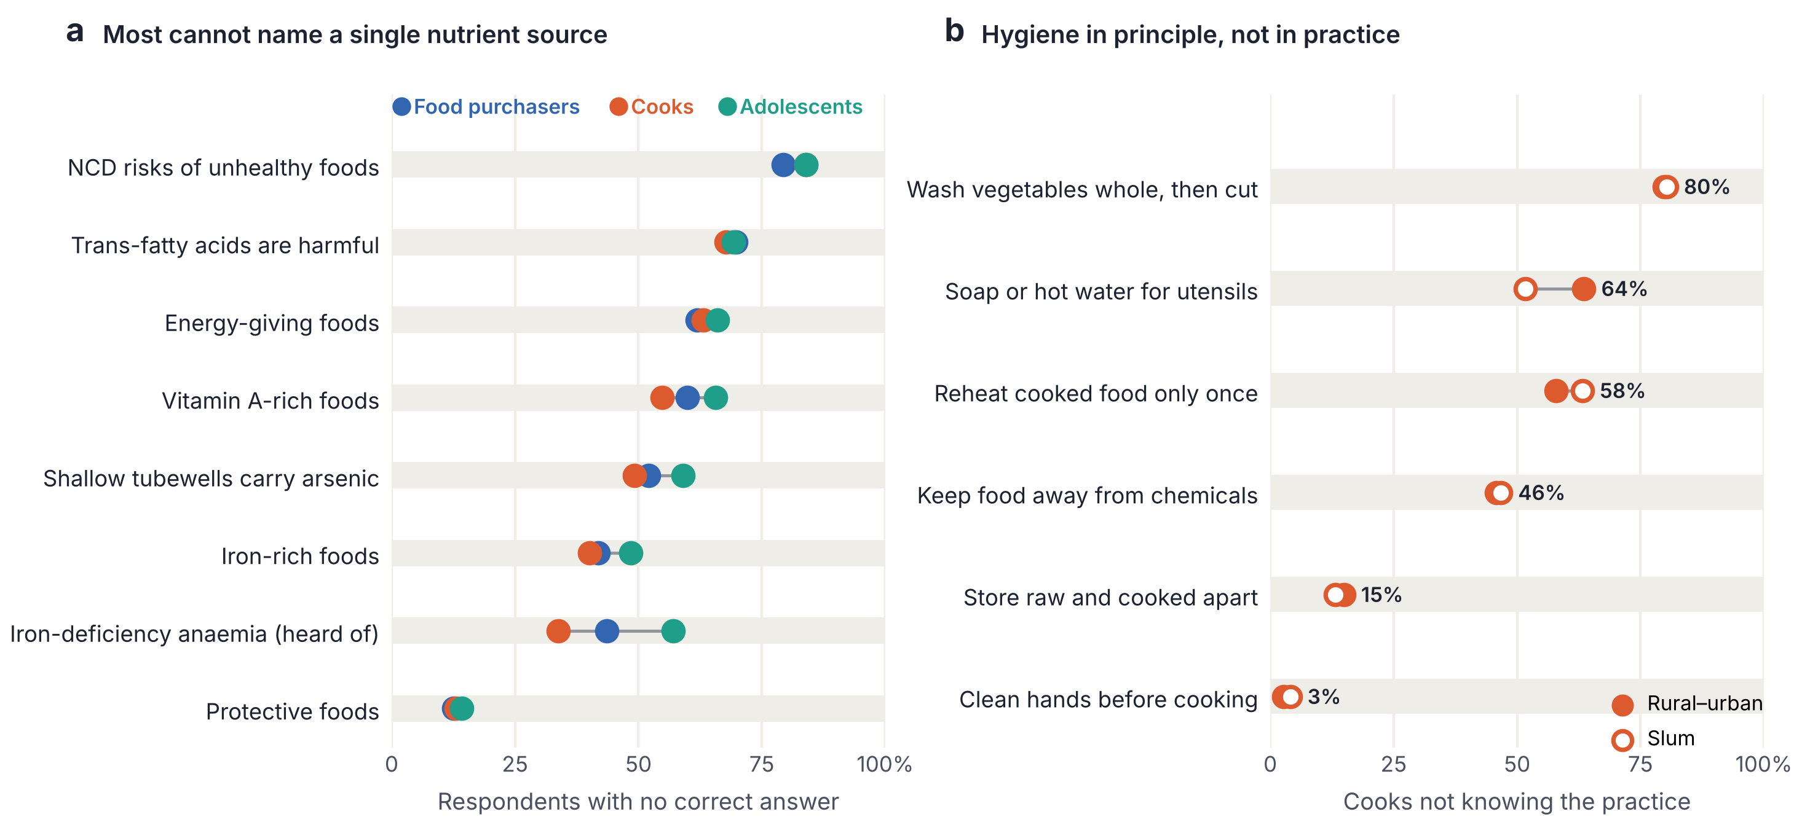
Fig. 1 | Gaps in specific nutrition and food-safety knowledge. a, Percentage of food purchasers (n = 3,021), cooks (n = 4,136) and adolescents (n = 1,862) in rural–urban households who gave no correct answer to each basic nutrition question; for iron-deficiency anaemia, the percentage who had never heard of it. Grey lines join the lowest and highest of the three groups. b, Percentage of cooks who did not know each food-safety or cooking practice in rural–urban (filled circles; value shown) and slum (open circles) households. Survey-weighted estimates.
Cooks' mean food-safety knowledge score was 54.9. General hygiene principles were nearly universal — 97.2% said that hands should be cleaned before cooking — but specific practices were not (Fig. 1b). In rural–urban households, 57.9% of cooks did not know that cooked food should be reheated only once, 45.8% did not know that food should be kept away from chemicals and cleaning products, 63.6% did not describe cleaning utensils with soap or hot water after each use, and 79.8% did not know that vegetables should be washed whole before cutting.

Knowledge rises with wealth, connectivity and messaging, and falls with food insecurity
In survey-weighted models including wealth, residence, division, internet access, recent exposure to nutrition messages and food insecurity, knowledge rose steadily with household wealth (Fig. 2 and Extended Data Table 2). Compared with the poorest quintile, knowledge scores in the richest quintile were 6.2 points higher among cooks (95% confidence interval (CI) 3.3–9.0), 8.7 points higher among purchasers (5.0–12.4) and 9.3 points higher among adolescents (5.2–13.3). Household internet access was independently associated with 4.0–5.0-point higher scores in all three groups. Having seen a nutrition or food-safety message in the previous 30 days was associated with 5.0–7.6-point higher scores. Food insecurity showed the opposite gradient: severe food insecurity was associated with 8.1 points lower knowledge among cooks (5.6–10.1 lower) and 8.8 points lower among purchasers (6.2–11.4 lower). Urban residence added 4.2 points among cooks but was not associated with adolescents' knowledge.
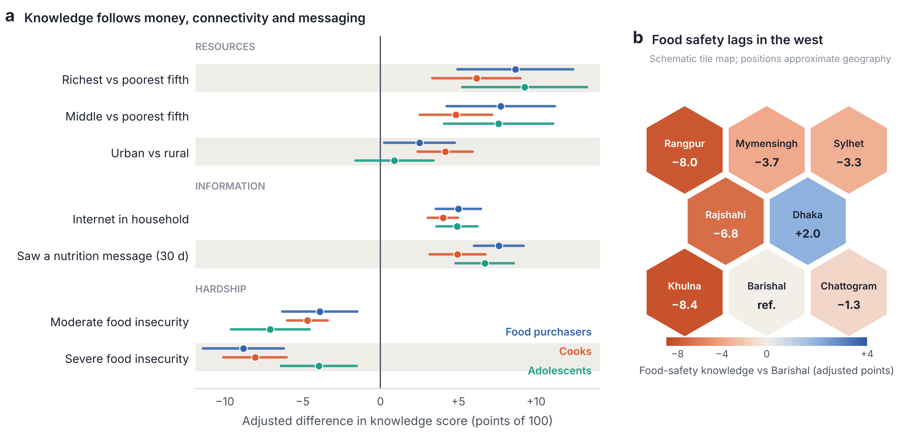
Fig. 2 | Who knows: wealth, connectivity, messaging and place. a, Adjusted differences in basic nutrition knowledge score (points of 100) with 95% confidence intervals for food purchasers, cooks and adolescents in rural–urban households, from survey-weighted linear regression including wealth quintile, urban residence, division, household internet access, exposure to a nutrition or food-safety message in the previous 30 days and food insecurity (HFIAS). Reference categories: poorest quintile, rural, food-secure. b, Adjusted difference in cooks' food-safety knowledge score by division relative to Barishal, from the same model. Hexagons are arranged schematically to approximate the relative geographical position of the eight divisions. Full estimates in Extended Data Table 2.
Food-safety knowledge showed a similar socioeconomic gradient (richest versus poorest quintile, +5.4 points; severe food insecurity, −4.0 points) but much larger regional differences. Relative to Barishal, cooks' food-safety scores were 8.4 points lower in Khulna (Fig. 2b), 8.0 points lower in Rangpur and 6.9 points lower in Rajshahi (all P < 0.001), after adjustment for wealth and other covariates.

Diets are low in diversity and high in discretionary foods
Diets were dominated by starchy staples, consumed by virtually everyone, and by fish or meat (73–76%) and vegetables (Fig. 3a). Fewer than a third of respondents had eaten eggs, and fewer than a fifth had eaten other fruits, vitamin A-rich fruits and vegetables, dairy products or nuts in the previous 24 hours. Mean dietary diversity was 4.2–4.4 of ten food groups, and 59–64% of respondents ate fewer than five groups. Discretionary foods were pervasive (Fig. 3b): 84.0% of purchasers, 70.8% of cooks and 79.1% of adolescents had consumed sugar-sweetened beverages, sweets or savoury fried snacks in the previous day (slums: 92.1%, 78.8% and 82.6%). Sugar-sweetened beverages, which here include sweetened tea, were the most common item among adults (56–74%), whereas adolescents most often ate sweets (49.8%) and fried snacks (36.2%).
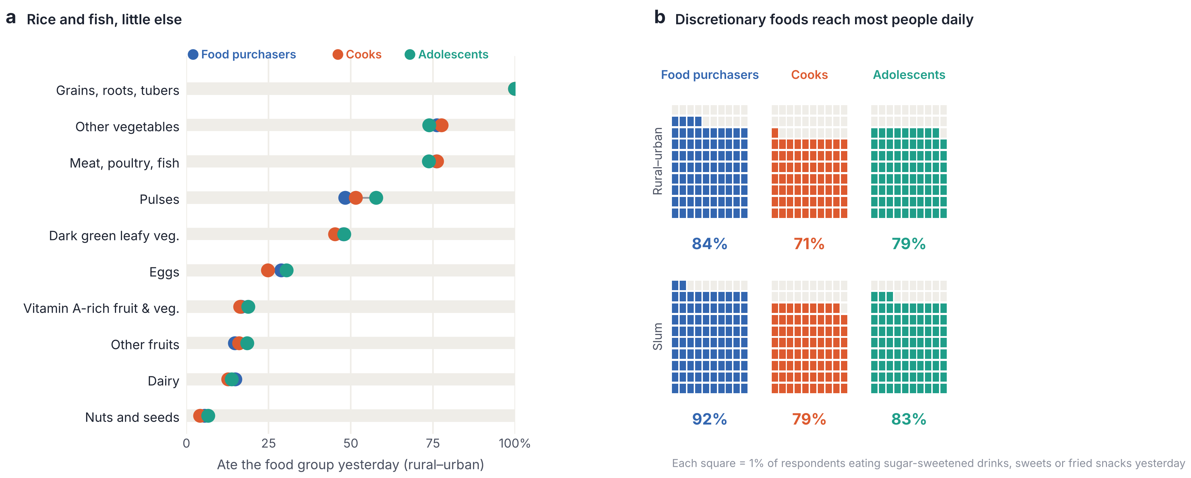
Fig. 3 | Diets are low in diversity and high in discretionary foods. a, Percentage of food purchasers, cooks and adolescents in rural–urban households who consumed each of ten food groups in the previous 24 hours. b, Percentage of respondents who consumed sugar-sweetened beverages (including sweetened tea), sweets, or savoury and fried snacks in the previous 24 hours, in rural–urban and slum households; each square represents 1% of respondents.

Knowledge is unrelated to dietary diversity once household resources are considered
In crude models, a 10-point higher knowledge score was associated with slightly greater dietary diversity among purchasers (+0.08 food groups; 95% CI 0.02–0.15) but not among cooks or adolescents (Table 1); the distribution of dietary diversity was virtually identical across fifths of knowledge (Fig. 4a). After adjustment for wealth, food expenditure, food insecurity, internet access, residence and division, these associations disappeared: −0.01 food groups among cooks (−0.07 to 0.05), +0.02 among purchasers (−0.03 to 0.08) and +0.02 among adolescents (−0.06 to 0.10). The confidence limits exclude effects larger than about 0.1 food groups per 10 knowledge points. Knowledge was likewise unrelated to achieving minimum dietary diversity (odds ratios 1.01–1.07 per 10 points; all 95% CIs including 1). By contrast, household food expenditure was strongly associated with diversity: each one-unit increase in log food expenditure per person was associated with 0.65 more food groups among cooks (0.45–0.85) and 0.72 more among adolescents (0.40–1.03). Results in slum households were similar (Table 1).
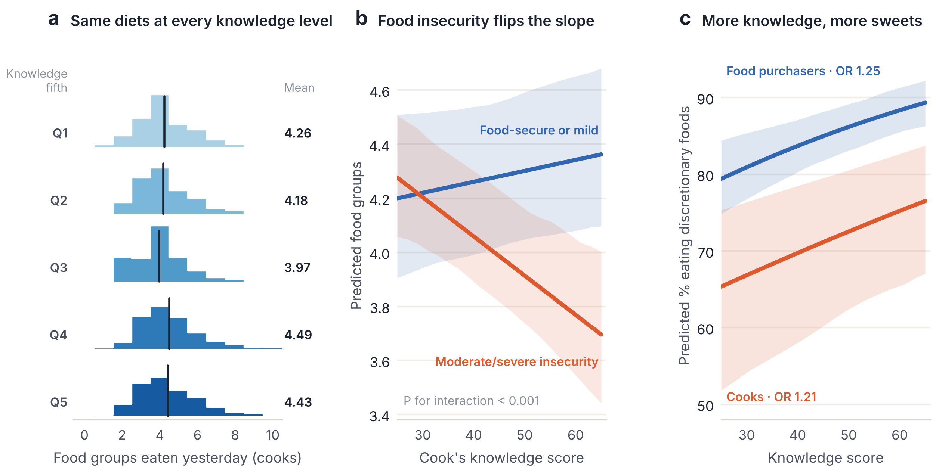
Fig. 4 | Knowledge does not translate into healthier diets. a, Distribution of dietary diversity (number of ten food groups eaten in the previous 24 hours) among cooks in rural–urban households, by fifth of basic nutrition knowledge (Q1, lowest); vertical lines and values show weighted means. b, Predicted dietary diversity by cook's knowledge score among food-secure or mildly food-insecure households and among moderately or severely food-insecure households, from a survey-weighted model with a knowledge × food-insecurity interaction adjusted for wealth quintile, log food expenditure per person, internet access, urban residence and division. c, Predicted percentage of cooks and food purchasers who consumed discretionary foods, by knowledge score, from survey-weighted logistic models with the same adjustment plus food insecurity; OR, odds ratio per 10 points. Curves are marginally standardised predictions; bands are 95% confidence intervals from 150 bootstrap resamples of primary sampling units.
Table 1 | Association of basic nutrition knowledge (per 10 points) with diet.
Respondent | Dietary diversity, crude (food groups) | Dietary diversity, adjusted (food groups) | Minimum dietary diversity, adjusted OR | Discretionary foods, adjusted OR
Rural–urban households
Food purchasers (n = 3,020) | 0.08 (0.02 to 0.15) | 0.02 (-0.03 to 0.08) | 1.03 (0.95 to 1.11) | 1.25 (1.14 to 1.37)
Cooks (n = 4,135) | 0.05 (-0.02 to 0.12) | -0.01 (-0.07 to 0.05) | 1.01 (0.93 to 1.09) | 1.21 (1.11 to 1.31)
Adolescents (n = 1,862) | 0.06 (-0.03 to 0.15) | 0.02 (-0.06 to 0.10) | 1.07 (0.97 to 1.19) | 1.01 (0.93 to 1.11)
Slum households
Food purchasers (n = 407) | 0.07 (-0.06 to 0.20) | -0.04 (-0.16 to 0.07) | 0.91 (0.68 to 1.23) | 1.98 (0.70 to 5.58)
Cooks (n = 1,103) | 0.01 (-0.08 to 0.11) | 0.05 (-0.04 to 0.14) | 1.15 (0.93 to 1.42) | 1.23 (0.99 to 1.52)
Adolescents (n = 419) | 0.03 (-0.15 to 0.20) | -0.13 (-0.27 to 0.02) | 0.75 (0.57 to 0.99) | 0.98 (0.63 to 1.52)
Estimates per 10-point higher knowledge score (0–100) with 95% confidence intervals. Dietary diversity: number of ten food groups consumed in the previous 24 hours (weighted linear regression). Minimum dietary diversity: five or more groups. Discretionary foods: savoury or fried snacks, sweets or sugar-sweetened beverages in the previous 24 hours (weighted logistic regression; OR, odds ratio). Adjusted models include wealth quintile, log food expenditure per person, food insecurity (HFIAS category), household internet access, division and (rural–urban only) urban residence. Standard errors clustered by primary sampling unit; rural–urban and slum samples analysed separately.
Decomposition of the difference in cooks' dietary diversity between the richest and poorest quintiles (0.81 food groups) attributed essentially none of the gap to knowledge (−0.3%), compared with 33.6% to urban residence, 11.5% to internet access, 5.6% to food expenditure and 3.8% to food insecurity, with 45.8% unexplained by these factors (Extended Data Table 4). For purchasers, knowledge accounted for 2.3% of a 0.87-group gap.

Knowledge accompanies more, not less, discretionary-food consumption
Higher knowledge was associated with greater consumption of discretionary foods (Fig. 4c). After adjustment, each 10-point increase in knowledge was associated with 21% higher odds of having eaten discretionary foods among cooks (odds ratio 1.21; 1.11–1.31) and 25% higher odds among purchasers (1.25; 1.14–1.37), with no association among adolescents (1.01; 0.93–1.11). In slums the association among cooks was of similar size (1.23; 0.99–1.52). These foods appear to be markers of greater purchasing power and market exposure, which accompany knowledge, rather than of ignorance.

Food insecurity reverses the knowledge–diet association
The association between knowledge and dietary diversity depended on household food security (Fig. 4b and Extended Data Table 3). Among food-secure or mildly food-insecure households, a 10-point increase in cooks' knowledge was associated with a small, non-significant increase in diversity (+0.04 food groups; −0.02 to 0.10). Among moderately or severely food-insecure households, the association was inverse (−0.15; −0.22 to −0.07; P for interaction < 0.001). The pattern was similar for purchasers (+0.06 versus −0.09; P for interaction = 0.009) and when households were stratified by wealth (cooks in the poorest two quintiles: −0.10; −0.18 to −0.02; P for interaction = 0.001). No such modification was seen among adolescents (P = 0.78). Knowledge therefore does not protect diets where resources are scarce.

Hygiene infrastructure follows wealth, not knowledge
Enumerators observed a handwashing place with both water and soap in 58.4% of rural–urban and 45.7% of slum households. This rose from 40.1% in the poorest to 77.1% in the richest rural–urban quintile (Fig. 5a); after adjustment the odds were 11.6 times higher in the richest quintile (7.3–18.5), whereas cooks' food-safety knowledge was not associated with having such a facility (odds ratio 1.26 per 10 points; 0.82–1.92). Food was observed stored near chemicals or cleaning supplies in 11.2% of households; this was not less common among cooks who knew it should be avoided (13.8% versus 8.3%).
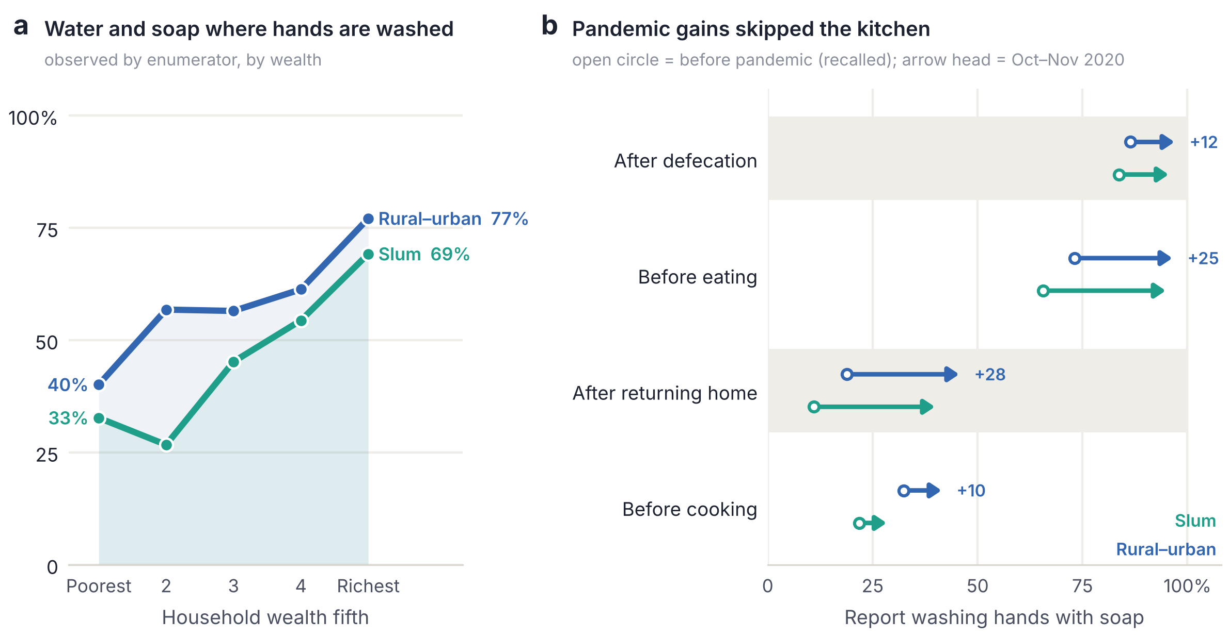
Fig. 5 | Hygiene infrastructure follows wealth, and pandemic messaging did least for handwashing before cooking. a, Percentage of households in which the enumerator observed a handwashing place with both water and soap (or another cleansing agent), by wealth fifth, in rural–urban and slum households. b, Reported handwashing with soap at selected critical times. Open circles show estimated pre-pandemic prevalence (current prevalence multiplied by the share of practitioners reporting that the practice predated the COVID-19 pandemic); arrow heads show prevalence in October–November 2020; values give the rural–urban change in percentage points.
Reported handwashing with soap was near-universal after defecation (98.3%) and before eating (97.8%) but much less common before cooking (42.8%; slums 29.7%), mirroring knowledge of when hands should be washed (40.9% named before cooking). Combining current prevalence with respondents' reports of whether each practice predated the COVID-19 pandemic (Methods), we estimate that washing after returning home rose from about 19% to 47% and washing before eating from 73% to 98%, whereas washing before cooking rose only from 32% to 43% (Fig. 5b). Pandemic messaging thus had least effect at the critical time most relevant to household food safety.

Child diets
Among children aged 6–23 months, 37.2% of rural–urban and 40.3% of slum children achieved minimum dietary diversity. Caregivers' infant-feeding knowledge was high for breastfeeding initiation and colostrum (over 97% correct) but lower for responding to perceived insufficient milk (56%) and not giving water to infants under six months (71%). Neither caregivers' infant-feeding knowledge (odds ratio 1.13 per 10 points; 0.96–1.33) nor cooks' nutrition knowledge (1.05; 0.88–1.24) was associated with children's minimum dietary diversity after adjustment.

Discussion
Using microdata from a nationally representative survey, we show that nutrition knowledge in Bangladesh is low, concentrated among the better-off and connected, and essentially unrelated to what people eat once household resources are accounted for. Higher knowledge accompanied more, not less, consumption of discretionary foods, and in food-insecure households it accompanied lower dietary diversity. Food expenditure, urban residence and connectivity — not knowledge — explained the diet gap between rich and poor households. Observed hygiene infrastructure, too, tracked wealth rather than knowledge.
These findings extend evidence from high-income countries that nutrition knowledge is necessary but not sufficient for healthy diets^{10,11} to a lower-middle-income setting in which a fifth to a third of households are moderately or severely food-insecure. In such settings, nutrient-dense foods such as eggs, dairy, fruit and vegetables cost several times more per calorie than rice¹³, and the cost of a healthy diet exceeds what many households can afford¹⁴. Knowing what to eat does not ensure that one can eat it¹². The inverse association between knowledge and diversity among food-insecure households is notable. One possible explanation is that more knowledgeable members of resource-constrained households prioritise quantity of staple foods, or allocate scarce resources to children; another is unmeasured confounding by recent income shocks during the pandemic. Either way, it argues against assuming that knowledge gains will translate into dietary gains for the households that most need them.
The positive association between knowledge and discretionary-food consumption is consistent with the nutrition transition: packaged snacks, sweets and sugar-sweetened beverages — including sweetened tea — are cheap, widely marketed and increasingly consumed by households with more income, connectivity and market exposure¹. That these foods reached 79–92% of adolescents in a single day, irrespective of their knowledge, signals that food-environment measures rather than education alone will be needed to curb them.
For food safety, the household remains a weak link. Large shares of cooks did not know safe reheating, storage or utensil-cleaning practices, and handwashing before cooking was reported by fewer than half — and had changed least during the pandemic^{19,20}. Observed handwashing facilities with water and soap were present in only two-fifths of the poorest households and were strongly patterned by wealth, consistent with earlier evidence that hygiene behaviour in Bangladesh depends on infrastructure as well as knowledge^{21,22}.
These results have direct implications for nutrition and food-safety policy. BCC remains justified: knowledge was low, and exposure to messages was associated with higher knowledge. But messages should focus on specific, actionable gaps — micronutrient-rich foods, NCD risks of discretionary foods, safe reheating and storage, and handwashing before cooking — and be targeted at poorer, food-insecure and less connected households and the divisions with the largest gaps. Above all, information should be paired with measures that make healthy, safe food affordable and accessible: linking nutrition messaging to social-protection transfers (received by fewer than one in five households), lowering the relative price of nutrient-dense foods, restricting the marketing of discretionary foods to children and adolescents, and investing in household water and handwashing infrastructure.
Our study has limitations. The survey is cross-sectional, so associations cannot be interpreted causally, and reverse causation and residual confounding are possible. The household roster containing respondents' age, sex and education was not available in the dataset analysed, so we could not adjust for individual education; wealth, internet access and message exposure partly capture this, and the survey report documented steep educational gradients in knowledge²³. Knowledge scores depend on item selection and scoring; we pre-specified a transparent fractional-credit key (Extended Data Table 7) and report item-level results. Diets were assessed by a single 24-hour recall, which captures population-level diversity but not usual individual intake; our sugar-sweetened beverage indicator includes sweetened tea. Handwashing practices and their pre-pandemic history were self-reported. Fieldwork took place under pandemic movement restrictions, and slum households were sampled and weighted separately, precluding pooled national estimates.
In conclusion, what Bangladeshi households know about food is unequal and does not determine what they eat. Strategies that rely on information alone risk leaving the diets of poor and food-insecure households unchanged; making healthy, safe food affordable must accompany efforts to make it known.

Methods

Study design and sampling
We analysed data from the Survey on Consumer Awareness of Nutrition, Food Safety and Hygiene, a cross-sectional household survey commissioned by the Food Planning and Monitoring Unit (FPMU) of the Ministry of Food and FAO under the Meeting the Undernutrition Challenge (MUCH) project and conducted from 1 October to 30 November 2020 in all eight divisions of Bangladesh²³. For rural and urban areas, the sampling frame was the list of enumeration areas of the Bangladesh Multiple Indicator Cluster Survey 2019 (ref. 5). Each division was stratified into urban and rural domains; primary sampling units were selected by systematic random sampling with independent allocation in each stratum, and about 20 households per unit were selected systematically from a new listing. Slums were sampled separately: 50 slums were selected with probability proportional to size from the 2014 Census of Slum Areas and Floating Population²⁴, and about 20 households were selected per slum. Sampling weights reflecting selection probabilities were provided with the data; because rural–urban and slum weights were constructed on different scales, the two samples were analysed separately.
In each household, interviewers identified the person primarily responsible for cooking, the person primarily responsible for purchasing food (interviewed separately when different from the cook), the primary caregiver of a child aged 6–23 months where present, and an adolescent aged 10–19 years where present.

Data collection
Face-to-face interviews were conducted in Bangla by 24 trained field research assistants and 6 supervisors using a pre-tested structured questionnaire programmed in KoboCollect. Supervisors observed interviews daily and revisited about 5% of households within 48 hours; data were reviewed daily by a central statistician. Field staff followed COVID-19 infection-prevention protocols.

Measures
Knowledge. Questions were asked without prompting the answer options. We scored basic nutrition knowledge (cooks, purchasers and adolescents) from 16 items: food groups in a balanced diet; unhealthy foods (salty, sweet and sugar-sweetened beverage categories); NCD consequences of unhealthy foods; need for a balanced diet; energy-giving, body-building and protective foods; vitamin C-, vitamin A- and iron-rich foods; iron-deficiency anaemia; the source of arsenic; diets in pregnancy and lactation; trans-fatty acids; and features of a healthy diet. Cooks' food-safety knowledge was scored from 12 items (storage away from chemicals, hand cleaning before cooking and eating, separate storage of raw and cooked food, safe handling of vegetables, fruits and cooked food, utensil cleaning, disease transmission routes, reheating and prevention of contamination), and cooking-practice knowledge from 8 items. Caregivers' infant-feeding knowledge was scored from 11 items. Following FAO guidance¹⁶, each correct single-answer item scored 1 and multiple-answer items received fractional credit equal to the share of correct options mentioned; incorrect options for iron-rich foods were penalised. Domain scores are the mean item score multiplied by 100. The full scoring key is given in Extended Data Table 7. We report continuous scores and the share scoring at least 60, rather than sample tertiles, so that prevalences are not fixed by construction.
Diets. Respondents reported consumption of 25 food groups in the previous 24 hours. Dietary diversity was the number of ten food groups consumed (grains, roots and tubers; pulses; nuts and seeds; dairy; meat, poultry and fish; eggs; dark green leafy vegetables; other vitamin A-rich fruits and vegetables; other vegetables; other fruits), with five or more defining minimum dietary diversity²⁵. Discretionary-food consumption was the consumption in the previous 24 hours of savoury or fried snacks, sweets, or sugar-sweetened beverages (including sweetened tea, soft drinks, juice drinks and malted drinks). For children aged 6–23 months, minimum dietary diversity was consumption of at least five of eight WHO food groups including breast milk²⁶.
Household characteristics. Food insecurity was measured with the nine-item HFIAS (4-week recall) and categorised as secure, mildly, moderately or severely food-insecure using the standard algorithm¹⁸. A wealth index was derived as the first principal component of 22 household assets, housing materials, number of rooms, cooking fuel, water source, sanitation, land and livestock, and divided into weighted quintiles within each sample. We also recorded monthly food expenditure (expressed per household member, log-transformed), household internet access, receipt of social-safety-net benefits, and whether each respondent had seen a nutrition, food-safety or hygiene message in any medium in the previous 30 days.
Hygiene and food safety practice. Enumerators observed the household's handwashing place and recorded whether water and soap or another cleansing agent were present, and whether food was stored near chemicals or cleaning supplies. The main female respondent reported the times at which household members wash hands with soap and, for each, whether the practice predated the COVID-19 pandemic. We estimated pre-pandemic prevalence as current prevalence multiplied by the share of practitioners reporting that the practice predated the pandemic.

Statistical analysis
All estimates are weighted. Regression models used sampling weights with standard errors clustered by primary sampling unit. Correlates of knowledge were examined with weighted linear regression of knowledge scores on wealth quintile, urban residence, division, internet access, recent message exposure and HFIAS category. Associations of knowledge (per 10 points) with diets were estimated with weighted linear regression for dietary diversity and weighted logistic regression for minimum dietary diversity and discretionary-food consumption, first without and then with adjustment for wealth quintile, log food expenditure per person, HFIAS category, internet access, urban residence and division. Effect modification was tested by adding an interaction between knowledge and moderate or severe food insecurity (and, separately, between knowledge and belonging to the poorest two wealth quintiles); we report stratum-specific slopes derived from the interaction models. The rich–poor gap in dietary diversity was decomposed by multiplying pooled regression coefficients by the difference in covariate means between the richest and poorest quintiles. Food-safety knowledge was related to observed practices with weighted logistic regression adjusted for wealth, residence, division and drinking-water source. Slum households were analysed separately with the same models (omitting urban residence). Predicted curves in Fig. 4 were obtained by marginal standardisation (setting knowledge to each value for all respondents and averaging weighted predictions), with 95% confidence bands from 150 bootstrap resamples of primary sampling units. We report 95% CIs and two-sided P values. Analyses were performed in Python 3.13 (pandas 3.0, statsmodels 0.15); code is available (see Code availability).

Ethics
The study was approved by the Institutional Review Board (ethical review board) of the James P Grant School of Public Health, BRAC University, Dhaka, Bangladesh (protocol IRB-1 September 2020-039). Adult participants provided informed oral consent after the consent statement was read to them in Bangla. [Describe parental consent and adolescent assent procedure for respondents aged 10–17 years.] Participation was voluntary and responses were identified by code numbers. The analysed dataset excluded names, telephone numbers and addresses.

Reporting summary
Further information on research design is available in the Nature Portfolio Reporting Summary linked to this article.

Data availability
The survey data are held by the Food Planning and Monitoring Unit, Ministry of Food, Government of Bangladesh, and FAO Bangladesh. De-identified data are available from the corresponding author on reasonable request and with permission from FPMU and FAO. [Confirm data-sharing terms; if possible deposit de-identified data in a public repository and give the DOI.] The English and Bangla questionnaires are provided as Supplementary Information.

Code availability
Analysis code (variable construction, models and figures) is available at [GitHub/Zenodo DOI].

References
1. Popkin, B. M., Corvalan, C. & Grummer-Strawn, L. M. Dynamics of the double burden of malnutrition and the changing nutrition reality. Lancet 395, 65–74 (2020).
2. GBD 2017 Diet Collaborators. Health effects of dietary risks in 195 countries, 1990–2017: a systematic analysis for the Global Burden of Disease Study 2017. Lancet 393, 1958–1972 (2019).
3. Food Planning and Monitoring Unit. Bangladesh Second Country Investment Plan: Nutrition-Sensitive Food Systems (CIP2 2016–2020). Monitoring Report 2020 (Ministry of Food, Government of the People's Republic of Bangladesh, 2020).
4. Nisbett, N., Davis, P., Yosef, S. & Akhtar, N. Bangladesh's story of change in nutrition: strong improvements in basic and underlying determinants with an unfinished agenda for direct community level support. Glob. Food Sec. 13, 21–29 (2017).
5. Bangladesh Bureau of Statistics & UNICEF Bangladesh. Progotir Pathey, Bangladesh Multiple Indicator Cluster Survey 2019, Survey Findings Report (BBS & UNICEF, 2019).
6. Havelaar, A. H. et al. World Health Organization global estimates and regional comparisons of the burden of foodborne disease in 2010. PLoS Med. 12, e1001923 (2015).
7. Islam, M. A. et al. Microbiological quality of complementary foods and its association with diarrhoeal morbidity and nutritional status of Bangladeshi children. Eur. J. Clin. Nutr. 66, 1242–1246 (2012).
8. Mostafa, I. et al. Children living in the slums of Bangladesh face risks from unsafe food and water and stunted growth is common. Acta Paediatr. 107, 1230–1239 (2018).
9. Hoddinott, J., Ahmed, A., Karachiwalla, N. I. & Roy, S. Nutrition behaviour change communication causes sustained effects on IYCN knowledge in two cluster-randomised trials in Bangladesh. Matern. Child Nutr. 14, e12498 (2018).
10. Spronk, I., Kullen, C., Burdon, C. & O'Connor, H. Relationship between nutrition knowledge and dietary intake. Br. J. Nutr. 111, 1713–1726 (2014).
11. Worsley, A. Nutrition knowledge and food consumption: can nutrition knowledge change food behaviour? Asia Pac. J. Clin. Nutr. 11, S579–S585 (2002).
12. Herforth, A. & Ahmed, S. The food environment, its effects on dietary consumption, and potential for measurement within agriculture-nutrition interventions. Food Secur. 7, 505–520 (2015).
13. Headey, D. D. & Alderman, H. H. The relative caloric prices of healthy and unhealthy foods differ systematically across income levels and continents. J. Nutr. 149, 2020–2033 (2019).
14. FAO, IFAD, UNICEF, WFP & WHO. The State of Food Security and Nutrition in the World 2020: Transforming Food Systems for Affordable Healthy Diets (FAO, 2020).
15. Roy, S. K. Survey of Household Food Safety and Hygiene Practices, Knowledge and Beliefs in Bangladesh (International Centre for Diarrhoeal Disease Research, Bangladesh & FAO, 2011).
16. Fautsch Macías, Y. & Glasauer, P. Guidelines for Assessing Nutrition-Related Knowledge, Attitudes and Practices (FAO, 2014).
17. World Health Organization. Five Keys to Safer Food Manual (WHO, 2006).
18. Coates, J., Swindale, A. & Bilinsky, P. Household Food Insecurity Access Scale (HFIAS) for Measurement of Food Access: Indicator Guide, Version 3 (Food and Nutrition Technical Assistance Project, 2007).
19. Ahmed, M. S. & Yunus, F. M. Trend of COVID-19 spreads and status of household handwashing practice and its determinants in Bangladesh – situation analysis using national representative data. Int. J. Environ. Health Res. 31, 1–9 (2021).
20. Fontannaz-Aujoulat, F., Frost, M. & Schlundt, J. WHO Five Keys to Safer Food communication campaign — evidence-based simple messages with a global impact. Food Control 101, 53–57 (2019).
21. Rabbi, S. E. & Dey, N. C. Exploring the gap between hand washing knowledge and practices in Bangladesh: a cross-sectional comparative study. BMC Public Health 13, 89 (2013).
22. Dey, N. C. et al. Effectiveness of a community-based water, sanitation, and hygiene (WASH) intervention in reduction of diarrhoea among under-five children: evidence from a repeated cross-sectional study (2007–2015) in rural Bangladesh. Int. J. Hyg. Environ. Health 222, 1098–1108 (2019).
23. Dey, N. C. et al. Survey on Consumer Awareness of Nutrition, Food Safety and Hygiene: Final Report (BRAC James P Grant School of Public Health, Bangladesh Agricultural University, FPMU and FAO, 2021).
24. Bangladesh Bureau of Statistics. Census of Slum Areas and Floating Population 2014 (BBS, 2015).
25. FAO. Minimum Dietary Diversity for Women: An Updated Guide to Measurement — From Collection to Action (FAO, 2021).
26. WHO & UNICEF. Indicators for Assessing Infant and Young Child Feeding Practices: Definitions and Measurement Methods (WHO, 2021).

Acknowledgements
We thank the participating households, the field research assistants and supervisors, and the members of the Technical Advisory Team. The study was supported by the Meeting the Undernutrition Challenge (MUCH) project, jointly implemented by FAO and the Food Planning and Monitoring Unit of the Ministry of Food, with financial support from the European Union and the United States Agency for International Development (LoA-1507316). [Confirm funder wording and state the role of the funders.]

Author contributions
[Author contributions in CRediT format.]

Competing interests
The authors declare no competing interests.

Inclusion and ethics statement
This research was designed and conducted by researchers based in Bangladesh (BRAC James P Grant School of Public Health, BRAC University, and Bangladesh Agricultural University) in partnership with the Ministry of Food and FAO Bangladesh, in response to a national policy need identified by the government. Local researchers led study design, data collection, analysis and interpretation. Findings were reviewed with national stakeholders through the project's technical advisory team, which included the Bangladesh Bureau of Statistics. The study was approved by the local Institutional Review Board of the James P Grant School of Public Health, BRAC University (IRB-1 September 2020-039).

Extended Data
Extended Data Table 1 | Sample characteristics, knowledge and diets (survey-weighted).
Characteristic | Rural–urban | Slum
Sample
Households (primary sampling units) | 4,136 (198) | 1,103 (50)
Separate food purchaser interviewed, n | 3,021 | 407
Cook was also the main food purchaser, % | 27.0 | 63.1
Adolescents interviewed, n | 1,862 | 419
Household characteristics (%)
Food insecurity (HFIAS): secure | 56.0 | 32.6
Food insecurity (HFIAS): mild | 21.7 | 32.9
Food insecurity (HFIAS): moderate | 12.5 | 17.6
Food insecurity (HFIAS): severe | 9.8 | 16.9
Household internet access | 37.9 | 32.0
Receives any social-safety-net benefit | 17.2 | 19.0
Handwashing place with water and soap (observed) | 58.4 | 45.7
Food stored near chemicals (observed) | 11.2 | 14.2
Knowledge (score 0–100, mean; % scoring ≥60)
Basic nutrition — food purchasers | 42.7; 11.7 | 38.5; 3.2
Basic nutrition — cooks | 44.6; 13.7 | 41.8; 7.9
Basic nutrition — adolescents | 40.4; 11.7 | 35.8; 4.3
Food safety — cooks | 54.9; 35.2 | 54.5; 35.9
Cooking practices — cooks (mean) | 77.3 | 77.6
Infant feeding — caregivers (mean) | 76.2 | 70.3
Diets, previous 24 h
Food purchasers: dietary diversity, mean groups; % ≥5 groups | 4.29; 39.4 | 4.37; 37.9
Food purchasers: any discretionary food / SSB / sweets / snacks, % | 84.0 / 73.6 / 39.3 / 27.0 | 92.1 / 86.7 / 48.8 / 30.8
Cooks: dietary diversity, mean groups; % ≥5 groups | 4.24; 35.8 | 4.15; 35.5
Cooks: any discretionary food / SSB / sweets / snacks, % | 70.8 / 56.3 / 32.3 / 11.2 | 78.8 / 71.6 / 31.1 / 13.5
Adolescents: dietary diversity, mean groups; % ≥5 groups | 4.41; 40.9 | 4.59; 44.0
Adolescents: any discretionary food / SSB / sweets / snacks, % | 79.1 / 44.5 / 49.8 / 36.2 | 82.6 / 56.0 / 48.3 / 42.3
Children 6–23 months: minimum dietary diversity, % | 37.2 | 40.3
SSB, sugar-sweetened beverages (including sweetened tea). HFIAS, Household Food Insecurity Access Scale.

Extended Data Table 2 | Correlates of knowledge scores (rural–urban households).
Characteristic | Basic nutrition, purchasers | Basic nutrition, cooks | Basic nutrition, adolescents | Food safety, cooks
Wealth quintile 2 (ref. poorest) | 5.7 (2.7 to 8.7) | 4.3 (2.4 to 6.3) | 5.3 (1.9 to 8.6) | 4.3 (0.6 to 7.9)
Wealth quintile 3 | 7.7 (4.3 to 11.2) | 4.9 (2.5 to 7.2) | 7.6 (4.1 to 11.1) | 4.4 (0.8 to 8.0)
Wealth quintile 4 | 7.2 (3.5 to 10.8) | 6.0 (3.5 to 8.6) | 10.2 (6.2 to 14.1) | 4.4 (0.6 to 8.1)
Wealth quintile 5 (richest) | 8.7 (5.0 to 12.4) | 6.2 (3.3 to 9.0) | 9.3 (5.2 to 13.3) | 5.4 (1.0 to 9.8)
Urban (ref. rural) | 2.5 (0.2 to 4.8) | 4.2 (2.4 to 5.9) | 0.9 (-1.6 to 3.4) | 3.3 (1.9 to 4.7)
Household internet access | 5.0 (3.5 to 6.5) | 4.0 (3.0 to 5.0) | 4.9 (3.6 to 6.2) | 1.0 (-2.1 to 4.0)
Saw nutrition/food-safety message, previous 30 days | 7.6 (6.0 to 9.2) | 5.0 (3.2 to 6.7) | 6.7 (4.8 to 8.6) | 4.8 (1.5 to 8.1)
Mild food insecurity (ref. secure) | -4.2 (-6.0 to -2.5) | -3.9 (-5.8 to -1.9) | -2.7 (-4.9 to -0.5) | -2.0 (-4.3 to 0.3)
Moderate food insecurity | -3.9 (-6.3 to -1.5) | -4.7 (-6.0 to -3.4) | -7.1 (-9.6 to -4.6) | -0.9 (-2.2 to 0.4)
Severe food insecurity | -8.8 (-11.4 to -6.2) | -8.1 (-10.1 to -6.0) | -4.0 (-6.4 to -1.5) | -4.0 (-5.7 to -2.2)
Chattogram (ref. Barishal) | -1.9 (-6.1 to 2.2) | -1.6 (-5.0 to 1.7) | -4.6 (-8.9 to -0.3) | -1.3 (-3.0 to 0.4)
Dhaka | 2.2 (-2.1 to 6.4) | 2.1 (-1.4 to 5.6) | 5.7 (1.7 to 9.7) | 2.0 (0.2 to 3.9)
Khulna | 3.5 (-0.1 to 7.2) | 0.6 (-2.7 to 3.8) | -1.3 (-4.8 to 2.1) | -8.4 (-10.5 to -6.2)
Mymensingh | 0.9 (-3.2 to 5.0) | -1.3 (-4.8 to 2.3) | 1.8 (-2.7 to 6.3) | -3.7 (-6.2 to -1.2)
Rajshahi | -1.7 (-6.2 to 2.8) | -3.6 (-7.7 to 0.5) | -3.2 (-7.1 to 0.6) | -6.8 (-9.9 to -3.8)
Rangpur | 1.5 (-2.4 to 5.3) | -1.6 (-5.0 to 1.8) | 0.8 (-3.2 to 4.8) | -8.0 (-10.7 to -5.4)
Sylhet | 2.1 (-3.5 to 7.8) | -1.3 (-5.8 to 3.2) | -1.4 (-8.5 to 5.6) | -3.3 (-5.2 to -1.4)
Adjusted differences in knowledge score (points, 0–100) with 95% confidence intervals from survey-weighted linear regression including all variables shown. Standard errors clustered by primary sampling unit.

Extended Data Table 3 | Association of knowledge with dietary diversity by food security and wealth.
Respondent | Food-secure or mild | Moderate or severe insecurity | P interaction | Wealth Q3–Q5 | Wealth Q1–Q2 | P interaction
Rural–urban
Food purchasers | 0.06 (-0.01 to 0.12) | -0.09 (-0.20 to 0.01) | 0.009 | 0.06 | -0.10 (-0.26 to 0.05) | 0.047
Cooks | 0.04 (-0.02 to 0.10) | -0.14 (-0.22 to -0.07) | <0.001 | 0.05 | -0.10 (-0.18 to -0.01) | 0.001
Adolescents | 0.02 (-0.07 to 0.12) | 0.00 (-0.11 to 0.12) | 0.784 | 0.02 | 0.04 (-0.10 to 0.18) | 0.696
Slum
Food purchasers | -0.09 (-0.27 to 0.10) | 0.04 (-0.16 to 0.23) | 0.460 | -0.08 | 0.03 (-0.26 to 0.31) | 0.528
Cooks | 0.07 (-0.04 to 0.17) | 0.06 (-0.10 to 0.22) | 0.928 | 0.08 | 0.00 (-0.09 to 0.10) | 0.208
Adolescents | -0.22 (-0.41 to -0.04) | 0.07 (-0.05 to 0.20) | 0.006 | -0.11 | -0.18 (-0.36 to -0.00) | 0.405
Difference in dietary diversity (food groups) per 10-point higher knowledge within each stratum, with 95% confidence intervals, from survey-weighted linear models with a knowledge × stratum interaction, adjusted for the covariates in Table 1.

Extended Data Table 4 | Decomposition of the rich–poor gap in dietary diversity (rural–urban households).
Component | Cooks: food groups (% of gap) | Purchasers: food groups (% of gap)
Gap in dietary diversity, richest − poorest quintile | 0.81 | 0.87
Knowledge | -0.00 (-0.3%) | 0.02 (2.3%)
Food insecurity | 0.03 (3.8%) | 0.02 (2.5%)
Food expenditure | 0.05 (5.6%) | 0.00 (0.0%)
Internet access | 0.09 (11.5%) | 0.03 (3.3%)
Urban residence | 0.27 (33.6%) | 0.24 (27.1%)
Unexplained (including division) | 0.37 (45.8%) | 0.57 (64.8%)
Contribution of each factor = pooled regression coefficient × difference in weighted means between the richest and poorest wealth quintiles. Model includes knowledge (per 10 points), HFIAS score, log food expenditure per person, internet access, urban residence and division.

Extended Data Table 5 | Food-safety knowledge, observed practice and handwashing.
Indicator | Rural–urban | Slum
Observed practice
Handwashing place with water and soap, % | 58.4 | 45.7
poorest / richest quintile, % | 40.1 / 77.1 | 32.7 / 69.2
adjusted OR, richest vs poorest quintile | 11.63 (7.29 to 18.55) | 3.97 (1.41 to 11.16)
adjusted OR per 10-point food-safety knowledge | 1.26 (0.82 to 1.92) | 1.15 (0.86 to 1.52)
Food stored near chemicals: cook knows / does not know it should be avoided, % | 13.8 / 8.3 | 19.5 / 8.0
Handwashing with soap: knows the critical time / reports practice / estimated pre-pandemic, %
After defecation | 96.2 / 98.3 / 86.4 | 95.5 / 96.9 / 83.7
Before eating | 96.4 / 97.8 / 73.2 | 91.8 / 96.2 / 65.6
Before cooking | 40.9 / 42.8 / 32.4 | 29.8 / 29.7 / 21.8
After returning home | 33.6 / 47.0 / 18.9 | 26.2 / 41.2 / 11.0
Observed indicators were recorded by enumerators. Estimated pre-pandemic prevalence = reported prevalence × share of practitioners reporting the practice predated the COVID-19 pandemic. OR, odds ratio (95% confidence interval) from survey-weighted logistic regression adjusted for wealth quintile, residence, division and drinking-water source.

Extended Data Table 6 | Item-level basic nutrition knowledge (rural–urban households).
Item | Food purchasers | Cooks | Adolescents
Food groups in a balanced diet | 40.9 (1.4) | 41.8 (0.8) | 40.3 (1.4)
Unhealthy foods (categories) | 40.6 (10.1) | 39.2 (11.0) | 40.1 (14.9)
NCD consequences of unhealthy foods | 6.4 (79.3) | 4.7 (84.0) | 4.8 (83.9)
Problems if balanced diet not eaten | 95.5 (4.5) | 96.8 (3.2) | 94.5 (5.5)
Energy-giving foods | 19.6 (61.9) | 18.9 (63.1) | 17.5 (66.0)
Body-building foods | 82.6 (5.0) | 78.6 (5.8) | 80.7 (4.9)
Protective foods | 67.9 (12.6) | 66.2 (13.1) | 65.6 (14.2)
Vitamin C-rich foods | 61.8 (38.2) | 65.0 (35.0) | 72.0 (28.0)
Heard of iron-deficiency anaemia | 56.4 (43.6) | 66.2 (33.8) | 43.0 (57.0)
Vitamin A-rich foods | 19.3 (59.9) | 23.6 (54.8) | 18.7 (65.6)
Iron-rich foods | 30.2 (41.8) | 30.9 (40.1) | 27.2 (48.4)
Source of arsenic | 47.9 (52.1) | 50.8 (49.2) | 40.9 (59.1)
Diet in pregnancy | 31.0 (4.2) | 38.4 (1.0) | 24.8 (25.1)
Diet in lactation | 30.8 (4.1) | 37.0 (0.7) | 24.5 (24.9)
Trans-fatty acids | 30.2 (69.8) | 32.3 (67.7) | 30.7 (69.3)
Features of a healthy diet | 22.3 (6.2) | 23.0 (3.9) | 21.3 (8.1)
Mean credit (%) with the percentage receiving no credit in parentheses. Survey-weighted.

Extended Data Table 7 | Knowledge scoring key.
Item | Credit
Basic nutrition (16 items)
Food groups in balanced diet | Fraction of 8 groups named
Unhealthy foods | Fraction of 3 categories (salty/fried; sweet; sugar-sweetened beverages) with ≥1 item named
NCD consequences of unhealthy foods | Fraction of 4 (NCD/kidney failure, obesity, high blood pressure, diabetes)
Problems if balanced diet not eaten; heard of anaemia | Yes = 1
Energy-giving / body-building / protective foods | Fraction of correct groups: grains and potatoes, oils and fats / fish–meat–egg–pulses, milk / vegetables, fruits
Vitamin C-rich foods | Amlaki, lemon or orange = 1
Vitamin A-rich foods | Fraction of 3 correct options
Iron-rich foods | Fraction of 3 correct options (flesh foods, pulses, leafy vegetables) minus 1/3 if potato named
Source of arsenic | Shallow tubewell = 1
Diet in pregnancy; diet in lactation | Fraction of 6 recommended practices
Trans-fatty acids | 'Bad for health' or 'should avoid' = 1; not heard = 0
Features of a healthy diet | Fraction of 12 dietary-guideline features
Food safety (12 items, cooks)
Store food away from chemicals; clean hands before cooking; wash before eating; separate raw and cooked; clean utensils | Correct answer = 1
Safety of vegetables; fruits | Fraction of 3 correct practices
Safety of cooked food; prevent contamination | Fraction of 5 correct practices
Utensil cleaning method | Hot soapy water after each use, or soap and ash = 1
Disease transmission sources | Fraction of 6
Reheating cooked food | Once = 1
Cooking practices (8 items, cooks)
Keep rice gruel; wash vegetables whole; keep boiling water; lid on; eat within 1 h; cover food; avoid stale food; iodised salt | Correct answer = 1
Infant feeding (11 items, caregivers)
Breastfeed after birth; initiate within 1 h; give colostrum; on demand; exclusive breastfeeding; increase breastfeeding if milk insufficient; no water <6 months; liquids and foods from 6 months; breastfeed ≥24 months; no other food in first days | Correct answer = 1
Domain score = mean item credit × 100. Basic nutrition scores required at least 14 of 16 items to be non-missing.

Extended Data Table 8 | Comparison with estimates published in the survey report.
Indicator (rural–urban unless stated) | Survey report | This analysis
Cooks: reheat cooked food only once, % | 42.3 | 42.1
Cooks: know not to store food near chemicals, % | 47.8 | 54.2
Cooks: store raw and cooked food separately, % | 81.7 | 85.1
Cooks: wash vegetables whole before cutting, % | 24.6 | 20.2
Cooks: keep rice gruel, % | 75.1 | 78.4
Reported handwashing with soap before eating, % | 96.5 | 97.8
Food purchasers: inadequate dietary diversity, % | 57.3 | 60.6
Children 6–23 months: minimum dietary diversity, % | 40.7 | 37.2
Slum food purchasers: normal BMI, % | 11.3 | 67.1
Differences reflect the larger analytical sample (5,239 versus 5,000 households), harmonised indicator definitions (for example, WHO 2021 child dietary diversity including breast milk) and correction of a tabulation error in the report's slum anthropometry table.

