Generative AI–Driven Scenario Generation and Stochastic Optimization for Solar-Powered Green Hydrogen Systems
Oct 10, 2026 · @Shrabon

Short abstract for submission (send to lahby@ieee.org by 20 October 2026)
Authors: Israt Jahan, Department of Computer Science and Engineering, East West University, Dhaka, Bangladesh (confirm the name; add co-authors or supervisor and email)
Chapter title: Generative AI–Driven Scenario Generation and Stochastic Optimization for Solar-Powered Green Hydrogen Systems
Target part: Part III – Generative AI for Renewable Energy Forecasting, Scenario Generation, and Uncertainty Modeling (also fits Part II – Stochastic, Robust, and Uncertainty-Aware Optimization)
Abstract (5 sentences): Sizing solar-powered green hydrogen plants on a single typical weather year hides the bad years that drive storage needs and supply shortfalls. This chapter couples a physics-informed conditional variational autoencoder, trained on open NREL irradiance data, with a genetic algorithm that sizes the PV array, PEM electrolyser, battery and hydrogen tank under risk-neutral and CVaR risk-averse formulations with a reliability chance constraint. The generator matches Gaussian and bootstrap baselines on probabilistic scores, is the only well-calibrated one, and alone reproduces the observed multi-day weather persistence. In semi-arid and humid case studies, scenario-based designs kept 95 % supply reliability in 49–78 % of unseen real-weather years versus 32–42 % for single-year designs, for an LCOH premium of only 1–2.5 %. The chapter closes with practical lessons on validating generative models for storage sizing, arid-site deployment and trustworthy AI in hydrogen infrastructure.

Abstract
Sizing a solar-powered green hydrogen plant on a single typical weather year hides the bad years that drive storage needs and supply shortfalls. This chapter couples generative AI with mathematical optimisation to design for the full range of weather instead. A physics-informed conditional variational autoencoder (CVAE), trained on open NREL irradiance data, generates hourly clearness-index and temperature profiles on a clear-sky envelope, and a latent autoregressive process strings them into synthetic years with realistic multi-day persistence. A real-coded genetic algorithm then sizes PV, PEM electrolyser, battery and hydrogen tank under deterministic, risk-neutral and CVaR risk-averse formulations with a chance constraint on 95 % supply reliability. In a semi-arid and a humid case study, the CVAE matched Gaussian and bootstrap baselines on probabilistic scores, was the only well-calibrated generator at both sites and the only one to reproduce day-to-day weather persistence, and scenario-based designs kept the reliability target in 49–78 % of unseen real-weather years versus 32–42 % for single-year designs, at an LCOH premium of only 1–2.5 % (7.8–8.1 USD/kg). The chapter closes with lessons on validating generative models for storage sizing, arid-site deployment and trustworthy AI in hydrogen infrastructure.
Keywords: green hydrogen · generative AI · variational autoencoder · scenario generation · genetic algorithm · stochastic optimisation · CVaR · PEM electrolyser · solar energy

1 Introduction
Green hydrogen made by water electrolysis from solar power is a cornerstone of deep decarbonisation for steel, ammonia, refining and heavy transport [1, 2]. Its cost, however, is dominated by two coupled design decisions: how much renewable generation and electrolyser capacity to install, and how much electrical and hydrogen storage to add to ride through variability. Both decisions depend on the weather the plant will see over a 20–25-year life — not on the single "typical" year usually used for design.
Classical design studies size the plant against one historical or typical meteorological year (TMY). A TMY is built to represent average conditions; by construction it under-represents long cloudy spells and bad years, exactly the events that drive storage size and supply shortfalls. Stochastic programming addresses this by optimising over many weather scenarios [3], but good scenarios are hard to get: on-site measurements rarely cover more than a few years, and simple statistical models (Gaussian, autoregressive) struggle with the bounded, diurnal, non-Gaussian nature of solar irradiance.
Generative artificial intelligence offers a way out. Deep generative models such as variational autoencoders (VAEs) [4] and generative adversarial networks (GANs) [5] learn the joint distribution of whole daily profiles and can draw an unlimited number of new, realistic scenarios from a short record [6]. What is still missing is a transparent, reproducible link between such a generator and the sizing optimisation of an off-grid hydrogen plant, and an honest comparison against simple baselines.
This chapter closes that gap with an end-to-end, open-data workflow. Its contributions are:
- A physics-informed conditional VAE (CVAE) that generates hourly irradiance and temperature profiles as a clearness index times a clear-sky envelope, so every synthetic day respects sunrise, sunset and the seasonal irradiance ceiling by construction.
- A latent first-order autoregressive (AR(1)) process that strings generated days into full synthetic years with realistic multi-day persistence of cloudy and sunny weather.
- A genetic-algorithm (GA) based stochastic sizing of a PV–battery–PEM electrolyser–hydrogen-tank system with a rule-based energy management system, a chance constraint on supply reliability and a risk-averse CVaR variant.
- A two-climate case study (a semi-arid high-desert site and a humid subtropical site) using open NREL data, with out-of-sample evaluation on both generated and bootstrapped weather years.
All code is written from scratch in Python/NumPy and released with the chapter. Section 2 reviews related work; Section 3 models the hydrogen system; Section 4 presents the data and the generative model; Section 5 formulates the optimisation; Section 6 reports results; Section 7 gives a deep statistical analysis of the data, the generator and the designs; Section 8 discusses operational trends and challenges; Section 9 concludes.

2 Background and Related Work
Green hydrogen systems. A solar-fed hydrogen plant couples photovoltaic (PV) generation, an electrolyser (alkaline or proton-exchange membrane, PEM), compression and storage [7, 8]. PEM electrolysers suit variable power because they ramp in seconds and operate down to roughly 5–10 % of rated load, at the price of higher capital cost [8, 9]. The levelised cost of hydrogen (LCOH) is driven mostly by electrolyser capital cost, its capacity factor and the cost of electricity [1]; storage decides how much of the solar resource can be turned into a steady hydrogen supply.
Optimisation of hydrogen system design. Capacity planning is usually posed as a mixed-integer linear programme over one representative year, or solved with metaheuristics when the operating model is non-linear. Genetic algorithms [10] and their multi-objective form NSGA-II [11] are popular because they treat the plant simulator as a black box, so part-load efficiency curves, minimum-load limits and rule-based control can be kept exactly. Stochastic programming [3] and risk measures such as conditional value-at-risk (CVaR) [12] extend these designs to uncertain weather, but they need many representative scenarios, and scenario-reduction methods [13] can only reduce what already exists.
Scenario generation with generative AI. Chen et al. [6] showed that GANs can generate wind and solar power scenarios that match the statistics of historical data without an explicit probability model. VAEs [4] offer a stable maximum-likelihood alternative with an explicit latent space, and diffusion models [14] have since raised sample quality further. Physics-informed learning [15] suggests embedding known structure — here, the clear-sky envelope — instead of asking the network to learn it. Generated scenarios are judged with proper scoring rules such as the energy score and the continuous ranked probability score (CRPS) [16].
Gap. Most generative-scenario studies stop at forecast-style scores, and most hydrogen sizing studies use a single year. Few connect the two, check whether the generator beats simple baselines, or test the resulting design on weather it was not optimised on. This chapter does all three on open data.

3 Green Hydrogen System Modelling
The plant is off-grid: PV feeds a PEM electrolyser directly, a lithium-ion battery shifts surplus PV into the night, and a compressed-gas tank buffers hydrogen against a constant industrial demand of 100 kg/day. Any hydrogen the plant cannot supply is bought in by truck at a penalty price. The model runs hourly over 8 760 h.

3.1 Photovoltaic generator
PV output per installed kWp follows a temperature-corrected linear model with the NOCT cell-temperature approximation:
P_{pv}(t) = C_{pv}\,\eta_{d}\,\frac{G(t)}{1000}\,\bigl[1 + \gamma\,(T_c(t) - 25)\bigr], \qquad T_c(t) = T_a(t) + G(t)\,\frac{NOCT - 20}{800}
with plane-of-array irradiance G (W/m²), air temperature T_a (°C), derate η_d = 0.86, γ = −0.4 %/°C and NOCT = 45 °C. The array faces south at a tilt equal to the site latitude; G is obtained from (generated) horizontal irradiance by the Erbs diffuse-fraction model [22] and an isotropic-sky transposition with ground albedo 0.2, using pvlib sun positions [17].

3.2 PEM electrolyser and compression
The electrolyser runs between a minimum load of 10 % and its rating C_el. Specific energy consumption (SEC) rises linearly with load fraction l = P_el/C_el, reflecting lower overpotentials at part load [23]; compression to storage pressure adds a constant 2.5 kWh/kg:
\dot m_{H_2}(t) = \frac{P_{el}(t)}{SEC(l) + e_{c}}, \qquad SEC(l) = 48 + 6\,l \;\; [\mathrm{kWh/kg}], \qquad 0.1\,C_{el} \le P_{el}(t) \le C_{el} \;\text{or}\; P_{el}(t)=0
At rated load SEC = 54 kWh/kg, a system efficiency of about 62 % on the lower heating value (33.3 kWh/kg). Water use is 15 L per kg H₂ including purification losses.

3.3 Battery and hydrogen storage
E(t+1) = E(t) + \eta_b\,P_{ch}(t) - P_{dis}(t)/\eta_b, \quad 0.1\,C_b \le E(t) \le C_b, \quad P_{ch}, P_{dis} \le 0.5\,C_b

H(t+1) = H(t) + \dot m_{H_2}(t) - \min\bigl(H(t) + \dot m_{H_2}(t),\, D\bigr), \quad 0 \le H(t) \le C_{H}
The tank starts half full; any end-of-year deficit below the initial level counts as shortfall, so a design cannot "borrow" hydrogen from the next year.

3.4 Rule-based energy management
Each hour the controller (i) caps electrolyser power at the lesser of its rating and the power needed to fill the tank; (ii) serves it from PV first and tops up from the battery; (iii) idles the electrolyser if the available power is below minimum load; (iv) charges the battery with any PV left over and curtails the rest. This priority logic mirrors the battery-aware task scheduling of an autonomous agent: keep the high-value converter busy, and spend stored energy only where it unlocks production.

3.5 Economics
All capital costs are annualised with the capital recovery factor CRF(r, n) = r(1+r)^n / ((1+r)^n − 1) at r = 7 %. The levelised cost of hydrogen for weather scenario s counts every delivered kilogram, whether produced on site or bought in:
LCOH_s = \frac{\sum_{k} C_k\,c_k\,[CRF(r,n_k) + o_k] \; + \; c_w\,W_s \; + \; c_{bk}\,U_s}{365\,D}
where C_k are the four capacities, W_s the water volume, U_s the unmet hydrogen (kg) and c_bk = 10 USD/kg the backup price. Supply reliability is ρ_s = 1 − U_s / (365 D).
Component | Capital cost | Fixed O&M | Life (yr) | Search range
PV array | 650 USD/kWp | 15 USD/kWp·yr | 25 | 100–4 000 kWp
PEM electrolyser (incl. BoP, compressor) | 1 100 USD/kW | 3 %/yr | 20 | 50–2 000 kW
Li-ion battery | 280 USD/kWh | 2 %/yr | 12 | 0–4 000 kWh
Compressed H₂ tank | 500 USD/kg | 1 %/yr | 25 | 10–3 000 kg
Water | 3.0 USD/m³ (arid), 1.5 USD/m³ (humid) | – | – | –
Backup hydrogen | 10 USD/kg | – | – | –
Cost figures are indicative 2025-level assumptions chosen from the ranges reported in [1, 9]; Section 6.4 tests their influence.

4 Data and the Generative Scenario Model
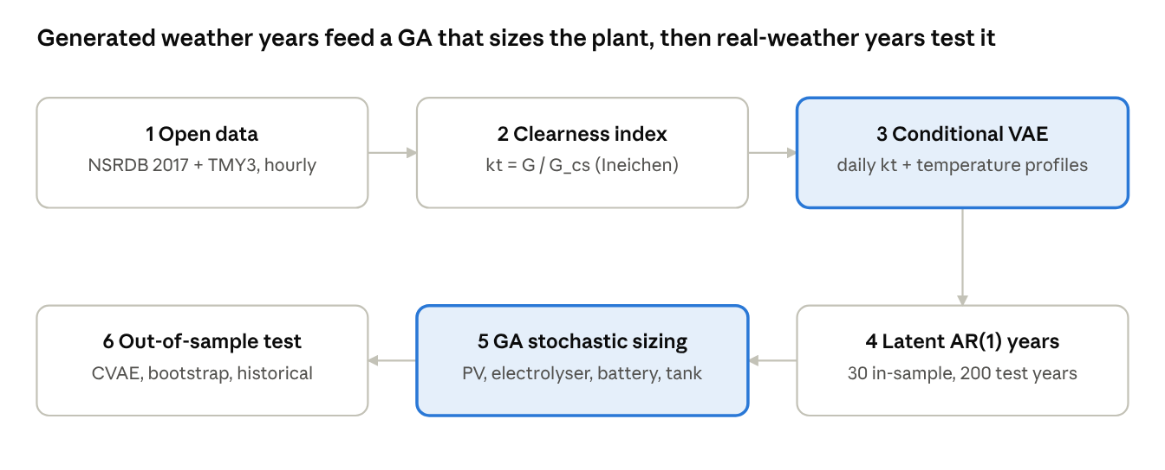
Fig. 1 · end-to-end workflow of the chapter · 6 stages
The generator (stage 3) is trained once for both sites; the GA (stage 5) never sees the weather it is finally judged on (stage 6).

4.1 Open datasets
Two open NREL datasets, mirrored in the pvlib-python repository [17], represent contrasting climates. Both were converted to hourly GHI and air temperature, and saved with the derived variables as a CSV/Excel workbook that accompanies the chapter.
Site | Source | Location | Elevation | Resolution | Annual GHI | Mean air temp.
A – semi-arid high desert | NSRDB PSM3, year 2017 [18] | 40.53° N, 108.54° W (Colorado, USA) | 2 168 m | 30 min → 1 h | 1 749 kWh/m² | 8.1 °C
B – humid subtropical | TMY3 station 723170 [19] | 36.10° N, 79.95° W (Greensboro, NC, USA) | 273 m | 1 h | 1 566 kWh/m² | 14.4 °C
Site A stands for the dry, high-irradiance, cold-winter locations where many hydrogen hubs are planned; site B for humid regions with frequent convective cloud. Every fifth day (73 per site, spread over all seasons) is held out for testing; the remaining 292 days per site (584 in total) train the model.

4.2 Physics-informed representation
Rather than learning raw irradiance, the model learns the hourly clearness index k_t = G / G_cs, where G_cs is the Ineichen clear-sky irradiance [20] computed from the sun position and Linke turbidity. Generated irradiance is recovered as G = k_t · G_cs with k_t clipped to [0, 1.3]. Night hours are therefore exactly zero, the seasonal envelope and day length are exact, and the network only has to learn the weather — the part that is genuinely uncertain. Each training sample is a 48-value vector: 24 hourly k_t values and 24 standardised temperatures (scaled by 0.5 so irradiance dominates the loss).

4.3 Conditional variational autoencoder
The CVAE [4] has an encoder q_φ(z | x, c) and a decoder p_θ(x | z, c). The condition c = [sin(2πd/365), cos(2πd/365), site one-hot] tells both networks the day of year d and the site, so one model serves both climates. The encoder has one hidden layer of 96 tanh units and outputs the mean and log-variance of an 8-dimensional latent z; the decoder has two hidden layers of 96 tanh units. Training minimises the negative evidence lower bound with a Gaussian likelihood (σ² = 0.01) and a KL weight β annealed from 0 to 1 over the first 600 epochs:
\mathcal{L}(\theta,\phi) = \mathbb{E}_{q_\phi(z\mid x,c)}\Bigl[\tfrac{1}{2\sigma^2}\lVert x - \hat x_\theta(z,c)\rVert^2\Bigr] + \beta\, D_{KL}\bigl(q_\phi(z\mid x,c)\,\Vert\,\mathcal{N}(0,I)\bigr)
The network, back-propagation and Adam optimiser [21] are implemented from scratch in NumPy (no deep-learning framework), and the analytic gradients were verified against finite differences (maximum relative error 2.6 × 10⁻⁹). Training uses 3 000 epochs, batch size 64 and learning rate 10⁻³.

4.4 From days to years: latent AR(1) persistence
Sampling each day independently would destroy multi-day weather persistence — the cloudy spells that empty a storage tank. We therefore encode all 365 observed days, estimate the lag-1 autocorrelation ρ of the latent means, and generate a year by an AR(1) chain in latent space, which keeps each z_d marginally standard normal:
z_{d+1} = \rho\, z_d + \sqrt{1-\rho^2}\;\varepsilon_d, \qquad \varepsilon_d \sim \mathcal{N}(0, I)
Decoding z_d with the condition of day d gives one synthetic year of 8 760 hourly values. Thirty such years per site form the in-sample set for optimisation; 200 fresh years form the out-of-sample test set.

4.5 Baselines and scores
The CVAE is compared with (i) a month-wise multivariate Gaussian fitted to the same 48-value vectors, (ii) a seasonal bootstrap that resamples training days within ±15 days of the target date, and (iii) a deterministic climatology. For each held-out day, 100 samples are scored with the energy score (ES) on the 24-h GHI profile, the CRPS of daily insolation [16], and the coverage of the central 90 % interval (PICP90; ideal 0.90).

5 Stochastic Optimisation with a Genetic Algorithm

5.1 Formulations
The decision vector is x = (C_pv, C_el, C_b, C_H): PV capacity (kWp), electrolyser rating (kW), battery energy (kWh) and tank size (kg). It is a two-stage problem: x is fixed before the weather is known, and the hourly dispatch is the recourse decided by the energy management system of Section 3.4. Three formulations are compared:
- Deterministic (D) — minimise LCOH on the single historical year, with reliability ≥ 95 % in that year.
- Risk-neutral stochastic (RN) — minimise the expected LCOH over S = 30 CVAE years.
- Risk-averse stochastic (RA) — minimise an equal blend of expected LCOH and its CVaR at the 90 % level [12], so the worst 10 % of years also count.
Both stochastic formulations carry a chance constraint: at least 90 % of scenarios must reach 95 % on-site supply reliability. It is handled with a penalty, so the GA works on one scalar fitness:
\min_{x \in X} \; F(x) = (1-\lambda)\,\frac{1}{S}\sum_{s=1}^{S} LCOH_s(x) + \lambda\, \mathrm{CVaR}_{0.9}\bigl[LCOH(x)\bigr] + \mu \max\Bigl(0,\; 0.9 - \frac{1}{S}\sum_{s=1}^{S} \mathbb{1}[\rho_s(x) \ge 0.95]\Bigr)
with λ = 0 (RN) or 0.5 (RA), μ = 20 USD/kg, and box bounds X from the search ranges in Section 3.5.

5.2 Genetic algorithm
The plant simulator is non-linear and non-smooth (minimum load, part-load SEC, storage limits, rule-based logic), so a gradient-free GA [10] is used. It extends the operators of a discrete task-assignment GA to real-valued sizing:
- Encoding: a real vector of the four capacities, initialised uniformly within the bounds.
- Selection: tournament of size k = 3.
- Crossover: BLX-α (α = 0.5) with probability 0.9, which can create children slightly outside the parents' range and so keeps exploring.
- Mutation: Gaussian, per gene with probability 0.2 and standard deviation 10 % of the range, clipped to the bounds.
- Elitism: the two best designs pass unchanged.
- Budget: population 40, 60 generations (2 320 fitness evaluations).
Each fitness evaluation simulates every design in the population against every scenario at once: the simulator is vectorised over a (designs × scenarios) array, so one generation runs 40 × 30 × 8 760 ≈ 10.5 million plant-hours in under a second on one CPU core. As a sanity check the GA is compared with pure random search at the same budget over three seeds.

5.3 Out-of-sample evaluation
A design that looks good on its own scenarios may be over-fitted to them. Every design is therefore re-simulated on three sets it never saw: 200 fresh CVAE years, 200 seasonal-bootstrap years built from the observed data, and the historical year itself. The bootstrap set is the referee: it contains only real days, so a design that does well there is not exploiting artefacts of the generator.

6 Case Study Results
On real-weather test years, the GA designs sized on generated scenarios meet the 95 % reliability target far more often than designs sized on one historical year, for an LCOH premium of only 1–2.5 %. All results come from one run of the released code (CVAE training: 29.5 s; each GA run: 20–45 s on one CPU core).

6.1 Quality of the generated scenarios
The CVAE has the lowest mean score at both sites, although Section 7.2 shows these differences are not statistically significant; it is clearly the best calibrated: its 90 % intervals cover 88 % and 86 % of held-out days, against 75 % and 85 % for the bootstrap. The margin over the bootstrap is small on the energy score, which is expected — resampling real days is a strong baseline — but the CVAE can also produce days that never occurred and can be steered by its condition.
Site | Method | Energy score (kW/m²) ↓ | CRPS daily insolation (kWh/m²) ↓ | PICP90 (ideal 0.90)
A semi-arid | CVAE (this work) | 0.315 | 0.684 | 0.88
A semi-arid | Seasonal bootstrap ±15 d | 0.316 | 0.714 | 0.75
A semi-arid | Monthly Gaussian | 0.316 | 0.719 | 0.81
A semi-arid | Climatology (point) | 0.722 | 2.129 | –
B humid | CVAE (this work) | 0.322 | 0.694 | 0.86
B humid | Seasonal bootstrap ±15 d | 0.324 | 0.694 | 0.85
B humid | Monthly Gaussian | 0.330 | 0.716 | 0.85
B humid | Climatology (point) | 0.610 | 1.618 | –
Scored on 73 held-out days per site with 100 samples per day.
At the year level, the latent AR(1) coefficient is ρ = 0.35 (site A) and 0.30 (site B). Synthetic years reproduce the observed annual insolation (A: 1 761 vs 1 749 kWh/m²; B: 1 589 vs 1 566 kWh/m²) with a 5–95 % range of about ±3 %. The longest run of days below half the clear-sky energy averages 3.7 days for site A against 4.0 for bootstrap years, and 4.1 against 3.8 for site B; so at the arid site the generator slightly under-represents long overcast spells. Tilting the array at latitude raises the specific yield of the historical year from 1 435 to 1 587 kWh/kWp (A) and from 1 279 to 1 359 kWh/kWp (B).

6.2 Optimal designs
Site | Formulation | PV (kWp) | Electrolyser (kW) | Battery (kWh) | H₂ tank (kg) | CAPEX (M USD) | Mean LCOH, bootstrap years (USD/kg) | Mean reliability, bootstrap years | Years with reliability ≥ 95 %
A semi-arid | Deterministic | 1 778 | 876 | 86 | 213 | 2.25 | 7.69 | 94.6 % | 32 %
A semi-arid | Risk-neutral | 1 780 | 906 | 73 | 224 | 2.29 | 7.77 | 95.0 % | 49 %
A semi-arid | Risk-averse | 1 813 | 905 | 64 | 187 | 2.29 | 7.77 | 95.0 % | 50 %
B humid | Deterministic | 1 897 | 892 | 90 | 181 | 2.33 | 7.90 | 94.8 % | 42 %
B humid | Risk-neutral | 2 061 | 866 | 59 | 257 | 2.44 | 8.10 | 95.7 % | 78 %
B humid | Risk-averse | 2 121 | 836 | 80 | 241 | 2.44 | 8.11 | 95.6 % | 76 %
All metrics evaluated on 200 seasonal-bootstrap years that the optimiser never saw.
Three patterns stand out. First, the deterministic design meets the target exactly in its own year (95.0 %) but fails it in most real-weather years: it is tuned to one weather sample. Second, the stochastic designs buy robustness mainly with more PV and a larger tank (site B: +164 kWp and +76 kg), lifting the share of compliant years from 42 % to 78 % for a 2.5 % LCOH increase. Third, the risk-averse design is almost identical to the risk-neutral one: the LCOH spread across years is narrow (CVaR₀.₉ exceeds the mean by only 0.2 USD/kg) because shortfalls are covered at a backup price close to the LCOH, so the tail carries little extra cost.
At the arid site the stochastic design reaches the chance constraint on CVAE years (P = 0.90) but only 0.49 on bootstrap years. This gap traces back to the slight under-representation of long overcast spells noted in Section 6.1: a generator that is a little too optimistic in the tail produces a design that is a little too small. At the humid site, where the generator's tail matches the data, CVAE and bootstrap results agree closely (0.81 vs 0.78).
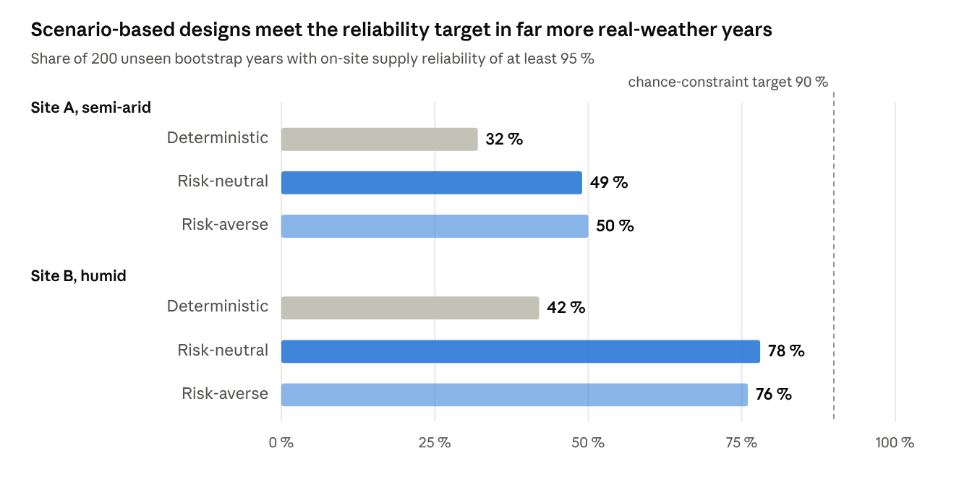
Fig. 2 · results/designs.csv (boot_p_rel95) · 200 bootstrap years per site
No design reaches the 90 % target on real-data years at site A, which points to the generator's tail rather than the optimiser.

6.3 Optimiser performance
With the same budget of 2 320 evaluations, the GA reached 7.63–7.64 USD/kg at site A and 8.07–8.08 USD/kg at site B across three seeds, a spread under 0.2 %. Random search ended at 7.92–8.80 and 8.50–8.96 USD/kg. The GA's elitism and BLX-α crossover concentrate the search near the cost-optimal ridge after about 600 evaluations.
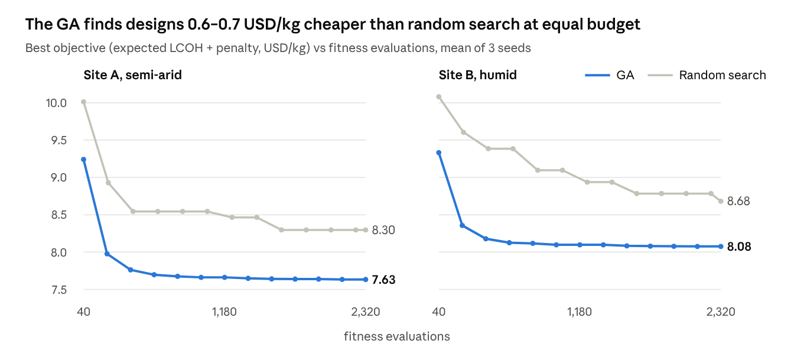
Fig. 3 · results/results.json (convergence) · risk-neutral problem, 3 seeds per method

6.4 Operation and sensitivity
The hourly trace of the risk-neutral design (figure file fig_dispatch.png in the code release) shows the electrolyser following PV to its rating at midday and then dropping to about 220 kW in the afternoon once the tank is full, matching the 4.2 kg/h demand. The tank cycles between about 78 % and 100 % every day and carries the whole night. The battery is almost unused: at 0.5 C, a 73 kWh battery can deliver only 37 kW, below the electrolyser's 91 kW minimum load, so it can never run the electrolyser at night on its own. Storing energy as compressed hydrogen (about 9 USD per kWh of electricity-equivalent at 500 USD/kg) is far cheaper than in batteries (280 USD/kWh), which is why the GA keeps the battery small. Electrolyser capacity factor is 25–27 % and 31–33 % of PV energy is curtailed in every design.
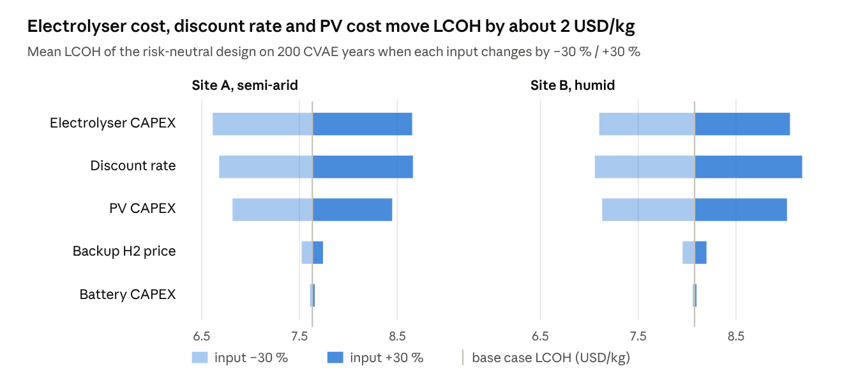
Fig. 4 · results/sensitivity.csv · base LCOH 7.63 (A) and 8.08 (B) USD/kg
The discount rate and the electrolyser and PV capital costs dominate LCOH; battery cost and backup price barely matter at these designs. Site B reacts slightly more strongly than site A to every parameter because it needs more installed capacity per kilogram.

7 Statistical and Deep Analysis
This section asks whether each result in Section 6 survives formal statistical testing, and what drives it. The short answer: the design results are highly significant; the generator's score advantage is not, but its calibration and persistence are.

7.1 Descriptive statistics of the solar resource
The semi-arid site has 12 % more annual insolation but a much harsher season, which is what drives oversizing. Daily insolation is close to symmetric (skewness 0.13 and 0.07) and flat-topped (excess kurtosis −1.08 and −1.11), typical of a bounded variable dominated by the seasonal cycle.
Statistic (daily insolation unless stated) | Site A, semi-arid | Site B, humid
Annual GHI (kWh/m²) | 1 749 | 1 566
Mean ± SD (kWh/m²·day) | 4.79 ± 2.35 | 4.29 ± 1.93
Coefficient of variation | 0.49 | 0.45
Min – max (kWh/m²·day) | 0.52 – 9.34 | 0.69 – 7.95
Skewness / excess kurtosis | 0.13 / −1.08 | 0.07 / −1.11
Mean daily clearness (G/G_cs) | 0.76 | 0.76
Clear days (≥ 0.7) / overcast days (< 0.4) | 242 / 32 | 233 / 32
Lag-1 autocorrelation of deseasonalised daily insolation | 0.28 | 0.25
Air temperature mean (min – max), °C | 8.1 (−27.7 – 34.9) | 14.4 (−16.7 – 35.6)
Correlation of insolation and temperature anomalies | 0.28 | 0.11
Deseasonalisation subtracts a 31-day centred moving average. The positive lag-1 autocorrelation (0.25–0.28) is the statistical signature of multi-day weather persistence that a storage design must survive.
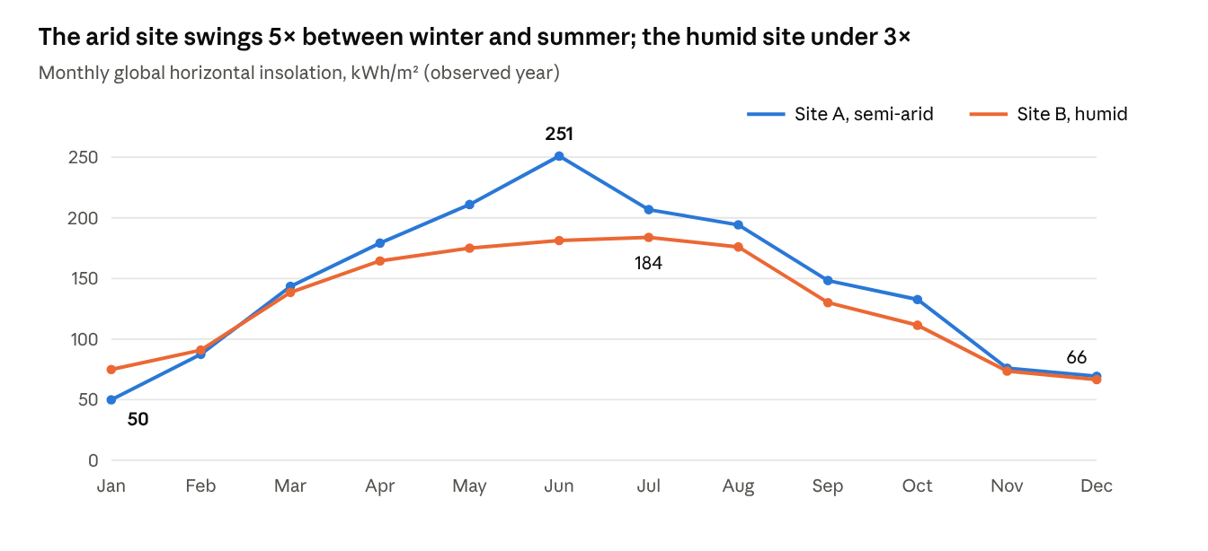
Fig. 5 · results/analysis_monthly.csv · month ≈ 365/12 days
At site A, January delivers only a fifth of June's insolation, so a plant sized for a constant demand must carry large surplus capacity through summer — the root of its 32 % curtailment.

7.2 Hypothesis tests on the scenario generator
The CVAE's lower mean scores in Table 6.1 are not statistically significant, but its calibration is: it is the only method whose probability integral transform (PIT) is consistent with uniformity at both sites.
Paired score differences. For each of the 73 held-out days per site, the per-day score of the CVAE was paired with that of each baseline. The table reports the mean difference (negative favours the CVAE), a 95 % percentile bootstrap interval (5 000 resamples of days), and the two-sided Wilcoxon signed-rank p-value.
Site | Comparison | Score | Mean difference | 95 % bootstrap CI | Wilcoxon p | Days CVAE better
A | CVAE − Gaussian | Energy score | −0.002 | [−0.023, 0.020] | 0.72 | 37 / 73
A | CVAE − Gaussian | CRPS | −0.035 | [−0.111, 0.038] | 0.45 | 38 / 73
A | CVAE − Bootstrap | Energy score | −0.001 | [−0.019, 0.018] | 0.94 | 36 / 73
A | CVAE − Bootstrap | CRPS | −0.030 | [−0.095, 0.035] | 0.60 | 31 / 73
B | CVAE − Gaussian | Energy score | −0.007 | [−0.023, 0.009] | 0.21 | 40 / 73
B | CVAE − Gaussian | CRPS | −0.022 | [−0.077, 0.036] | 0.17 | 43 / 73
B | CVAE − Bootstrap | Energy score | −0.001 | [−0.015, 0.014] | 0.17 | 43 / 73
B | CVAE − Bootstrap | CRPS | 0.000 | [−0.050, 0.055] | 0.33 | 42 / 73
Every interval contains zero, so on point-wise skill the three generators are statistically indistinguishable with 73 test days. This is an honest and useful negative result: a deep generative model does not automatically beat simple resampling on forecast-style scores.
Calibration, distribution and structure. The PIT of observed daily insolation within each 100-member ensemble was binned into quintiles and tested against uniformity with a χ² test (4 degrees of freedom); pooled generated daily insolation was compared with the held-out days by a two-sample Kolmogorov–Smirnov (KS) test and the Wasserstein distance; and the mean absolute error between generated and observed inter-hour correlation matrices of the clearness index (daylight hours) measures how well the diurnal structure is reproduced.
Site | Method | PIT χ² (p) | KS D (p) | Wasserstein (kWh/m²) | Mean ± SD generated vs observed (kWh/m²·day) | Hour-correlation error
A | CVAE | 2.96 (0.56) | 0.078 (0.75) | 0.244 | 4.83 ± 2.32 vs 4.79 ± 2.41 | 0.066
A | Gaussian | 27.5 (< 0.001) | 0.090 (0.58) | 0.301 | 4.77 ± 2.30 | 0.109
A | Bootstrap | 10.4 (0.035) | 0.075 (0.79) | 0.263 | 4.76 ± 2.31 | 0.074
B | CVAE | 0.90 (0.92) | 0.079 (0.73) | 0.163 | 4.37 ± 1.93 vs 4.23 ± 1.85 | 0.107
B | Gaussian | 10.6 (0.031) | 0.069 (0.86) | 0.174 | 4.26 ± 1.84 | 0.102
B | Bootstrap | 5.97 (0.20) | 0.070 (0.85) | 0.126 | 4.31 ± 1.94 | 0.083
Three findings follow. (i) The Gaussian model is mis-calibrated at both sites (PIT p < 0.05) and the bootstrap at site A (p = 0.035); the CVAE passes comfortably at both (p = 0.56, 0.92), so its 90 % intervals can be trusted as stated. (ii) No KS test rejects (all p > 0.5): all three reproduce the marginal distribution of daily energy. (iii) The CVAE best reproduces the hour-to-hour correlation at the arid site (error 0.066), where cloud structure is simple, but not at the humid site (0.107 vs 0.083 for the bootstrap), where convective clouds create more complex intraday patterns. At site B the CVAE also over-estimates mean daily insolation by 3.4 % (4.37 vs 4.23 kWh/m²), a bias that makes its designs slightly optimistic.

7.3 Persistence and extreme-spell statistics of synthetic years
The latent AR(1) process gives CVAE years the observed day-to-day persistence; bootstrap years have none. That is the CVAE's decisive advantage for storage studies — and the bootstrap's hidden weakness as a referee.
For each of 200 synthetic years per method, the lag-1 autocorrelation of deseasonalised daily insolation, the annual total, and the worst 3-day mean insolation (the deepest short dark spell) were computed.
Statistic | Site A observed | Site A CVAE years | Site A bootstrap years | Site B observed | Site B CVAE years | Site B bootstrap years
Lag-1 autocorrelation, mean [5 %, 95 %] | 0.28 | 0.29 [0.19, 0.37] | −0.03 [−0.14, 0.07] | 0.25 | 0.25 [0.15, 0.34] | −0.02 [−0.12, 0.08]
Annual insolation, mean ± SD (kWh/m²) | 1 749 | 1 761 ± 33 | 1 735 ± 21 | 1 566 | 1 589 ± 27 | 1 554 ± 24
Worst 3-day mean, mean (5 % quantile), kWh/m²·day | 0.92 | 1.05 (0.68) | 0.98 (0.77) | 0.89 | 1.00 (0.66) | 1.12 (0.87)
The distributions of lag-1 autocorrelation from the two methods differ decisively (two-sample KS p < 10⁻¹⁰ at both sites), and only the CVAE's interval contains the observed value. Resampling days independently destroys persistence by construction, so bootstrap years under-state multi-day dark spells; the CVAE's 5 % worst-spell quantile (0.68 and 0.66 kWh/m²·day) is accordingly deeper than the bootstrap's (0.77 and 0.87).
Two cautions refine Section 6.2. First, at site A the CVAE's typical worst spell (mean 1.05) is milder than the observed year's (0.92): its daily lower tail is slightly too light, even though its persistence is right. This, together with the bootstrap's sampling of real low days, explains why designs pass more often on CVAE years than on bootstrap years at site A. Second, because bootstrap years lack persistence, the bootstrap referee is itself optimistic about consecutive bad days; the true compliance of every design is therefore likely somewhat below the bootstrap figures. A combined generator — CVAE persistence with an empirically calibrated lower tail — is the natural next step.

7.4 Monte Carlo confidence intervals and paired tests for the designs
The reliability gain of the stochastic designs is overwhelmingly significant: in paired comparisons over the same 200 real-weather years, no year favours the deterministic design. The LCOH premium is also significant, but small.
Each design was simulated on the same 200 bootstrap years, so comparisons are paired. The table gives the mean LCOH with a 95 % t-interval, the year-to-year standard deviation and 5–95 % range, and the share of compliant years (reliability ≥ 95 %) with a 95 % Wilson score interval.
Site | Design | Mean LCOH [95 % CI] (USD/kg) | SD across years | LCOH 5–95 % | Mean reliability ± SD | Worst-year reliability | Compliant years [95 % Wilson CI]
A | Deterministic | 7.687 [7.676, 7.699] | 0.079 | 7.56–7.81 | 94.6 ± 0.8 % | 92.4 % | 32 % [26, 39]
A | Risk-neutral | 7.767 [7.756, 7.778] | 0.081 | 7.64–7.89 | 95.0 ± 0.8 % | 92.7 % | 49 % [42, 55]
A | Risk-averse | 7.765 [7.754, 7.776] | 0.079 | 7.65–7.89 | 95.0 ± 0.8 % | 92.7 % | 50 % [43, 57]
B | Deterministic | 7.902 [7.888, 7.915] | 0.098 | 7.74–8.07 | 94.8 ± 1.0 % | 92.0 % | 42 % [35, 49]
B | Risk-neutral | 8.099 [8.086, 8.112] | 0.092 | 7.95–8.25 | 95.7 ± 0.9 % | 93.0 % | 78 % [71, 83]
B | Risk-averse | 8.111 [8.098, 8.123] | 0.089 | 7.96–8.26 | 95.6 ± 0.9 % | 93.1 % | 76 % [70, 81]
The non-overlapping Wilson intervals already separate deterministic from stochastic designs. Paired tests make it exact:
Site | Stochastic vs deterministic | Δ LCOH (USD/kg, %) | Wilcoxon p (LCOH) | Δ reliability (pp) | Cohen's d (reliability) | Years only stochastic compliant / only deterministic compliant | McNemar exact p
A | Risk-neutral | +0.080 (+1.0 %) | < 10⁻³⁰ | +0.36 | 6.4 | 33 / 0 | 2.3 × 10⁻¹⁰
A | Risk-averse | +0.077 (+1.0 %) | < 10⁻³⁰ | +0.40 | 5.3 | 36 / 0 | 2.9 × 10⁻¹¹
B | Risk-neutral | +0.197 (+2.5 %) | < 10⁻³⁰ | +0.91 | 6.6 | 71 / 0 | 8.5 × 10⁻²²
B | Risk-averse | +0.209 (+2.6 %) | < 10⁻³⁰ | +0.83 | 5.3 | 68 / 0 | 6.8 × 10⁻²¹
The stochastic design dominates the deterministic one year by year: no year is compliant under the deterministic design alone, so the discordant counts are one-sided, and the paired reliability gains are large relative to their spread (Cohen's d > 5). The LCOH premium is equally systematic — it is positive in all 200 years, which is why the Wilcoxon p-value reaches its floor (1.4 × 10⁻³⁴). The cost of this dominance is a near-deterministic shift of 1–2.6 % in LCOH, with a year-to-year LCOH spread (SD 0.08–0.10 USD/kg) that is similar for all designs. Note that the confidence intervals describe Monte Carlo sampling of weather; they do not include model or cost uncertainty, which Section 7.6 treats.
At 200 years, the 95 % Wilson half-width on compliance is about ±7 percentage points, so differences of a few points between risk-neutral and risk-averse designs (49 vs 50 %, 78 vs 76 %) are not meaningful — confirming statistically that CVaR adds nothing here.

7.5 Seasonal shortfall analysis
November to February account for 97–99 % of all unmet hydrogen at both sites, and an annual reliability target hides a severe mid-winter deficit.
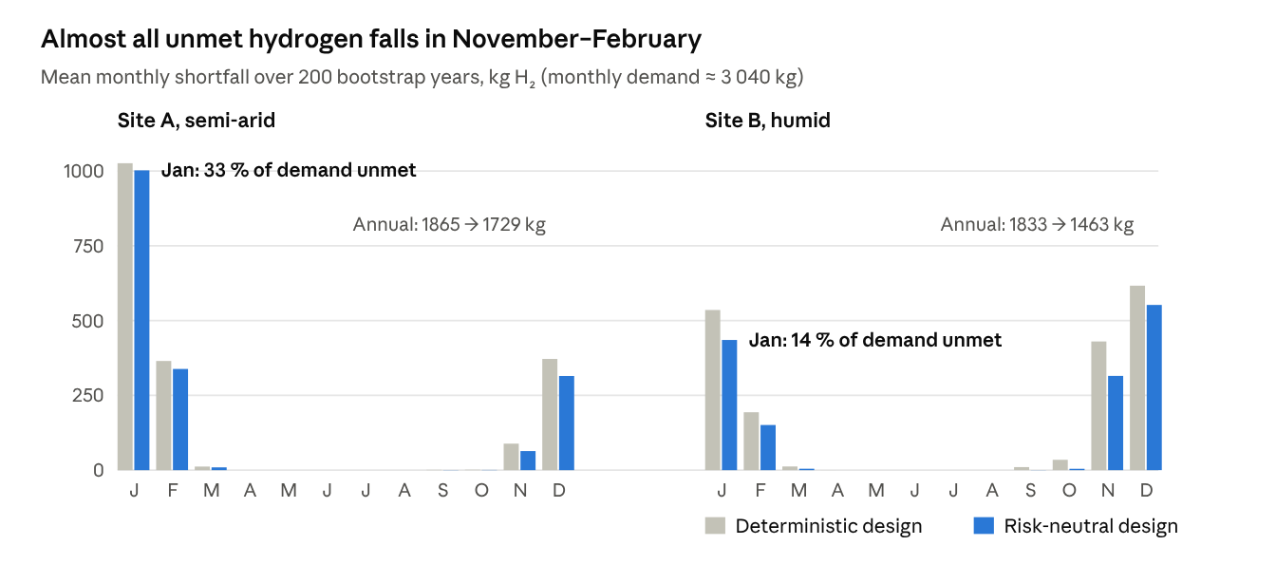
Fig. 6 · results/analysis_monthly_shortfall.csv · 200 bootstrap years
The risk-neutral designs reduce shortfall most in the shoulder months (site B: November −27 %, October −87 %) but barely touch January, when the day is short and the sun low. Even the stochastic design at site A leaves about a third of January demand to backup supply. Three design implications follow: (i) an annual reliability metric can mislead — a monthly or seasonal constraint would expose the January gap; (ii) meeting winter demand on site would need seasonal hydrogen storage (salt caverns, pipelines or lined rock caverns) rather than more daily tank capacity, because the tank is full every summer afternoon (Section 6.4); (iii) for small off-grid plants, a contracted winter backup supply is a legitimate, cheaper design element. The monthly sums are slightly below the annual shortfall in Table 7.4 because the end-of-year tank refill is not assigned to a month.

7.6 Global sensitivity and variance decomposition
Cost assumptions, not weather, dominate the uncertainty in LCOH: across plausible cost ranges LCOH spans about 3 USD/kg, while year-to-year weather moves it by less than 0.1 USD/kg.
The one-at-a-time analysis of Section 6.4 was extended to a global analysis. Seven inputs were sampled jointly by Latin hypercube (2 000 samples): capital costs of PV, electrolyser, battery and tank, the discount rate and the backup price (each ±30 %), and the water price (×0.5–×2). For each sample the risk-neutral design was costed on all 200 bootstrap years, giving a 2 000 × 200 matrix of LCOH. Standardised regression coefficients (SRC) of mean LCOH on the inputs explain 99.5 % of its variance (R² = 0.995 and 0.994), so the linear sensitivity measures are reliable; Spearman rank correlations give the same ranking.
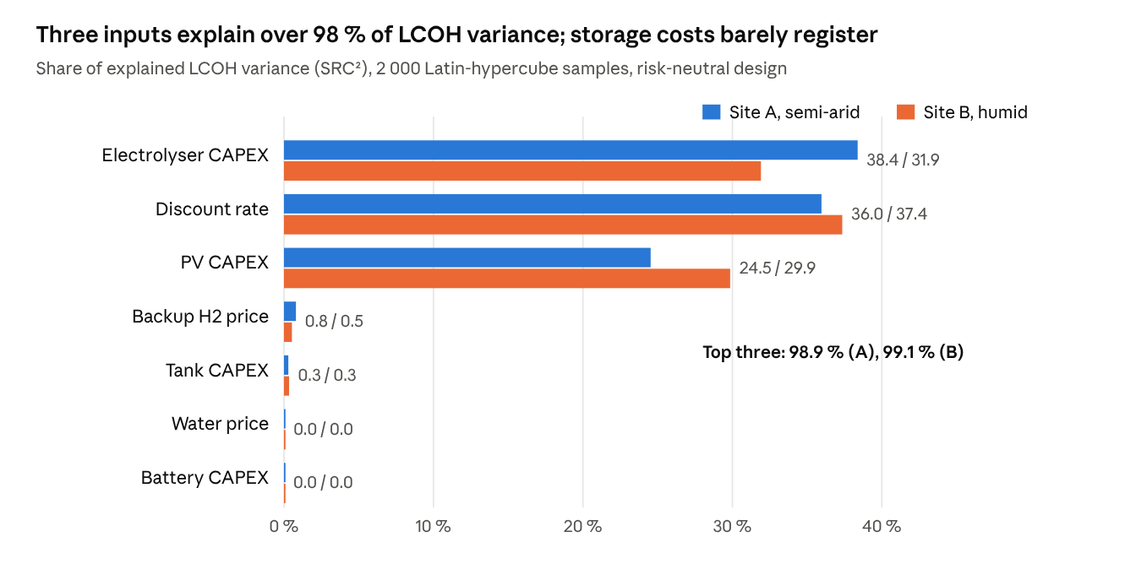
Fig. 8 · results/analysis_gsa.csv · regression R² = 0.995 (A), 0.994 (B)
Electrolyser capital cost, discount rate and PV capital cost together account for 98.9 % (A) and 99.1 % (B) of the explained variance, almost equally. Battery, tank and water costs are negligible (< 0.4 % each) — doubling the water price changes nothing, even at the arid site, which reframes the water–energy–hydrogen debate: for PEM electrolysis water availability is a permitting and sourcing issue, not a cost driver.
Weather versus economic uncertainty. By the law of total variance, Var(LCOH) = E_econ[Var_weather] + Var_econ[E_weather].
Site | LCOH 5 % – 50 % – 95 % (USD/kg) | Share of variance from weather (between years) | Share from economic inputs
A, semi-arid | 6.34 – 7.74 – 9.43 | 0.8 % | 99.2 %
B, humid | 6.60 – 8.07 – 9.84 | 0.9 % | 99.1 %
For a fixed design, weather moves the cost very little; its effect falls almost entirely on reliability, which the backup purchase absorbs. Two practical consequences follow. First, the purpose of weather scenarios in hydrogen planning is to size for reliability, not to forecast cost. Second, policy levers that cut the cost of capital (green-finance instruments, de-risking guarantees) are as powerful as a 30 % fall in electrolyser prices.

7.7 Cost–reliability trade-off
The GA was re-run for reliability targets of 80, 90, 95, 97 and 99 % (chance level 0.9) to trace the price of reliability.
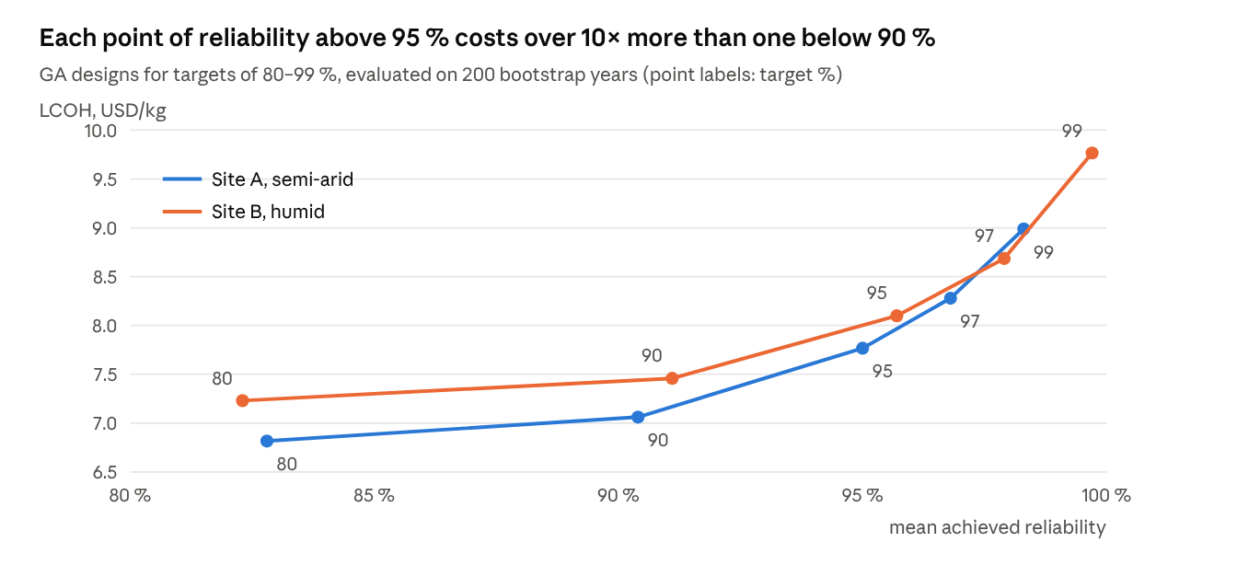
Fig. 7 · results/analysis_tradeoff.csv · risk-neutral GA, chance level 0.9
Raising the target from 80 to 90 % costs about 0.24 USD/kg at both sites (0.025 USD/kg per percentage point); going from 95 to 99 % costs 1.22 (site A) and 1.67 USD/kg (site B), roughly 0.3–0.4 USD/kg per point — more than ten times steeper. The marginal kilogram near 100 % reliability is a mid-winter kilogram, and the GA buys it with storage that sits idle most of the year: the tank grows from 88–89 kg at 80 % to 685 kg (A) and 1 110 kg (B) at 99 %, while PV grows only 1.7-fold.
Target | Site A: PV / EL / battery / tank | Site A: LCOH (USD/kg), compliant years | Site B: PV / EL / battery / tank | Site B: LCOH (USD/kg), compliant years
80 % | 1 266 kWp / 652 kW / 38 kWh / 88 kg | 6.82, 100 % | 1 467 / 655 / 25 / 89 | 7.23, 99 %
90 % | 1 531 / 760 / 55 / 137 | 7.06, 66 % | 1 799 / 764 / 14 / 140 | 7.46, 90 %
95 % | 1 780 / 906 / 73 / 224 | 7.77, 49 % | 2 061 / 866 / 59 / 257 | 8.10, 78 %
97 % | 2 038 / 944 / 37 / 292 | 8.28, 41 % | 2 336 / 921 / 49 / 321 | 8.69, 86 %
99 % | 2 113 / 979 / 95 / 685 | 8.99, 14 % | 2 366 / 940 / 131 / 1 110 | 9.77, 91 %
Compliance is measured on bootstrap years against each design's own target. At site B every design reaches 78–99 % compliance, near the 90 % chance level it was built for. At site A compliance falls steadily as the target tightens (100 % → 14 %): the stricter the target, the more the design depends on the lower tail of winter weather — exactly where the CVAE is too mild at site A (Section 7.3). The trade-off curve thus doubles as a diagnostic of generator quality: when out-of-sample compliance collapses at high targets, the generator's tail needs attention before the design can be trusted.

7.8 Robustness of the GA and scenario-count convergence
The GA returns the same cost to within 0.04 % across seeds, and 30 scenarios estimate expected LCOH precisely; the weak point is the chance constraint, whose estimate from 30 scenarios carries a standard error of 5–7 percentage points.
Seed robustness. The risk-neutral problem was solved with five further random seeds per site (population 40, 60 generations each).
Site | Objective (USD/kg), mean ± SD | PV (kWp) mean ± SD (CV) | Electrolyser (kW) | Battery (kWh) | Tank (kg)
A | 7.630 ± 0.003 | 1 820 ± 36 (2.0 %) | 888 ± 10 (1.2 %) | 81 ± 32 (40 %) | 209 ± 8 (3.6 %)
B | 8.071 ± 0.002 | 2 095 ± 28 (1.3 %) | 855 ± 12 (1.5 %) | 66 ± 18 (27 %) | 229 ± 14 (5.9 %)
PV, electrolyser and tank sizes are reproducible to within 1–6 %. The battery varies by 27–40 % between seeds while the objective does not move, which shows a flat direction in the cost landscape: within 30–110 kWh the battery hardly matters (Section 6.4). Reporting such flat directions matters for practice — the battery size here is a free engineering choice, not an optimisation result.
Scenario count (sample-average approximation). Subsets of S CVAE years were drawn 1 000 times from the 200-year set, and the standard error (SE) of the two quantities the optimiser estimates was measured for the risk-neutral design.
Scenarios S | SE of mean LCOH, site A / B (USD/kg) | SE of compliance share, site A / B (percentage points)
5 | 0.050 / 0.045 | 13.4 / 17.8
10 | 0.035 / 0.032 | 9.2 / 12.6
20 | 0.024 / 0.022 | 6.6 / 8.7
30 (used) | 0.018 / 0.017 | 5.1 / 6.9
50 | 0.013 / 0.012 | 3.8 / 4.8
100 | 0.008 / 0.007 | 2.2 / 2.8
Both errors fall as 1/√S, as theory predicts. With 30 scenarios, the expected LCOH is known to ±0.2 %, far finer than any cost difference that matters. The compliance share, however, is uncertain by about ±6 points, so a design can satisfy "90 % of scenarios" in-sample by luck. This sampling noise, together with the generator's tail bias, explains why in-sample compliance (0.90) did not carry over to bootstrap years at site A. Practical guidance: use at least 100 scenarios when a chance constraint is binding, or add a safety margin of two standard errors to the chance level.

8 Discussion: Operational Trends and Technical Challenges
The central lesson is that a design is only as robust as the weather it is optimised against — and that a generative model is useful exactly to the extent that its tails are right.
Design to a distribution, not a year. A single historical year produced a plant that met its reliability target in only 32–42 % of real-weather years. Scenario-based design raised this to 49–78 % for a 1–2.5 % cost premium. For project developers and lenders, who care about the bad years, this is a cheap insurance policy. The same workflow can serve as a stress test: generate a thousand years, rank them, and hand the worst to the engineers.
Validate the generator against real data, in the units that matter. The CVAE tied the baselines on forecast scores and beat them on calibration and persistence, yet at the arid site its daily lower tail was slightly too mild, and the design inherited that optimism (Sections 7.3 and 7.7). Generic scores (energy score, CRPS) are necessary but not sufficient; a generator for storage sizing must also be checked on persistence statistics such as run lengths of low-irradiance days. A practical safeguard, used here, is to referee every design on bootstrap years built from real days.
Hydrogen storage, not batteries, buffers a constant off-take. The GA consistently chose small batteries and tanks of 190–260 kg. A battery's power rating must exceed the electrolyser's minimum load before it can run it overnight; below that, it only smooths start-ups. This interaction between minimum load and storage power is easy to miss in linear models that ignore minimum load, and it is captured naturally by a simulation-based GA.
Arid versus humid deployment. The semi-arid site gives 17 % more specific PV yield and a 0.3 USD/kg lower LCOH even with water priced twice as high, because water is a small cost item (15 L/kg). In real desert hubs, other harsh-environment factors — dust soiling, high cell temperatures, sand ingress into electrolyser balance-of-plant, and water sourcing from desalination — would need explicit modelling; the open-data workflow here is designed to be extended with such terms.
Trustworthy and responsible AI. A generative model in an engineering decision loop must be transparent and auditable. The design choices here support that: a physics-informed output space (clearness index on a clear-sky envelope), a small network written without a deep-learning framework, verified gradients, explicit baselines, out-of-sample tests on real data, and fully open data and code. Training took 30 s on one CPU core, so the computational footprint is negligible next to the infrastructure it informs.
Limitations. (i) Only one year of data per site was available offline; with multi-decade NSRDB or reanalysis data the generator could learn inter-annual variability directly. (ii) Day-to-day persistence uses a single AR(1) coefficient; regime-switching or sequence models (transformers, diffusion over weeks) would capture long spells better. (iii) The electrolyser model is static: degradation, stack replacement, ramp limits and cold-start losses are omitted. (iv) Cost data are indicative, and the demand is constant. (v) The GA uses a penalty for the chance constraint; multi-objective GAs such as NSGA-II [11] would expose the full cost–reliability trade-off.
Future directions. Promising next steps include conditioning the generator on climate-model projections for climate-aware design; replacing the hour-by-hour simulator with a neural-operator surrogate [24] to speed up large GA searches; degradation-aware model-predictive control for operation; and large language model agents that query the generator and optimiser to answer planners' "what if" questions in plain language.

9 Conclusion
This chapter linked a physics-informed conditional VAE to genetic-algorithm sizing of an off-grid solar hydrogen plant, using open NREL data for a semi-arid and a humid site. The CVAE, written from scratch in NumPy and trained in 30 s, was statistically indistinguishable from Gaussian and bootstrap baselines on forecast scores, but it was the only generator with calibrated intervals at both sites (PIT χ² p = 0.56 and 0.92) and the only one to reproduce observed day-to-day persistence (lag-1 autocorrelation 0.29 vs 0.28). Designs optimised on generated weather years kept 95 % supply reliability in 49–78 % of unseen real-weather years, against 32–42 % for designs sized on one historical year, at an LCOH cost of 1–2.5 % (7.8–8.1 USD/kg at 100 kg/day). The GA outperformed random search by 0.3–0.9 USD/kg at equal budget, and showed that compressed-hydrogen storage, not batteries, should buffer a constant off-take. The statistical analysis adds four lessons: the reliability gain of stochastic design is overwhelmingly significant (McNemar p < 10⁻⁹, no year favouring the deterministic design); 97–99 % of shortfall falls in November–February, so annual reliability targets hide a mid-winter gap; electrolyser cost, discount rate and PV cost explain 99 % of LCOH variance while weather explains under 1 %; and 30 scenarios estimate cost to ±0.2 % but a chance constraint only to ±6 points, so at least 100 scenarios are advisable when reliability is binding. The main caution is that a generator's tail behaviour flows straight into the design, so generators for storage sizing should be validated on persistence and extreme-spell statistics against real data. Code and data accompany the chapter so that every number can be reproduced.
Code and data availability. All code, the processed datasets (CSV and Excel) and the result files are in the Book-Chapter-Green-Hydrogen folder of the authors' repository.

References
References are given from the authors' knowledge (no live database lookup was possible); check every entry and convert to Springer style before submission.
- IRENA (2020) Green hydrogen cost reduction: Scaling up electrolysers to meet the 1.5 °C climate goal. International Renewable Energy Agency, Abu Dhabi.
- IEA (2019) The future of hydrogen: Seizing today's opportunities. International Energy Agency, Paris.
- Birge JR, Louveaux F (2011) Introduction to stochastic programming, 2nd edn. Springer, New York.
- Kingma DP, Welling M (2014) Auto-encoding variational Bayes. In: Proc. 2nd International Conference on Learning Representations (ICLR).
- Goodfellow I, Pouget-Abadie J, Mirza M, Xu B, Warde-Farley D, Ozair S, Courville A, Bengio Y (2014) Generative adversarial nets. Advances in Neural Information Processing Systems 27.
- Chen Y, Wang Y, Kirschen D, Zhang B (2018) Model-free renewable scenario generation using generative adversarial networks. IEEE Transactions on Power Systems 33(3):3265–3275.
- Buttler A, Spliethoff H (2018) Current status of water electrolysis for energy storage, grid balancing and sector coupling via power-to-gas and power-to-liquids: A review. Renewable and Sustainable Energy Reviews 82:2440–2454.
- Shiva Kumar S, Himabindu V (2019) Hydrogen production by PEM water electrolysis – A review. Materials Science for Energy Technologies 2(3):442–454.
- IEA (2024) Global hydrogen review 2024. International Energy Agency, Paris.
- Goldberg DE (1989) Genetic algorithms in search, optimization and machine learning. Addison-Wesley, Reading, MA.
- Deb K, Pratap A, Agarwal S, Meyarivan T (2002) A fast and elitist multiobjective genetic algorithm: NSGA-II. IEEE Transactions on Evolutionary Computation 6(2):182–197.
- Rockafellar RT, Uryasev S (2000) Optimization of conditional value-at-risk. Journal of Risk 2(3):21–41.
- Dupačová J, Gröwe-Kuska N, Römisch W (2003) Scenario reduction in stochastic programming: An approach using probability metrics. Mathematical Programming 95(3):493–511.
- Ho J, Jain A, Abbeel P (2020) Denoising diffusion probabilistic models. Advances in Neural Information Processing Systems 33.
- Raissi M, Perdikaris P, Karniadakis GE (2019) Physics-informed neural networks: A deep learning framework for solving forward and inverse problems involving nonlinear partial differential equations. Journal of Computational Physics 378:686–707.
- Gneiting T, Raftery AE (2007) Strictly proper scoring rules, prediction, and estimation. Journal of the American Statistical Association 102(477):359–378.
- Holmgren WF, Hansen CW, Mikofski MA (2018) pvlib python: A python package for modeling solar energy systems. Journal of Open Source Software 3(29):884.
- Sengupta M, Xie Y, Lopez A, Habte A, Maclaurin G, Shelby J (2018) The National Solar Radiation Data Base (NSRDB). Renewable and Sustainable Energy Reviews 89:51–60.
- Wilcox S, Marion W (2008) Users manual for TMY3 data sets. Technical Report NREL/TP-581-43156, National Renewable Energy Laboratory, Golden, CO.
- Ineichen P, Perez R (2002) A new airmass independent formulation for the Linke turbidity coefficient. Solar Energy 73(3):151–157.
- Kingma DP, Ba J (2015) Adam: A method for stochastic optimization. In: Proc. 3rd International Conference on Learning Representations (ICLR).
- Erbs DG, Klein SA, Duffie JA (1982) Estimation of the diffuse radiation fraction for hourly, daily and monthly-average global radiation. Solar Energy 28(4):293–302.
- Ulleberg Ø (2003) Modeling of advanced alkaline electrolyzers: A system simulation approach. International Journal of Hydrogen Energy 28(1):21–33.
- Li Z, Kovachki N, Azizzadenesheli K, Liu B, Bhattacharya K, Stuart A, Anandkumar A (2021) Fourier neural operator for parametric partial differential equations. In: Proc. 9th International Conference on Learning Representations (ICLR).

