Hypergraph Neural Network for Symptom-Based Differential Diagnosis using Disease-Symptom Co-occurrence Patterns

Abstract
Symptom-based differential diagnosis maps a set of co-occurring symptoms to a ranked list of likely diseases. Previous work on public symptom-checker data has relied on flat classifiers or pairwise graph neural networks, and has almost always been evaluated with random train/test splits. We propose HyperDiag, a hypergraph attention network in which every disease is a hyperedge over its symptoms, auxiliary hyperedges encode recurring symptom clusters, and a dual-level (node and hyperedge) attention mechanism is complemented by disease-hyperedge prototype scoring and query-adaptive hyperedge-likelihood evidence. Before modelling, we audit the Kaggle Diseases-and-Symptoms dataset (246,945 cases, 773 diseases, 377 symptoms) and find that 57,298 rows (23.2%) are exact duplicates and that 12,634 symptom patterns map to more than one disease. A conventional random split therefore places 43.9% of test cases in the training set, and no classifier can exceed a top-1 accuracy of 89.6% on the de-duplicated data. We introduce a leakage-free, symptom-pattern-grouped protocol and benchmark eight models on it. HyperDiag reaches 84.59% top-1, 97.83% top-5 accuracy and an MRR of 90.36%. It significantly outperforms Naive Bayes, Random Forest and Logistic Regression (McNemar p < 0.02) and is statistically on par with the strongest neural baselines (MLP, GCN, GAT, HGNN), while its symptom attention passes a deletion-based faithfulness test. The results show that, on this dataset, honest evaluation matters more than architecture. They also show where hypergraph structure helps (interpretability, consistency) and where it does not (raw accuracy near the Bayes ceiling).

CHAPTER 1

INTRODUCTION
In modern healthcare, arriving at an accurate diagnosis from a patient's reported symptoms is one of the most fundamental and challenging tasks. When a patient describes what they are experiencing, for example fever, cough, and sore throat a clinician does not immediately settle on a single disease. Instead, the clinician forms a shortlist of the most likely possibilities and reasons among them. This process of proposing and ranking several candidate diseases for a given set of symptoms is known as differential diagnosis, and it lies at the heart of safe and effective medical decision-making.
With the rapid growth of digital health platforms and online symptom checkers, there is increasing interest in building intelligent systems that can support this reasoning process. Such systems take a set of symptoms as input and return a ranked list of probable diseases. Publicly available datasets, such as the Kaggle Disease-Symptom dataset used in this work, have made it possible for researchers to train and evaluate these systems. This dataset records 246,945 patient cases spanning 773 unique diseases and 377 distinct symptoms; each case lists the symptoms that are present and the associated disease.
Most existing work on this and similar datasets has relied on traditional machine learning algorithms such as Random Forest, Support Vector Machines, and simple neural networks, or more recently on pairwise graph neural networks. While these methods can achieve reasonable performance, they share a common limitation: they treat relationships between symptoms and diseases as isolated or two-way connections. A disease manifests through an entire group of symptoms that appear together as a set. For instance, influenza is characterized by the simultaneous presence of fever, cough, sore throat, and body ache not merely by pairs of these symptoms considered independently.
This observation motivates the use of hypergraph. In an ordinary graph, an edge links exactly two nodes. In hypergraph, however, a single connection, called hyperedge, can link many nodes at once (Feng et al., 2019). This makes hypergraph a naturally suitable structure for modeling diseases, because a disease can be represented as one hyperedge that connects all of its associated symptoms simultaneously. To the best of our knowledge, hypergraph neural networks have not previously been applied to symptom-checker-style differential diagnosis data, which forms the central novelty of this research.
In this paper we propose HyperDiag, a Hypergraph Attention Network for symptom-set-aware differential disease diagnosis. HyperDiag represents each disease as a hyperedge over its symptoms, constructs additional co-occurrence hyperedges for symptoms that frequently appear together, and employs a dual-level attention mechanism that learns both which symptoms are most informative and which disease patterns are most relevant to a query. Given a partial or complete set of symptoms, the model predicts the top-k most likely diseases, closely mirroring the real clinical practice of differential diagnosis.

1.1 Background and Motivation
Diagnosis from symptoms is inherently uncertain because many diseases share overlapping symptoms, and the same symptom can point to very different conditions depending on what accompanies it. A skilled clinician resolves this ambiguity by considering the whole constellation of symptoms together and weighing which combinations are most characteristic of which diseases. Any automated system that hopes to assist in this task must therefore be able to reason for symptoms as interacting sets rather than as independent features.
Graph-based learning has emerged as a powerful paradigm for capturing relationships between entities, and graph neural networks have been applied successfully across medical imaging, electronic health records, and biological networks. Yet the standard graph formulation restricts each edge to a pair of nodes, which forces higher-order symptom relationships to be broken down into many pairwise links. This decomposition loses the very information that makes a symptom set diagnostic the fact that a specific group of symptoms occurs together. Hypergraphs overcome this restriction directly, and hypergraph neural networks extend the message-passing framework so that information can flow across entire hyperedges.
Despite the natural fit between hypergraph and set-based symptom data, existing medical hypergraph research has concentrated almost exclusively on brain-imaging and electronic health record applications. The application of hypergraph attention to publicly available symptom-diagnosis datasets remains unexplored. This gap, combined with the strong structural match between hyperedges and disease-symptom sets, provides the primary motivation for the present study.

1.2 Problem Statement
The key challenges that motivate this research can be summarized as follows:
a) Higher-Order Symptom Relationships: A disease is defined by a set of co-occurring symptoms, but conventional models represent these relationships only as isolated features or pairwise links, losing crucial set-level information.
b) Limitations of Traditional Machine Learning: Classifiers such as Random Forest and Support Vector Machines treat each symptom as an independent input and cannot explicitly model the structural relationships among symptoms and diseases.
c) Inadequacy of Pairwise Graph Models: Standard graph neural networks connect only two nodes per edge and therefore cannot represent a disease as a single unit that binds all of its symptoms together.
d) Large and Imbalanced Label Space: With 773 distinct diseases, many of which appear infrequently, the classification task is highly imbalanced, making accurate prediction of rare diseases difficult.
e) Partial Symptom Information: In realistic settings a patient may report only some of the relevant symptoms, so the model must produce sensible rankings even from incomplete symptom sets.
f) Need for Differential, Not Single, Prediction: Real clinical reasoning produces a ranked shortlist of candidate diseases rather than a single answer, which most existing classification setups do not directly address.
g) Lack of Interpretability: Many high-performing models act as black boxes, whereas clinical trust requires knowing which symptoms drove a particular diagnosis.
h) Unreliable Evaluation: The public dataset contains many duplicate records and identical symptom patterns with different diagnoses. Random splits leak these into the test set and inflate reported accuracy, so models cannot be compared fairly.

1.3 Research Gaps
a) Absence of Hypergraph Methods on Symptom Data: Although hypergraph neural networks exist, they have not been applied to publicly available symptom-checker datasets, leaving their potential for differential diagnosis unexamined.
b) Over-Reliance on Traditional Classifiers: Most of the prior work on disease-symptom datasets uses conventional machine learning that ignores the relational structure of symptoms.
c) Limited Use of Set-Based Co-occurrence: Symptom co-occurrence patterns, which are highly informative for diagnosis, are rarely modeled explicitly as structural elements of a learning model.
d) Weak Handling of Class Imbalance: Existing studies seldom address the severe imbalance introduced by hundreds of diseases, which harms performance on rare conditions.
e) Little Attention to Differential Ranking: Most models are evaluated as single-label classifiers rather than on their ability to produce a clinically meaningful ranked shortlist.
f) Insufficient Interpretability: Prior approaches rarely provide symptom-level explanations that clinicians can inspect and trust.
g) No Leakage-Free Benchmark or Performance Ceiling: Prior studies neither control for duplicate symptom patterns across splits nor report the Bayes-optimal accuracy that the label noise of the dataset permits.

1.4 Objective
The primary objectives of this research are outlined below:
- To design a hypergraph representation of disease-symptom data in which each disease is modeled as a hyperedge connecting all its associated symptoms.
- To construct auxiliary co-occurrence hyperedges that capture groups of symptoms which frequently appear together.
- To develop HyperDiag, a hypergraph attention network with dual-level attention operating at both the node and hyperedge levels.
- To formulate the task as differential diagnosis, predicting the top-k most likely diseases from a given symptom set.
- To benchmark HyperDiag against Multi-Layer Perceptron, Graph Convolutional Network, and Graph Attention Network baselines.
- To evaluate the model using top-k accuracy, Mean Reciprocal Rank, and macro F1-score, accounting for the large and imbalanced label space.
- To provide interpretable attention visualizations that reveal which symptoms contributed to each predicted diagnosis.
- To audit the dataset, quantify train/test leakage under common protocols, derive the Bayes-optimal top-k ceiling, and establish a leakage-free benchmark.

1.5 Research Questions
This research is guided by the following questions, which we address throughout the experimental phase:
- How does a hypergraph attention network improve differential diagnosis accuracy compared with traditional classifiers and pairwise graph neural networks?
- Can representing each disease as a hyperedge over its symptoms capture higher-order relationships that pairwise models fail to model?
- Does the inclusion of symptom co-occurrence hyperedges improve prediction quality, particularly for diseases with overlapping symptoms?
- How effectively does dual-level attention identify the most informative symptoms and the most relevant disease patterns?
- How well does the model perform when only a partial symptom set is provided, as in realistic clinical scenarios?
- How robust is the model against the severe class imbalance introduced by 773 diseases, especially for rare conditions?
- To what extent can attention weights be used to produce clinically meaningful and interpretable explanations for each diagnosis?

1.6 Contribution
This thesis makes five contributions. First, we audit a widely used public symptom-checker dataset. We show that random splits leak 43.9% of test cases into training and derive a Bayes-optimal accuracy ceiling. We then propose a leakage-free, symptom-pattern-grouped evaluation protocol. Second, we introduce what is, to our knowledge, the first hypergraph neural network for symptom-checker-style differential diagnosis, with disease hyperedges and NPMI-based co-occurrence hyperedges built only from training data. Third, we design HyperDiag, which combines dual-level hypergraph attention, query-aware attention over symptom clusters, disease-hyperedge prototype scoring and query-adaptive hyperedge-likelihood evidence. Fourth, we frame the problem as top-k differential diagnosis and benchmark eight models under identical conditions with multiple seeds, significance tests, partial-symptom and rare-disease analyses and a full ablation. Finally, we provide symptom-level explanations and verify their faithfulness with a deletion test.

CHAPTER 2

LITERATURE REVIEW
This chapter reviews prior work relevant to symptom-based diagnosis and graph learning. We organize the discussion into three areas: traditional machine learning approaches to disease prediction, graph neural network methods for medical data, and hypergraph learning.

2.1 Traditional Machine Learning for Disease Prediction
A substantial body of work has applied classical machine learning to symptom-based disease prediction. Methods such as Decision Trees, Random Forests, Naive Bayes, k-Nearest Neighbors, and Support Vector Machines have been widely used on disease-symptom datasets, often achieving high accuracy on well-separated classes (Yadav & Pal, 2020). These approaches treat each symptom as an independent feature within a fixed-length vector. While simple and effective for small label spaces, they do not explicitly model the relational structure between symptoms and diseases, and their performance can degrade sharply when the number of diseases is large and the class distribution is imbalanced (Rajpurkar et al., 2022).

2.2 Graph Neural Networks for Medical Data
Graph neural networks have been increasingly adopted in medicine (Chen et al., 2022), with applications spanning brain-imaging analysis using Graph Convolutional Networks (Kipf & Welling, 2017), disease prediction using collaborative-filtering-style graph models (Li et al., 2021), and clinical outcome prediction using Graph Attention Networks on electronic health records (Veličković et al., 2018). These methods exploit relationships between entities that classical models ignore. However, they are built on the pairwise graph assumption, in which each edge connects exactly two nodes. As a result, higher-order relationships — such as the simultaneous co-occurrence of an entire set of symptoms — must be approximated by many pairwise edges, which fragments the very structure that makes a symptom set diagnostic.

2.3 Hypergraph Learning
Hypergraph neural networks generalize graph learning by allowing each hyperedge to connect an arbitrary number of nodes, enabling direct modeling of higher-order relationships (Feng et al., 2019). Hypergraph convolution and hypergraph attention networks have been proposed and applied successfully in domains such as recommendation, computer vision, and, within medicine, brain-imaging and electronic health record analysis (Bai et al., 2021; Zhang et al., 2020). Comprehensive surveys of hypergraph learning methods confirm their strength in capturing set-based structure (Gao et al., 2022). Despite these advances, the application of hypergraph learning to publicly available symptom-diagnosis datasets remain absent from the literature. This work fills that gap by adapting hypergraph attention to symptom-set-aware differential diagnosis.

CHAPTER 3

METHODOLOGY
This chapter describes the complete methodology of the proposed HyperDiag framework, beginning with data collection and preprocessing, followed by hypergraph construction, model design, baseline training, and performance evaluation. The overall workflow proceeds from raw data to an interpretable, hypergraph-based differential diagnosis model. Figure 1 presents the high-level framework of our experiments, showing the flow from the raw dataset through hypergraph construction, model training, and differential diagnosis to interpretable output.
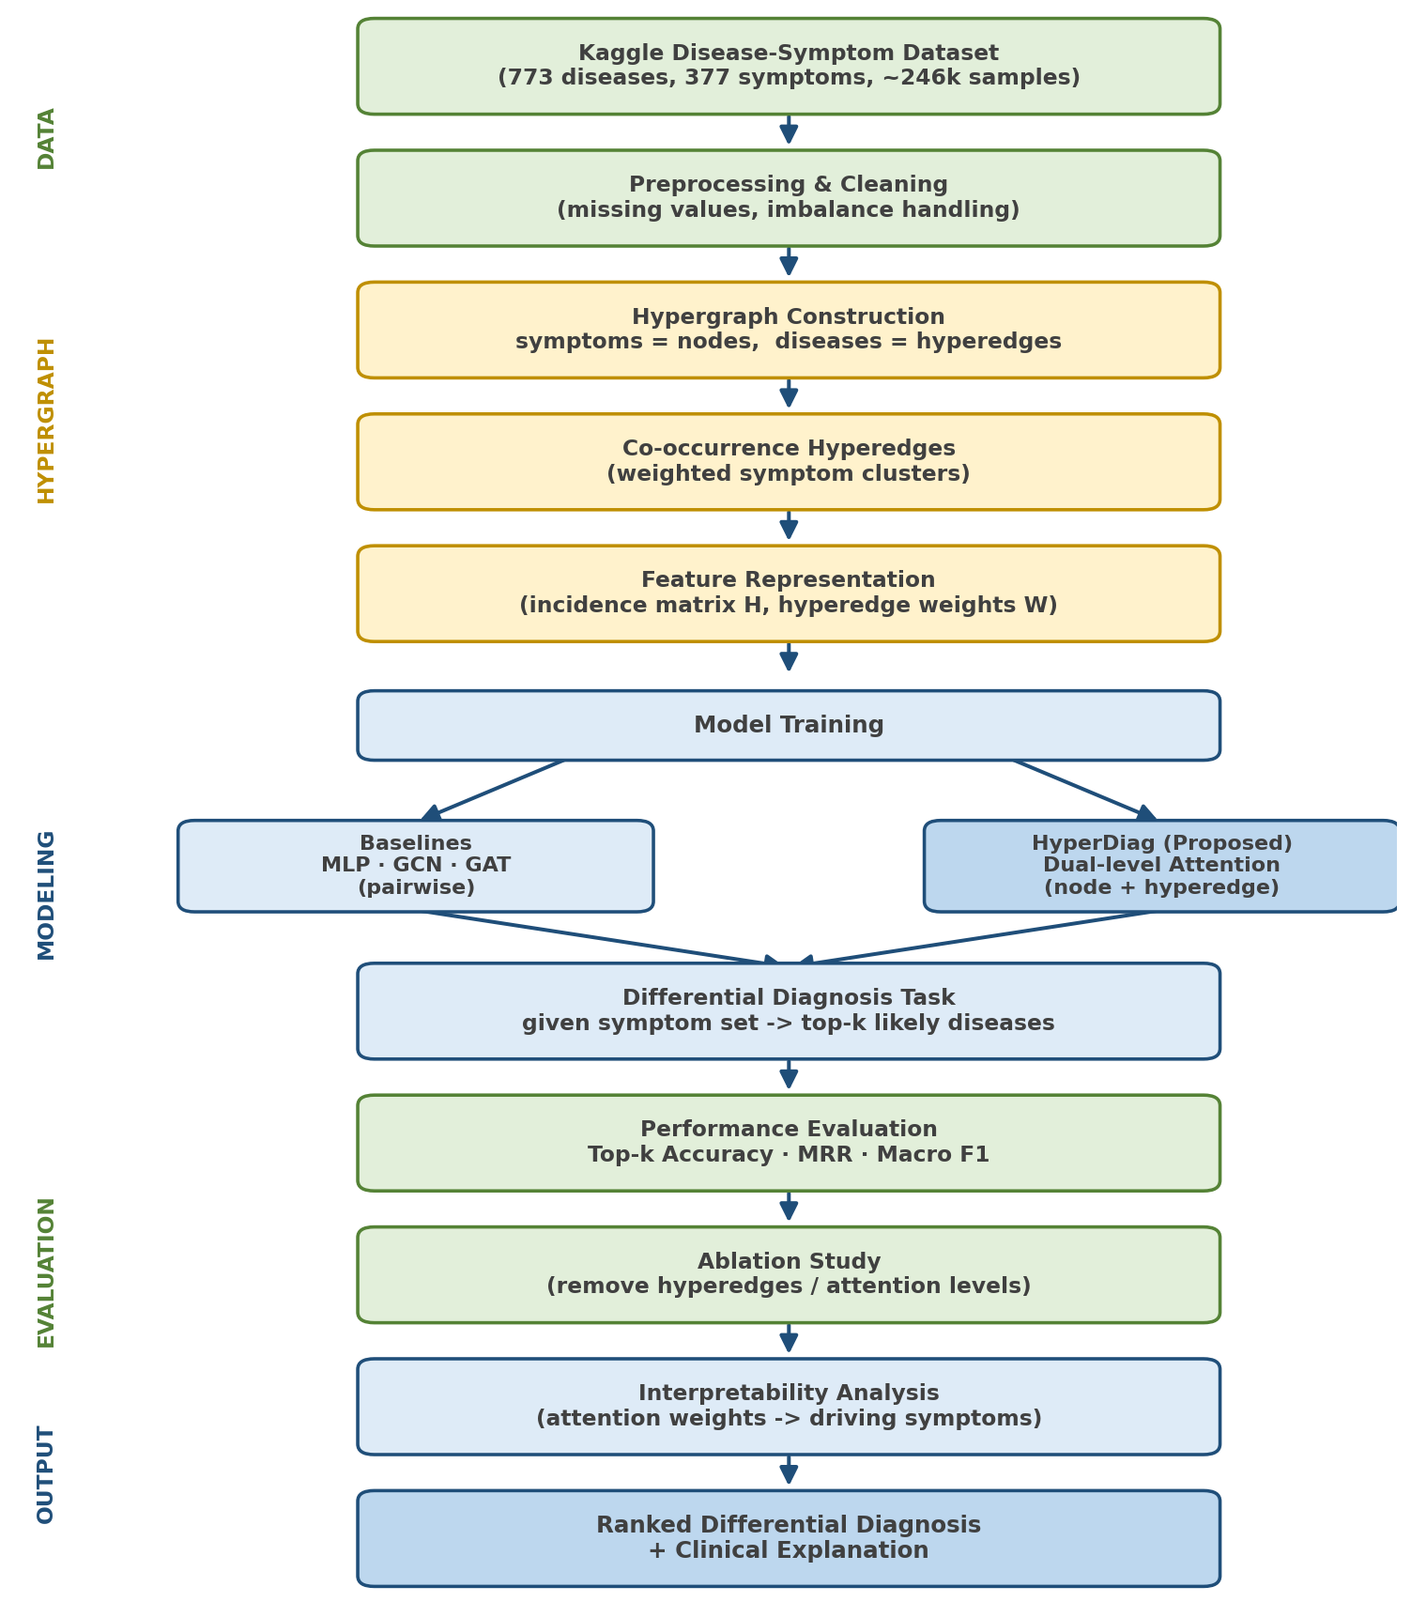
Figure 1: High-level framework of our experiments.

3.1 Dataset Collection
We use the publicly available Kaggle Diseases and Symptoms dataset (Kumar, 2023), file Final_Augmented_dataset_Diseases_and_Symptoms.csv. It contains 246,945 rows, 773 unique diseases and 377 binary symptom columns. Each row is a patient case: the symptom columns record presence (1) or absence (0), and the label column records the disease. On average a case has 5.33 symptoms present. Class sizes range from 1 to 1219 cases (imbalance ratio 1219:1).

3.2 Dataset Preprocessing
Disease labels are lower-cased and stripped, and all symptom columns are verified to be strictly binary. The data audit (Table 1) found 57,298 exact duplicate records, which are removed. 49 symptoms that never occur are dropped. Diseases with fewer than five unique cases cannot be represented in all three splits and are excluded, which leaves 189,409 cases, 328 symptoms and 658 diseases.
Table 1: Data audit of the Kaggle Diseases and Symptoms dataset.
Property | Value
Rows / diseases / symptoms | 246,945 / 773 / 377
Missing values / non-binary values | 0 / none
Exact duplicate rows | 57,298 (23.2%)
Unique symptom vectors | 169,888
Vectors mapping to >1 disease | 12,634
Rows with an ambiguous vector | 39,728
Unused symptoms | 49
Largest / median / smallest class | 1219 / 168 / 1
Bayes ceiling Top-1 / Top-5 (raw) | 91.62% / 99.56%
Bayes ceiling Top-1 / Top-5 (de-duplicated) | 89.58% / 99.43%
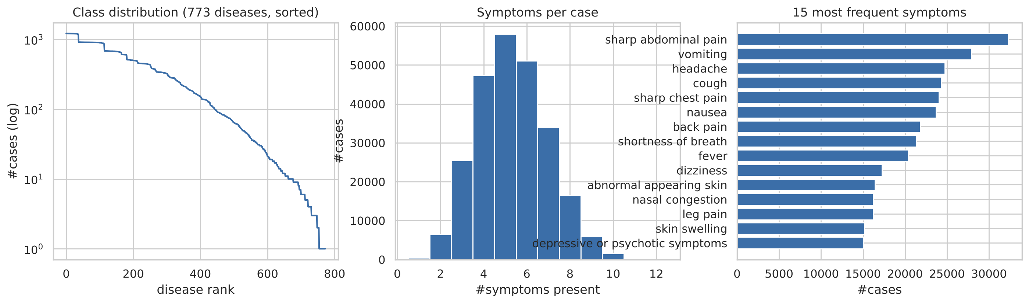
Figure 2: Class distribution, number of symptoms per case and most frequent symptoms.

3.3 Missing Value Handling
The audit found no missing or malformed symptom indicators. The pipeline still treats any absent value as 'symptom not present', consistent with the one-hot encoding, and discards samples with an empty or corrupted disease label.

3.4 Class Imbalance Handling
The label distribution is highly imbalanced. All neural models are trained with a class-weighted cross-entropy loss in which the weight of disease c is proportional to n_c^(-0.5) (normalised to mean 1), plus label smoothing of 0.05. Instead of oversampling, which would recreate exact duplicates of rare cases and re-introduce the leakage problem, we use variable-rate symptom-masking augmentation: for every training case a rate r ~ U(0, 0.5) is drawn and each present symptom is dropped with probability r, always keeping at least one. This acts as feature-level resampling and simulates patients who report only part of their symptoms.

3.5 Leakage-Free Evaluation Protocol and Bayes Ceiling
Because identical symptom vectors occur many times, and sometimes with different diseases, a random split lets the model see the exact test pattern during training. We therefore use a stratified group split in which the group is the symptom vector: every distinct pattern is assigned to exactly one of train (70%), validation (10%) or test (20%), stratified by its majority disease. This gives 132,694 training, 18,947 validation and 37,768 test cases, with zero symptom vectors shared between train and test. We also compute the Bayes-optimal top-k ceiling: for every distinct vector x with disease counts n(x,d), the best achievable top-k hit rate is the sum over x of its k largest counts, divided by N. Table 2 compares three protocols with the same MLP.
Table 2: Train/test leakage under three evaluation protocols (same MLP).
Protocol | Test cases | Leaked test cases | MLP Top-1 | MLP Top-5
(A) random split, raw data | 49,239 | 43.9% | 86.02 | 98.02
(B) random split, de-duplicated | 37,882 | 15.1% | 82.42 | 97.31
(C) grouped split (ours) | 37,768 | 0.0% | 84.02 | 97.70
Under the usual protocol (A), 43.9% of test cases are exact copies of training patterns, which inflates top-1 accuracy to 86.02%. After de-duplication (B), leakage still affects 15.1% of test cases. Our grouped split (C) removes leakage completely. All results in Chapter 4 use protocol C. Because conflicting patterns stay together in one split, the test-set ceiling under protocol C is 89.89% top-1 and 99.55% top-5.

3.6 Hypergraph Construction
The disease-symptom matrix is turned into a hypergraph using training data only. Symptoms are nodes. Each disease d becomes a hyperedge containing every symptom with P(s|d) of at least 0.02, with soft incidence weight h(s,d) = P(s|d). Unlike a pairwise edge, a single disease hyperedge binds the whole symptom set of the disease. Auxiliary co-occurrence hyperedges capture symptom clusters that recur across diseases: for every symptom v, the set {v} plus its top-4 partners by normalised pointwise mutual information (NPMI ≥ 0.10, co-occurrence count ≥ 10) forms a hyperedge, weighted by the mean NPMI, and duplicates are merged. The resulting hypergraph has 658 disease hyperedges (mean size 7.7) and 284 co-occurrence hyperedges (mean size 5.0). For the pairwise baselines, the same NPMI statistics define a graph in which each symptom is linked to its top-10 partners.
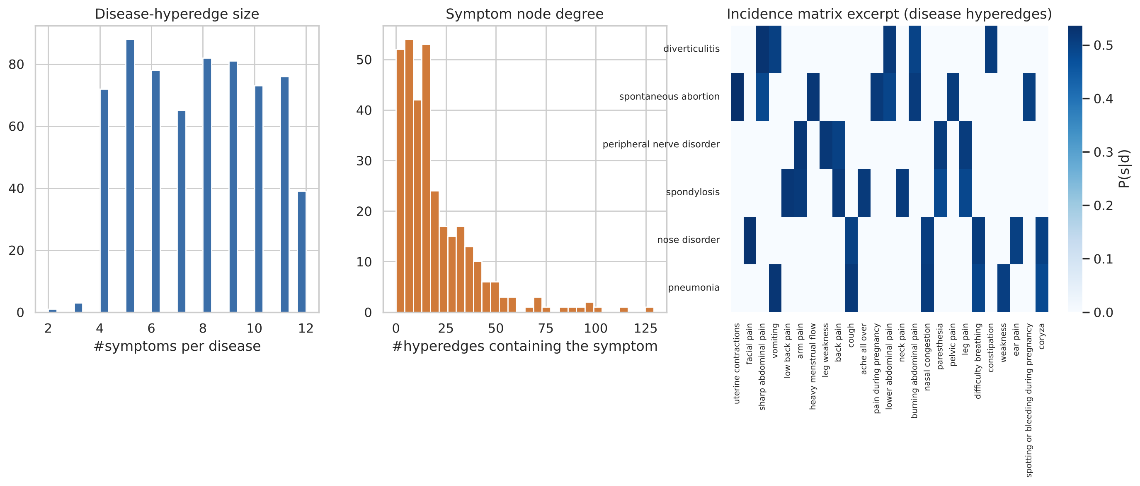
Figure 3: Disease-hyperedge sizes, symptom node degrees and an excerpt of the weighted incidence matrix.

3.7 Feature Representation
Each symptom node starts from a learnable identity embedding plus a linear projection of its row-normalised positive PMI co-occurrence profile, so both one-hot identity and co-occurrence statistics are encoded. The incidence matrix encodes which symptoms belong to which hyperedges, and the incidence weights enter the node-level attention as a log-prior.

3.8 Proposed HyperDiag Model
HyperDiag is a hypergraph attention network built upon the constructed hypergraph. Drawing on the attention paradigm that has proven effective across deep learning (Vaswani et al., 2017), it employs a dual-level attention mechanism. Node-level attention learns how much each symptom contributes within a hyperedge, capturing the intuition that some symptoms are highly specific to a disease while others are common and less discriminative. Hyperedge-level attention learns which disease patterns are most relevant to a given query symptom set, allowing the model to emphasize the disease hyperedges that best explain the observed symptoms.
Message passing proceeds in two stages. First, node features are aggregated into hyperedge representations using node-level attention α(v,e), a masked softmax over the members of e with a LeakyReLU score of the node and hyperedge states plus log h(v,e). Second, hyperedge representations are propagated back to nodes with hyperedge-level attention β(e,v), a masked softmax over the hyperedges incident to v. Two such layers (dimension 128, four heads, residual connections and layer normalisation) produce structure-aware symptom and hyperedge embeddings. A patient query S is encoded by context-aware attention pooling over its present symptoms; the pooling weights γ(v) are the symptom-level explanation. The query then attends over the co-occurrence hyperedges that touch its symptoms (query-aware hyperedge attention) and is refined with the matched symptom clusters.
Two further components tie the decision directly to the hypergraph. (i) Disease-hyperedge prototype scoring: the score of disease d is the scaled cosine similarity between the query embedding and the learned embedding of the hyperedge of d, plus a bias. Every class is therefore represented by its own hyperedge rather than a free weight vector. (ii) Query-adaptive hyperedge-likelihood evidence: the score also receives λ+(q)·Σ_{v∈S} log h(v,d) + λ−(q)·Σ_{v∉S} log(1 − h(v,d)), where the non-negative weights λ± are predicted from the query and the number of reported symptoms. When few symptoms are reported, the model can learn that missing symptoms carry little information.
Algorithm 1: HyperDiag Training and Inference
ALGORITHM 1: HyperDiag — Hypergraph Attention for Differential Diagnosis
Input: Disease-symptom matrix D; symptom nodes V = {v₁, …, vₘ}; disease hyperedges E_d; co-occurrence hyperedges E_c; incidence matrix H; hyperedge weight matrix W; number of layers L; ranking depth k.
Output: Trained model f (·) that maps a query symptom set S to a ranked list of top-k diseases.
———————————————————————————————————
1. Construct hypergraph G = (V, E), where E = E_d ∪ E_c; map each disease to a hyperedge over its symptoms and add weighted co-occurrence hyperedges.
2. Build incidence matrix H and initialize node features X⁰ from one-hot identities and co-occurrence statistics.
3. for layer l = 1 to L do
4. Node → hyperedge: aggregate node features into hyperedge embeddings using node-level attention α_ve.
5. Hyperedge → node: propagate hyperedge embeddings back to nodes using hyperedge-level attention β_ev.
6. Update node representations Xˡ with non-linear activation and residual connection.
7. end for
8. Score each candidate disease for query set S from final embeddings and rank scores in descending order.
9. Optimize a class-weighted ranking loss; update parameters via backpropagation until convergence.
10. return top-k ranked diseases for S together with attention weights for interpretation.

3.9 Baseline Models
HyperDiag is compared with seven baselines trained on the same split: Bernoulli Naive Bayes; a Random Forest (60 trees, at most 4,000 leaves per tree so that the model fits in memory with more than 600 classes); softmax Logistic Regression; a two-hidden-layer MLP (512 units); a GCN and a GAT on the pairwise symptom graph; and HGNN (Feng et al., 2019), a hypergraph convolution on the same hypergraph without attention. GCN, GAT and HGNN share HyperDiag's node initialisation and attention readout, so differences come from the structure encoder. All neural models use AdamW (learning rate 2e-3, weight decay 1e-4), batch size 1024, a one-cycle schedule over 20 epochs with model selection on validation MRR, and the same loss and augmentation. Each neural model is trained with three seeds.

3.10 Task Formulation
Rather than predicting a single disease, the task is formulated as differential diagnosis: given a partial or complete symptom set, the model ranks all candidate diseases. We report Top-k accuracy (k = 1, 3, 5, 10) and Mean Reciprocal Rank, computed from the full ranking, and macro- and weighted-F1 of the top-1 prediction over the diseases present in the test set. Robustness to incomplete input is measured by keeping a random 80%, 60%, 40% or 20% of each test case's symptoms (at least one), with the same masks for all models. Significance is assessed with McNemar's test on top-1 correctness and paired bootstrap confidence intervals for Top-5 and MRR.

3.11 Ablation Study
To understand the contribution of each component, we retrain HyperDiag (three seeds each) without co-occurrence hyperedges, without node-level attention (replaced by incidence-weighted averaging), without hyperedge-level attention (replaced by degree-normalised averaging), without both, without query-aware hyperedge attention, with an MLP head instead of prototype scoring, and without the hyperedge-likelihood evidence.

3.12 Interpretability Analysis
We visualise the symptom-evidence weights γ for individual patients together with their top-5 differential, and the node-level attention α inside disease hyperedges. We compare α with the prevalence P(s|d) and the specificity P(d|s) using Spearman correlation. To test whether the explanations are faithful, we delete the most-attended, a random, or the least-attended symptom of each test case and measure the drop in the probability of the true disease.

CHAPTER 4

RESULT AND DISCUSSION
This chapter presents the results on the leakage-free test set (37,768 cases, 658 diseases). Neural results are the mean ± standard deviation over three seeds. Naive Bayes and Random Forest are deterministic or use a single seed. The test-set Bayes ceiling is 89.89% top-1, 98.37% top-3 and 99.55% top-5.

4.1 Comparative Performance
Table 3: Comparative performance on the leakage-free test set (%).
Model | Top-1 | Top-3 | Top-5 | Top-10 | MRR | Macro-F1
Naive Bayes (Bernoulli) | 84.31 | 95.35 | 97.67 | 99.24 | 90.15 | 76.43
Random Forest | 82.80 | 94.70 | 97.36 | 99.14 | 89.11 | 71.02
LogReg (softmax) | 84.24 ± 0.02 | 95.27 ± 0.02 | 97.62 ± 0.00 | 99.26 ± 0.02 | 90.08 ± 0.01 | 75.11 ± 0.21
MLP | 84.63 ± 0.03 | 95.49 ± 0.07 | 97.84 ± 0.01 | 99.38 ± 0.02 | 90.38 ± 0.01 | 81.71 ± 0.32
GCN (pairwise) | 84.48 ± 0.01 | 95.49 ± 0.02 | 97.80 ± 0.00 | 99.35 ± 0.01 | 90.28 ± 0.01 | 81.12 ± 0.04
GAT (pairwise) | 84.50 ± 0.03 | 95.48 ± 0.00 | 97.84 ± 0.04 | 99.36 ± 0.02 | 90.31 ± 0.02 | 81.35 ± 0.52
HGNN (hypergraph, no attention) | 84.51 ± 0.04 | 95.48 ± 0.02 | 97.82 ± 0.02 | 99.36 ± 0.00 | 90.30 ± 0.02 | 81.28 ± 0.05
HyperDiag (ours) | 84.59 ± 0.01 | 95.53 ± 0.06 | 97.83 ± 0.03 | 99.37 ± 0.03 | 90.36 ± 0.02 | 81.16 ± 0.09
Bayes-optimal ceiling | 89.89 | 98.37 | 99.55 | 99.96 | — | —
HyperDiag reaches 84.59 ± 0.01% top-1, 97.83 ± 0.03% top-5 and 90.36 ± 0.02% MRR, which is 94.1% of the achievable top-1 accuracy. It is significantly better than Naive Bayes (McNemar p = 0.017), Logistic Regression (p = 0.002) and Random Forest (p < 0.001), with a macro-F1 gain of 4.7 points over Naive Bayes. Against the neural baselines the differences are within 0.15 points and not statistically significant (MLP p = 0.59, GAT p = 0.61, HGNN p = 0.40). All neural models converge to the same performance band, about five points below the Bayes ceiling. The remaining gap is dominated by symptom patterns that never appear in training, which no model can resolve from symptoms alone.
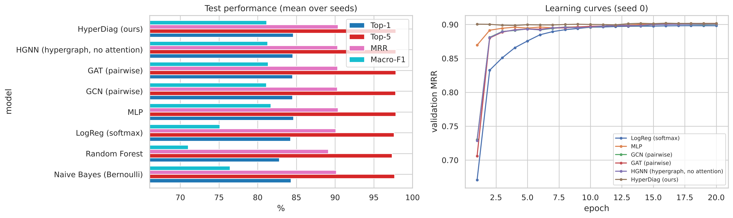
Figure 4: Test performance of all models and validation learning curves.
Table 4: Statistical significance of HyperDiag versus each baseline (seed 0).
Baseline | HyperDiag-only correct | Baseline-only correct | McNemar p | ΔTop-5 [95% CI] | ΔMRR [95% CI]
Naive Bayes (Bernoulli) | 1033 | 926 | 0.0166 | +0.16 [+0.02, +0.28] | +0.22 [+0.10, +0.36]
Random Forest | 2289 | 1612 | 0 | +0.47 [+0.33, +0.62] | +1.26 [+1.07, +1.46]
LogReg (softmax) | 972 | 840 | 0.00209 | +0.21 [+0.09, +0.32] | +0.30 [+0.17, +0.42]
MLP | 977 | 1002 | 0.59 | -0.01 [-0.13, +0.10] | +0.01 [-0.12, +0.14]
GCN (pairwise) | 1104 | 1061 | 0.367 | +0.02 [-0.09, +0.13] | +0.11 [-0.03, +0.25]
GAT (pairwise) | 1141 | 1116 | 0.613 | -0.02 [-0.14, +0.09] | +0.05 [-0.09, +0.19]
HGNN (hypergraph, no attention) | 1098 | 1058 | 0.401 | -0.02 [-0.13, +0.09] | +0.09 [-0.05, +0.23]

4.2 Robustness to Partial Symptom Sets
Table 5: Top-5 accuracy (%) when only a fraction of each test case's symptoms is reported.
Model | 100% kept | 80% kept | 60% kept | 40% kept | 20% kept
Naive Bayes (Bernoulli) | 97.67 | 97.13 | 92.61 | 82.08 | 52.91
LogReg (softmax) | 97.62 | 97.02 | 92.17 | 80.62 | 50.23
MLP | 97.84 | 97.28 | 91.97 | 79.11 | 44.59
GCN (pairwise) | 97.80 | 97.24 | 92.10 | 79.28 | 42.90
GAT (pairwise) | 97.84 | 97.28 | 92.09 | 79.29 | 42.82
HGNN (hypergraph, no attention) | 97.82 | 97.26 | 92.08 | 79.27 | 42.82
HyperDiag (ours) | 97.83 | 97.24 | 92.11 | 79.28 | 43.39
Performance falls quickly as symptoms are removed: with 40% of symptoms HyperDiag keeps 79.3% top-5 accuracy and with 20% it keeps 43.4%. Among the structure-based neural models HyperDiag is the most robust at the 20% level (43.4% versus 42.9% for the best of GCN/GAT/HGNN). The generative models, however, remain clearly better with very sparse input (Naive Bayes 52.9%). This shows that discriminative models, including ours, learn to rely on the absence of symptoms. Closing this gap is an important direction for future work.
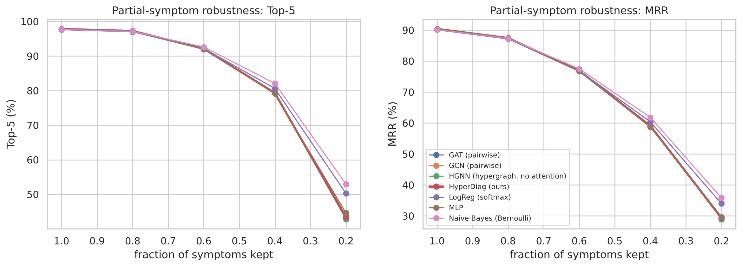
Figure 5: Top-5 accuracy and MRR as a function of the fraction of symptoms kept.

4.3 Rare versus Frequent Diseases
Table 6: Mean per-disease recall@1 (%) grouped by number of training cases.
Model (recall@1, %) | rare (≤20) | low (21–100) | mid (101–400) | frequent (>400)
Naive Bayes (Bernoulli) | 51.29 | 75.36 | 86.96 | 83.36
MLP | 76.35 | 86.84 | 87.58 | 82.61
GAT (pairwise) | 77.21 | 84.54 | 87.03 | 82.84
HGNN (hypergraph, no attention) | 75.79 | 84.47 | 86.98 | 82.77
HyperDiag (ours) | 73.35 | 84.61 | 87.83 | 82.63
For rare diseases (≤ 20 training cases), the neural models outperform Naive Bayes by a large margin (HyperDiag 73.3% recall@1 and 93.2% recall@5, versus 51.3% and 74.2% for Naive Bayes). Class weighting is effective. Within the neural family, rare-disease performance differs by a few points between models and seeds, which reflects the small number of test cases per rare disease.

4.4 Ablation Study
Table 7: Ablation study of HyperDiag components (%; mean ± std over three seeds).
Variant | Top-1 | Top-5 | MRR | Macro-F1 | Top-5 (40% symptoms)
Full HyperDiag | 84.59 ± 0.01 | 97.83 ± 0.03 | 90.36 ± 0.02 | 81.16 ± 0.09 | 79.28 ± 0.05
w/o co-occurrence hyperedges | 84.64 ± 0.08 | 97.81 ± 0.01 | 90.38 ± 0.05 | 81.04 ± 0.23 | 79.38 ± 0.12
w/o node-level attention | 84.59 ± 0.09 | 97.82 ± 0.02 | 90.36 ± 0.06 | 81.12 ± 0.24 | 79.31 ± 0.03
w/o hyperedge-level attention | 84.55 ± 0.04 | 97.82 ± 0.02 | 90.35 ± 0.03 | 81.07 ± 0.06 | 79.36 ± 0.13
w/o both attentions | 84.61 ± 0.07 | 97.82 ± 0.03 | 90.36 ± 0.06 | 81.21 ± 0.14 | 79.32 ± 0.06
w/o query-aware hyperedge attention | 84.65 ± 0.03 | 97.81 ± 0.05 | 90.39 ± 0.03 | 81.35 ± 0.10 | 79.28 ± 0.09
w/o prototype scoring (MLP head) | 84.41 ± 0.15 | 97.75 ± 0.07 | 90.23 ± 0.10 | 79.24 ± 1.05 | 79.91 ± 0.71
w/o hyperedge-likelihood evidence | 84.49 ± 0.04 | 97.83 ± 0.04 | 90.29 ± 0.02 | 81.14 ± 0.16 | 79.38 ± 0.17
Removing individual components changes Top-1, Top-5 and MRR by at most 0.19 points, comparable to the seed-to-seed variation. The largest effect on macro-F1 comes from removing 'prototype scoring (MLP head)' (-1.92 points). This is consistent with the comparative results: near the ceiling, the attention mechanisms mainly change how the decision is reached and how it can be explained, not its accuracy.

4.5 Interpretability and Faithfulness
Figure 6 shows three test patients with the symptom-evidence weights γ and the top-5 differential. Inside disease hyperedges, the node-level attention closely follows prevalence (mean Spearman ρ = 0.86 with P(s|d), positive for 99% of diseases) and is weakly related to specificity (ρ = 0.29 with P(d|s)). The model therefore highlights the symptoms that characterise each disease. The deletion test (Table 8) confirms that γ is faithful: removing the most-attended symptom lowers the true-disease probability by 0.155 on average, versus 0.095 for a random symptom and 0.062 for the least-attended one. Top-1 accuracy falls to 68.4%, 75.4% and 79.6% respectively.
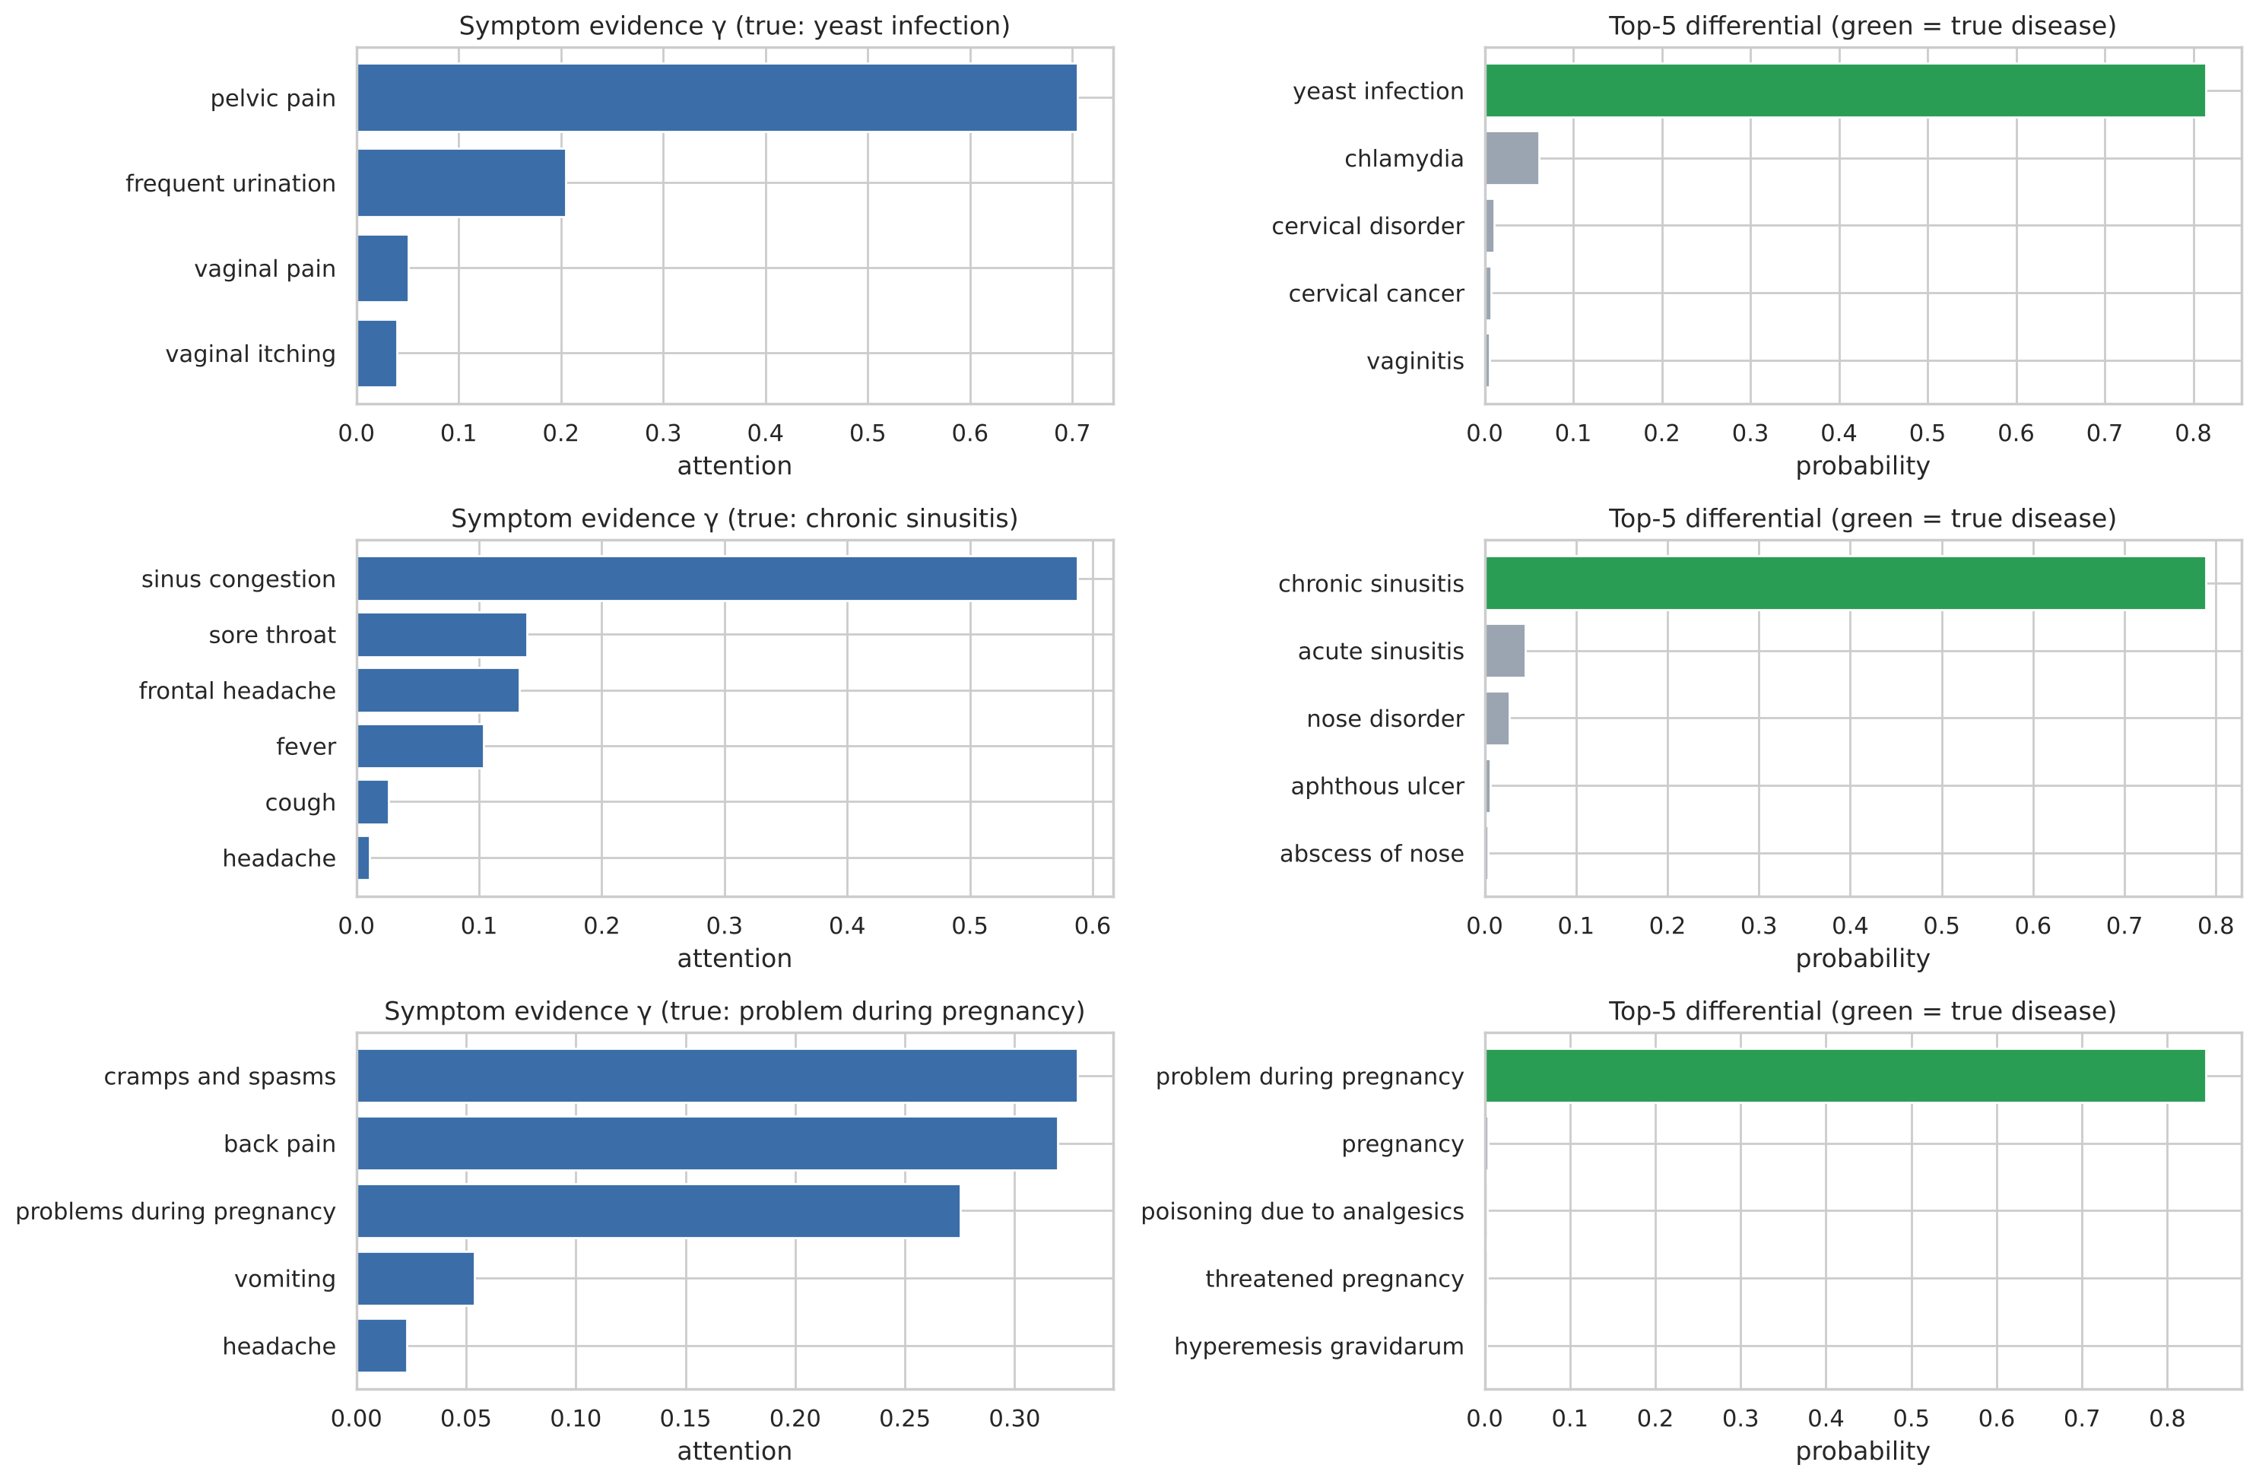
Figure 6: Symptom-evidence attention and top-5 differential for three test patients.
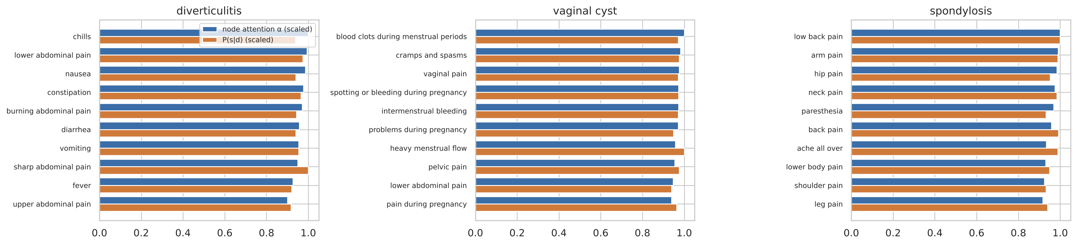
Figure 7: Node-level attention within three disease hyperedges compared with P(s|d).
Table 8: Attention-faithfulness deletion test (3,000 test cases with at least three symptoms).
Deleted symptom | Mean drop in P(true disease) | Top-1 after | Top-5 after
most attended | 0.155 | 68.40 | 91.73
random | 0.095 | 75.40 | 94.93
least attended | 0.062 | 79.60 | 96.87
no deletion | 0.000 | 87.13 | 98.50

CHAPTER 5

DISCUSSION AND FUTURE WORK
Prior studies on the Disease-Symptom dataset have mostly used traditional classifiers or pairwise graph neural networks evaluated with random splits. Our audit shows that such splits leak a large share of test cases into training, so the high accuracies reported for this dataset should be read with care. HyperDiag differs from earlier work in three ways: it represents each disease as a hyperedge over its full symptom set, it is evaluated under a leakage-free protocol against an explicit Bayes ceiling, and its explanations are checked for faithfulness. Table 9 places our approach among representative prior studies.
Table 9: Comparison with relevant research.
Study / Approach | Method | Structure | Task | Interpretable
Traditional ML studies | RF / SVM / NB | None (flat features) | Single-label | Limited
Pairwise GNN studies | GCN / GAT | Pairwise graph | Single-label | Partial
EHR hypergraph studies | HGNN | Hypergraph | Outcome prediction | Partial
HyperDiag (proposed) | Hypergraph attention | Disease + co-occ. hyperedges | Top-k differential | Yes (dual attention)

5.2 Impact of Hypergraph Structure on Model Performance
Contrary to our initial hypothesis, the hypergraph structure was not the main driver of accuracy on this dataset. Every neural model, whether flat (MLP), pairwise (GCN, GAT) or higher-order (HGNN, HyperDiag), reached the same performance band, and the ablations changed accuracy by less than the variation across seeds. Two properties of the data explain this. First, the dataset is close to saturation: 12,634 symptom patterns are shared by several diseases, which caps top-1 accuracy at 89.9% on our test set. Second, Naive Bayes, which assumes symptoms are independent given the disease, is almost as accurate as the best neural model. This suggests that cases were generated from per-disease symptom profiles with little higher-order interaction, which is exactly the structure that hyperedges are designed to capture. The hypergraph still adds value. It significantly improves on classical models, ties every class to an explicit, inspectable disease hyperedge, and yields symptom-level explanations that pass a deletion test. We expect the higher-order structure to matter more on real clinical records, where symptom interactions are richer.

5.3 Limitations
The dataset is an augmented symptom-checker resource rather than real patient records, so the conclusions may not transfer directly to clinical practice. Diseases with fewer than five unique cases were excluded. The Random Forest was size-capped for memory reasons. All neural models were trained with one shared set of hyperparameters rather than per-model tuning. Finally, every neural model, HyperDiag included, degrades more than Naive Bayes when very few symptoms are reported.

5.4 Future Work
Several directions remain. The framework should be validated on real electronic health records and on other symptom-diagnosis datasets, where higher-order symptom interactions are expected to be stronger. Hybrid generative-discriminative training could close the gap with Naive Bayes on very sparse inputs. Patient demographics, vital signs and the temporal evolution of symptoms could be added as further node or hyperedge types. Finally, the faithful attention explanations could be developed into an interactive clinical decision-support tool that presents ranked diagnoses together with their supporting symptoms.

CHAPTER 6

CONCLUSION
This research proposes HyperDiag, a hypergraph attention network for symptom-set-aware differential diagnosis. Each disease is modelled as a hyperedge over its symptoms, co-occurrence hyperedges capture recurring symptom clusters, dual-level attention propagates information between symptoms and disease patterns, and each disease is scored through its own hyperedge. A careful audit of the Kaggle Diseases and Symptoms dataset revealed that 23% of the records are duplicates and that random splits leak 44% of test cases. We therefore introduced a leakage-free grouped protocol together with a Bayes-optimal ceiling. Under this protocol HyperDiag achieves 84.59% top-1 accuracy, 97.83% top-5 accuracy and 90.36% MRR. It significantly outperforms classical baselines, matches the strongest neural baselines and provides faithful symptom-level explanations. Our findings show that honest evaluation is a prerequisite for meaningful progress on public symptom-checker benchmarks, and they establish a reproducible baseline and protocol for future structurally aware, interpretable clinical decision support.

REFERENCES
Bai, S., Zhang, F., & Torr, P. H. S. (2021). Hypergraph convolution and hypergraph attention. Pattern Recognition, 110, 107637. https://doi.org/10.1016/j.patcog.2020.107637
Chen, X., Zhang, Y., & Sun, F. (2022). Graph neural networks for medical diagnosis: A survey. Artificial Intelligence in Medicine, 128, 102301. https://doi.org/10.1016/j.artmed.2022.102301
Feng, Y., You, H., Zhang, Z., Ji, R., & Gao, Y. (2019). Hypergraph neural networks. Proceedings of the AAAI Conference on Artificial Intelligence, 33(1), 3558–3565. https://doi.org/10.1609/aaai.v33i01.33013558
Gao, Y., Zhang, Z., Lin, H., Zhao, X., Du, S., & Zou, C. (2022). Hypergraph learning: Methods and practices. IEEE Transactions on Pattern Analysis and Machine Intelligence, 44(5), 2548–2566. https://doi.org/10.1109/TPAMI.2020.3039374
Kumar, D. R. (2023). Diseases and symptoms dataset [Data set]. Kaggle. https://www.kaggle.com/datasets/dhivyeshrk/diseases-and-symptoms-dataset
Kipf, T. N., & Welling, M. (2017). Semi-supervised classification with graph convolutional networks. In Proceedings of the 5th International Conference on Learning Representations (ICLR). https://doi.org/10.48550/arXiv.1609.02907
Li, Y., Qian, B., Zhang, X., & Liu, H. (2021). Graph-based clinical decision support for disease prediction. Journal of Biomedical Informatics, 113, 103655. https://doi.org/10.1016/j.jbi.2020.103655
Rajpurkar, P., Chen, E., Banerjee, O., & Topol, E. J. (2022). AI in health and medicine. Nature Medicine, 28(1), 31–38. https://doi.org/10.1038/s41591-021-01614-0
Vaswani, A., Shazeer, N., Parmar, N., Uszkoreit, J., Jones, L., Gomez, A. N., Kaiser, Ł., & Polosukhin, I. (2017). Attention is all you need. In Advances in Neural Information Processing Systems (Vol. 30, pp. 5998–6008). https://doi.org/10.48550/arXiv.1706.03762
Veličković, P., Cucurull, G., Casanova, A., Romero, A., Liò, P., & Bengio, Y. (2018). Graph attention networks. In Proceedings of the 6th International Conference on Learning Representations (ICLR). https://doi.org/10.48550/arXiv.1710.10903
Yadav, D. C., & Pal, S. (2020). Prediction of heart disease using feature selection and machine learning ensemble methods. International Journal of Engineering and Advanced Technology, 9(3), 3866–3870. https://doi.org/10.35940/ijeat.C6440.029320
Zhang, R., Zou, Y., & Ma, J. (2020). Hyper-SAGNN: A self-attention based graph neural network for hypergraphs. In Proceedings of the 8th International Conference on Learning Representations (ICLR). https://doi.org/10.48550/arXiv.1911.02613

