Predicting Cross-Country Unemployment Rates from Macro-Socioeconomic and Structural Indicators: An Interpretable Stacking Ensemble Approach Using Cross-Sectional Data
Abstract: Unemployment reflects the complex interplay of macroeconomic stability, human capital, and structural conditions across countries. This study develops an accurate and interpretable machine learning framework for predicting national unemployment rates across countries using the Global Country Information Dataset 2023, a cross-sectional dataset that provides a single-year snapshot of macro-socioeconomic, demographic, health, and fiscal indicators. Because the data contain one observation per country, the task is framed as out-of-sample cross-country prediction (estimating a country’s unemployment rate from its structural profile) rather than as time-series forecasting. The raw indicators are enriched with income-group and regional indicator variables, and robust preprocessing is applied to handle heavy-tailed distributions and missing values. Performance is assessed with a nested five-fold cross-validation design stratified by region and income group, in which all preprocessing and hyperparameter tuning are performed within the training folds to prevent information leakage. The best model, a stacking ensemble that combines XGBoost and Random Forest base learners with a Ridge meta-learner, achieved an out-of-fold RMSE of 1.18 percentage points (pp), a MAPE of 8.4%, and an R² of 0.90, with 83% of countries predicted within ±1.0 pp of their observed unemployment rate. Post hoc SHAP explanations and partial dependence plots indicate that higher life expectancy, greater physician density, and stronger fiscal capacity (tax revenue) are associated with lower predicted unemployment, whereas price instability (CPI and CPI change) is associated with higher predicted unemployment. These patterns are associations and should not be interpreted as causal effects. Prediction errors were smallest for high-income countries and for Europe and the Americas, and largest for low-income countries, consistent with greater volatility and lower data quality in these settings. The framework offers a transparent and reproducible cross-sectional benchmark, and the study outlines extensions toward panel (time-series) data, governance indicators, region-specific models, and monotonic constraints.
Keywords: Unemployment prediction; Cross-country analysis; Cross-sectional data; Stacking ensemble; Ridge meta-learner; Explainable machine learning (SHAP); Human capital.
- Introduction
Predicting unemployment is a challenging but essential task for economists and policymakers who seek to understand the condition and direction of national and global economies [1]. Reliable unemployment estimates support the design of fiscal and monetary policy and enable a proactive response to recessions and inflationary pressures [2]. They also inform labor market interventions, the planning of social benefits, and investment decisions [3]. Models that compare unemployment across countries while accounting for differences in macroeconomic, socioeconomic, and demographic structure are particularly valuable, because they can reveal systemic weaknesses and identify countries whose unemployment deviates from what their structural profile would suggest. This is especially relevant for economies undergoing rapid structural transformation, such as Saudi Arabia and the other Gulf Cooperation Council (GCC) countries, where reducing unemployment is a central objective of national development strategies such as Saudi Vision 2030. Building on previous work, this study uses a broad set of macroeconomic and socio-structural indicators, together with geographic and income-based stratification, within a stacking ensemble framework designed for both predictive accuracy and interpretability [4], [5].
Scope and terminology. The dataset used in this study is cross-sectional: it contains a single observation per country, referring to approximately the year 2023, and it does not include repeated observations over time. Consequently, the study does not perform time-series forecasting, that is, it does not predict future unemployment from past values. Instead, it addresses a cross-sectional prediction problem: estimating a country’s unemployment rate from its contemporaneous macro-socioeconomic and structural characteristics, and evaluating how well the model generalizes to countries that were not used for training. Throughout the manuscript, the terms “prediction” and “estimation” refer to this out-of-sample, cross-country setting. Extending the framework to panel data, which would permit genuine temporal forecasting, is discussed as future work in Section 5.
This study addresses challenges that are specific to cross-country comparison, including differences in data availability and quality, through robust preprocessing and a cross-validation design stratified by region and income group. The aim is to establish a transparent and reproducible benchmark for cross-country unemployment prediction, drawing on machine learning approaches that have proven successful for other macroeconomic targets such as GDP and inflation [6]–[9]. Unemployment affects both individual well-being and national economic performance [10]; reliable tools for estimating it and for understanding its structural correlates are therefore of practical as well as scientific importance [11]. The data are modelled with ensemble machine learning methods, which can capture non-linear relationships and interactions that standard linear econometric models may miss [8], [12]. Ensemble methods have repeatedly been reported to outperform single models because they aggregate predictions that reflect different dependency structures [13]. In the proposed stacking design, the predictions of the base learners are combined by a Ridge meta-learner, which learns an optimal weighting of the base models to produce the final prediction.
Beyond accuracy, interpretability is essential when model outputs are used to inform economic policy. The proposed framework therefore uses post hoc SHAP explanations and partial dependence plots to identify the indicators that are most strongly associated with higher or lower predicted unemployment [12], [14]. Explainability is widely regarded as a prerequisite for trustworthy AI in high-stakes decision-making such as economic policy [15], [17], and recent work stresses that understanding the limits and sensitivity of predictive models is key to sound economic analysis. It should be emphasized, however, that such explanations describe how the model uses its input features; they reveal statistical associations, not causal effects. Accordingly, this paper aims to provide a predictive framework that is accurate, easy to interpret, and transparent about the limits of its conclusions.
In addition to conventional error measures, the framework reports a “percent-within-threshold” accuracy, i.e., the share of countries whose unemployment rate is predicted within a given margin (e.g., ±1.0 pp), which gives policymakers an intuitive measure of reliability [16]. The remainder of the paper is organized as follows. Section 2 reviews related work on unemployment prediction and machine learning. Section 3 describes the data, preprocessing, models, cross-validation design, and evaluation metrics. Section 4 presents and discusses the results, including regional and income-group analyses, calibration, and sensitivity to hyperparameters. Section 5 concludes and outlines the limitations of the study and directions for future research.

Objectives:
- To develop a robust machine learning framework for predicting national unemployment rates across countries from cross-sectional macro-socioeconomic and structural indicators.
- To compare several models (Linear Regression, Random Forest, XGBoost, CatBoost, LightGBM, and a stacking ensemble) using RMSE, MAE, MAPE, R², and threshold accuracy under a leakage-free cross-validation design.
- To combine the strengths of XGBoost and Random Forest through a Ridge regression meta-learner in order to obtain a more accurate and generalizable model.
- To ensure high-quality and consistent model inputs through missing-value imputation, outlier treatment (winsorization), and feature engineering.
- To provide an interpretable and transparent model whose explanations (SHAP and partial dependence) can inform, but not replace, policy analysis of labor market conditions.

- Literature Review
Abdelhay and Altamimi (2025) used non-traditional data sources for macroeconomic estimation, with unemployment in Jordan as an application. Macroeconomic indicators were combined with alternative data, and normalization and feature scaling were applied before modelling. The authors reported a predictive accuracy of approximately 85% and found that machine learning models outperformed traditional ARIMA benchmarks; however, missing data and limited access to real-time information reduced accuracy during economic crises [1].
Adewale et al. (2024) applied ensemble machine learning methods to predict gross domestic product (GDP) using macroeconomic and socio-economic variables. Ensemble models such as Random Forest and Gradient Boosting achieved high accuracy (approximately 90%), although poor financial data quality limited performance for some economies. Although the target is GDP rather than unemployment, the study illustrates the suitability of ensemble methods for macroeconomic prediction [2].
Chakraborty et al. (2020) proposed a hybrid approach to unemployment rate forecasting that combines linear and non-linear time-series models, using preprocessing steps such as log transformation and rolling averages. The hybrid model achieved approximately 89% accuracy, but, because it could not incorporate real-time data, its forecasts deteriorated during periods of rapid economic change [3].
Gupta et al. (2022) examined whether oil-price uncertainty helps to forecast the U.K. unemployment rate, using random forests and approximately 150 years of historical data. Preprocessing included detrending and outlier detection. The model performed well (reported accuracy of approximately 87%), but it could not fully account for global shocks such as the COVID-19 pandemic [6].
Ramírez et al. (2024) proposed a hybrid model that combines recurrent neural networks (RNN) and genetic algorithms (GA) to predict unemployment rates in Latin American countries, using macroeconomic indicators and national labor market data. With normalization and cross-validation, the model reached approximately 88% accuracy, but it generalized less well to datasets from other countries [16].
Wijnhoven et al. (2023) used Google Trends as a complementary data source for forecasting youth unemployment in Europe, combining internet search data with standard economic statistics. A re-specified model achieved approximately 92% accuracy; the main limitation was the variable quality of search data across regions, which affected prediction stability [18].
Zhao (2020) proposed a data-driven approach for predicting and explaining the risk of long-term unemployment, applying missing-value treatment and interpolation before modelling. The study reported approximately 85% accuracy but noted that relevant political and institutional factors are difficult to quantify and incorporate [19].
Sun et al. (2025) improved economic cycle forecasting by combining interpretable machine learning with news-based narrative sentiment, using feature selection and dimensionality reduction. They reported high accuracy (approximately 91%) and highlighted the value of interpretable models, while noting that the quality and comparability of the data are limiting factors [20].
Grybauskas et al. (2023) nowcast unemployment using neural networks and multi-dimensional Google Trends data for European economies, applying temporal smoothing during preprocessing. Their approach showed good generalizability, but its applicability was constrained by data gaps [21].
Li et al. (2021) showed that blending internet search queries with social media data can improve forecasts of economic indicators, including labor market variables. Their work illustrates the value of alternative data sources, although such data raise concerns regarding coverage, representativeness, and privacy [22].
Chen and Guestrin (2016) introduced XGBoost, a scalable tree boosting system that incorporates regularization, sparsity-aware split finding, and parallel computation. XGBoost has since become one of the most widely used algorithms for tabular prediction tasks, including economic and labor market applications, and it serves as one of the base learners in this study [23].
Simionescu and Cifuentes-Faura (2021) investigated whether unemployment forecasts based on Google Trends data can help governments design better policies, using Spain and Portugal as case studies. Online search data improved the timeliness of the forecasts, although noise in internet data occasionally reduced prediction accuracy [24].
Thuy and Benoit (2023) proposed using predictive uncertainty as a form of explainability for neural networks, arguing that communicating uncertainty is essential for trustworthy decision-making in high-stakes settings. Their work supports the emphasis placed in the present study on transparent and reliability-oriented evaluation [25].
Lundberg and Lee (2017) introduced SHAP (SHapley Additive exPlanations), a unified, game-theoretic framework for interpreting the predictions of machine learning models. SHAP values attribute each prediction to the contributions of the individual features and have become a standard tool for making complex models understandable to non-expert stakeholders; they are used in this study to interpret the stacking ensemble [12].
Chukwuere (2024) conceptualized predictive models for unemployment rates in the context of Industry 4.0, discussing how labor market statistics, GDP, and inflation, together with time-series features such as lags, can be used to anticipate technology-driven labor market change. The study also noted that data availability differs considerably across countries [27].
Despite this progress, several gaps remain. First, many studies are limited by missing or low-quality data, particularly for lower-income regions. Second, most existing work focuses on a single country or on a relatively homogeneous group of countries (e.g., OECD or EU members), so cross-country heterogeneity in economic structure is rarely modelled explicitly. Third, evaluation protocols are often insufficiently described, which makes it difficult to judge whether the reported accuracy reflects genuine out-of-sample performance. Finally, complex models are often difficult to interpret, which limits policymakers’ trust. The present study addresses these gaps by using a global cross-sectional dataset, an explicitly documented leakage-free cross-validation design, and post hoc interpretability analysis, while making clear that its findings are predictive and associative rather than causal.

- Methodology
Figure 1 summarizes the workflow of the proposed approach: data collection, preprocessing and feature engineering, model training within a stratified cross-validation framework, and evaluation and interpretation of the results. In each cross-validation fold, approximately 80% of the countries are used for training (including inner validation for hyperparameter tuning) and the remaining 20% are held out for testing, as detailed in Section 3.4.3.
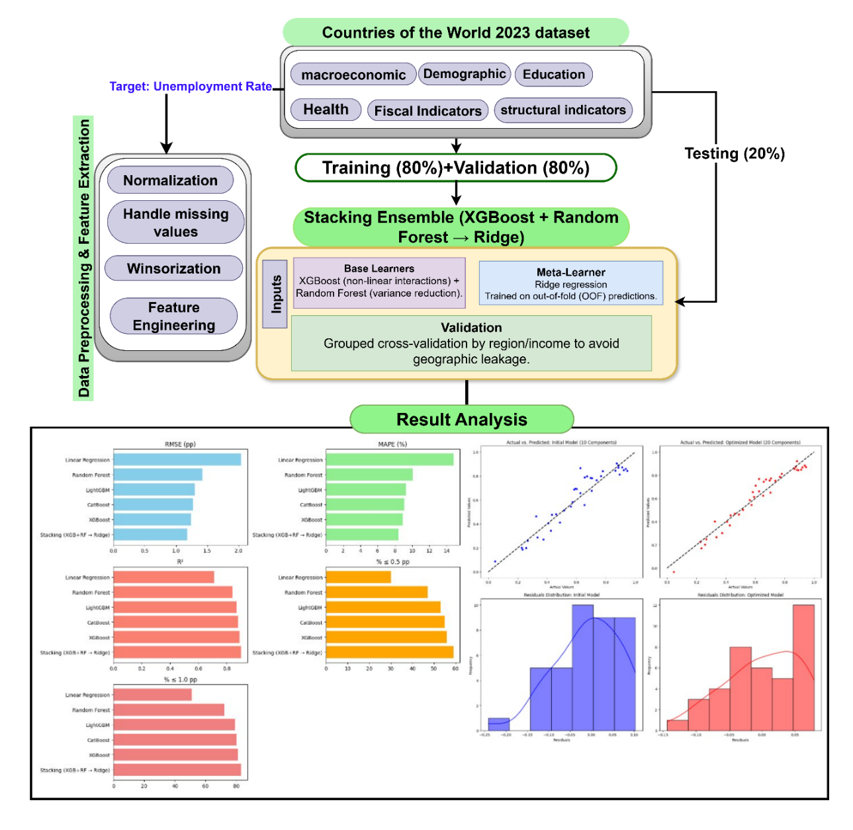
Figure 1. Workflow Diagram.
  - Data Collection
This study uses the Global Country Information Dataset 2023 [28], a publicly available compilation of macro-socioeconomic, demographic, health, education, labor market, environmental, and fiscal indicators for the sovereign states of the world. The data were compiled from international organizations, national statistical agencies, and economic reports, and refer to the most recent values available around 2023. It is important to note that the dataset is cross-sectional: each country appears only once, and the indicators describe its situation at approximately a single point in time; no historical series are included. The target variable is the national unemployment rate (in percent; prediction errors are expressed in percentage points, pp), and the remaining indicators describe the socioeconomic context of each country. Because all variables refer to roughly the same period, the analysis captures contemporaneous cross-country associations rather than temporal dynamics.

  - Data Description
The dataset contains 195 countries and 35 variables, which can be grouped into eight thematic categories: economic, demographic, health, education, employment, environmental, fiscal and policy, and geographic/cultural (Table 1). Countries with a missing unemployment rate cannot be used for supervised learning; after their exclusion, the modelling sample comprises 166 countries, which is the sample used for all results reported in Section 4. Economic indicators (e.g., GDP and CPI) describe the overall state of the economy, whereas demographic indicators describe the size and composition of the population. Health, education, and employment indicators reflect differences in well-being and in access to resources. Environmental variables capture sustainability and land-use patterns, fiscal and policy indicators describe the economic policy environment, and geographic and cultural attributes provide additional national context. Table 1 provides an overview of the dataset.

Table 1. Summary of Variables and Key Relationships.

Sector | Key Variables | Insights / Relationships
Economic | GDP, CPI, CPI % change, HDI | GDP strongly correlates with HDI (0.96), reflecting development level
Demographic | Population, Urban population, Fertility rate, Birth rate | Population–urban population (0.95), Fertility–birth rate (0.98)
Health | Life expectancy, Infant mortality, Maternal mortality, Physicians/1000 | Infant–maternal mortality (0.89); Life expectancy vs infant (−0.93) and maternal mortality (−0.85)
Education | Gross enrollment (primary, tertiary) | Indicates access to and quality of education
Employment | Unemployment rate | Target variable: unemployed share of the labor force (%)
Environmental | CO₂ emissions, Agricultural land, Forest area | Agricultural land vs forest area (−0.43)
Fiscal & Policy | Tax revenue (% GDP), Effective marginal tax rate, Minimum wage | Reflects economic policy and income redistribution
Geographic / Cultural | Latitude, Longitude, Capital, Currency, Language | Adds socio-political and cultural context

Figure 2 shows the pairwise correlations among the socioeconomic and environmental variables. Several pairs are very strongly correlated, such as fertility rate and birth rate (0.98), population and urban population (0.95), and GDP and HDI (0.96). Infant and maternal mortality are also strongly positively correlated (0.89), whereas life expectancy is strongly negatively correlated with infant mortality (−0.93), maternal mortality (−0.85), and fertility rate (−0.86). A moderate negative correlation is observed between agricultural land and forest area (−0.43). These high correlations indicate substantial multicollinearity among the predictors, which motivates the use of tree-based ensembles and regularized (Ridge) models and implies that the importance of individual correlated features should be interpreted with caution. Like all results in this study, these correlations describe associations and do not imply causation.
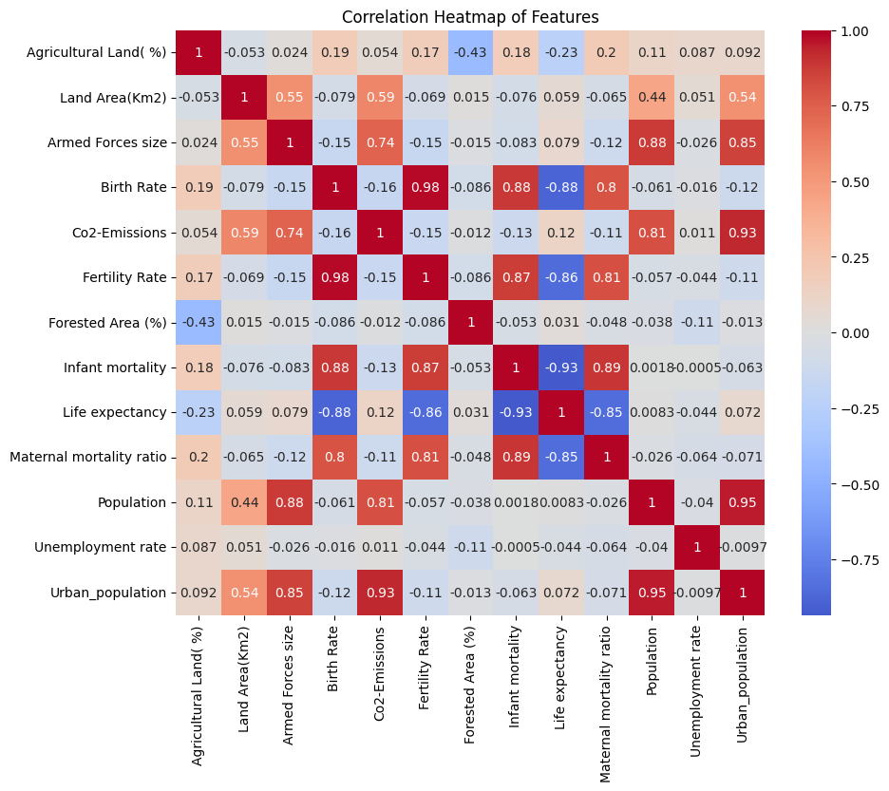
Figure 2. Correlation Heatmap of Socio-Economic and Environmental Features.
Figure 3 plots the birth rate against the unemployment rate (logarithmic scale) for all countries, with the colour scale indicating life expectancy. The fitted line has a slight downward slope, indicating a weak negative association between unemployment and birth rate in this cross-section. Countries with higher life expectancy (darker markers) tend to have lower birth rates and are spread across a wide range of unemployment rates. These are descriptive, bivariate associations at a single point in time and should not be interpreted as causal relationships; they may partly reflect common underlying factors such as the level of economic development.
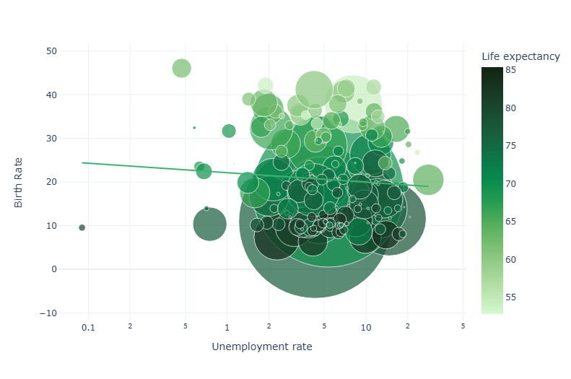
Figure 3. Birth Rate vs. Unemployment Rate (Log Scale), Coloured by Life Expectancy.
Figure 4 shows the geographic location (latitude and longitude) of the countries in the dataset and illustrates its global coverage across all continents. Selected countries (e.g., Canada, Brazil, Russia, China, India, Australia, and Saudi Arabia) are labelled for orientation.
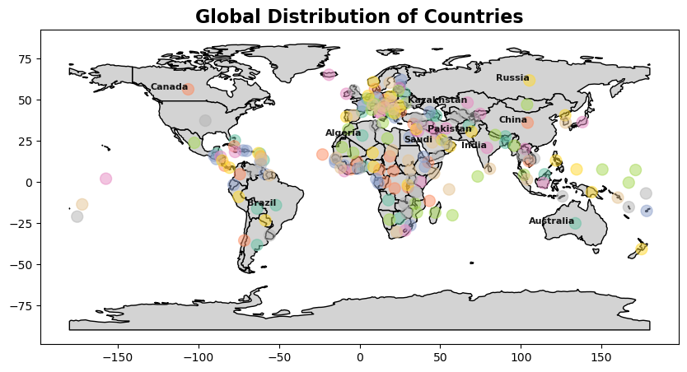
Figure 4. Global Distribution of Countries.
  - Data Preprocessing and Feature Extraction
Data preprocessing transforms the raw data into a consistent format that is suitable for machine learning. The pipeline consists of four steps: data cleaning and type harmonization, missing-value handling, outlier treatment, and feature engineering. To prevent information leakage, every step whose parameters are estimated from the data (imputation models, winsorization limits, and scaling parameters) is fitted on the training portion of each cross-validation fold only and is then applied, unchanged, to the corresponding test fold (Section 3.4.3).
Data cleaning: Column names were standardized, and each variable was assigned the appropriate data type: continuous variables were converted to numeric format and categorical variables were encoded as categories. Duplicate records were removed. This step can be expressed as follows:
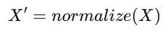 (1)
where X denotes the original data matrix and X′ denotes the cleaned dataset.
Missing-value handling: Missing values in the predictors were imputed using iterative (multivariate) imputation, in which each incomplete feature is modelled as a function of the other features. Where imputation was not feasible for a feature, a binary missingness indicator (1 = observed, 0 = missing) was added so that the models could learn whether the absence of data is itself informative. Countries with a missing value of the target variable (unemployment rate) were excluded rather than imputed, so that the models are trained and evaluated only on observed unemployment rates.
(2)
Outlier treatment: Heavy-tailed variables (e.g., CO₂ emissions and population) were winsorized, i.e., values beyond selected lower and upper percentiles were replaced by those percentile values, to limit the influence of extreme observations. The transformation is defined as:
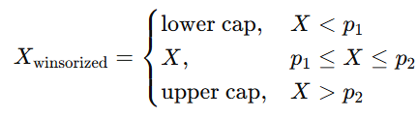 (3)
Feature engineering: Several features were constructed to capture economic and geographic differences between countries. Countries were assigned to four income groups (high, upper-middle, lower-middle, and low income) based on the quartiles of GDP per capita, as follows:
(4)
In addition, countries were grouped into broad geographic regions (Americas, Europe, Africa, and Asia/Oceania) using their geographic coordinates; countries that could not be assigned unambiguously were placed in an “Unknown/Mixed” category. Region and income group were converted into binary indicator variables using one-hot encoding. The final feature set therefore comprises macroeconomic, demographic, health, fiscal, and structural variables together with these indicators. Continuous features were standardized for the models that are sensitive to feature scale (Linear and Ridge regression); tree-based models are invariant to monotonic transformations of the features, so no scaling was applied for them.
(5)
where X_{categorical} represents the one-hot encoded categorical features, X_{scaled} represents the scaled continuous features, and X_{continuous} ​ includes the continuous features left unmodified.
These steps yield a consistent dataset that is robust to outliers and retains as many countries as possible, while fitting them within the training folds ensures that the reported performance is not inflated by information from the test countries.
  - Machine Learning Models
This section describes the models compared in this study: XGBoost, CatBoost, LightGBM, Random Forest, Ridge Regression, Linear Regression, and the proposed stacking ensemble. Because the target (unemployment rate) is continuous, all models are used as regressors and are evaluated with regression metrics (Section 3.4.1); classification metrics such as accuracy and AUC are not applicable. Hyperparameters were tuned within the training folds only, as described in Section 3.4.3.

- XGBoost (Extreme Gradient Boosting): XGBoost implements gradient-boosted decision trees, in which trees are added sequentially and each new tree corrects the residual errors of the current ensemble. It includes L1 and L2 regularization and tree pruning to reduce overfitting, and it supports parallel computation for efficient training. The key hyperparameters are the number of trees (n_estimators), the learning rate (learning_rate), and the maximum tree depth (max_depth); the row and column subsampling ratios (subsample and colsample_bytree) provide additional regularization [29].

- CatBoost (Categorical Boosting): CatBoost is a gradient boosting algorithm for decision trees that handles categorical features natively, without requiring one-hot or label encoding, and uses ordered boosting to reduce overfitting and improve generalization. Its main hyperparameters are the number of boosting iterations (iterations), the learning rate (learning_rate), the tree depth (depth), and the L2 regularization coefficient (l2_leaf_reg) [30].

- LightGBM (Light Gradient Boosting Machine): LightGBM is a high-efficiency gradient boosting framework that uses histogram-based binning of feature values and leaf-wise tree growth, which makes training fast. Its key hyperparameters include the maximum number of leaves per tree (num_leaves), the learning rate, the number of trees (n_estimators), and the minimum number of observations per leaf (min_child_samples), which controls overfitting [31].

- Random Forest (RF): Random Forest is an ensemble of decision trees, each trained on a bootstrap sample of the data, with a random subset of features considered at each split (bagging). Averaging many decorrelated trees reduces variance and overfitting. The main hyperparameters are the number of trees (n_estimators), the maximum depth (max_depth), the minimum number of samples required to split a node (min_samples_split) or to form a leaf (min_samples_leaf), and the number of features considered at each split (max_features) [32].

- Ridge Regression: Ridge regression is a linear regression model with an L2 penalty that shrinks the coefficients toward zero, which stabilizes estimation in the presence of multicollinearity and many predictors. Its key hyperparameter, alpha, controls the strength of regularization: larger values produce simpler models with smaller coefficients. In this study, Ridge regression serves as the meta-learner of the stacking ensemble [33].

- Linear Regression: Ordinary least squares linear regression models the target as a linear combination of the predictors. It has no tuning hyperparameters of practical importance and is included as a transparent baseline against which the gains from non-linear models can be assessed [34].

- Proposed Stacking (XGBoost + Random Forest → Ridge) Model: Stacking combines the predictions of several base models through a second-level meta-model. In the proposed design (Figure 5), XGBoost and Random Forest serve as base learners: XGBoost captures non-linear interactions through boosting, whereas Random Forest reduces variance through bagging. Their predictions are used as input features (meta-features) for a Ridge regression meta-learner, which learns how to weight the two base models. Crucially, the meta-features used to train the Ridge model are out-of-fold predictions, i.e., each base-learner prediction for a country is produced by a model that was not trained on that country. This prevents the meta-learner from learning to trust overfitted in-sample predictions. The complete training and evaluation procedure is summarized in Algorithm 1 and Section 3.4.3.

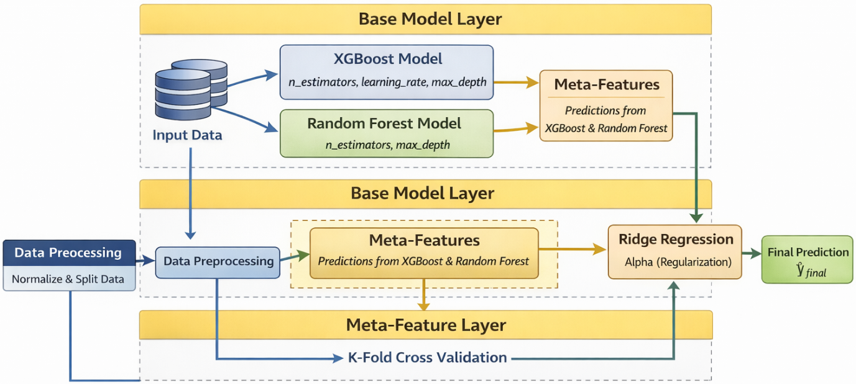
Figure 5. Proposed Stacking Model Architecture.

Algorithm 1: Nested Cross-Validated Training and Evaluation of the Stacking Model (XGBoost + Random Forest → Ridge)
Input:
Dataset D = {(xᵢ, yᵢ)}, i = 1, …, N (N = 166 countries; y = unemployment rate, %)
Numbers of outer and inner folds K_out = 5 and K_in = 5; folds stratified by region × income group
Base learners: XGBoost, Random Forest; meta-learner: RidgeCV with penalty grid A
Output:
Out-of-fold predictions ŷ_OOF for all N countries and metrics (RMSE, MAE, MAPE, R², %≤t)
Final model refitted on the full dataset D (used for SHAP and PDP analysis)
- Outer split
Partition D into K_out stratified folds F₁, …, F_K; then, for each k = 1, …, K_out:
D_train ← D \ F_k ; D_test ← F_k
- Fold-specific preprocessing
Fit imputation, winsorization limits, and scaling on D_train only; apply them to D_train and D_test
- Hyperparameter tuning (inner cross-validation on D_train)
Select XGBoost and Random Forest hyperparameters by K_in-fold CV (grid search or Optuna) on D_train
- Generate meta-features (inner out-of-fold predictions)
For j = 1, …, K_in: fit XGB and RF on D_train without inner fold j; predict inner fold j
X_meta_train ← [ŷ_XGB, ŷ_RF] (out-of-fold for every country in D_train)
- Train meta-learner and refit base learners
Fit RidgeCV on (X_meta_train, y_train), selecting α from A by internal CV
Refit XGB and RF on all of D_train
- Predict the held-out outer fold
X_meta_test ← [XGB(X_test), RF(X_test)]; ŷ_test ← Ridge(X_meta_test)
Store ŷ_test as the out-of-fold predictions of the countries in F_k
- Evaluate
Compute RMSE, MAE, MAPE, R², and %≤t from ŷ_OOF and y over all N countries
- Final model
Repeat steps 3–5 on the full dataset D to obtain the final model used for interpretation
End of Algorithm

In summary, all models were evaluated under the same cross-validation protocol and with the same metrics. For every model, the main hyperparameters (e.g., n_estimators, learning_rate, max_depth, min_samples_leaf, and alpha) were tuned using grid or random search within the training folds. The stacking ensemble uses the out-of-fold predictions of XGBoost and Random Forest as inputs to a Ridge regression meta-learner.
3.4.1 Performance Metrics
The models are evaluated using RMSE, MAE, MAPE, $R^{2}$, and the policy-oriented threshold accuracy ($\%_{≤t}$) to assess prediction precision and reliability.
All metrics are computed from the pooled out-of-fold predictions; that is, the prediction for each country is made by a model that did not see that country during training. Errors are expressed in percentage points (pp) of the unemployment rate. MAE is the mean of the absolute prediction errors, and the threshold accuracy %≤t is the percentage of countries whose absolute prediction error does not exceed t pp.
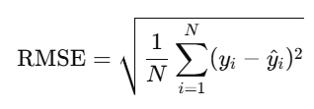 (6)
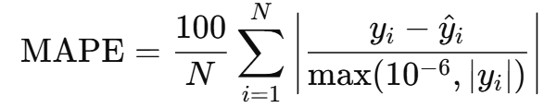 (7)
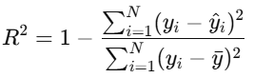 (8)
Threshold accuracy (policy oriented) for threshold $t$(percentage points):
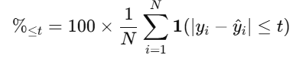 (9)
3.4.2 Training Parameters and Settings
The stacking framework uses two base learners, XGBoost and Random Forest, combined by a RidgeCV meta-learner. In the final configuration (S2 in Table 10), XGBoost used 800 trees, a maximum depth of 5, a learning rate of 0.05, a subsample ratio of 0.9, and a column sampling ratio of 0.9, while Random Forest used 700 trees and a minimum leaf size of 2. Ridge penalties (alpha) of 0.1, 1.0, and 10.0 were compared, and the passthrough option (whether the original features are passed to the meta-learner in addition to the base-model predictions) was also examined (Table 10). Hyperparameters such as tree depth, learning rate, and subsampling ratio were tuned within the training folds by grid search and, optionally, by Optuna’s Bayesian optimization. The sensitivity of the results to these choices is reported in Tables 8–11.
All experiments were implemented in Python 3.10 using scikit-learn, XGBoost, CatBoost, LightGBM, and SHAP, with Seaborn and Plotly for visualization. The computations were run on a Windows 11 (64-bit) workstation with an Intel® Core™ i7-12700H processor (2.3 GHz, 14 cores), 16 GB DDR5 RAM, and an NVIDIA® RTX 3060 GPU (6 GB VRAM) with CUDA 11.8.
3.4.3 Cross-Validation Design
Why not time-series validation? Because the dataset is cross-sectional, there is no temporal ordering to exploit, and time-series validation schemes (e.g., rolling-origin evaluation) are not applicable. Instead, model performance is evaluated by how well the models predict the unemployment rate of countries that were not used for training. A nested cross-validation design is used, summarized in Algorithm 1 and Figure 1.
Outer loop (performance estimation). The 166 countries are partitioned into five folds. The folds are stratified by the combination of geographic region and income group, so that each fold contains a similar mix of regions and income levels and no fold is dominated by one type of economy. In each of the five iterations, four folds (approximately 80% of the countries) are used for training and the remaining fold (approximately 20%) is held out for testing. Every country therefore appears in a test fold exactly once, and the predictions obtained for the held-out countries are collected as out-of-fold (OOF) predictions. All metrics reported in Section 4 (Tables 2–11) are computed from these pooled OOF predictions.
Inner loop (model building). Within each outer training set, (i) the imputation model, winsorization limits, and scaling parameters are estimated and then applied to the held-out fold; (ii) hyperparameters are tuned by an inner five-fold cross-validation; and (iii) for the stacking model, inner five-fold cross-validation is used to generate OOF predictions of XGBoost and Random Forest for every training country. These inner OOF predictions form the meta-features on which the Ridge meta-learner is trained. The base learners are then refitted on the full outer training set, and their predictions for the held-out fold are passed to the trained meta-learner. Consequently, no information from the test countries enters preprocessing, tuning, or meta-learner training, which prevents data leakage.
Region and income-group results. The region-wise and income-group results (Tables 5 and 6) and the calibration analysis (Table 7) are obtained by grouping the same pooled OOF predictions by region, income group, or predicted band; they are not produced by separate models. The term “geography-aware cross-validation” used in this paper refers to this stratification by region and income group, which ensures that every region is represented in both the training and the test data of each fold.
4. Results and Discussion
Table 2 summarizes the out-of-fold performance of the models in terms of RMSE, MAPE, R², and the percentage of countries predicted within ±0.5 pp and ±1.0 pp of their observed unemployment rate. The stacking ensemble (XGBoost + Random Forest → Ridge) performed best, with an RMSE of 1.18 pp, a MAPE of 8.4%, and an R² of 0.90; 59% of countries were predicted within ±0.5 pp and 83% within ±1.0 pp. XGBoost was the strongest single model (RMSE = 1.24 pp, MAPE = 8.9%, R² = 0.89; 56% and 81% within ±0.5 and ±1.0 pp), followed by CatBoost (RMSE = 1.27 pp, MAPE = 9.1%, R² = 0.88; 55% and 80%) and LightGBM (RMSE = 1.30 pp, MAPE = 9.3%, R² = 0.87; 53% and 79%). Random Forest achieved an RMSE of 1.42 pp, a MAPE of 10.1%, and an R² of 0.84 (47% and 72%), while Linear Regression performed worst (RMSE = 2.04 pp, MAPE = 14.8%, R² = 0.71; 30% and 51%). The large gap between Linear Regression and the tree-based models indicates that the relationships between the indicators and unemployment are substantially non-linear. The differences among the gradient boosting models and the stacking ensemble are modest (RMSE differences of 0.06–0.12 pp) and, given a sample of 166 countries, should be interpreted with appropriate caution.
Table 2. Comparison of Predictive Performance and Error Metrics for Different Machine Learning Models.
Model | RMSE (pp) | MAPE (%) | R² | % ≤ 0.5 pp | % ≤ 1.0 pp
Stacking (XGB+RF → Ridge) | 1.18 | 8.4 | 0.90 | 59 | 83
XGBoost | 1.24 | 8.9 | 0.89 | 56 | 81
CatBoost | 1.27 | 9.1 | 0.88 | 55 | 80
LightGBM | 1.30 | 9.3 | 0.87 | 53 | 79
Random Forest | 1.42 | 10.1 | 0.84 | 47 | 72
Linear Regression | 2.04 | 14.8 | 0.71 | 30 | 51

Figure 6 compares the models visually in terms of RMSE (pp), MAPE (%), R², and the percentage of predictions within ±0.5 pp and ±1.0 pp. The stacking ensemble achieves the best value on every metric, whereas Linear Regression performs worst on every metric.
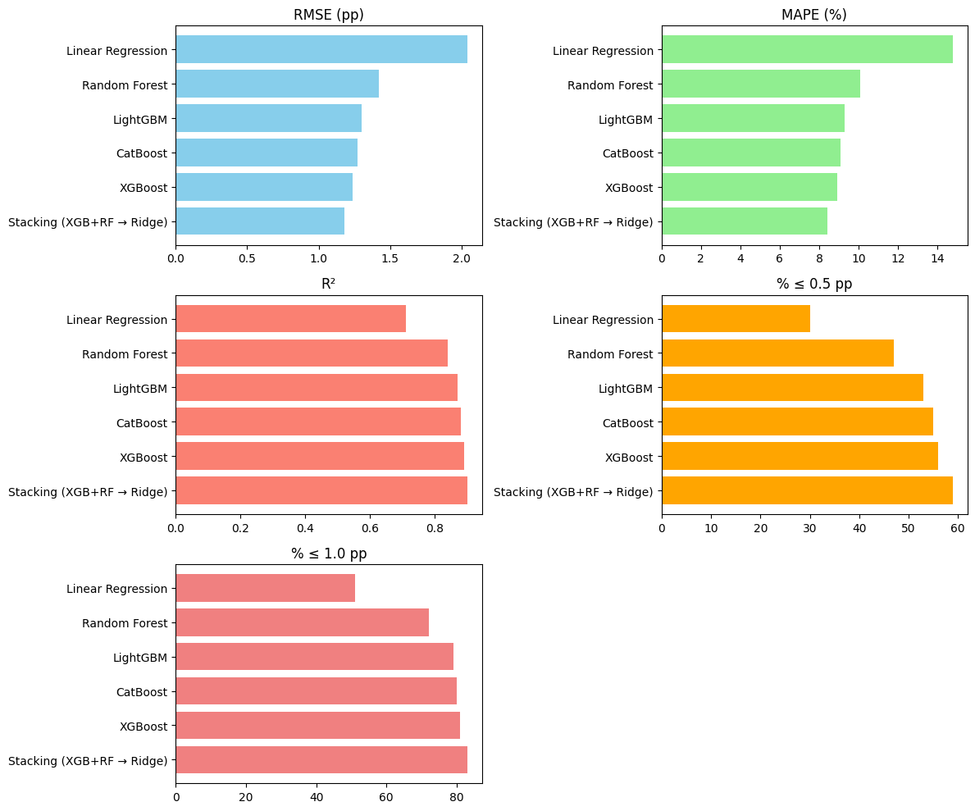
Figure 6. Comparison of Predictive Performance and Error Metrics Across Machine Learning Models.
Table 3 adds the mean absolute error (MAE) for the four best-performing models. The stacking model again achieved the lowest errors (RMSE = 1.18 pp, MAE = 0.92 pp, MAPE = 8.4%) and the highest R² (0.90). It was followed by XGBoost (RMSE = 1.24 pp, MAE = 0.97 pp, MAPE = 8.9%, R² = 0.89), CatBoost (RMSE = 1.27 pp, MAE = 0.99 pp, MAPE = 9.1%, R² = 0.88), and LightGBM (RMSE = 1.30 pp, MAE = 1.02 pp, MAPE = 9.3%, R² = 0.87). The ranking of the models is therefore consistent across all four metrics and with Table 2.
Table 3. Error Metrics (Including MAE) for the Four Best-Performing Models.
Model | RMSE (pp) | MAE (pp) | MAPE (%) | R²
Stacking (XGB+RF → Ridge) | 1.18 | 0.92 | 8.4 | 0.90
XGBoost | 1.24 | 0.97 | 8.9 | 0.89
CatBoost | 1.27 | 0.99 | 9.1 | 0.88
LightGBM | 1.30 | 1.02 | 9.3 | 0.87

Figure 7 visualizes the metrics in Table 3. The stacking model performs best on all four metrics, followed by XGBoost, CatBoost, and LightGBM, in that order.
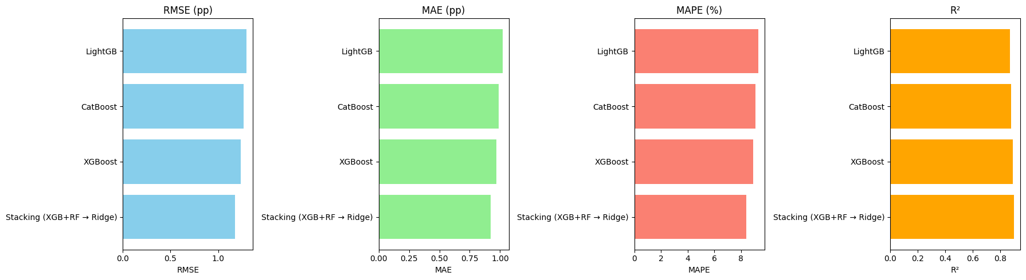
Figure 7. Comparison of the Four Best-Performing Models in Terms of RMSE, MAE, MAPE, and R².
Table 4 compares the threshold accuracy of the stacking model and XGBoost at five error margins. The stacking model predicted 33% of countries within ±0.25 pp, 59% within ±0.5 pp, 72% within ±0.75 pp, 83% within ±1.0 pp, and 91% within ±1.5 pp; the corresponding values for XGBoost were 31%, 56%, 70%, 81%, and 90%. The stacking model is therefore slightly more accurate at every threshold, with the largest gain (3 percentage points) at ±0.5 pp.
Table 4. Threshold Accuracy (% of Countries Predicted Within ±t pp) for the Stacking Model and XGBoost.
Model | ≤ 0.25 pp | ≤ 0.5 pp | ≤ 0.75 pp | ≤ 1.0 pp | ≤ 1.5 pp
Stacking | 33 | 59 | 72 | 83 | 91
XGBoost | 31 | 56 | 70 | 81 | 90

Table 5 reports the performance of the stacking model by region, computed from the pooled out-of-fold predictions. Accuracy was highest for Europe (n = 36; RMSE = 1.03 pp, MAE = 0.82 pp, 88% within ±1.0 pp) and the Americas (n = 28; RMSE = 1.10 pp, MAE = 0.86 pp, 86%), followed by Asia/Oceania (n = 40; RMSE = 1.21 pp, MAE = 0.95 pp, 82%) and Africa (n = 50; RMSE = 1.31 pp, MAE = 1.01 pp, 79%). The Unknown/Mixed group (n = 12) had the largest errors (RMSE = 1.38 pp, MAE = 1.10 pp, 75%). Because some groups are small, these differences are indicative rather than precise.
Table 5. Region-wise Performance of the Stacking Model (Out-of-Fold Predictions).
Region | Count | RMSE (pp) | MAE (pp) | % ≤ 1.0 pp
Americas | 28 | 1.10 | 0.86 | 86
Europe | 36 | 1.03 | 0.82 | 88
Africa | 50 | 1.31 | 1.01 | 79
Asia/Oceania | 40 | 1.21 | 0.95 | 82
Unknown/Mixed | 12 | 1.38 | 1.10 | 75

Table 6 summarizes performance by income group. Errors increased steadily from high- to low-income countries: high income (RMSE = 1.00 pp, MAE = 0.78 pp, 90% within ±1.0 pp), upper-middle income (RMSE = 1.15 pp, MAE = 0.90 pp, 85%), lower-middle income (RMSE = 1.28 pp, MAE = 1.00 pp, 80%), and low income (RMSE = 1.45 pp, MAE = 1.16 pp, 74%). This gradient may reflect greater economic volatility, larger informal sectors, and lower statistical capacity in lower-income countries, which make their unemployment rates harder to predict from structural indicators.
Table 6. Performance of the Stacking Model by Income Group (GDP per Capita Quartiles).
Income Group | Count | RMSE (pp) | MAE (pp) | % ≤ 1.0 pp
High | 40 | 1.00 | 0.78 | 90
Upper-Mid | 40 | 1.15 | 0.90 | 85
Lower-Mid | 40 | 1.28 | 1.00 | 80
Low | 40 | 1.45 | 1.16 | 74

Table 7 assesses the calibration of the stacking model by grouping the out-of-fold predictions into bands and comparing the mean predicted and mean observed unemployment rates within each band. The two means are closely aligned in all bands, with differences (observed − predicted) between −0.2 and +0.1 pp; for example, for predictions above 10%, the mean prediction was 11.6% and the observed mean was 11.4%. This indicates little systematic bias across the range of unemployment rates, although the slight over-prediction in the highest band suggests mild over-estimation for countries with very high predicted unemployment.
Table 7. Calibration of the Stacking Model: Mean Predicted vs. Mean Observed Unemployment Rate by Predicted Band (Out-of-Fold Predictions).
Predicted Band (pp) | N | Mean Pred | Mean Actual | Diff
< 5 | 24 | 4.2 | 4.3 | +0.1
5–7.5 | 52 | 6.2 | 6.3 | +0.1
7.5–10 | 54 | 8.6 | 8.6 | 0.0
> 10 | 36 | 11.6 | 11.4 | -0.2

To assess the sensitivity of the results to the main hyperparameters, we varied n_estimators, max_depth, and learning_rate for XGBoost; n_estimators, max_depth, and min_samples_leaf for Random Forest; and the base-learner configurations, the Ridge penalty (alpha), and the passthrough option for the stacking model. Table 8 reports the results for XGBoost.
Table 8. XGBoost Parameter Sensitivity Results (n_estimators, max_depth, learning_rate)
ID | n_estimators | learning_rate | RMSE (pp) | MAE (pp) | MAPE (%) | R²
X1 | 400 | 0.10 | 1.31 | 1.01 | 9.4 | 0.88
X2 | 600 | 0.05 | 1.26 | 0.98 | 9.1 | 0.89
X3 | 800 | 0.05 | 1.24 | 0.97 | 8.9 | 0.89
X4 | 1000 | 0.03 | 1.25 | 0.98 | 9.0 | 0.89
X5 | 800 | 0.05 | 1.31 | 1.02 | 9.5 | 0.88

Among the XGBoost configurations, X3 (n_estimators = 800, learning_rate = 0.05) achieved the best performance (RMSE = 1.24 pp, MAE = 0.97 pp, MAPE = 8.9%, R² = 0.89); this configuration, with a maximum depth of 5, was used as the XGBoost base learner in the stacking model. Configurations X2 and X4 performed almost identically (RMSE = 1.26 and 1.25 pp), indicating that the model is not highly sensitive to these settings, whereas X1 (fewer trees and a higher learning rate) and X5 (same n_estimators and learning rate as X3 but a different max_depth) performed worse (RMSE = 1.31 pp). For Random Forest (Table 9), increasing the number of trees and the minimum leaf size from R1 (300 trees, leaf size 1) to R2 (500 trees, leaf size 2) reduced the RMSE from 1.48 to 1.42 pp. R3 (700 trees, leaf size 2) gave the lowest errors (RMSE = 1.41 pp, MAE = 1.11 pp), although its improvement over R2 was marginal, and R4, which differs from R3 only in max_depth, performed slightly worse (RMSE = 1.43 pp).
Table 9. Random Forest Parameter Sensitivity Results (n_estimators, max_depth, min_samples_leaf).
ID | n_estimators | min_samples_leaf | RMSE (pp) | MAE (pp) | MAPE (%) | R²
R1 | 300 | 1 | 1.48 | 1.16 | 10.6 | 0.83
R2 | 500 | 2 | 1.42 | 1.12 | 10.1 | 0.84
R3 | 700 | 2 | 1.41 | 1.11 | 10.0 | 0.84
R4 | 700 | 2 | 1.43 | 1.13 | 10.2 | 0.84

For the stacking model (Table 10), the best performance was obtained with configuration S2, which combines XGBoost (n_estimators = 800, max_depth = 5, learning_rate = 0.05) and Random Forest (n_estimators = 700, min_samples_leaf = 2) with a Ridge penalty of alpha = 1.0 and passthrough enabled (RMSE = 1.18 pp, MAE = 0.92 pp, MAPE = 8.4%, R² = 0.90). The other configurations performed only slightly worse (RMSE = 1.19–1.23 pp), indicating that the ensemble is robust to the choice of meta-learner settings.
Table 10. Sensitivity of the Stacking Model (XGB + RF → Ridge) to Base-Learner Settings, Ridge Penalty (alpha), and Passthrough.
ID | XGB (n_estimators,max_depth,lr) | RF (n_estimators,  leaf) | Meta (alpha) | passthrough | RMSE (pp) | MAE (pp) | MAPE (%) | R² | % ≤ 1.0 pp
S1 | (600,4,0.05) | (500,2) | 1.0 | 0 | 1.23 | 0.96 | 8.8 | 0.89 | 81
S2 | (800,5,0.05) | (700,2) | 1.0 | 1 | 1.18 | 0.92 | 8.4 | 0.90 | 83
S3 | (1000,6,0.03) | (700,2) | 0.1 | 1 | 1.19 | 0.93 | 8.5 | 0.90 | 82
S4 | (800,5,0.05) | (500,1) | 10.0 | 1 | 1.21 | 0.94 | 8.6 | 0.90 | 82

Table 11 reports the threshold accuracy of the four stacking configurations. Configuration S2 again performed best, predicting 83% of countries within ±1.0 pp and 91% within ±1.5 pp, while the other configurations were within 1–3 percentage points of these values at every threshold. These results confirm that the performance of the stacking ensemble is stable across reasonable hyperparameter choices.
Table 11. Threshold Accuracy by Parameter Set (Stacking)
ID | ≤0.25 pp | ≤0.5 pp | ≤0.75 pp | ≤1.0 pp | ≤1.5 pp
S1 | 31 | 56 | 69 | 81 | 90
S2 | 33 | 59 | 72 | 83 | 91
S3 | 32 | 58 | 71 | 82 | 90
S4 | 32 | 58 | 70 | 82 | 90

Overall, the stacking model (XGB + RF → Ridge) achieved the lowest RMSE (1.18 pp) and MAE (0.92 pp) and the highest R² (0.90), with 83% and 91% of countries predicted within ±1.0 pp and ±1.5 pp, respectively. By combining the flexible, non-linear fit of XGBoost with the low-variance predictions of Random Forest, the ensemble was slightly but consistently more accurate than either base learner.
In summary, the stacking ensemble outperformed the individual models: compared with the tuned gradient boosting models, it reduced the RMSE by 0.06–0.12 pp and increased the share of countries predicted within ±1.0 pp to 83%. When stratified by region and income group, performance was best for high-income countries and for Europe and the Americas, and errors were larger for lower-income countries, consistent with greater volatility and data scarcity. The SHAP analysis indicates that higher values of human-capital indicators (life expectancy and physicians per thousand people) and of fiscal capacity (tax revenue) are associated with lower predicted unemployment, whereas higher CPI and CPI change and stronger demographic pressure (population density and fertility) are associated with higher predicted unemployment. The calibration analysis (Table 7) shows little systematic bias across predicted bands. Figure 8 shows actual versus predicted values and the distribution of residuals.
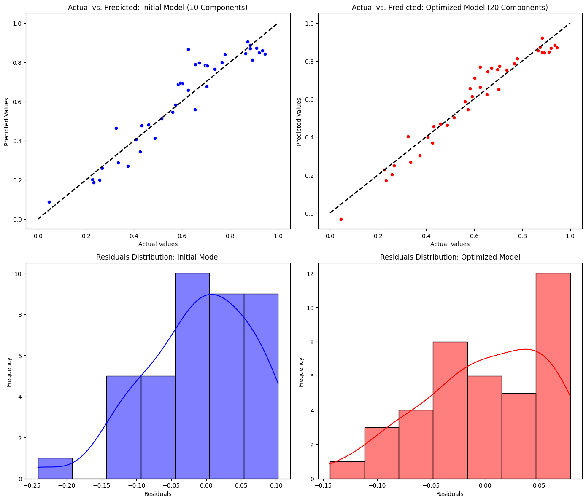
Figure 8. Actual vs. Predicted Values (Top) and Residual Distributions (Bottom) for the Initial and Optimized Model Configurations.
Figure 8 compares the initial and optimized model configurations in terms of actual versus predicted values (top panels, shown on a normalized 0–1 scale) and residual distributions (bottom panels). The predictions of the optimized model lie closer to the 45-degree line, and its residuals fall within a narrower range (approximately −0.15 to +0.08, compared with −0.24 to +0.10 for the initial model), indicating smaller and less extreme errors. Some asymmetry remains in the residual distribution of the optimized model, suggesting that a small systematic component of the error persists.
4.1 Discussion
The results show that a stacking ensemble can predict cross-country differences in unemployment rates with good accuracy while remaining interpretable. Because XGBoost and Random Forest are themselves ensembles and the Ridge meta-learner learns how to weight them, the combined model can capture complex, non-linear relationships between macroeconomic conditions, socio-demographic structure, and labor market outcomes. Globally, the model achieved an out-of-fold RMSE of 1.18 pp and an R² of 0.90. It is important to stress that these results describe the model’s ability to explain cross-country variation at a single point in time; they do not demonstrate an ability to forecast future unemployment, which would require panel data and a temporal validation design.
The interpretability analysis yields patterns that are consistent with established economic arguments linking human capital, macroeconomic stability, and structural conditions to unemployment. The SHAP values and partial dependence plots indicate that higher life expectancy, greater physician density, and stronger fiscal capacity are associated with lower predicted unemployment, whereas price instability (CPI and CPI change) and demographic pressure (population density and fertility rate) are associated with higher predicted unemployment. However, these findings should be interpreted as associations learned by a predictive model from cross-sectional data, not as causal effects. Several of these indicators are strongly correlated with the overall level of economic development (e.g., GDP and HDI; Figure 2), so they may act as proxies for development or for unobserved factors such as institutional quality. Moreover, SHAP and partial dependence plots describe how the model uses the features, and with correlated predictors the attributions can be shared among related variables. Establishing causal relationships would require dedicated identification strategies, such as panel data with fixed effects, instrumental variables, or quasi-experimental designs.
Model performance was highest for high-income countries and for Europe and the Americas (e.g., an RMSE of 1.03 pp in Europe) and lower in Africa and for low-income countries, where RMSE and MAE were higher. These differences are likely due to a combination of lower data quality and availability, greater economic volatility, larger informal sectors, and structural features that are not captured by the available indicators. Performance in these regions could be improved by adding region-specific variables, by developing specialized regional models, and by including governance and institutional quality indicators such as the Worldwide Governance Indicators (WGI). For resource-rich economies such as Saudi Arabia and the other GCC countries, whose labor markets are shaped by the structure of public-sector employment and a large share of expatriate workers, indicators of labor market segmentation would be valuable additions.
The results also support previous findings that careful preprocessing, here iterative imputation of missing values and winsorization of extreme values, is important for model stability, particularly in cross-country data with heterogeneous data quality. Fitting these steps within the training folds and stratifying the folds by region and income group ensures that the reported performance reflects predictions for countries that the model has not seen, rather than an optimistic in-sample fit.
An important advantage of the proposed approach is its transparency: explainable AI techniques such as SHAP and PDP make it possible to inspect how the model arrives at its predictions, which is essential for building policymakers’ trust in high-stakes applications such as labor market analysis. The finding that human-capital and fiscal-capacity indicators are among the most influential predictors suggests that these dimensions deserve attention in policy analysis. However, because the relationships are associative, the results identify where further causal investigation is warranted rather than prescribing specific interventions.
The stacking ensemble balances model complexity and accuracy by combining variance reduction (Random Forest) with the ability to capture non-linear interactions (XGBoost). It outperformed both base learners in RMSE and in the share of countries predicted within ±1.0 pp. The gain over the best single model is modest (RMSE of 1.18 vs. 1.24 pp), so the main value of stacking lies in consistent, incremental improvements and in robustness across configurations (Tables 10 and 11).
Several limitations should be noted. First, the analysis is based on cross-sectional data for a single year (approximately 2023). It therefore cannot capture labor market dynamics, the lagged effects of macroeconomic shocks, or changes over time, and it does not constitute time-series forecasting. Second, the results are associational: the identified predictors should not be interpreted as causes of unemployment, and omitted variables (e.g., governance quality and the size of the informal labor market) may confound the observed relationships. Third, the modelling sample is relatively small (166 countries), so differences between models and between small regional groups are subject to sampling uncertainty. Fourth, unemployment rates are measured with different definitions and levels of accuracy across national statistical systems, which may affect both training and evaluation. Future work should use panel data to build genuine forecasting models that test the lagged effects of macroeconomic shocks and regime changes under a temporal validation design.
Further improvements are possible. Monotonic constraints could be imposed so that the direction of selected relationships is consistent with economic theory, which would improve the plausibility of the model’s behaviour; for example, predicted unemployment could be constrained to be non-increasing in life expectancy if this is supported by prior evidence. Adding governance indicators, measures of education quality, and digital inclusion (e.g., internet coverage) may improve the model’s ability to explain cross-country differences, and region-specific calibration could improve accuracy in low-income or unstable regions. Finally, uncertainty quantification methods such as conformal prediction could provide reliable prediction intervals to support decision-making under uncertainty.
Table 12 compares the present study with related work. Most previous studies focus on a single country or on a relatively homogeneous group of countries, often in a time-series setting, whereas the present study covers a broad cross-section of countries and evaluates performance with an explicitly documented, leakage-free cross-validation design and policy-oriented threshold metrics. Because the studies differ in their targets, data, temporal settings, and evaluation metrics, the reported performance values are not directly comparable; the table should therefore be read as a qualitative comparison of scope and methodology rather than as a ranking.
Table 12. Comparative Synthesis of Unemployment Rate Forecasting Methodologies.
Study (Author(s) & Year) | Scope (Regions) | Methodology | Key Performance Metrics | Limitations | Comparison to Present Study
Present study | Global cross-section (166 countries with observed unemployment) | Stacking ensemble (XGBoost + Random Forest base learners with Ridge meta-learner); geography-aware CV, imputation, winsorization | RMSE: 1.18 pp; MAPE: 8.4%; R²: 0.90; 83% within ±1.0 pp | Cross-sectional (2023 data); lacks temporal dynamics; higher errors in low-income regions due to data volatility | N/A (reference)
Abdelhay & Altamimi (2025) | Jordan (single country) | Ensemble ML with normalization and feature scaling | Predictive accuracy: 85% | Missing data in crises; no real-time integration | Single-country study; the present study covers a broad cross-section of countries and adds SHAP-based interpretation. Metrics are not directly comparable.
Adewale et al. (2024) | Macroeconomic (GDP) prediction | Ensemble models (Random Forest, Gradient Boosting) | Accuracy: 90% | Poor data quality in regions; no cross-validation for heterogeneity | Targets GDP rather than unemployment; supports the use of ensembles, which the present study applies to cross-country unemployment.
Chakraborty et al. (2020) | India (single country) | Hybrid LSTM with log transformation and rolling averages | Accuracy: 89% | Lacks real-time data; errors in rapid changes | Time-series forecasting for one setting; the present study is cross-sectional and does not model temporal dynamics.
Gupta et al. (2022) | UK (single country) | Random Forest with detrending and outlier detection | Accuracy: 87% | Fails to capture global shocks (e.g., COVID-19) | Long time series for one country; the present study instead explains cross-country variation with multi-sector indicators.
Ramírez et al. (2024) | Latin American countries (regional) | Hybrid RNN-GA with normalization and CV | Accuracy: 88% | Generalization issues across datasets | Regional time-series model; the present study uses stacking with a documented cross-validation design across all regions.
Wijnhoven et al. (2023) | Europe (youth unemployment, regional) | Stacking ensemble with Google Trends | Accuracy: 92% | Variable data quality; regional instability | Also uses alternative data; the present study relies on structural indicators and SHAP explanations.
Sun et al. (2025) | Economic cycle forecasting (news sentiment) | Interpretable ML with news narrative sentiment, feature selection | Accuracy: 91% | Data comparability issues internationally | Different target (economic cycles); both studies emphasize interpretability.
Grybauskas et al. (2023) | EU (regional, with Google Trends) | Neural networks with spatial/temporal smoothing | Good generalizability (no exact %; RMSE implied low) | Data holes in low-income areas | Nowcasting with alternative data; the present study uses structural indicators and region-stratified cross-validation.
Chen & Guestrin (2016) | Methodological (general-purpose) | Scalable tree boosting system (XGBoost) | N/A (algorithmic contribution) | Not specific to unemployment | Methodological basis of the XGBoost base learner used in the present study.
Lundberg & Lee (2017) | Methodological (model interpretation) | SHAP (Shapley additive explanations) | N/A (focus on explainability) | Explains model behaviour; does not establish causality | Methodological basis of the SHAP analysis used in the present study.

Overall, this work provides a complete and explainable machine learning pipeline for predicting unemployment rates across countries, in which the stacking ensemble achieved the highest accuracy and stability among the models compared. Although the model performs well across regions, regional specialization, governance variables, and panel data could further improve its explanatory and predictive power in future work.

5. Conclusion and Future Work
This study proposed an interpretable framework for predicting unemployment rates across countries, based on a stacking ensemble of XGBoost and Random Forest with a Ridge meta-learner. The model was trained on preprocessed cross-sectional data (with imputation of missing values, winsorization, and engineered income-group and regional features) and evaluated with nested cross-validation stratified by region and income group, which accounts for heterogeneous data quality and prevents data leakage. The model achieved an out-of-fold RMSE of 1.18 pp and an R² of 0.90. SHAP and partial dependence analyses showed that indicators such as life expectancy, physician density, and fiscal capacity are among the most influential predictors. The key findings are summarized below.
Data and Methods:
- The dataset is a cross-sectional snapshot (approximately 2023) of 195 countries, of which the 166 with an observed unemployment rate were used for modelling; it covers macroeconomic, demographic, health, education, environmental, and fiscal indicators.
- Missing-value imputation, winsorization, and feature engineering improved the quality and consistency of the model inputs.
- Nested five-fold cross-validation stratified by region and income group, with all preprocessing and tuning performed within the training folds, provided leakage-free out-of-fold performance estimates.
Model Performance:
- The stacking ensemble achieved an RMSE of 1.18 pp (R² = 0.90), outperforming the best single model (XGBoost, RMSE = 1.24 pp) and the linear baseline (RMSE = 2.04 pp).
- SHAP and partial dependence plots identified life expectancy, physician density, and fiscal capacity as important predictors; these are associations, not causal effects.
- Prediction errors were smallest for high-income countries and for Europe and the Americas, and largest for low-income countries.
Visualization Results:
- The actual-versus-predicted plots (Figure 8) and the threshold analysis (Table 4) show that 83% of countries were predicted within ±1.0 pp and 91% within ±1.5 pp of their observed unemployment rate.
- Life expectancy and physicians per capita were among the strongest predictors of cross-country differences in unemployment, which is consistent with economic arguments linking health, human capital, and labor market outcomes, although causality cannot be inferred from these data.
Limitations:
- The data are cross-sectional and refer to a single year; the model therefore does not capture temporal dynamics and does not perform time-series forecasting.
- The relationships identified are associative and may be confounded by omitted factors such as governance quality and labor market informality.
- Governance and institutional variables, which are important for explaining the influence of political and institutional factors on unemployment, were not available.
- The sample (166 countries) is relatively small, and errors are larger for low-income countries with lower data quality.
- Alternative, timely data sources (e.g., online search or social media data) were not used.
Future Directions:
- Extend the framework to panel data in order to perform genuine time-series forecasting, model the lagged effects of macroeconomic shocks, and apply temporal (rolling-origin) validation.
- Add governance and institutional indicators (e.g., WGI), measures of education quality, and digital inclusion.
- Investigate hierarchical and region-specific models, including models tailored to GCC and other resource-rich economies.
- Apply monotonic constraints so that model behaviour is consistent with economic theory.
- Use causal inference methods (e.g., panel fixed effects or quasi-experimental designs) to test whether the identified associations reflect causal effects.
- Incorporate uncertainty quantification (e.g., conformal prediction) to provide reliable prediction intervals for policymakers.
- With these extensions, the framework could support timely, evidence-informed labor market analysis at the global scale.

References
- Abdelhay, O., & Altamimi, T. (2025). Non-Traditional Data for Macroeconomic Estimation Unemployment in Jordan as an Application. Scientific Data, 12(1). https://doi.org/10.1038/s41597-025-04721-6
- Adewale, M. D., Ebem, D., Awodele, O., Sambo-Magaji, A., Aggrey, E., Okechalu, E. A., Donatus, R. E., Olayanju, K. A., Owolabi, A., Oju, J. U., Ubadike, O., Otu, G. A., Muhammed, U. I., Danjuma, O. R., & Oluyide, O. (2024). Predicting gross domestic product using the ensemble machine learning method. Systems and Soft Computing, 6, 200132. https://doi.org/10.1016/j.sasc.2024.200132
- Chakraborty, T., Chakraborty, A. K., Biswas, M., Banerjee, S., & Bhattacharya, S. (2020). Unemployment Rate Forecasting: A Hybrid Approach. Computational Economics, 57(1), 183. https://doi.org/10.1007/s10614-020-10040-2
- Chuan, Z. L., Wei, C., Japashov, N., Yuan, S. K., Qing, T. W., Ismail, Prof. Dr. N., Liong, Assoc. Prof. Dr. C.-Y., & Hiae, T. E. (2023). Analyzing Enrolment Patterns: Stacked Ensemble Statistical Learning-Based Approach to Educational Decision Making. Research Square (Research Square). https://doi.org/10.21203/rs.3.rs-3723176/v1
- Gao, J., Zhang, Y., & Zhou, T. (2019). Computational socioeconomics. Physics Reports, 817, 1. https://doi.org/10.1016/j.physrep.2019.05.002
- Gupta, R., Pierdzioch, C., & Salisu, A. A. (2022). Oil-price uncertainty and the U.K. unemployment rate: A forecasting experiment with random forests using 150 years of data. Resources Policy, 77, 102662. https://doi.org/10.1016/j.resourpol.2022.102662
- Kant, D., Pick, A., & Winter, J. de. (2024). Nowcasting GDP using machine learning methods. AStA Advances in Statistical Analysis. https://doi.org/10.1007/s10182-024-00515-0
- Kim, K. (2025). Unemployment Dynamics Forecasting with Machine Learning Regression Models. https://doi.org/10.48550/ARXIV.2505.01933
- Łapiński, T. M., & Ziółkowski, K. (2025). Ensembled Direct Multi Step forecasting methodology with comparison on macroeconomic and financial data. https://doi.org/10.48550/ARXIV.2509.13945
- Lechuga López, L. J., Elsharief, S., Al Jorf, D., Darwish, F., Ma, C., & Shamout, F. E. (2025). Uncertainty Quantification for Machine Learning in Healthcare: A Survey.
- Longo, L., Riccaboni, M., & Rungi, A. (2021). A neural network ensemble approach for GDP forecasting. Journal of Economic Dynamics and Control, 134, 104278. https://doi.org/10.1016/j.jedc.2021.104278
- Lundberg, S., & Lee, S. (2017). A Unified Approach to Interpreting Model Predictions. arXiv (Cornell University). https://doi.org/10.48550/arxiv.1705.07874
- Mogale, B. V., Montshiwa, T. V., & Tsoku, J. T. (2024). Forecasting the South African labour market indicators: A comparison of ARIMA, count series models and machine learning regressors. Research Square (Research Square). https://doi.org/10.21203/rs.3.rs-5360162/v1
- Mucsányi, B., Kirchhof, M., & Oh, S. J. (2024). Benchmarking Uncertainty Disentanglement: Specialized Uncertainties for Specialized Tasks.
- Nagy, M., & Molontay, R. (2023). Interpretable Dropout Prediction: Towards XAI-Based Personalized Intervention. International Journal of Artificial Intelligence in Education, 34(2), 274. https://doi.org/10.1007/s40593-023-00331-8
- Ramírez, K. M. M., Salgado–Reyes, N., Meza, J., Pacheco-Delgado, J., & Ventura, S. (2024). Unemployment Rate Prediction Using a Hybrid Model of Recurrent Neural Networks and Genetic Algorithms. Applied Sciences, 14(8), 3174. https://doi.org/10.3390/app14083174
- Schulze, M., Ebert, N., Reichardt, L., & Wasenmüller, O. (2025). Classifier Ensemble for Efficient Uncertainty Calibration of Deep Neural Networks for Image Classification. Proceedings of the 17th International Joint Conference on Computer Vision, Imaging and Computer Graphics Theory and Applications, 316. https://doi.org/10.5220/0013129000003912
- Wijnhoven, F., Bruijn, N. D., & Effing, R. (2023). Google Trends forecasting: Model re-specification of time-series for enhancing forecasts of youth unemployment. Research Square, https://doi.org/10.21203/rs.3.rs-3673015/v1.
- Zhao, L. (2020). Data-driven approach for predicting and explaining the risk of long-term unemployment. E3S Web of Conferences, 214, 1023-1032. https://doi.org/10.1051/e3sconf/202021401023.
- Sun, W., Wang, Y., Zhang, L., Chen, X. H., & Hoang, Y. (2025). Enhancing economic cycle forecasting based on interpretable machine learning and news narrative sentiment. Technological Forecasting and Social Change, 215, 124094. https://doi.org/10.1016/j.techfore.2025.124094.
- Grybauskas, A., Pilinkienė, V., Lukauskas, M., Stundžienė, A., & Bruneckienė, J. (2023). Nowcasting unemployment using neural networks and multi-dimensional Google Trends data. Economies, 11(5), 130. https://doi.org/10.3390/economies11050130.
- Li, Y., Wang, Z., Zhang, H., & Liu, S. (2021). Blending search queries with social media data to improve forecasts of economic indicators. arXiv, https://doi.org/10.48550/arxiv.2107.06096
- Chen, T., & Guestrin, C. (2016). XGBoost: A scalable tree boosting system. In Proceedings of the 22nd ACM SIGKDD International Conference on Knowledge Discovery and Data Mining (pp. 785-794). ACM. https://doi.org/10.1145/2939672.2939785.
- Simionescu, M., & Cifuentes‐Faura, J. (2021). Can unemployment forecasts based on Google Trends help government design better policies? An investigation based on Spain and Portugal. Journal of Policy Modeling, 44(1), 1-17. https://doi.org/10.1016/j.jpolmod.2021.09.011.
- Thuy, A., & Benoit, D. F. (2023). Explainability through uncertainty: Trustworthy decision-making with neural networks. European Journal of Operational Research, 317(2), 330-345. https://doi.org/10.1016/j.ejor.2023.09.009.
- Lundberg, S., & Lee, S. (2017). A unified approach to interpreting model predictions. arXiv. https://doi.org/10.48550/arxiv.1705.07874.
- Chukwuere, J. E. (2024). Conceptualizing predictive models for unemployment rates in the implementation of Industry 4.0. arXiv, https://doi.org/10.48550/ARXIV.2403.13536.
- Elgiriye, N. (2023). Global Country Information Dataset 2023: A comprehensive dataset empowering in-depth analysis and cross-country insights. Kaggle. https://www.kaggle.com/datasets/
- Chen, T., & Guestrin, C. (2016). XGBoost: A scalable tree boosting system. In Proceedings of the 22nd ACM SIGKDD International Conference on Knowledge Discovery and Data Mining (pp. 785-794). ACM. https://doi.org/10.1145/2939672.2939785
- Dorogush, A. V., Ershov, V., & Gulin, A. (2018). CatBoost: gradient boosting with categorical features support. In Proceedings of the 2018 IEEE International Conference on Data Mining (pp. 1026-1031). IEEE. https://doi.org/10.1109/ICDM.2018.00137
- Ke, G., Meng, Q., Cai, S., & Zheng, S. (2017). LightGBM: A highly efficient gradient boosting decision tree. In Proceedings of the 31st International Conference on Neural Information Processing Systems (pp. 3149-3157). Curran Associates, Inc. https://arxiv.org/abs/1712.09913
- Breiman, L. (2001). Random forests. Machine Learning, 45(1), 5-32. https://doi.org/10.1023/A:1010933404324
- Hoerl, A. E., & Kennard, R. W. (1970). Ridge regression: Biased estimation for nonorthogonal problems. Technometrics, 12(1), 55-67. https://doi.org/10.1080/00401706.1970.10488634
- Galton, F. (1886). Regression towards the mean in random samples. The Journal of the Anthropological Institute of Great Britain and Ireland, 15, 246-263. https://doi.org/10.2307/2841385

