Few-shot calibration rather than architecture drives cross-participant EEG emotion recognition with full and six-electrode montages
Saif Khan✉, Osama Bin Qashem, K. M. Fahim A. Bari, Rafid Rahman & Ahmed Wasif Reza
Abstract
Electroencephalography (EEG) emotion decoders must work for people whose data were never used in training, ideally on headsets with few electrodes, yet published cross-participant results differ in whether test-participant data are used. We benchmarked 26 models, including a two-stage contrastive model (CLISA-EWU), on four-class SEED-IV emotion recognition with repeated leave-one-participant-out validation (15 participants, three seeds) using 62 electrodes and a six-electrode frontal–temporal subset, scoring each held-out participant zero-shot and after calibration with 20 labelled windows (about 80 s). Zero-shot accuracy was modest (best 0.485, 95% CI 0.428–0.542; chance 0.25), and CLISA-EWU did not differ from a two-layer perceptron. Calibration added 16–21 percentage points to contrastive, adversarial and pseudo-label models but at most 2 points to supervised networks. Calibrated CLISA-EWU reached an accuracy of 0.678 (0.641–0.718; Cohen’s κ = 0.57, MCC = 0.58) with 62 electrodes and 0.620 (0.590–0.648; κ = 0.49) with six, retaining 91.4% of full-montage performance, and calibration made the model ranking consistent across participants (Kendall’s W 0.35 → 0.79). Brief user calibration, rather than architecture, explained most of the measurable gain.
Keywords EEG emotion recognition, cross-subject generalization, contrastive learning, few-shot calibration, wearable EEG, leave-one-subject-out validation
[Drafting note – delete before submission: yellow text marks pending results or facts to verify. All values are recomputed at the participant level from the per-fold results in the project repository.]

1 Introduction
Emotional states shape attention, decision making and mental health, and objective markers of emotion could support adaptive human–computer interaction, neurofeedback and digital mental-health monitoring^{1,2}. Electroencephalography (EEG) is portable, inexpensive and has millisecond resolution, which makes it the most practical neural signal for everyday affect sensing^{3,4}. Two obstacles separate laboratory results from use. First, a deployed decoder must work for a person whose data were never used in training, but EEG responses to the same stimulus differ markedly between individuals because of anatomy, electrode contact, baseline rhythms and appraisal^{5–7}. Second, research datasets are recorded with 32–64 electrodes, whereas wearable headsets carry far fewer.
Many methods target the first obstacle, including domain-adversarial networks^{6,8}, hemispheric-asymmetry models⁹, graph neural networks^{10–12} and contrastive learning designed to make representations participant-invariant⁵. Reported cross-participant accuracies on SEED and SEED-IV range from about 53% to above 80%^{7–15}. These values are rarely comparable. Studies differ in whether unlabelled EEG from the test participant is used during training (transductive adaptation), whether a few labelled test-participant samples are used to adapt the model (calibration), how windows are split, and whether the reported figure is a mean over participants or a best fold. Splitting matters because features from adjacent windows of the same trial are strongly correlated, so any overlap between fitting and testing data inflates accuracy^{16–18}.
We therefore asked three questions under a single, fully reported protocol. How well do classical, supervised, self-supervised, adversarial and semi-supervised models decode four emotions in unseen participants without any target data? How much does brief labelled calibration change this picture, and does the effect depend on the training objective? How much performance is lost when a 62-electrode research montage is reduced to six frontal–temporal electrodes compatible with a headband-style wearable?
This work addresses these gaps through a controlled benchmark with a rigorous, participant-level evaluation. The main contributions of this research are:
- Controlled cross-participant benchmark: Ten classical and 16 deep models are evaluated on SEED-IV under the same repeated leave-one-participant-out protocol, giving 45 runs per model and electrode montage, with all per-fold outputs released.
- Zero-shot versus calibrated evaluation: Every held-out participant is scored without any of their data and after calibration with 20 labelled windows, showing that the advantage of representation-learning objectives appears mainly after calibration.
- Wearable electrode reduction: The same models are evaluated with a 62-electrode montage and a six-electrode frontal–temporal subset (FP1, FP2, F7, F8, T7, T8), and the retained performance is quantified at the participant level.
- Rigorous statistics and interpretation: Participant-level bootstrap confidence intervals and paired Wilcoxon tests with Holm correction are complemented by class-level, representation-geometry and attribution analyses and a software prototype for wearable use.
The remainder of this paper is organized as follows. Section 2 reviews the literature on cross-participant and reduced-electrode EEG emotion recognition. Section 3 describes the materials and methods: the data, preprocessing and augmentation, the evaluation protocol, the baseline and proposed models, the training algorithm, the evaluation metrics and the statistical analysis. Section 4 presents and discusses the results, including their implications and limitations. Section 5 concludes the paper and outlines future work.

2 Literature Review
This section reviews the work on which the present study builds. It moves from the psychological and neurophysiological basis of emotion recognition, through datasets, features and deep architectures, to the transfer-learning, self-supervised and evaluation practices that determine whether a decoder generalises to new people, and finally to reduced-electrode and wearable EEG. Reported results are summarised in Table 1, the main method families are contrasted in Table 2, and the section closes with the research gap addressed by this study.

Study | Dataset(s) | Approach | Reported accuracy
DGCNN¹⁰ | SEED, DREAMER | Graph convolution with learned adjacency | 52.82%
DAN⁷ | SEED, SEED-IV | Maximum mean discrepancy adaptation | 58.87%
BiDANN⁸ | SEED, SEED-IV | Bi-hemispheric adversarial adaptation | 65.59%
BiHDM⁹ | SEED, SEED-IV, MPED | Hemispheric discrepancy modelling | 69.03%
RGNN¹¹ | SEED, SEED-IV | Regularised graph neural network | 73.84%
SOGNN¹² | SEED, SEED-IV | Self-organised graph neural network | 75.27%
AttGraph¹⁴ | SEED, SEED-IV | Multi-dimensional attention graph | 78.36%
BFE-Net¹³ | SEED, SEED-IV | Frequency-band graph construction | 79.81%
SS-EMERGE¹⁵ | SEED, SEED-IV | Self-supervised graph attention | 81.51%
This study (CLISA-EWU) | SEED-IV | Two-stage contrastive pretraining | 48.5% zero-shot; 67.8% calibrated
Table 1. Cross-participant EEG emotion recognition results reported in the literature. Values are as reported and are not directly comparable, because datasets, features, splitting, use of target-participant data and reporting unit differ [verify every value against the original paper].

Family | Representative work | Target data typically used | Main limitation
Hand-crafted features + classical classifiers | DE features^{3,28}; feature surveys²³ | None (zero-shot) | Limited capacity to model inter-participant variability
Graph and attention networks | DGCNN¹⁰, RGNN¹¹, SOGNN¹², AttGraph¹⁴ | Varies; often unlabelled target data | Protocol and reporting unit often unclear
Shallow transfer and alignment | TCA³⁸, Riemannian⁴⁰ and Euclidean⁴¹ alignment | Unlabelled target data | Assumes a stable target distribution
Deep domain adaptation | DAN⁷, DANN⁶, BiDANN⁸, plug-and-play DA⁴⁴ | Unlabelled or a few labelled target samples | Transductive; not zero-shot
Self-supervised and contrastive | SimCLR⁴⁶, BYOL⁴⁷, BENDR⁵⁰, CLISA⁵ | None for pretraining; labels for fine-tuning | Gains often reported after fine-tuning or calibration
Semi-supervised | Pseudo-label⁵¹, MixMatch⁵² | Unlabelled target data when transductive | Transductive; confirmation bias
Reduced-electrode and distillation | Channel selection³, distillation⁵³ | Varies | Mostly subject-dependent evaluation
Table 2. Main families of cross-participant EEG emotion recognition methods, the target-participant data they typically use, and the main limitation relevant to this study.

2.1 Emotion models and EEG correlates of affect
Computational studies of emotion usually adopt either discrete categories, such as the neutral, sad, fear and happy states of SEED-IV, or dimensional models in which emotions are located in a space spanned by valence and arousal¹. The discrete view simplifies labelling with film clips, whereas the dimensional view underlies datasets such as DEAP⁴ and DREAMER¹⁹. Both rest on the observation that affective states modulate cortical oscillations. The best-established correlate is frontal alpha asymmetry, in which relatively greater left frontal activity accompanies approach-related, positive affect and greater right frontal activity accompanies withdrawal-related, negative affect^{20,21}. Beyond the frontal lobes, emotion-related changes have been reported across theta, beta and gamma bands and in temporal and parietal regions, and high-frequency beta and gamma activity over lateral temporal sites has been found to be particularly discriminative for emotion³.
Systematic surveys of EEG emotion recognition^{22,23} highlight two consequences of this neurophysiology for machine learning. First, informative features are spread over many frequency bands and electrodes, which motivates multichannel spectral features and spatial models. Second, the same emotional stimulus evokes different spectral patterns in different people, so that a model trained on one group generalises poorly to another; this inter-participant variability is the central difficulty that the present study examines.

2.2 Datasets and the cross-participant problem
Public datasets have made controlled comparison possible. DEAP recorded 32-channel EEG from 32 participants watching music videos rated for valence and arousal⁴; SEED recorded 62-channel EEG from 15 participants watching film clips eliciting positive, neutral and negative emotions³; SEED-IV extended this design to four discrete emotions over three sessions²; SEED-V added a fifth class²⁴; DREAMER used a 14-channel consumer headset¹⁹; and FACED provides 32-channel recordings from 123 participants with nine fine-grained emotion categories²⁵. Because SEED and SEED-IV release precomputed differential-entropy features, they have become the de facto benchmarks for cross-participant studies.
In these datasets, each film clip yields many consecutive windows that share a label. This structure creates two distinct generalisation problems: generalisation to new windows or trials of a participant whose other data were used for training (subject-dependent), and generalisation to a participant whose data were never seen (subject-independent or cross-participant). Accuracies for the second problem are consistently and substantially lower than for the first^{26,27}, and it is the second that matters for deployment.

2.3 Hand-crafted features and classical classifiers
Early work relied on hand-crafted features. Jenke and colleagues compared a broad set of time-domain, frequency-domain and time–frequency features and found that band-power-related features and their combinations were among the most informative²³. Differential entropy (DE), the entropy of a band-limited signal, which for approximately Gaussian signals equals the logarithm of band power up to a constant, was introduced as a robust emotion feature²⁸ and outperformed band power in SEED³. Smoothing the DE sequence with a linear dynamical system further improved accuracy by suppressing window-to-window noise³, at the cost of introducing temporal dependence between neighbouring windows. Classical classifiers such as support vector machines, linear discriminant analysis and ensembles of decision trees remain strong baselines on these features^{29,30}, and our own classical benchmark confirms that they carry emotion information across participants.

2.4 Deep architectures for EEG emotion recognition
Deep learning has been applied both to raw EEG and to spectral features^{31,32}. Convolutional architectures designed for raw EEG, such as the deep and shallow ConvNets of Schirrmeister and colleagues³³ and the compact EEGNet³⁴, learn temporal and spatial filters end to end, and transformer-based models such as EEG Conformer add global self-attention^{35,36}. For DE features, which are organised by electrode and band, graph neural networks have been particularly influential. DGCNN learns an adjacency matrix between electrodes¹⁰; RGNN regularises this graph with anatomical connectivity and node-wise domain adversarial training¹¹; SOGNN constructs a sample-specific graph¹²; and hierarchical spatial–temporal models aggregate regional and global brain information³⁷. More recent attention-based and frequency-band graph models^{13,14} and self-supervised graph models¹⁵ report the highest SEED-IV accuracies (Table 1).
Two observations temper these advances. First, systematic reviews have noted that the reported gains of deep models over classical pipelines vary widely, depend strongly on the evaluation protocol and are often obtained with within-participant evaluation^{31,32}. Second, the architectural gains reported on SEED-IV are entangled with differences in evaluation protocol, as discussed below, so that the contribution of the architecture itself is difficult to isolate.

2.5 Transfer learning and domain adaptation across participants
Because inter-participant variability resembles a shift between data distributions, cross-participant EEG has been framed as a transfer-learning or domain-adaptation problem^{26,27}. Shallow approaches align feature distributions directly, for example with transfer component analysis³⁸, and early EEG studies showed that personalising models through transfer learning improves accuracy on new participants³⁹. In brain–computer interfaces more broadly, Riemannian re-centring of covariance matrices⁴⁰ and Euclidean alignment of each participant’s data⁴¹ reduce inter-participant shift with little or no labelled target data.
Deep domain adaptation extends these ideas to learned representations. Deep adaptation networks minimise a maximum mean discrepancy between source and target features⁴², and their application to SEED and SEED-IV improved cross-participant accuracy⁷. Domain-adversarial training removes domain information with a gradient-reversal layer⁶ and has been combined with bi-hemispheric models^{8,9}. Multisource transfer selects and weights the most similar source participants⁴³, and plug-and-play domain adaptation adapts a pretrained model to a new participant with a small amount of target data⁴⁴. A simpler mechanism, adaptive batch normalisation, re-estimates normalisation statistics on target data without changing the learned weights⁴⁵. A common feature of most of these methods is that they use data from the test participant: unlabelled data in the transductive setting, or a small labelled set in the calibration setting. Their reported accuracies therefore measure a different quantity from zero-shot generalisation, a distinction that is rarely made explicit.

2.6 Self-supervised, contrastive and semi-supervised learning
Self-supervised learning offers a way to learn representations without labels. Contrastive methods such as SimCLR pull together two augmented views of the same sample and push apart other samples⁴⁶, while BYOL avoids negative pairs by predicting one view from another with a slowly updated target network⁴⁷. For EEG, contrastive pretraining with signal-specific augmentations⁴⁸, relative-positioning and temporal-shuffling pretext tasks⁴⁹ and transformer-based contrastive pretraining on large unlabelled corpora⁵⁰ have all produced representations that transfer to downstream tasks. CLISA adapted contrastive learning specifically to cross-participant emotion recognition by treating the time-aligned responses of different participants to the same stimulus as positive pairs, explicitly encouraging inter-participant alignment⁵.
Semi-supervised methods exploit unlabelled data during supervised training. Pseudo-labelling adds confident predictions on unlabelled data as training targets⁵¹, and MixMatch combines consistency regularisation, entropy minimisation and mixing⁵². When the unlabelled data come from the test participant, these methods become transductive. Knowledge distillation⁵³ has been used to transfer information from a large teacher to a compact student and is relevant when moving from dense to sparse electrode montages.

2.7 Calibration, evaluation protocols and reporting
In motor-imagery and event-related brain–computer interfaces, a short calibration session for each new user is standard practice, and transfer learning is primarily used to shorten it^{26,27,29}. In EEG emotion recognition, by contrast, results labelled as cross-participant or subject-independent may be zero-shot, transductive or calibrated, and the protocol is often described only implicitly. The amount of target data and how it is selected are rarely reported, even though, as the present study shows, they can dominate the outcome.
Data splitting raises related concerns. When windows from the same participant or trial appear in both training and test data, models can exploit participant identity or temporal autocorrelation rather than the effect of interest, inflating accuracy^{16,17}. In EEG, block designs in which all samples of a class are recorded together allow classifiers to learn slow temporal drifts instead of class-specific responses¹⁸. Finally, many studies report the mean of a small number of runs without participant-level uncertainty, and some report the best fold, which is not an estimate of expected performance. Reporting guidelines for prediction models, such as TRIPOD+AI⁵⁴, and statistical procedures for comparing classifiers across data sets⁵⁵ provide a framework for addressing these issues that has seldom been applied to EEG emotion recognition.

2.8 Reduced-electrode and wearable EEG
Practical affective interfaces require few electrodes. Consumer headsets such as the 14-channel device used in DREAMER¹⁹ and four-channel forehead-and-ear headbands have been validated for some research purposes⁵⁶, and wearable EEG is an active area of engineering development⁵⁷. In SEED, Zheng and Lu showed that selected subsets of four to six lateral temporal electrodes retained accuracy close to the full montage in subject-dependent classification³, consistent with the emotion-related information carried by frontal and temporal sites^{20,21}. Knowledge distillation from dense to sparse montages has also been proposed⁵³.
However, most reduced-electrode studies evaluate subject-dependent performance, select electrodes using data from the same participants on which they are tested, or compare different models across montages. How much cross-participant performance survives electrode reduction when the same models and the same protocol are used, and how this depends on calibration, has not been quantified with participant-level uncertainty.

2.9 Research gap
Four gaps emerge from this literature. First, reported cross-participant accuracies mix zero-shot, transductive and calibrated protocols and are sometimes summarised as a best fold rather than a participant mean, so they cannot be compared (Table 1). Second, no study has separated, under one protocol, how much of the performance of classical, supervised, self-supervised, adversarial and semi-supervised models (Table 2) comes from labelled data of the new user. Third, the consequences of temporal dependence between windows for calibration and validation are rarely considered. Fourth, electrode reduction is rarely quantified with the same models, the same protocol and participant-level uncertainty. The present study addresses these gaps with a 26-model benchmark that reports zero-shot and calibrated performance separately, uses participant-level statistics, documents the limitations of its own calibration protocol, and evaluates a six-electrode wearable-compatible montage under identical conditions.

3 Materials and Methods
In this section, the dataset, evaluation protocol, model families, the CLISA-EWU architecture, evaluation metrics and statistical analysis are described. The overall workflow of the study is shown in Fig. 1.
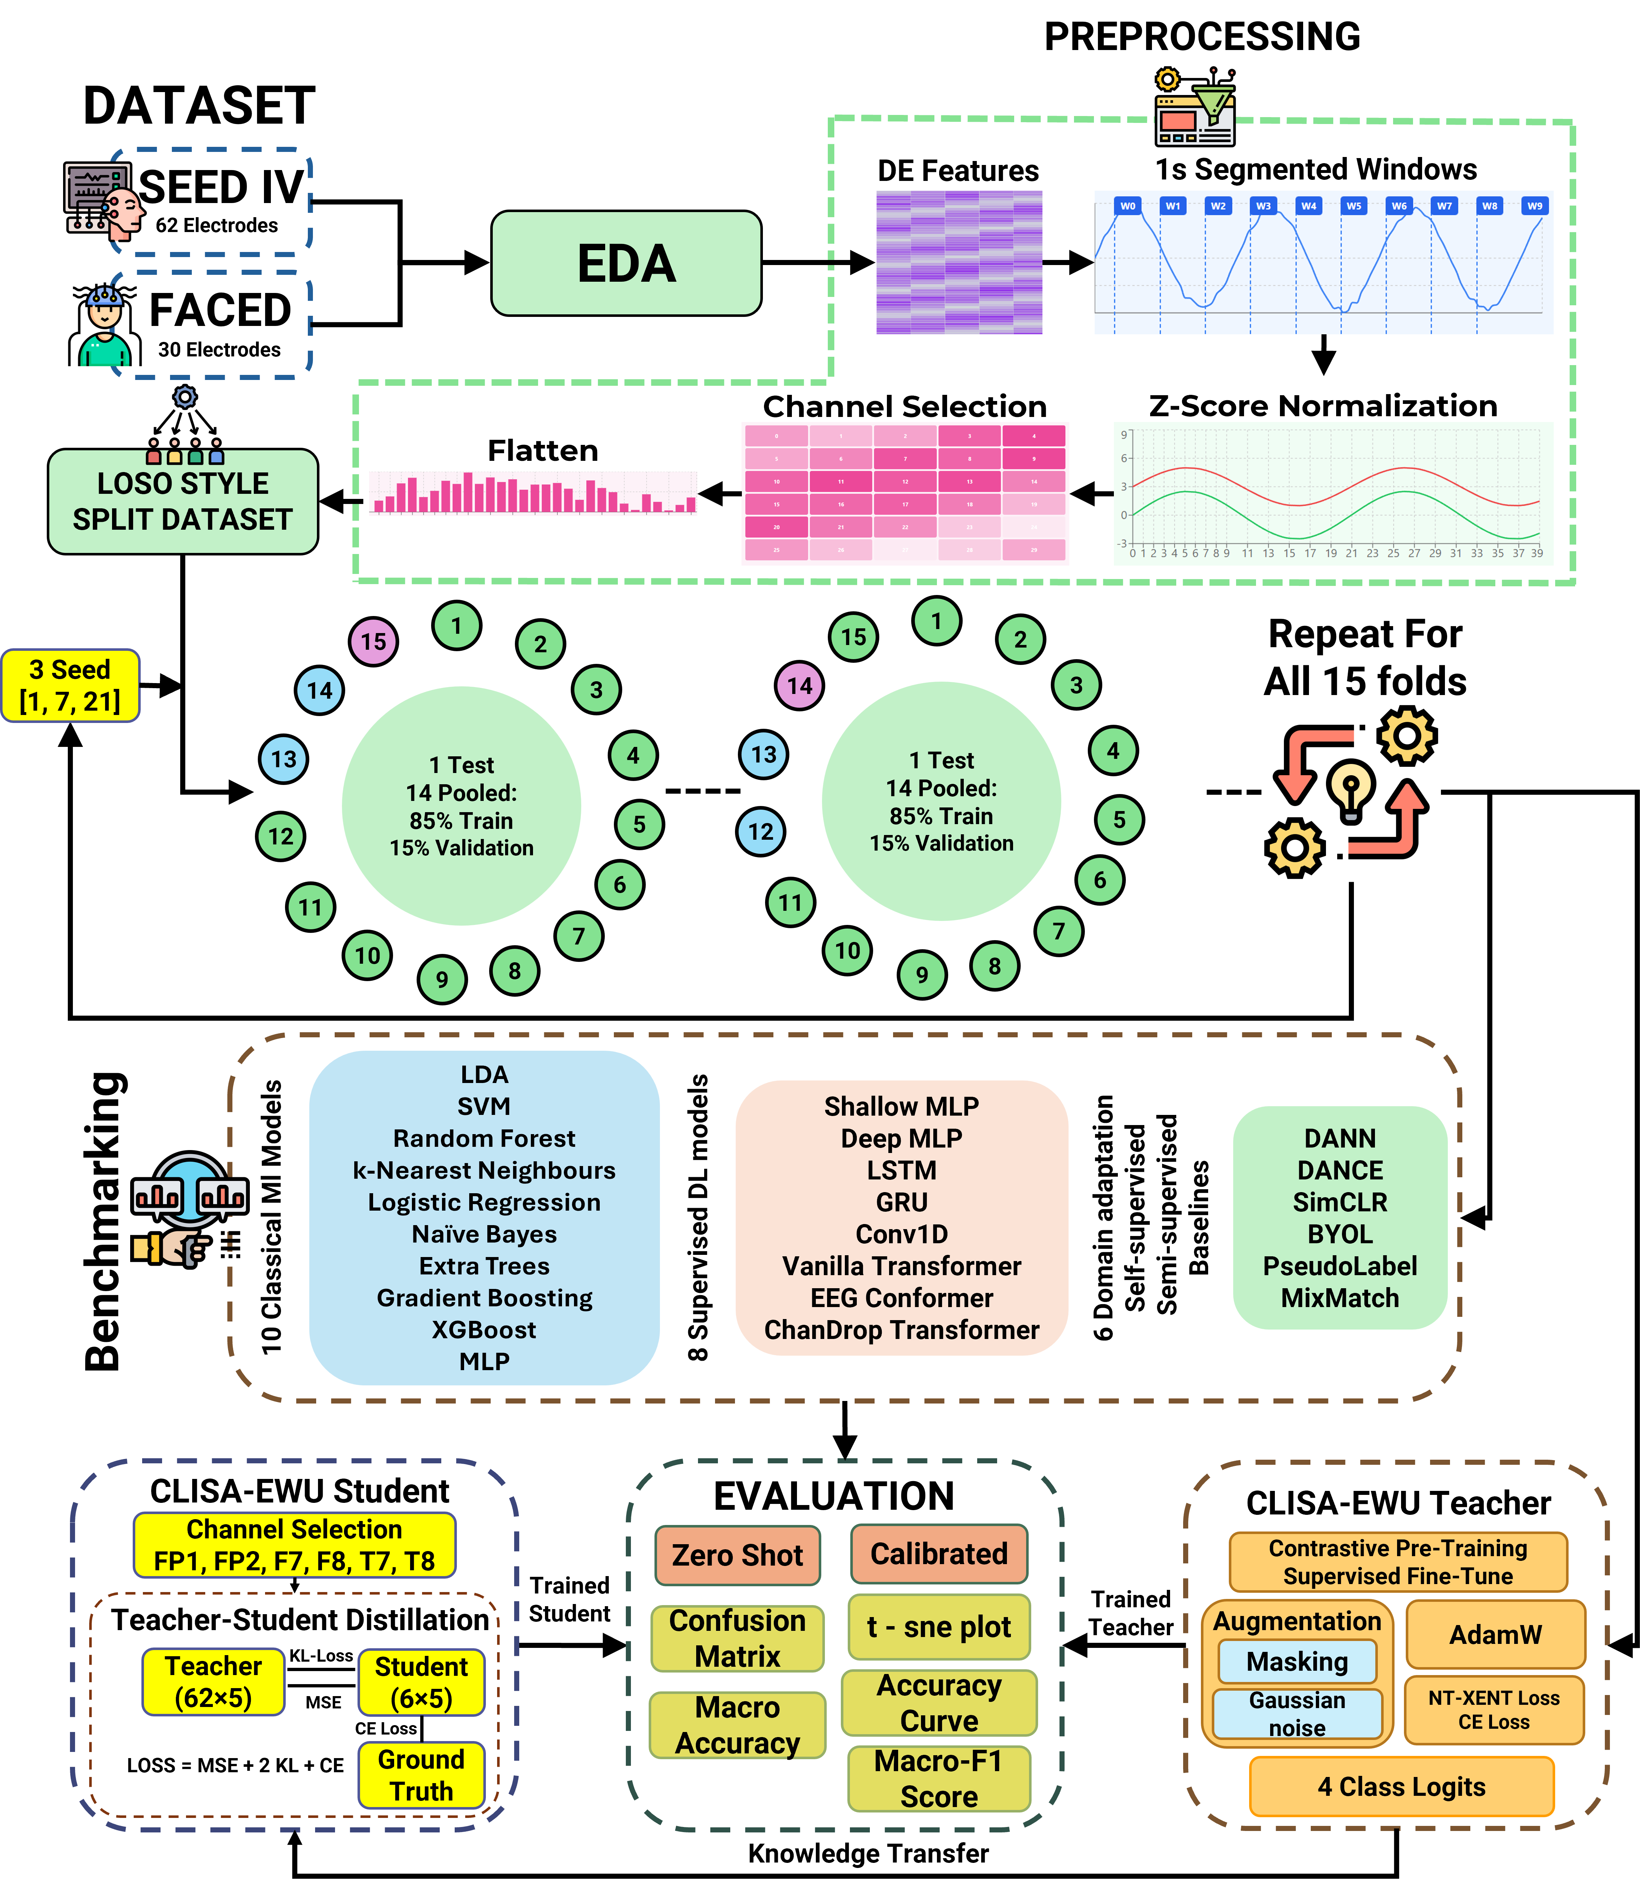
Fig. 1. Experimental workflow. Exploratory data analysis; leave-one-participant-out splitting with three seeds; classical, supervised, self-supervised, semi-supervised and domain-adversarial model families; electrode selection for the six-electrode montage; and zero-shot and calibrated evaluation with accuracy, macro F1, confusion matrices and t-SNE.

3.1 Data description
The public SEED-IV dataset² was used. Fifteen healthy adults [report sex and age range from the dataset paper] watched 72 film clips (24 per session, three sessions on different days) selected to elicit neutral, sad, fear and happy states while 62-channel EEG was recorded according to the international 10–20 system. The released feature set contains 37,575 four-second windows, 2505 per participant, with 10,170 neutral (27.1%), 10,245 sad (27.3%), 9225 fear (24.6%) and 7935 happy (21.1%) windows (Fig. 2); the classes are therefore close to balanced. Labels are assigned per film clip, so all windows of a trial share one label.
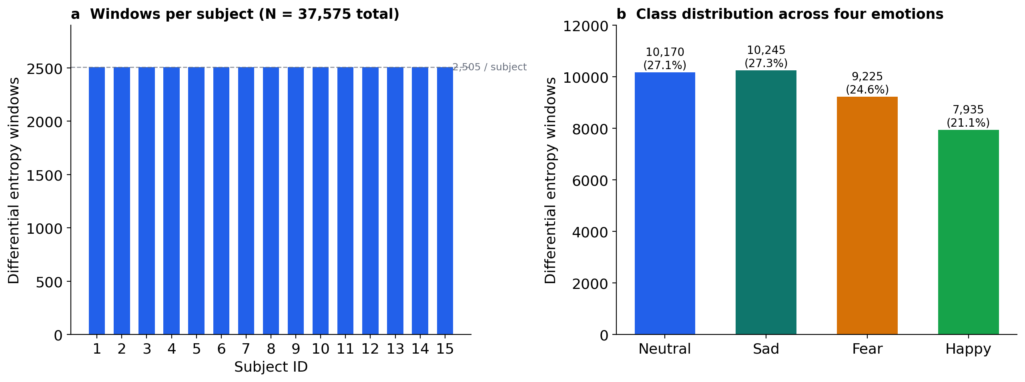
Fig. 2. SEED-IV differential-entropy dataset composition. (a) Windows per participant (2505 each; 37,575 in total). (b) Windows per emotion class.
This study used only the publicly available, de-identified SEED-IV dataset. Data collection was approved by the providers’ institutional ethics committee and all participants gave informed consent; no new human data were collected. All methods were carried out in accordance with relevant guidelines and regulations.

3.2 Data preprocessing and feature extraction
The EEG in SEED-IV was downsampled to 200 Hz and band-pass filtered by the dataset providers^{2,3}. Differential entropy (DE) features were computed in non-overlapping 4-s windows for five frequency bands (delta, theta, alpha, beta and gamma) [confirm band limits against the dataset documentation]. For a band-limited signal that is approximately Gaussian with variance σ², the differential entropy reduces to a function of band power:
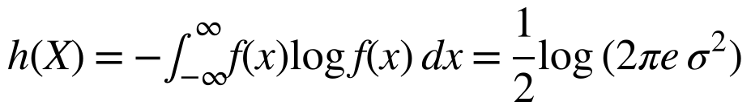 (1)
The released DE features were smoothed over time with a linear dynamical system (de_LDS)³, which reduces window-to-window noise but also increases the correlation between neighbouring windows of a trial. For each window the 62 × 5 DE matrix was flattened into a 310-dimensional vector. Each feature j was z-standardised,
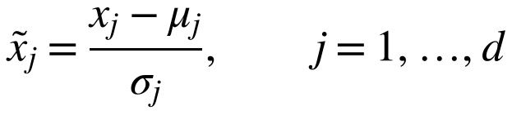 (2)
where μ_{j} and σ_{j} are the mean and standard deviation of feature j [confirm that μ and σ are computed on the training participants of each fold; if they were computed on all 15 participants, re-run with fold-wise statistics]. No further normalisation was applied.

3.3 Electrode montages
Two electrode configurations were compared. The full montage used all 62 electrodes (310 features). The wearable-compatible montage used six electrodes reachable by a forehead-and-temple band, FP1, FP2, F7, F8, T7 and T8, giving 30 features (6 electrodes × 5 bands). The six-electrode features are an exact column subset of the full feature matrix (indices 0, 2, 5, 13, 23 and 31 of the 62-channel ordering), so the two configurations differ only in electrode density and not in preprocessing.

3.4 Data augmentation and class balancing
Data augmentation was used to create the two views required by contrastive pretraining. For a standardised window x, the first view adds isotropic Gaussian noise, and the second view masks whole electrodes across all five bands with a random binary mask m, each electrode being kept with probability 0.7:
(3)
The noise view encourages invariance to small amplitude perturbations, and the masking view encourages invariance to missing or poorly contacting electrodes, a frequent problem with wearable headsets. Augmentation was applied on the fly to each mini-batch during stage 1 only; supervised fine-tuning and evaluation used unaugmented windows. To counter the mild class imbalance, training mini-batches were drawn with a class-balanced sampler whose sampling weight for a window of class i is proportional to 1/n_{i}.

3.5 Data splitting and evaluation protocol
We used leave-one-participant-out (LOSO) cross-validation. In each of 15 folds one participant was held out entirely, and the windows of the remaining 14 were split at random into training (85%, about 29,810 windows) and validation (15%, about 5260 windows) sets (Fig. 3). The procedure was repeated with seeds 1, 7 and 21, giving 45 runs per model and montage (Table 3). The complete workflow is shown in Fig. 1.

Item | Setting
Dataset | SEED-IV, 15 participants, 3 sessions, 72 trials per participant
Classes | Neutral, sad, fear, happy (four-class)
Features | Differential entropy (de_LDS), 4-s windows, five bands
Full montage | 62 electrodes, 310 features
Wearable montage | FP1, FP2, F7, F8, T7, T8; 30 features
Split | Leave-one-participant-out, 15 folds; 85/15 random train/validation split of the 14 training participants
Seeds | 1, 7, 21 (45 runs per model and montage)
Protocols | Zero-shot; few-shot calibration with 20 labelled target windows
Metrics | Accuracy and macro F1 (all models); balanced accuracy, precision, specificity, weighted F1, Cohen’s κ, MCC, G-mean and ITR (CLISA-EWU and DANN)
Statistics | Participant-level means, bootstrap 95% CI, paired Wilcoxon signed-rank tests, Holm correction
Table 3. Dataset, feature and evaluation protocol summary.
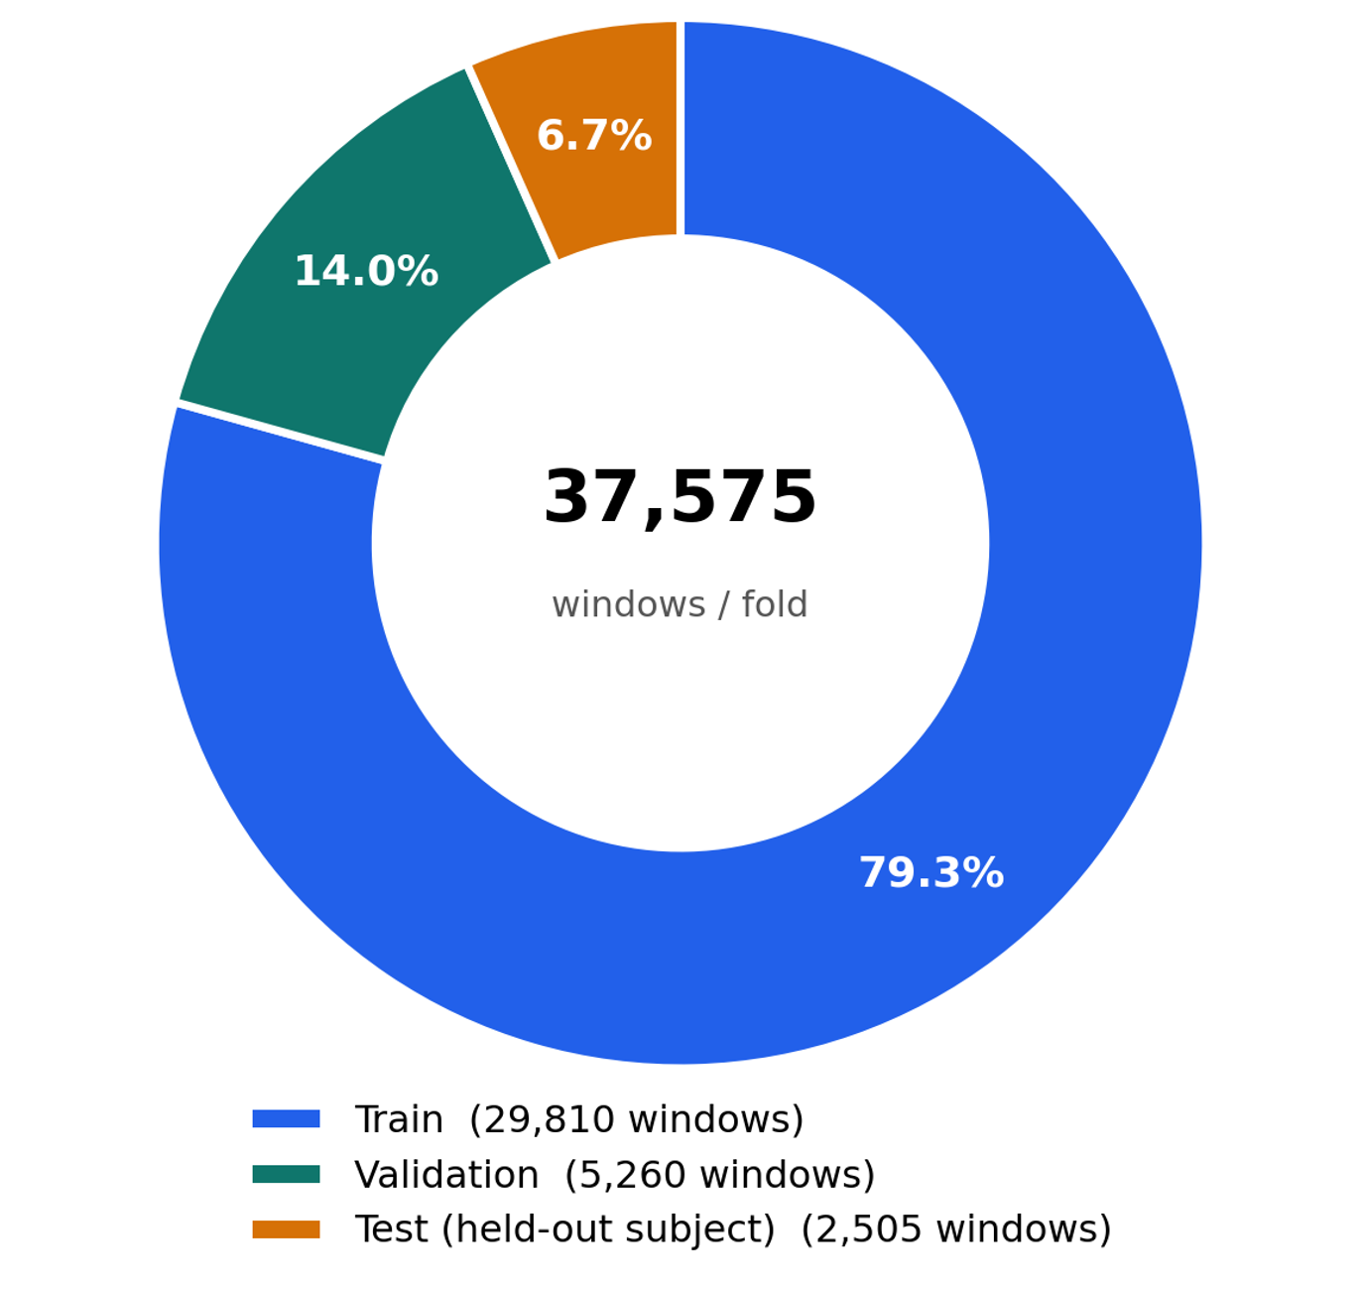
Fig. 3. Composition of one leave-one-participant-out fold. Windows of the 14 training participants were split at random into training (79.3% of all windows) and validation (14.0%) sets; all 2505 windows of the held-out participant (6.7%) formed the test set. Validation windows share participants and trials with training windows.
Strategy 1: zero-shot evaluation
The trained model predicts all 2505 windows of the held-out participant without access to any of their labels or unlabelled EEG (except for PseudoLabel, which uses unlabelled held-out EEG during training by design). This protocol measures true cross-participant generalization.
Strategy 2: few-shot calibration
Twenty windows of the held-out participant are drawn at random, all network parameters are fine-tuned on them for 10 epochs (Adam, learning rate 10⁻³), and performance is measured on the remaining 2485 windows. Twenty windows correspond to about 80 s of EEG, or 0.8% of the participant’s data, and emulate a short user-calibration session.
Because calibration windows were sampled across trials, a calibration window and a test window could come from the same film-clip trial; with temporally smoothed features such windows are correlated, so calibrated estimates may be optimistic¹⁸ [pending: trial-held-out calibration (calibrate on session 1, test on sessions 2–3) and a calibration-budget curve of 5–200 windows]. Validation windows came from the same participants and trials as training windows, so validation scores were near ceiling (median macro F1 1.00 for supervised models) and early stopping effectively selected late epochs; this does not compromise the independence of the held-out participant.

3.6 Baseline models
We evaluated ten classical classifiers (linear discriminant analysis, support vector machine with radial basis kernel, random forest, extra trees, gradient boosting, XGBoost³⁰, k-nearest neighbours, logistic regression, naive Bayes and a scikit-learn multilayer perceptron) and 16 deep models in five families (Table 4): supervised networks (two-layer and deep perceptrons, LSTM, GRU, one-dimensional CNN, transformer³⁶, EEG Conformer³⁵ and a channel-dropout transformer); a domain-adversarial network (DANN)⁶ whose discriminator predicted training-participant identity through a gradient-reversal layer; self-supervised models (SimCLR⁴⁶, BYOL⁴⁷); semi-supervised models (PseudoLabel⁵¹, which used confident predictions on the unlabelled held-out participant, and MixMatch⁵²); and a teacher–student distillation pair (DANCE)⁵³.

Family | Models | Role
Classical machine learning | LDA, SVM, random forest, extra trees, gradient boosting, XGBoost, k-NN, logistic regression, naive Bayes, MLP (scikit-learn) | Non-deep baselines
Supervised deep learning | Two-layer perceptron, deep perceptron, LSTM, GRU, Conv1D, transformer, EEG Conformer, channel-dropout transformer | Supervised neural baselines
Domain-adversarial | DANN | Removes training-participant information
Self-supervised | SimCLR, BYOL | Contrastive and bootstrap pretraining
Semi-supervised | PseudoLabel (transductive), MixMatch | Exploits unlabelled data
Distillation | DANCE teacher (62) → student (6) | Secondary reference
Model of interest | CLISA-EWU | Two-stage contrastive pretraining and supervised fine-tuning
Table 4. Model families evaluated in this study.

3.7 Proposed model: CLISA-EWU
CLISA-EWU (Fig. 4) consists of an encoder f_{θ}, a projection head g_{φ} used only during pretraining, and a linear classifier. The encoder maps a window x to a 128-dimensional representation h, and the projection head maps h to a 64-dimensional unit vector z:
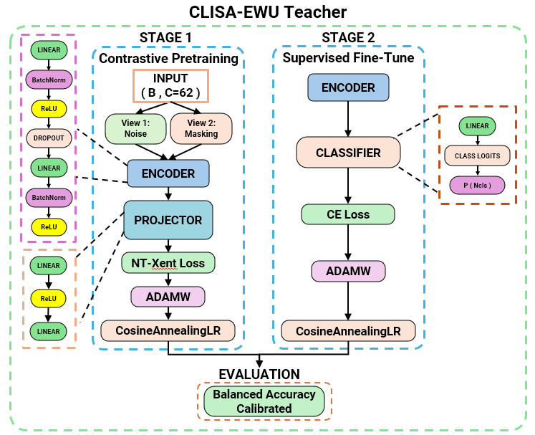
Fig. 4. CLISA-EWU architecture. Stage 1: contrastive pretraining of the encoder and projector with the NT-Xent loss on a Gaussian-noise view and an electrode-masking view of each window (AdamW, cosine annealing). Stage 2: supervised fine-tuning of the encoder and linear classifier with cross-entropy. The model is evaluated zero-shot and after 20-window calibration.
(4)
where W₁ ∈ ℝ^{256×d} and W₂ ∈ ℝ^{128×256} (d = 310 or 30), BN denotes batch normalisation and dropout has rate 0.3. The classifier outputs class probabilities ŷ = softmax(W_{c}h + b_{c}). Training has two stages. In stage 1, the encoder and projection head are trained with the NT-Xent contrastive loss⁴⁶ on the two augmented views. For a batch of N windows, the views give 2N projections, and for a positive pair (i, j) the loss is
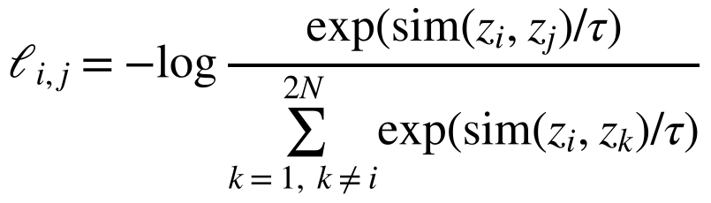 (5)
where sim(·,·) is cosine similarity and τ = 0.5. In stage 2, the encoder and classifier are fine-tuned with the cross-entropy loss over mini-batches B,
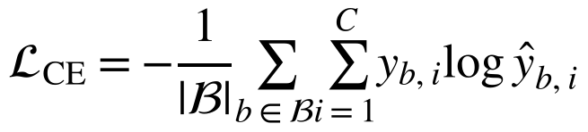 (6)
Unlike the original CLISA⁵, which treats time-aligned responses of different participants to the same stimulus as positives, the stage-1 objective here contrasts augmented views of the same window and does not use participant or stimulus identity [either implement cross-participant stimulus-aligned positives or rename the model to avoid implying explicit inter-subject alignment].

3.8 Training algorithm
Algorithm 1 summarises the complete training and evaluation procedure for one montage, including both evaluation protocols.
Algorithm 1 CLISA-EWU leave-one-participant-out training and evaluation
Input: Standardised DE features X ∈ ℝ^{N×d}, labels y, participant identifiers s, seeds {1, 7, 21}, calibration budget m = 20
Output: Zero-shot accuracy A_{zs} and calibrated accuracy A_{cal} for every seed and held-out participant
1: for each seed r ∈ (1, 7, 21) do
2: for each participant p = 1, …, 15 do
3: D_{test} ← windows of participant p; D_{pool} ← windows of the other 14 participants
4: Split D_{pool} at random into D_{train} (85%) and D_{val} (15%)
5: Initialise encoder f_{θ}, projection head g_{φ} and classifier c_{ψ}
6: for epoch = 1, …, 50 do ▷ Stage 1: contrastive pretraining
7: for each class-balanced mini-batch x ⊂ D_{train} do
8: v₁, v₂ ← noise and electrode-masking views of x, Eq. (3)
9: Update θ, φ by minimising the NT-Xent loss of the projections of v₁ and v₂, Eq. (5)
10: end for
11: end for
12: for epoch = 1, …, 50 do ▷ Stage 2: supervised fine-tuning
13: Update θ, ψ by minimising the cross-entropy loss on D_{train}, Eq. (6)
14: if validation macro F1 has not improved for 15 epochs then
15: stop training
16: end if
17: end for
18: Restore the best (θ, ψ); A_{zs}(r, p) ← accuracy on D_{test} ▷ zero-shot
19: Draw m windows D_{cal} ⊂ D_{test} at random; D_{eval} ← D_{test} ∖ D_{cal}
20: Fine-tune θ, ψ on D_{cal} for 10 epochs (Adam, learning rate 10⁻³)
21: A_{cal}(r, p) ← accuracy on D_{eval} ▷ calibrated
22: end for
23: end for
24: return A_{zs} and A_{cal} for all seeds and participants

3.9 Implementation details
Stage 1 uses AdamW (learning rate 10⁻³, weight decay 10⁻⁴, cosine annealing, 50 epochs, batch size 128). Stage 2 uses AdamW (learning rate 3 × 10⁻⁴, weight decay 10⁻⁴, cosine annealing, up to 50 epochs, early stopping with patience 15 on validation macro F1, class-balanced sampling). Supervised baselines were trained for up to 100 epochs with the same early-stopping rule. Mixed-precision training was used throughout.
All experiments were implemented in Python 3 with PyTorch [version] (deep models), scikit-learn [version] and XGBoost [version] (classical models), and SciPy and statsmodels (statistics), and were run on an NVIDIA GeForce RTX 3050 Laptop GPU [confirm hardware].

3.10 Evaluation metrics
Model performance is assessed with complementary metrics computed on the test windows of the held-out participant. For class i of C = 4 classes, TP_{i}, FP_{i}, FN_{i} and TN_{i} denote true positives, false positives, false negatives and true negatives, n_{i} the number of windows of class i and N the total number of test windows. Accuracy, the metric logged for every run of all models, and per-class specificity are
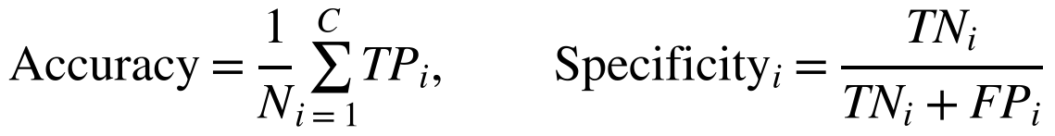 (7)
Per-class recall (sensitivity) and precision are
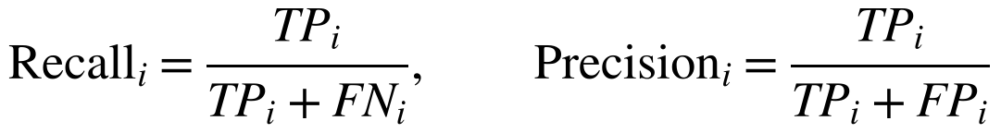 (8)
Balanced accuracy (BA) is the mean per-class recall⁵⁸ and removes the influence of class frequency:
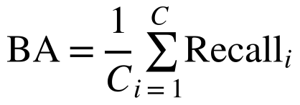 (9)
The per-class F1 score is the harmonic mean of precision and recall; macro F1 averages it with equal class weights and weighted F1 with weights proportional to class support:
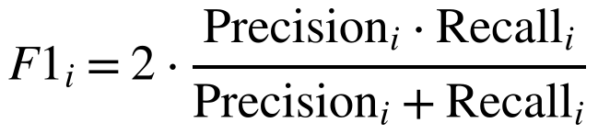 (10)
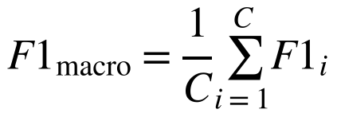 (11)
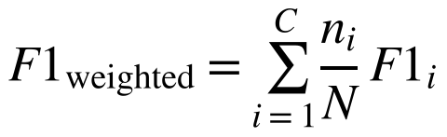 (12)
Cohen’s kappa⁵⁹ corrects accuracy for the agreement expected by chance, where p_{o} is the observed accuracy and n_{i·} and n_{·i} are the row and column totals of the confusion matrix:
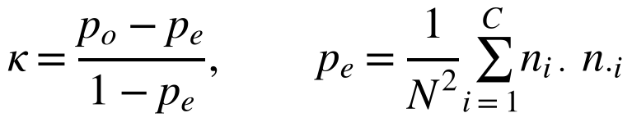 (13)
The multi-class Matthews correlation coefficient^{60,61} uses every cell of the confusion matrix, with c correctly classified windows and t_{i} and p_{i} the true and predicted totals of class i; it ranges from −1 to 1, with 0 at chance:
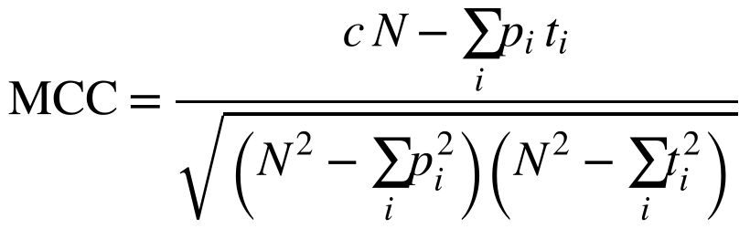 (14)
The geometric mean of the recalls⁶² penalises a model that neglects any class:
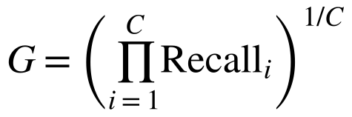 (15)
To express performance in brain–computer-interface terms, the information transfer rate⁶³ is computed from accuracy P with window length T = 4 s, giving bits per window (B) and bits per minute:
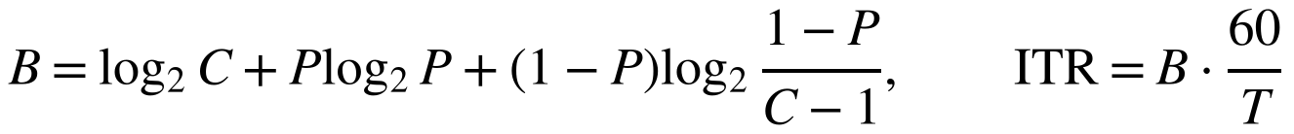 (16)
Electrode-reduction retention is the ratio of six-electrode to 62-electrode accuracy for the same model:
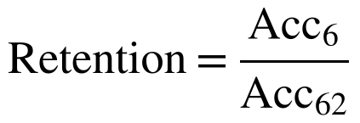 (17)
The run logs stored accuracy and macro F1 for every deep model, and full confusion matrices for CLISA-EWU and DANN. The complete metric set is therefore reported for these two models, and model-wide comparisons use accuracy and macro F1. Because the four classes are nearly balanced (21–27% of windows), accuracy and balanced accuracy differed by 0.0–0.4 percentage points on average and by at most 2.4 points in any single run. Confusion matrices are row-normalised so that each row shows the recall of one true class.

3.11 Statistical analysis
Runs from the same participant are not independent, so the three seeds were averaged for each participant, giving 15 paired observations per model, montage and protocol. Participant-level means are reported with 95% confidence intervals from 10,000 bootstrap resamples of participants.
Differences among all models within a montage and protocol were tested with the Friedman test⁶⁴ on participant-level accuracy, with Kendall’s W as the effect size. Average ranks R̄_{j} of k models over n = 15 participants were compared with the Nemenyi critical difference⁵⁵, where q_{α} is the studentised range statistic divided by √2 at α = 0.05:
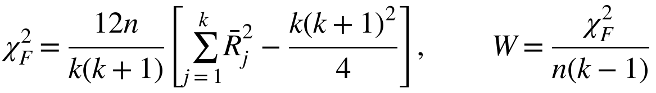 (18)
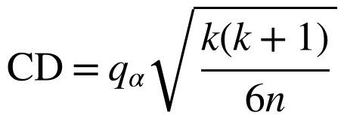 (19)
Pairwise comparisons of CLISA-EWU with seven comparators used two-sided Wilcoxon signed-rank tests⁶⁵ with Holm adjustment⁶⁶ over the 14 comparisons of each protocol, and paired t-tests as a parametric check. Effect sizes were Cohen’s d_{z} for the paired differences D⁶⁷ and the matched-pairs rank-biserial correlation r_{rb}⁶⁸, where T⁺ and T⁻ are the sums of positive and negative signed ranks:
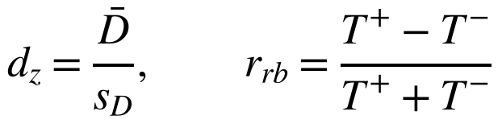 (20)
Variability of CLISA-EWU across participants and seeds was decomposed with a two-way analysis of variance without replication (participant × seed), and reliability across seeds was summarised with the consistency intraclass correlation⁶⁹, where MS_{P} and MS_{E} are the participant and residual mean squares and k = 3 seeds:
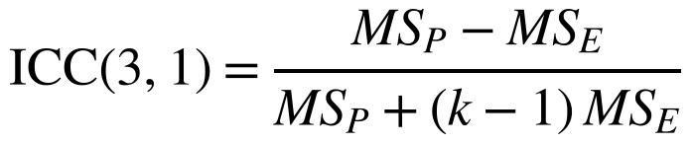 (21)
Associations between zero-shot accuracy, calibration gain and montage were assessed with Spearman’s ρ. The 62- versus six-electrode difference was tested with the Wilcoxon test, and the confidence interval for retention was obtained by resampling participants. Analyses used Python 3 with SciPy and statsmodels, and the scripts are provided in the repository. Reporting follows TRIPOD+AI where applicable⁵⁴.

3.12 Representation and attribution analysis
Representation geometry was examined with t-SNE⁷⁰ and with silhouette⁷¹, Davies–Bouldin⁷² and Calinski–Harabasz⁷³ indices computed on PCA-reduced raw features and on CLISA-EWU encoder embeddings, using emotion and participant labels. Electrode importance was estimated with gradient-based SHAP⁷⁴ on the 62-electrode model of the best run, summing absolute attributions over the five bands of each electrode separately for each predicted class.

4 Results and Discussion
In this section, the results of the benchmark are presented. Zero-shot performance is reported first, followed by the effect of few-shot calibration, the paired statistical comparisons, electrode reduction, variability across participants, class-level behaviour, representation geometry and secondary analyses. The implications and limitations of the findings are discussed at the end of the section.

4.1 Benchmark overview
All 26 models completed 45 runs per montage. The best classical classifier reached an accuracy of 0.484 (XGBoost) with 62 electrodes and 0.441 (LDA) with six electrodes (Fig. 5), confirming that differential-entropy features carry emotion information in unseen participants. Fig. 6 shows the calibrated leaderboard for all deep models, and Table 5 summarises zero-shot and calibrated results for the main comparators.

Model | Acc (ZS) | F1 (ZS) | Acc (Cal) | SD (Cal) | F1 (Cal) | Gain, points (95% CI) | CV (%) | Worst | Best | Rank
62 electrodes
CLISA-EWU | 0.485 | 0.479 | 0.678 | 0.078 | 0.673 | 19.3 (14.9, 23.8) | 11.5 | 0.541 | 0.813 | 1.40
DANN | 0.458 | 0.455 | 0.662 | 0.080 | 0.654 | 20.4 (16.2, 24.5) | 12.0 | 0.528 | 0.800 | 2.40
PseudoLabel | 0.468 | 0.466 | 0.657 | 0.072 | 0.654 | 18.9 (14.4, 23.7) | 10.9 | 0.538 | 0.766 | 2.53
BYOL | 0.431 | 0.423 | 0.609 | 0.074 | 0.594 | 17.8 (15.3, 20.2) | 12.2 | 0.476 | 0.718 | 4.07
SimCLR | 0.410 | 0.405 | 0.575 | 0.078 | 0.557 | 16.4 (13.2, 19.5) | 13.6 | 0.461 | 0.692 | 5.80
MixMatch | 0.285 | 0.243 | 0.535 | 0.087 | 0.522 | 25.0 (22.0, 28.0) | 16.3 | 0.380 | 0.692 | 7.33
DANCE teacher | 0.419 | 0.408 | 0.519 | 0.080 | 0.503 | 10.0 (7.0, 13.2) | 15.4 | 0.409 | 0.677 | 8.20
Two-layer perceptron | 0.476 | 0.474 | 0.496 | 0.096 | 0.493 | 2.0 (0.9, 3.1) | 19.4 | 0.305 | 0.710 | 8.33
Deep perceptron | 0.479 | 0.476 | 0.492 | 0.100 | 0.489 | 1.3 (0.3, 2.4) | 20.3 | 0.306 | 0.704 | 8.67
EEG Conformer | 0.453 | 0.447 | 0.459 | 0.109 | 0.454 | 0.7 (−0.0, 1.5) | 23.8 | 0.248 | 0.635 | 10.53
Conv1D | 0.430 | 0.419 | 0.445 | 0.103 | 0.438 | 1.5 (0.5, 2.7) | 23.2 | 0.291 | 0.677 | 11.57
GRU | 0.439 | 0.431 | 0.441 | 0.104 | 0.434 | 0.2 (0.1, 0.4) | 23.5 | 0.273 | 0.691 | 11.70
ChanDrop transformer | 0.430 | 0.418 | 0.431 | 0.064 | 0.419 | 0.1 (0.1, 0.2) | 14.8 | 0.335 | 0.579 | 12.07
LSTM | 0.430 | 0.420 | 0.431 | 0.116 | 0.421 | 0.1 (0.0, 0.3) | 26.9 | 0.268 | 0.695 | 12.40
Transformer | 0.405 | 0.393 | 0.407 | 0.072 | 0.395 | 0.2 (0.1, 0.3) | 17.6 | 0.277 | 0.555 | 13.00
Six electrodes
CLISA-EWU | 0.405 | 0.398 | 0.620 | 0.060 | 0.611 | 21.4 (18.2, 25.2) | 9.7 | 0.518 | 0.719 | 2.67
BYOL | 0.440 | 0.433 | 0.612 | 0.086 | 0.598 | 17.2 (14.0, 20.3) | 14.0 | 0.469 | 0.735 | 3.07
PseudoLabel | 0.405 | 0.394 | 0.610 | 0.072 | 0.600 | 20.6 (17.5, 24.0) | 11.7 | 0.484 | 0.725 | 3.07
SimCLR | 0.446 | 0.441 | 0.602 | 0.090 | 0.582 | 15.6 (13.0, 17.8) | 14.9 | 0.423 | 0.739 | 3.73
DANN | 0.396 | 0.386 | 0.590 | 0.063 | 0.579 | 19.4 (16.5, 22.5) | 10.7 | 0.500 | 0.695 | 3.87
DANCE student | 0.390 | 0.377 | 0.571 | 0.078 | 0.541 | 18.1 (14.9, 21.5) | 13.6 | 0.452 | 0.699 | 4.60
Two-layer perceptron | 0.400 | 0.393 | 0.412 | 0.085 | 0.405 | 1.1 (0.3, 1.9) | 20.6 | 0.256 | 0.539 | 9.33
ChanDrop transformer | 0.391 | 0.383 | 0.398 | 0.049 | 0.390 | 0.7 (0.4, 1.0) | 12.4 | 0.323 | 0.497 | 9.67
Deep perceptron | 0.398 | 0.389 | 0.401 | 0.076 | 0.396 | 0.3 (−0.6, 1.2) | 18.9 | 0.254 | 0.516 | 10.00
Transformer | 0.368 | 0.358 | 0.371 | 0.052 | 0.360 | 0.3 (0.1, 0.4) | 14.1 | 0.296 | 0.490 | 10.93
LSTM | 0.384 | 0.376 | 0.385 | 0.066 | 0.377 | 0.1 (−0.1, 0.2) | 17.2 | 0.246 | 0.520 | 11.13
Conv1D | 0.375 | 0.366 | 0.379 | 0.074 | 0.373 | 0.4 (−0.4, 1.1) | 19.6 | 0.232 | 0.522 | 11.47
GRU | 0.376 | 0.369 | 0.378 | 0.073 | 0.371 | 0.2 (0.0, 0.4) | 19.4 | 0.269 | 0.532 | 11.73
MixMatch | 0.270 | 0.226 | 0.364 | 0.038 | 0.334 | 9.4 (7.8, 11.1) | 10.4 | 0.312 | 0.431 | 12.07
EEG Conformer | 0.353 | 0.344 | 0.361 | 0.065 | 0.353 | 0.8 (0.2, 1.4) | 18.1 | 0.263 | 0.481 | 12.67
Table 5. Cross-participant four-class emotion recognition for all 15 deep models per montage, zero-shot (ZS) and after 20-window calibration (Cal). Values are means over 15 held-out participants (each averaged over three seeds). Gain = calibrated minus zero-shot accuracy in percentage points with 95% bootstrap CI; CV = between-participant coefficient of variation of calibrated accuracy; worst/best = lowest/highest participant; rank = Friedman average rank after calibration (1 = best). Chance accuracy is 0.25.
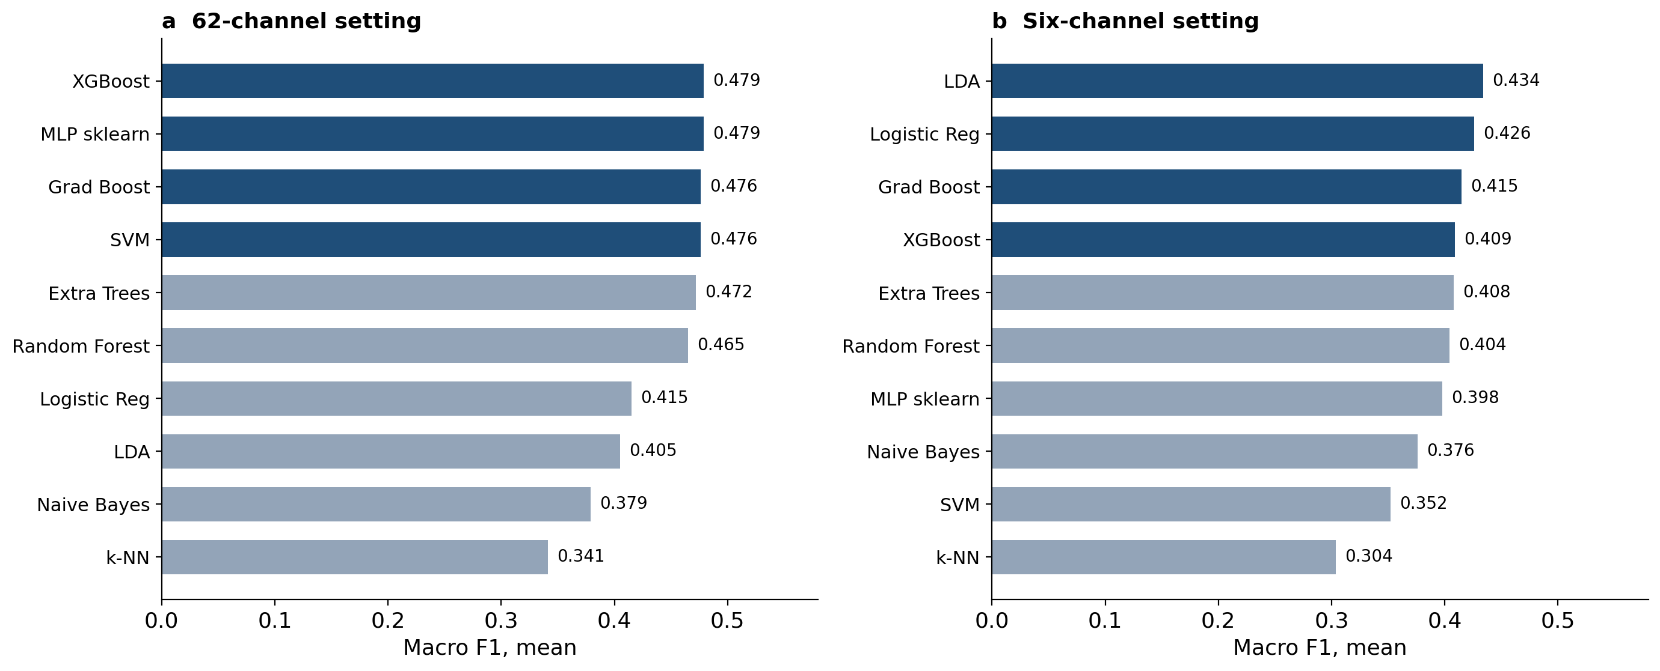
Fig. 5. Classical machine-learning baselines. Mean macro F1 over 45 leave-one-participant-out runs with (a) 62 electrodes and (b) six electrodes.
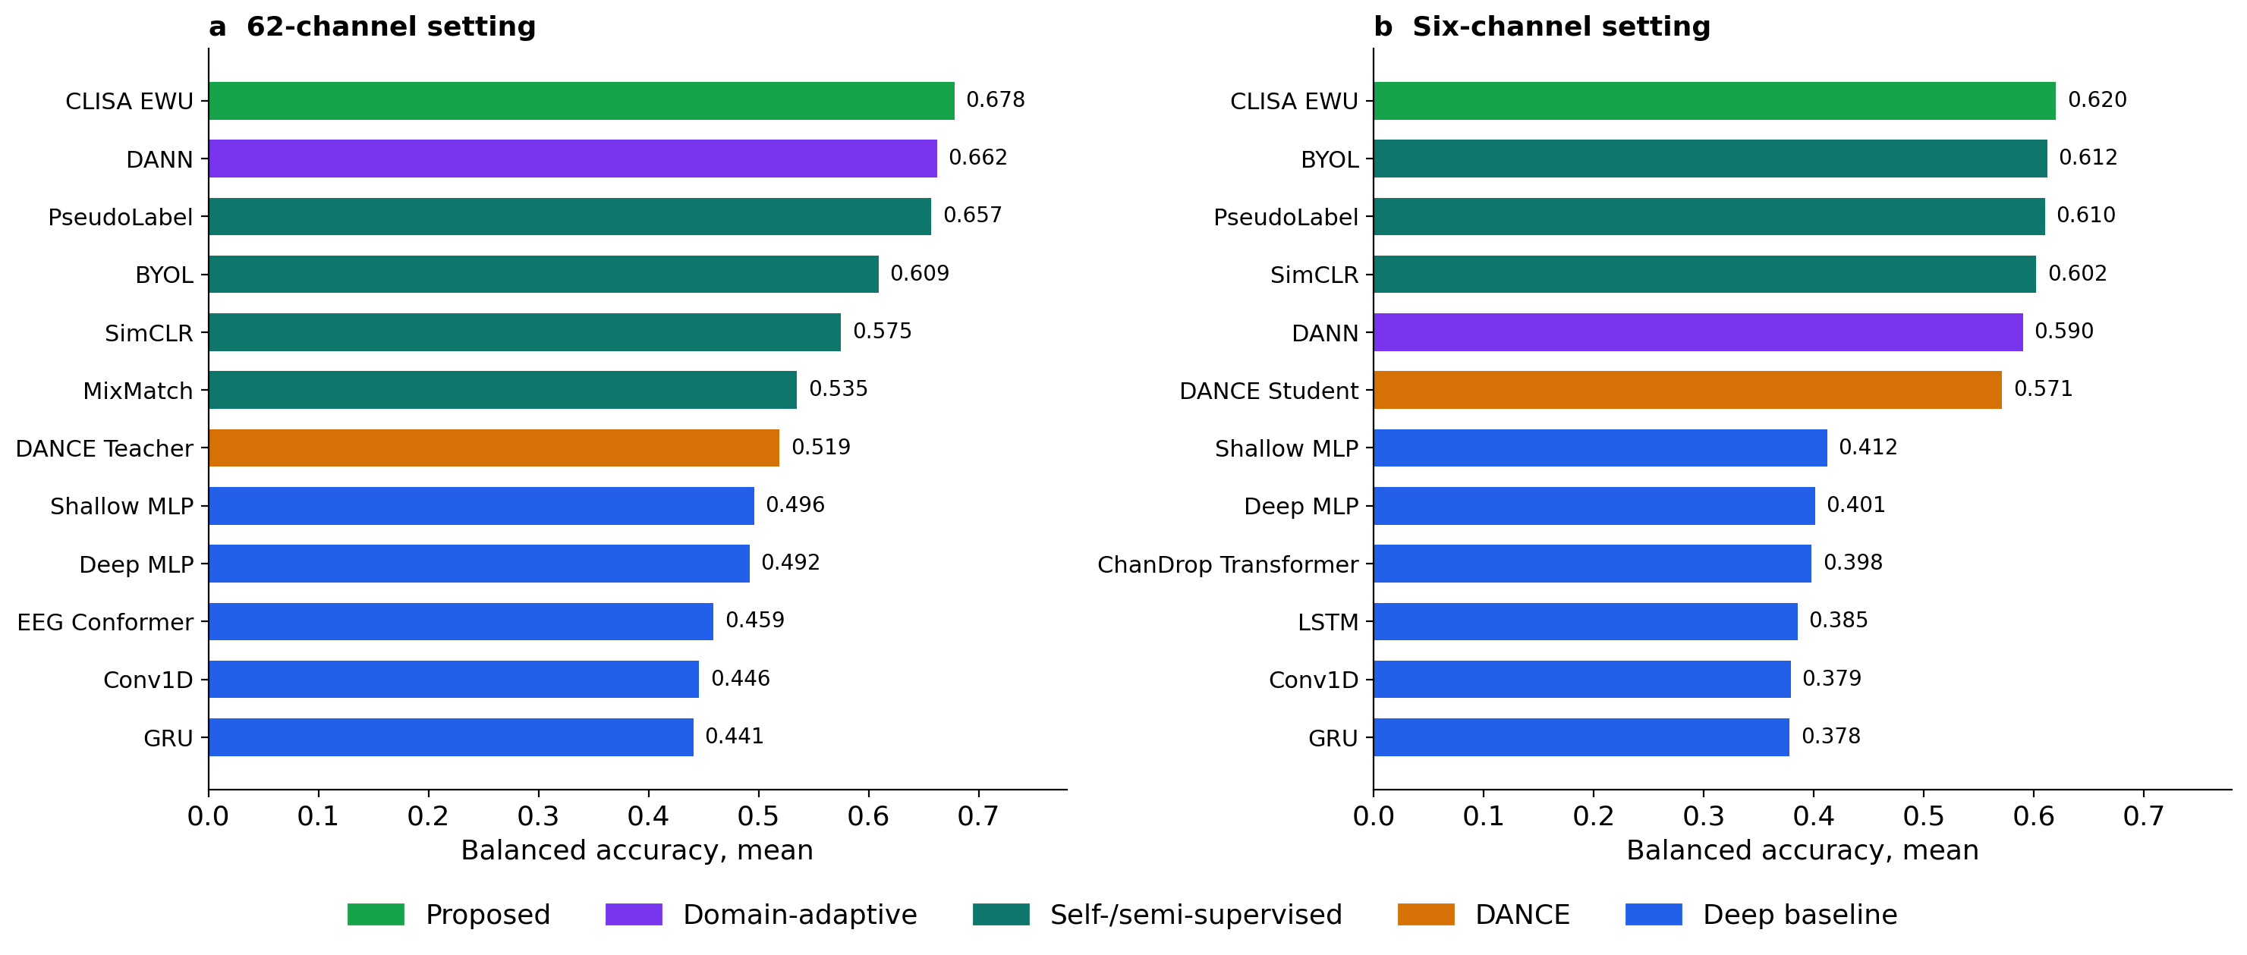
Fig. 6. Calibrated performance of all deep models. Mean accuracy over 45 runs after 20-window calibration with (a) 62 electrodes and (b) six electrodes. Colours denote model family (proposed, domain-adaptive, self/semi-supervised, DANCE, supervised baselines). Zero-shot results are shown in Fig. 7. The axis label ‘balanced accuracy’ in this thesis figure denotes accuracy (see Methods).

4.2 Zero-shot cross-participant decoding
Without target data, no model approached the accuracies reported in much of the literature (Fig. 7). With 62 electrodes, CLISA-EWU had the highest mean zero-shot accuracy (0.485, 95% CI 0.428–0.542) but did not differ from the two-layer perceptron (difference 0.9 percentage points, −0.5 to 2.1; Wilcoxon p = 0.25) or the deep perceptron (0.6 points, −0.9 to 2.2; p = 0.64). Its advantage over DANN (2.7 points, 1.0 to 4.2; unadjusted p = 0.010) did not survive Holm correction (p = 0.12). With six electrodes, zero-shot accuracy fell to 0.406 (0.370–0.439) for CLISA-EWU, and SimCLR (0.446) and BYOL (0.440) were numerically higher (both Holm-adjusted p = 1.00). Zero-shot performance varied greatly between participants, from 0.244 (participant 11, at chance) to 0.723 (participant 7) for CLISA-EWU with 62 electrodes (Fig. 8a).
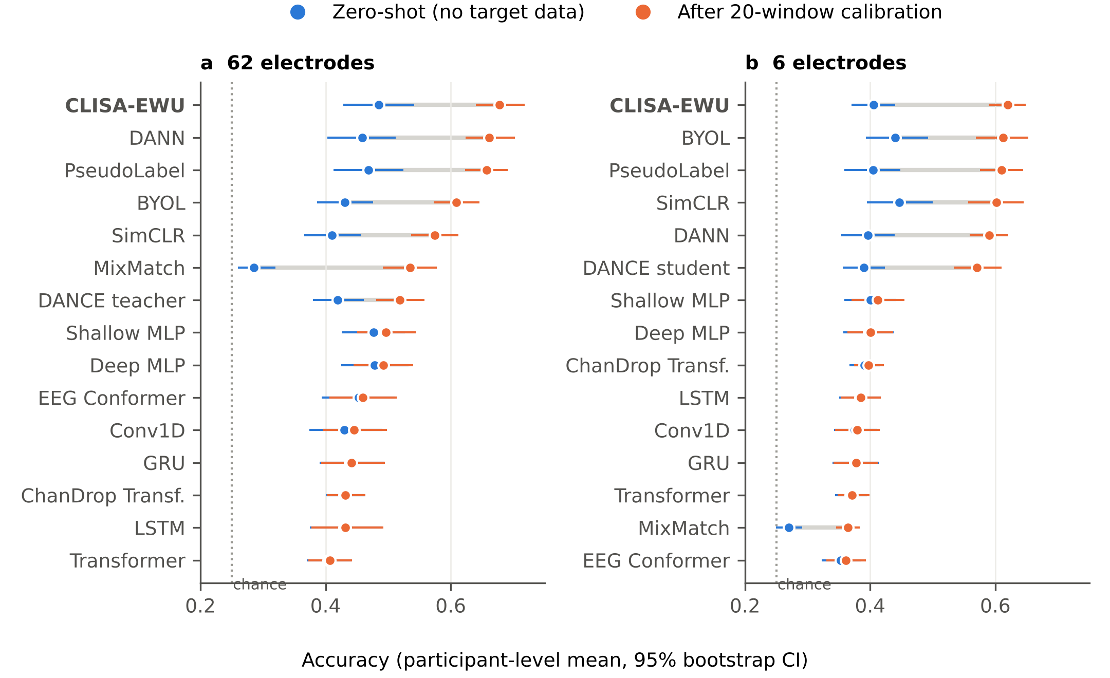
Fig. 7. Zero-shot versus calibrated accuracy for 16 deep models. (a) 62 electrodes. (b) Six electrodes (FP1, FP2, F7, F8, T7, T8). Points are means over 15 held-out participants (each averaged over three seeds); bars are 95% bootstrap confidence intervals; the grey segment joins the two protocols for each model. The dotted line marks chance (0.25).
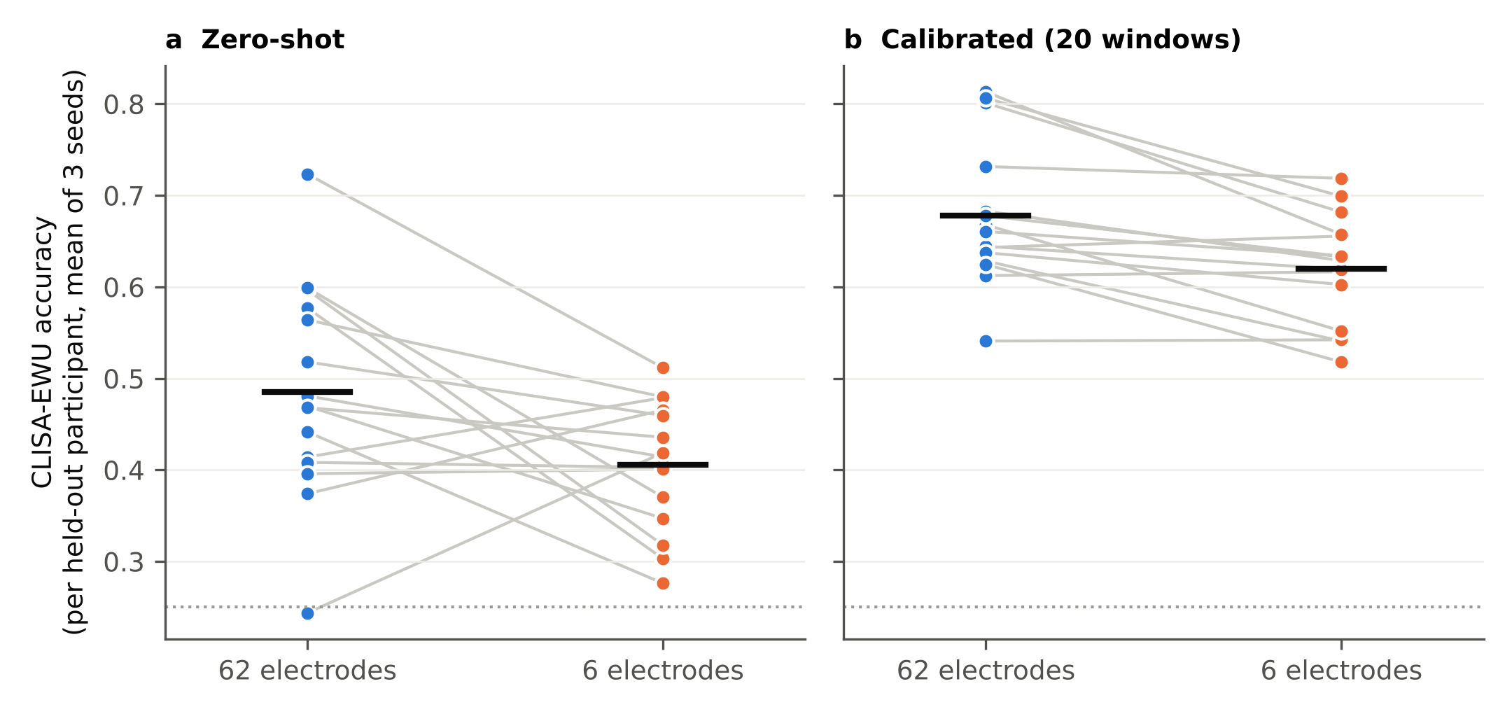
Fig. 8. Participant-level accuracy of CLISA-EWU with 62 and six electrodes. (a) Zero-shot. (b) After 20-window calibration. Each line is one held-out participant (mean of three seeds); black bars are means over participants. The dotted line marks chance (0.25).

4.3 Effect of few-shot calibration
Calibration with 20 labelled windows changed the ranking of models (Fig. 7, Table 5). Models trained with a contrastive, domain-adversarial or pseudo-label objective (CLISA-EWU, SimCLR, BYOL, DANN, PseudoLabel) gained 15.6–21.4 percentage points (MixMatch and the DANCE pair gained 9.4–25.0 points), whereas purely supervised networks gained 0.1–2.0 points under the identical calibration routine. After calibration CLISA-EWU had the highest mean accuracy with both montages: 0.678 (0.641–0.718) with 62 electrodes and 0.620 (0.590–0.648) with six (Fig. 9). The mechanism behind the objective-dependent gain is not established here; candidate explanations include adaptation of batch-normalisation statistics to the new participant⁴⁵ and differences in how sharply each objective fits the training participants [pending ablation: calibrate batch-normalisation statistics only, the classifier only, and all parameters].
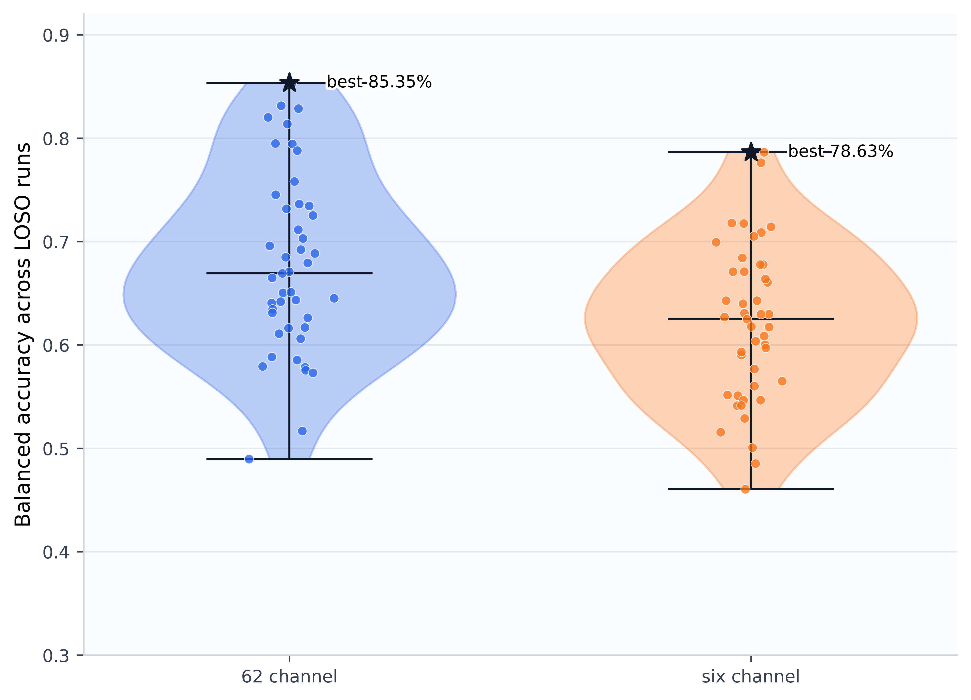
Fig. 9. Run-level distribution of calibrated CLISA-EWU performance. Accuracy for each of the 45 runs (15 held-out participants × 3 seeds) with 62 and six electrodes. Horizontal lines mark the mean and range; stars mark the best single runs (85.35% and 78.63%), shown for completeness and not as estimates of expected performance. The axis label ‘balanced accuracy’ in this thesis figure denotes accuracy (see Methods).
In paired participant-level comparisons (Table 6, Fig. 10), calibrated CLISA-EWU outperformed BYOL (6.9 points, 5.2–8.5), SimCLR (10.3 points) and all supervised networks with 62 electrodes, for every one of the 15 participants. Its margin over PseudoLabel (2.1 points, 1.0–3.1; Holm p = 0.016) remained significant, but its margin over DANN (1.6 points, 0.6–2.6; Holm p = 0.062) did not. With six electrodes, CLISA-EWU, BYOL, PseudoLabel, SimCLR and DANN were statistically indistinguishable.

Comparison | Δ, points (95% CI) | d_{z} | r_{rb} | Wins | t-test p | Wilcoxon p | Holm p
Calibrated, 62 electrodes
vs DANN | 1.6 (0.7, 2.6) | 0.82 | 0.72 | 11/15 | 0.007 | 0.012 | 0.062
vs PseudoLabel | 2.1 (1.0, 3.1) | 0.98 | 0.83 | 13/15 | 0.002 | 0.003 | 0.016
vs BYOL | 6.9 (5.3, 8.6) | 2.04 | 1.00 | 15/15 | <0.001 | <0.001 | <0.001
vs SimCLR | 10.3 (8.4, 12.3) | 2.62 | 1.00 | 15/15 | <0.001 | <0.001 | <0.001
vs Two-layer perceptron | 18.2 (14.3, 22.0) | 2.33 | 1.00 | 15/15 | <0.001 | <0.001 | <0.001
vs Deep perceptron | 18.6 (14.1, 22.9) | 2.07 | 1.00 | 15/15 | <0.001 | <0.001 | <0.001
vs EEG Conformer | 21.9 (17.6, 26.4) | 2.42 | 1.00 | 15/15 | <0.001 | <0.001 | <0.001
Calibrated, six electrodes
vs DANN | 3.0 (0.9, 5.0) | 0.70 | 0.67 | 11/15 | 0.017 | 0.022 | 0.086
vs PseudoLabel | 1.0 (−0.7, 2.7) | 0.28 | 0.30 | 9/15 | 0.300 | 0.330 | 0.688
vs BYOL | 0.7 (−1.8, 3.4) | 0.14 | 0.13 | 8/15 | 0.591 | 0.679 | 0.688
vs SimCLR | 1.8 (−1.2, 4.7) | 0.30 | 0.37 | 10/15 | 0.266 | 0.229 | 0.688
vs Two-layer perceptron | 20.8 (17.0, 24.9) | 2.58 | 1.00 | 15/15 | <0.001 | <0.001 | <0.001
vs Deep perceptron | 21.9 (18.6, 25.5) | 3.07 | 1.00 | 15/15 | <0.001 | <0.001 | <0.001
vs EEG Conformer | 25.9 (22.6, 29.4) | 3.61 | 1.00 | 15/15 | <0.001 | <0.001 | <0.001
Zero-shot, 62 electrodes
vs DANN | 2.7 (1.0, 4.3) | 0.80 | 0.73 | 12/15 | 0.008 | 0.010 | 0.123
vs PseudoLabel | 1.7 (−0.1, 3.5) | 0.46 | 0.43 | 8/15 | 0.099 | 0.151 | 1.000
vs BYOL | 5.4 (1.1, 9.7) | 0.62 | 0.58 | 11/15 | 0.032 | 0.048 | 0.527
vs SimCLR | 7.5 (2.8, 12.3) | 0.76 | 0.75 | 13/15 | 0.010 | 0.008 | 0.109
vs Two-layer perceptron | 0.8 (−0.5, 2.1) | 0.31 | 0.35 | 10/15 | 0.243 | 0.252 | 1.000
vs Deep perceptron | 0.6 (−0.9, 2.2) | 0.19 | 0.15 | 7/15 | 0.465 | 0.639 | 1.000
vs EEG Conformer | 3.2 (−0.1, 6.7) | 0.45 | 0.45 | 9/15 | 0.102 | 0.135 | 1.000
Zero-shot, six electrodes
vs DANN | 0.9 (−1.4, 3.3) | 0.19 | 0.15 | 9/15 | 0.472 | 0.639 | 1.000
vs PseudoLabel | 0.1 (−1.7, 1.9) | 0.02 | 0.03 | 8/15 | 0.936 | 0.934 | 1.000
vs BYOL | −3.5 (−7.1, 0.2) | −0.46 | −0.45 | 5/15 | 0.096 | 0.135 | 1.000
vs SimCLR | −4.1 (−8.7, 0.3) | −0.45 | −0.48 | 7/15 | 0.105 | 0.107 | 1.000
vs Two-layer perceptron | 0.5 (−1.1, 2.3) | 0.14 | 0.03 | 6/15 | 0.597 | 0.934 | 1.000
vs Deep perceptron | 0.8 (−0.9, 2.6) | 0.21 | 0.17 | 9/15 | 0.419 | 0.599 | 1.000
vs EEG Conformer | 5.3 (3.5, 7.2) | 1.38 | 1.00 | 15/15 | <0.001 | <0.001 | <0.001
Table 6. Paired participant-level comparisons of CLISA-EWU with other models. Δ = CLISA-EWU minus comparator in percentage points of accuracy (95% bootstrap CI); d_{z} = Cohen’s paired effect size; r_{rb} = matched-pairs rank-biserial correlation; wins = participants favouring CLISA-EWU; p values from paired t-tests, Wilcoxon signed-rank tests and Holm adjustment (14 comparisons per protocol).
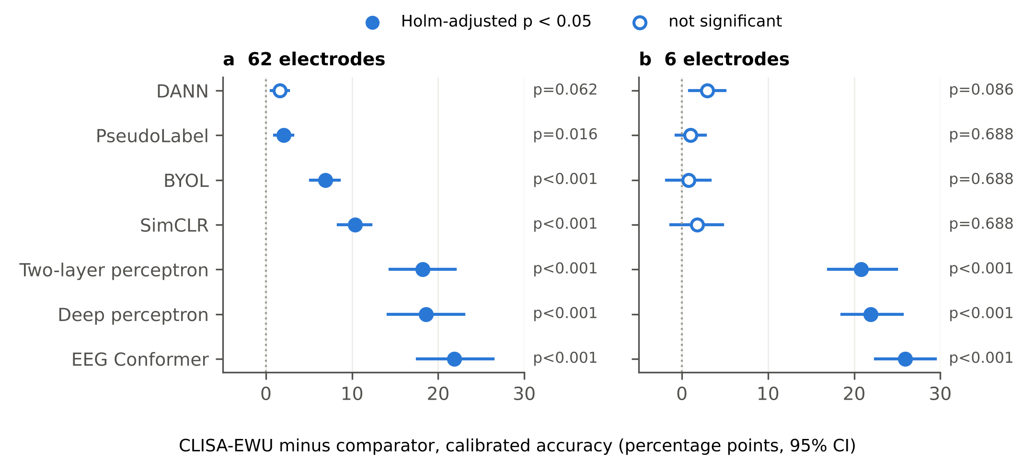
Fig. 10. Paired participant-level comparisons of calibrated CLISA-EWU with other models. Differences in accuracy (CLISA-EWU minus comparator, percentage points) with 95% bootstrap confidence intervals for (a) 62 and (b) six electrodes. Filled markers: Holm-adjusted Wilcoxon p < 0.05 (14 comparisons). This figure replaces a Welch t-test on run-level summaries, which treated 45 runs from 15 participants as independent.

4.4 Ranking across participants
Friedman tests showed significant differences among the 15 deep models in every montage and protocol (Table 7; all p < 0.001). Agreement between participants on the ordering of models was weak zero-shot (Kendall’s W = 0.35 for both montages) but strong after calibration (W = 0.79 and 0.77), so calibration made the ranking consistent across people (Fig. 11). After calibration, CLISA-EWU had the best average rank with 62 electrodes (1.40) and with six (2.67). The Nemenyi critical difference for 15 models and 15 participants was 5.54 ranks; by this conservative criterion, calibrated CLISA-EWU was distinguishable from every supervised network, MixMatch and the DANCE pair, but not from DANN (2.40), PseudoLabel (2.53), BYOL (4.07) or SimCLR (5.80) with 62 electrodes. Zero-shot, CLISA-EWU ranked first with 62 electrodes (4.53), but the deep and two-layer perceptrons were within 0.4 ranks of it, and with six electrodes it ranked third (5.93) behind BYOL (4.13) and SimCLR (4.87).

Ch | Protocol | k | n | χ²_{F} | p | W | CD | Best model (rank) | CLISA-EWU rank
62 | Zero-shot | 15 | 15 | 72.6 | <0.001 | 0.35 | 5.54 | CLISA-EWU (4.53) | 4.53
62 | Calibrated | 15 | 15 | 164.9 | <0.001 | 0.79 | 5.54 | CLISA-EWU (1.40) | 1.40
6 | Zero-shot | 15 | 15 | 74.5 | <0.001 | 0.35 | 5.54 | BYOL (4.13) | 5.93
6 | Calibrated | 15 | 15 | 161.4 | <0.001 | 0.77 | 5.54 | CLISA-EWU (2.67) | 2.67
Table 7. Friedman tests across the 15 deep models of each montage (k models, n participants) with Kendall’s W, the Nemenyi critical difference (CD, α = 0.05), the best-ranked model and the average rank of CLISA-EWU.
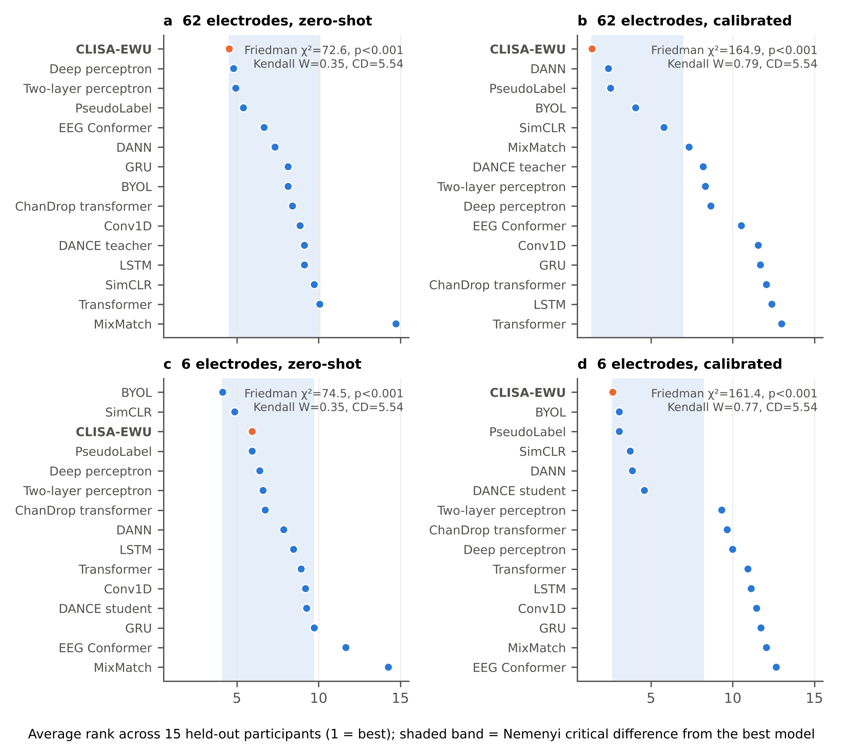
Fig. 11. Average ranks of the deep models across participants. Friedman average rank of each model over the 15 held-out participants (1 = best) for (a) 62 electrodes zero-shot, (b) 62 electrodes calibrated, (c) six electrodes zero-shot and (d) six electrodes calibrated. The shaded band extends one Nemenyi critical difference (CD = 5.54) from the best model; models inside it are not significantly different from the best at α = 0.05. CLISA-EWU is shown in orange.

4.5 Effect sizes
Paired effect sizes (Table 6) separate statistical from practical significance. After calibration with 62 electrodes, the advantage of CLISA-EWU over BYOL and SimCLR was very large (d_{z} = 2.04 and 2.62; r_{rb} = 1.00, with all 15 participants favouring CLISA-EWU), whereas its advantage over PseudoLabel and DANN was large in standardised terms (d_{z} = 0.98 and 0.82) but small in absolute terms (2.1 and 1.6 percentage points), and only the PseudoLabel difference survived Holm correction. With six electrodes, effects against the self-supervised and semi-supervised models were small (d_{z} = 0.14–0.30) and non-significant. Zero-shot, CLISA-EWU differed meaningfully only from EEG Conformer with six electrodes (5.3 points, d_{z} = 1.38, Holm p = 0.001); its differences from the perceptrons were negligible (d_{z} = 0.14–0.32).

4.6 Electrode reduction
Reducing the montage from 62 to six electrodes lowered calibrated accuracy for CLISA-EWU by 5.8 percentage points (Wilcoxon p < 0.001), a retention of 91.4% (95% CI 87.9–95.0%; Fig. 8b, Fig. 12a). Zero-shot retention was lower, at 83.6%. Retention differed between models (Fig. 12b): BYOL and SimCLR performed as well or better with six electrodes than with 62, whereas EEG Conformer retained 78.5%. After calibration, every six-electrode contrastive, domain-adversarial and pseudo-label model remained above chance for every participant (CLISA-EWU minimum 0.518).
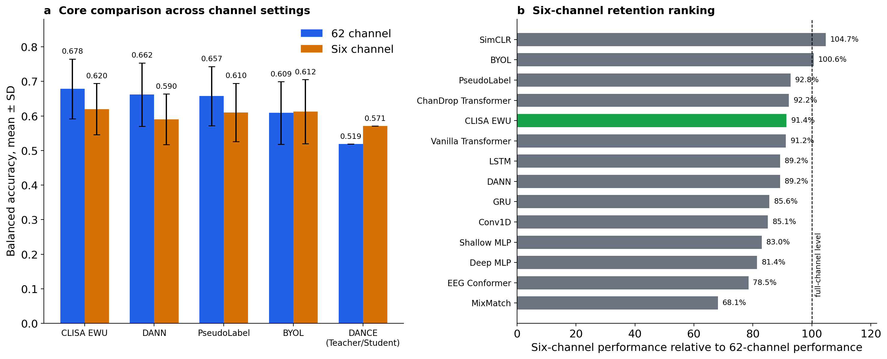
Fig. 12. Electrode reduction. (a) Calibrated accuracy (mean ± s.d. over 45 runs) with 62 and six electrodes for CLISA-EWU, DANN, PseudoLabel, BYOL and the DANCE teacher→student pair. (b) Six-electrode retention (six-electrode ÷ 62-electrode performance) for all models; the dashed line marks 100%. The axis label ‘balanced accuracy’ in this thesis figure denotes accuracy (see Methods).

4.7 Multi-metric evaluation
Table 8 reports the complete confusion-matrix metric set for CLISA-EWU and DANN. Calibrated CLISA-EWU with 62 electrodes reached an accuracy of 0.678, balanced accuracy 0.676, macro F1 0.673, Cohen’s κ 0.569 (95% CI 0.519–0.622) and MCC 0.577; with six electrodes the corresponding values were 0.620, 0.615, 0.611, 0.490 (0.449–0.530) and 0.499. On the Landis–Koch scale⁷⁵, calibrated agreement beyond chance was moderate (κ 0.41–0.60) for both montages, whereas zero-shot agreement was fair with 62 electrodes (κ = 0.31) and at the border of slight and fair with six (κ = 0.21). MCC tracked κ to within 0.01, macro and weighted F1 differed by at most 0.004, and the geometric mean of recalls (0.659 and 0.594 after calibration) stayed close to balanced accuracy, so the results were not driven by class imbalance or by neglect of any class. Mean specificity was high (0.893 and 0.873), indicating that errors were spread across classes rather than concentrated on one. Expressed as an information transfer rate, calibration raised throughput from 3.35 to 9.13 bits min⁻¹ with 62 electrodes and from 1.51 to 6.85 bits min⁻¹ with six. CLISA-EWU exceeded DANN on every metric in both montages and protocols, by 1.2–3.8 points of κ.

Model | Ch | Protocol | Acc | BA | P_{macro} | F1_{m} | F1_{w} | κ | MCC | G | Spec | ITR
DANN | 62 | Zero-shot | 0.458 | 0.459 | 0.479 | 0.455 | 0.456 | 0.278 | 0.282 | 0.436 | 0.820 | 2.76
DANN | 62 | Calibrated | 0.662 | 0.658 | 0.688 | 0.654 | 0.658 | 0.547 | 0.556 | 0.637 | 0.887 | 8.52
DANN | 6 | Zero-shot | 0.396 | 0.397 | 0.404 | 0.386 | 0.387 | 0.195 | 0.199 | 0.359 | 0.799 | 1.50
DANN | 6 | Calibrated | 0.590 | 0.586 | 0.604 | 0.579 | 0.584 | 0.452 | 0.458 | 0.562 | 0.863 | 5.85
CLISA-EWU | 62 | Zero-shot | 0.485 | 0.485 | 0.504 | 0.479 | 0.481 | 0.312 | 0.317 | 0.460 | 0.828 | 3.35
CLISA-EWU | 62 | Calibrated | 0.678 | 0.676 | 0.700 | 0.673 | 0.675 | 0.569 | 0.577 | 0.659 | 0.893 | 9.13
CLISA-EWU | 6 | Zero-shot | 0.405 | 0.407 | 0.412 | 0.398 | 0.398 | 0.207 | 0.212 | 0.374 | 0.802 | 1.51
CLISA-EWU | 6 | Calibrated | 0.620 | 0.615 | 0.641 | 0.611 | 0.615 | 0.490 | 0.499 | 0.594 | 0.873 | 6.84
Table 8. Complete confusion-matrix metrics for CLISA-EWU and DANN (means over 15 participants). Ch = electrodes; BA = balanced accuracy; P_{macro} = macro precision; F1_{m} and F1_{w} = macro and weighted F1; κ = Cohen’s kappa; MCC = Matthews correlation coefficient; G = geometric mean of recalls; Spec = macro specificity; ITR in bits min⁻¹ (4-s windows).

4.8 Variability across participants and seeds
Between-participant variability exceeded between-seed variability. With 62 electrodes, calibrated CLISA-EWU ranged from 0.541 (participant 5) to 0.813 (participant 2) across participants, whereas seed means ranged from 0.658 to 0.691 (Fig. 9). The best single runs reached 0.854 with 62 electrodes (participant 15, seed 7) and 0.786 with six (participant 7, seed 1); they are shown for completeness and are not estimates of expected performance. Fine-tuning converged smoothly (Fig. 13).
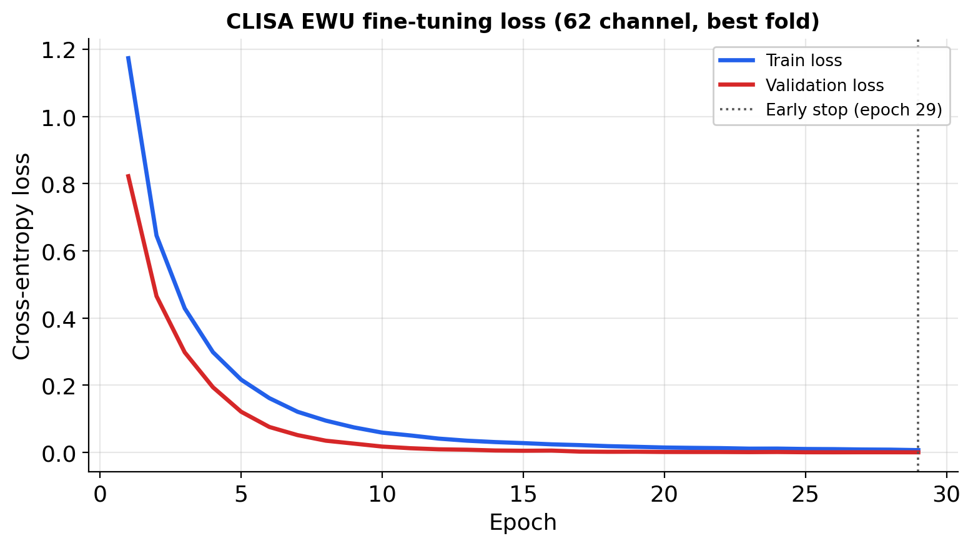
Fig. 13. Fine-tuning convergence. Training and validation cross-entropy for CLISA-EWU with 62 electrodes in the best run (participant 15, seed 7); early stopping at epoch 29. Validation loss lies below training loss because dropout is active during training and validation windows share participants and trials with training windows.
A two-way decomposition (Table 9) quantified the sources of this variability. Zero-shot with 62 electrodes, participant identity explained 96.9% of the variance in CLISA-EWU accuracy and the seed only 0.05% (ICC(3,1) = 0.95). After calibration, the participant share fell to 77.8%, residual variance rose to 19.3% and the ICC dropped to 0.70; with six electrodes the seed effect became significant (F = 4.49, p = 0.020; ICC = 0.53). Because the seed also determines which 20 windows are drawn for calibration, this increase reflects sensitivity to the choice of calibration samples, which argues for averaging over several calibration draws in practice.

Ch | Protocol | Participant (%) | Seed (%) | Residual (%) | F participant (p) | F seed (p) | ICC(3,1)
62 | Zero-shot | 96.9 | 0.0 | 3.1 | 63.50 (<0.001) | 0.22 (0.805) | 0.95
62 | Calibrated | 77.8 | 2.9 | 19.3 | 8.06 (<0.001) | 2.13 (0.138) | 0.70
6 | Zero-shot | 84.3 | 2.3 | 13.4 | 12.54 (<0.001) | 2.40 (0.109) | 0.79
6 | Calibrated | 62.3 | 9.2 | 28.6 | 4.36 (<0.001) | 4.49 (0.020) | 0.53
Table 9. Decomposition of CLISA-EWU accuracy variance into participant, seed and residual components (two-way ANOVA without replication) and consistency across seeds (ICC(3,1)).

4.9 Who benefits from calibration
Calibration gain was negatively correlated with zero-shot accuracy (Spearman ρ = −0.60, p = 0.017 with 62 electrodes; ρ = −0.58, p = 0.024 with six; Fig. 14a): participants who were decoded worst without calibration gained most, up to 39 percentage points for participant 11. Part of this association is expected from regression to the mean, because the gain contains the zero-shot score. Across montages, participants’ calibrated accuracies were strongly correlated (ρ = 0.80, p < 0.001) whereas their zero-shot accuracies were not (ρ = −0.05, p = 0.86; Fig. 14b), so after calibration a participant who is decoded well with 62 electrodes is also decoded well with six. Across models, participant rankings before and after calibration were almost identical for supervised networks (ρ = 0.94–1.00) but less so for the adaptable models (ρ = 0.43–0.93), consistent with calibration substantively changing only the latter.
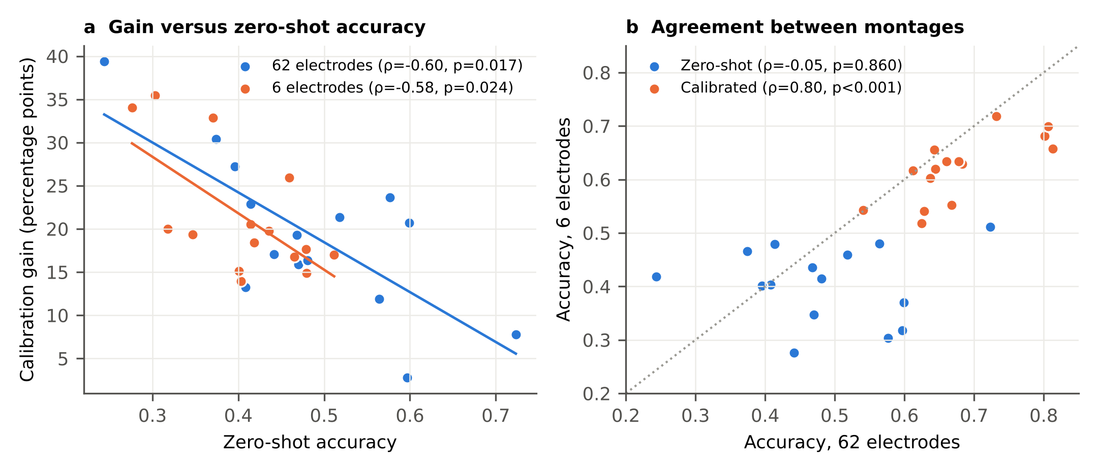
Fig. 14. Who benefits from calibration. (a) Calibration gain versus zero-shot accuracy for each participant with 62 and six electrodes, with least-squares lines and Spearman correlations. (b) Agreement of participant accuracy between montages, zero-shot and calibrated; the dotted line marks equality.

4.10 Class-level behaviour and electrode importance
Per-class metrics (Table 10, Fig. 15) and the mean confusion matrices over all 45 runs (Fig. 16) show where the errors arose. After calibration with 62 electrodes, sad had the highest recall (0.733) but the lowest specificity (0.858), because it attracted errors from fear (16.9% of fear windows) and happy (14.3%); neutral had the highest precision (0.790) and F1 (0.728). Fear was the hardest class in both montages (F1 = 0.621 and 0.565) and was confused mostly with sad. Electrode reduction affected classes unequally: recall fell by 9.6 percentage points for happy, 7.4 for fear, 4.4 for sad and 2.9 for neutral. Zero-shot, the confusion matrices were diffuse and biased towards fear, which received 21.0% of neutral, 24.5% of sad and 21.3% of happy windows with 62 electrodes; calibration removed most of this bias. In the best single runs (Fig. 17), sad recall reached 100% with 62 electrodes.

Class | P (ZS) | R (ZS) | F1 (ZS) | Spec (ZS) | P (Cal) | R (Cal) | F1 (Cal) | Spec (Cal)
62 electrodes
Neutral | 0.595 | 0.535 | 0.541 | 0.848 | 0.790 | 0.697 | 0.728 | 0.919
Sad | 0.539 | 0.464 | 0.480 | 0.837 | 0.687 | 0.733 | 0.695 | 0.858
Fear | 0.393 | 0.438 | 0.408 | 0.776 | 0.675 | 0.604 | 0.621 | 0.895
Happy | 0.490 | 0.504 | 0.488 | 0.852 | 0.648 | 0.671 | 0.647 | 0.898
Six electrodes
Neutral | 0.489 | 0.430 | 0.446 | 0.829 | 0.674 | 0.668 | 0.659 | 0.870
Sad | 0.419 | 0.399 | 0.402 | 0.787 | 0.636 | 0.689 | 0.644 | 0.828
Fear | 0.336 | 0.327 | 0.322 | 0.797 | 0.645 | 0.530 | 0.565 | 0.901
Happy | 0.402 | 0.473 | 0.422 | 0.795 | 0.607 | 0.575 | 0.577 | 0.892
Table 10. Per-class precision (P), recall (R), F1 and specificity (Spec) of CLISA-EWU, zero-shot (ZS) and calibrated (Cal), means over 15 participants.
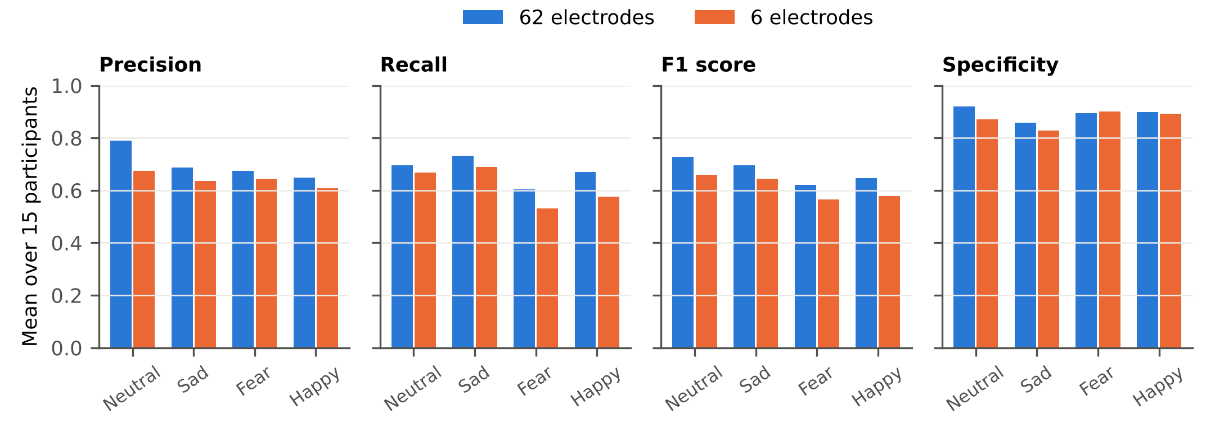
Fig. 15. Per-class metrics of calibrated CLISA-EWU. Precision, recall, F1 score and specificity for each emotion with 62 and six electrodes, means over 15 held-out participants.
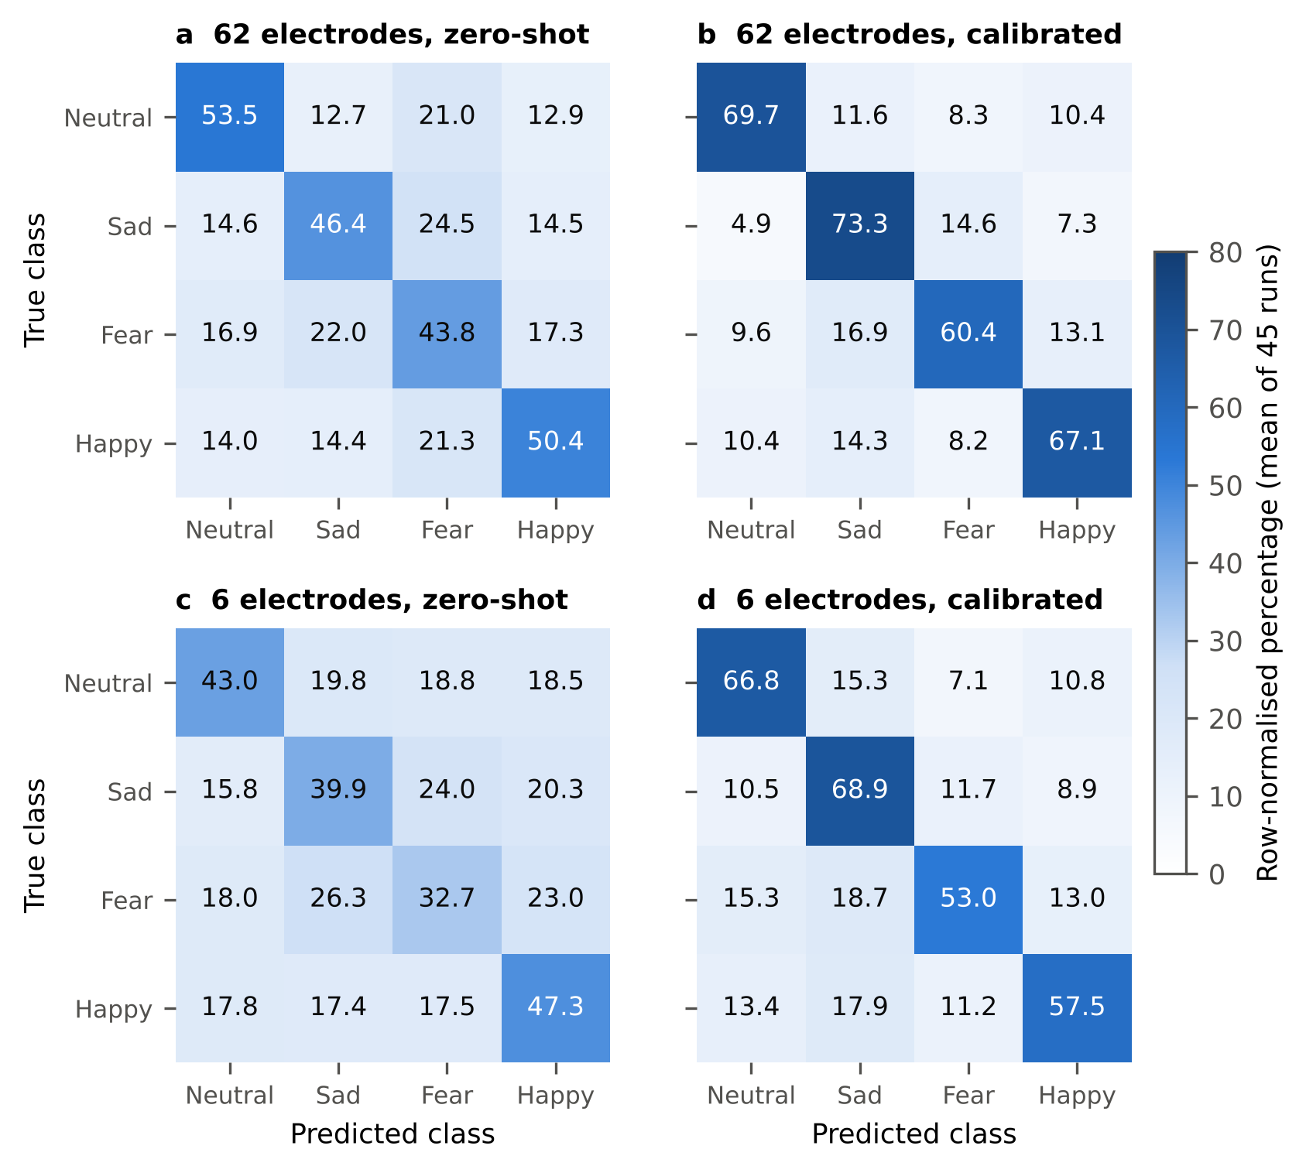
Fig. 16. Mean confusion matrices of CLISA-EWU. Row-normalised percentages averaged over all 45 runs for (a) 62 electrodes zero-shot, (b) 62 electrodes calibrated, (c) six electrodes zero-shot and (d) six electrodes calibrated. Diagonal cells are per-class recall.
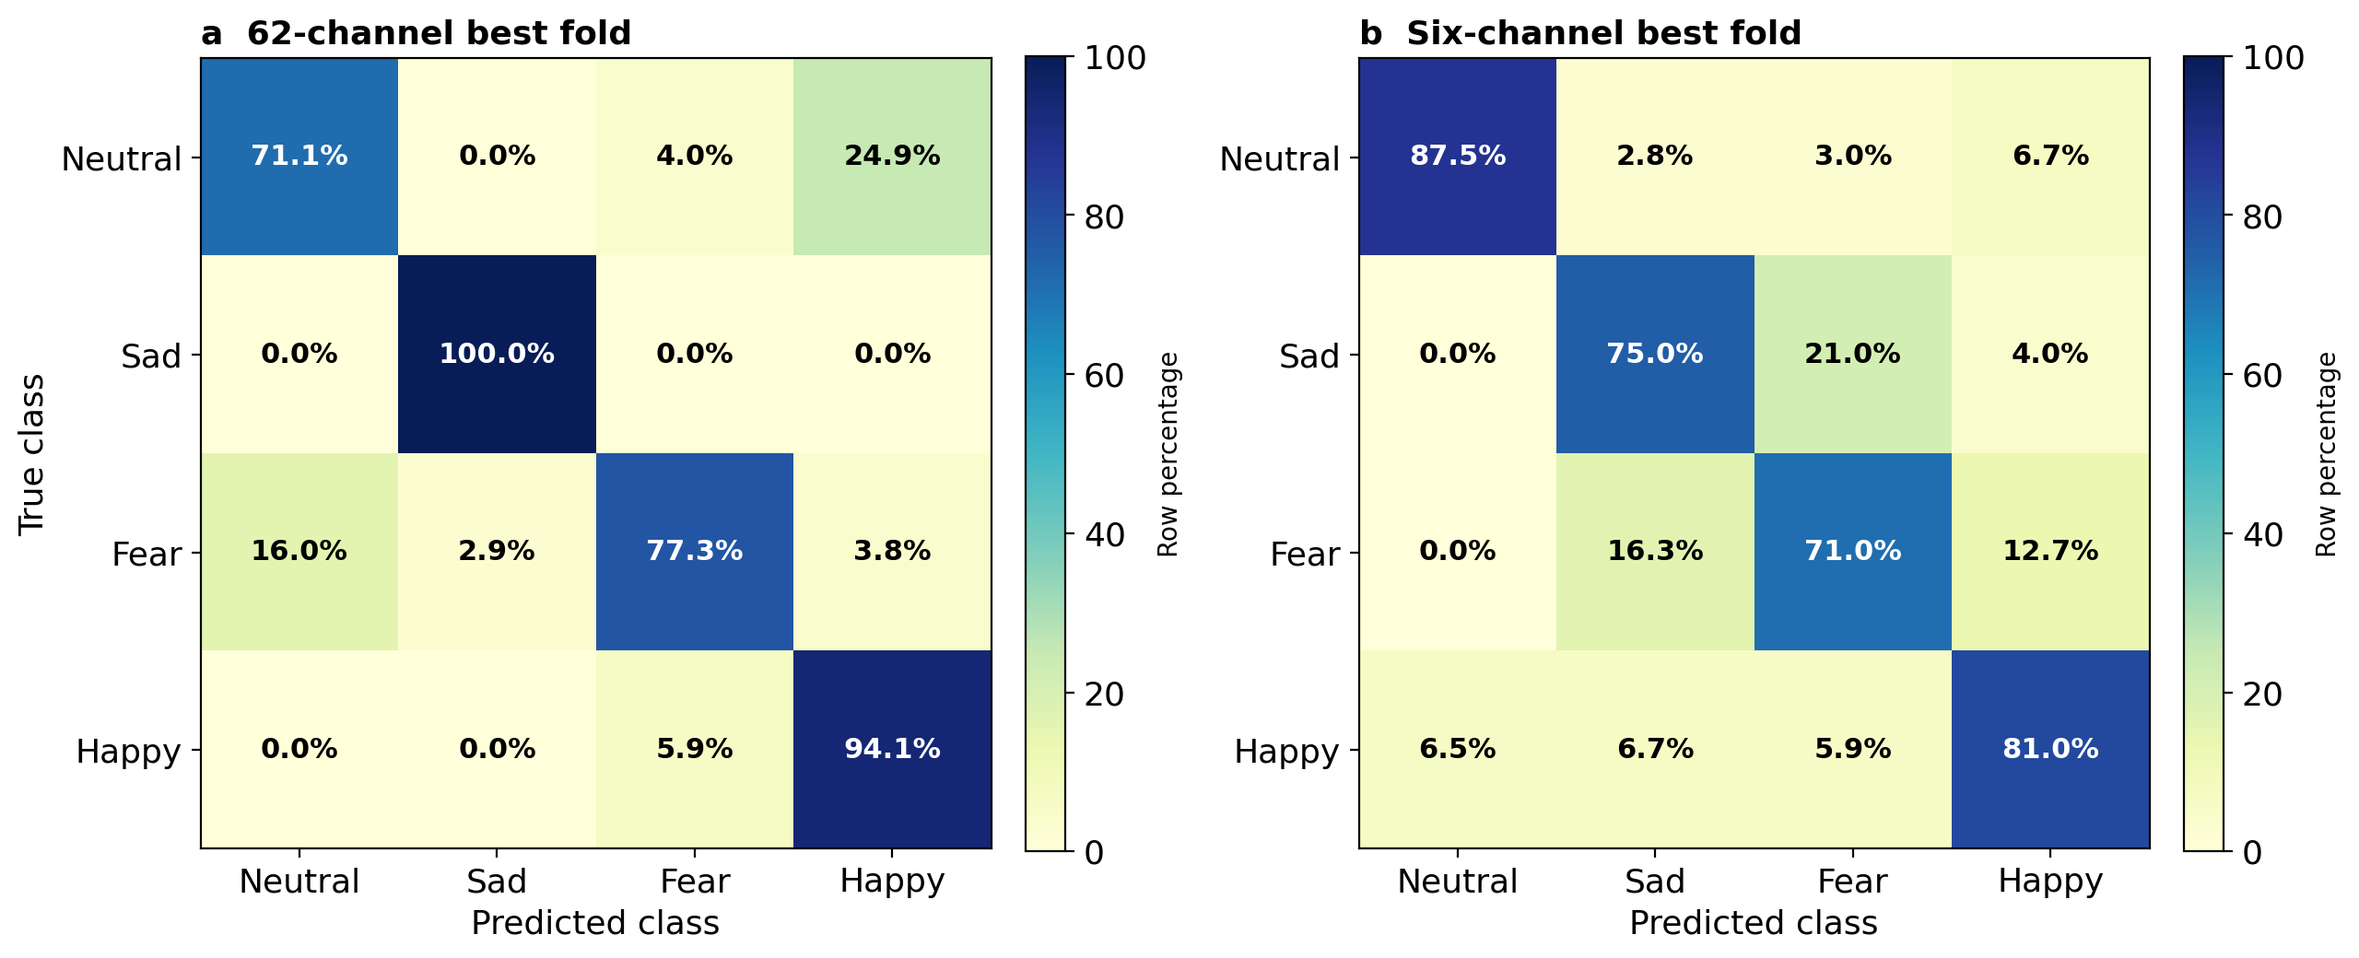
Fig. 17. Confusion matrices of CLISA-EWU in the best single runs. Row-normalised percentages after calibration with (a) 62 electrodes (participant 15, seed 7) and (b) six electrodes (participant 7, seed 1). Best runs illustrate class-level behaviour and are not representative; mean per-class recall over all runs is reported in the text.
Electrode importance differed by class (Fig. 18). For happy, the wearable electrodes FP1 and FP2 ranked second and sixth of 62. For sad, FP1 and F8 ranked fourth and seventh, and the most important electrode was the adjacent midline FPZ. For neutral, FP2 ranked third. For fear, the most important electrodes were parieto-occipital (POZ, PO8), and only F7 among the wearable electrodes ranked in the top five, consistent with fear being the class most affected by electrode reduction. This analysis is based on a single run and is exploratory.
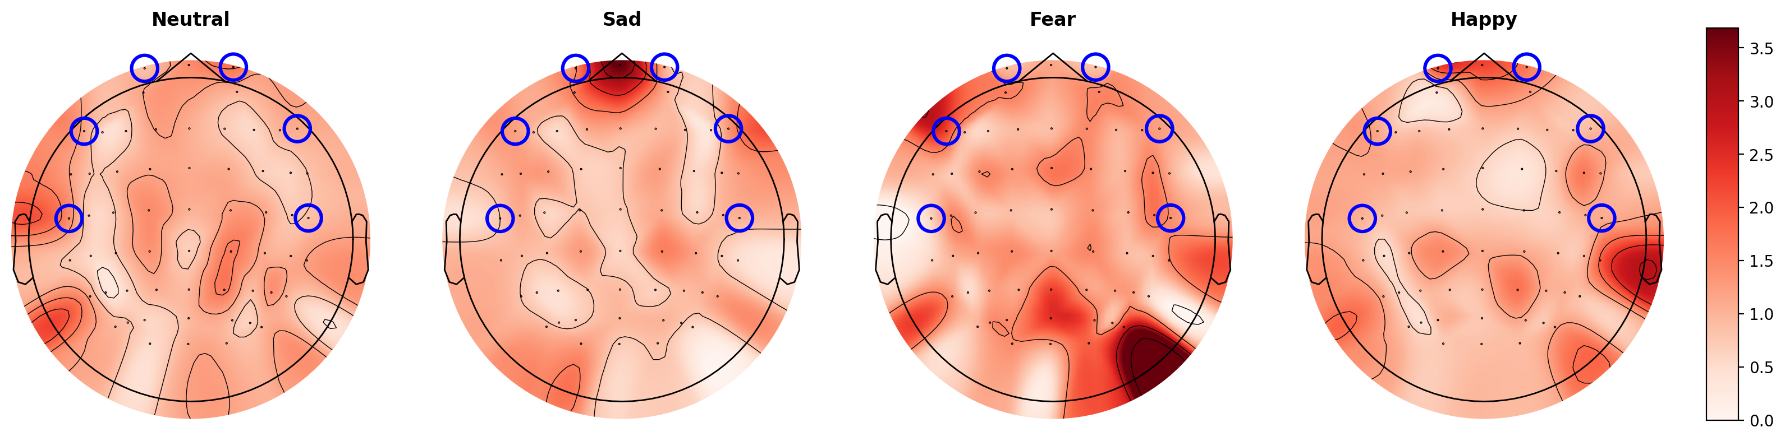
Fig. 18. Electrode importance by predicted class. SHAP attributions summed over five frequency bands per electrode for neutral, sad, fear and happy (left to right), CLISA-EWU with 62 electrodes, best run; shared colour scale. Blue circles mark the six-electrode wearable subset. Single-run, exploratory analysis.

4.11 Representation geometry
In the raw feature space, emotion classes were not separable (emotion silhouette −0.017 with 62 electrodes and −0.013 with six; Table 11). In the CLISA-EWU embedding, emotion silhouette rose to 0.220 (62 electrodes) and 0.046 (six), Davies–Bouldin indices fell, and participant silhouettes were negative (−0.098 and −0.057), indicating that participant identity did not dominate the embedding (Fig. 19). These embeddings were computed on all 15 participants with the best-run model, 14 of whom contributed labelled training data, so the emotion structure partly reflects supervised fitting [recompute on held-out participants only].

Feature space | Labels (clusters) | Silhouette | Davies–Bouldin | Calinski–Harabasz
Raw, 62 electrodes | Emotion (4) | −0.017 | 7.68 | 511.8
Raw, 62 electrodes | Participant (15) | −0.034 | 1.40 × 10⁵ | <0.1
CLISA-EWU, 62 electrodes | Emotion (4) | 0.220 | 1.64 | 7309.0
CLISA-EWU, 62 electrodes | Participant (15) | −0.098 | 11.10 | 84.4
Raw, six electrodes | Emotion (4) | −0.013 | 8.16 | 536.3
Raw, six electrodes | Participant (15) | −0.045 | 5.56 × 10⁴ | <0.1
CLISA-EWU, six electrodes | Emotion (4) | 0.046 | 3.75 | 1434.1
CLISA-EWU, six electrodes | Participant (15) | −0.057 | 10.09 | 159.6
Table 11. Clustering metrics for raw features and CLISA-EWU embeddings. Higher silhouette and Calinski–Harabasz and lower Davies–Bouldin values indicate tighter clusters. Embeddings were computed with the best-run model on all 15 participants (14 of whom were in its training set).
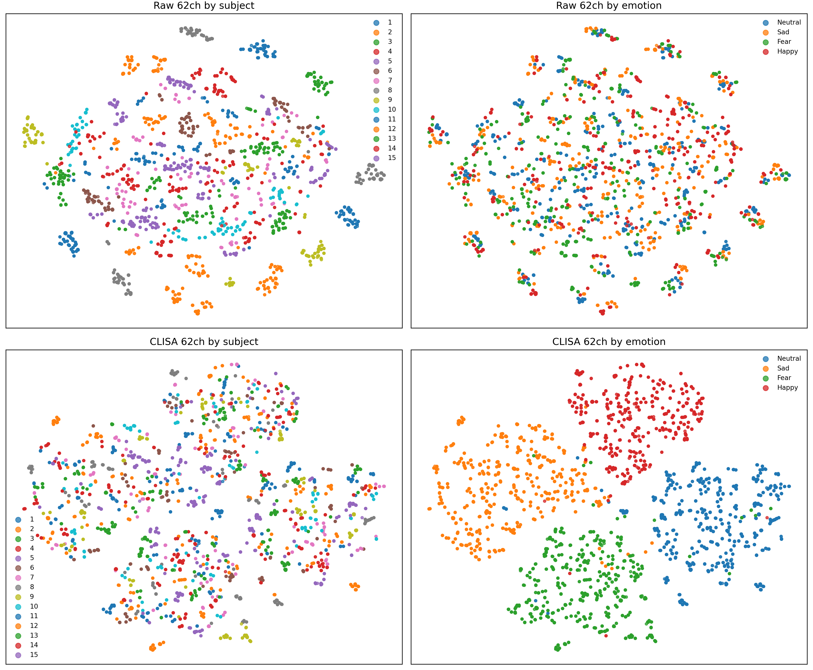
Fig. 19. Representation geometry. t-SNE projections of raw 62-electrode differential-entropy features (top) and CLISA-EWU 62-electrode encoder embeddings (bottom), coloured by participant (left) and emotion (right). The embedding model is from the best run, and 14 of the 15 participants contributed labelled training data to it, so the emotion structure should be interpreted qualitatively.

4.12 Secondary analyses
The DANCE teacher–student pair was included as a secondary reference. Its calibrated accuracy was 0.519 (teacher, 62 electrodes) and 0.571 (student, six electrodes). An ablation of the DANCE framework is shown in Fig. 20; four of its variants produced identical results, indicating that the corresponding options were not applied, so this ablation should be regarded as incomplete [re-run, and add a CLISA-EWU ablation: no pretraining, noise-only, masking-only, temperature]. A software prototype, NeuroSync, displays signal traces, band power, predicted state and class probabilities from the trained model (Fig. 21); it was demonstrated on a synthetic replay session and has not been validated on live wearable recordings.
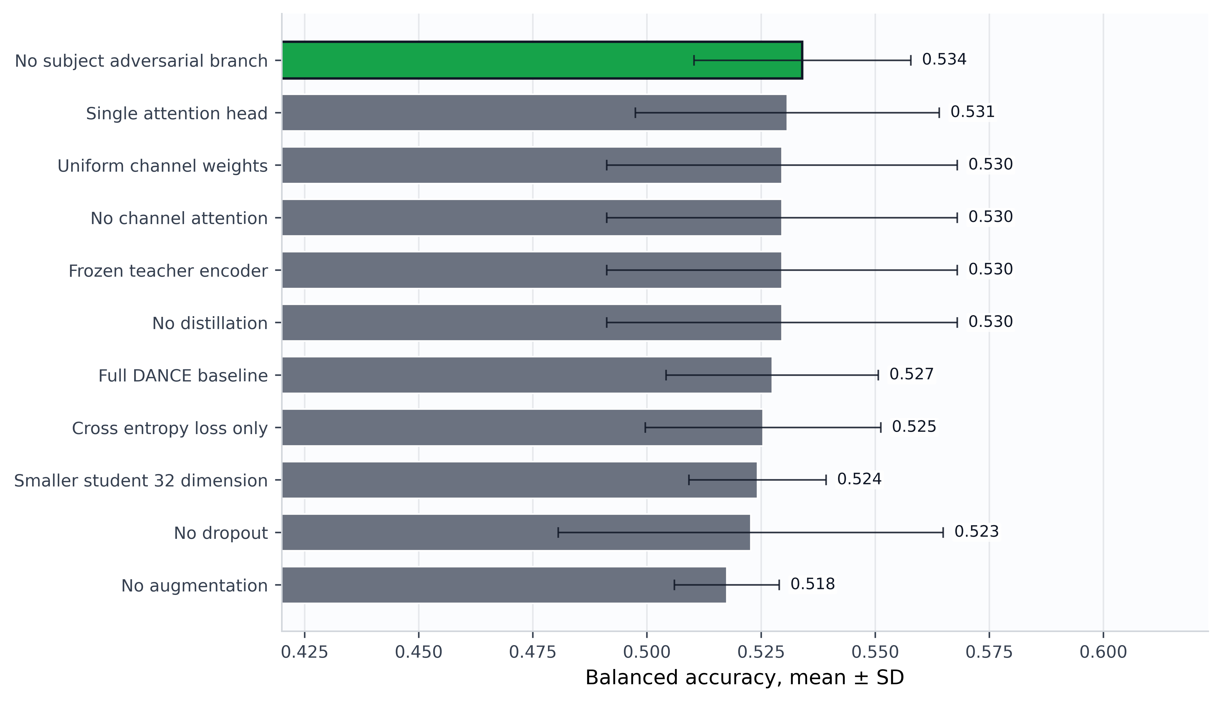
Fig. 20. Ablation of the DANCE teacher–student framework (secondary comparator). Calibrated accuracy (mean ± s.d. over three seeds) of 11 DANCE variants under a reduced protocol. Four variants produced identical values, indicating that their options were not applied; this ablation is incomplete and does not concern CLISA-EWU. The axis label ‘balanced accuracy’ in this thesis figure denotes accuracy (see Methods). [Re-run before submission.]
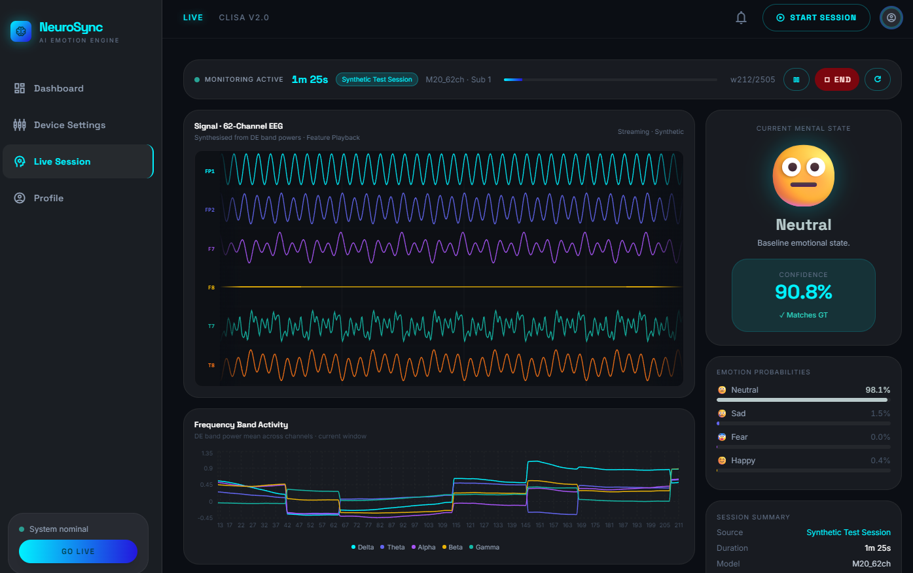
Fig. 21. NeuroSync dashboard prototype. Signal traces, frequency-band activity, predicted state with confidence and class probabilities produced by the trained model during a synthetic replay session. Software demonstration only; not validated on live wearable recordings.

4.13 Comparison with published studies
The calibrated mean of CLISA-EWU (67.8%) lies within the range of published cross-participant SEED-IV results (Table 1), and the zero-shot mean (48.5%) lies below it. Because the published values differ in their use of target-participant data and in reporting unit, they cannot be ranked against the present results; a fair comparison requires re-evaluating published architectures under both protocols used here.

4.14 Implications
These findings change how cross-participant results should be read. Much of the published progress on SEED-IV has been attributed to architectural innovation, yet our results suggest that the protocol, and specifically whether and how target-participant data are used, may explain as much variance as the architecture. Under calibration, the ordering of model families inverted: supervised networks that matched self-supervised models zero-shot fell far behind them. Comparisons that mix zero-shot, transductive and calibrated results, or that compare a best fold with another study's mean, are therefore uninterpretable. We recommend that cross-participant EEG studies report zero-shot and calibrated results separately, specify the number and selection of calibration samples, keep calibration and test trials disjoint, and summarise results at the participant level with confidence intervals^{17,54}.
The practical message for wearable affective computing is cautiously positive. A short calibration session is acceptable in most consumer and research workflows, and a headband carrying frontal and temporal electrodes appears to keep most of the decodable signal under calibration. That some self-supervised models lost nothing from electrode reduction suggests that the frontal–temporal subset contains much of the information these models exploit, consistent with the established role of frontal activity in affect³. The attribution analysis indicates where the six-electrode montage falls short: fear relied on parieto-occipital electrodes outside the subset, and fear recall dropped most. A seven- or eight-electrode montage adding a parieto-occipital site is a natural next design to test. Nevertheless, the absolute calibrated accuracy (about 62% for four classes with six electrodes) and the large between-participant spread mean that individual predictions remain unreliable, and the system is not suitable for clinical decisions.

4.15 Limitations
This study has limitations. The cohort was small (15 participants), healthy and drawn from one laboratory, and emotions were elicited with film clips under controlled conditions; generalisation to other populations, naturalistic settings and clinical groups is unknown^{3,24,25}. The six-electrode montage was simulated by selecting channels from a laboratory cap rather than recorded with a wearable device. Calibration windows were sampled across trials, so calibration and test windows could share a trial, which may have inflated calibrated accuracy¹⁸. Labels were assigned per film clip rather than per moment. We used precomputed features, so preprocessing choices could not be varied, and hyperparameters were not tuned separately for each model. Finally, the contrastive model contrasted augmented views of single windows rather than aligning participants explicitly, so its gains should not be attributed to inter-participant alignment.

5 Conclusion and Future Work
In this benchmark of 26 models under one leave-one-participant-out protocol, three findings stand out. First, decoding four emotions in an unseen participant without any of their data was modest for every model, and the deep architectures, including the contrastive model of primary interest, did not clearly outperform a two-layer perceptron. Second, about 80 s of labelled calibration data raised accuracy by roughly 20 percentage points, but only for models trained with contrastive, domain-adversarial or pseudo-label objectives. Third, a six-electrode frontal–temporal montage retained about nine-tenths of calibrated full-montage performance. In a controlled participant-independent benchmark, brief labelled calibration rather than architecture accounted for most of the measurable gain in EEG emotion recognition, and a six-electrode wearable-compatible montage retained about 91% of calibrated performance. Rigorous separation of zero-shot and calibrated evaluation, external validation and real wearable recordings are the next steps towards dependable EEG-based affect sensing.
Future work will address the limitations identified above:
- External validation on SEED, SEED-V and FACED, and training on SEED-IV with testing on these datasets without retraining^{3,24,25}.
- A trial-held-out calibration protocol (calibrate on session 1, test on sessions 2–3) and a calibration-budget curve of 5–200 windows to remove the trial-overlap optimism of the present calibration.
- An ablation that calibrates only batch-normalisation statistics, only the classifier, or all parameters, to identify the mechanism behind the objective-dependent calibration gain.
- A true inter-participant contrastive objective with stimulus-aligned positives from different participants, to test whether zero-shot accuracy can be improved.
- A seven- or eight-electrode montage that adds a parieto-occipital site, motivated by the attribution results for fear.
- Recording a new cohort with a dry-electrode wearable headband and real-time deployment of the NeuroSync interface, followed by studies in clinically relevant populations.

Data availability
The SEED-IV dataset is available from its providers under their licence at https://bcmi.sjtu.edu.cn/home/seed/. Data splits, per-fold predictions, confusion matrices and result tables are available at https://github.com/saifkhancse/clisa-ewu-brain-informatics [archive a tagged release on Zenodo and cite its DOI].

Code availability
Model, training, evaluation and analysis code, including the scripts that regenerate every statistic and figure in this paper, is available at https://github.com/saifkhancse/clisa-ewu-brain-informatics.

References
- Russell, J. A. A circumplex model of affect. J. Pers. Soc. Psychol. 39, 1161–1178 (1980).
- Zheng, W.-L., Liu, W., Lu, Y., Lu, B.-L. & Cichocki, A. EmotionMeter: a multimodal framework for recognizing human emotions. IEEE Trans. Cybern. 49, 1110–1122 (2019).
- Zheng, W.-L. & Lu, B.-L. Investigating critical frequency bands and channels for EEG-based emotion recognition with deep neural networks. IEEE Trans. Auton. Ment. Dev. 7, 162–175 (2015).
- Koelstra, S. et al. DEAP: a database for emotion analysis using physiological signals. IEEE Trans. Affect. Comput. 3, 18–31 (2012).
- Shen, X., Liu, X., Hu, X., Zhang, D. & Song, S. Contrastive learning of subject-invariant EEG representations for cross-subject emotion recognition. IEEE Trans. Affect. Comput. https://doi.org/10.1109/TAFFC.2022.3164516 (2022). [verify author list]
- Ganin, Y. et al. Domain-adversarial training of neural networks. J. Mach. Learn. Res. 17, 1–35 (2016).
- Li, H., Jin, Y.-M., Zheng, W.-L. & Lu, B.-L. Cross-subject emotion recognition using deep adaptation networks. In Neural Information Processing (ICONIP 2018) 403–413 (Springer, 2018).
- Li, Y., Zheng, W., Cui, Z., Zhang, T. & Zong, Y. A novel neural network model based on cerebral hemispheric asymmetry for EEG emotion recognition. In Proc. IJCAI 1561–1567 (2018).
- Li, Y. et al. A novel bi-hemispheric discrepancy model for EEG emotion recognition. IEEE Trans. Cogn. Dev. Syst. 13, 354–367 (2021).
- Song, T., Zheng, W., Song, P. & Cui, Z. EEG emotion recognition using dynamical graph convolutional neural networks. IEEE Trans. Affect. Comput. 11, 532–541 (2020).
- Zhong, P., Wang, D. & Miao, C. EEG-based emotion recognition using regularized graph neural networks. IEEE Trans. Affect. Comput. 13, 1290–1301 (2022).
- Li, J., Li, S., Pan, J. & Wang, F. Cross-subject EEG emotion recognition with self-organized graph neural network. Front. Neurosci. 15, 611653 (2021).
- Zhang, J. et al. Subject-independent emotion recognition based on EEG frequency band features and self-adaptive graph construction. Brain Sci. 14, 271 (2024).
- Zhang, S., Chu, C., Zhang, X. & Zhang, X. EEG emotion recognition using AttGraph: a multi-dimensional attention-based dynamic graph convolutional network. Brain Sci. 15, 615 (2025).
- Ahuja, C. & Sethia, D. SS-EMERGE: self-supervised enhancement for multidimension emotion recognition using GNNs for EEG. Sci. Rep. 15, 14254 (2025).
- Saeb, S., Lonini, L., Jayaraman, A., Mohr, D. C. & Kording, K. P. The need to approximate the use-case in clinical machine learning. GigaScience 6, 1–9 (2017).
- Kapoor, S. & Narayanan, A. Leakage and the reproducibility crisis in machine-learning-based science. Patterns 4, 100804 (2023).
- Li, R. et al. The perils and pitfalls of block design for EEG classification experiments. IEEE Trans. Pattern Anal. Mach. Intell. 43, 316–333 (2021).
- Katsigiannis, S. & Ramzan, N. DREAMER: a database for emotion recognition through EEG and ECG signals from wireless low-cost off-the-shelf devices. IEEE J. Biomed. Health Inform. 22, 98–107 (2018).
- Davidson, R. J. Anterior cerebral asymmetry and the nature of emotion. Brain Cogn. 20, 125–151 (1992).
- Coan, J. A. & Allen, J. J. B. Frontal EEG asymmetry as a moderator and mediator of emotion. Biol. Psychol. 67, 7–49 (2004).
- Alarcão, S. M. & Fonseca, M. J. Emotions recognition using EEG signals: a survey. IEEE Trans. Affect. Comput. 10, 374–393 (2019).
- Jenke, R., Peer, A. & Buss, M. Feature extraction and selection for emotion recognition from EEG. IEEE Trans. Affect. Comput. 5, 327–339 (2014).
- Liu, W., Qiu, J.-L., Zheng, W.-L. & Lu, B.-L. Comparing recognition performance and robustness of multimodal deep learning models for multimodal emotion recognition. IEEE Trans. Cogn. Dev. Syst. 14, 715–729 (2022).
- Chen, J. et al. A large finer-grained affective computing EEG dataset. Sci. Data 10, 740 (2023).
- Jayaram, V., Alamgir, M., Altun, Y., Schölkopf, B. & Grosse-Wentrup, M. Transfer learning in brain–computer interfaces. IEEE Comput. Intell. Mag. 11, 20–31 (2016).
- Wu, D., Xu, Y. & Lu, B.-L. Transfer learning for EEG-based brain–computer interfaces: a review of progress made since 2016. IEEE Trans. Cogn. Dev. Syst. 14, 4–19 (2022).
- Duan, R.-N., Zhu, J.-Y. & Lu, B.-L. Differential entropy feature for EEG-based emotion classification. In Proc. 6th Int. IEEE/EMBS Conf. Neural Eng. 81–84 (2013).
- Lotte, F. et al. A review of classification algorithms for EEG-based brain–computer interfaces: a 10 year update. J. Neural Eng. 15, 031005 (2018).
- Chen, T. & Guestrin, C. XGBoost: a scalable tree boosting system. In Proc. 22nd ACM SIGKDD 785–794 (2016).
- Craik, A., He, Y. & Contreras-Vidal, J. L. Deep learning for electroencephalogram (EEG) classification tasks: a review. J. Neural Eng. 16, 031001 (2019).
- Roy, Y. et al. Deep learning-based electroencephalography analysis: a systematic review. J. Neural Eng. 16, 051001 (2019).
- Schirrmeister, R. T. et al. Deep learning with convolutional neural networks for EEG decoding and visualization. Hum. Brain Mapp. 38, 5391–5420 (2017).
- Lawhern, V. J. et al. EEGNet: a compact convolutional neural network for EEG-based brain–computer interfaces. J. Neural Eng. 15, 056013 (2018).
- Song, Y., Zheng, Q., Liu, B. & Gao, X. EEG Conformer: convolutional transformer for EEG decoding and visualization. IEEE Trans. Neural Syst. Rehabil. Eng. 31, 710–719 (2023).
- Vaswani, A. et al. Attention is all you need. Adv. Neural Inf. Process. Syst. 30 (2017).
- Li, Y. et al. From regional to global brain: a novel hierarchical spatial-temporal neural network model for EEG emotion recognition. IEEE Trans. Affect. Comput. 13, 568–578 (2022).
- Pan, S. J., Tsang, I. W., Kwok, J. T. & Yang, Q. Domain adaptation via transfer component analysis. IEEE Trans. Neural Netw. 22, 199–210 (2011).
- Zheng, W.-L. & Lu, B.-L. Personalizing EEG-based affective models with transfer learning. In Proc. 25th Int. Joint Conf. Artif. Intell. 2732–2738 (2016).
- Zanini, P., Congedo, M., Jutten, C., Said, S. & Berthoumieu, Y. Transfer learning: a Riemannian geometry framework with applications to brain–computer interfaces. IEEE Trans. Biomed. Eng. 65, 1107–1116 (2018).
- He, H. & Wu, D. Transfer learning for brain–computer interfaces: a Euclidean space data alignment approach. IEEE Trans. Biomed. Eng. 67, 399–410 (2020).
- Long, M., Cao, Y., Wang, J. & Jordan, M. I. Learning transferable features with deep adaptation networks. In Proc. 32nd Int. Conf. Mach. Learn. 97–105 (2015).
- Li, J., Qiu, S., Shen, Y.-Y., Liu, C.-L. & He, H. Multisource transfer learning for cross-subject EEG emotion recognition. IEEE Trans. Cybern. 50, 3281–3293 (2020).
- Zhao, L.-M., Yan, X. & Lu, B.-L. Plug-and-play domain adaptation for cross-subject EEG-based emotion recognition. In Proc. AAAI Conf. Artif. Intell. 35, 863–870 (2021).
- Li, Y., Wang, N., Shi, J., Hou, X. & Liu, J. Adaptive batch normalization for practical domain adaptation. Pattern Recognit. 80, 109–117 (2018).
- Chen, T., Kornblith, S., Norouzi, M. & Hinton, G. A simple framework for contrastive learning of visual representations. In Proc. ICML 1597–1607 (2020).
- Grill, J.-B. et al. Bootstrap your own latent: a new approach to self-supervised learning. Adv. Neural Inf. Process. Syst. 33, 21271–21284 (2020).
- Mohsenvand, M. N., Izadi, M. R. & Maes, P. Contrastive representation learning for electroencephalogram classification. In Proc. Machine Learning for Health, PMLR 136, 238–253 (2020).
- Banville, H., Chehab, O., Hyvärinen, A., Engemann, D.-A. & Gramfort, A. Uncovering the structure of clinical EEG signals with self-supervised learning. J. Neural Eng. 18, 046020 (2021).
- Kostas, D., Aroca-Ouellette, S. & Rudzicz, F. BENDR: using transformers and a contrastive self-supervised learning task to learn from massive amounts of EEG data. Front. Hum. Neurosci. 15, 653659 (2021).
- Lee, D.-H. Pseudo-label: the simple and efficient semi-supervised learning method for deep neural networks. In ICML Workshop on Challenges in Representation Learning (2013).
- Berthelot, D. et al. MixMatch: a holistic approach to semi-supervised learning. Adv. Neural Inf. Process. Syst. 32 (2019).
- Hinton, G., Vinyals, O. & Dean, J. Distilling the knowledge in a neural network. Preprint at https://arxiv.org/abs/1503.02531 (2015).
- Collins, G. S. et al. TRIPOD+AI statement: updated guidance for reporting clinical prediction models that use regression or machine learning methods. BMJ 385, e078378 (2024).
- Demšar, J. Statistical comparisons of classifiers over multiple data sets. J. Mach. Learn. Res. 7, 1–30 (2006).
- Krigolson, O. E., Williams, C. C., Norton, A., Hassall, C. D. & Colino, F. L. Choosing MUSE: validation of a low-cost, portable EEG system for ERP research. Front. Neurosci. 11, 109 (2017).
- Casson, A. J. Wearable EEG and beyond. Biomed. Eng. Lett. 9, 53–71 (2019).
- Brodersen, K. H., Ong, C. S., Stephan, K. E. & Buhmann, J. M. The balanced accuracy and its posterior distribution. In Proc. 20th Int. Conf. Pattern Recognit. 3121–3124 (2010).
- Cohen, J. A coefficient of agreement for nominal scales. Educ. Psychol. Meas. 20, 37–46 (1960).
- Gorodkin, J. Comparing two K-category assignments by a K-category correlation coefficient. Comput. Biol. Chem. 28, 367–374 (2004).
- Chicco, D. & Jurman, G. The advantages of the Matthews correlation coefficient (MCC) over F1 score and accuracy in binary classification evaluation. BMC Genomics 21, 6 (2020).
- Kubat, M. & Matwin, S. Addressing the curse of imbalanced training sets: one-sided selection. In Proc. 14th Int. Conf. Mach. Learn. 179–186 (1997).
- Wolpaw, J. R., Birbaumer, N., McFarland, D. J., Pfurtscheller, G. & Vaughan, T. M. Brain–computer interfaces for communication and control. Clin. Neurophysiol. 113, 767–791 (2002).
- Friedman, M. The use of ranks to avoid the assumption of normality implicit in the analysis of variance. J. Am. Stat. Assoc. 32, 675–701 (1937).
- Wilcoxon, F. Individual comparisons by ranking methods. Biom. Bull. 1, 80–83 (1945).
- Holm, S. A simple sequentially rejective multiple test procedure. Scand. J. Stat. 6, 65–70 (1979).
- Lakens, D. Calculating and reporting effect sizes to facilitate cumulative science: a practical primer for t-tests and ANOVAs. Front. Psychol. 4, 863 (2013).
- Kerby, D. S. The simple difference formula: an approach to teaching nonparametric correlation. Compr. Psychol. 3, 11.IT.3.1 (2014).
- Shrout, P. E. & Fleiss, J. L. Intraclass correlations: uses in assessing rater reliability. Psychol. Bull. 86, 420–428 (1979).
- van der Maaten, L. & Hinton, G. Visualizing data using t-SNE. J. Mach. Learn. Res. 9, 2579–2605 (2008).
- Rousseeuw, P. J. Silhouettes: a graphical aid to the interpretation and validation of cluster analysis. J. Comput. Appl. Math. 20, 53–65 (1987).
- Davies, D. L. & Bouldin, D. W. A cluster separation measure. IEEE Trans. Pattern Anal. Mach. Intell. 1, 224–227 (1979).
- Caliński, T. & Harabasz, J. A dendrite method for cluster analysis. Commun. Stat. 3, 1–27 (1974).
- Lundberg, S. M. & Lee, S.-I. A unified approach to interpreting model predictions. Adv. Neural Inf. Process. Syst. 30 (2017).
- Landis, J. R. & Koch, G. G. The measurement of observer agreement for categorical data. Biometrics 33, 159–174 (1977).

Acknowledgements
The authors thank the providers of the SEED-IV dataset and the Department of Computer Science and Engineering, East West University, for their support. All figures were created by the authors; schematic illustrations (Figs. 1 and 4) were drawn manually and all plots were generated with Python.

Author contributions
S.K.: conceptualization, methodology, software, experiments, formal analysis, visualization and writing of the original draft. O.B.Q.: experiments, analysis and manuscript preparation. K.M.F.A.B.: implementation, evaluation and documentation. R.R.: experiments, reporting and software integration (NeuroSync). A.W.R.: supervision, review and editing. All authors reviewed and approved the final manuscript.

Funding
No external funding was received for this study [confirm].

Declarations

Competing interests
The authors declare no competing interests.

Additional information
Correspondence and requests for materials should be addressed to S.K.

