What a held-out-position split measures: the apparent failure of deep mutational scanning models to extrapolate across positions is a property of their representation, shown across 218 assays
[Author names and affiliations]

Abstract
Supervised models of deep mutational scanning data are normally validated by holding out random variants. In a saturating library almost every position is mutated somewhere in the training set, so this measures interpolation, not the case that matters for surveillance, in which a lineage mutates a position no experiment has probed. We benchmarked eleven model families on SARS-CoV-2 receptor-binding-domain variants with three measured phenotypes under a conventional random split and under a held-out-position split in which no training variant mutates any test position. That failure is a property of the representation rather than of the data. Every model in this class encodes a substitution by which position it occupies, so none holds a parameter applicable to a position absent from training. Given features that remain defined at unseen positions — how the residue changes chemically, and descriptors of the position taken from the crystal structure of the receptor complex — a ridge regression reaches a partial correlation of +0.650 ± 0.074 for binding and +0.600 ± 0.069 for antibody escape. Decomposing it, structure contributes +0.554 ± 0.112 and chemistry +0.371 ± 0.060; removing the two descriptors that mark the receptor interface, and are therefore close to circular for binding, leaves +0.518 ± 0.095. ESM-2 contributes nothing on this protein: its zero-shot scores reach +0.340 ± 0.067 for binding, of which -0.004 ± 0.091 survives the substitution-count control. A second task on 806 coronavirus genomes from 287 species shows how much of a headline number a control can account for even when the models are genuinely good: under a held-out-species split, genome length and base composition alone reach balanced accuracy 0.914 ± 0.037, and the sequence models do add a real increment here (5-mer + logistic regression reaches 0.998 ± 0.004), so on this task the control bounds how much of a headline accuracy is informative rather than explaining all of it. Repeating the comparison over all 217 substitution assays in ProteinGym shows this is a property of the benchmark and not of one protein. A model given only position indicators, which knows nothing about which substitution is made, has a median per-assay rho of 0.665 under a random split against 0.455 for a model given only the chemistry of the substitution; under a held-out-position split the first falls to 0.0, which is an identity rather than a degradation, and the second retains 0.313. The standard evaluation rewards memorising per-position means, and that capability is worth nothing at a position no experiment has probed. We conclude that a hard evaluation split is interpretable only against an untrained baseline computed on the same partition, that the apparent inability of sequence models to extrapolate across positions is an artefact of how they index substitutions rather than a limit of the measurements, and that before a phenotype is called unpredictable at an unseen position one should check whether the models tested hold any parameter that applies there.
Keywords: deep mutational scanning; SARS-CoV-2; model evaluation; generalisation; baselines; protein structure; protein language models; variant effect prediction.

1. Introduction
Deep mutational scanning measures the phenotypic consequences of thousands of amino-acid substitutions in a single experiment, and such data underpin much of what is known about the SARS-CoV-2 receptor-binding domain (RBD): which substitutions raise ACE2 affinity, which destabilise the fold, and which abolish binding by therapeutic antibodies [1,2]. Supervised models trained on these measurements are routinely used to score substitutions that were never assayed.
How such models are validated has received less scrutiny than how they are built. The standard protocol holds out a random subset of variants. In a saturating combinatorial library almost every position is mutated somewhere in the training data, so a random test variant differs from training variants in which substitutions it combines, not in where those substitutions fall. A model can therefore score well by learning a per-position, per-residue effect table together with a link function, without any capacity to speak about a position it has never seen mutated. That capacity is what surveillance requires.
Position-based evaluation is not a new proposal, and we are not making one. The supervised ProteinGym benchmark already defines two position-based cross-validation schemes alongside a random one: fold_modulo_5, which assigns positions to folds by position modulo five, and fold_contiguous_5, which cuts the sequence into five consecutive blocks [10,11]. Both are used below, reconstructed exactly, so that the numbers here sit on the same footing as the published leaderboard. What this paper contributes is not the split but the diagnostics evaluated on it, and what they reveal.
This paper makes three points, and the second corrects the first. First, held-out-position evaluation is uninterpretable without an untrained control: on a combinatorial library a model that has learned nothing about the withheld positions still orders test variants correctly to the extent that fitness falls with the number of substitutions, and that alone produces a respectable-looking rank correlation. Second — and this is where our own first analysis went wrong — the conclusion that no model extrapolates across positions does not follow. The models we had compared all encode a substitution by the position it occupies, so none of them holds a parameter that applies to a held-out position; their failure was a property of the representation. Given features that remain defined at an unseen position, extrapolation is substantial. Third, structure is what carries it, while a protein language model contributes nothing measurable on this protein.
We report the correction explicitly rather than presenting only the final result, because the sequence of errors is the methodological content of the paper: a confounded metric produced an inflated number, the right control removed it, and an over-general conclusion drawn from that control was itself wrong for a reason the control could not reveal.
Stated precisely, the contributions are: a position-mean baseline, which uses only which position a variant mutates and nothing about which substitution is made, and which turns out to be the strongest model under a random split and identically zero under every position-based one; an untrained mutation-count control and a partial rank correlation that removes the same confound directly and validates itself; the observation that the collapse of conventional models is representational rather than a property of the measurements; and an evaluation of all of this across every substitution assay in ProteinGym rather than on a single protein.

2. Materials and methods

2.1 Phenotype data
Binding and expression come from the yeast-display RBD scan of Starr et al. [1] (Wuhan-Hu-1 background, spike residues 331–531; 201 positions). Variants containing stop codons were removed and barcodes sharing an amino-acid genotype were collapsed to the mean of their measurements, so an identical sequence can never appear on both sides of a split. This yields 124,197 unique genotypes, of which 105,526 carry a binding value and 116,258 an expression value. Antibody escape comes from the aggregated RBD escape maps [2]: for each substitution the escape fraction was averaged over all monoclonal antibodies assayed against it, substitutions measured against fewer than 20 antibodies were dropped, and the mean was log-transformed, giving 2,029 labelled single-substitution genotypes. Roughly 1.5 % of escape rows were measured in a non-Wuhan-Hu-1 background; their listed wild-type residue is an Omicron residue and they were discarded, both because the models operate in the Wuhan-Hu-1 background and because the affected positions are exactly those used in the Variant-of-Concern analysis.

2.2 Structural data
Per-position structural descriptors were computed from PDB 6M0J, the crystal structure of the RBD (chain E) bound to human ACE2 (chain A), which resolves 194 of the 201 positions. Solvent accessibility was computed with the Shrake–Rupley algorithm for the isolated domain and again for the complex, and normalised by the residue's theoretical maximum. The descriptors are: rsa_unbound, rsa_bound, d_rsa, min_dist_ace2, contact_number, depth, bfactor, is_interface. Positions absent from the crystal structure were imputed at the column median. A residue contact graph was built from CB–CB distances below 8 Å (CA for glycine) together with backbone neighbours, giving 913 edges at mean degree 9.1. As a check on the pipeline, the positions it marks as buried by receptor binding (ΔRSA > 0.05) are 417, 446, 449, 453, 455, 456, 475, 476, 484, 486, 487, 489, 493, 496, 498, 500, 501, 502, 505, which is the ACE2 contact set reported in the structural literature. Every one of these quantities is a property of the folded protein and is available for a position whether or not it was ever assayed.
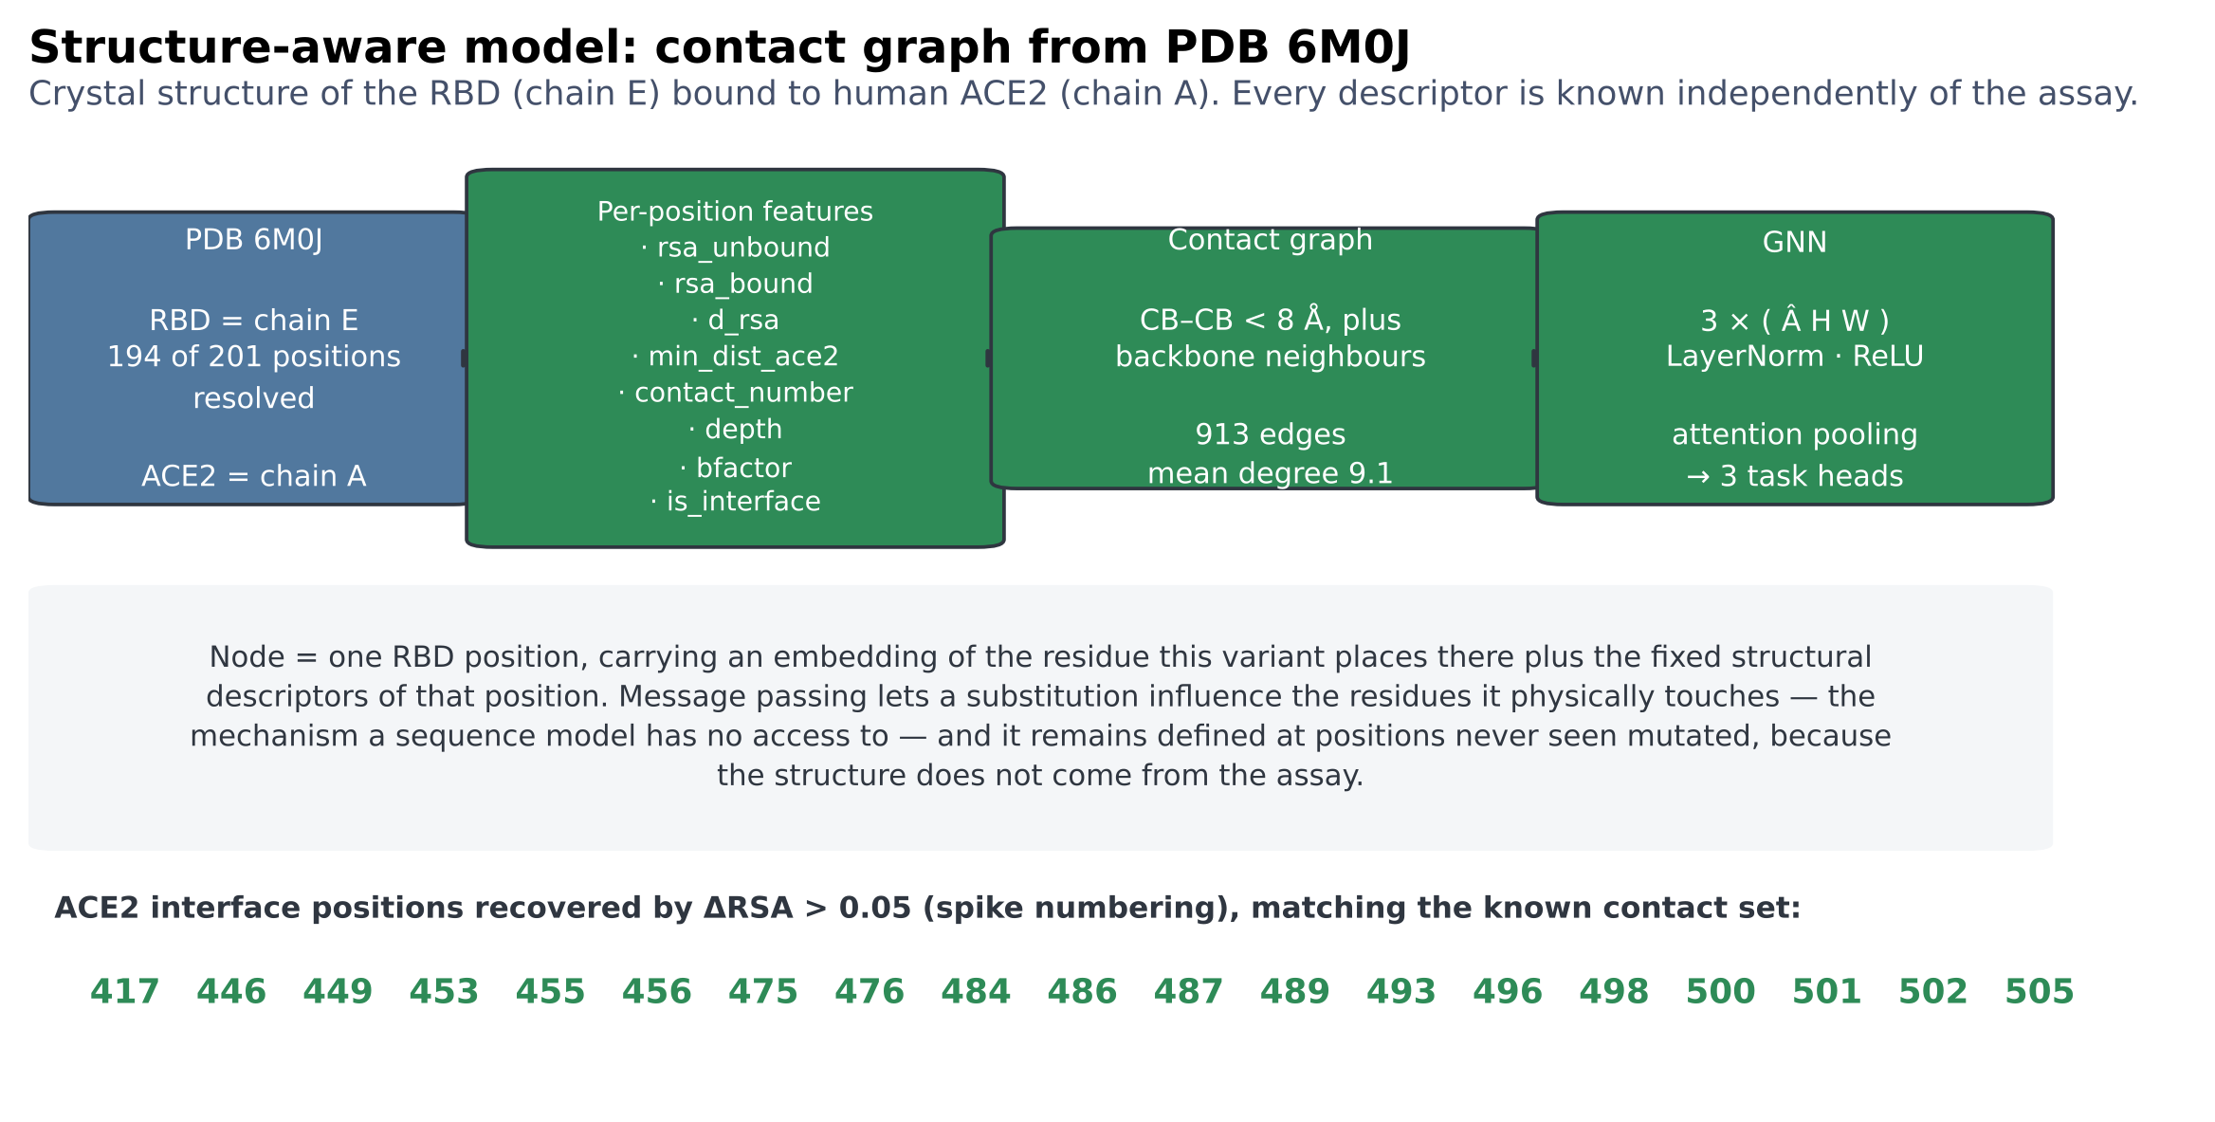
Figure M1. Structural pipeline and residue contact graph from PDB 6M0J. Descriptor names, edge count, mean degree and the recovered interface set are read from the computed features, not written by hand.

2.3 Protein language model
ESM-2 (esm2_t33_650M_UR50D, 650 M parameters) was run once over the wild-type sequence. Two products were taken. Masked marginals: each position in turn is replaced by the mask token and the substitution is scored as log p(mutant | context) − log p(wild type | context), the standard zero-shot variant effect score [6]; a multi-substitution genotype is scored as the sum over its substitutions. Per-residue embeddings from the final layer were reduced by PCA to 16 dimensions per position and supplied to the network through its per-position side-input. Neither product sees any measurement, so the zero-shot scorer is leakage-free at held-out positions by construction.
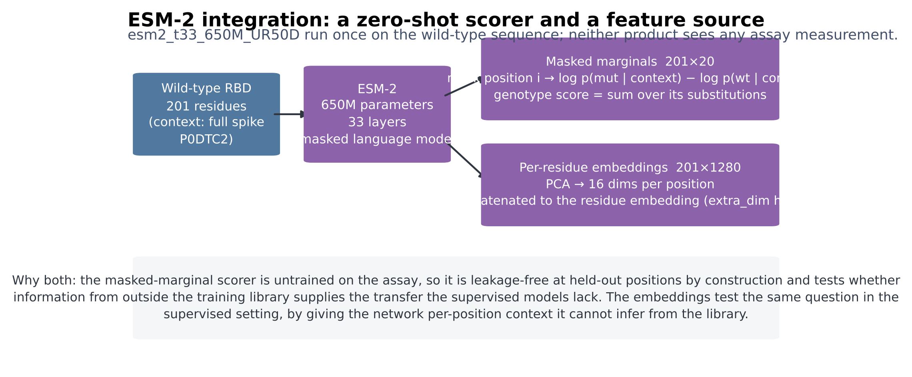
Figure M2. ESM-2 enters the study twice: as an untrained zero-shot scorer, and as per-position features for the supervised network.

2.4 Evaluation designs
Random split. Genotypes are divided 80/10/10 % into training, validation and test sets.
Two further designs, used for the ProteinGym analysis in Section 3.11, are the position-based cross-validation schemes the supervised ProteinGym benchmark already defines [10,11]: fold_modulo_5 assigns a position to fold p mod 5, and fold_contiguous_5 cuts the sequence into five consecutive blocks of positions. The published fold assignments are distributed in an archive that was not reachable from this compute environment, but both are deterministic functions of residue position and were reconstructed exactly; a variant joins the test fold only if every position it mutates does.
Held-out-position split. The 201 positions are partitioned at random into training (75 %), validation (10 %) and test (15 %) sets. A genotype joins a partition only if every position it mutates lies in that partition's position set; genotypes spanning partitions are discarded. No training genotype therefore mutates any validation or test position, a property asserted directly in the test suite rather than assumed. Section 3.7 repeats the design with 5, 15, 30 and 50 % of positions withheld. Both designs were run over 10 seeds, and all models within a seed see the identical partition, so every model comparison is paired.
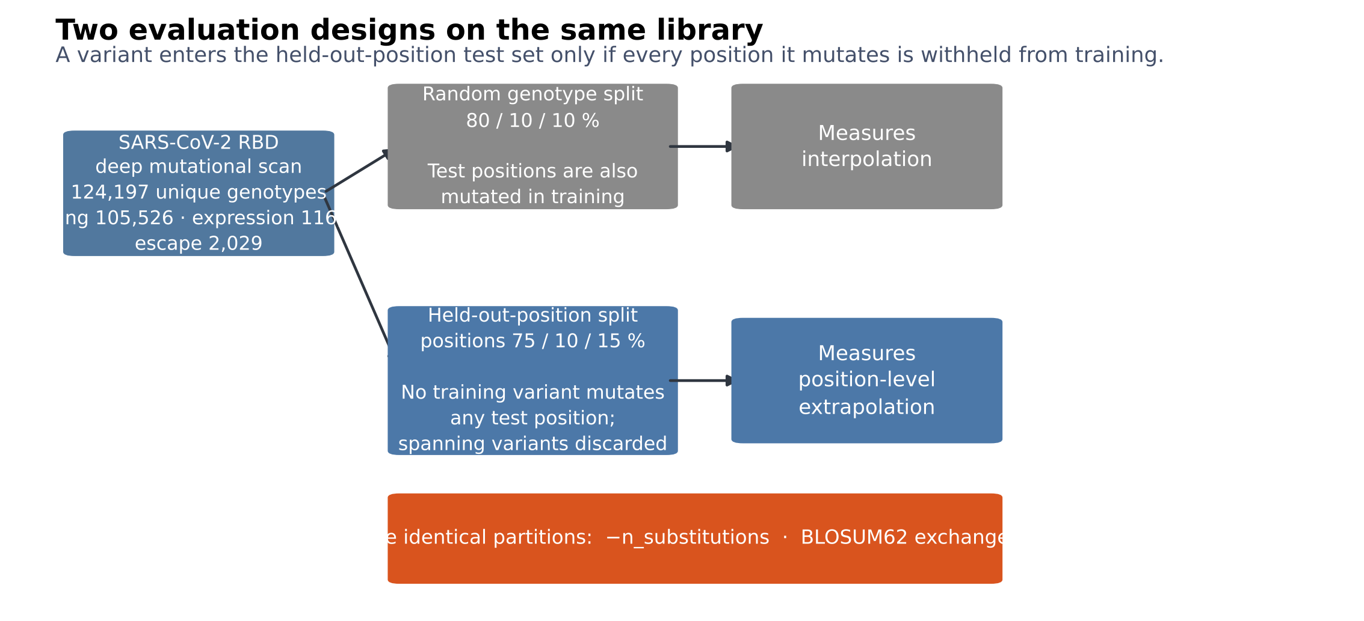
Figure M3. The two evaluation designs, and the untrained controls evaluated on the identical partitions.

2.5 Models
Three untrained scorers. Mutation count ranks by the negative number of substitutions. BLOSUM62 sums substitution-matrix exchangeabilities. ESM-2 sums masked-marginal log-likelihood ratios. None is fitted to any measurement, so each is defined, unchanged, at held-out positions.
Four models on a position-transferable feature block. Each substitution contributes the change in eight physicochemical properties (hydropathy, side-chain volume, charge, polarity, flexibility, helix and sheet propensity, mass), the wild-type residue's values for the same, its BLOSUM62 score, indicator variables for the wild-type and mutant residue identity, its ESM-2 score, and the structural descriptors of the position it occupies; a genotype is the sum over its substitutions plus the substitution count. Nothing in this block indexes a position by identity, so the representation is defined for a genotype that mutates positions never seen. On it we fit ridge regression with generalised cross-validated regularisation (referred to below as the physicochemical model), gradient boosting, random forest and k-nearest neighbours.
A structure graph network. Each of the 201 positions is a node carrying an embedding of the residue this variant places there together with the fixed structural descriptors of the position; edges are the contact graph of Section 2.2. Three graph-convolution layers with symmetric normalisation are followed by attention pooling and three task heads.
Four position-indexed models. Additive ridge regression on one-hot (position, residue) indicators; a global-epistasis model fitting an additive latent phenotype per task through a learned monotone sigmoid link [3]; EvoClassNet, a multi-task network of three convolutional blocks, a bidirectional LSTM, four-head self-attention and attention pooling, trained with a masked Huber loss and learned homoscedastic task weights [4]; and the same network given the structural descriptors and ESM-2 embeddings as per-position side information. The additive and global-epistasis models have no parameter for a substitution at an unseen position; the two networks have position embeddings that were never updated for such a position.
Hyper-parameters were selected by a genetic algorithm maximising mean validation Spearman ρ on a random-split validation set; test data were never used for selection. Optimisation used AdamW [5] with a one-cycle schedule, batch size 256, up to 8 epochs with early stopping, gradient clipping at global norm 1.0. All experiments ran on four CPU cores.
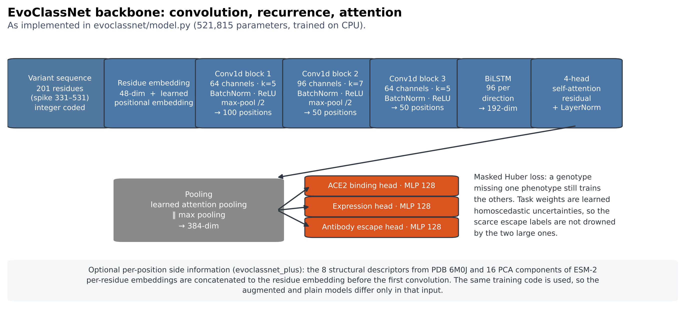
Figure M4. EvoClassNet backbone. Channel counts, kernel sizes, pooling, hidden widths and the parameter count are read from the trained configuration.

2.6 Metrics
The primary metric is Spearman's ρ on the test partition, computed per task over genotypes carrying that measurement; a model emitting a constant prediction conveys no rank information and is assigned ρ = 0. Because part of any rank correlation on a combinatorial library is explained by how many substitutions a variant carries, we also report the partial Spearman correlation, in which the substitution count is regressed out of the ranks of both prediction and measurement. This measures position-level signal directly rather than inferring it from a baseline comparison, and it has a built-in check: the mutation-count baseline must score exactly zero on it. We additionally report Pearson's r, Kendall's τ, R², RMSE, MAE, AUROC for ranking the lower measurement quartile, precision at k and NDCG for top-variant retrieval, the calibration slope, and correlations within fixed substitution-count strata.

2.7 Statistics
Models are compared on per-seed paired differences with a two-sided Wilcoxon signed-rank test, bootstrap percentile intervals, and Cliff's δ as a scale-free effect size. Because the central claim about the position-indexed models is a negative one, and failing to reject a null is not evidence for it, we also report two one-sided tests of equivalence against a margin of ±0.05 in Spearman ρ; a significant result there is positive evidence that two models differ by less than that margin. P values are corrected for false discovery rate across the whole family of model-by-task comparisons. Per-position outcomes recur across seeds and are not independent, so they are analysed with a random-intercept model over positions. Seed-level P values describe reproducibility across partitions of one data set; they do not license inference to other proteins.

2.8 Genome classification task
Complete coronavirus genomes (25–35 kb) were retrieved from NCBI nucleotide and labelled by genus, giving 806 sequences from 287 species after removal of duplicates (Alphacoronavirus 285, Betacoronavirus 371, Gammacoronavirus 71, Deltacoronavirus 79). SARS-CoV-2 was excluded from the Betacoronavirus class: with over three million deposited genomes against a few hundred for whole genera, including it would make the class a measure of one outbreak's sequencing effort. Sequences are represented by normalised 5-mer frequencies, and classified by logistic regression, gradient boosting, random forest, and a 1D convolutional network over the first 4,000 nucleotides. Two untrained controls are reported: the majority class, and genome length together with base composition. The split is either random or by species, the latter placing every genome of a species on one side only, which is the genome-level analogue of withholding positions.
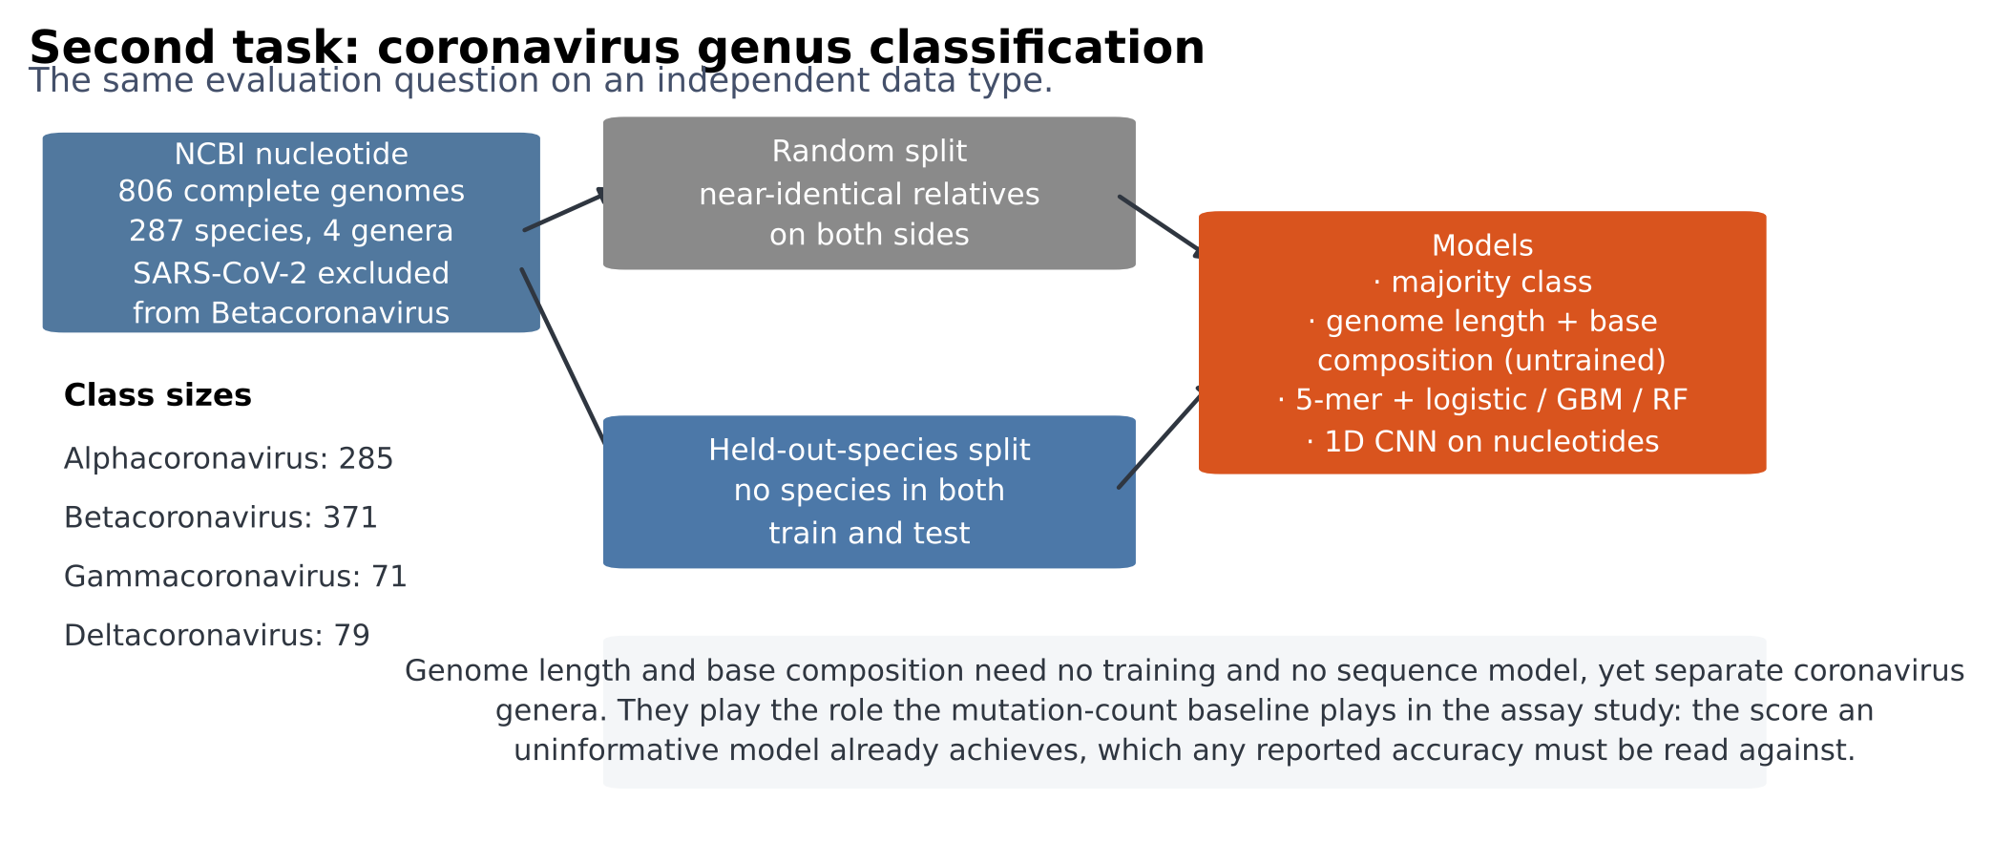
Figure M5. The genome classification design, with class sizes and the untrained controls.

3. Results

3.1 Under random splits every trained model performs well
Two entries are zero by construction rather than by failure. The additive ridge model scores zero on escape because escape labels exist only for single substitutions, so each (position, residue) indicator occurs in exactly one training row and the regularised fit collapses to the intercept. Mutation count scores zero on escape for the same reason: every labelled variant carries exactly one substitution, so the baseline is constant. This makes escape the one phenotype on which mutation count cannot masquerade as skill.

3.2 At held-out positions the position-indexed models fall to the untrained baseline
When every test variant mutates positions never mutated in training, the additive model has no applicable parameter and emits a constant. The global-epistasis model does worse than nothing, its predictions anti-correlated with measurement, because latent effects for unseen substitutions are shrunk towards zero and then passed through a link fitted to the training distribution. EvoClassNet stays positive. Read on its own, the table says the network extrapolates where the conventional models cannot.

3.3 The mutation-count control, and a metric that makes it unnecessary

3.4 Extrapolation is possible; the earlier conclusion was about representations
Our first analysis stopped here and concluded that none of the models extrapolates across positions. That conclusion does not follow from the evidence, and it is wrong. Every model compared above encodes a substitution by the position it occupies: the additive model by a (position, residue) indicator, the global-epistasis model by a per-position latent effect, the networks by a position embedding. For a position absent from training, none of them holds a parameter that was ever updated. Their collapse measures that fact, not a limit on what the data support.
Table 4. Held-out-position split: a ridge regression on position-transferable features, by feature block. Partial ρ removes the substitution-count confound. Antibody escape has no partial column because every escape-labelled variant carries one substitution, so the confound is absent there by construction.
Features | ACE2 binding ρ | ACE2 binding partial | Expression ρ | Expression partial | Antibody escape ρ | Antibody escape partial
Substitution count only | +0.386 ± 0.047 | -0.000 ± 0.001 | +0.368 ± 0.049 | +0.000 ± 0.001 | +0.000 ± 0.000 | +0.000 ± 0.000
ESM-2 score only | +0.340 ± 0.067 | -0.004 ± 0.091 | +0.301 ± 0.066 | -0.058 ± 0.097 | +0.108 ± 0.050 | —
Residue chemistry only | +0.508 ± 0.046 | +0.371 ± 0.060 | +0.416 ± 0.075 | +0.257 ± 0.091 | +0.340 ± 0.123 | —
Structure only | +0.644 ± 0.075 | +0.554 ± 0.112 | +0.581 ± 0.068 | +0.485 ± 0.101 | +0.470 ± 0.079 | —
Structure, interface descriptors removed | +0.615 ± 0.061 | +0.518 ± 0.095 | +0.572 ± 0.064 | +0.477 ± 0.094 | +0.361 ± 0.148 | —
Chemistry + structure, interface removed | +0.678 ± 0.060 | +0.609 ± 0.084 | +0.569 ± 0.081 | +0.480 ± 0.097 | +0.452 ± 0.092 | —
Chemistry + structure | +0.706 ± 0.059 | +0.642 ± 0.085 | +0.582 ± 0.067 | +0.494 ± 0.088 | +0.597 ± 0.071 | —
Chemistry + structure + ESM-2 | +0.712 ± 0.051 | +0.650 ± 0.074 | +0.592 ± 0.060 | +0.506 ± 0.082 | +0.600 ± 0.069 | —

Given features that remain defined at an unseen position, extrapolation is substantial. Chemistry alone reaches a partial correlation of +0.371 ± 0.060 for binding, structure alone +0.554 ± 0.112, and the combination +0.650 ± 0.074 — against — for the untrained baseline and not yet measured for the sequence network on the identical partitions. The information needed to predict the effect of a substitution at an unseen position is present in the data; the earlier models simply had no way to express it.
One component of that signal needs separating out before it is believed. Two of the structural descriptors, the change in solvent accessibility on binding and the interface indicator, are derived from the RBD bound to ACE2 and therefore mark precisely the residues that touch the receptor, which for the binding task is close to being told the answer. Dropping both leaves +0.518 ± 0.095, against +0.554 ± 0.112 with them, so the structural contribution does not rest on them. The remaining descriptors — solvent accessibility of the unbound domain, contact number, burial, B-factor — describe the folded domain alone.

3.5 Where the transfer comes from: positions, not substitutions
Table 5. Per-position rank accuracy of the transferable model at withheld positions: within each withheld position, how well it orders the 19 possible substitutions. Compared against BLOSUM62 exchangeability on identical instances. The P value for the median comes from a random-intercept model over positions, because positions recur across seeds.
Phenotype | Median ρ | % positive | Random-intercept P | BLOSUM62 median ρ | Difference | P | n position–seed
ACE2 binding | +0.533 | 92 | 2.74e-25 | +0.528 | +0.005 | 0.407 | 300
Expression | +0.510 | 90 | 3.6e-24 | +0.561 | +0.003 | 0.926 | 300
Antibody escape | +0.570 | 96 | 3.49e-17 | -0.350 | +0.869 | 8.65e-30 | 178

Restricting to single substitutions and asking a narrower question — within one withheld position, can the model order the nineteen substitutions available there — separates two components of the transfer. For binding the model reaches a median per-position ρ of +0.533, positive at 92 % of position–seed cells, but BLOSUM62 reaches +0.528 on the same instances and the difference is +0.005 (P = 0.407). Within a position, in other words, the ordering is chemistry, and an untrained substitution matrix already supplies it.
The model's advantage therefore lies in discriminating between positions — which positions tolerate substitution at all — and that is precisely what the structural descriptors provide and what a substitution matrix, being position-independent, cannot. It is consistent with the whole-test-set result: summed BLOSUM62 scores reach n/a there, against +0.712 ± 0.051 for the full feature block.
Escape is the exception in the opposite direction. BLOSUM62 is not merely uninformative but anti-correlated (-0.350), because the substitutions that abolish antibody binding are not the chemically radical ones, while the model reaches +0.570 (difference +0.869, P = 8.65e-30). There the within-position ordering is genuinely learned.
Per-position accuracy for binding is associated with rsa_bound (ρ = -0.24, P = 2.4e-05), rsa_unbound (ρ = -0.20, P = 0.0004), depth (ρ = +0.19, P = 0.00096).
Per-position accuracy for escape is associated with min_dist_ace2 (ρ = -0.23, P = 0.0024), bfactor (ρ = -0.23, P = 0.0025), depth (ρ = +0.13, P = 0.088).
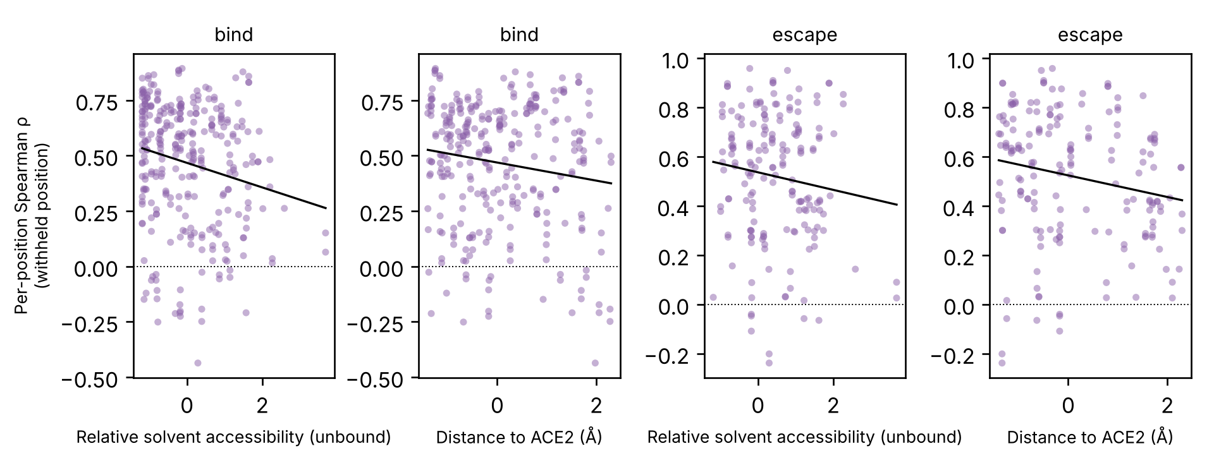
Figure 6. Per-position rank accuracy at withheld positions against solvent accessibility and distance to ACE2.

3.6 The protein language model contributes nothing here
ESM-2 is the component most often expected to supply exactly this kind of position-independent knowledge, and on this protein it does not. Its zero-shot scores reach +0.340 ± 0.067 for binding at held-out positions, of which -0.004 ± 0.091 survives the substitution-count control: the raw figure is the confound in full. Added to chemistry and structure it moves the partial correlation from +0.642 ± 0.085 to +0.650 ± 0.074.

3.7 Permuting the amino-acid alphabet

3.8 Withholding more positions

3.9 Run-to-run instability
Holding partition 0 fixed and varying only the weight initialisation gave binding ρ of +0.374, +0.423, +0.387 (range 0.050).
Holding partition 2 fixed and varying only the weight initialisation gave binding ρ of +0.236, +0.558, +0.385 (range 0.322).
Across all 6 runs the spread was +0.236 to +0.558. Initialisation alone accounts for a substantial part of it, and on some partitions the spread exceeds the differences being discussed, so a single run on this benchmark is not a measurement. Every table here reports a seed distribution for that reason.

3.10 Variant-of-Concern ranking without leakage
Table 7. Ranking Variant-of-Concern substitutions at withheld positions only, pooled over seeds, with 95 % bootstrap intervals.
Score | AUROC | CI | n_positives
EvoClassNet predicted escape | 0.588 | 0.441–0.730 | 15
EvoClassNet predicted binding | 0.469 | 0.291–0.638 | 15
BLOSUM62 exchangeability | 0.718 | 0.602–0.820 | 15
Measured escape (held-out positions) | 0.749 | 0.636–0.856 | 14
Measured binding DMS (held-out positions) | 0.664 | 0.537–0.797 | 15

Variant-of-Concern substitutions are present in the escape training data, so ranking them with a model that has seen them measures memorisation; restricting to withheld positions removes that circularity. Predicted escape gave AUROC 0.588 (95 % CI 0.441–0.730), an interval that includes 0.5. The measured values on the identical subset gave 0.749, which is the ceiling available to any model of this phenotype, and BLOSUM62 exchangeability, which requires no training at all, gave 0.718. The assay carries real information about which substitutions went on to define lineages; at positions it never saw, the trained sequence model does not recover it. The positives are a small set chosen with hindsight, so the comparison between scorers on identical instances is meaningful while the absolute values are not.
Table 8. Median per-position Spearman ρ over single substitutions at withheld positions, against a substitution matrix.
Phenotype | EvoClassNet | BLOSUM62 | Difference | P | n
ACE2 binding | 0.181 | 0.538 | -0.269 | 1.54e-14 | 150
Antibody escape | 0.251 | -0.337 | +0.598 | 1.02e-15 | 98

Per-position rank accuracy separates the phenotypes. For binding an untrained substitution matrix beats the network (0.538 against 0.181, P = 1.54e-14); for escape the matrix is actively misleading, its median correlation negative (-0.337) where the network is positive (0.251, P = 1.02e-15), because the substitutions that abolish antibody binding are not the chemically radical ones.
Maximising escape with a genetic algorithm visited 7,714 distinct sequences. The top 1 % carried 0.000 Variant-of-Concern substitutions per variant against 0.062 for size-matched random samples of the same archive (permutation P = 1.000). A learned fitness surface is constrained only where it was fitted, and an optimiser leaves that region.
Maximising escape and binding with a genetic algorithm visited 7,744 distinct sequences. The top 1 % carried 0.000 Variant-of-Concern substitutions per variant against 0.034 for size-matched random samples of the same archive (permutation P = 1.000). A learned fitness surface is constrained only where it was fitted, and an optimiser leaves that region.

3.11 Does it hold across proteins? 217 ProteinGym assays
Everything above concerns one protein. To ask whether it is a property of the benchmark rather than of the receptor-binding domain, the same comparison was run over every substitution assay in ProteinGym v1.3: 217 assays spanning organismal fitness, stability, activity, expression and binding. Two baselines are added that make the decomposition unambiguous. A position-mean model is a ridge regression on position indicators alone: it knows which position a variant mutates and nothing whatever about which substitution is made. A residue-identity model is its mirror image, knowing the wild-type and mutant residue and nothing about position.
Table 9. ProteinGym: distribution of per-assay Spearman ρ by model family and split. Each assay contributes one value, averaged over seeds.
Split | Family | Model | Assays | Median ρ | Mean ρ | Q1 | Q3 | Frac ρ > 0.2 | Frac ρ = 0
Random split | untrained | Mutation count | 216 | 0.0 | 0.12 | 0.0 | 0.178 | 0.245 | 0.681
Random split | untrained | BLOSUM62 | 216 | 0.22 | 0.209 | 0.134 | 0.284 | 0.546 | 0.0
Random split | position-indexed | Position mean | 216 | 0.665 | 0.63 | 0.564 | 0.732 | 0.968 | 0.0
Random split | position-indexed | Additive ridge | 216 | 0.0 | 0.22 | 0.0 | 0.546 | 0.319 | 0.681
Random split | transferable | Residue identity | 216 | 0.402 | 0.455 | 0.293 | 0.632 | 0.944 | 0.0
Random split | transferable | Chemistry ridge | 216 | 0.455 | 0.493 | 0.344 | 0.65 | 0.972 | 0.0
Held-out-position split | untrained | Mutation count | 212 | 0.0 | 0.024 | 0.0 | 0.0 | 0.042 | 0.83
Held-out-position split | untrained | BLOSUM62 | 212 | 0.198 | 0.2 | 0.123 | 0.27 | 0.486 | 0.0
Held-out-position split | position-indexed | Position mean | 212 | 0.0 | 0.0 | 0.0 | 0.0 | 0.0 | 1.0
Held-out-position split | position-indexed | Additive ridge | 212 | 0.0 | 0.0 | 0.0 | 0.0 | 0.0 | 1.0
Held-out-position split | transferable | Residue identity | 212 | 0.253 | 0.273 | 0.189 | 0.352 | 0.712 | 0.0
Held-out-position split | transferable | Chemistry ridge | 212 | 0.313 | 0.322 | 0.24 | 0.405 | 0.84 | 0.0
ProteinGym fold_modulo_5 | untrained | Mutation count | 214 | 0.0 | 0.03 | 0.0 | 0.0 | 0.061 | 0.818
ProteinGym fold_modulo_5 | untrained | BLOSUM62 | 214 | 0.203 | 0.202 | 0.126 | 0.273 | 0.514 | 0.0
ProteinGym fold_modulo_5 | position-indexed | Position mean | 214 | 0.0 | 0.0 | 0.0 | 0.0 | 0.0 | 1.0
ProteinGym fold_modulo_5 | position-indexed | Additive ridge | 214 | 0.0 | 0.0 | 0.0 | 0.0 | 0.0 | 1.0
ProteinGym fold_modulo_5 | transferable | Residue identity | 214 | 0.252 | 0.269 | 0.184 | 0.352 | 0.701 | 0.0
ProteinGym fold_modulo_5 | transferable | Chemistry ridge | 214 | 0.309 | 0.318 | 0.237 | 0.411 | 0.827 | 0.0
ProteinGym fold_contiguous_5 | untrained | Mutation count | 193 | 0.0 | 0.031 | 0.0 | 0.0 | 0.057 | 0.782
ProteinGym fold_contiguous_5 | untrained | BLOSUM62 | 193 | 0.207 | 0.201 | 0.132 | 0.268 | 0.523 | 0.0
ProteinGym fold_contiguous_5 | position-indexed | Position mean | 193 | 0.0 | 0.0 | 0.0 | 0.0 | 0.0 | 1.0
ProteinGym fold_contiguous_5 | position-indexed | Additive ridge | 193 | 0.0 | 0.0 | 0.0 | 0.0 | 0.0 | 1.0
ProteinGym fold_contiguous_5 | transferable | Residue identity | 193 | 0.251 | 0.26 | 0.165 | 0.339 | 0.668 | 0.0
ProteinGym fold_contiguous_5 | transferable | Chemistry ridge | 193 | 0.314 | 0.306 | 0.228 | 0.386 | 0.788 | 0.0

The result is the paper's argument in two numbers, repeated across the benchmark. Under a random split the position-mean model reaches a median ρ of 0.665 across assays, against 0.455 for the chemistry model: knowing only which position is mutated beats knowing only how the residue changes. Under the held-out-position split the position-mean model falls to 0.0, which is not a degradation but an identity — it has no parameter for a position it never saw — while the chemistry model retains 0.313. A random split rewards memorising per-position means, and that capability is worth exactly nothing at a position no experiment has probed.
The mutation-count confound, which dominates the receptor-binding-domain analysis, is largely absent here and that is worth stating plainly: 69 of 217 assays contain any multi-substitution variant at all. On the rest the baseline is constant, the partial correlation is undefined, and the raw rank correlation is already free of the confound. The separation between representations therefore does not depend on the confound existing; it is simply cleaner to see where it does not.
Table 10. ProteinGym, held-out-position split: each model against the position-mean model, paired with the assay as the unit of analysis.
Model | Assays | Median Δρ | CI low | CI high | P (FDR) | Frac assays better | Cliff's δ | Effect
Mutation count | 212 | 0.0 | 0.0146 | 0.0334 | 1e-06 | 0.156 | 0.142 | negligible
BLOSUM62 | 212 | 0.1983 | 0.1864 | 0.2129 | 0.0 | 0.995 | 0.991 | large
Additive ridge | 212 | 0.0 | 0.0 | 0.0 |  | 0.0 | 0.0 | negligible
Residue identity | 212 | 0.2531 | 0.2545 | 0.2925 | 0.0 | 0.976 | 0.953 | large
Chemistry ridge | 212 | 0.3127 | 0.3032 | 0.341 | 0.0 | 0.991 | 0.981 | large

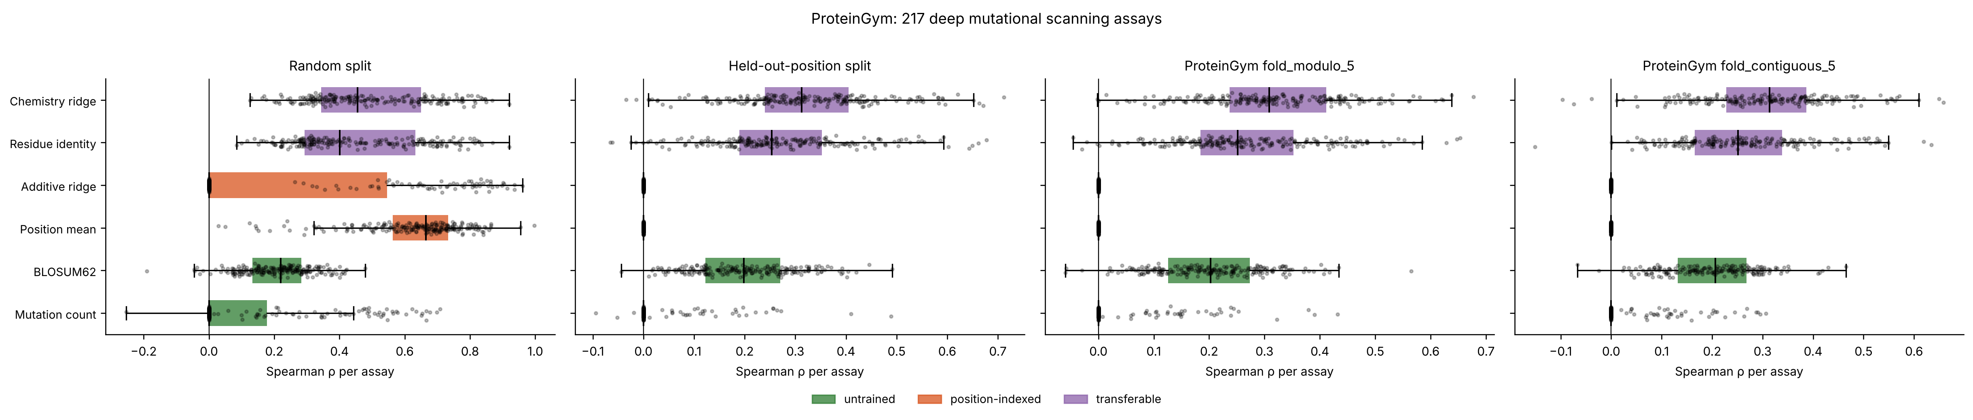
Figure 7. ProteinGym: distribution of per-assay Spearman ρ for each model family under both evaluation designs. Each point is one assay.
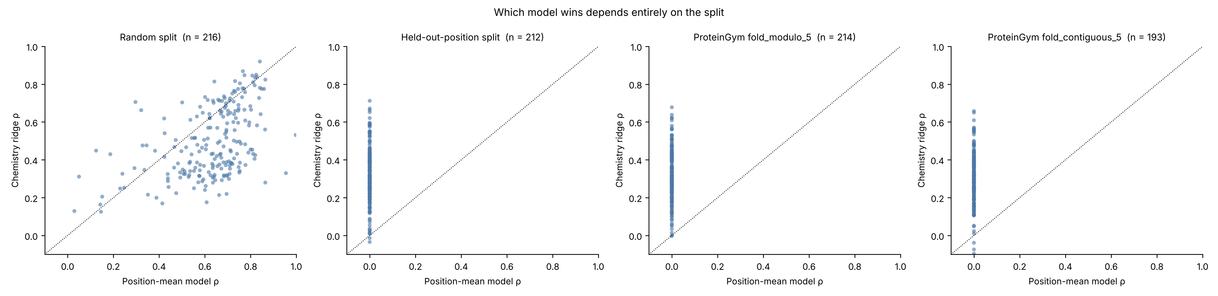
Figure 8. The position-mean model against the chemistry model, per assay. Which one wins is decided entirely by the split.

3.12 A second data type: coronavirus genomes
Table 11. Coronavirus genus classification under both splits, mean ± SD across seeds.
Split | Family | Model | Seeds | Accuracy | Balanced acc. | Macro F1 | Weighted F1 | MCC | f1_Alphacoronavirus | f1_Betacoronavirus | f1_Gammacoronavirus | f1_Deltacoronavirus
random | untrained | Majority class | 10 | 0.457 ± 0.044 | 0.250 ± 0.000 | 0.157 ± 0.010 | 0.288 ± 0.045 | 0.000 ± 0.000 | 0.000 ± 0.000 | 0.626 ± 0.042 | 0.000 ± 0.000 | 0.000 ± 0.000
random | trivial | Genome length + base composition | 10 | 0.950 ± 0.010 | 0.953 ± 0.015 | 0.941 ± 0.016 | 0.951 ± 0.010 | 0.924 ± 0.016 | 0.945 ± 0.016 | 0.958 ± 0.016 | 0.861 ± 0.053 | 1.000 ± 0.000
random | sequence | 5-mer + logistic regression | 10 | 1.000 ± 0.000 | 1.000 ± 0.000 | 1.000 ± 0.000 | 1.000 ± 0.000 | 1.000 ± 0.000 | 1.000 ± 0.000 | 1.000 ± 0.000 | 1.000 ± 0.000 | 1.000 ± 0.000
random | sequence | 5-mer + random forest | 10 | 0.997 ± 0.006 | 0.993 ± 0.013 | 0.995 ± 0.009 | 0.997 ± 0.006 | 0.995 ± 0.009 | 1.000 ± 0.000 | 0.996 ± 0.006 | 1.000 ± 0.000 | 0.984 ± 0.028
random | sequence | 5-mer + gradient boosting | 10 | 0.998 ± 0.004 | 0.995 ± 0.009 | 0.997 ± 0.006 | 0.997 ± 0.004 | 0.996 ± 0.006 | 0.999 ± 0.004 | 0.997 ± 0.004 | 1.000 ± 0.000 | 0.991 ± 0.019
random | sequence | 1D CNN on nucleotides | 10 | 0.990 ± 0.015 | 0.992 ± 0.009 | 0.992 ± 0.010 | 0.990 ± 0.015 | 0.985 ± 0.022 | 0.986 ± 0.023 | 0.991 ± 0.016 | 1.000 ± 0.000 | 0.992 ± 0.016
heldout_species | untrained | Majority class | 10 | 0.497 ± 0.077 | 0.250 ± 0.000 | 0.165 ± 0.017 | 0.334 ± 0.086 | 0.000 ± 0.000 | 0.000 ± 0.000 | 0.661 ± 0.069 | 0.000 ± 0.000 | 0.000 ± 0.000
heldout_species | trivial | Genome length + base composition | 10 | 0.894 ± 0.044 | 0.914 ± 0.037 | 0.891 ± 0.038 | 0.897 ± 0.044 | 0.843 ± 0.062 | 0.860 ± 0.074 | 0.918 ± 0.054 | 0.799 ± 0.113 | 0.989 ± 0.020
heldout_species | sequence | 5-mer + logistic regression | 10 | 0.999 ± 0.003 | 0.998 ± 0.004 | 0.997 ± 0.007 | 0.999 ± 0.003 | 0.998 ± 0.005 | 0.996 ± 0.009 | 1.000 ± 0.000 | 0.991 ± 0.020 | 1.000 ± 0.000
heldout_species | sequence | 5-mer + random forest | 10 | 0.969 ± 0.038 | 0.962 ± 0.034 | 0.968 ± 0.031 | 0.968 ± 0.038 | 0.953 ± 0.053 | 0.958 ± 0.049 | 0.977 ± 0.051 | 0.959 ± 0.073 | 0.979 ± 0.025
heldout_species | sequence | 5-mer + gradient boosting | 10 | 0.986 ± 0.017 | 0.976 ± 0.026 | 0.982 ± 0.021 | 0.986 ± 0.017 | 0.978 ± 0.026 | 0.980 ± 0.028 | 0.996 ± 0.007 | 0.958 ± 0.056 | 0.992 ± 0.019
heldout_species | sequence | 1D CNN on nucleotides | 10 | 0.986 ± 0.018 | 0.988 ± 0.017 | 0.985 ± 0.019 | 0.986 ± 0.017 | 0.978 ± 0.026 | 0.972 ± 0.037 | 0.990 ± 0.012 | 1.000 ± 0.000 | 0.976 ± 0.041

Under the random split, genome length and base composition alone reach balanced accuracy 0.953 ± 0.015, against 1.000 ± 0.000 for the best sequence model (5-mer + logistic regression) and 0.250 ± 0.000 for the majority class.
Under the held-out-species split, genome length and base composition alone reach balanced accuracy 0.914 ± 0.037, against 0.998 ± 0.004 for the best sequence model (5-mer + logistic regression) and 0.250 ± 0.000 for the majority class.
Table 12. Sequence models against the untrained length-and-composition control, paired over seeds.
Split | Model | Reference | Seeds | Median Δ | CI low | CI high | P (FDR) | TOST P | Equivalent | Cliff's δ
random | 5-mer + logistic regression | Genome length + base composition | 10 | 0.0425 | 0.0382 | 0.056 | 0.0024 | 0.9962195228420556 | False | 1.0
random | 5-mer + random forest | Genome length + base composition | 10 | 0.0425 | 0.0235 | 0.0536 | 0.00417 | 0.8563707454400075 | False | 0.9
random | 5-mer + gradient boosting | Genome length + base composition | 10 | 0.0425 | 0.029 | 0.0545 | 0.0024 | 0.940786186396648 | False | 1.0
random | 1D CNN on nucleotides | Genome length + base composition | 10 | 0.0397 | 0.0258 | 0.0514 | 0.0024 | 0.8767656463820934 | False | 1.0
random | 5-mer + logistic regression | Majority class | 10 | 0.75 | 0.75 | 0.75 | 0.0024 |  | False | 1.0
random | 5-mer + random forest | Majority class | 10 | 0.75 | 0.7334 | 0.75 | 0.0024 | 1.0 | False | 1.0
random | 5-mer + gradient boosting | Majority class | 10 | 0.75 | 0.7393 | 0.75 | 0.0024 | 1.0 | False | 1.0
random | 1D CNN on nucleotides | Majority class | 10 | 0.7446 | 0.7363 | 0.7469 | 0.0024 | 1.0 | False | 1.0
heldout_species | 5-mer + logistic regression | Genome length + base composition | 10 | 0.0743 | 0.0617 | 0.1069 | 0.0024 | 0.9991319386515816 | False | 1.0
heldout_species | 5-mer + random forest | Genome length + base composition | 10 | 0.043 | 0.0255 | 0.0717 | 0.00586 | 0.9074907782169516 | False | 0.7
heldout_species | 5-mer + gradient boosting | Genome length + base composition | 10 | 0.0656 | 0.0366 | 0.0856 | 0.00417 | 0.9802436647065402 | False | 0.84
heldout_species | 1D CNN on nucleotides | Genome length + base composition | 10 | 0.0637 | 0.0477 | 0.1007 | 0.0024 | 0.9934615381173167 | False | 0.96
heldout_species | 5-mer + logistic regression | Majority class | 10 | 0.75 | 0.7456 | 0.75 | 0.0024 | 1.0 | False | 1.0
heldout_species | 5-mer + random forest | Majority class | 10 | 0.7226 | 0.6909 | 0.7307 | 0.0024 | 0.9999999999998336 | False | 1.0
heldout_species | 5-mer + gradient boosting | Majority class | 10 | 0.7361 | 0.7108 | 0.7412 | 0.0024 | 0.9999999999999868 | False | 1.0
heldout_species | 1D CNN on nucleotides | Majority class | 10 | 0.7447 | 0.7268 | 0.7463 | 0.0024 | 0.9999999999999998 | False | 1.0

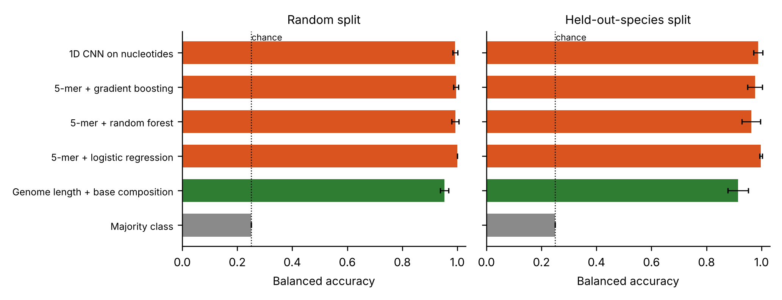
Figure 9. Balanced accuracy on coronavirus genus classification under both splits. The dotted line is chance for four classes.
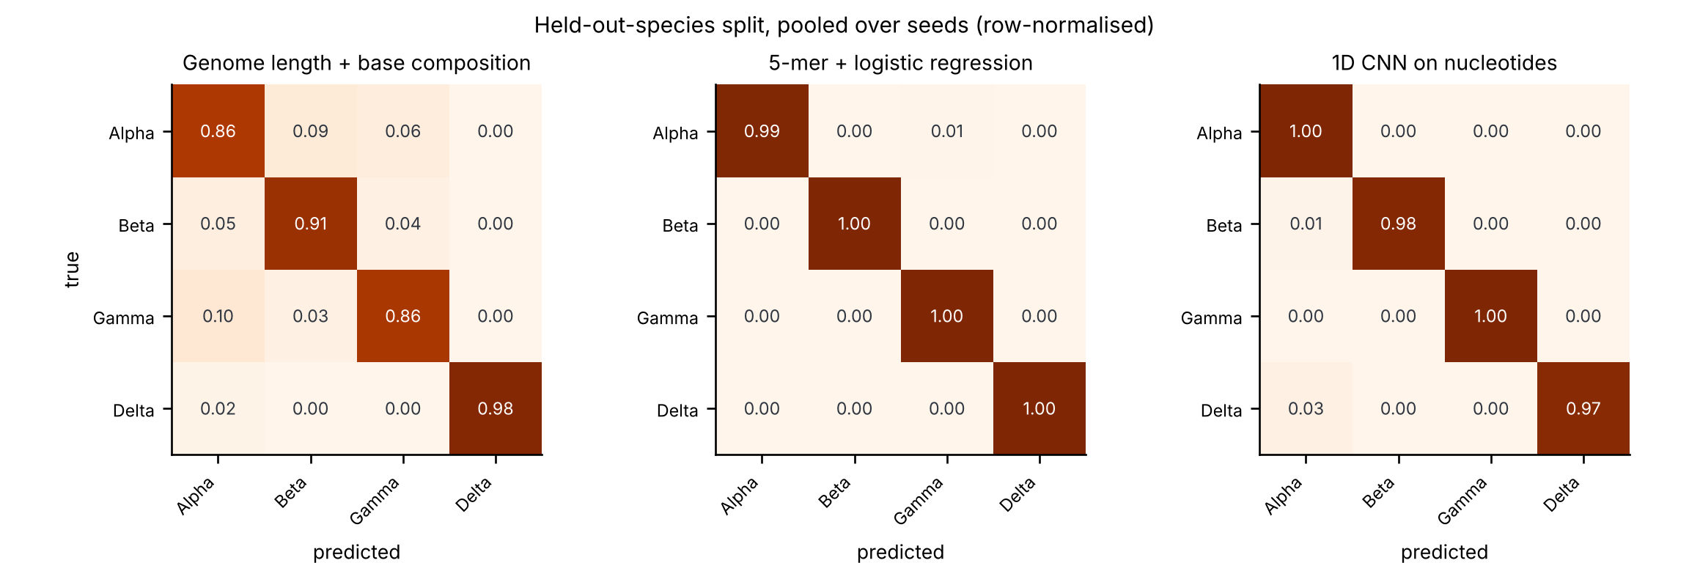
Figure 10. Confusion matrices under the held-out-species split, pooled over seeds and row-normalised.
The original project proposal reported this task as a five-way classification at 99.92 % accuracy, with no baseline. The lesson here is not that such a number must be wrong, but that it is uninterpretable on its own: an untrained control looking only at genome length and base composition already reaches most of it, so the reported figure conveys almost none of the information it appears to. Where the sequence models do beat that control, as they do here, the control is what makes the increment visible and worth reporting.

4. Discussion
Four evaluation designs applied to the same library support four different conclusions. A random split says the trained models work well and that the choice between them hardly matters. A held-out-position split says a sequence network extrapolates where conventional models fail. Adding an untrained baseline to that split says the network does nothing of the kind. Adding models whose features remain defined at an unseen position says that extrapolation is nonetheless possible, and substantial. Only the fourth conclusion survives, and reaching it required two corrections in sequence.
The first correction is the familiar one about controls. Making a split harder does not by itself make the resulting number meaningful: it changes what an uninformative model would score, and unless that value is measured on the same partition it is easy to mistake a shift in the null for evidence of skill. On a combinatorial mutagenesis library the uninformative score is far from zero, because the number of substitutions a variant carries is itself predictive. We would go further and recommend the partial correlation over the baseline comparison: it measures the quantity of interest directly, it needs no second model, and it carries its own validity check, since the trivial baseline must score zero on it.
The second correction is the one we did not anticipate, and it is the more interesting. Having established that the sequence models do not transfer across positions, we wrote that none of the models tested demonstrates position-level extrapolation — a statement about the data that the evidence did not support. All three models we had compared share a representational commitment: a substitution is identified by where it occurs. Such a model cannot transfer across positions for the same reason a lookup table cannot, and observing that it does not is uninformative about whether the phenotype is predictable at an unseen position. It is. The information is carried by the chemistry of the substitution and by the structural environment of the position, both available without having assayed it.
That this is a negative result about architectures rather than about proteins has a practical consequence. A model intended for surveillance should be built on features that survive the arrival of a position no one has measured; the structural descriptors used here are cheap, and for SARS-CoV-2 they were available from early 2020. The protein language model, which is the component usually expected to provide this, supplied nothing measurable on this protein, and we are careful to scope that claim to this protein.
The practical recommendations are narrow, and the first of them is already available. Position-based cross-validation schemes exist in the benchmark most of this field reports against; use them, and report them alongside the random split rather than instead of it, because the two rank models differently and the comparison is the informative part. Second, report an untrained baseline on every split, or better, the partial correlation that removes the confound outright. Third, include a model that uses only the position: if it beats the model under evaluation on a random split, the random split is not measuring what the paper says it is. Fourth, before concluding that a phenotype cannot be extrapolated, check whether the models tested hold any parameter that applies to the held-out condition. And report a seed distribution: initialisation alone moved held-out binding ρ across a range wide enough to reverse conclusions.

4.1 Limitations
- This is one protein, one genetic background (Wuhan-Hu-1) and two assay platforms. The evaluation lesson is general; the specific finding that structure carries the transfer is not established beyond this domain.
- The structural descriptors come from a crystal structure of the complex. Two of them mark the receptor interface and are close to circular for the binding task; we quantify the effect of removing them rather than claiming it is negligible a priori. For a target without a solved structure the same descriptors would have to come from a prediction, and that substitution was not tested here.
- Only one protein language model, at one size, was evaluated, with a single scoring scheme. A larger model, a different scoring convention, or fine-tuning on viral sequences could change the conclusion.
- Hyper-parameters were selected on random-split validation and may be unsuited to the held-out-position regime; this would, if anything, understate the trained models there.
- Escape labels average over an antibody panel assembled from many studies with differing antibody selections, and exist only for single substitutions, so that task has far fewer labels and wider intervals than the other two.
- Binding measurements are censored at an assay floor, which we did not model; expression is a proxy for folding stability.
- The genome task uses a few hundred genomes per genus and truncates sequences for the convolutional model; it is a demonstration that the evaluation lesson transfers, not a competitive classifier.
- Seed-level P values describe reproducibility across partitions of one data set. They do not license inference to other proteins or other scans.

5. Data and code availability
Phenotype data: Starr et al., SARS-CoV-2-RBD_DMS, and the aggregated escape maps at jbloomlab/SARS2_RBD_Ab_escape_maps. Structure: PDB 6M0J. Reference sequence: UniProt P0DTC2. Genomes: NCBI nucleotide. Language model: facebook/esm2_t33_650M_UR50D. All analysis code, the retrieval scripts, every per-run output and the script that generates this manuscript from them are in the accompanying repository; run_all.sh reproduces every table and figure from raw data on four CPU cores.

References
- Starr TN, Greaney AJ, Hilton SK, et al. Deep mutational scanning of SARS-CoV-2 receptor binding domain reveals constraints on folding and ACE2 binding. Cell 2020;182:1295–1310.
- Greaney AJ, Starr TN, Bloom JD. An antibody-escape estimator for mutations to the SARS-CoV-2 receptor-binding domain. Virus Evolution 2022;8:veac021.
- Otwinowski J, McCandlish DM, Plotkin JB. Inferring the shape of global epistasis. Proc Natl Acad Sci USA 2018;115:E7550–E7559.
- Kendall A, Gal Y, Cipolla R. Multi-task learning using uncertainty to weigh losses for scene geometry and semantics. CVPR 2018:7482–7491.
- Loshchilov I, Hutter F. Decoupled weight decay regularization. ICLR 2019.
- Meier J, Rao R, Verkuil R, et al. Language models enable zero-shot prediction of the effects of mutations on protein function. NeurIPS 2021.
- Lin Z, Akin H, Rao R, et al. Evolutionary-scale prediction of atomic-level protein structure with a language model. Science 2023;379:1123–1130.
- Lan J, Ge J, Yu J, et al. Structure of the SARS-CoV-2 spike receptor-binding domain bound to the ACE2 receptor. Nature 2020;581:215–220.
- Shrake A, Rupley JA. Environment and exposure to solvent of protein atoms. Lysozyme and insulin. J Mol Biol 1973;79:351–371.
- Notin P, Kollasch AW, Ritter D, et al. ProteinGym: large-scale benchmarks for protein fitness prediction and design. NeurIPS Datasets and Benchmarks 2023.
- Notin P, Weitzman R, Marks DS, Gal Y. ProteinNPT: improving protein property prediction and design with non-parametric transformers. NeurIPS 2023. (Defines the fold_random_5, fold_contiguous_5 and fold_modulo_5 cross-validation schemes used here.)

