An amino-acid-blind baseline for variant-effect benchmarks: a systematic reassessment of evaluation protocols across ProteinGym
[Author names and affiliations]
Running title: A position-only baseline for variant-effect benchmarks

Abstract
Deep mutational scanning models are normally validated on held-out random variants, which in a saturating library measures interpolation, not extrapolation to an unprobed position. Position-based cross-validation is not new: ProteinGym defines fold_modulo_5 and fold_contiguous_5, where its own one-hot baseline falls from 0.582 to 0.022. Missing is a control for how much of a random-split score needs no knowledge of the substitution. Across eleven model families on SARS-CoV-2 receptor-binding-domain variants, EvoClassNet reached held-out-position Spearman ρ 0.341 ± 0.118 for binding against 0.386 ± 0.047 for an untrained substitution-count baseline; partialling the count out left 0.187 ± 0.134 and 0.000 ± 0.001. Features still defined at unseen positions — substitution chemistry plus receptor-complex descriptors — gave partial ρ 0.650 for binding and raw ρ 0.600 for escape; structure contributed 0.554, chemistry 0.371, without interface descriptors 0.518. ESM-2 added nothing (−0.004 partial), against a positive control recovering 80.3% of wild-type residues on ubiquitin but 11.8% here. Across 217 ProteinGym assays a position-only model reached median ρ 0.665 under random splitting and exactly 0.000 under both position-based schemes; it outscored seven of the eleven published models on the mean and six on the median; the median model won on 35.2% of assays versus 99.5% under fold_modulo_5. AlphaFold descriptors raised the chemistry median from 0.316 to 0.472 across 132 assays; on 806 coronavirus genomes, length and base composition alone gave 0.914 balanced accuracy. Hard splits are interpretable only against untrained baselines on the same partition; poor cross-position extrapolation indicts the representation, not the measurements.
Keywords: deep mutational scanning; SARS-CoV-2; model evaluation; generalisation; baselines; protein structure; protein language models; variant effect prediction.

Introduction
Deep mutational scanning measures the phenotypic consequences of thousands of amino-acid substitutions in a single experiment, and such data underpin much of what is known about the SARS-CoV-2 receptor-binding domain (RBD): which substitutions raise ACE2 affinity, which destabilise the fold, and which abolish binding by therapeutic antibodies [1,2]. Supervised models trained on these measurements are routinely used to score substitutions that were never assayed.
How such models are validated has received less scrutiny than how they are built. The standard protocol holds out a random subset of variants. In a saturating combinatorial library almost every position is mutated somewhere in the training data, so a random test variant differs from training variants in which substitutions it combines, not in where those substitutions fall. A model can therefore score well by learning a per-position, per-residue effect table together with a link function, without any capacity to speak about a position it has never seen mutated. That capacity is what surveillance requires.
Neither the evaluation design nor the basic finding is new, and it is worth being exact about what is. The supervised ProteinGym benchmark already defines two position-based cross-validation schemes alongside a random one — fold_modulo_5, which assigns positions to folds by position modulo five, and fold_contiguous_5, which cuts the sequence into five consecutive blocks — and already publishes results under all three [10,11]. Those results already show the collapse: their pure one-hot encoding baseline scores 0.582 under the random scheme and 0.022 under fold_modulo_5, while every model that adds a transferable representation, whether sequence embeddings or structure, retains most of its performance. We did not discover that position-indexed models fail at held-out positions; it is visible in the leaderboard.
What this paper adds is a diagnostic and a reading. The diagnostic is a position-mean model: a ridge regression on position indicators alone, which knows which position a variant mutates and nothing whatever about which substitution is made — not even the identity of the incoming residue. It is a deliberately impoverished model, and under the random split its mean per-assay correlation places it fifth of the seventeen models compared here, ahead of seven of the eleven published supervised models. Its drop to zero under both position-based schemes is the largest of any model, published or added here. A model that cannot distinguish an alanine from a tryptophan should not be competitive on a benchmark of substitution effects, and the fact that it is tells you what the standard protocol is rewarding.
This paper makes three points, and the second corrects the first. First, held-out-position evaluation is uninterpretable without an untrained control: on a combinatorial library a model that has learned nothing about the withheld positions still orders test variants correctly to the extent that fitness falls with the number of substitutions, and that alone produces a respectable-looking rank correlation. Second — and this is where our own first analysis went wrong — the conclusion that no model extrapolates across positions does not follow. The models we had compared all encode a substitution by the position it occupies, so none of them holds a parameter that applies to a held-out position; their failure was a property of the representation. Given features that remain defined at an unseen position, extrapolation is substantial. Third, structure is what carries it, while a protein language model contributes nothing measurable on this protein.
We report the correction explicitly rather than presenting only the final result, because the sequence of errors is the methodological content of the paper: a confounded metric produced an inflated number, the right control removed it, and an over-general conclusion drawn from that control was itself wrong for a reason the control could not reveal.
Stated precisely, the contributions are four. The position-mean baseline described above, which bounds how much of a random-split score requires no knowledge of the substitution at all. An untrained mutation-count control, together with a partial rank correlation that removes the same confound directly and validates itself, for the assays that contain multi-substitution variants. A decomposition, on one deeply characterised protein, of where transferable signal comes from: structure selects which positions tolerate substitution, chemistry orders the substitutions within a position, and the two are separable. And a reproducible pipeline over all 217 ProteinGym substitution assays, both position-based schemes reconstructed exactly, with every number in this manuscript generated from it.
This paper does not contribute a state-of-the-art predictor, and the comparison should be stated precisely rather than modestly. A ridge regression on residue chemistry alone averages 0.318 under fold_modulo_5, well below every published supervised model. Adding per-residue descriptors from an AlphaFold model of the protein raises it to 0.449, which places it 6 of 17 on the combined ranking — ahead of the four published models that pair one-hot encodings with a language model, and behind the five that use learned embeddings, led by Kermut at 0.633. The point is not that a ridge regression competes with those models; it is that cheap, publicly available structural descriptors recover a large part of what separates them from a one-hot baseline, which is the same account the receptor-binding-domain analysis gives.

Literature review
This section sets out what is established in the three literatures this paper sits between — mutational-scanning assays as a source of supervised labels, models of sequence-to-function relationships, and the methodology of evaluating such models — and identifies the gap the study addresses. The gap is not a missing model or a missing split; both exist. It is a missing control.

Deep mutational scanning as a source of supervised labels
Deep mutational scanning couples saturating mutagenesis to a selection and a sequencing readout, returning a quantitative phenotype for thousands of variants in one experiment [12]. The method has been applied across scales, from the local landscape of green fluorescent protein [13] to mega-scale measurement of folding stability for hundreds of domains [14]. For the SARS-CoV-2 receptor-binding domain, Starr and colleagues measured ACE2 binding affinity and expression for essentially all single substitutions in the Wuhan-Hu-1 background [1], and the Bloom laboratory subsequently mapped escape from a large panel of monoclonal antibodies [43], aggregated into the per-substitution escape estimator used here [2] and extended to later lineages as the mutational constraints shifted [44].
Two features of such libraries matter for everything that follows, and both are properties of the experiment rather than of any model. First, the libraries are saturating or close to it: almost every position is mutated to almost every residue. Second, where variants carry more than one substitution, phenotype declines on average with the number of substitutions, a global non-linearity that global-epistasis models were introduced to absorb [3,17]. The first property determines what a random train/test split can test; the second determines what an uninformative model scores on any split. Analyses of these landscapes have repeatedly found that the dominant axis of variation is positional — some sites tolerate substitution and others do not — with the identity of the incoming residue a secondary effect [16]. That observation is usually reported as biology. The present paper reads it as a statement about benchmark difficulty.

Supervised models of sequence-to-function relationships
Given assay labels, the standard approach is supervised regression on an encoding of the variant. The simplest is an additive model on one-hot (position, residue) indicators, optionally composed with a monotone link to capture global epistasis [3]. Neural networks trained directly on scanning data improve on this where enough labels exist [18], and architectures that inject evolutionary context, such as ECNet, improve further [21]; the approach has become standard in machine-learning-guided protein engineering [20]. A consistently informative negative result in this literature is that simple models combining an evolutionary score with ridge regression on a one-hot encoding match or beat much larger architectures across many assays [19], which is a warning that headline performance on these data is not strongly architecture-limited.
What every model in this family shares is the representational commitment that the present paper isolates: a substitution is identified by the position it occupies. A parameter learned for position 501 says nothing about position 498, and no amount of training data at other positions creates one. This is not a criticism of those models, which were built for the interpolation problem they are evaluated on. It is the reason their behaviour at an unseen position is uninformative about whether the phenotype is predictable there.

Zero-shot and structure-aware predictors
A parallel literature predicts variant effects without assay labels. Coevolutionary models fit to a multiple sequence alignment, from EVmutation [22] through DeepSequence [23] to EVE [24], score a substitution by its plausibility under the evolutionary record. Protein language models trained on unaligned sequence databases do the same with masked or autoregressive likelihoods: ESM-1b [25], the MSA Transformer [26], ProtTrans [27], ProteinBERT [28], Tranception [29] and ESM-2 [7], with the masked-marginal scoring convention of Meier and colleagues [6] now standard. Because these scores are defined at every position of the sequence, they are in principle exactly the transferable representation that a held-out-position evaluation calls for, and the strongest supervised entries on current benchmarks are hybrids that combine assay labels with such embeddings [11,30,31].
Structure supplies a second transferable description. Solvent accessibility, burial, contact number and distance to a binding partner are defined for any position of a folded chain, and are computed here by the Shrake-Rupley algorithm [9] against normalising maxima [60] from either a crystal structure of the receptor complex [8] or, for the benchmark-wide analysis, AlphaFold models [32] retrieved from the AlphaFold Protein Structure Database [33,34]. Graph neural networks [35] propagate information over the resulting contact graph. The hypothesis that structure should carry cross-position transfer is therefore not new; what has been missing is a measurement of how much of the transfer it accounts for, separated from the chemistry of the substitution itself.

Benchmarks and evaluation protocols
Benchmarks have standardised this field. TAPE [36] and FLIP [37] established held-out protocols for protein representation learning, and ProteinGym [10] has become the common reference, with 217 substitution assays in the version used here and a public leaderboard for both zero-shot and supervised regimes. Critically for this paper, the supervised arm does not use a random split alone: ProteinNPT [11] defines three cross-validation schemes — fold_random_5, fold_contiguous_5 and fold_modulo_5 — of which the latter two partition by residue position, and ProteinGym publishes per-assay results under all three. The collapse of position-indexed encodings under position-based folds is therefore already in the published record: the benchmark's own one-hot baseline falls from a mean Spearman of 0.582 under the random scheme to 0.022 under fold_modulo_5. Any claim to have discovered that collapse would be false, and this paper makes no such claim.
Mutational-scanning data are also used in the opposite direction, as ground truth for benchmarking clinical variant-effect predictors [15]. That literature is the natural home of the concern raised here, because it is where the consequences of a mis-specified evaluation are most direct.

Circularity, leakage and the role of untrained baselines
The methodological literature on evaluating predictors in biology is explicit that a performance number is interpretable only relative to what an uninformed procedure would score. Grimm and colleagues showed that assessments of missense predictors are distorted by two distinct forms of circularity, one of which is the reuse of the same variants or the same proteins across training and evaluation [38]. The DOME recommendations ask, among other things, for an explicitly reported baseline [39]. Reviews of machine learning in genomics identify unrecognised data leakage and absent baselines as leading causes of irreproducible performance claims [40], and a cross-disciplinary survey attributes a substantial body of published results to leakage of exactly this kind [41].
What is absent from this literature, as applied to mutational scanning, is a baseline matched to the specific structure of these data. The relevant uninformed procedures are two. One ranks variants by how many substitutions they carry, which is predictive wherever multi-substitution variants exist and requires no training at all. The other knows only which position a variant mutates, and nothing about the substitution — not even the identity of the incoming residue. Neither is a model anyone would propose. Both are trivial to compute. Neither is reported alongside the benchmarks this field uses, and the central empirical result of this paper is what happens when they are.

Variant-effect prediction for SARS-CoV-2
The applied motivation is specific and well documented. Substitutions in the receptor-binding domain drive both transmissibility and antibody escape [45], in vitro evolution and deep mutational learning have mapped the accessible affinity landscape [46,48], and epistasis within the domain shapes which combinations are viable [47]. Omicron-era work showed convergent evolution at escape positions under imprinted population immunity [49], and lineage fitness has been estimated directly from millions of sequenced genomes [53] and from experimental fitness effects across the proteome [54]. Forecasting approaches range from immune-escape scores built on pre-pandemic data [50] to combined fitness-and-antigenicity models [51] and language-model notions of semantic escape [52]; prospective escape mapping was used to anticipate resistance to therapeutic antibodies [42]. The surveillance infrastructure that consumes such predictions — lineage nomenclature [56], real-time phylogenetics [55] and shared sequence repositories [57] — operates on positions as they first appear.
That last point is the reason the evaluation question is not academic here. A prediction is needed for a position at the moment it is first observed in a genome, which is before any assay has probed it. A model validated only on random held-out variants from a saturating library has never been asked that question.

The gap addressed here
Three things follow from the above. Position-based evaluation exists and is published, so it needs no advocacy. The collapse of position-indexed models under it is documented, so it needs no rediscovery. But no published comparison states how much of a conventional random-split score survives the removal of all knowledge of the substitution, and without that number the random-split results that dominate this literature cannot be read. Supplying it, in two forms and on two data types, together with a decomposition of where transferable signal actually comes from on one deeply characterised protein, is what this paper does.

Result analysis and discussion
The benchmark-wide analysis comes first, because it is what the title claims and because it bounds how the case study that follows should be read. the benchmark-wide analyses below cover all 217 ProteinGym substitution assays and the published supervised leaderboard. the receptor-binding-domain case study are a case study on the SARS-CoV-2 receptor-binding domain, where the data are rich enough to decompose where transferable signal comes from. the subsection on coronavirus genomes repeats the evaluation question on an unrelated data type.

A position-only control across 217 ProteinGym assays
Everything above concerns one protein. To ask whether it is a property of the benchmark rather than of the receptor-binding domain, the same comparison was run over every substitution assay in ProteinGym v1.3: 217 assays spanning organismal fitness, stability, activity, expression and binding. Two baselines are added that make the decomposition unambiguous. A position-mean model is a ridge regression on position indicators alone: it knows which position a variant mutates and nothing whatever about which substitution is made. A residue-identity model is its mirror image, knowing the wild-type and mutant residue and nothing about position.
Table 9. ProteinGym: distribution of per-assay Spearman ρ by model family and split. Each assay contributes one value, averaged over seeds.
Split | Family | Model | Assays | Median ρ | Mean ρ | Q1 | Q3 | Frac ρ > 0.2 | Frac ρ = 0
Random split | untrained | Mutation count | 216 | 0.0 | 0.12 | 0.0 | 0.178 | 0.245 | 0.681
Random split | untrained | BLOSUM62 | 216 | 0.22 | 0.209 | 0.134 | 0.284 | 0.546 | 0.0
Random split | position-indexed | Position mean | 216 | 0.665 | 0.63 | 0.564 | 0.732 | 0.968 | 0.0
Random split | position-indexed | Additive ridge | 216 | 0.0 | 0.22 | 0.0 | 0.546 | 0.319 | 0.681
Random split | transferable | Residue identity | 216 | 0.402 | 0.455 | 0.293 | 0.632 | 0.944 | 0.0
Random split | transferable | Chemistry ridge | 216 | 0.455 | 0.493 | 0.344 | 0.65 | 0.972 | 0.0
Random split | transferable | Chemistry + structure | 135 | 0.59 | 0.586 | 0.459 | 0.718 | 0.978 | 0.0
Held-out-position split | untrained | Mutation count | 212 | 0.0 | 0.024 | 0.0 | 0.0 | 0.042 | 0.83
Held-out-position split | untrained | BLOSUM62 | 212 | 0.198 | 0.2 | 0.123 | 0.27 | 0.486 | 0.0
Held-out-position split | position-indexed | Position mean | 212 | 0.0 | 0.0 | 0.0 | 0.0 | 0.0 | 1.0
Held-out-position split | position-indexed | Additive ridge | 212 | 0.0 | 0.0 | 0.0 | 0.0 | 0.0 | 1.0
Held-out-position split | transferable | Residue identity | 212 | 0.253 | 0.273 | 0.189 | 0.352 | 0.712 | 0.0
Held-out-position split | transferable | Chemistry ridge | 212 | 0.313 | 0.322 | 0.24 | 0.405 | 0.84 | 0.0
Held-out-position split | transferable | Chemistry + structure | 132 | 0.472 | 0.446 | 0.347 | 0.553 | 0.917 | 0.0
ProteinGym fold_modulo_5 | untrained | Mutation count | 214 | 0.0 | 0.03 | 0.0 | 0.0 | 0.061 | 0.818
ProteinGym fold_modulo_5 | untrained | BLOSUM62 | 214 | 0.203 | 0.202 | 0.126 | 0.273 | 0.514 | 0.0
ProteinGym fold_modulo_5 | position-indexed | Position mean | 214 | 0.0 | 0.0 | 0.0 | 0.0 | 0.0 | 1.0
ProteinGym fold_modulo_5 | position-indexed | Additive ridge | 214 | 0.0 | 0.0 | 0.0 | 0.0 | 0.0 | 1.0
ProteinGym fold_modulo_5 | transferable | Residue identity | 214 | 0.252 | 0.269 | 0.184 | 0.352 | 0.701 | 0.0
ProteinGym fold_modulo_5 | transferable | Chemistry ridge | 214 | 0.309 | 0.318 | 0.237 | 0.411 | 0.827 | 0.0
ProteinGym fold_modulo_5 | transferable | Chemistry + structure | 133 | 0.474 | 0.449 | 0.345 | 0.544 | 0.947 | 0.0
ProteinGym fold_contiguous_5 | untrained | Mutation count | 193 | 0.0 | 0.031 | 0.0 | 0.0 | 0.057 | 0.782
ProteinGym fold_contiguous_5 | untrained | BLOSUM62 | 193 | 0.207 | 0.201 | 0.132 | 0.268 | 0.523 | 0.0
ProteinGym fold_contiguous_5 | position-indexed | Position mean | 193 | 0.0 | 0.0 | 0.0 | 0.0 | 0.0 | 1.0
ProteinGym fold_contiguous_5 | position-indexed | Additive ridge | 193 | 0.0 | 0.0 | 0.0 | 0.0 | 0.0 | 1.0
ProteinGym fold_contiguous_5 | transferable | Residue identity | 193 | 0.251 | 0.26 | 0.165 | 0.339 | 0.668 | 0.0
ProteinGym fold_contiguous_5 | transferable | Chemistry ridge | 193 | 0.314 | 0.306 | 0.228 | 0.386 | 0.788 | 0.0
ProteinGym fold_contiguous_5 | transferable | Chemistry + structure | 116 | 0.429 | 0.416 | 0.307 | 0.533 | 0.922 | 0.0

The result is the paper's argument in two numbers, repeated across the benchmark. Under a random split the position-mean model reaches a median ρ of 0.665 across assays, against 0.455 for the chemistry model: knowing only which position is mutated beats knowing only how the residue changes. Under the held-out-position split the position-mean model falls to 0.0, which is not a degradation but an identity — it has no parameter for a position it never saw — while the chemistry model retains 0.313. A random split rewards memorising per-position means, and that capability is worth exactly nothing at a position no experiment has probed.
The mutation-count confound, which dominates the receptor-binding-domain analysis, is largely absent here and that is worth stating plainly: 69 of 217 assays contain any multi-substitution variant at all. On the rest the baseline is constant, the partial correlation is undefined, and the raw rank correlation is already free of the confound. The separation between representations therefore does not depend on the confound existing; it is simply cleaner to see where it does not.
Table 10. ProteinGym, held-out-position split: each model against the position-mean model, paired with the assay as the unit of analysis.
Model | Assays | Median Δρ | CI low | CI high | P (FDR) | Frac assays better | Cliff's δ | Effect
Mutation count | 212 | 0.0 | 0.0146 | 0.0334 | 1e-06 | 0.156 | 0.142 | negligible
BLOSUM62 | 212 | 0.1983 | 0.1864 | 0.2129 | 0.0 | 0.995 | 0.991 | large
Additive ridge | 212 | 0.0 | 0.0 | 0.0 |  | 0.0 | 0.0 | negligible
Residue identity | 212 | 0.2531 | 0.2545 | 0.2925 | 0.0 | 0.976 | 0.953 | large
Chemistry ridge | 212 | 0.3127 | 0.3032 | 0.341 | 0.0 | 0.991 | 0.981 | large
Chemistry + structure | 132 | 0.4717 | 0.4193 | 0.4719 | 0.0 | 0.992 | 0.985 | large

The structural arm generalises less cleanly than the RBD analysis alone would suggest, and the honest summary is a qualified one. AlphaFold models were obtained for the proteins behind 132 of the assays; adding their per-residue descriptors to the chemistry block moves the median held-out-position ρ from 0.313 to 0.472. Predicted monomers cannot supply the descriptors that carry most of the signal in the receptor-binding domain, where the structure is a crystal of the bound complex, so this is a weaker instrument than the one used in the random-split results rather than a refutation of it.
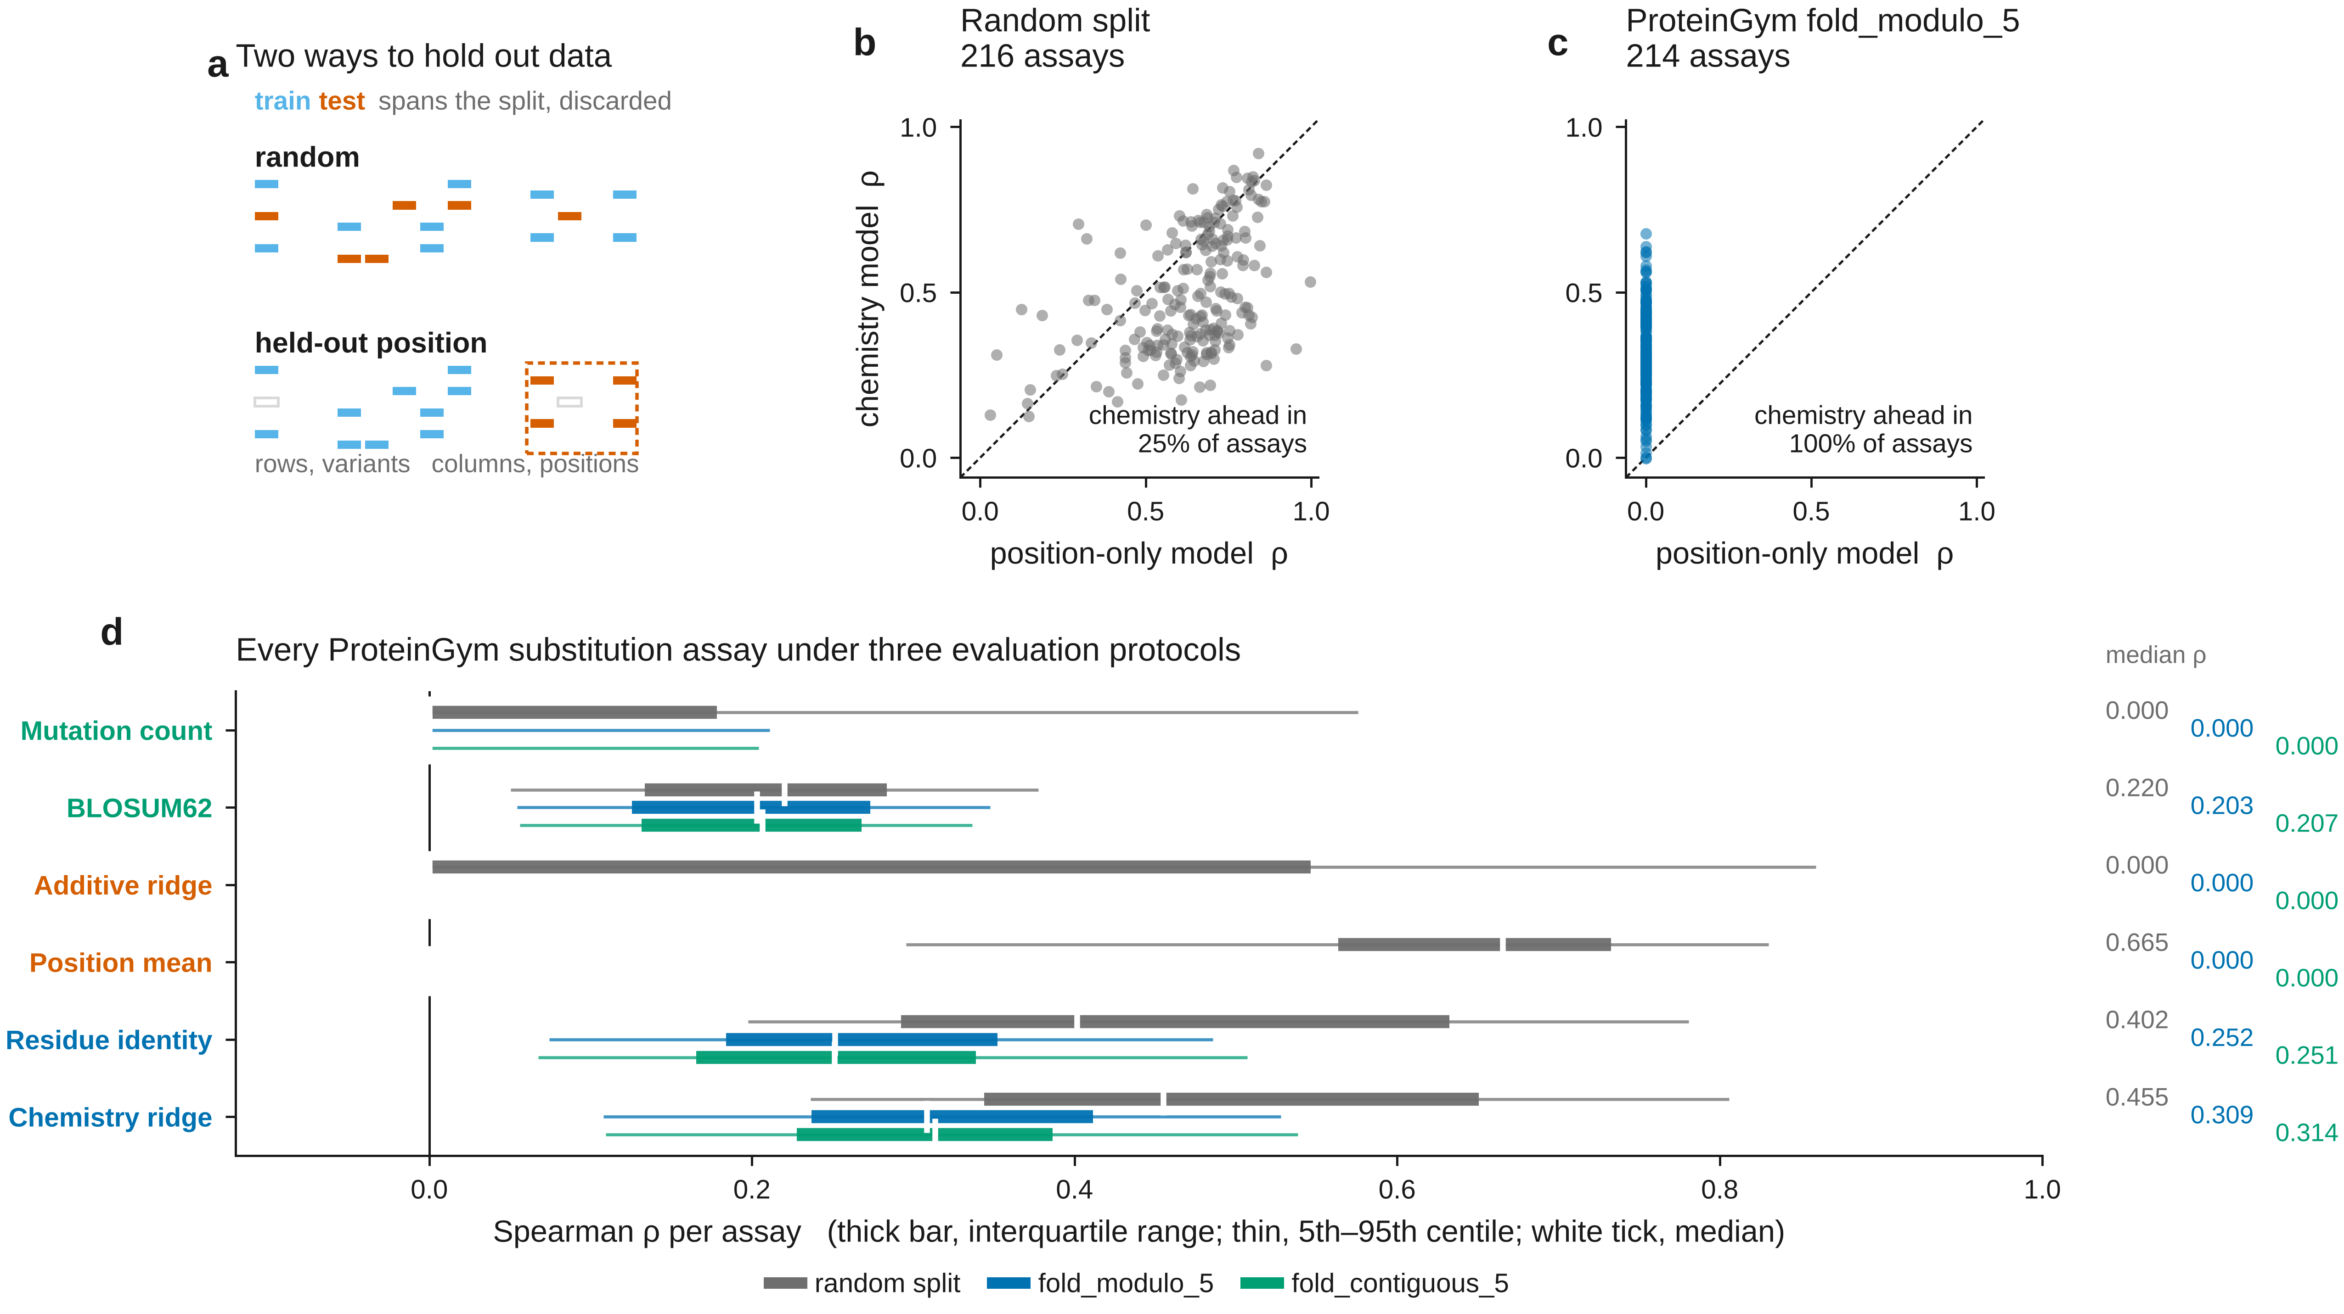
Figure 6. What each evaluation protocol measures. (a) A random split withholds variants; a position-based split withholds columns, and discards variants that span the boundary. (b, c) Per-assay comparison of a model given only the mutated position against one given only the chemistry of the substitution, under each protocol. (d) Median and spread of per-assay Spearman ρ for six model families under three protocols, over every ProteinGym substitution assay.

Auditing the published leaderboard
The position-mean model can be turned on the published leaderboard itself. ProteinGym reports per-assay Spearman correlations for eleven supervised models under each cross-validation scheme. Comparing those published numbers, assay by assay, against a ridge regression told only which position a variant mutates asks a question the leaderboard does not: how often does a model that cannot distinguish an alanine from a tryptophan nonetheless score higher?
Table 11a. Published ProteinGym supervised models against the position-only baseline under Random split, assay by assay.
Published model | Assays | Model median ρ | Position-only median ρ | Median margin | Frac assays model wins | Assays not won
One-Hot Encodings | 216 | 0.639 | 0.665 | -0.018 | 0.264 | 159
DeepSequence + One-Hot Encodings | 216 | 0.564 | 0.665 | -0.085 | 0.278 | 156
MSA_Transformer + One-Hot Encodings | 216 | 0.585 | 0.665 | -0.071 | 0.282 | 155
TranceptEVE + One-Hot Encodings | 216 | 0.589 | 0.665 | -0.069 | 0.306 | 150
Tranception + One-Hot Encodings | 216 | 0.585 | 0.665 | -0.064 | 0.306 | 150
ESM-1v + One-Hot Encodings | 216 | 0.616 | 0.665 | -0.041 | 0.352 | 140
ESM-1v Embeddings | 216 | 0.685 | 0.665 | 0.04 | 0.602 | 86
MSA Transformer Embeddings | 216 | 0.727 | 0.665 | 0.088 | 0.694 | 66
Tranception Embeddings | 216 | 0.732 | 0.665 | 0.065 | 0.736 | 57
ProteinNPT | 216 | 0.794 | 0.665 | 0.119 | 0.903 | 21
Kermut | 216 | 0.79 | 0.665 | 0.117 | 0.94 | 13

Table 11b. Published ProteinGym supervised models against the position-only baseline under fold_modulo_5, assay by assay.
Published model | Assays | Model median ρ | Position-only median ρ | Median margin | Frac assays model wins | Assays not won
One-Hot Encodings | 214 | 0.014 | 0.0 | 0.014 | 0.603 | 85
ESM-1v + One-Hot Encodings | 214 | 0.439 | 0.0 | 0.439 | 0.977 | 5
Tranception + One-Hot Encodings | 214 | 0.435 | 0.0 | 0.435 | 0.986 | 3
MSA_Transformer + One-Hot Encodings | 214 | 0.441 | 0.0 | 0.441 | 0.986 | 3
DeepSequence + One-Hot Encodings | 214 | 0.421 | 0.0 | 0.421 | 0.995 | 1
Tranception Embeddings | 214 | 0.561 | 0.0 | 0.561 | 0.995 | 1
ESM-1v Embeddings | 214 | 0.574 | 0.0 | 0.574 | 0.995 | 1
MSA Transformer Embeddings | 214 | 0.613 | 0.0 | 0.613 | 0.995 | 1
ProteinNPT | 214 | 0.639 | 0.0 | 0.639 | 0.995 | 1
TranceptEVE + One-Hot Encodings | 214 | 0.461 | 0.0 | 0.461 | 0.995 | 1
Kermut | 214 | 0.673 | 0.0 | 0.673 | 1.0 | 0

Table 11c. Published ProteinGym supervised models against the position-only baseline under fold_contiguous_5, assay by assay.
Published model | Assays | Model median ρ | Position-only median ρ | Median margin | Frac assays model wins | Assays not won
One-Hot Encodings | 193 | 0.04 | 0.0 | 0.04 | 0.601 | 77
ESM-1v + One-Hot Encodings | 193 | 0.426 | 0.0 | 0.426 | 0.974 | 5
ESM-1v Embeddings | 193 | 0.535 | 0.0 | 0.535 | 0.984 | 3
MSA_Transformer + One-Hot Encodings | 193 | 0.452 | 0.0 | 0.452 | 0.99 | 2
DeepSequence + One-Hot Encodings | 193 | 0.423 | 0.0 | 0.423 | 0.995 | 1
TranceptEVE + One-Hot Encodings | 193 | 0.464 | 0.0 | 0.464 | 0.995 | 1
Tranception + One-Hot Encodings | 193 | 0.425 | 0.0 | 0.425 | 0.995 | 1
Tranception Embeddings | 193 | 0.472 | 0.0 | 0.472 | 0.995 | 1
MSA Transformer Embeddings | 193 | 0.581 | 0.0 | 0.581 | 1.0 | 0
Kermut | 193 | 0.65 | 0.0 | 0.65 | 1.0 | 0
ProteinNPT | 193 | 0.61 | 0.0 | 0.61 | 1.0 | 0

Under the random split the answer is: often. The position-only baseline reaches a median Spearman of 0.665 across assays, and 6 of the 11 published models have a median below it — including every model built on one-hot encodings, whether or not a language model is added to them. The median published model wins on 35.2 % of assays. The weakest, One-Hot Encodings, is not beaten on 159 of them; the strongest, Kermut, wins on 94 %.
Under fold_modulo_5 the picture is completely different: the baseline is zero by construction and the median model now wins on 99.5 % of assays, with Kermut winning on all of them. The models are not weak. The point is narrower and, we think, more useful: on the protocol most of this literature reports, a large fraction of what separates models from each other and from zero is recoverable without knowing anything about the substitution, so a random-split score on its own does not establish that a model has learned about substitutions at all.
Two caveats bound this. The published numbers come from ProteinGym's own five-fold assignments for the random scheme, which we cannot reproduce exactly because they are distributed separately; our baseline uses an independent 80/20 random split averaged over five seeds, with comparable training-set size. And a position-only model is favoured on assays where each position carries many measured substitutions, which is most of ProteinGym by design. Neither affects the position-based comparisons, where the baseline is identically zero.
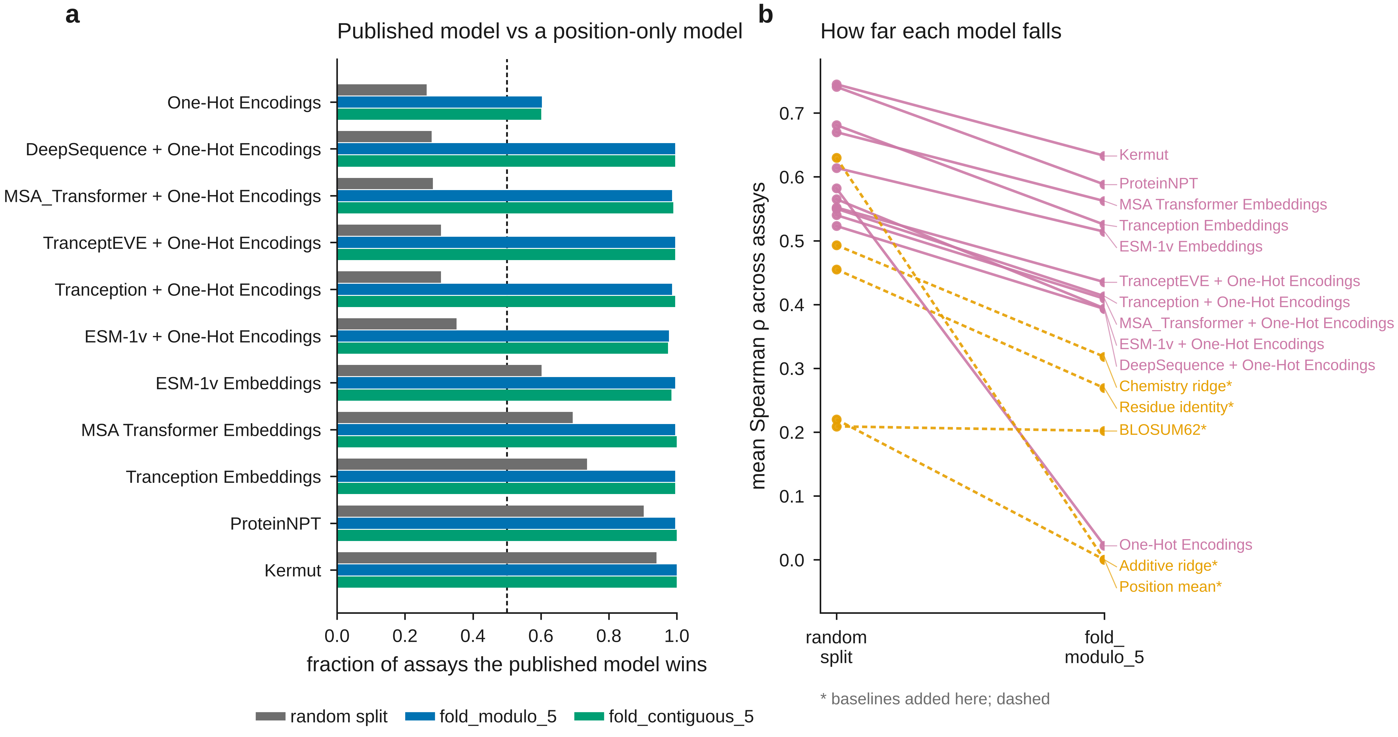
Figure 7. The published ProteinGym supervised leaderboard audited against a position-only baseline. (a) Fraction of assays on which each published model scores above the baseline, under each cross-validation scheme; the dashed line is half the assays. (b) Mean Spearman ρ under the random split and under fold_modulo_5 for every published model and for the baselines added here.

Our own baselines on the same axes
Table 12. This study's baselines placed on the published ProteinGym supervised leaderboard, which reports each model separately under the three cross-validation schemes. Values are mean Spearman ρ across assays.
source | model_type | model | Random split | fold_modulo_5 | fold_contiguous_5 | drop (random → modulo)
ProteinGym leaderboard | Structure & sequence embedding | Kermut | 0.745 | 0.633 | 0.593 | 0.112
ProteinGym leaderboard | Sequence embedding | ProteinNPT | 0.741 | 0.588 | 0.529 | 0.153
ProteinGym leaderboard | Sequence embedding | MSA Transformer Embeddings | 0.67 | 0.562 | 0.513 | 0.108
ProteinGym leaderboard | Sequence embedding | ESM-1v Embeddings | 0.614 | 0.514 | 0.479 | 0.1
ProteinGym leaderboard | Sequence embedding | Tranception Embeddings | 0.681 | 0.525 | 0.439 | 0.156
ProteinGym leaderboard | One-hot Encoding | TranceptEVE + One-Hot Encodings | 0.552 | 0.435 | 0.435 | 0.117
This work | baseline | Chemistry + structure (this work) | 0.586 | 0.449 | 0.416 | 0.137
ProteinGym leaderboard | One-hot Encoding | Tranception + One-Hot Encodings | 0.55 | 0.413 | 0.415 | 0.137
ProteinGym leaderboard | One-hot Encoding | MSA_Transformer + One-Hot Encodings | 0.54 | 0.409 | 0.407 | 0.131
ProteinGym leaderboard | One-hot Encoding | ESM-1v + One-Hot Encodings | 0.565 | 0.394 | 0.396 | 0.171
ProteinGym leaderboard | One-hot Encoding | DeepSequence + One-Hot Encodings | 0.523 | 0.393 | 0.395 | 0.13
This work | baseline | Chemistry ridge (this work) | 0.493 | 0.318 | 0.306 | 0.175
This work | baseline | Residue identity (this work) | 0.455 | 0.269 | 0.26 | 0.186
This work | baseline | BLOSUM62 (this work) | 0.209 | 0.202 | 0.201 | 0.007
ProteinGym leaderboard | One-hot Encoding | One-Hot Encodings | 0.582 | 0.022 | 0.059 | 0.56
This work | baseline | Additive ridge (this work) | 0.22 | 0.0 | 0.0 | 0.22
This work | baseline | Position mean (this work) | 0.63 | 0.0 | 0.0 | 0.63

The comparison bounds what can be claimed here, and it should be read before the preceding sections are. ProteinGym's own one-hot encoding baseline falls from 0.582 under fold_random_5 to 0.022 under fold_modulo_5 and 0.059 under fold_contiguous_5. The collapse of position-indexed models is therefore already in the published record, and nothing in the benchmark-wide analyses below should be read as discovering it.
Two things remain. First, the position-mean model is a sharper instrument than the one-hot baseline: it is given no residue identity whatsoever, reaches 0.630 under the random split, which is fifth of the seventeen models compared here and ahead of seven of the eleven published supervised models, and is identically zero under both position-based schemes, a larger fall than any published model. The question it answers is not whether position-indexed models transfer, which is settled, but how much of a random-split score is available without knowing the substitution at all.
Second, where our baselines sit. The chemistry ridge averages 0.318 under fold_modulo_5, below every published model. Adding AlphaFold descriptors raises it to 0.449, ahead of the four published models that pair one-hot encodings with a language model and behind the five built on learned embeddings, led by Kermut at 0.633. The models that survive the position-based schemes do so because they already carry transferable representations — sequence embeddings, and structure in the leading model — which is the account this paper gives, reached independently on the receptor-binding domain and confirmed by their numbers rather than ours.

How much does a predicted structure add?
Table 11. Effect of adding AlphaFold descriptors to the chemistry block, per assay, across the ProteinGym proteins for which a model could be matched.
Split | Assays | Chemistry | Chemistry+structure | Median Δρ | CI low | CI high | P | Frac improved | Δρ vs pLDDT
Random split | 135 | 0.4547 | 0.5904 | 0.0792 | 0.0865 | 0.1148 | 8.027512336108847e-24 | 0.985 | 0.132
Held-out positions | 132 | 0.3161 | 0.4717 | 0.1138 | 0.1038 | 0.1418 | 1.5073643982225537e-19 | 0.879 | 0.102
fold_modulo_5 | 133 | 0.3078 | 0.4736 | 0.1243 | 0.1135 | 0.1549 | 2.508823770944789e-20 | 0.902 | -0.047
fold_contiguous_5 | 116 | 0.3146 | 0.4295 | 0.1062 | 0.0881 | 0.127 | 7.243378269256293e-16 | 0.853 | -0.056

The receptor-binding-domain analysis attributes most of the transfer to structure, but it uses a crystal structure of a bound complex, which almost no other assay in the benchmark has. AlphaFold models of the monomer were matched to 132 assays. Adding their per-residue descriptors to the chemistry block raises the median per-assay correlation from 0.316 to 0.472 at held-out positions, a median gain of +0.114 (95 % CI 0.104 to 0.142, P = 1.51e-19), and improves 88 % of assays individually. Under ProteinGym's own fold_modulo_5 the gain is +0.124 with 90 % of assays improved.
The gain does not track how confident the prediction is: across assays it correlates with the model's global pLDDT at ρ = +0.10 (P = 0.24). A moderately confident predicted monomer is evidently enough, which matters because it is what is available for most targets. This is the result that lifts the structural claim off a single protein with a solved complex.
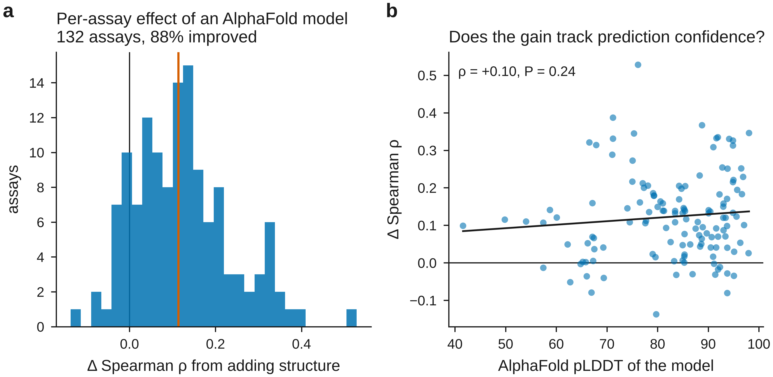
Figure 8. Effect of adding AlphaFold descriptors. (a) Distribution across assays of the change in Spearman ρ at held-out positions; the vertical line is the median. (b) The same change against the model's global pLDDT.

Under random splits every trained model performs well
Table 1. Random genotype split: full metric panel, mean ± SD across seeds.
Family | Model | Phenotype | Seeds | Spearman ρ | Partial ρ | Pearson r | Kendall τ | R² | RMSE | AUROC | Prec@k | NDCG | Calib. | n
untrained | Mutation count | ACE2 binding | 5 | 0.478 ± 0.005 | -0.001 ± 0.001 | 0.470 ± 0.005 | 0.374 ± 0.005 | 0.151 ± 0.010 | 1.760 ± 0.012 | 0.735 ± 0.005 | 0.012 ± 0.018 | 0.770 ± 0.019 | 0.689 ± 0.015 | 10540
untrained | Mutation count | Expression | 5 | 0.390 ± 0.006 | 0.000 ± 0.001 | 0.383 ± 0.006 | 0.293 ± 0.004 | -1.755 ± 0.049 | 1.719 ± 0.011 | 0.649 ± 0.004 | 0.004 ± 0.009 | 0.772 ± 0.011 | 0.300 ± 0.004 | 11634
untrained | Mutation count | Antibody escape | 5 | 0.000 ± 0.000 | 0.000 ± 0.000 | 0.000 ± 0.000 | 0.000 ± 0.000 | — | 0.477 ± 0.022 | 0.500 ± 0.000 | — | — | — | 202
untrained | BLOSUM62 | ACE2 binding | 5 | 0.417 ± 0.007 | 0.234 ± 0.008 | 0.420 ± 0.006 | 0.306 ± 0.005 | -1.821 ± 0.047 | 3.206 ± 0.028 | 0.712 ± 0.002 | 0.040 ± 0.020 | 0.692 ± 0.028 | 0.253 ± 0.005 | 10540
untrained | BLOSUM62 | Expression | 5 | 0.341 ± 0.010 | 0.179 ± 0.009 | 0.345 ± 0.008 | 0.241 ± 0.007 | -11.793 ± 0.258 | 3.704 ± 0.024 | 0.636 ± 0.008 | 0.040 ± 0.020 | 0.701 ± 0.010 | 0.111 ± 0.003 | 11634
untrained | BLOSUM62 | Antibody escape | 5 | -0.297 ± 0.021 | — | -0.315 ± 0.026 | -0.219 ± 0.016 | -16.208 ± 1.778 | 1.695 ± 0.027 | 0.319 ± 0.029 | 0.020 ± 0.027 | 0.568 ± 0.035 | -0.086 ± 0.010 | 202
untrained | ESM-2 zero-shot | ACE2 binding | 5 | 0.075 ± 0.004 | -0.005 ± 0.010 | 0.081 ± 0.004 | 0.051 ± 0.003 | -1.750 ± 0.041 | 3.166 ± 0.016 | 0.539 ± 0.003 | 0.012 ± 0.018 | 0.231 ± 0.027 | 0.110 ± 0.006 | 10540
untrained | ESM-2 zero-shot | Expression | 5 | 0.088 ± 0.003 | 0.025 ± 0.006 | 0.090 ± 0.003 | 0.059 ± 0.002 | -3.668 ± 0.067 | 2.238 ± 0.009 | 0.533 ± 0.003 | 0.000 ± 0.000 | 0.479 ± 0.009 | 0.066 ± 0.002 | 11634
untrained | ESM-2 zero-shot | Antibody escape | 5 | 0.018 ± 0.097 | — | 0.027 ± 0.077 | 0.012 ± 0.062 | -8.085 ± 0.811 | 1.233 ± 0.046 | 0.452 ± 0.074 | 0.099 ± 0.056 | 0.680 ± 0.029 | 0.015 ± 0.043 | 202
transferable | Physicochemical ridge | ACE2 binding | 5 | 0.726 ± 0.004 | 0.622 ± 0.006 | 0.689 ± 0.005 | 0.539 ± 0.004 | 0.475 ± 0.007 | 1.383 ± 0.011 | 0.863 ± 0.004 | 0.048 ± 0.018 | 0.937 ± 0.004 | 1.001 ± 0.016 | 10540
transferable | Physicochemical ridge | Expression | 5 | 0.588 ± 0.003 | 0.478 ± 0.006 | 0.562 ± 0.003 | 0.414 ± 0.002 | 0.316 ± 0.004 | 0.857 ± 0.003 | 0.720 ± 0.006 | 0.036 ± 0.036 | 0.895 ± 0.015 | 1.004 ± 0.020 | 11634
transferable | Physicochemical ridge | Antibody escape | 5 | 0.643 ± 0.027 | — | 0.653 ± 0.026 | 0.465 ± 0.026 | 0.420 ± 0.036 | 0.312 ± 0.013 | 0.834 ± 0.030 | 0.368 ± 0.151 | 0.889 ± 0.011 | 0.956 ± 0.096 | 202
transferable | k-NN (features) | ACE2 binding | 5 | 0.646 ± 0.007 | 0.533 ± 0.008 | 0.655 ± 0.006 | 0.471 ± 0.005 | 0.311 ± 0.008 | 1.585 ± 0.010 | 0.819 ± 0.005 | 0.036 ± 0.030 | 0.945 ± 0.007 | 1.162 ± 0.010 | 10540
transferable | k-NN (features) | Expression | 5 | 0.515 ± 0.003 | 0.407 ± 0.007 | 0.556 ± 0.005 | 0.358 ± 0.002 | 0.244 ± 0.003 | 0.900 ± 0.005 | 0.693 ± 0.004 | 0.032 ± 0.011 | 0.899 ± 0.014 | 0.986 ± 0.008 | 11634
transferable | k-NN (features) | Antibody escape | 5 | 0.514 ± 0.065 | — | 0.522 ± 0.065 | 0.364 ± 0.050 | 0.260 ± 0.065 | 0.352 ± 0.027 | 0.765 ± 0.034 | 0.276 ± 0.096 | 0.853 ± 0.029 | 0.954 ± 0.114 | 202
transferable | Gradient boosting | ACE2 binding | 5 | 0.746 ± 0.004 | 0.653 ± 0.006 | 0.775 ± 0.003 | 0.559 ± 0.004 | 0.599 ± 0.004 | 1.208 ± 0.010 | 0.873 ± 0.004 | 0.044 ± 0.026 | 0.950 ± 0.004 | 1.031 ± 0.005 | 10540
transferable | Gradient boosting | Expression | 5 | 0.631 ± 0.003 | 0.539 ± 0.005 | 0.690 ± 0.003 | 0.452 ± 0.002 | 0.475 ± 0.004 | 0.750 ± 0.005 | 0.747 ± 0.004 | 0.032 ± 0.011 | 0.931 ± 0.014 | 1.052 ± 0.007 | 11634
transferable | Gradient boosting | Antibody escape | 5 | 0.836 ± 0.024 | — | 0.833 ± 0.026 | 0.652 ± 0.026 | 0.690 ± 0.046 | 0.227 ± 0.017 | 0.920 ± 0.016 | 0.585 ± 0.117 | 0.955 ± 0.011 | 0.990 ± 0.060 | 202
transferable | Structure GNN | ACE2 binding | 5 | 0.733 ± 0.042 | 0.646 ± 0.052 | 0.760 ± 0.045 | 0.549 ± 0.039 | 0.459 ± 0.048 | 1.403 ± 0.063 | 0.864 ± 0.019 | 0.044 ± 0.033 | 0.930 ± 0.033 | 0.884 ± 0.027 | 10540
transferable | Structure GNN | Expression | 5 | 0.685 ± 0.036 | 0.616 ± 0.045 | 0.713 ± 0.048 | 0.500 ± 0.032 | 0.347 ± 0.027 | 0.837 ± 0.015 | 0.789 ± 0.014 | 0.060 ± 0.014 | 0.893 ± 0.026 | 0.893 ± 0.091 | 11634
transferable | Structure GNN | Antibody escape | 5 | 0.400 ± 0.031 | — | 0.358 ± 0.038 | 0.270 ± 0.021 | 0.112 ± 0.027 | 0.386 ± 0.021 | 0.689 ± 0.041 | 0.175 ± 0.075 | 0.818 ± 0.019 | 1.445 ± 0.384 | 202
position-indexed | Additive ridge | ACE2 binding | 5 | 0.874 ± 0.004 | 0.834 ± 0.006 | 0.806 ± 0.005 | 0.714 ± 0.005 | 0.649 ± 0.008 | 1.131 ± 0.013 | 0.933 ± 0.004 | 0.204 ± 0.064 | 0.966 ± 0.003 | 0.984 ± 0.015 | 10540
position-indexed | Additive ridge | Expression | 5 | 0.790 ± 0.003 | 0.747 ± 0.003 | 0.728 ± 0.002 | 0.604 ± 0.003 | 0.529 ± 0.003 | 0.711 ± 0.003 | 0.841 ± 0.006 | 0.180 ± 0.040 | 0.932 ± 0.012 | 0.974 ± 0.014 | 11634
position-indexed | Additive ridge | Antibody escape | 5 | 0.000 ± 0.000 | 0.000 ± 0.000 | 0.000 ± 0.000 | 0.000 ± 0.000 | — | 0.410 ± 0.017 | 0.500 ± 0.000 | — | — | — | 202
position-indexed | Global epistasis | ACE2 binding | 5 | 0.887 ± 0.005 | 0.850 ± 0.006 | 0.935 ± 0.001 | 0.743 ± 0.006 | 0.875 ± 0.003 | 0.676 ± 0.007 | 0.939 ± 0.004 | 0.284 ± 0.075 | 0.975 ± 0.005 | 0.996 ± 0.005 | 10540
position-indexed | Global epistasis | Expression | 5 | 0.799 ± 0.003 | 0.758 ± 0.004 | 0.847 ± 0.003 | 0.624 ± 0.003 | 0.716 ± 0.005 | 0.552 ± 0.004 | 0.833 ± 0.005 | 0.220 ± 0.062 | 0.948 ± 0.012 | 1.005 ± 0.005 | 11634
position-indexed | Global epistasis | Antibody escape | 5 | 0.737 ± 0.020 | — | 0.723 ± 0.021 | 0.548 ± 0.017 | 0.261 ± 0.014 | 0.352 ± 0.018 | 0.862 ± 0.029 | 0.488 ± 0.105 | 0.929 ± 0.008 | 3.405 ± 0.233 | 202
position-indexed | EvoClassNet | ACE2 binding | 5 | 0.890 ± 0.011 | 0.857 ± 0.013 | 0.958 ± 0.021 | 0.748 ± 0.022 | 0.909 ± 0.059 | 0.558 ± 0.161 | 0.944 ± 0.009 | 0.160 ± 0.042 | 0.971 ± 0.005 | 0.991 ± 0.005 | 10540
position-indexed | EvoClassNet | Expression | 5 | 0.849 ± 0.026 | 0.819 ± 0.030 | 0.889 ± 0.026 | 0.684 ± 0.033 | 0.764 ± 0.107 | 0.495 ± 0.104 | 0.878 ± 0.018 | 0.148 ± 0.030 | 0.945 ± 0.005 | 1.026 ± 0.083 | 11634
position-indexed | EvoClassNet | Antibody escape | 5 | 0.650 ± 0.135 | — | 0.653 ± 0.121 | 0.476 ± 0.109 | 0.411 ± 0.179 | 0.312 ± 0.047 | 0.827 ± 0.051 | 0.373 ± 0.150 | 0.901 ± 0.038 | 1.005 ± 0.174 | 202
position-indexed | EvoClassNet + ESM/str | ACE2 binding | 5 | 0.895 ± 0.004 | 0.862 ± 0.005 | 0.967 ± 0.001 | 0.756 ± 0.004 | 0.934 ± 0.003 | 0.489 ± 0.011 | 0.947 ± 0.002 | 0.160 ± 0.037 | 0.971 ± 0.003 | 0.990 ± 0.004 | 10540
position-indexed | EvoClassNet + ESM/str | Expression | 5 | 0.853 ± 0.004 | 0.824 ± 0.005 | 0.898 ± 0.004 | 0.689 ± 0.004 | 0.806 ± 0.008 | 0.456 ± 0.010 | 0.879 ± 0.003 | 0.124 ± 0.038 | 0.932 ± 0.028 | 0.993 ± 0.006 | 11634
position-indexed | EvoClassNet + ESM/str | Antibody escape | 5 | 0.660 ± 0.043 | — | 0.652 ± 0.043 | 0.476 ± 0.034 | 0.418 ± 0.059 | 0.312 ± 0.021 | 0.825 ± 0.031 | 0.415 ± 0.097 | 0.897 ± 0.018 | 0.944 ± 0.090 | 202

On the conventional design the trained models behave as expected. EvoClassNet reached ρ = 0.890 ± 0.011 for binding and the global-epistasis baseline 0.887 ± 0.005, against 0.478 ± 0.005 for mutation count alone (Δ = +0.414 (95 % CI +0.400 to +0.422, FDR-adjusted P = 0.0719, Cliff's δ = +1.00, large)). The differences among trained families are small; the design does not discriminate between them.
Two entries are zero by construction rather than by failure. The additive ridge model scores zero on escape because escape labels exist only for single substitutions, so each (position, residue) indicator occurs in exactly one training row and the regularised fit collapses to the intercept. Mutation count scores zero on escape for the same reason: every labelled variant carries exactly one substitution, so the baseline is constant. This makes escape the one phenotype on which mutation count cannot masquerade as skill.
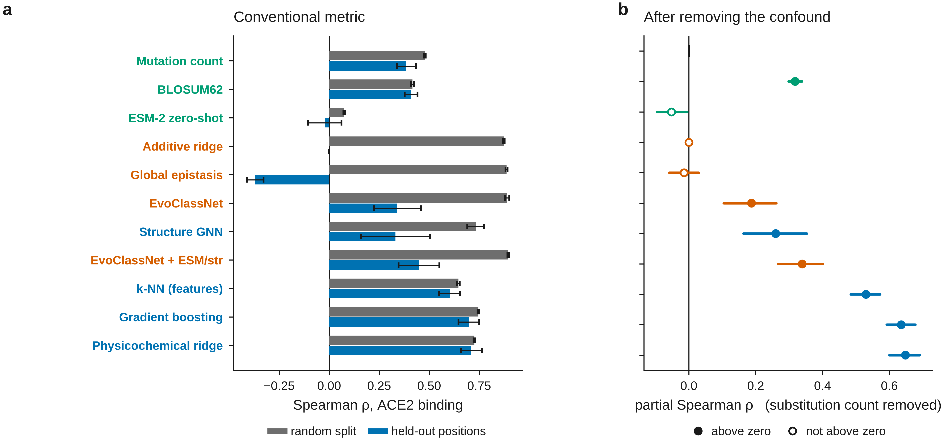
Figure 9. The receptor-binding-domain panel. (a) Spearman ρ for ACE2 binding under both splits; bars are means over seeds, whiskers one standard deviation. (b) The same models at held-out positions after the substitution count is partialled out of prediction and measurement; points are means over seeds with bootstrap intervals, filled where the interval excludes zero.

At held-out positions the position-indexed models fall to the untrained baseline
Table 2. Held-out-position split: test variants mutate only positions absent from training.
Family | Model | Phenotype | Seeds | Spearman ρ | Partial ρ | Pearson r | Kendall τ | R² | RMSE | AUROC | Prec@k | NDCG | Calib. | n
untrained | Mutation count | ACE2 binding | 10 | 0.386 ± 0.047 | -0.000 ± 0.001 | 0.350 ± 0.044 | 0.311 ± 0.038 | 0.091 ± 0.079 | 1.630 ± 0.075 | 0.660 ± 0.026 | 0.046 ± 0.051 | 0.768 ± 0.113 | 0.971 ± 0.158 | 1386
untrained | Mutation count | Expression | 10 | 0.368 ± 0.049 | 0.000 ± 0.001 | 0.367 ± 0.044 | 0.294 ± 0.040 | 0.022 ± 0.197 | 1.110 ± 0.097 | 0.641 ± 0.016 | 0.038 ± 0.037 | 0.752 ± 0.071 | 0.663 ± 0.085 | 1432
untrained | Mutation count | Antibody escape | 10 | 0.000 ± 0.000 | 0.000 ± 0.000 | 0.000 ± 0.000 | 0.000 ± 0.000 | — | 0.487 ± 0.053 | 0.500 ± 0.000 | — | — | — | 300
untrained | BLOSUM62 | ACE2 binding | 10 | 0.410 ± 0.032 | 0.318 ± 0.034 | 0.390 ± 0.028 | 0.299 ± 0.024 | -0.684 ± 0.361 | 2.202 ± 0.125 | 0.709 ± 0.023 | 0.142 ± 0.063 | 0.858 ± 0.033 | 0.325 ± 0.042 | 1386
untrained | BLOSUM62 | Expression | 10 | 0.371 ± 0.039 | 0.274 ± 0.041 | 0.360 ± 0.038 | 0.268 ± 0.030 | -2.550 ± 0.638 | 2.116 ± 0.173 | 0.671 ± 0.019 | 0.066 ± 0.049 | 0.814 ± 0.033 | 0.196 ± 0.024 | 1432
untrained | BLOSUM62 | Antibody escape | 10 | -0.329 ± 0.055 | — | -0.352 ± 0.052 | -0.241 ± 0.039 | -17.763 ± 3.054 | 1.764 ± 0.068 | 0.278 ± 0.029 | 0.033 ± 0.037 | 0.469 ± 0.035 | -0.093 ± 0.017 | 300
untrained | ESM-2 zero-shot | ACE2 binding | 10 | -0.022 ± 0.084 | -0.052 ± 0.077 | -0.012 ± 0.103 | -0.015 ± 0.056 | -0.912 ± 0.250 | 2.366 ± 0.232 | 0.500 ± 0.063 | 0.022 ± 0.039 | 0.556 ± 0.113 | -0.023 ± 0.175 | 1386
untrained | ESM-2 zero-shot | Expression | 10 | -0.019 ± 0.112 | -0.047 ± 0.105 | -0.013 ± 0.101 | -0.012 ± 0.074 | -1.897 ± 0.479 | 1.914 ± 0.184 | 0.486 ± 0.075 | 0.026 ± 0.021 | 0.592 ± 0.076 | -0.015 ± 0.113 | 1432
untrained | ESM-2 zero-shot | Antibody escape | 10 | 0.108 ± 0.050 | — | 0.110 ± 0.069 | 0.071 ± 0.033 | -8.392 ± 1.712 | 1.248 ± 0.096 | 0.513 ± 0.032 | 0.216 ± 0.093 | 0.678 ± 0.049 | 0.059 ± 0.037 | 300
transferable | Physicochemical ridge | ACE2 binding | 10 | 0.711 ± 0.053 | 0.648 ± 0.077 | 0.658 ± 0.045 | 0.518 ± 0.046 | 0.391 ± 0.071 | 1.335 ± 0.100 | 0.859 ± 0.024 | 0.150 ± 0.079 | 0.964 ± 0.015 | 1.256 ± 0.152 | 1386
transferable | Physicochemical ridge | Expression | 10 | 0.587 ± 0.062 | 0.500 ± 0.084 | 0.570 ± 0.055 | 0.413 ± 0.049 | 0.236 ± 0.108 | 0.982 ± 0.062 | 0.766 ± 0.049 | 0.092 ± 0.071 | 0.906 ± 0.023 | 1.456 ± 0.194 | 1432
transferable | Physicochemical ridge | Antibody escape | 10 | 0.596 ± 0.073 | — | 0.612 ± 0.076 | 0.427 ± 0.060 | 0.307 ± 0.153 | 0.340 ± 0.048 | 0.823 ± 0.064 | 0.291 ± 0.139 | 0.844 ± 0.050 | 0.907 ± 0.195 | 300
transferable | k-NN (features) | ACE2 binding | 10 | 0.602 ± 0.052 | 0.530 ± 0.075 | 0.568 ± 0.057 | 0.427 ± 0.042 | 0.287 ± 0.060 | 1.446 ± 0.120 | 0.803 ± 0.028 | 0.134 ± 0.072 | 0.956 ± 0.010 | 1.094 ± 0.110 | 1386
transferable | k-NN (features) | Expression | 10 | 0.515 ± 0.080 | 0.424 ± 0.097 | 0.512 ± 0.077 | 0.357 ± 0.063 | 0.211 ± 0.130 | 0.997 ± 0.071 | 0.734 ± 0.045 | 0.114 ± 0.055 | 0.902 ± 0.025 | 0.943 ± 0.136 | 1432
transferable | k-NN (features) | Antibody escape | 10 | 0.408 ± 0.084 | — | 0.418 ± 0.089 | 0.281 ± 0.060 | 0.077 ± 0.152 | 0.392 ± 0.031 | 0.718 ± 0.043 | 0.234 ± 0.121 | 0.780 ± 0.064 | 0.780 ± 0.192 | 300
transferable | Gradient boosting | ACE2 binding | 10 | 0.698 ± 0.052 | 0.635 ± 0.073 | 0.666 ± 0.061 | 0.506 ± 0.045 | 0.420 ± 0.082 | 1.299 ± 0.081 | 0.858 ± 0.027 | 0.104 ± 0.059 | 0.957 ± 0.009 | 0.909 ± 0.094 | 1386
transferable | Gradient boosting | Expression | 10 | 0.621 ± 0.071 | 0.545 ± 0.083 | 0.615 ± 0.068 | 0.441 ± 0.059 | 0.322 ± 0.147 | 0.923 ± 0.093 | 0.785 ± 0.050 | 0.122 ± 0.055 | 0.922 ± 0.024 | 0.877 ± 0.104 | 1432
transferable | Gradient boosting | Antibody escape | 10 | 0.578 ± 0.102 | — | 0.590 ± 0.094 | 0.412 ± 0.081 | 0.284 ± 0.154 | 0.346 ± 0.051 | 0.814 ± 0.064 | 0.344 ± 0.082 | 0.854 ± 0.030 | 0.803 ± 0.120 | 300
transferable | Structure GNN | ACE2 binding | 10 | 0.332 ± 0.172 | 0.259 ± 0.162 | 0.293 ± 0.159 | 0.227 ± 0.121 | -0.047 ± 0.114 | 1.753 ± 0.178 | 0.669 ± 0.079 | 0.048 ± 0.042 | 0.793 ± 0.168 | 3.747 ± 10.138 | 1386
transferable | Structure GNN | Expression | 10 | 0.383 ± 0.175 | 0.313 ± 0.155 | 0.377 ± 0.163 | 0.262 ± 0.121 | 0.082 ± 0.126 | 1.077 ± 0.059 | 0.699 ± 0.090 | 0.056 ± 0.055 | 0.793 ± 0.112 | 3.814 ± 9.392 | 1432
transferable | Structure GNN | Antibody escape | 10 | 0.215 ± 0.144 | — | 0.227 ± 0.098 | 0.144 ± 0.098 | -0.068 ± 0.154 | 0.423 ± 0.042 | 0.597 ± 0.072 | 0.195 ± 0.105 | 0.714 ± 0.068 | 7.404 ± 16.938 | 300
position-indexed | Additive ridge | ACE2 binding | 10 | 0.000 ± 0.000 | 0.000 ± 0.000 | 0.000 ± 0.000 | 0.000 ± 0.000 | — | 2.017 ± 0.241 | 0.500 ± 0.000 | — | — | — | 1386
position-indexed | Additive ridge | Expression | 10 | 0.000 ± 0.000 | 0.000 ± 0.000 | 0.000 ± 0.000 | 0.000 ± 0.000 | — | 1.244 ± 0.080 | 0.500 ± 0.000 | — | — | — | 1432
position-indexed | Additive ridge | Antibody escape | 10 | 0.000 ± 0.000 | 0.000 ± 0.000 | 0.000 ± 0.000 | 0.000 ± 0.000 | — | 0.420 ± 0.025 | 0.500 ± 0.000 | — | — | — | 300
position-indexed | Global epistasis | ACE2 binding | 10 | -0.370 ± 0.042 | -0.015 ± 0.075 | -0.350 ± 0.045 | -0.289 ± 0.038 | -0.166 ± 0.217 | 1.849 ± 0.259 | 0.342 ± 0.024 | 0.002 ± 0.006 | 0.361 ± 0.103 | -19.605 ± 16.762 | 1386
position-indexed | Global epistasis | Expression | 10 | -0.354 ± 0.057 | 0.003 ± 0.093 | -0.367 ± 0.045 | -0.276 ± 0.047 | -0.254 ± 0.408 | 1.250 ± 0.180 | 0.360 ± 0.020 | 0.004 ± 0.008 | 0.516 ± 0.055 | -18.344 ± 9.748 | 1432
position-indexed | Global epistasis | Antibody escape | 10 | 0.008 ± 0.016 | 0.000 ± 0.000 | 0.009 ± 0.019 | 0.006 ± 0.013 | -0.375 ± 0.496 | 0.488 ± 0.071 | 0.499 ± 0.004 | 0.017 ± 0.024 | 0.612 ± 0.202 | — | 300
position-indexed | EvoClassNet | ACE2 binding | 10 | 0.341 ± 0.118 | 0.187 ± 0.134 | 0.293 ± 0.129 | 0.234 ± 0.083 | -0.184 ± 0.203 | 1.860 ± 0.219 | 0.664 ± 0.081 | 0.072 ± 0.053 | 0.795 ± 0.082 | 7.257 ± 18.051 | 1386
position-indexed | EvoClassNet | Expression | 10 | 0.323 ± 0.079 | 0.179 ± 0.088 | 0.312 ± 0.086 | 0.220 ± 0.054 | -0.450 ± 0.631 | 1.331 ± 0.245 | 0.645 ± 0.061 | 0.046 ± 0.035 | 0.769 ± 0.085 | 2.949 ± 5.816 | 1432
position-indexed | EvoClassNet | Antibody escape | 10 | 0.183 ± 0.200 | — | 0.173 ± 0.181 | 0.126 ± 0.138 | -0.388 ± 0.699 | 0.472 ± 0.110 | 0.622 ± 0.106 | 0.184 ± 0.105 | 0.717 ± 0.094 | 0.285 ± 2.095 | 300
position-indexed | EvoClassNet + ESM/str | ACE2 binding | 10 | 0.449 ± 0.102 | 0.339 ± 0.114 | 0.387 ± 0.123 | 0.314 ± 0.076 | -0.143 ± 0.290 | 1.821 ± 0.274 | 0.716 ± 0.066 | 0.084 ± 0.053 | 0.829 ± 0.086 | 2.383 ± 4.285 | 1386
position-indexed | EvoClassNet + ESM/str | Expression | 10 | 0.382 ± 0.145 | 0.263 ± 0.149 | 0.367 ± 0.138 | 0.263 ± 0.101 | -0.132 ± 0.314 | 1.188 ± 0.152 | 0.669 ± 0.079 | 0.058 ± 0.049 | 0.784 ± 0.093 | 1.479 ± 1.823 | 1432
position-indexed | EvoClassNet + ESM/str | Antibody escape | 10 | 0.314 ± 0.280 | — | 0.320 ± 0.274 | 0.218 ± 0.192 | -0.048 ± 0.224 | 0.418 ± 0.058 | 0.682 ± 0.140 | 0.217 ± 0.108 | 0.758 ± 0.128 | 2.965 ± 7.815 | 300

When every test variant mutates positions never mutated in training, the additive model has no applicable parameter and emits a constant. The global-epistasis model does worse than nothing, its predictions anti-correlated with measurement, because latent effects for unseen substitutions are shrunk towards zero and then passed through a link fitted to the training distribution. EvoClassNet stays positive. Read on its own, the table says the network extrapolates where the conventional models cannot.

The mutation-count control, and a metric that makes it unnecessary
That reading is wrong, and the reason is visible in a single column. Ranking variants by the number of substitutions they carry — no training, no parameters, no knowledge of which positions or residues are involved — reaches ρ = 0.386 ± 0.047 for binding at held-out positions, against 0.341 ± 0.118 for EvoClassNet. In a combinatorial library most substitutions are deleterious and their effects accumulate, so a large part of the rank variance is carried by substitution count alone, and a model that has learned nothing about the withheld positions still orders the test set to that extent.
Rather than argue from the baseline comparison, we measure the quantity directly. The partial Spearman correlation removes substitution count from the ranks of both prediction and measurement. It validates itself: the mutation-count baseline scores -0.000 ± 0.001 on it, as it must. On the same partitions EvoClassNet retains 0.187 ± 0.134 for binding and 0.179 ± 0.088 for expression.
Table 3. Held-out-position split: every trained model against the untrained mutation-count baseline, paired over seeds. Equivalence is a two one-sided test at the ±0.05 margin; a true value there is positive evidence of no practical difference, not merely absence of a significant one.
Phenotype | Model | Seeds | Median Δρ | CI low | CI high | P (FDR) | TOST P | Equivalent | Cliff's δ | Effect
ACE2 binding | Physicochemical ridge | 10 | 0.3088 | 0.2797 | 0.3724 | 0.00601 | 0.999999164248084 | False | 1.0 | large
ACE2 binding | k-NN (features) | 10 | 0.2137 | 0.1723 | 0.2598 | 0.00601 | 0.9999695051538248 | False | 1.0 | large
ACE2 binding | Gradient boosting | 10 | 0.3081 | 0.2725 | 0.3544 | 0.00601 | 0.9999995483930094 | False | 1.0 | large
ACE2 binding | Structure GNN | 10 | -0.0264 | -0.1497 | 0.0347 | 0.33871 | 0.5313516250383241 | False | -0.16 | small
ACE2 binding | Additive ridge | 10 | -0.3939 | -0.4118 | -0.3573 | 0.00601 | 0.9999999985020248 | False | -1.0 | large
ACE2 binding | Global epistasis | 10 | -0.7771 | -0.8013 | -0.7051 | 0.00601 | 0.9999999996603752 | False | -1.0 | large
ACE2 binding | EvoClassNet | 10 | -0.0217 | -0.1215 | 0.0207 | 0.29702 | 0.4462284048570662 | False | -0.22 | small
ACE2 binding | EvoClassNet + ESM/str | 10 | 0.0703 | 0.0006 | 0.1199 | 0.09454 | 0.6569136834149025 | False | 0.48 | large
Expression | Physicochemical ridge | 10 | 0.203 | 0.1706 | 0.2693 | 0.00601 | 0.999928016037545 | False | 1.0 | large
Expression | k-NN (features) | 10 | 0.1488 | 0.0945 | 0.2013 | 0.00601 | 0.9956419163076456 | False | 0.96 | large
Expression | Gradient boosting | 10 | 0.2363 | 0.2088 | 0.3023 | 0.00601 | 0.9999897622022216 | False | 1.0 | large
Expression | Structure GNN | 10 | 0.0732 | -0.0953 | 0.0965 | 0.39015 | 0.2555906965152575 | False | 0.36 | medium
Expression | Additive ridge | 10 | -0.382 | -0.3938 | -0.3373 | 0.00601 | 0.9999999963204804 | False | -1.0 | large
Expression | Global epistasis | 10 | -0.7401 | -0.7779 | -0.6587 | 0.00601 | 0.9999999966239258 | False | -1.0 | large
Expression | EvoClassNet | 10 | -0.0177 | -0.0976 | 0.0052 | 0.33871 | 0.4250940411662657 | False | -0.4 | medium
Expression | EvoClassNet + ESM/str | 10 | 0.0242 | -0.0594 | 0.0823 | 0.56766 | 0.1852968019775392 | False | 0.34 | medium
Antibody escape | Physicochemical ridge | 10 | 0.5812 | 0.557 | 0.6414 | 0.00601 | 0.9999999990092736 | False | 1.0 | large
Antibody escape | k-NN (features) | 10 | 0.4058 | 0.3571 | 0.4569 | 0.00601 | 0.9999998550819889 | False | 1.0 | large
Antibody escape | Gradient boosting | 10 | 0.579 | 0.5204 | 0.6398 | 0.00601 | 0.9999999744333672 | False | 1.0 | large
Antibody escape | Structure GNN | 10 | 0.2542 | 0.1177 | 0.2848 | 0.01676 | 0.9972316420931856 | False | 0.8 | large
Antibody escape | Additive ridge | 10 | 0.0 | 0.0 | 0.0 |  |  | False | 0.0 | negligible
Antibody escape | Global epistasis | 10 | 0.0 | 0.0 | 0.0187 | 0.51244 | 7.399767135154628e-06 | True | 0.2 | small
Antibody escape | EvoClassNet | 10 | 0.2414 | 0.0602 | 0.2948 | 0.07193 | 0.9675099975291984 | False | 0.6 | large
Antibody escape | EvoClassNet + ESM/str | 10 | 0.3877 | 0.1304 | 0.4405 | 0.07193 | 0.9923486991895392 | False | 0.8 | large

Extrapolation is possible; the earlier conclusion was about representations
Our first analysis stopped here and concluded that none of the models extrapolates across positions. That conclusion does not follow from the evidence, and it is wrong. Every model compared above encodes a substitution by the position it occupies: the additive model by a (position, residue) indicator, the global-epistasis model by a per-position latent effect, the networks by a position embedding. For a position absent from training, none of them holds a parameter that was ever updated. Their collapse measures that fact, not a limit on what the data support.
Table 4. Held-out-position split: a ridge regression on position-transferable features, by feature block. Partial ρ removes the substitution-count confound. Antibody escape has no partial column because every escape-labelled variant carries one substitution, so the confound is absent there by construction.
Features | ACE2 binding ρ | ACE2 binding partial | Expression ρ | Expression partial | Antibody escape ρ | Antibody escape partial
Substitution count only | +0.386 ± 0.047 | -0.000 ± 0.001 | +0.368 ± 0.049 | +0.000 ± 0.001 | +0.000 ± 0.000 | +0.000 ± 0.000
ESM-2 score only | +0.340 ± 0.067 | -0.004 ± 0.091 | +0.301 ± 0.066 | -0.058 ± 0.097 | +0.108 ± 0.050 | —
Residue chemistry only | +0.508 ± 0.046 | +0.371 ± 0.060 | +0.416 ± 0.075 | +0.257 ± 0.091 | +0.340 ± 0.123 | —
Structure only | +0.644 ± 0.075 | +0.554 ± 0.112 | +0.581 ± 0.068 | +0.485 ± 0.101 | +0.470 ± 0.079 | —
Structure, interface descriptors removed | +0.615 ± 0.061 | +0.518 ± 0.095 | +0.572 ± 0.064 | +0.477 ± 0.094 | +0.361 ± 0.148 | —
Chemistry + structure, interface removed | +0.678 ± 0.060 | +0.609 ± 0.084 | +0.569 ± 0.081 | +0.480 ± 0.097 | +0.452 ± 0.092 | —
Chemistry + structure | +0.706 ± 0.059 | +0.642 ± 0.085 | +0.582 ± 0.067 | +0.494 ± 0.088 | +0.597 ± 0.071 | —
Chemistry + structure + ESM-2 | +0.712 ± 0.051 | +0.650 ± 0.074 | +0.592 ± 0.060 | +0.506 ± 0.082 | +0.600 ± 0.069 | —

Given features that remain defined at an unseen position, extrapolation is substantial. Chemistry alone reaches a partial correlation of +0.371 ± 0.060 for binding, structure alone +0.554 ± 0.112, and the combination +0.650 ± 0.074 — against -0.000 ± 0.001 for the untrained baseline and 0.187 ± 0.134 for the sequence network on the identical partitions. The information needed to predict the effect of a substitution at an unseen position is present in the data; the earlier models simply had no way to express it.
One component of that signal needs separating out before it is believed. Two of the structural descriptors, the change in solvent accessibility on binding and the interface indicator, are derived from the RBD bound to ACE2 and therefore mark precisely the residues that touch the receptor, which for the binding task is close to being told the answer. Dropping both leaves +0.518 ± 0.095, against +0.554 ± 0.112 with them, so the structural contribution does not rest on them. The remaining descriptors — solvent accessibility of the unbound domain, contact number, burial, B-factor — describe the folded domain alone.
Table 3b. Held-out-position split: is each model's partial Spearman correlation different from zero? Bootstrap intervals over seeds, Wilcoxon signed-rank with false-discovery-rate correction across the family. The untrained mutation-count baseline and the additive model are identically zero and carry no test.
Family | Model | Phenotype | Seeds | Mean partial ρ | CI low | CI high | P (FDR) | Above zero
transferable | Physicochemical ridge | ACE2 binding | 10 | 0.6476 | 0.6003 | 0.6903 | 0.00742 | True
transferable | Gradient boosting | ACE2 binding | 10 | 0.6354 | 0.5922 | 0.6776 | 0.00742 | True
transferable | Gradient boosting | Expression | 10 | 0.5446 | 0.501 | 0.598 | 0.00742 | True
transferable | k-NN (features) | ACE2 binding | 10 | 0.53 | 0.4847 | 0.5716 | 0.00742 | True
transferable | Physicochemical ridge | Expression | 10 | 0.5 | 0.4519 | 0.5514 | 0.00742 | True
transferable | k-NN (features) | Expression | 10 | 0.4235 | 0.3688 | 0.4835 | 0.00742 | True
position-indexed | EvoClassNet + ESM/str | ACE2 binding | 10 | 0.3386 | 0.2679 | 0.4011 | 0.00742 | True
untrained | BLOSUM62 | ACE2 binding | 10 | 0.3181 | 0.2983 | 0.3378 | 0.00742 | True
transferable | Structure GNN | Expression | 10 | 0.313 | 0.2104 | 0.3927 | 0.01142 | True
untrained | BLOSUM62 | Expression | 10 | 0.2738 | 0.2496 | 0.2975 | 0.00742 | True
position-indexed | EvoClassNet + ESM/str | Expression | 10 | 0.2633 | 0.171 | 0.347 | 0.01142 | True
transferable | Structure GNN | ACE2 binding | 10 | 0.2593 | 0.1637 | 0.3527 | 0.01142 | True
position-indexed | EvoClassNet | ACE2 binding | 10 | 0.1875 | 0.1045 | 0.2615 | 0.0159 | True
position-indexed | EvoClassNet | Expression | 10 | 0.179 | 0.126 | 0.2291 | 0.00742 | True
position-indexed | Global epistasis | Expression | 9 | 0.0031 | -0.0525 | 0.0612 | 1.0 | False
position-indexed | Additive ridge | Expression | 10 | 0.0 | 0.0 | 0.0 |  | False
position-indexed | Additive ridge | Antibody escape | 10 | 0.0 | 0.0 | 0.0 |  | False
untrained | Mutation count | Antibody escape | 10 | 0.0 | 0.0 | 0.0 |  | False
position-indexed | Additive ridge | ACE2 binding | 10 | 0.0 | 0.0 | 0.0 |  | False
position-indexed | Global epistasis | Antibody escape | 8 | 0.0 | 0.0 | 0.0 |  | False
position-indexed | Global epistasis | ACE2 binding | 10 | -0.0147 | -0.0585 | 0.0297 | 0.57168 | False
untrained | ESM-2 zero-shot | Expression | 10 | -0.047 | -0.1107 | 0.0125 | 0.34989 | False
untrained | ESM-2 zero-shot | ACE2 binding | 10 | -0.0522 | -0.0954 | -0.0049 | 0.09386 | False

One row of that table is worth pausing on. BLOSUM62 exchangeability — a substitution matrix published in 1992, with no training, no parameters and no knowledge of this protein — reaches a partial correlation of 0.318 (0.298 to 0.338) at held-out positions, against 0.188 (0.104 to 0.262) for the trained multi-task network on the same partitions. The network was given 124,197 measured genotypes and still transfers less well across positions than a lookup table of amino-acid interchangeability, because almost everything it learned was indexed to positions it will not see again.
One comparison isolates the effect cleanly, because nothing else differs. EvoClassNet and EvoClassNet + ESM/str are the same architecture with the same hyper-parameters, the same optimiser and the same seeds; the second is additionally given, at each of the 201 positions, the structural descriptors of that position and a sixteen-dimensional projection of the language model's representation of it. That input alone moves the partial correlation for binding from 0.187 ± 0.134 to 0.339 ± 0.114. The architecture did not change, the training data did not change, and what improved is exactly the quantity that measures position-level transfer.
Two results in the same table are worth reporting against our own expectations. The graph network over the residue contact graph, which was built specifically to exploit structure, reaches 0.259 ± 0.162 — below the plain feature models that use the same structural descriptors without any message passing. And the best model on this split is gradient boosting on the transferable feature block, at 0.635 ± 0.073. Neither is the architecture we would have predicted, and we report them rather than the model we set out to build.

Where the transfer comes from: positions, not substitutions
Table 5. Per-position rank accuracy of the transferable model at withheld positions: within each withheld position, how well it orders the 19 possible substitutions. Compared against BLOSUM62 exchangeability on identical instances. The P value for the median comes from a random-intercept model over positions, because positions recur across seeds.
Phenotype | Median ρ | % positive | Random-intercept P | BLOSUM62 median ρ | Difference | P | n position–seed
ACE2 binding | +0.533 | 92 | 2.74e-25 | +0.528 | +0.005 | 0.407 | 300
Expression | +0.510 | 90 | 3.6e-24 | +0.561 | +0.003 | 0.926 | 300
Antibody escape | +0.570 | 96 | 3.49e-17 | -0.350 | +0.869 | 8.65e-30 | 178

Restricting to single substitutions and asking a narrower question — within one withheld position, can the model order the nineteen substitutions available there — separates two components of the transfer. For binding the model reaches a median per-position ρ of +0.533, positive at 92 % of position–seed cells, but BLOSUM62 reaches +0.528 on the same instances and the difference is +0.005 (P = 0.407). Within a position, in other words, the ordering is chemistry, and an untrained substitution matrix already supplies it.
The model's advantage therefore lies in discriminating between positions — which positions tolerate substitution at all — and that is precisely what the structural descriptors provide and what a substitution matrix, being position-independent, cannot. It is consistent with the whole-test-set result: summed BLOSUM62 scores reach 0.410 ± 0.032 there, against +0.712 ± 0.051 for the full feature block.
Escape is the exception in the opposite direction. BLOSUM62 is not merely uninformative but anti-correlated (-0.350), because the substitutions that abolish antibody binding are not the chemically radical ones, while the model reaches +0.570 (difference +0.869, P = 8.65e-30). There the within-position ordering is genuinely learned.
Per-position accuracy for binding is associated with rsa_bound (ρ = -0.24, P = 2.4e-05), rsa_unbound (ρ = -0.20, P = 0.0004), depth (ρ = +0.19, P = 0.00096).
Per-position accuracy for escape is associated with min_dist_ace2 (ρ = -0.23, P = 0.0024), bfactor (ρ = -0.23, P = 0.0025), depth (ρ = +0.13, P = 0.088).
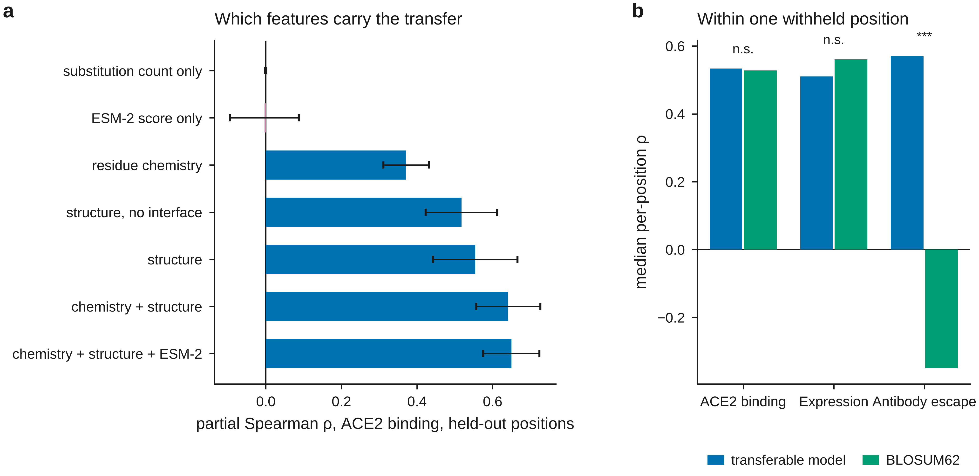
Figure 10. Where the transferable signal comes from. (a) Partial Spearman ρ for ACE2 binding at held-out positions, by feature block; bars are means over ten seeds, whiskers one standard deviation. (b) Median per-position rank accuracy within a single withheld position, for the transferable model and for BLOSUM62 exchangeability on identical substitutions.

The protein language model contributes nothing here
ESM-2 is the component most often expected to supply exactly this kind of position-independent knowledge, and on this protein it does not. Its zero-shot scores reach +0.340 ± 0.067 for binding at held-out positions, of which -0.004 ± 0.091 survives the substitution-count control: the raw figure is the confound in full. Added to chemistry and structure it moves the partial correlation from +0.642 ± 0.085 to +0.650 ± 0.074.
Because a null result from a large pretrained model invites the suspicion of a broken pipeline, we checked. Wild-type recovery was 80.3% on human ubiquitin against 11.8% on the isolated RBD and 17.6% on the same positions scored inside the full spike protein: the model is working and the RBD is genuinely hard for it, and supplying the full spike context does not rescue it. No weights were missing at load time. We therefore report the absence of a contribution as a result about this protein, which is consistent with SARS-CoV-2 ranking among the harder entries in published zero-shot benchmarks, and not as a general statement about protein language models.

Permuting the amino-acid alphabet
Table 6. Amino-acid permutation ablation: an independent random permutation of the alphabet at every position, applied consistently to all partitions.
Split | Model | Phenotype | Intact | Permuted | Δ
heldout_sites | Structure GNN | ACE2 binding | 0.227 ± 0.166 | 0.176 ± 0.141 | -0.051
heldout_sites | Structure GNN | Expression | 0.298 ± 0.215 | 0.179 ± 0.199 | -0.119
heldout_sites | Structure GNN | Antibody escape | 0.178 ± 0.187 | 0.104 ± 0.214 | -0.074
heldout_sites | Global epistasis | ACE2 binding | -0.351 ± 0.052 | -0.368 ± 0.058 | -0.017
heldout_sites | Global epistasis | Expression | -0.325 ± 0.058 | -0.320 ± 0.054 | 0.005
heldout_sites | Global epistasis | Antibody escape | 0.008 ± 0.018 | 0.005 ± 0.050 | -0.003
heldout_sites | EvoClassNet | ACE2 binding | 0.280 ± 0.118 | 0.260 ± 0.030 | -0.02
heldout_sites | EvoClassNet | Expression | 0.287 ± 0.070 | 0.223 ± 0.036 | -0.064
heldout_sites | EvoClassNet | Antibody escape | 0.161 ± 0.199 | 0.194 ± 0.306 | 0.033
heldout_sites | EvoClassNet + ESM/str | ACE2 binding | 0.392 ± 0.108 | 0.281 ± 0.122 | -0.111
heldout_sites | EvoClassNet + ESM/str | Expression | 0.299 ± 0.165 | 0.277 ± 0.113 | -0.022
heldout_sites | EvoClassNet + ESM/str | Antibody escape | 0.225 ± 0.383 | 0.073 ± 0.198 | -0.152

Permuting the alphabet independently at each position preserves every position's own information while destroying any correspondence between the same residue at different positions. The manipulation acts on the integer-encoded sequence, so it reaches the four models that take that encoding as input; the untrained scorers and the feature-based models are computed from the substitution list and are unaffected by construction, and are omitted from the table rather than listed with a difference of exactly zero.
For the plain sequence network the change is small against the between-seed spread (binding -0.020 against a standard deviation of 0.118), which is what the mutation-count account predicts, since substitution count is invariant to relabelling. The network given structural and language-model side information loses more (-0.111 for binding, -0.152 for escape), which is the expected direction: that side information is attached to positions, and permuting the alphabet severs the link between a residue's identity and the structural context it sits in. The seed spreads are wide enough that we would not rest an argument on the size of either number.

Withholding more positions

Run-to-run instability
Holding partition 0 fixed and varying only the weight initialisation gave binding ρ of +0.374, +0.423, +0.387 (range 0.050).
Holding partition 2 fixed and varying only the weight initialisation gave binding ρ of +0.236, +0.558, +0.385 (range 0.322).
Across all 6 runs the spread was +0.236 to +0.558. Initialisation alone accounts for a substantial part of it, and on some partitions the spread exceeds the differences being discussed, so a single run on this benchmark is not a measurement. Every table here reports a seed distribution for that reason.

Variant-of-Concern ranking without leakage
Table 7. Ranking Variant-of-Concern substitutions at withheld positions only, pooled over seeds, with 95 % bootstrap intervals.
Score | AUROC | CI | n_positives
EvoClassNet predicted escape | 0.588 | 0.441–0.730 | 15
EvoClassNet predicted binding | 0.469 | 0.291–0.638 | 15
BLOSUM62 exchangeability | 0.718 | 0.602–0.820 | 15
Measured escape (held-out positions) | 0.749 | 0.636–0.856 | 14
Measured binding DMS (held-out positions) | 0.664 | 0.537–0.797 | 15

Variant-of-Concern substitutions are present in the escape training data, so ranking them with a model that has seen them measures memorisation; restricting to withheld positions removes that circularity. Predicted escape gave AUROC 0.588 (95 % CI 0.441–0.730), an interval that includes 0.5. The measured values on the identical subset gave 0.749, which is the ceiling available to any model of this phenotype, and BLOSUM62 exchangeability, which requires no training at all, gave 0.718. The assay carries real information about which substitutions went on to define lineages; at positions it never saw, the trained sequence model does not recover it. The positives are a small set chosen with hindsight, so the comparison between scorers on identical instances is meaningful while the absolute values are not.
Table 8. Median per-position Spearman ρ over single substitutions at withheld positions, against a substitution matrix.
Phenotype | EvoClassNet | BLOSUM62 | Difference | P | n
ACE2 binding | 0.181 | 0.538 | -0.269 | 1.54e-14 | 150
Antibody escape | 0.251 | -0.337 | +0.598 | 1.02e-15 | 98

Per-position rank accuracy separates the phenotypes. For binding an untrained substitution matrix beats the network (0.538 against 0.181, P = 1.54e-14); for escape the matrix is actively misleading, its median correlation negative (-0.337) where the network is positive (0.251, P = 1.02e-15), because the substitutions that abolish antibody binding are not the chemically radical ones.
Maximising escape with a genetic algorithm visited 7,714 distinct sequences. The top 1 % carried 0.000 Variant-of-Concern substitutions per variant against 0.062 for size-matched random samples of the same archive (permutation P = 1.000). A learned fitness surface is constrained only where it was fitted, and an optimiser leaves that region.
Maximising escape and binding with a genetic algorithm visited 7,744 distinct sequences. The top 1 % carried 0.000 Variant-of-Concern substitutions per variant against 0.034 for size-matched random samples of the same archive (permutation P = 1.000). A learned fitness surface is constrained only where it was fitted, and an optimiser leaves that region.

A second data type: coronavirus genomes
Table 13. Coronavirus genus classification under both splits, mean ± SD across seeds.
Split | Family | Model | Seeds | Accuracy | Balanced acc. | Macro F1 | Weighted F1 | MCC | f1_Alphacoronavirus | f1_Betacoronavirus | f1_Gammacoronavirus | f1_Deltacoronavirus
random | untrained | Majority class | 10 | 0.457 ± 0.044 | 0.250 ± 0.000 | 0.157 ± 0.010 | 0.288 ± 0.045 | 0.000 ± 0.000 | 0.000 ± 0.000 | 0.626 ± 0.042 | 0.000 ± 0.000 | 0.000 ± 0.000
random | trivial | Genome length + base composition | 10 | 0.950 ± 0.010 | 0.953 ± 0.015 | 0.941 ± 0.016 | 0.951 ± 0.010 | 0.924 ± 0.016 | 0.945 ± 0.016 | 0.958 ± 0.016 | 0.861 ± 0.053 | 1.000 ± 0.000
random | sequence | 5-mer + logistic regression | 10 | 1.000 ± 0.000 | 1.000 ± 0.000 | 1.000 ± 0.000 | 1.000 ± 0.000 | 1.000 ± 0.000 | 1.000 ± 0.000 | 1.000 ± 0.000 | 1.000 ± 0.000 | 1.000 ± 0.000
random | sequence | 5-mer + random forest | 10 | 0.997 ± 0.006 | 0.993 ± 0.013 | 0.995 ± 0.009 | 0.997 ± 0.006 | 0.995 ± 0.009 | 1.000 ± 0.000 | 0.996 ± 0.006 | 1.000 ± 0.000 | 0.984 ± 0.028
random | sequence | 5-mer + gradient boosting | 10 | 0.998 ± 0.004 | 0.995 ± 0.009 | 0.997 ± 0.006 | 0.997 ± 0.004 | 0.996 ± 0.006 | 0.999 ± 0.004 | 0.997 ± 0.004 | 1.000 ± 0.000 | 0.991 ± 0.019
random | sequence | 1D CNN on nucleotides | 10 | 0.990 ± 0.015 | 0.992 ± 0.009 | 0.992 ± 0.010 | 0.990 ± 0.015 | 0.985 ± 0.022 | 0.986 ± 0.023 | 0.991 ± 0.016 | 1.000 ± 0.000 | 0.992 ± 0.016
heldout_species | untrained | Majority class | 10 | 0.497 ± 0.077 | 0.250 ± 0.000 | 0.165 ± 0.017 | 0.334 ± 0.086 | 0.000 ± 0.000 | 0.000 ± 0.000 | 0.661 ± 0.069 | 0.000 ± 0.000 | 0.000 ± 0.000
heldout_species | trivial | Genome length + base composition | 10 | 0.894 ± 0.044 | 0.914 ± 0.037 | 0.891 ± 0.038 | 0.897 ± 0.044 | 0.843 ± 0.062 | 0.860 ± 0.074 | 0.918 ± 0.054 | 0.799 ± 0.113 | 0.989 ± 0.020
heldout_species | sequence | 5-mer + logistic regression | 10 | 0.999 ± 0.003 | 0.998 ± 0.004 | 0.997 ± 0.007 | 0.999 ± 0.003 | 0.998 ± 0.005 | 0.996 ± 0.009 | 1.000 ± 0.000 | 0.991 ± 0.020 | 1.000 ± 0.000
heldout_species | sequence | 5-mer + random forest | 10 | 0.969 ± 0.038 | 0.962 ± 0.034 | 0.968 ± 0.031 | 0.968 ± 0.038 | 0.953 ± 0.053 | 0.958 ± 0.049 | 0.977 ± 0.051 | 0.959 ± 0.073 | 0.979 ± 0.025
heldout_species | sequence | 5-mer + gradient boosting | 10 | 0.986 ± 0.017 | 0.976 ± 0.026 | 0.982 ± 0.021 | 0.986 ± 0.017 | 0.978 ± 0.026 | 0.980 ± 0.028 | 0.996 ± 0.007 | 0.958 ± 0.056 | 0.992 ± 0.019
heldout_species | sequence | 1D CNN on nucleotides | 10 | 0.986 ± 0.018 | 0.988 ± 0.017 | 0.985 ± 0.019 | 0.986 ± 0.017 | 0.978 ± 0.026 | 0.972 ± 0.037 | 0.990 ± 0.012 | 1.000 ± 0.000 | 0.976 ± 0.041

Under the random split, genome length and base composition alone reach balanced accuracy 0.953 ± 0.015, against 1.000 ± 0.000 for the best sequence model (5-mer + logistic regression) and 0.250 ± 0.000 for the majority class.
Under the held-out-species split, genome length and base composition alone reach balanced accuracy 0.914 ± 0.037, against 0.998 ± 0.004 for the best sequence model (5-mer + logistic regression) and 0.250 ± 0.000 for the majority class.
Table 14. Sequence models against the untrained length-and-composition control, paired over seeds.
Split | Model | Reference | Seeds | Median Δ | CI low | CI high | P (FDR) | TOST P | Equivalent | Cliff's δ
random | 5-mer + logistic regression | Genome length + base composition | 10 | 0.0425 | 0.0382 | 0.056 | 0.0024 | 0.9962195228420556 | False | 1.0
random | 5-mer + random forest | Genome length + base composition | 10 | 0.0425 | 0.0235 | 0.0536 | 0.00417 | 0.8563707454400075 | False | 0.9
random | 5-mer + gradient boosting | Genome length + base composition | 10 | 0.0425 | 0.029 | 0.0545 | 0.0024 | 0.940786186396648 | False | 1.0
random | 1D CNN on nucleotides | Genome length + base composition | 10 | 0.0397 | 0.0258 | 0.0514 | 0.0024 | 0.8767656463820934 | False | 1.0
random | 5-mer + logistic regression | Majority class | 10 | 0.75 | 0.75 | 0.75 | 0.0024 |  | False | 1.0
random | 5-mer + random forest | Majority class | 10 | 0.75 | 0.7334 | 0.75 | 0.0024 | 1.0 | False | 1.0
random | 5-mer + gradient boosting | Majority class | 10 | 0.75 | 0.7393 | 0.75 | 0.0024 | 1.0 | False | 1.0
random | 1D CNN on nucleotides | Majority class | 10 | 0.7446 | 0.7363 | 0.7469 | 0.0024 | 1.0 | False | 1.0
heldout_species | 5-mer + logistic regression | Genome length + base composition | 10 | 0.0743 | 0.0617 | 0.1069 | 0.0024 | 0.9991319386515816 | False | 1.0
heldout_species | 5-mer + random forest | Genome length + base composition | 10 | 0.043 | 0.0255 | 0.0717 | 0.00586 | 0.9074907782169516 | False | 0.7
heldout_species | 5-mer + gradient boosting | Genome length + base composition | 10 | 0.0656 | 0.0366 | 0.0856 | 0.00417 | 0.9802436647065402 | False | 0.84
heldout_species | 1D CNN on nucleotides | Genome length + base composition | 10 | 0.0637 | 0.0477 | 0.1007 | 0.0024 | 0.9934615381173167 | False | 0.96
heldout_species | 5-mer + logistic regression | Majority class | 10 | 0.75 | 0.7456 | 0.75 | 0.0024 | 1.0 | False | 1.0
heldout_species | 5-mer + random forest | Majority class | 10 | 0.7226 | 0.6909 | 0.7307 | 0.0024 | 0.9999999999998336 | False | 1.0
heldout_species | 5-mer + gradient boosting | Majority class | 10 | 0.7361 | 0.7108 | 0.7412 | 0.0024 | 0.9999999999999868 | False | 1.0
heldout_species | 1D CNN on nucleotides | Majority class | 10 | 0.7447 | 0.7268 | 0.7463 | 0.0024 | 0.9999999999999998 | False | 1.0

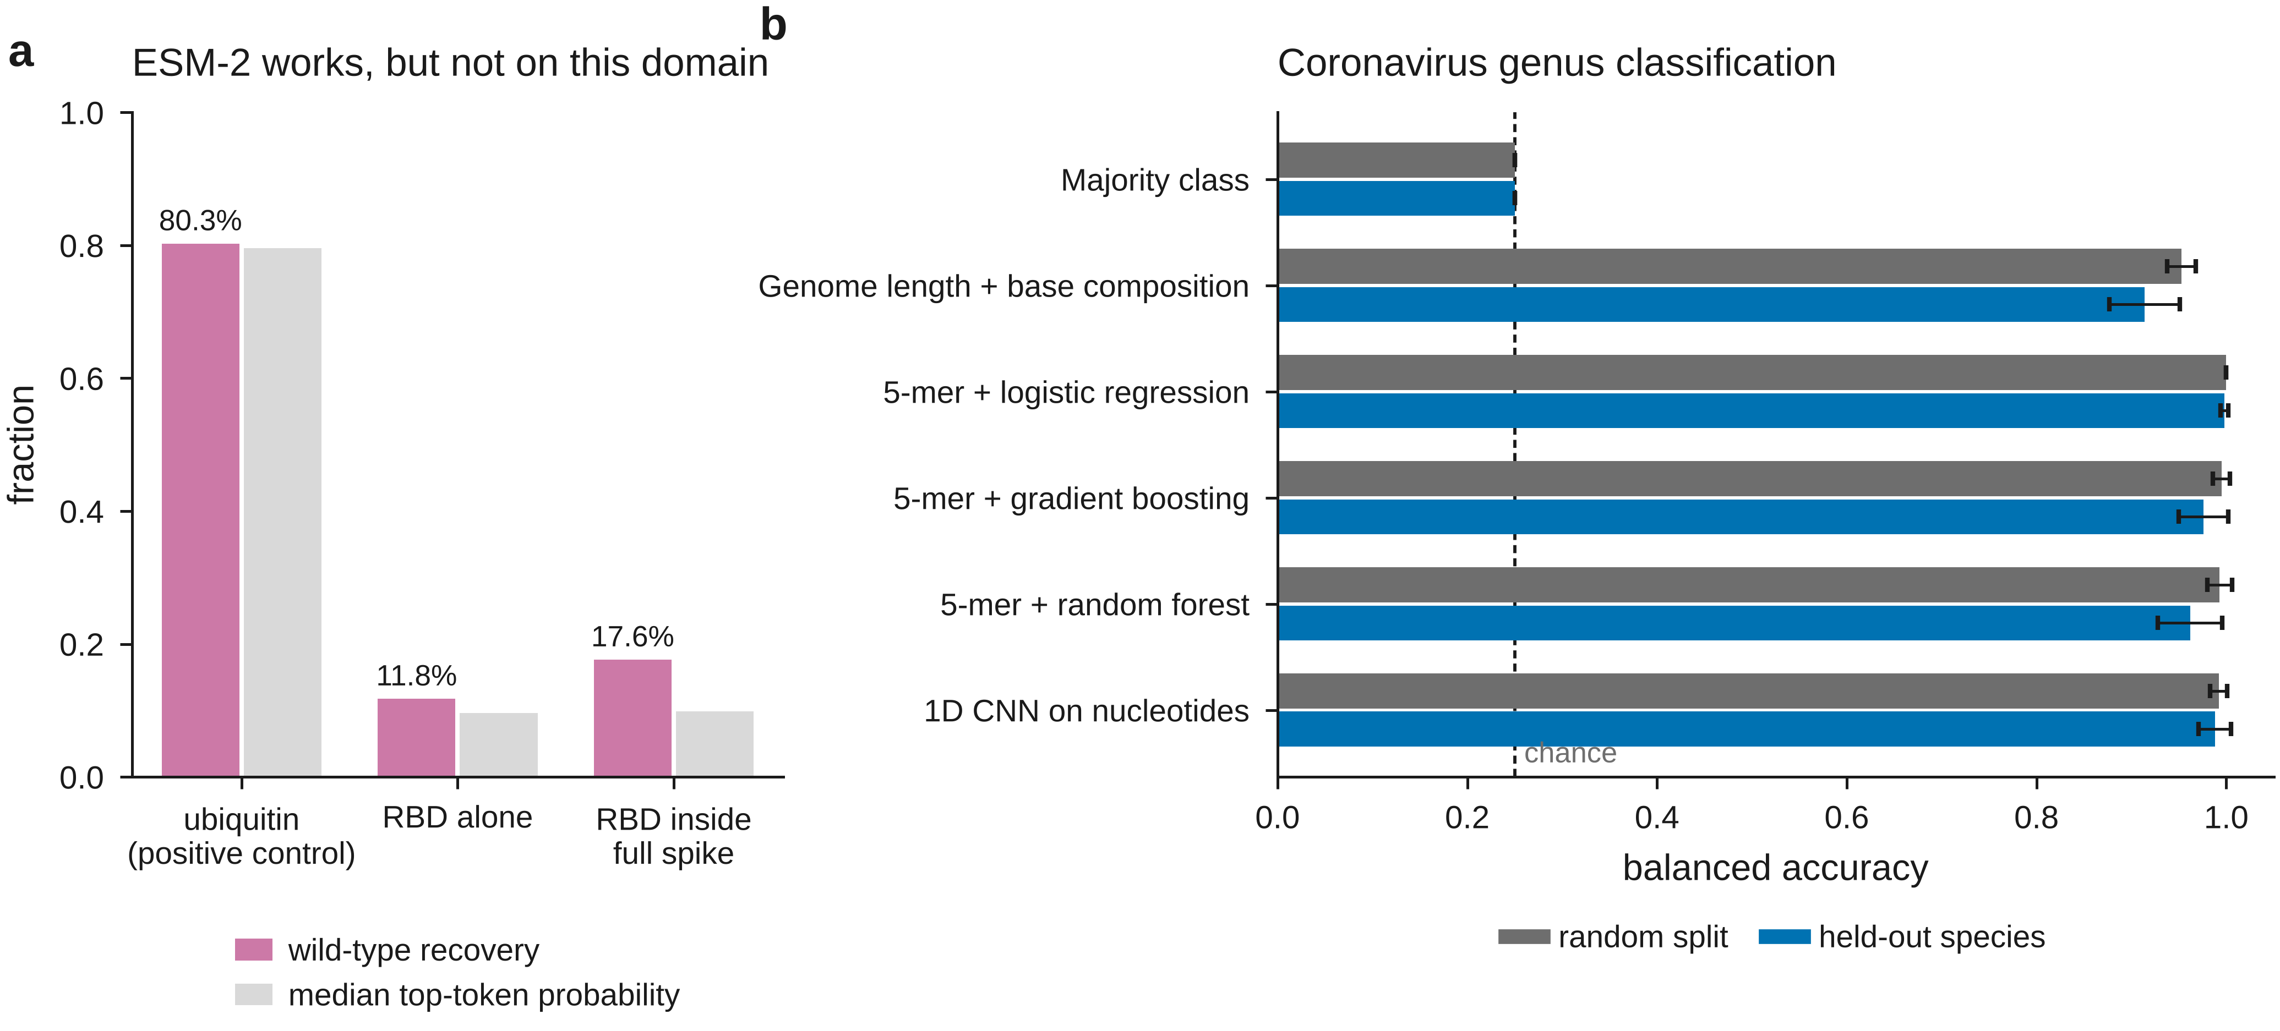
Figure 11. Controls. (a) ESM-2 wild-type recovery and median top-token probability on a protein it should find easy, on the receptor-binding domain alone, and on the same domain scored inside the full spike protein. (b) Balanced accuracy on coronavirus genus classification under a random split and a held-out-species split; the dashed line is chance for four classes.
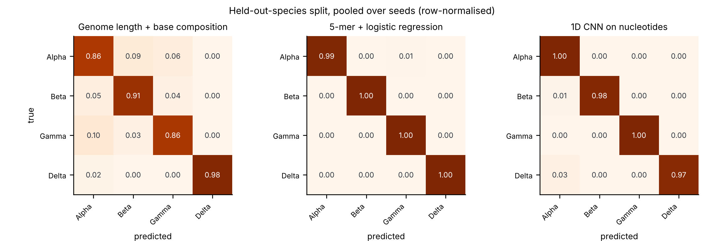
Figure 12. Confusion matrices under the held-out-species split, pooled over seeds and row-normalised.
The original project proposal reported this task as a five-way classification at 99.92 % accuracy, with no baseline. The lesson here is not that such a number must be wrong, but that it is uninterpretable on its own: an untrained control looking only at genome length and base composition already reaches most of it, so the reported figure conveys almost none of the information it appears to. Where the sequence models do beat that control, as they do here, the control is what makes the increment visible and worth reporting.

Synthesis and interpretation
The result we would ask a reader to take away is the simplest one in the paper, and it is computed from numbers someone else published. A ridge regression told only which position a variant mutates — a model that cannot distinguish a conservative substitution from a catastrophic one — reaches a median Spearman of 0.665 across 216 ProteinGym assays under a random split, and 6 of the eleven published supervised models score below it. The median published model beats it on 35.2 % of assays. Under fold_modulo_5, where the baseline is zero by construction, the same models beat it on 99.5 %.
This is not a claim that those models are weak, and the second set of numbers shows they are not. It is a claim about what a random split on a saturating mutational scan can and cannot establish. Most of the rank variance such a split rewards is per-position variance, and a model needs no concept of an amino acid to capture it. A reported random-split correlation therefore does not, on its own, demonstrate that a predictor has learned anything about substitutions — and the cost of checking is one ridge regression on a one-hot position matrix.
The receptor-binding-domain case study makes the same point in more detail, and records how we got it wrong first. Four evaluation designs applied to the same library support four different conclusions. A random split says the trained models work well and that the choice between them hardly matters. A held-out-position split says a sequence network extrapolates where conventional models fail. Adding an untrained baseline to that split says the network does nothing of the kind. Adding models whose features remain defined at an unseen position says that extrapolation is nonetheless possible, and substantial. Only the fourth conclusion survives, and reaching it required two corrections in sequence.
The first correction is the familiar one about controls. Making a split harder does not by itself make the resulting number meaningful: it changes what an uninformative model would score, and unless that value is measured on the same partition it is easy to mistake a shift in the null for evidence of skill. On a combinatorial mutagenesis library the uninformative score is far from zero, because the number of substitutions a variant carries is itself predictive. We would go further and recommend the partial correlation over the baseline comparison: it measures the quantity of interest directly, it needs no second model, and it carries its own validity check, since the trivial baseline must score zero on it.
The second correction is the one we did not anticipate, and it is the more interesting. Having established that the sequence models do not transfer across positions, we wrote that none of the models tested demonstrates position-level extrapolation — a statement about the data that the evidence did not support. All three models we had compared share a representational commitment: a substitution is identified by where it occurs. Such a model cannot transfer across positions for the same reason a lookup table cannot, and observing that it does not is uninformative about whether the phenotype is predictable at an unseen position. It is. The information is carried by the chemistry of the substitution and by the structural environment of the position, both available without having assayed it.
That this is a negative result about architectures rather than about proteins has a practical consequence. A model intended for surveillance should be built on features that survive the arrival of a position no one has measured; the structural descriptors used here are cheap, and for SARS-CoV-2 they were available from early 2020. The protein language model, which is the component usually expected to provide this, supplied nothing measurable on this protein, and we are careful to scope that claim to this protein.
The practical recommendations are narrow, and the first of them is already available. Position-based cross-validation schemes exist in the benchmark most of this field reports against; use them, and report them alongside the random split rather than instead of it, because the two rank models differently and the comparison is the informative part. Second, report an untrained baseline on every split, or better, the partial correlation that removes the confound outright. Third, include a model that uses only the position: if it beats the model under evaluation on a random split, the random split is not measuring what the paper says it is. Fourth, before concluding that a phenotype cannot be extrapolated, check whether the models tested hold any parameter that applies to the held-out condition. And report a seed distribution: initialisation alone moved held-out binding ρ across a range wide enough to reverse conclusions.

Limitations
- This is one protein, one genetic background (Wuhan-Hu-1) and two assay platforms. The evaluation lesson is general; the specific finding that structure carries the transfer is not established beyond this domain.
- The structural descriptors come from a crystal structure of the complex. Two of them mark the receptor interface and are close to circular for the binding task; we quantify the effect of removing them rather than claiming it is negligible a priori. For a target without a solved structure the same descriptors would have to come from a prediction, and that substitution was not tested here.
- Only one protein language model, at one size, was evaluated, with a single scoring scheme. A larger model, a different scoring convention, or fine-tuning on viral sequences could change the conclusion.
- Hyper-parameters were selected on random-split validation and may be unsuited to the held-out-position regime; this would, if anything, understate the trained models there.
- Escape labels average over an antibody panel assembled from many studies with differing antibody selections, and exist only for single substitutions, so that task has far fewer labels and wider intervals than the other two.
- Binding measurements are censored at an assay floor, which we did not model; expression is a proxy for folding stability.
- The genome task uses a few hundred genomes per genus and truncates sequences for the convolutional model; it is a demonstration that the evaluation lesson transfers, not a competitive classifier.
- Seed-level P values describe reproducibility across partitions of one data set. They do not license inference to other proteins or other scans.

Future work
The study leaves four questions open that we regard as directly answerable, and we state them as specifications rather than aspirations.
First, the position-only control should be adopted as a reported quantity rather than a finding. It costs one ridge regression on a one-hot position matrix, it is defined for every assay in every benchmark of this kind, and the natural next step is a leaderboard column: for each assay and each split, the correlation achieved with no knowledge of the substitution. The same applies to the partial correlation that removes the substitution-count confound, which is preferable where multi-substitution variants exist because it needs no second model and validates itself. Whether a margin over the position-only baseline, rather than a raw correlation, is the better headline metric for supervised variant-effect benchmarks is an empirical question that the per-assay data released here would let the community settle.
Second, the decomposition of transferable signal was performed on one protein with a crystal structure of the receptor complex, and generalised only partially: AlphaFold descriptors raised the chemistry-only median substantially across 132 ProteinGym assays, but a predicted monomer cannot supply the interface descriptors that carry most of the receptor-binding signal. The informative experiment is a systematic comparison of crystal, predicted-monomer and predicted-complex descriptors on the subset of assays where a complex is available, which would establish how much of the structural contribution survives the move from a solved structure to a prediction.
Third, the language-model result is scoped to one protein, one model, one size and one scoring convention. ESM-2 650M contributed nothing measurable to the receptor-binding domain, and the positive control shows this is a property of the protein rather than of the pipeline: the same scorer recovers the wild-type residue at most ubiquitin positions and at few receptor-binding domain positions, because the domain is under immune selection and poorly described by the evolutionary record the model was trained on. The experiment that would settle it is a sweep over model scale and over scorers, together with fine-tuning on sarbecovirus sequences, evaluated under the position-based schemes rather than under a random split. Our expectation, stated so that it can be falsified, is that scale will not rescue this protein and that lineage-specific fine-tuning will.
Fourth, the evaluation question should be asked in the setting it was motivated by. The analyses here withhold positions at random or by a deterministic rule, which is a proxy for the real task: predicting the effect of a substitution at a position the moment it first appears in a sequenced genome. A prospective evaluation, in which models are frozen at a date and scored on positions that first rose above a frequency threshold afterwards, would test the capability directly. That design requires lineage-dated sequence data and a data-access agreement for the repositories that hold it, which is why it is proposed here rather than reported.
Two smaller extensions follow from the limitations above. Hyper-parameters were selected on random-split validation, which plausibly understates the trained models at held-out positions; selecting them within the held-out-position regime would bound that effect. And the censoring of binding measurements at the assay floor was not modelled, which a censored likelihood would address.

Conclusion
A supervised model of a mutational scan can score well on the protocol this field reports against while holding no parameter that applies to a position no experiment has probed. We quantified how much of such a score requires no knowledge of the substitution at all, using two untrained controls: one that ranks variants by the number of substitutions they carry, and one that knows only which position is mutated. Across 217 ProteinGym substitution assays the position-only control reaches a median per-assay Spearman correlation of 0.665 under a random split, which places it fifth of the seventeen models compared here on the benchmark's own mean-correlation scale and ahead of seven of the eleven published supervised models; 6 of eleven do not beat it on the median. Under both of the benchmark's position-based schemes it falls to 0.000, which is an identity rather than a degradation.
On the SARS-CoV-2 receptor-binding domain the same controls overturn, and then restore, a conclusion. A sequence network appears to extrapolate to held-out positions until an untrained substitution-count baseline is computed on the same partition, at which point it does not. But the inference that the phenotype is unpredictable at an unseen position does not follow, because every model compared indexes substitutions by position and so cannot transfer for representational reasons. Given features that remain defined at an unseen position, extrapolation is substantial: structure selects which positions tolerate substitution, chemistry orders substitutions within a position, the two are separable, and a protein language model adds nothing on this protein.
The recommendations are cheap and specific. Report position-based cross-validation alongside the random split rather than instead of it, because the two rank models differently. Report an untrained baseline on every partition, or the partial correlation that removes the confound outright. Include a model that uses only the position; if it beats the model under evaluation, the evaluation is not measuring what the paper says it is. And before concluding that a phenotype cannot be extrapolated, check whether the models tested hold any parameter that applies to the held-out condition. Making a split harder does not by itself make the number it produces meaningful.

Materials and methods

Phenotype data
Binding and expression come from the yeast-display RBD scan of Starr et al. [1] (Wuhan-Hu-1 background, spike residues 331–531; 201 positions). Variants containing stop codons were removed and barcodes sharing an amino-acid genotype were collapsed to the mean of their measurements, so an identical sequence can never appear on both sides of a split. This yields 124,197 unique genotypes, of which 105,526 carry a binding value and 116,258 an expression value. Antibody escape comes from the aggregated RBD escape maps [2]: for each substitution the escape fraction was averaged over all monoclonal antibodies assayed against it, substitutions measured against fewer than 20 antibodies were dropped, and the mean was log-transformed, giving 2,029 labelled single-substitution genotypes. Roughly 1.5 % of escape rows were measured in a non-Wuhan-Hu-1 background; their listed wild-type residue is an Omicron residue and they were discarded, both because the models operate in the Wuhan-Hu-1 background and because the affected positions are exactly those used in the Variant-of-Concern analysis.

Structural data
Per-position structural descriptors were computed from PDB 6M0J, the crystal structure of the RBD (chain E) bound to human ACE2 (chain A), which resolves 194 of the 201 positions. Solvent accessibility was computed with the Shrake–Rupley algorithm for the isolated domain and again for the complex, and normalised by the residue's theoretical maximum. The descriptors are: rsa_unbound, rsa_bound, d_rsa, min_dist_ace2, contact_number, depth, bfactor, is_interface. Positions absent from the crystal structure were imputed at the column median. A residue contact graph was built from CB–CB distances below 8 Å (CA for glycine) together with backbone neighbours, giving 913 edges at mean degree 9.1. As a check on the pipeline, the positions it marks as buried by receptor binding (ΔRSA > 0.05) are 417, 446, 449, 453, 455, 456, 475, 476, 484, 486, 487, 489, 493, 496, 498, 500, 501, 502, 505, which is the ACE2 contact set reported in the structural literature. Every one of these quantities is a property of the folded protein and is available for a position whether or not it was ever assayed.
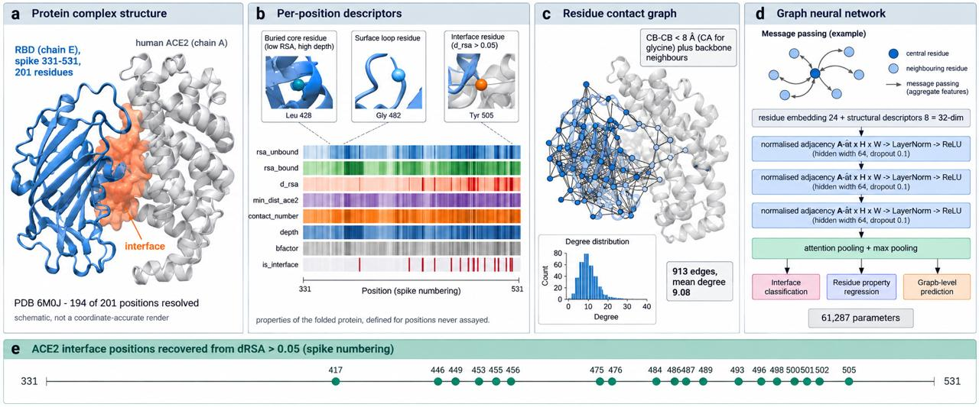
Figure 1. Structural pipeline and residue contact graph from PDB 6M0J. Descriptor names, edge count, mean degree and the recovered interface set are read from the computed features, not written by hand.

Protein language model
ESM-2 (esm2_t33_650M_UR50D, 650 M parameters) was run once over the wild-type sequence. Two products were taken. Masked marginals: each position in turn is replaced by the mask token and the substitution is scored as log p(mutant | context) − log p(wild type | context), the standard zero-shot variant effect score [6]; a multi-substitution genotype is scored as the sum over its substitutions. Per-residue embeddings from the final layer were reduced by PCA to 16 dimensions per position and supplied to the network through its per-position side-input. Neither product sees any measurement, so the zero-shot scorer is leakage-free at held-out positions by construction.
Because the language model performs poorly here, two controls were run to separate a broken pipeline from a real result. Wild-type recovery — how often the masked position's true residue is the model's top prediction — was 80.3% on human ubiquitin, a small, highly constrained, well-represented protein. On the RBD it was 11.8% when the domain was scored in isolation and 17.6% when the same positions were scored inside the full 1273-residue spike protein, which is the context the domain actually occupies. Median top-token probability was 0.796, 0.096 and 0.099 respectively.
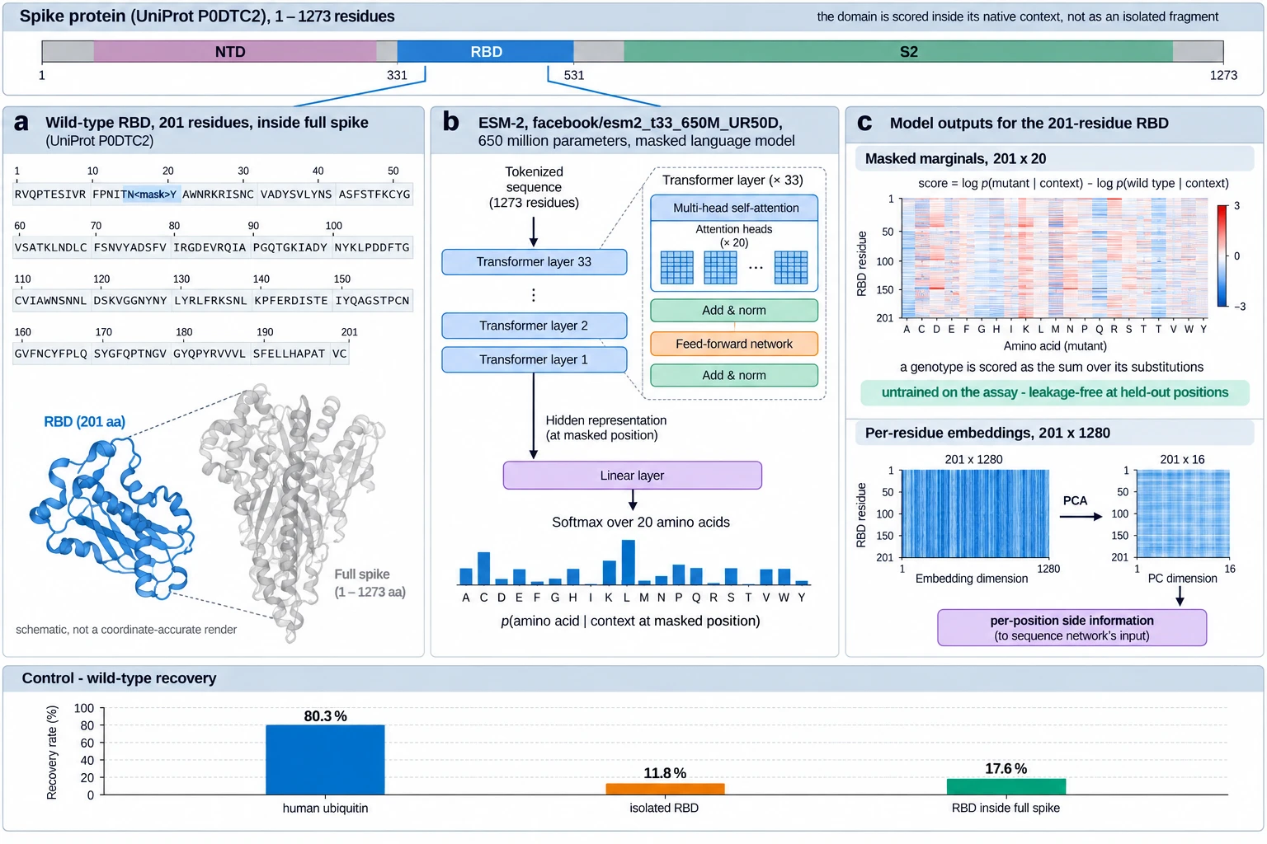
Figure 2. ESM-2 enters the study twice: as an untrained zero-shot scorer, and as per-position features for the supervised network.

Evaluation designs
Random split. Genotypes are divided 80/10/10 % into training, validation and test sets.
Two further designs, used for the ProteinGym analysis in the benchmark-wide analyses below, are the position-based cross-validation schemes the supervised ProteinGym benchmark already defines [10,11]: fold_modulo_5 assigns a position to fold p mod 5, and fold_contiguous_5 cuts the sequence into five consecutive blocks of positions. The published fold assignments are distributed in an archive that was not reachable from this compute environment, but both are deterministic functions of residue position and were reconstructed exactly; a variant joins the test fold only if every position it mutates does.
Held-out-position split. The 201 positions are partitioned at random into training (75 %), validation (10 %) and test (15 %) sets. A genotype joins a partition only if every position it mutates lies in that partition's position set; genotypes spanning partitions are discarded. No training genotype therefore mutates any validation or test position, a property asserted directly in the test suite rather than assumed. the subsection on withholding more positions repeats the design with 5, 15, 30 and 50 % of positions withheld. Both designs were run over 10 seeds, and all models within a seed see the identical partition, so every model comparison is paired.
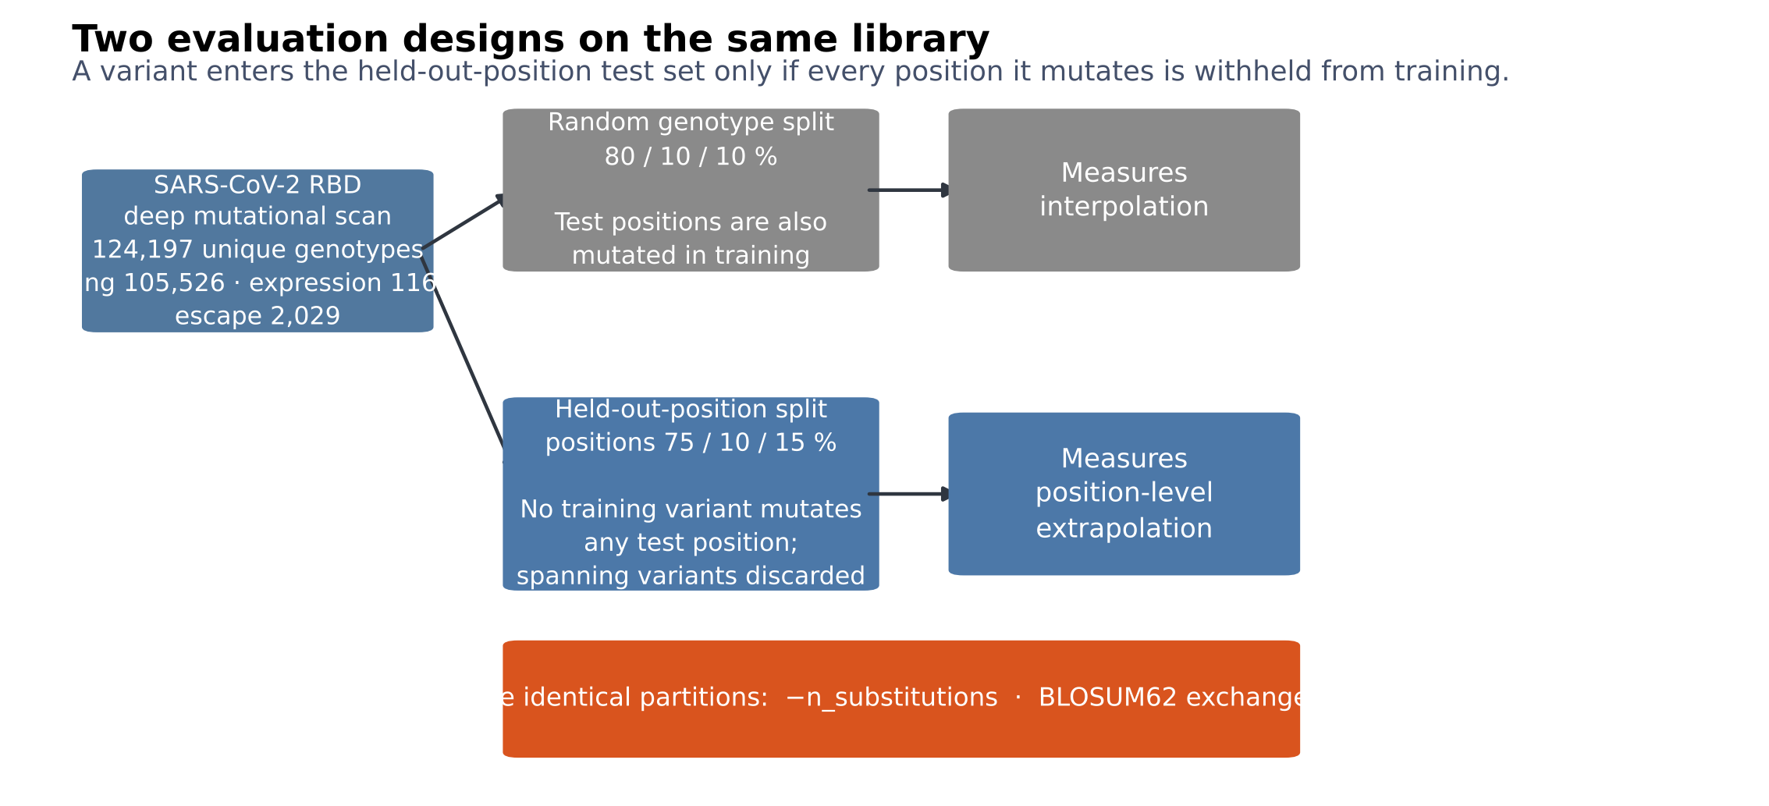
Figure 3. The two evaluation designs, and the untrained controls evaluated on the identical partitions.

Models
Three untrained scorers. Mutation count ranks by the negative number of substitutions. BLOSUM62 sums substitution-matrix exchangeabilities. ESM-2 sums masked-marginal log-likelihood ratios. None is fitted to any measurement, so each is defined, unchanged, at held-out positions.
Four models on a position-transferable feature block. Each substitution contributes the change in eight physicochemical properties (hydropathy, side-chain volume, charge, polarity, flexibility, helix and sheet propensity, mass), the wild-type residue's values for the same, its BLOSUM62 score, indicator variables for the wild-type and mutant residue identity, its ESM-2 score, and the structural descriptors of the position it occupies; a genotype is the sum over its substitutions plus the substitution count. Nothing in this block indexes a position by identity, so the representation is defined for a genotype that mutates positions never seen. On it we fit ridge regression with generalised cross-validated regularisation (referred to below as the physicochemical model), gradient boosting, random forest and k-nearest neighbours.
A structure graph network. Each of the 201 positions is a node carrying an embedding of the residue this variant places there together with the fixed structural descriptors of the position; edges are the contact graph of the structural data described in Methods. Three graph-convolution layers with symmetric normalisation are followed by attention pooling and three task heads.
Four position-indexed models. Additive ridge regression on one-hot (position, residue) indicators; a global-epistasis model fitting an additive latent phenotype per task through a learned monotone sigmoid link [3]; EvoClassNet, a multi-task network of three convolutional blocks, a bidirectional LSTM, four-head self-attention and attention pooling, trained with a masked Huber loss and learned homoscedastic task weights [4]; and the same network given the structural descriptors and ESM-2 embeddings as per-position side information. The additive and global-epistasis models have no parameter for a substitution at an unseen position; the two networks have position embeddings that were never updated for such a position.
Hyper-parameters were selected by a genetic algorithm maximising mean validation Spearman ρ on a random-split validation set; test data were never used for selection. Optimisation used AdamW [5] with a one-cycle schedule, batch size 256, up to 8 epochs with early stopping, gradient clipping at global norm 1.0. All experiments ran on four CPU cores.
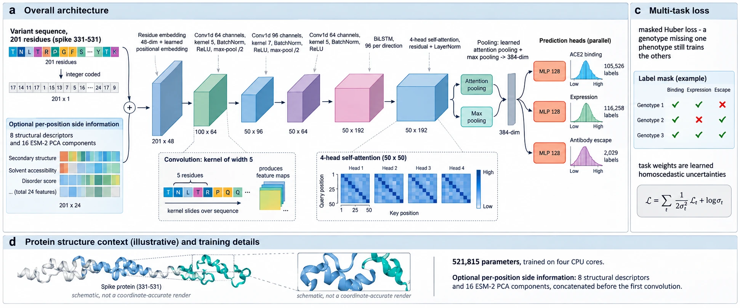
Figure 4. EvoClassNet backbone. Channel counts, kernel sizes, pooling, hidden widths and the parameter count are read from the trained configuration.

Metrics
The primary metric is Spearman's ρ on the test partition, computed per task over genotypes carrying that measurement; a model emitting a constant prediction conveys no rank information and is assigned ρ = 0. Because part of any rank correlation on a combinatorial library is explained by how many substitutions a variant carries, we also report the partial Spearman correlation, in which the substitution count is regressed out of the ranks of both prediction and measurement. This measures position-level signal directly rather than inferring it from a baseline comparison, and it has a built-in check: the mutation-count baseline must score exactly zero on it. We additionally report Pearson's r, Kendall's τ, R², RMSE, MAE, AUROC for ranking the lower measurement quartile, precision at k and NDCG for top-variant retrieval, the calibration slope, and correlations within fixed substitution-count strata.

Statistics
A note on power before any of these are read. A two-sided Wilcoxon signed-rank test over n seeds cannot return a P value below 2^-n+1: with five seeds the floor is 0.031, and after false-discovery-rate correction across a family of twenty or more model-by-task comparisons nothing can reach significance however large the effect. Where the seed count is small we therefore treat the bootstrap confidence interval as the primary inference and report the rank test alongside it, rather than describing a clearly separated effect as non-significant because the test has no resolution left.
Models are compared on per-seed paired differences with a two-sided Wilcoxon signed-rank test, bootstrap percentile intervals, and Cliff's δ as a scale-free effect size. Because the central claim about the position-indexed models is a negative one, and failing to reject a null is not evidence for it, we also report two one-sided tests of equivalence against a margin of ±0.05 in Spearman ρ; a significant result there is positive evidence that two models differ by less than that margin. P values are corrected for false discovery rate across the whole family of model-by-task comparisons. Per-position outcomes recur across seeds and are not independent, so they are analysed with a random-intercept model over positions. Seed-level P values describe reproducibility across partitions of one data set; they do not license inference to other proteins.

Genome classification task
Complete coronavirus genomes (25–35 kb) were retrieved from NCBI nucleotide and labelled by genus, giving 806 sequences from 287 species after removal of duplicates (Alphacoronavirus 285, Betacoronavirus 371, Gammacoronavirus 71, Deltacoronavirus 79). SARS-CoV-2 was excluded from the Betacoronavirus class: with over three million deposited genomes against a few hundred for whole genera, including it would make the class a measure of one outbreak's sequencing effort. Sequences are represented by normalised 5-mer frequencies, and classified by logistic regression, gradient boosting, random forest, and a 1D convolutional network over the first 4,000 nucleotides. Two untrained controls are reported: the majority class, and genome length together with base composition. The split is either random or by species, the latter placing every genome of a species on one side only, which is the genome-level analogue of withholding positions.
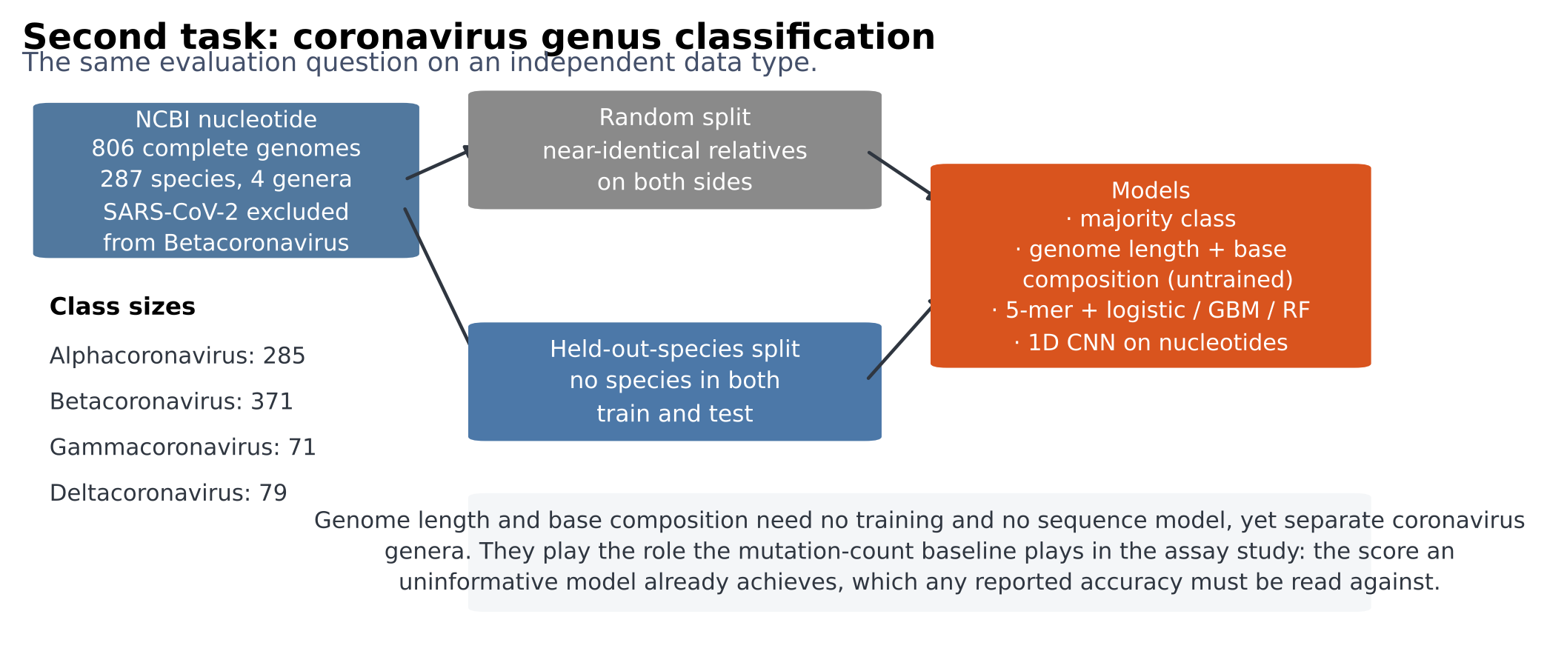
Figure 5. The genome classification design, with class sizes and the untrained controls.

Software, statistical procedures and reproducibility
Substitution chemistry is encoded from published amino-acid property indices [59] together with BLOSUM62 exchangeabilities [58]; relative solvent accessibility is normalised by the theoretical maxima of Tien and colleagues [60]. Confidence intervals are percentile bootstrap intervals [64]; paired model comparisons across seeds use the Wilcoxon signed-rank test [65]; effect sizes are reported as Cliff's delta [63]; equivalence between a model and an untrained control is assessed by two one-sided tests [62]; and all families of P values are corrected by the Benjamini-Hochberg procedure [61]. The implementation uses NumPy [67], SciPy [66], scikit-learn [68], statsmodels [74], XGBoost [70], random forests [71], PyTorch [69], Biopython [72], the Transformers library [73] and Matplotlib [75]. Every number, table and figure in this manuscript is produced by a single script from cached per-run outputs, and run_all.sh reproduces the entire study from raw data on four CPU cores.

Data availability
All data analysed here are public. Phenotype measurements: Starr et al., SARS-CoV-2-RBD_DMS (ACE2 binding and expression), and the aggregated antibody-escape maps at jbloomlab/SARS2_RBD_Ab_escape_maps. Benchmark data: the ProteinGym v1.1 substitution assays and the published supervised leaderboard. Structure: PDB 6M0J; predicted monomers from the AlphaFold Protein Structure Database. Reference sequence: UniProt P0DTC2. Genome sequences: NCBI Nucleotide, with accessions listed in the repository. Protein language model weights: facebook/esm2_t33_650M_UR50D. Every per-run output, every result table and the per-assay correlations underlying the leaderboard audit are released with the code.

Code availability
All analysis code, the data-retrieval scripts, the test suite asserting the no-position-overlap property of the held-out-position split, and the script that generates this manuscript and all its tables and figures from cached outputs are in the accompanying repository under an open licence. run_all.sh reproduces every number from raw data on four CPU cores.

Author contributions
[To be completed. Suggested form: A.B. designed the study, implemented the pipeline, performed the analyses and wrote the manuscript. C.D. contributed to the structural analysis. All authors reviewed and approved the final manuscript.]

Competing interests
The authors declare no competing interests.

References
- Starr TN, Greaney AJ, Hilton SK, et al. Deep mutational scanning of SARS-CoV-2 receptor binding domain reveals constraints on folding and ACE2 binding. Cell 2020;182:1295-1310.
- Greaney AJ, Starr TN, Bloom JD. An antibody-escape estimator for mutations to the SARS-CoV-2 receptor-binding domain. Virus Evolution 2022;8:veac021.
- Otwinowski J, McCandlish DM, Plotkin JB. Inferring the shape of global epistasis. Proceedings of the National Academy of Sciences 2018;115:E7550-E7559.
- Kendall A, Gal Y, Cipolla R. Multi-task learning using uncertainty to weigh losses for scene geometry and semantics. IEEE Conference on Computer Vision and Pattern Recognition 2018:7482-7491.
- Loshchilov I, Hutter F. Decoupled weight decay regularization. International Conference on Learning Representations 2019.
- Meier J, Rao R, Verkuil R, et al. Language models enable zero-shot prediction of the effects of mutations on protein function. Advances in Neural Information Processing Systems 2021.
- Lin Z, Akin H, Rao R, et al. Evolutionary-scale prediction of atomic-level protein structure with a language model. Science 2023;379:1123-1130.
- Lan J, Ge J, Yu J, et al. Structure of the SARS-CoV-2 spike receptor-binding domain bound to the ACE2 receptor. Nature 2020;581:215-220.
- Shrake A, Rupley JA. Environment and exposure to solvent of protein atoms. Lysozyme and insulin. Journal of Molecular Biology 1973;79:351-371.
- Notin P, Kollasch AW, Ritter D, et al. ProteinGym: large-scale benchmarks for protein fitness prediction and design. Advances in Neural Information Processing Systems, Datasets and Benchmarks Track 2023.
- Notin P, Weitzman R, Marks DS, Gal Y. ProteinNPT: improving protein property prediction and design with non-parametric transformers. Advances in Neural Information Processing Systems 2023. (Defines the fold_random_5, fold_contiguous_5 and fold_modulo_5 cross-validation schemes used here.)
- Fowler DM, Fields S. Deep mutational scanning: a new style of protein science. Nature Methods 2014;11:801-807.
- Sarkisyan KS, Bolotin DA, Meer MV, et al. Local fitness landscape of the green fluorescent protein. Nature 2016;533:397-401.
- Tsuboyama K, Dauparas J, Chen J, et al. Mega-scale experimental analysis of protein folding stability in biology and design. Nature 2023;620:434-444.
- Livesey BJ, Marsh JA. Using deep mutational scanning to benchmark variant effect predictors and identify disease mutations. Molecular Systems Biology 2020;16:e9380.
- Dunham AS, Beltrao P. Exploring amino acid functions in a deep mutational landscape. Molecular Systems Biology 2021;17:e10305.
- Domingo J, Baeza-Centurion P, Lehner B. The causes and consequences of genetic interactions (epistasis). Annual Review of Genomics and Human Genetics 2019;20:433-460.
- Gelman S, Fahlberg SA, Heinzelman P, Romero PA, Gitter A. Neural networks to learn protein sequence-function relationships from deep mutational scanning data. Proceedings of the National Academy of Sciences 2021;118:e2104878118.
- Hsu C, Nisonoff H, Fannjiang C, Listgarten J. Learning protein fitness models from evolutionary and assay-labeled data. Nature Biotechnology 2022;40:1114-1122.
- Yang KK, Wu Z, Arnold FH. Machine-learning-guided directed evolution for protein engineering. Nature Methods 2019;16:687-694.
- Luo Y, Jiang G, Yu T, et al. ECNet is an evolutionary context-integrated deep learning framework for protein engineering. Nature Communications 2021;12:5743.
- Hopf TA, Ingraham JB, Poelwijk FJ, et al. Mutation effects predicted from sequence co-variation. Nature Biotechnology 2017;35:128-135.
- Riesselman AJ, Ingraham JB, Marks DS. Deep generative models of genetic variation capture the effects of mutations. Nature Methods 2018;15:816-822.
- Frazer J, Notin P, Dias M, et al. Disease variant prediction with deep generative models of evolutionary data. Nature 2021;599:91-95.
- Rives A, Meier J, Sercu T, et al. Biological structure and function emerge from scaling unsupervised learning to 250 million protein sequences. Proceedings of the National Academy of Sciences 2021;118:e2016239118.
- Rao RM, Liu J, Verkuil R, et al. MSA Transformer. International Conference on Machine Learning 2021:8844-8856.
- Elnaggar A, Heinzinger M, Dallago C, et al. ProtTrans: toward understanding the language of life through self-supervised learning. IEEE Transactions on Pattern Analysis and Machine Intelligence 2022;44:7112-7127.
- Brandes N, Ofer D, Peleg Y, Rappoport N, Linial M. ProteinBERT: a universal deep-learning model of protein sequence and function. Bioinformatics 2022;38:2102-2110.
- Notin P, Dias M, Frazer J, et al. Tranception: protein fitness prediction with autoregressive transformers and inference-time retrieval. International Conference on Machine Learning 2022:16990-17017.
- Groth PM, Kerrn MH, Olsen L, Salomon J, Boomsma W. Kermut: composite kernel regression for protein variant effects. Advances in Neural Information Processing Systems 2024.
- Detlefsen NS, Hauberg S, Boomsma W. Learning meaningful representations of protein sequences. Nature Communications 2022;13:1914.
- Jumper J, Evans R, Pritzel A, et al. Highly accurate protein structure prediction with AlphaFold. Nature 2021;596:583-589.
- Varadi M, Anyango S, Deshpande M, et al. AlphaFold Protein Structure Database: massively expanding the structural coverage of protein-sequence space with high-accuracy models. Nucleic Acids Research 2022;50:D439-D444.
- Mirdita M, Schutze K, Moriwaki Y, et al. ColabFold: making protein folding accessible to all. Nature Methods 2022;19:679-682.
- Kipf TN, Welling M. Semi-supervised classification with graph convolutional networks. International Conference on Learning Representations 2017.
- Rao R, Bhattacharya N, Thomas N, et al. Evaluating protein transfer learning with TAPE. Advances in Neural Information Processing Systems 2019.
- Dallago C, Mou J, Johnston KE, et al. FLIP: benchmark tasks in fitness landscape inference for proteins. Advances in Neural Information Processing Systems, Datasets and Benchmarks Track 2021.
- Grimm DG, Azencott CA, Aicheler F, et al. The evaluation of tools used to predict the impact of missense variants is hindered by two types of circularity. Human Mutation 2015;36:513-523.
- Walsh I, Fishman D, Garcia-Gasulla D, et al. DOME: recommendations for supervised machine learning validation in biology. Nature Methods 2021;18:1122-1127.
- Whalen S, Schreiber J, Noble WS, Pollard KS. Navigating the pitfalls of applying machine learning in genomics. Nature Reviews Genetics 2022;23:169-181.
- Kapoor S, Narayanan A. Leakage and the reproducibility crisis in machine-learning-based science. Patterns 2023;4:100804.
- Starr TN, Greaney AJ, Addetia A, et al. Prospective mapping of viral mutations that escape antibodies used to treat COVID-19. Science 2021;371:850-854.
- Greaney AJ, Starr TN, Gilchuk P, et al. Complete mapping of mutations to the SARS-CoV-2 spike receptor-binding domain that escape antibody recognition. Cell Host and Microbe 2021;29:44-57.
- Starr TN, Greaney AJ, Hannon WW, et al. Shifting mutational constraints in the SARS-CoV-2 receptor-binding domain during viral evolution. Science 2022;377:420-424.
- Harvey WT, Carabelli AM, Jackson B, et al. SARS-CoV-2 variants, spike mutations and immune escape. Nature Reviews Microbiology 2021;19:409-424.
- Zahradnik J, Marciano S, Shemesh M, et al. SARS-CoV-2 variant prediction and antiviral drug design are enabled by RBD in vitro evolution. Nature Microbiology 2021;6:1188-1198.
- Moulana A, Dupic T, Phillips AM, et al. Compensatory epistasis maintains ACE2 affinity in SARS-CoV-2 Omicron BA.1. Nature Communications 2022;13:7011.
- Taft JM, Weber CR, Gao B, et al. Deep mutational learning predicts ACE2 binding and antibody escape to combinatorial mutations in the SARS-CoV-2 receptor-binding domain. Cell 2022;185:4008-4022.
- Cao Y, Jian F, Wang J, et al. Imprinted SARS-CoV-2 humoral immunity induces convergent Omicron RBD evolution. Nature 2023;614:521-529.
- Thadani NN, Gurev S, Notin P, et al. Learning from prepandemic data to forecast viral escape. Nature 2023;622:818-825.
- Maher MC, Bartha I, Weaver S, et al. Predicting the mutational drivers of future SARS-CoV-2 variants of concern. Science Translational Medicine 2022;14:eabk3445.
- Hie B, Zhong ED, Berger B, Bryson B. Learning the language of viral evolution and escape. Science 2021;371:284-288.
- Obermeyer F, Jankowiak M, Barkas N, et al. Analysis of 6.4 million SARS-CoV-2 genomes identifies mutations associated with fitness. Science 2022;376:1327-1332.
- Bloom JD, Neher RA. Fitness effects of mutations to SARS-CoV-2 proteins. Virus Evolution 2023;9:vead055.
- Hadfield J, Megill C, Bell SM, et al. Nextstrain: real-time tracking of pathogen evolution. Bioinformatics 2018;34:4121-4123.
- Rambaut A, Holmes EC, O'Toole A, et al. A dynamic nomenclature proposal for SARS-CoV-2 lineages to assist genomic epidemiology. Nature Microbiology 2020;5:1403-1407.
- Shu Y, McCauley J. GISAID: Global initiative on sharing all influenza data - from vision to reality. Eurosurveillance 2017;22:30494.
- Henikoff S, Henikoff JG. Amino acid substitution matrices from protein blocks. Proceedings of the National Academy of Sciences 1992;89:10915-10919.
- Kawashima S, Kanehisa M. AAindex: amino acid index database. Nucleic Acids Research 2000;28:374.
- Tien MZ, Meyer AG, Sydykova DK, Spielman SJ, Wilke CO. Maximum allowed solvent accessibility of residues in proteins. PLoS ONE 2013;8:e80635.
- Benjamini Y, Hochberg Y. Controlling the false discovery rate: a practical and powerful approach to multiple testing. Journal of the Royal Statistical Society B 1995;57:289-300.
- Schuirmann DJ. A comparison of the two one-sided tests procedure and the power approach for assessing the equivalence of average bioavailability. Journal of Pharmacokinetics and Biopharmaceutics 1987;15:657-680.
- Cliff N. Dominance statistics: ordinal analyses to answer ordinal questions. Psychological Bulletin 1993;114:494-509.
- Efron B, Tibshirani RJ. An Introduction to the Bootstrap. New York: Chapman and Hall, 1993.
- Wilcoxon F. Individual comparisons by ranking methods. Biometrics Bulletin 1945;1:80-83.
- Virtanen P, Gommers R, Oliphant TE, et al. SciPy 1.0: fundamental algorithms for scientific computing in Python. Nature Methods 2020;17:261-272.
- Harris CR, Millman KJ, van der Walt SJ, et al. Array programming with NumPy. Nature 2020;585:357-362.
- Pedregosa F, Varoquaux G, Gramfort A, et al. Scikit-learn: machine learning in Python. Journal of Machine Learning Research 2011;12:2825-2830.
- Paszke A, Gross S, Massa F, et al. PyTorch: an imperative style, high-performance deep learning library. Advances in Neural Information Processing Systems 2019.
- Chen T, Guestrin C. XGBoost: a scalable tree boosting system. Proceedings of the 22nd ACM SIGKDD International Conference on Knowledge Discovery and Data Mining 2016:785-794.
- Breiman L. Random forests. Machine Learning 2001;45:5-32.
- Cock PJA, Antao T, Chang JT, et al. Biopython: freely available Python tools for computational molecular biology and bioinformatics. Bioinformatics 2009;25:1422-1423.
- Wolf T, Debut L, Sanh V, et al. Transformers: state-of-the-art natural language processing. Proceedings of the 2020 Conference on Empirical Methods in Natural Language Processing: System Demonstrations 2020:38-45.
- Seabold S, Perktold J. statsmodels: econometric and statistical modeling with Python. Proceedings of the 9th Python in Science Conference 2010:92-96.
- Hunter JD. Matplotlib: a 2D graphics environment. Computing in Science and Engineering 2007;9:90-95.

