Stock Price Analysis
1.Project Overview
This project analyses historical stock market data using SQL to uncover trends in stock performance, volatility, trading activity, and return patterns. The analysis focuses on identifying top-performing stocks, market seasonality, and consistency in stock returns. Insights derived from the data can support investment decision-making and market trend evaluation.
2.Dataset Summary
Row: 497472
Columns:7
Key Features:
• The dataset contains 497,472 daily trading records covering 505 publicly traded companies.
• Data spans from January 2, 2014, to December 29, 2017, providing four years of historical market activity.
• Each record includes stock symbol, trading date, opening price, highest price, lowest price, closing price, and trading volume.
• Average daily trading volume across all records is approximately 4.25 million shares, indicating substantial market activity.
3.Exploratory Data Analysing using Python
I began with data preparation and cleaning in Python:
- Data Loading: Imported the dataset using pandas
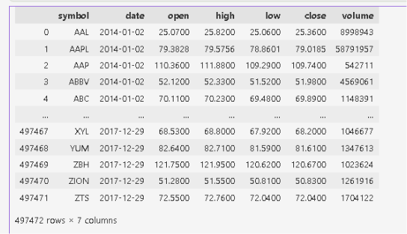
- Initial Exploration: Used df.info() to check structure and df.describe() for summary statistics.

- Missing Data Handling: Checked for null values and cleaned missing and inconsistent stock price records using statistical imputation, forward filling, and logical price-based replacements. Invalid observations with zero trading volume and incomplete pricing information were removed to ensure data quality and reliability for analysis.
- Feature Engineering:
  - Created range column to see volatility of stock price
  - Created return column to see ROI
- Column Standardization: Renamed columns to avoid contradictions with sql reserved key words like ‘Date’, ’Range’, ’Return’ .
- EDA:
  - Engineered new features including returns, price range, month, and year for deeper analysis.
  - Performed descriptive statistics, correlation analysis, and trend analysis using Pandas.
  - Visualized return distributions, feature relationships, and stock price movements over time.
  - Developed and evaluated a Linear Regression model to predict stock closing prices
- Database Integration:Connected Python script to MySQL and loaded the cleaned DataFrame into the database for SQLanalysis.
4.Data Analysis using SQL:
I performed structured analysis in MySQL to answer key business questions:
1. Long-Term Capital Growth: Identified which stocks generated the highest percentage growth by comparing their absolute earliest recorded closing price to their final recorded closing price.
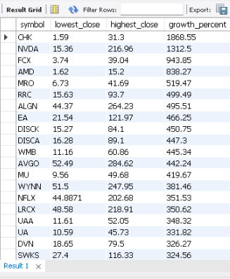

2. Aggregated Performance: Tracked overall profitability by calculating the cumulative total return for each individual stock over the entire historical period

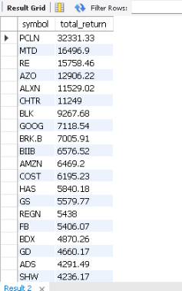

3. Risk & Volatility Profiling: Measured market risk by identifying the most volatile assets based on their average daily price spread (price_range)
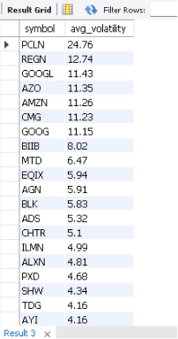

4.Risk-Adjusted Efficiency: Isolated the "Top 10" most efficient investment options by calculating a return-to-volatility ratio, highlighting stocks that deliver the highest average return with the lowest relative risk.
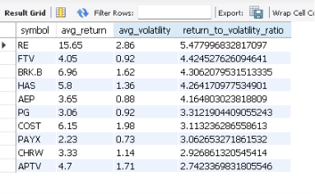
5. Market Liquidity & Demand: Evaluated trading activity and liquidity across different assets by calculating the average historical trading volume for each stock.
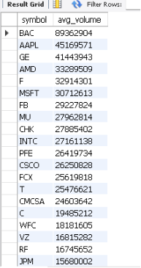

6. Seasonality & Macro Trends: Analyzed cyclical market performance over time to discover which specific year-and-month combinations yielded the highest average market returns.

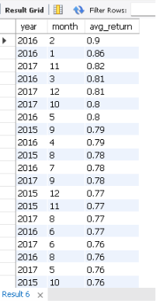

7. Consistency & Momentum: Measured historical reliability by calculating the exact number of days each stock closed with a positive net return.
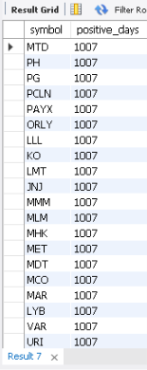
5.Dashboard in Power BI
Finally, we built an interactive dashboard on Power BI to present insights visually

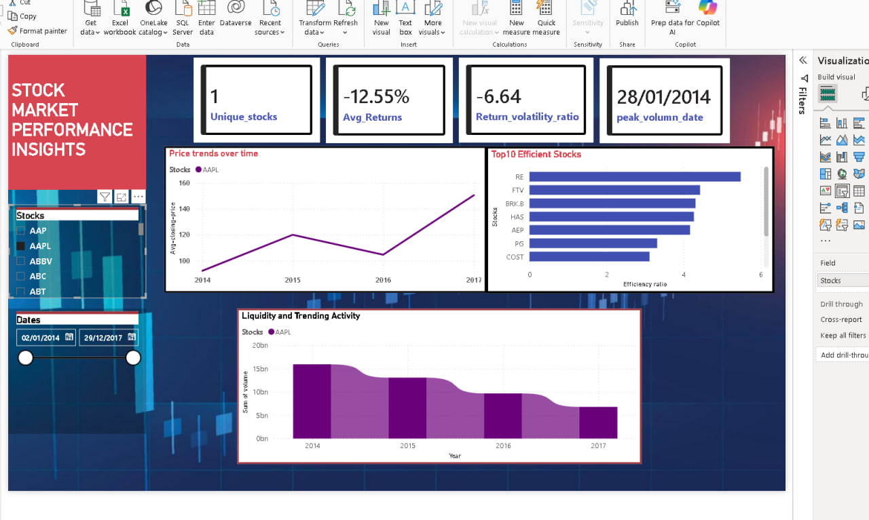

Executive Investment Summary
- Focus on Efficiency: Avoid chasing raw return spikes. Prioritize the Top 10 Efficient Stocks to secure the highest return with the lowest daily price volatility.
- Enforce Liquidity Floors: Stay completely away from low-volume stocks. High trading volume guarantees you can cash out instantly during market emergencies without losing money to price slippage.
- Target High Win-Frequency: When picking between similar assets, choose the stock with the most positive trading days. Steady growth curves prevent portfolio drawdowns and panic-selling.
- Invest by the Calendar: Optimize your entry timing. Deploy large capital injections immediately before historically strong market months, and hold cash during stagnant seasonal windows.

