CUSTOMER CHURN
ANALYSIS REPORT
Telecom Industry • Dataset: churnbigml80.csv

2,666  Total Customers | 388  Churned | 14.55%  Churn Rate | 2,278  Retained

Prepared by: Senior Data Analyst Team
Analysis Date: June 2026

1. Executive Summary
This report presents a comprehensive analysis of customer churn behavior for a telecom provider, using a dataset of 2,666 customers and 20 variables. The overall churn rate is 14.55% (388 customers). The analysis uncovers six critical churn drivers, profiles the highest-risk customer segments, and provides ranked business recommendations to reduce churn.

Key Findings
- Overall churn rate: 14.55% (388 of 2,666 customers)
- International Plan holders churn at 43.7% vs. 11.3% — a 3.9x higher rate
- Customers making 4+ service calls churn at 52.9% — a sharp cliff from 10.6% at 3 calls
- Premium spenders churn at 28.2%, the highest of any spend tier
- The extreme high-risk profile (Intl Plan + 4+ CS calls + No VM Plan) produces an 80% churn rate
- TX (29.1%) and NJ (28.0%) are the worst-performing states, both >2x the national average

2. Dataset Overview & Cleaning

2.1 Dataset Summary
Attribute | Detail
Source File | churnbigml80.csv
Total Records | 2,666 rows
Features | 20 columns (17 numeric, 3 categorical)
Target Variable | Churn (Boolean — encoded as 0/1)
Missing Values | None (0 null cells across all columns)
Duplicate Rows | None detected
Date of Analysis | June 2026

2.2 Cleaning Steps Applied
- Column names normalized to snake_case (e.g., "Total day minutes" to "total_day_minutes")
- Binary Yes/No columns (International plan, Voice mail plan) encoded as integer flags (1/0)
- Churn boolean encoded as integer: True = 1, False = 0
- Area code treated as categorical string, not a numeric variable
- IQR x3 outlier clamping applied to 9 usage and charge columns
- Five derived features engineered: total_charge, total_minutes, spend_tier, high_cs_calls, risk_score

3. Analysis Results

Q1: What is the Overall Churn Rate?
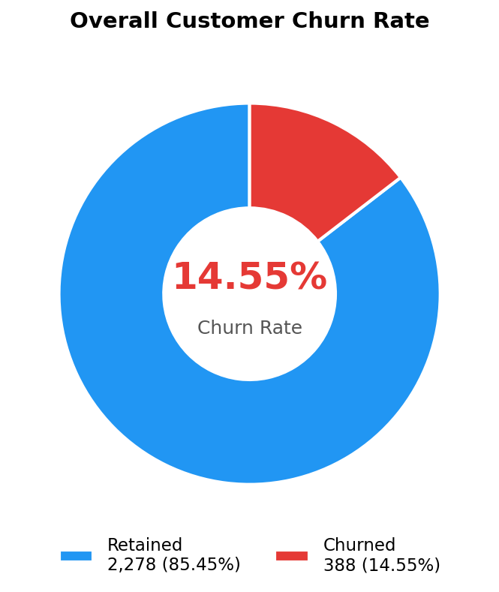
Metric | Count | Percentage
Total Customers | 2,666 | 100.00%
Retained (Not Churned) | 2,278 | 85.45%
Churned | 388 | 14.55%

Insight: At 14.55%, the churn rate sits at the lower bound of the telecom industry average (15-25%). However, 388 lost customers each cycle represents significant recurring revenue leakage that warrants targeted intervention.

Q2: Which Customer Segments Churn the Most?
Geographic Analysis — Top 10 States by Churn Rate
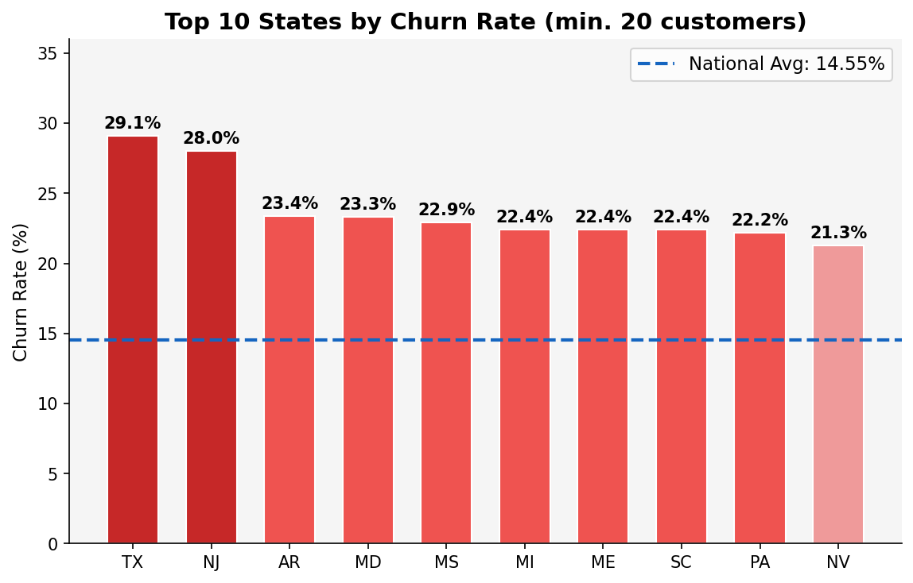
Rank | State | Customers | Churned | Churn Rate
1 | TX | 55 | 16 | 29.1%
2 | NJ | 50 | 14 | 28.0%
3 | AR | 47 | 11 | 23.4%
4 | MD | 60 | 14 | 23.3%
5 | MS | 48 | 11 | 22.9%
6 | MI | 58 | 13 | 22.4%
7 | ME | 49 | 11 | 22.4%
8 | SC | 49 | 11 | 22.4%
9 | PA | 36 | 8 | 22.2%
10 | NV | 61 | 13 | 21.3%

Insight: TX and NJ churn at roughly twice the national average (29.1% and 28.0% respectively). All top-10 states exceed 21%, suggesting regional service or competitive issues requiring targeted campaigns.

Voice Mail Plan Segment
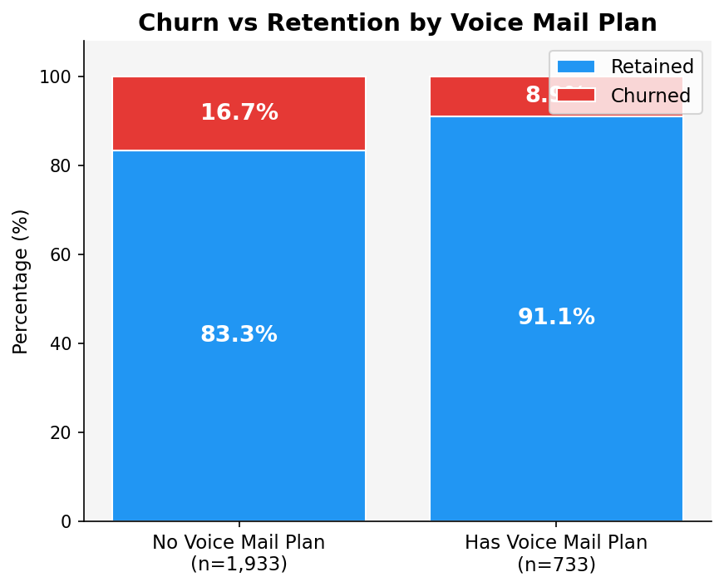
Segment | Customers | Churned | Churn Rate
No Voice Mail Plan | 1,933 | 323 | 16.7%
Has Voice Mail Plan | 733 | 65 | 8.9%

Insight: Customers without a Voice Mail Plan churn at nearly twice the rate (16.7% vs 8.9%). VM plan adoption is a strong retention proxy — likely indicating deeper product engagement and satisfaction.

Q3: Does the International Plan Increase Churn?
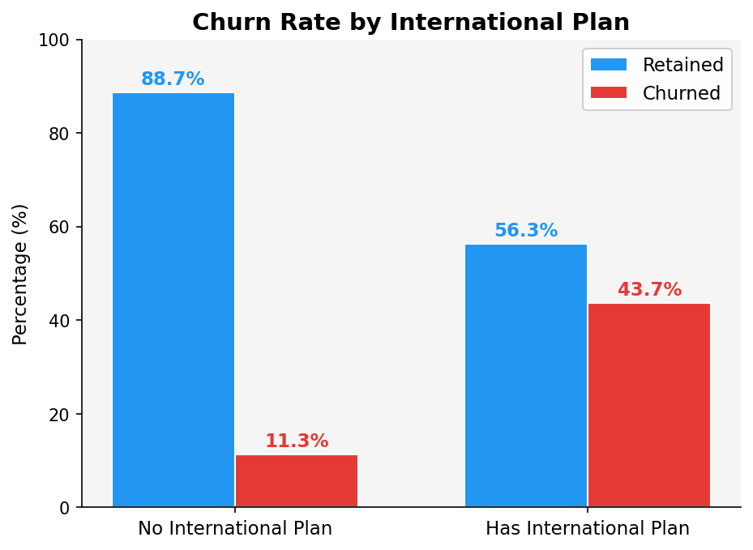
Segment | Customers | Churned | Churn Rate | vs Baseline
No International Plan | 2,396 | 270 | 11.3% | Baseline
Has International Plan | 270 | 118 | 43.7% | +32.4 pp (3.9x higher)

Insight: International Plan is the single strongest individual predictor of churn. Subscribers churn at 43.7% — nearly 4x the non-subscriber rate. This strongly suggests the plan may be overpriced, poorly structured, or generating billing frustration.

Q4: How Do Customer Service Calls Impact Churn?
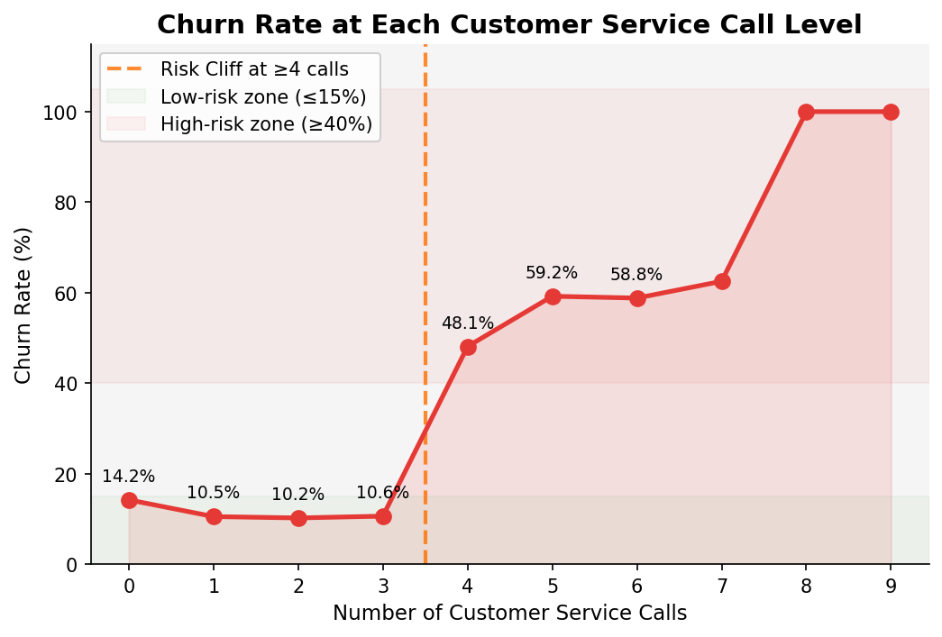

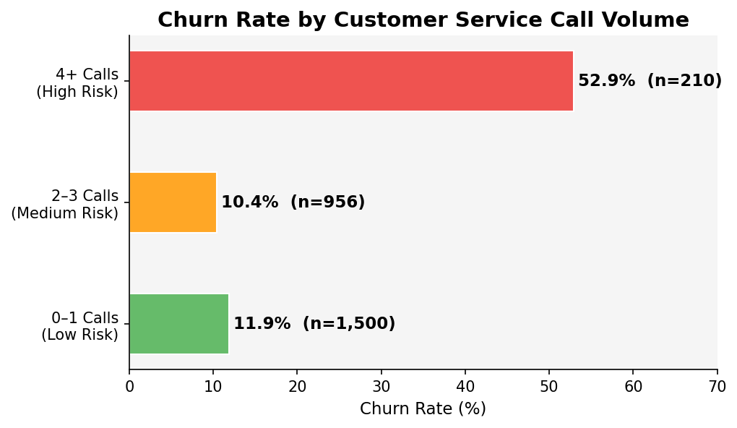
CS Calls | Customers | Churned | Churn Rate
0 | 555 | 79 | 14.2%
1 | 945 | 99 | 10.5%
2 | 608 | 62 | 10.2%
3 | 348 | 37 | 10.6%
4 | 133 | 64 | 48.1%
5 | 49 | 29 | 59.2%
6 | 17 | 10 | 58.8%
7 | 8 | 5 | 62.5%
8+ | 3 | 3 | 100.0%

Insight: A dramatic churn cliff occurs at the 4-call threshold: rate jumps from 10.6% to 48.1% between 3 and 4 calls. Churned customers average 2.21 service calls vs. 1.45 for retained customers (a 52% difference). The 3rd call is the critical intervention point.

Q5: Are High-Value Customers More Likely to Churn?
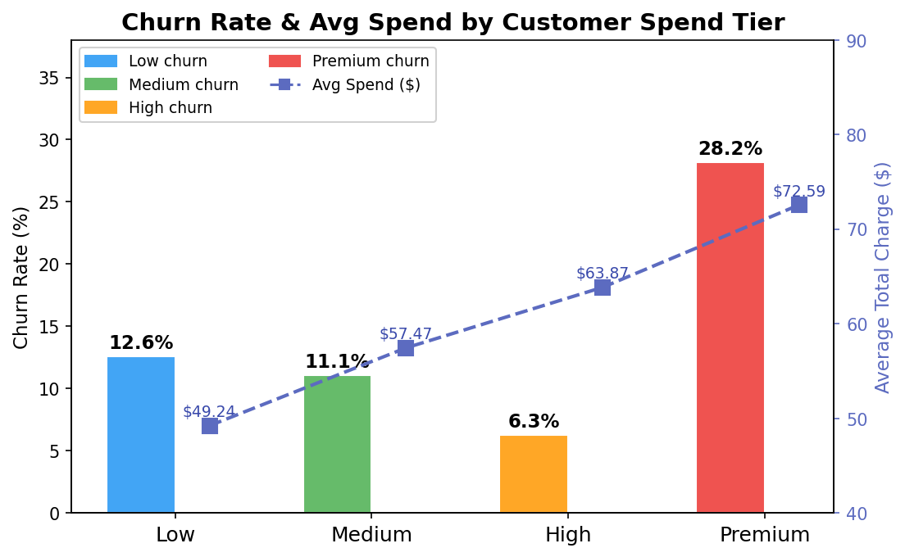
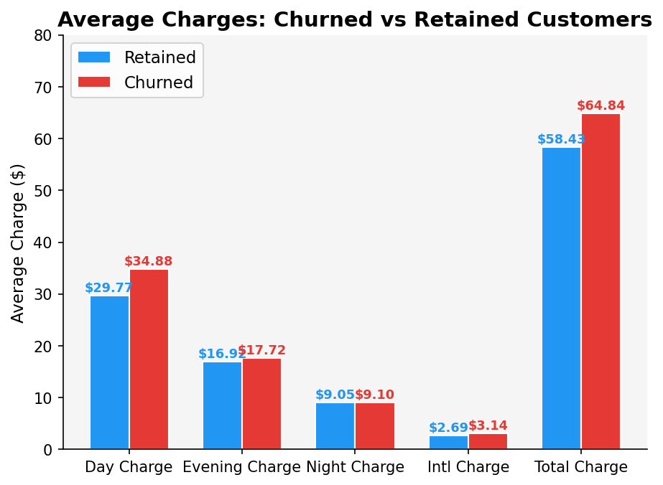
Spend Tier | Customers | Churned | Churn Rate | Avg Total Charge
Low | 667 | 84 | 12.6% | $49.24
Medium | 666 | 74 | 11.1% | $57.47
High | 667 | 42 | 6.3% | $63.87
Premium | 666 | 188 | 28.2% | $72.59

Customer Status | Avg Day Charge | Avg Eve Charge | Avg Night Charge | Avg Intl Charge | Avg Total Charge
Retained | $29.77 | $16.92 | $9.05 | $2.69 | $58.43
Churned | $34.88 | $17.72 | $9.10 | $3.14 | $64.84

Insight: Premium spenders churn at 28.2% — the highest of any tier — while High spenders churn at only 6.3%. Churned customers spend 11% more on average ($64.84 vs $58.43). The highest-paying customers are the most dissatisfied, representing the greatest revenue risk.

Q6: What Customer Profile is Most Likely to Churn?
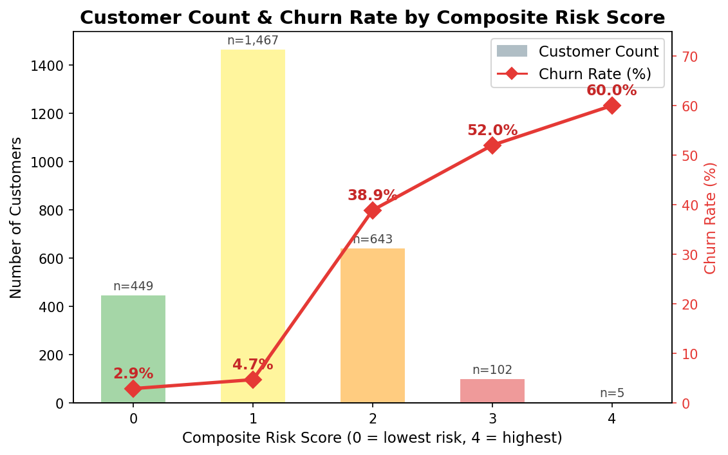
Composite Risk Score — Methodology
Each customer is assigned a score from 0 to 4, with one point per risk factor:
- International Plan active (+1)
- 4 or more Customer Service Calls (+1)
- No Voice Mail Plan (+1)
- Spend Tier = Premium (+1)

Risk Score | Customers | Churned | Churn Rate | Avg Spend | Risk Level
0 (Lowest) | 449 | 13 | 2.9% | $55.06 | Minimal
1 | 1,467 | 69 | 4.7% | $57.74 | Low
2 | 643 | 250 | 38.9% | $64.45 | High
3 | 102 | 53 | 52.0% | $68.89 | Critical
4 (Highest) | 5 | 3 | 60.0% | $74.19 | Extreme

Extreme High-Risk Profile Isolation
Profile | Customers | Churned | Churn Rate
Intl Plan + 4+ CS Calls + No VM Plan | 15 | 12 | 80.0%
All Other Customers | 2,651 | 376 | 14.2%

Insight: Customers scoring 2 or higher represent 28.1% of the base but account for 78.9% of all churns (306 of 388). The extreme high-risk profile churns at 80%. Risk score 2 is the actionable intervention threshold.

4. Business Recommendations
Based on the data analysis, the following six recommendations are prioritized for maximum churn reduction impact:

Recommendation 1: Urgently Review the International Plan
Priority: Critical | Segment Churn Rate: 43.7% | Affected: 270 customers
- Conduct an immediate pricing and UX audit of the International Plan
- Proactively reach out to all current International Plan holders via call, SMS, and email
- Offer a billing simplification review or rate lock to all subscribers in their first 90 days
- Consider introducing tiered international add-ons to reduce bill shock
Insight: Reducing International Plan churn from 43.7% to the national average of 14.55% would retain approximately 78 additional customers per cycle.

Recommendation 2: Implement a 3-Call Service Alert System
Priority: Critical | Churn Rate at 4+ calls: 52.9% | 210 at-risk customers
- Build a CRM flag that triggers a senior retention agent contact when a customer logs their 3rd service call
- Introduce a proactive satisfaction callback after a customer's 2nd call within any 30-day window
- Analyze call transcripts to identify the most common complaint themes among 4+ call customers
- Create a dedicated Service Recovery fast-track team for customers with 3+ unresolved contacts
Insight: Intervening at 3 calls — before the 4-call churn cliff — has the highest potential ROI. 210 customers are already in the danger zone with a 52.9% churn rate.

Recommendation 3: Launch a Premium Customer Retention Program
Priority: High | Churn Rate: 28.2% | 188 churned | Avg Spend: $72.59/mo
- Create a dedicated VIP support line and priority resolution track for the top spending quartile
- Offer Premium customers exclusive loyalty credits, proactive annual account reviews, and premium perks
- Monitor Premium customers' service call frequency closely — they are simultaneously highest-value and highest-risk
- Flag Premium customers with risk score 2 or higher for immediate proactive outreach
Insight: A 10% reduction in Premium churn would retain approximately 19 customers at $72.59/mo average — significant lifetime value recovery with minimal program cost.

Recommendation 4: Drive Voice Mail Plan Adoption
Priority: High | No-VM churn: 16.7% vs VM churn: 8.9% | 1,933 customers without VM
- Offer a free 3-month Voice Mail Plan trial to all customers without one, especially those with risk score 1 or higher
- Promote VM plan value prominently during onboarding and after every service call interaction
- Include VM plan adoption as a measurable KPI within all retention campaign reporting
Insight: VM plan adoption is the lowest-cost intervention available: no pricing changes required and it nearly halves churn risk. Targeting the 1,933 no-VM customers with a free trial could materially reduce overall churn.

Recommendation 5: Deploy Regional Retention Task Forces
Priority: Medium | TX: 29.1% | NJ: 28.0% | Both more than 2x the national average
- Conduct state-specific NPS and satisfaction surveys in TX and NJ immediately
- Investigate whether local competitors have recently launched aggressive promotions in these markets
- Assign regional account managers with churn-reduction OKRs for the five worst-performing states
- Run geo-targeted retention offers in TX, NJ, AR, MD, and MS

Recommendation 6: Operationalize the Churn Risk Score
Priority: Strategic | Score 2+ = 38.9-60% churn | 750 customers currently at risk
- Deploy the 4-factor risk score as a live CRM dashboard metric updated daily
- Set automated workflow triggers: Score 2 = priority queue, Score 3+ = immediate retention call within 24 hours
- Expand the model over time with tenure, device type, and billing dispute history for higher precision
- Run immediate intervention campaigns targeting all 750 customers currently at risk score 2 or above
Insight: Customers at risk score 2+ are 28.1% of the base but account for 78.9% of churns. Concentrating retention resources on this cohort maximizes ROI and makes the program sustainable.

5. Summary: Churn Drivers Ranked by Impact

Rank | Churn Driver | Segment Churn Rate | Customers Affected | Priority
1 | International Plan active | 43.7% | 270 | Critical
2 | Customer Service Calls 4 or more | 52.9% | 210 | Critical
3 | High-Risk Combined Profile | 80.0% | 15 | Critical
4 | Spend Tier = Premium | 28.2% | 666 | High
5 | No Voice Mail Plan | 16.7% | 1,933 | High
6 | Risk Score 2 or above | 38.9%+ | 750 | High
7 | State: TX | 29.1% | 55 | Medium
8 | State: NJ | 28.0% | 50 | Medium
9 | States: AR / MD / MS / MI / ME / SC | 22-23% | 297 | Medium

-- End of Report --

