

**IOT Based Smart Solar Power Plants**

**GroupId:014**

Sravan B R – 1947263

Geoffrey George Daniel - 1947222

Rashmi Raj - 1947254

DRAFT REPORT- DOCUMENT

**Table of Contents**

**Acknowledgements**

**Project Synopsis**

**1.Introduction**

1.1 Purpose

1.2 Scope

1.3 Overview

**2. The Overall Description**

2.1 Product Perspective

2.1.1 System Interfaces

2.1.2 Hardware Interfaces

2.2.3 Software Interfaces

2.2.4 Operations

2.2 Product Functions

2.3 User Characteristics

2.4 Constraints

2.5 Assumptions and Dependencies

**3. Specific Requirements**

3.1 External interfaces

3.3 Performance Requirements

3.4 Logical Database Requirements

3.4.1 Panel details

3.4.2 Panel status

3.5 Design Constraints

3.6 Software Attributes

**4. Change Management Process**

**5. Project Architecture Design**

5.1 Architecture Design

5.2 Data Flow Diagram

5.3 Application Architecture

5.4 Application Services

5.5 Application Flow and Interaction

5.6 Description of all modules

**6. Functional Architecture**

6.1 Functional Communication and Interaction

6.2 Functional Impact

6.3 Data Model

**7.Technical Architecture**

7.1 Technical Composition

7.2 Libraries and Function

**8. Deployment Architecture**

8.1 Geographical Deployment

8.2 Operational Constraints

**9. References**

**LIST OF FIGURE**

|  |  |  |
| --- | --- | --- |
| **Fig. No.** | **Figure Name** | **Page No.** |
| 1 | Basic Block Diagram | 5 |
| 2 | Boost in power production | 10 |
| 3 | Layered Architecture | 13 |
| 4 | Application Block Diagram | 15 |
| 5 | Arduino UNO R3 | 16 |
| 6 | Solar Panel | 16 |
| 7 | ESP8266 Wi-Fi Module | 17 |
| 8 | Tower Pro (Servo Motor) | 17 |
| 9 | LDR Photo Resistor | 18 |
| 10 | *Project ER Diagram* | 21 |
| 11 | Project Deployment | 24 |

**ACKNOWLEDGEMENTS**

First of all, we thank the lord almighty for his immense grace and blessings showered on me at every stage of this work. we are greatly indebted to our Head of the Department of Computer Science, **Prof. Joy Paulose**, CHRIST (Deemed to be University) for providing the opportunity to take up this project as part of my curriculum.

We are greatly indebted to our MCA Course Coordinator, **Dr. Tulasi B**, for providing the opportunity to take up this project and for helping with her valuable suggestions.

we are deeply indebted to our project guide **Dr. Sandeep J** for his assistance and valuable suggestions as a guide. He made this project a reality.

we express our sincere thanks to **Dr. Saravanakumar K** and **Dr. Sagaya P** lecturers of the Department of Computer Science, CHRIST (Deemed to be University), for their valuable suggestions during the course of this project. Their critical suggestions helped us to improve the project work.

Acknowledging the efforts of everyone, their chivalrous help in the course of the project preparation and their willingness to corroborate with the work, their magnanimity through lucid technical details lead to the successful completion of my project.

we would like to express our sincere thanks to all our friends, colleagues, parents and all those who have directly or indirectly assisted during this work.

**Project Synopsis**

**Title:** **IOT Based Smart Solar Power Plants**

This IOT based solar plant would be a prototype of a smarter version of the solar unit installed in our houses for power production. Solar units being installed in our households are just a basic installation, that sets up the panels and then these panel produce power which are then stored either in inverter or are transmitted to the electricity board. Our IOT project aims to make this into a smarter version, which would give real time updates and information to the users.

Our project is a solar power unit which would be smart enough to track the intensity of the sunlight and adjust its panels (left to right) to obtain maximum sunlight for the panels. It would also have a top mounted camera that would give the user a live feed of the condition of the panels, information like if they were dusty or if they needed cleaning. User can also monitor the live production of power through a mobile app, this interface would give the user an insight on the efficiency of the power plant.

User would be able to monitor the camera feed to determine if the panels need cleaning, they would also be provided with a live data feed of the power being produced by the solar unit, this would greatly help the users as they would be able to monitor their power plant just by sitting at home connected to their house Wi-Fi’s.

We would like to provide the users with a better representation of the data collect from the power unit such as which day of the week the power production was the maximum, and which days the production was below average so that data analysis can be performed over the obtained data. All these function, would help the basic solar units installed at our household’s into a Smarter version.

**1.Introduction**

Solar units being installed in our households are just a basic installation, that sets up the panels and then these panel produce power which are then stored either in inverter or are transmitted to the electricity board. The project aims to make this into a smarter version, which would give real time updates and information to the users. The project is a solar power unit which would be smart enough to track the intensity of the sunlight and adjust its panels (left to right) to obtain maximum sunlight for the panels. The project provide the users with a better representation of the data collect from the power unit such as which day of the week the power production was the maximum, and which days the production was below average so that data analysis can be performed over the obtained data.

**1.1 Purpose:**

The purpose of this project is to investigate if it is possible to harvest energy more efficiently. This project aims to examine how a system of light sensors can be used to track the sunlight and these sensors will be mounted to the solar panel.

**1.2 Scope:**

## This project focuses on constructing a model mechanism which allows a solar panel to be able to follow a light source. This project is completely automatic and user need not manually track the sunlight. In this project, direction of the panel will change (left to right) automatically during the day to capture the maximum solar energy . User will get an insight on data being generated like units produced per day, and user will also be able to compare the data to know which day has the higher production and vice versa.

**1.3 Overview:**

This project would deliver a smart solar power plant, which would rotate the solar panels to the direction with high intensity of sunlight and the current produced would also be recorded for the users to view.

**2. The Overall Description**

Our project is a prototype smaller version of the large solar power plants installed in the houses, for solar energy harvesting. Our project tries to make a smarter version of this product, by incorporating various IOT function to it.

**2.1 Product Perspective:**

This prototype tries to showcase the benefits and convenience, that are achieved by incorporating IOT into the basic solar power plant.

This smarter setup would help user to harvest the solar energy more efficiently throughout the day and would provide users with a more comprehensive display of the data that are being generated through the functioning of this system.

**Basic Block Diagram**

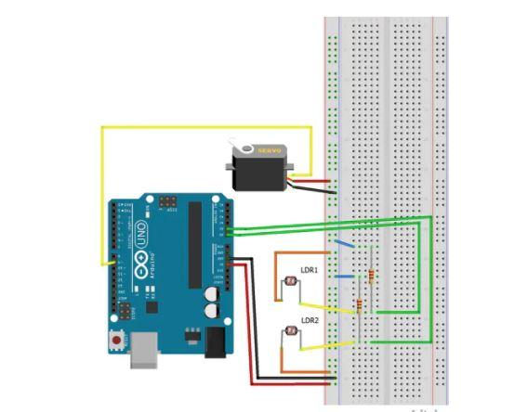

**Fig1: Basic Block Diagram**

***2.1.1 System Interfaces:***

Our project would have to interact with the state electricity department. To monitor and analyze the electricity consumption of the particular household and to advise the user about their consumption habits and also to help to set up an efficient plant that would meet their consumption requirements of particular users.

***2.1.2 Hardware Interfaces:***

Hardware requirements to run this setup are:

1. Laptop run Arduino IDE.
2. Stable Wi-Fi connection for data transfer.

***2.2.3 Software Interfaces;***

Arduino IDE

Android Studio

***2.2.4 Operations;***

Once the system is setup the user can observe the data collected through a mobile app.

They can also view the camera visuals and determine if the panels require cleaning or not.

This system could be setup in such a way that at night hours they could remain inactive (6pm to 6am).

**2.2 Product Functions:**

The major functions of the project are:

**1.** Be an efficient sunlight tracker, it could track the sunlight all throughout the day and adjust the panel accordingly to maximize the collection of sunlight during the day.

**2.** The data such as how much electricity is being generated, which day of the week was the highest production, which day had the least production all this could be displayed to the user remotely via a mobile app. This feature would help to track and monitor their solar plants production and efficiency anywhere in the house by just being connect to the house Wi-Fi.

**2.3 User Characteristics:**

Users should have basic knowledge on electricity readings and outputs.

Users would be required to interact with the system via a mobile app, thus would require basic knowledge on how to operate a mobile application.

**2.4 Constraints:**

Work of our system can be interrupted by natural causes such as cloudy sky, rainy sky all this weather conditions can affect the production of power as the panels require visible sunlight to track it and get stored.

**2.5 Assumptions and Dependencies:**

We are working on this prototype system with the goal to improve the already installed stationary systems that face the sunlight only in one direction, by incorporating moving parts to the panel, collecting production data and installing monitoring components we like to make this setup into an overall more efficient system.

We also have to consider the cost factor as installing a solar setup at homes is already an expensive task, we are building up on that cost by adding more feature to it. We have to make sure the final product we are delivering is worth the extra cost for the user.

**3. Specific Requirements**

The specific requirements required for the project include are described in the following sections. There are different types of specific requirements that describes the external interfaces, performance requirements, database requirements, design constraints and software attributes.

**3.1 External interfaces:**

The IOT device is connected with the cloud storage for data transfer. The data is send to the server using WiFi.

**3.2 Performance Requirements:**

System requires proper WiFi for providing live updates of the solar panel.

**3.3 Logical Database Requirements:**

The following are database-design of the system. The necessary tables to store the data are included in this section.

***3.4.1 Panel details:***

|  |  |  |
| --- | --- | --- |
| Panel ID | Temperature | Lux |
| Integer | String | String |

Here Panel ID will be used to identify the panel , temperature is recorded for each panel and the light intensity captured by the panel is stored in the form of a unit of measure called Lux.

**3.5 Design Constraints:**

Some of the design constraints are as follows:

*Accuracy of data*

Since the data is heavily dependent on the intensity of light falling on the panels. Hence a slight variation in light will change the values in the reading of the sensor.

Stable Wi-Fi connection is required for sending live data feed to the user.

**3.6 Software Attributes:**

The data can be made use to predict the estimated backup period based upon the power usage of the user.

**4. Change Management Process**

Once the SRS is submitted to the client, and the clients need to make any updates or changes to the project they can notify us through mail and we would then log the modification mentioned by the client into our sheets. We would then evaluate the changes and modification required by the client to check if it could be incorporated into the project. Once the evaluation is completed we would get back to the client with our feedback and remakes.

**5. Project Architecture Design**

The project is a solar power unit which would be smart enough to track the intensity of the sunlight and adjust its panels (left to right) to obtain maximum sunlight for the panels.. User can also monitor the live production of power through the website, This interface would give the user an insight on the efficiency of the power plant. The project provides the users with a better representation of the data collect from the power unit such as which day of the week the power production was the maximum, and which days the production was below average so that data analysis can be performed over the obtained data.

This is mainly due to the fact that our smart solar plant can rotate its panels on a single axial from left to right. This improves the sunlight absorption of the panels greatly, thus improving the overall efficacy of the whole plant.

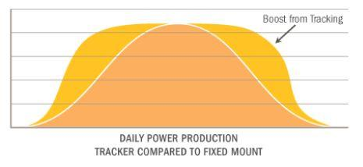

**Fig2: Boost in power production**

**5.1 Data Flow Diagrams:**

**Processing panel Data:**

This data flow diagram shows how the data collect by the solar panel would be processed according to the required format and then displayed to the user via a mobile app.

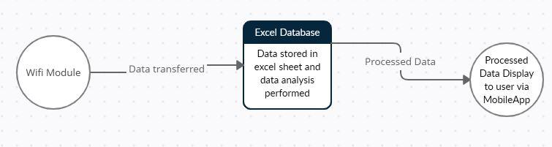

**LDR Sensor processing:**

This data flow diagram helps us to understand how the LDR sensor sense sunlight and how the servo motors change the angle of the solar panel to maximize absorption.

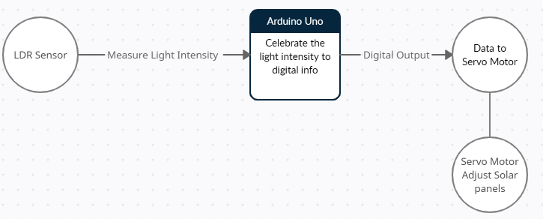

**5.2 Application Architecture:**

**5.2.1Composition**

Result Display

The amount of voltage and current received are shown on the LCD display with the help of IoT technology. As there is a Wi-Fi module connected to the sensors, we can view the readings in our mobile device by connecting to the Wi-Fi network. Whenever the readings or data changes it is automatically updated in our mobile. By using IoT technology we can monitor the working of solar panels and there may be a chance to detect the problem when anything goes wrong.

**5.2.2Layered Architectural Diagram**

For transfer the data collected from the solar panel, (1). firstly, the collected data would be transferred to an excel spreadsheet, where records like intensity of light duration of working of panel along with timestamp would be stored.

(2). Then with the collected data we would be able to perform data analysis which would give the user a better and clearer picture of the working and efficiency of the solar plant.

(3) This processed data is then transfer to the user via a mobile app this is done for user convenience.

Wifi Module

Transfer Camera Feed

Tansfer Collected Data to Excel Sheet

Perform Data Analysis

Display Via MobileApp

Display Peak Production

Display minimal Production

Display Production Pattern

**Fig3: Layered Architecture**

**5.3 Application Services:**

* The servo motor act as an actuator the helps the solar panels to move from side to side 180’. This module adjusts the panel depending on the intensity of light that is falling on the LDR Sensor’s.
* The Hobby solar panel absorb the sunlight that fall on their surface and converts it to electrical energy and sends it to the Arduino board. The data is then stored into excel sheets for data analytics.
* LDR sensor reads the intensity of light that is falling on them and sends an analog signal to the Arduino board that tells the degree by which the servo motor has to rotate to absorb maximum sunlight.

The Wi-Fi module transfers the collected data from the Arduino to the user mobile app for better data visualization.

**5.4 Application Flow and Interaction:**

The main intention of this proposed project is to get maximum power output from the solar panels. Additionally, if there is any improper functioning of the solar panels will be shown and also the parameters like voltage and current are monitored by using the sensors and displayed by using the IoT technology. This model is explained by using the solar radiation i.e., sunlight from the sun is trapped by the solar panels and then these solar panels capture sunlight and turn into useful energy forms of energy such as heat and electricity.

Then the obtained electrical energy is sensed by the sensors such as voltage sensor sense the voltage generated by the solar panel with the help of voltage divider principle and current is obtained by using mathematical formulation. The designed structure of the proposed monitoring system is shown in figure 1. The experimental arrangement of the introduced system consists of solar panels, Regulator power supply, Wi-Fi module-ESP8266, Voltage sensor, Current sensor, LCD (Liquid Crystal Display) and Arduino Uno microcontroller. Programming codes are developed on Arduino IDE, Embedded C.

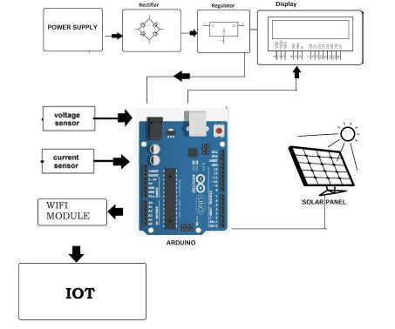

**Fig4: Application Block Diagram**

**5.5 Description of all modules:**

***5.5.1. Arduino Uno***

It is a microcontroller board which is built on ATmega328P microchip. The word Uno means ‘one’. It consists of 14 digital input/output pins that can be associated with various types of other circuits and Arduino Uno also has 6 analog I/O pins that are supported by Arduino IDE (Integrated Development Environment), with the help of a USB cable. Apart from these Arduino Uno shown in figure 2 also consists of a Power Jack, a 16MHz crystal oscillator and a reset button. It operates at a voltage of 5v. It has all the features required to support the microcontroller.

**Fig5: Arduino UNO R3**

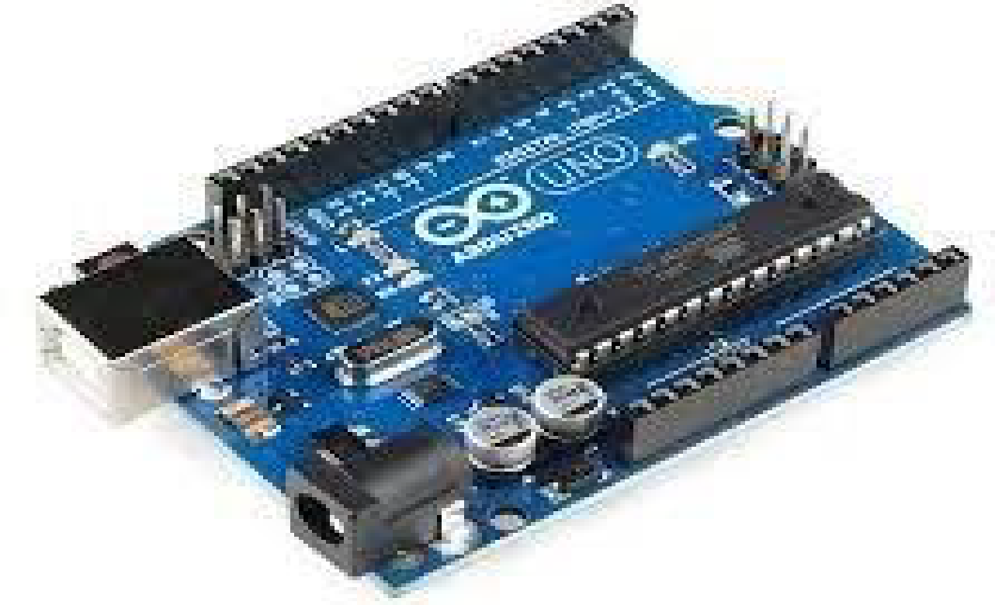

***5.5.2 Solar Panels***

Solar Panels are also called as PV (Photovoltaic) panels shown in figure 3 are used to convert the light energy from the sun. Solar panels are made up of many independent solar cells which are formed by combining the elements like silicon, phosphorus and boron layers. These panels absorb the photons from sunlight and collaborate with the electrons which are present in the panels and generate electricity which can then be used for various purposes.

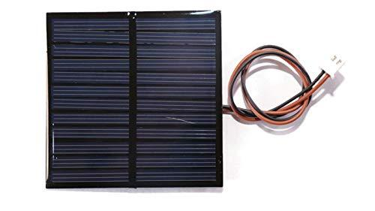

**Fig6: Solar Panel**

***5.5.3. WI-FI Module***

We are using WI-FI Module-ESP8266 in this system, which is shown in figure 5. This is a self-contained SoC microchip which consists of a TCP/IP protocol stack that permits access to any microcontroller to a Wi-Fi network. It has enough storage capability and on-board processing that allows it to interact with the other sensors and gadgets. This module requires an external logic level converter as it is not capable of 5V-3V logic shifting.

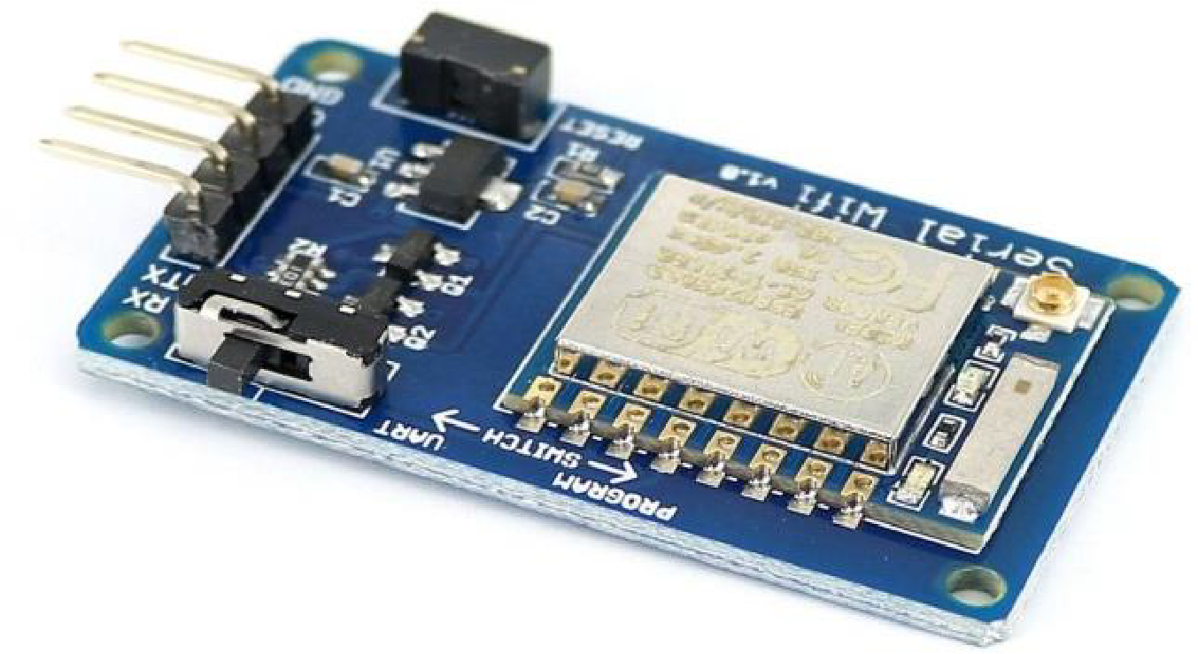

**Fig 7: ESP8266 Wi-Fi Module**

***5.5.4. Servo Motor:***

A Servo Motor is a small device that has an output shaft. This shaft can be positioned to specific angular positions by sending the servo a coded signal. As long as the coded signal exists on the input line, the servo will maintain the angular position of the shaft.

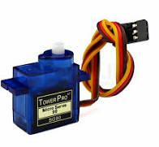

**Fig 8: Tower Pro (Servo Motor)**

***5.5.5 Photo Resistors:***

Photo resistors, also known as light dependent resistors (LDR), are light sensitive devices most often used to indicate the presence or absence of light, or to measure the light intensity. LDRs have a sensitivity that varies with the wavelength of the light applied and are nonlinear devices. Some photocells might not at all response to a certain range of wavelengths. Based on the material used different cells have different spectral response curves.

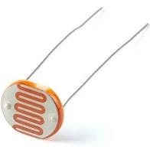

**Fig 9: LDR Photo Resistor**

**6. Functional Architecture**

**6.1 Functional Communication and Interaction:**

**1.**Be an efficient sunlight tracker, it could track the sunlight all throughout the day and adjust the panel accordingly to maximize the collection of sunlight during the day.

**2.**The data such as how much electricity is being generated, which day of the week was the highest production, which day had the least production all this could be displayed to the user remotely via a mobile app. This feature would help to track and monitor their solar plants production and efficiency anywhere in the house by just being connect to the house Wi-Fi.

**6.2 Functional Impact:**

The two LDR’s are placed at the two sides of the solar panel and the [Servo Motor](http://circuitdigest.com/article/servo-motor-basics) is used to rotate the solar panel. The servo will move the solar panel towards the LDR whose resistance will be low, ie. to the LDR on which light is falling, that way it will keep following the light. And if there is some amount of light falling on both the LDR, then the servo will not rotate. The servo will try to move the solar panel in the position where both LDR’s will have the same resistance means where the same amount of light will fall on both the resistors and if the resistance of one of the LDR will change then it rotates towards lower resistance LDR.

**6.3 Data Model:**

The system tries to identify the location of the solar firstly. The panel is first returned to the east for determining the correct position of the sun. When the PV panel moved to most eastern location, panel is rotated westward step by step and each step is measured the amount of radiation by light sensor in that position. When panel reaches to the west side, the values measured by the radiation are compared. The highest radiation values are determined comparing values and then the PV panels are brought to the position. After the exact location of PV panel is determined, the system acquires the radiation values from the light sensor located on the eastern and western edges of the solar panel with analogue channels. The acquired radiation values are compared with each other. If the acquired values from the two light sensors are equal, it means solar irradiation is perpendicular to the panel and the motor stops to turn. Thus, PV panels maintain its position. When the equality between sensors is imbalanced in favour of east side, the algorithm will get the motor to turn eastward and will try to equalize the radiation values between the two light sensors. Similarly, if the acquired value of the light sensor on the west side is acquired, then motor will turn westward.

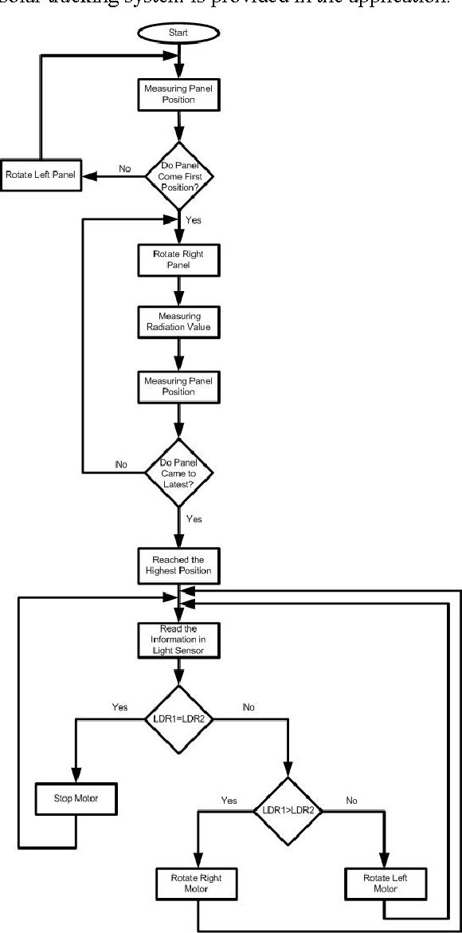

***Fig10: Project ER Diagram***

**7.Technical Architecture**

**7.1 Technical Composition:**

|  |  |  |
| --- | --- | --- |
| **S.No** | **Technology** | **Architecture Layer** |
| 1 | Solar Panel | Photovoltaics cell |
| 2 | Servo Motor | Sensing |
| 3 | Photo sensor(LDR) | Sensing |
| 4 | WiFi (WLAN) | Network  Infrastructure |
| 5 | 10k Ohm resistor | Resistor |
| 6 | LCD | Monitor |
| 7 | Arduino UNO | Sensing |

**7.2 Libraries and Function:**

**Wifi Library-** With the Arduino WiFi Shield, this library allows an Arduino board to connect to the internet. It can serve as either a server accepting incoming connections or a client making outgoing ones. The library supports WEP and WPA2 Personal encryption, but not WPA2 Enterprise. Also note, if the SSID is not broadcast, the shield cannot connect.

Arduino communicates with the WiFi shield using the SPI bus. This is on digital pins 11, 12, and 13 on the Uno and pins 50, 51, and 52 on the Mega. On both boards, pin 10 is used as SS. On the Mega, the hardware SS pin, 53, is not used but it must be kept as an output or the SPI interface won't work. Digital pin 7 is used as a handshake pin between the Wifi shield and the Arduino, and should not be used.

The WiFi library is very similar to the Ethernet library, and many of the function calls are the same.

**Ethernet Library:** This library is designed to work with the Arduino Ethernet Shield, Arduino Ethernet Shield 2, Leonardo Ethernet, and any other W5100/W5200/W5500-based devices. The library allows an Arduino board to connect to the Internet. The board can serve as either a server accepting incoming connections or a client making outgoing ones. The library supports up to eight (W5100 and boards with <= 2 kB SRAM are limited to four) concurrent connections (incoming, outgoing, or a combination).

The Arduino board communicates with the shield using the SPI bus. This is on digital pins 11, 12, and 13 on the Uno and pins 50, 51, and 52 on the Mega. On both boards, pin 10 is used as SS. On the Mega, the hardware SS pin, 53, is not used to select the Ethernet controller chip, but it must be kept as an output or the SPI interface won't work.

**Servo Library:** Allows Arduino/Genuino boards to control a variety of servo motors.

This library can control a great number of servos. It makes careful use of timers: the library can control 12 servos using only 1 timer. On the Arduino Due you can control up to 60 servos. This library is compatible with the avr, megaavr, sam, samd, nrf52, stm32f4, mbed architectures.

**8. Deployment Architecture**

**8.1 Geographical Deployment:**

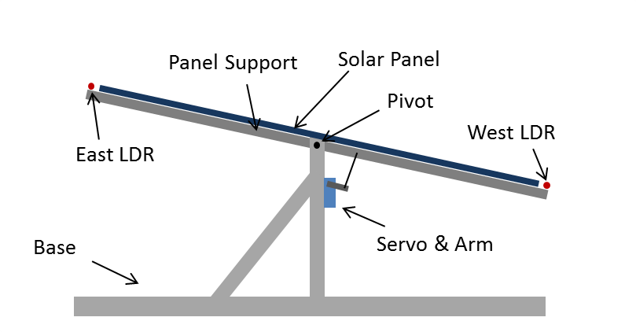

**Fig 11: Project Deployment**

The servo motor act as an actuator the helps the solar panels to move from side to side 180’. This module adjusts the panel depending on the intensity of light that is falling on the LDR Sensor’s.The Hobby solar panel absorb the sunlight that fall on their surface and converts it to electrical energy and sends it to the Arduino board. The data is then stored into excel sheets for data analytics. The two LDR’s are placed at the two sides of the solar panel and the [Servo Motor](http://circuitdigest.com/article/servo-motor-basics) is used to rotate the solar panel. The servo will move the solar panel towards the LDR whose resistance will be low, mean towards the LDR on which light is falling, that way it will keep following the light. And if there is some amount of light falling on both the LDR, then the servo will not rotate. The servo will try to move the solar panel in the position where both LDR’s will have the same resistance means where the same amount of light will fall on both the resistors and if the resistance of one of the LDR will change then it rotates towards lower resistance LDR. LDR sensor reads the intensity of light that is falling on them and sends an analog signal to the Arduino board that tells the degree by which the servo motor has to rotate to absorb maximum sunlight.The Wi-Fi module transfers the collected data from the Arduino to the user mobile app for better data visualization.

**8.2 Operational Constraints:**

**Reliability -** The system must be able to detect the sun rays and tilt the solar panels in the same direction. The solar panel basically tracks the sun rays and hence, the main objective of the system is to detect the sun rays and tilt the solar panels accordingly.

**Efficiency**: The project is efficient as it absorbs the solar energy completely. Most of the solar panels are able to process around 15-22 % of the solar energy. The shifting of the solar panels as per the direction of the sun ensures that all the solar energy is absorbed and hence is a better option than normal solar panels.

**8.3 Pseudo Code**

**if (eastLDR_value < 400 && westLDR_value < 400) { //Check to see if there is low light on both LDR's**

**while (servoSet <=140 && servoSet>=15)**

**{ // if so, send panels back to east for the sunrise**

**servoSet ++;**

**servo.write(servoSet);**

**delay(100);**

**}**

**}**

**difference = eastLDR_value – westLDR_value ; //Check the difference**

**if (difference > 10)**

**{ //Send the panel towards the LDR with a higher reading**

**if (servoSet <= 140)**

**{**

**servoSet ++;**

**servo.write(servoSet);**

**}**

**}**

**else if (difference < -10) {**

**if (servoSet >= 15) {**

**servoSet --;**

**servo.write(servoSet);**

**}**

**}**

**8.4 Data Collection**

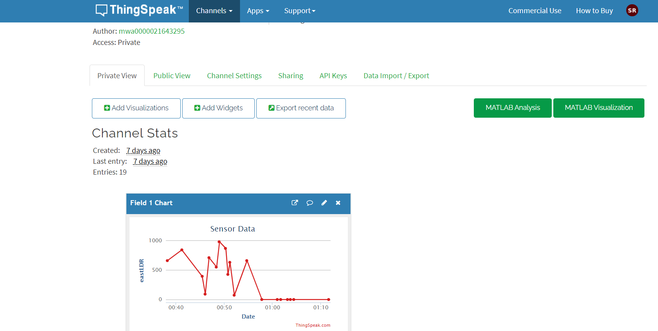

**9. References**

[1].Internet of things (IOT) for smart solar energy: A case study of the smart farm at Maejo University;Publisher: IEEE

[2].Weather based Smart Home Solar Power management with IOT; Aranganathan COUNTRY: India

[3]. An IoT Based Smart Solar Photovoltaic Remote Monitoring and Control unit; Conference: 2nd International Conference on Control, Instrumentation, Energy & Communication

[4]. Solar Energy Monitoring System by IOT; K.G.Srinivasan Research Scholar, Velammal Engineering College, Chennai. Email: kgsrinivasanped@gmail.com Dr.K.Vimaladevi Professor CSE, Velammal Engineering College, Chennai.

[5]. IoT Enabled Solar Power Monitoring System

R.L.R. Lokesh Babu1, D Rambabu2, A. Rajesh Naidu3, R. D. Prasad4, P. Gopi Krishna5

[6]. Solar tracking system

Deekshith K , Dhruva Aravind , Nagaraju H , Bhaskar Reddy, International Journal of Scientific & Engineering Research, Volume 6