**Fashion Item Classification Using Machine Learning**

1. Abstract

This report presents a machine learning project focused on classifying fashion items using the Fashion MNIST dataset. We compare the performance of three different models, including a Convolutional Neural Network (CNN), a Random Forest Classifier, and a Logistic Regression. The objective is to identify the most effective model for classifying fashion items based on their images.

1. Introduction

Fashion MNIST is a dataset containing 70,000 grayscale images of various clothing items, each with a size of 28x28 pixels. The dataset is split into 60,000 training images and 10,000 test images. There are ten categories of fashion items, including T-shirts/tops, trousers, pullovers, dresses, coats, sandals, shirts, sneakers, bags, and ankle boots.  
The problem of classifying fashion items is an essential task in the fashion industry, with applications ranging from inventory management to recommendation systems. Image classification techniques have been widely used in the field of computer vision and have shown promising results in various domains, including fashion item classification.  
In this project, we aim to investigate and compare the performance of three popular machine learning models for classifying fashion items using the Fashion MNIST dataset. The models include a Convolutional Neural Network (CNN), a Random Forest Classifier (RFC), and a Logistic Regression.

1. Data Preprocessing

The first step in the project was preprocessing the dataset to ensure optimal input for the machine learning models. The following steps were performed:

3.1. Normalization: The images were normalized by dividing each pixel value by 255, which scales the pixel values to a range between 0 and 1. This step is essential for improving the performance of the machine learning models as it helps in faster convergence of the optimization algorithms.

3.2. Data Visualization: The dataset was visualized to gain insights into the distribution of classes and the appearance of the images. We plotted a sample of 25 images along with their corresponding labels. Additionally, we analyzed the class distribution by plotting a pie chart, which showed that the dataset was evenly distributed across all ten classes.

1. Model Comparison

We compared three different machine learning models: a Convolutional Neural Network (CNN), a Random Forest Classifier (RFC), and a Logistic Regression.

* 1. Convolutional Neural Network (CNN)

Convolutional Neural Networks (CNNs) are a type of deep learning model that has shown remarkable success in image classification tasks. CNNs are particularly suitable for this task due to their ability to learn hierarchical features from raw image data through a series of convolutional and pooling layers.

The CNN model in our experiment consists of the following layers:

* A convolutional layer with 64 filters of size 3x3 and ReLU activation function.
* A max-pooling layer with a pool size of 2x2.
* Another convolutional layer with 64 filters of size 3x3 and ReLU activation function.
* A max-pooling layer with a pool size of 2x2.
* A flattening layer to convert the feature maps into a one-dimensional array.
* A fully connected (dense) layer with 128 neurons and ReLU activation function.
* An output layer with ten neurons corresponding to the number of classes and a softmax activation function to output class probabilities.

The model was trained for five epochs with the Adam optimizer and sparse categorical cross-entropy loss. We reshaped the training and test images to include an additional dimension for the number of channels to comply with the input requirements of the CNN model.

* 1. Random Forest Classifier (RFC)

Random Forest is an ensemble learning method that constructs multiple decision trees during training and outputs the class with the majority vote among the trees. The main advantage of the Random Forest algorithm is its ability to handle complex datasets with high-dimensionality and a large number of features.

We performed a grid search to optimize the hyper parameters of the Random Forest model, including the number of estimators and the criterion (Gini or Entropy). The best model was then trained on the entire training dataset. The training images were flattened before being input into the Random Forest model.

* 1. Logistic Regression

Logistic Regression is a popular machine learning technique used for binary or multi-class classification tasks. It is a linear model that estimates the probability of a certain class by fitting a logistic function to the training data. Logistic Regression can be extended to handle multi-class problems using techniques such as one-vs.-rest or multinomial logistic regression.  
We trained a logistic regression model using a one-vs-rest approach to handle the multi-class problem. The training images were flattened before being input into the logistic regression model. The model's hyper parameters, such as the regularization strength, were optimized using a grid search.

1. Results

The performance of each model was evaluated based on their accuracy on the test dataset. The CNN model achieved the highest accuracy, followed by the Random Forest Classifier and the Logistic Regression

|  |  |
| --- | --- |
| Model | Accuracy |
| CNN | 92.9% |
| Random forest | 87.8% |
| Logistic Regression | 84.6% |

Moreover, confusion matrices were plotted for the Random Forest and Logistic Regression models to visualize the classification performance of each model on the different categories of fashion items. The CNN model demonstrated the most accurate performance in classifying the fashion items, with fewer misclassifications compared to the other two models.

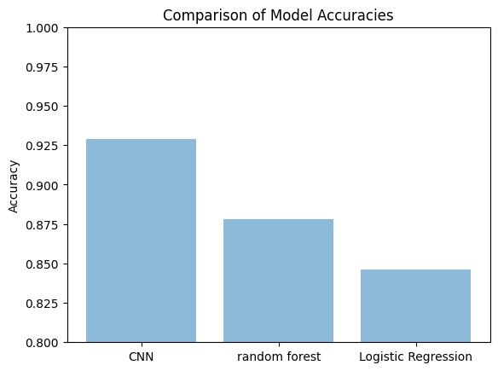

1. Discussion

The results indicate that the Convolutional Neural Network (CNN) model outperforms the Random Forest Classifier and the Logistic Regression in classifying fashion items using the Fashion MNIST dataset. This can be attributed to the following reasons:

6.1. Feature Extraction: CNNs are designed to learn hierarchical features from raw image data through a series of convolutional and pooling layers. This allows the CNN model to automatically learn relevant features from the images, whereas the Random Forest and Logistic Regression models rely on the raw pixel values as input features.

6.2. Parameter Tuning: The CNN model requires fewer hyper parameters to be tuned compared to the Random Forest and Logistic Regression models. In this project, we used a grid search to optimize the hyper parameters of the Random Forest and Logistic Regression models, which can be computationally expensive and time-consuming.

6.3. Model Complexity: The CNN model has a higher model complexity compared to the Random Forest and Logistic Regression models, allowing it to capture complex patterns in the image data. However, this also makes the CNN model more prone to over fitting, which can be mitigated using techniques such as dropout or regularization.

7. Conclusion

Based on the results, the Convolutional Neural Network (CNN) model outperforms the Random Forest Classifier and the Logistic Regression in classifying fashion items using the Fashion MNIST dataset. This project highlights the effectiveness of using deep learning techniques, such as CNNs, for image classification tasks in the fashion industry.