# 第一天

内容： 1.git应用基础

2.分布式工程创建

## 简介： 分布式，前后端分离的，电商管理项目；

### 版本控制 git 码云

### 1.2 项目构建 maven

1.3 开发工具 ： idea vscode

1.4 数据库： mysql8.0

1.5 jdk - 1.8

## Git安装：

2.1 下载https://git-scm.com/downloads

2.2 安装 参照演示胡pdf文档

3.git的使用：

### 3.1.在文件夹中，右键点击 git bash here:输入

$ git init 初始化，让git管理文件夹；

3.2.设置签名：

3.2.1 （项目级别） 在当前库有效；

输入： 用户名 和 email

Administrator@Z6P9QYHIOCNLDV8 MINGW64 /e/wechat (master)

$ git config user.name tom_pro

Administrator@Z6P9QYHIOCNLDV8 MINGW64 /e/wechat (master)

$ git config user.mail goodmoring@maomao.com

3.2.2 （系统级别） 在当前库有效；

输入： 用户名 和 email

Administrator@Z6P9QYHIOCNLDV8 MINGW64 /e/wechat (master)

$ git config --global user.name tom_pro

Administrator@Z6P9QYHIOCNLDV8 MINGW64 /e/wechat (master)

$ git config --global user.mail goodmoring@maomao.com

## 操作命令基础：

### 3.1 查看状态 ： $ git status

Administrator@Z6P9QYHIOCNLDV8 MINGW64 /e/wechat (master)

$ git status

On branch master

No commits yet

nothing to commit (create/copy files and use "git add" to track)

Administrator@Z6P9QYHIOCNLDV8 MINGW64 /e/wechat (master)

### 3.2 创建文件E:\wechat/good.txt

### 3.3 再次输入 $ git status

Administrator@Z6P9QYHIOCNLDV8 MINGW64 /e/wechat (master)

$ git status

On branch master

No commits yet

Untracked files:

(use "git add <file>..." to include in what will be committed)

good.txt

nothing added to commit but untracked files present (use "git add" to track)

### 3.4：输入 将文件 放入缓冲区；

Administrator@Z6P9QYHIOCNLDV8 MINGW64 /e/wechat (master)

$ git add good.txt

3.5 查看状态

$ git status

On branch master

No commits yet

Changes to be committed:

(use "git rm --cached <file>..." to unstage)

new file: good.txt

### 3.6 从缓冲区删除

Administrator@Z6P9QYHIOCNLDV8 MINGW64 /e/wechat (master)

$ git rm --cached good.txt

rm 'good.txt'

### 3.7 提交文件到本地仓库：

Administrator@Z6P9QYHIOCNLDV8 MINGW64 /e/wechat (master)

$ git commit good.txt

[master (root-commit) fa6c9a8] init v 0.1

1 file changed, 0 insertions(+), 0 deletions(-)

create mode 100644 good.txt

Vim 编辑：输入：i或者a ，光标就可以移动了，可以输入但是不要写在#后面；

Esc退出输入模式

保存退出 : wq

3.8 修改下good.txt 保存 查看状态：

Administrator@Z6P9QYHIOCNLDV8 MINGW64 /e/wechat (master)

$ git status

On branch master

Changes not staged for commit:

(use "git add <file>..." to update what will be committed)

(use "git checkout -- <file>..." to discard changes in working directory)

modified: good.txt

no changes added to commit (use "git add" and/or "git commit -a")

3.9 讲更新 提交到本地库：

Administrator@Z6P9QYHIOCNLDV8 MINGW64 /e/wechat (master)

$ git add good.txt

Administrator@Z6P9QYHIOCNLDV8 MINGW64 /e/wechat (master)

$ git status

On branch master

Changes to be committed:

(use "git reset HEAD <file>..." to unstage)

modified: good.txt

Administrator@Z6P9QYHIOCNLDV8 MINGW64 /e/wechat (master)

$ git commit -m "my 2th commit" good.txt

[master fa22b4e] my 2th commit

1 file changed, 1 insertion(+)

### 3.10版本的前进和后退

3.10.1 查看历史版本

Administrator@Z6P9QYHIOCNLDV8 MINGW64 /e/wechat (master)

$ git log

commit fa22b4e743249223063b4c3de9a7e1be52b4c452 (HEAD -> master)

Author: tom_pro <99142388@qq.com>

Date: Wed Oct 14 10:35:40 2020 +0800

my 2th commit

commit fa6c9a8c5cef751821390ffc5b52bad5bbb2efb6

Author: tom_pro <99142388@qq.com>

Date: Wed Oct 14 10:26:13 2020 +0800

init v 0.1

3.10.2 查看历史版本

Administrator@Z6P9QYHIOCNLDV8 MINGW64 /e/wechat (master)

$ git log --oneline

fa22b4e (HEAD -> master) my 2th commit

fa6c9a8 init v 0.1

3.10.3 在good.txt中再次添加一行数据（换一行随便写） 提交：

Administrator@Z6P9QYHIOCNLDV8 MINGW64 /e/wechat (master)

$ git add good.txt

Administrator@Z6P9QYHIOCNLDV8 MINGW64 /e/wechat (master)

$ git status

On branch master

Changes to be committed:

(use "git reset HEAD <file>..." to unstage)

modified: good.txt

Administrator@Z6P9QYHIOCNLDV8 MINGW64 /e/wechat (master)

$ git commit -m" m 3rd commit" good.txt

[master 5a76677] m 3rd commit

1 file changed, 2 insertions(+), 1 deletion(-)

Administrator@Z6P9QYHIOCNLDV8 MINGW64 /e/wechat (master)

$ git log --oneline

5a76677 (HEAD -> master) m 3rd commit

fa22b4e my 2th commit

fa6c9a8 init v 0.1

3.10.4： 查看历史版本

Administrator@Z6P9QYHIOCNLDV8 MINGW64 /e/wechat (master)

$ git reflog

索引值

5a76677 (HEAD -> master) HEAD@{0}: commit: m 3rd commit

fa22b4e HEAD@{1}: commit: my 2th commit

fa6c9a8 HEAD@{2}: commit (initial): init v 0.1

3.10.5 通过索引值 读取对应的历史信息

Administrator@Z6P9QYHIOCNLDV8 MINGW64 /e/wechat (master)

$ git reset --hard fa22b4e

HEAD is now at fa22b4e my 2th commit

查看历史信息 及 文件：

Administrator@Z6P9QYHIOCNLDV8 MINGW64 /e/wechat (master)

$ git reflog

fa22b4e (HEAD -> master) HEAD@{0}: reset: moving to fa22b4e

5a76677 HEAD@{1}: commit: m 3rd commit

fa22b4e (HEAD -> master) HEAD@{2}: commit: my 2th commit

fa6c9a8 HEAD@{3}: commit (initial): init v 0.1

3.10.6 尝试将历史修改为 5a76677

Administrator@Z6P9QYHIOCNLDV8 MINGW64 /e/wechat (master)

$ git reset --hard 5a76677

HEAD is now at 5a76677 m 3rd commit

Administrator@Z6P9QYHIOCNLDV8 MINGW64 /e/wechat (master)

$ git reflog

5a76677 (HEAD -> master) HEAD@{0}: reset: moving to 5a76677

fa22b4e HEAD@{1}: reset: moving to fa22b4e

5a76677 (HEAD -> master) HEAD@{2}: commit: m 3rd commit

fa22b4e HEAD@{3}: commit: my 2th commit

fa6c9a8 HEAD@{4}: commit (initial): init v 0.1

3.10.7 删除 找回文件

A 创建文件 aaa.txt

B 提交到本地库

C 删除

查看此时状态：

Administrator@Z6P9QYHIOCNLDV8 MINGW64 /e/wechat (master)

$ git status

On branch master

Changes not staged for commit:

(use "git add/rm <file>..." to update what will be committed)

(use "git checkout -- <file>..." to discard changes in working directory)

deleted: aaa.txt

no changes added to commit (use "git add" and/or "git commit -a")

3.10.8 恢复文件

A.查看历史日志：

Administrator@Z6P9QYHIOCNLDV8 MINGW64 /e/wechat (master)

$ git reflog

43d4d4f (HEAD -> master) HEAD@{0}: commit: aaa v1.0

5a76677 HEAD@{1}: reset: moving to 5a76677

fa22b4e HEAD@{2}: reset: moving to fa22b4e

5a76677 HEAD@{3}: commit: m 3rd commit

fa22b4e HEAD@{4}: commit: my 2th commit

fa6c9a8 HEAD@{5}: commit (initial): init v 0.1

B恢复文件： 通过索引回复文件

Administrator@Z6P9QYHIOCNLDV8 MINGW64 /e/wechat (master)

$ git reset --hard 43d4d4f

HEAD is now at 43d4d4f aaa v1.0

总结下：

git init

git add .

git commit -m”注释” 文件名

git status

git clone url地址

4.远程库访问：

以码云为例： <https://gitee.com/>

4.1创建一个工程

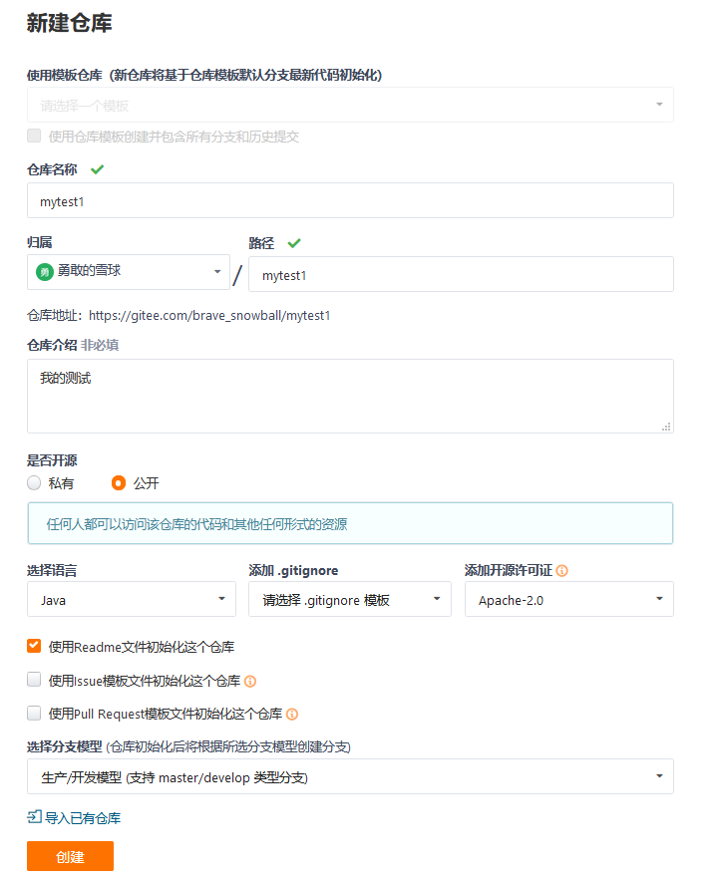

4.2.将远程仓库克隆到本地

4.2.1创建文件夹 E:\gittest1

4.2.2 使用git初始化该文件夹

Administrator@Z6P9QYHIOCNLDV8 MINGW64 /e/gittest1

$ git init

Initialized empty Git repository in E:/gittest1/.git/

4.2.3 克隆远程仓库

Administrator@Z6P9QYHIOCNLDV8 MINGW64 /e/gittest1 (master)

$ git clone https://gitee.com/brave_snowball/mytest1.git

Cloning into 'mytest1'...

remote: Enumerating objects: 5, done.

remote: Counting objects: 100% (5/5), done.

remote: Compressing objects: 100% (5/5), done.

remote: Total 5 (delta 0), reused 0 (delta 0), pack-reused 0

Unpacking objects: 100% (5/5), done.

4.2.4：将本地文件提交到远程仓库

A 提交到本地缓冲区

B 提交到本地库

C 推送到远程库

Administrator@Z6P9QYHIOCNLDV8 MINGW64 /e/gittest1/mytest1 (master)

$ git push -u origin master