**Instructions to host WebAPI core from your Desktop:**

1. Download and install ASP.Net Core Runtime Hosting Bundle (3.0.3) specific to the Operating system where you will be hosting the Pokemon API, with the below steps.

Download Link: [Download .NET Core 3.0 (Linux, macOS, and Windows) (microsoft.com)](https://dotnet.microsoft.com/download/dotnet/3.0)

From the above link, install the .Net Core SDK Version 3.0.103 under the Hosting Bundle version 3.03 for the Operating System you intend to host Pokemon API.

Hosting Bundle Version: 3.0.3

.Net Core SDK Version: 3.0.103

1. Once the installation is completed, you can check if the runtime is installed with the following command in the command prompt.

dotnet --info

1. Download the Pokemon project to your Local Directory (This will be referred to as referred to as [Your Project Directory] henceforth in the document).
2. Contents required to publish Pokemon API is under the following path

[Your Project Directory]\ bin\Release\netcoreapp3.0\publish

1. Create a folder to Publish Pokemon API (This will be referred to as [Your Publish Directory] henceforth in the document)
2. Execute the following command in the command prompt to host the Pokemon API locally.

* cd [Your Publish Directory]
* Pokemon.exe

1. Once hosting is successful, you should see message as below in command prompt.

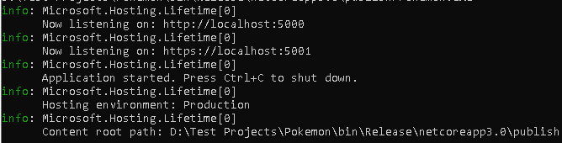

1. You can consume the API with the following endpoints either from browser or from httpie.

[http://localhost:5000/pokemon/{name}](http://localhost:5000/pokemon/%7bname%7d)

[http://localhost:5000/pokemon/translated/{name}](http://localhost:5000/pokemon/translated/%7bname%7d)