

**SOFTWARE REQUIREMENT ENGINEERING**

**ONLINE SCHOLARSHIP PORTAL**

**SECTION: B**

**GUIDED BY**

**FARZANA BINTE ALAM**

**Department of Computer Science**

**American International University-Bangladesh**

**PREPARED BY**

|  |  |  |  |
| --- | --- | --- | --- |
| **NO** | **NAME** | **ID** | |
| 1. | NAYAN, SHEIK NOOR | | 17-35043-2 | |
| 2. | ISMAIL, ISRITA | | 17-35675-3 | |
| 3. | ISHRAK, MD NAFIS | | 17-35500-3 | |
| 4. | SAHA, ANIK | | 17-35556-3 | |

**INDEX**

1. Introduction

1.1. Purpose

1.2. Definitions, Acronyms, Abbreviations

1.3. Document Convention

1.4. Project Scope

2. Overall Description

2.1. User Classes & Characteristics

2.2. Operating Environment

2.3. Design & implementation Constraints

3. System Features

3.1. Description of Feature

3.2. Functional Requirements

3.3. User Stories

4. External Interface Requirements

4.1. User Interface

4.2. Software Interface

4.3. Hardware Interface

5. Quality Attributes

5.1. Usability

5.2. Reliability & Availability

5.3. Performance

5.4. Security

6. Data Requirements

6.1. Logical Data Models

6.2. Data Dictionary

1. **Introduction**

The project “Online Scholarship Portal” is a web-based application for managing scholarship details of different national-international college, university, organization / government. In order to be updated and have general consciousness of different types of scholarships that are being offered nationally and internationally, this portal will be very helpful. This project will make the process of applying for scholarships easier.

Many students are unaware of scholarship opportunities are being offered, this project will also facilitate the way of finding and comparing scholarships easily for them. After registration, as per the status of the student the portal will start showing related scholarships, he/she can apply for. Any queries regarding scholarships and related topic asked by students will be fulfilled. Organizations can easily advertise their offered scholarship notice in the portal and all the information will be verified by the admins.

* 1. **Purpose**

The purpose of this project is to build a common platform for students and organizations to contact about scholarship offers and facilities and applying systems.

* 1. **Document Convention**
* **Main Section Titles** 
  + Font: Times New Roman
  + Face: Bold
  + Size: 16
  + Color: Black
* **Sub Section Titles** 
  + Font: Times New Roman
  + Face: Bold
  + Size: 14
  + Color: Black
* **Other Text Explanations** 
  + Font: Times New Roman
  + Face: Normal
  + Size: 12
  + Color: Black
  1. **Project Scope**

It is an online based software project. This online scholarship portal will give many facilities. The students will get all information about scholarship of all universities from this software. They can also apply their scholarship according to their abilities.

1. **Overall Description**
   1. **User Classes & Characteristics**
2. **Admin** shall have all the access and control of all information of the system
3. **Student** shall apply for scholarship and will update his profile throughout the portal of the system.
4. **University** will offer scholarship and update the scholarship curriculum.
5. **Organization/Government will** communicate with the candidates and applicants and will update their profile also.
6. **Operating Environment**

Operating system for the **SCHOLARSHIP SYSTEM** is as listed below.

* Distributed Database
* Client/Server System
* Operating System: Windows / Linux / iOS
* Geographical Location: Bangladesh
* Database: Oracle
* Platform: Java / C# / HTML / PHP/ CSS

**2.3. Design & Implementation Constraints**

1. The organization should be following the international scholarship policy for offer any scholarship event.
2. The admin of the system can take any action on behalf of the organization which is break the law of the country.

1. **System Features:**
   1. **Description of Feature**
      1. **Admin**

* Admin can Log In to the site
* Admin can Edit Profile
* Admin can Delete profile
* Admin can access and control of all information

1. **Student**

* Students can Register to the system
* Log In to the site
* Edit and Delete their profile
* Students can comment for any post
* Students can search

1. **University**

* Register
* Log In
* Edit and delete profile
* Upload and Update their Curriculum

1. **Organization / Government:**

* Register into the system
* Login to the system
* Edit and delete their profile
* Offer their scholarship, facilities and clearly posts their rules and regulations
* Communicate with candidates and applicants

**3.2 Functional Requirements**

**3.2.1. Admin**

* Shall have payment section
* Shall change Password
* Shall search Scholarship details
* Modify scholarship status (Like it is canceled or it is banned etc.)
* Shall search registered Student’s Profile
* Shall be able to see the applications searching by student id or application id and modify it if needed.
* Shall be able to see the Offered Scholarships searching by Varsity or Govt. id or Offered scholarship id and modify it if needed.
* See the review
* Contact with other users
* See the report by users
* Analyst the data by users and make Excel sheets
* Shall answer the question
* Make charts with many options like based on student region or based on department

**3.2.2. Student**

* Can view their profile
* Can view scholarship offered by university
* Can view scholarship offered by organization
* Able to apply any scholarship
* Able to ask question
* Can report any post
* Able to upload their CV
* Can vote for post
* Able to contact with admin/manager
* Able to contact with university
* Able to contact with organization
* Able to send review to admin
* Able to view their application
* Can update profile
* Can view application status

**3.2.3. University**

* Can offer scholarship
* Can ask for verification student's details
* Can view how many applications are there
* Can reject an application
* Can send reply as need to be changed
* Can ban a profile for fake information
* Can delete an application
* Can update the offer
* Can contact the admin
* Can contact the students
* University can update their profile
* Can delete a scholarship offer
* Log will be there to record all application
* Can edit an offer
* Can buy premium offer by the admin to post unlimited scholarship offer

**3.2.4. Organization / Government**

* They can view own profile
* They can offer scholarship
* Can view students’ application
* Can view students’ profile
* Contact with students who apply scholarship
* They can approve and rejected student application
* They can view scholarship offer University
* They can search specific students
* They can search specific University
* Update profile
* Contact admin
* Store all apply students’ application
* Offer scholarship specific University
* Contact other scholarship organizations

**3.3. User Stories**

**3.3.1. Admin**

1. As an admin I want to login to the system, so that I can do my work.
2. As an admin I want to modify the scholarship status. (such as: For doing uncertain things which is break the scholarship terms and condition in that situation I can delete or modify the status as banned or delete).
3. As an admin I can see & search registered students account details.
4. As an admin I have access and control of all information.

**3.3.2. Student**

1. As a student I want to register to the system so that I can apply for scholarship.
2. As a student I want to login to the site so that I can get more information.
3. As a student I want to update my profile so that I can add or remove.
4. As a student I want to comment in a post so that I can make sure my query.
5. As a student I want to search in this portal so that I can find my destination easily.

**3.3.3. University**

1. As a University Financial aid coordinator, I want to register into the system, So that I can offer Scholarships.
2. As a University Financial aid coordinator, I want to log into the site, so that I can give information.
3. As a University Financial aid coordinator, I want to update profile so that I can edit or remove the profile.
4. As a University Financial aid coordinator, I want to upload curriculum so that I can update the curriculum.

**3.3.4. Organization/Government**

1. As an Organizer, I want to register into the system, so that I can give scholarships to the students.
2. As an Organizer, I want to log into the site, so that I can give information.
3. As an Organizer, I want to update my profile so that I can edit or remove the profiles.
4. As an Organizer, I want to give advertisement so that I can communicate with

the candidates and applicants.

**4. External Interface Requirements**

**4.1 User Interface**

The user interface for the software shall be compatible to any browser such as Internet Explorer, Mozilla or Google Chrome by which user can access to the system. The user interface shall be implemented using any tool or software package like Java Applet, MS Front Page etc.

**4.1.1 Log In**

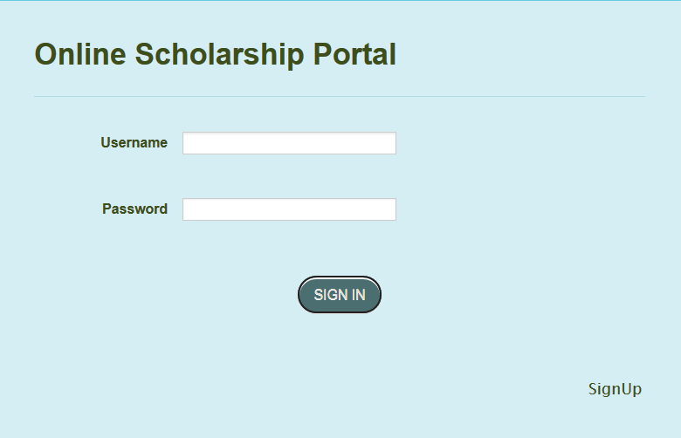

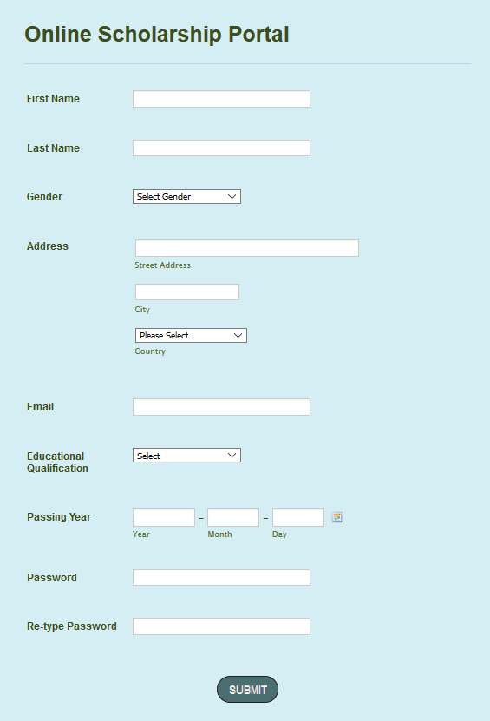**4.1.2. Sign Up**

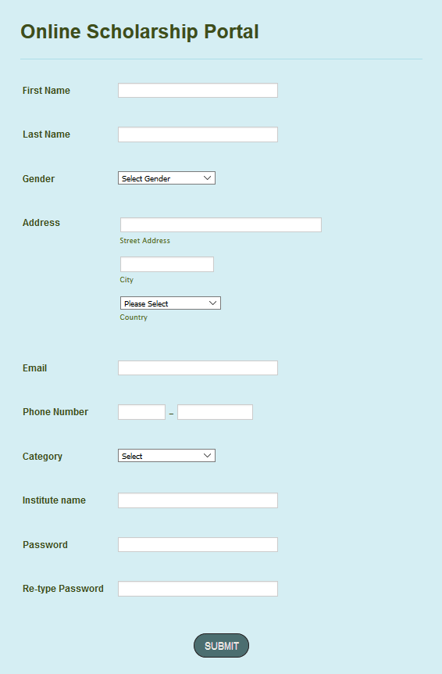

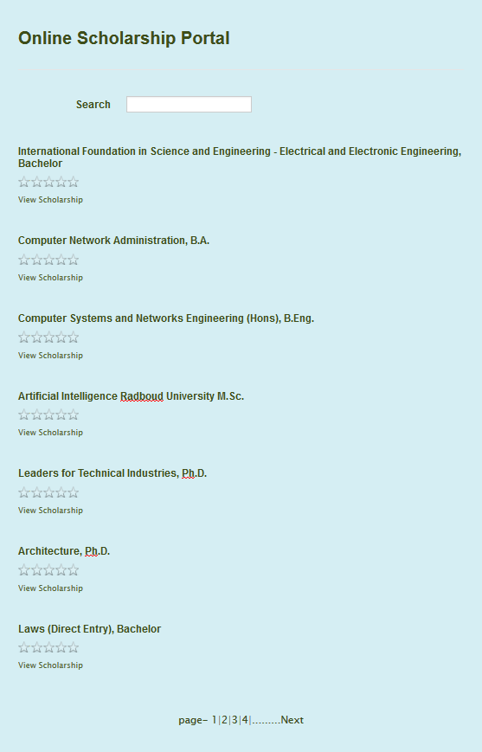**4.1.3. Search Scholarship**

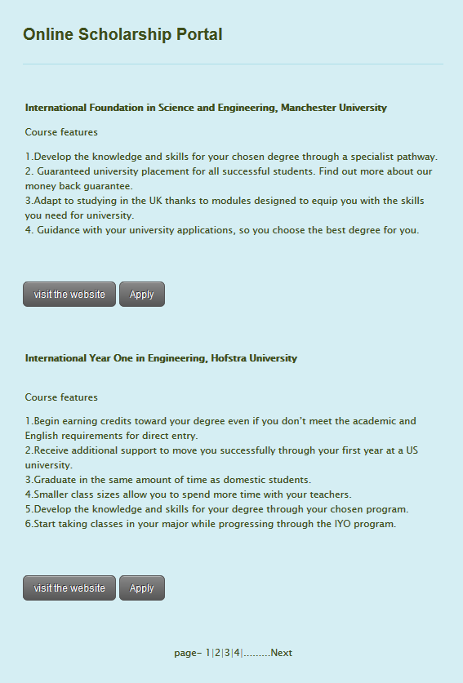**4.1.4 Scholarship details**

**4.2. Software Interface**

The system shall communicate with the students to receive their scholarship requests. The system shall communicate with the University or Government/Organizer to post their scholarship offers. The system can ask for verification student's details. The system shall communicate with students who apply scholarship. The system shall communicate with the admin. The system can able to apply any scholarship. The system can view student’s scholarship. The system can approve or rejected student’s application.

**4.3. Hardware Interface**

Since the application must run over the internet, all the hardware shall require to connect internet will be hardware interface for the system. As for e.g. Firefox, Google Chrome, Internet Explorer.

**5. Quality Attributes**

**5.1. Usability**

1. The system shall provide a uniform look and feel between all the web pages.
2. The system shall provide use of button in the website (video tutorial).
3. The system shall provide multi language support.

**5.2. Reliability & Availability**

**5.2.1. Back-End Internal Computer**

The system shall provide storage of all databases on redundant computers with automatic switchover. The system shall provide for replication of databases to off-site storage locations.

**5.2.2. Internet Service Provider**

The system shall provide a contractual agreement with an internet service provider for T3 access with 99.9999% availability**.**

**5.3. Performance**

1. The product shall be based on web and has to be run from a web server.
2. The product shall take initial load time depending on internet connection
3. The performance will be depending upon hardware components of the client/ customer.

**5.4. Security**

1. The users web browser shall never display a users’ password. It shall always be echoed with special characters representing typed characters.
2. The system’s back-end servers shall never display a users’ password. The users’ password may be reset but never shown.
3. The system’s back-end databases shall be encrypted.

**6. Data Requirements**

**6.1. Logical Data Model**

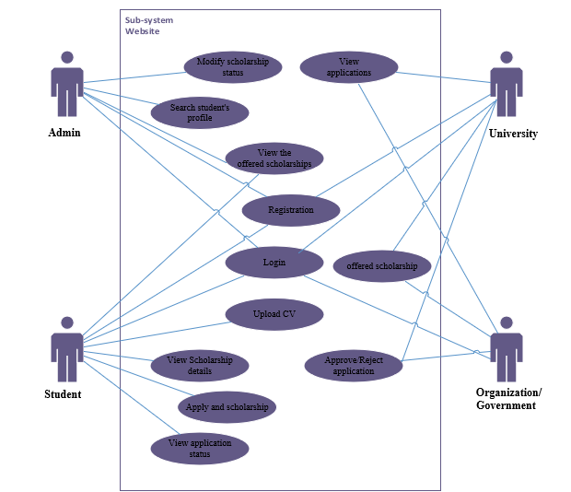**6.1.1 Use Case Diagram**

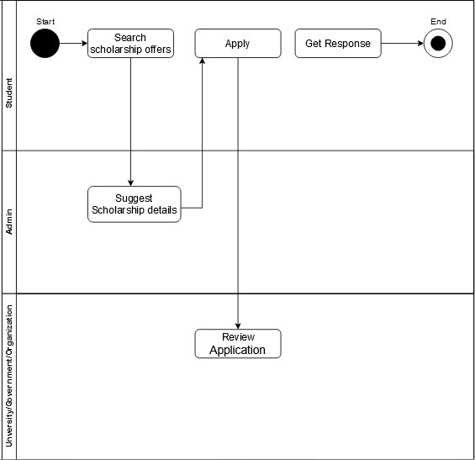**6.1.2. AS-IS Process Flow Diagram**

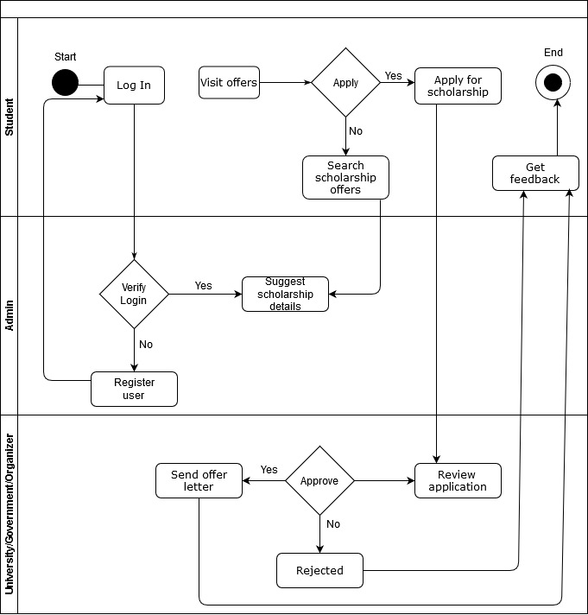**6.1.3. TO-BE Process Flow Diagram**

**6.2. Data Dictionary**

|  |  |  |  |  |
| --- | --- | --- | --- | --- |
| **Field Name** | **Data Type** | **Field Size** | **Description** | **Example** |
| **Admin ID** | **int** | **6** | **Unique number id for admin** | **1234** |
| **Admin Name** | **varchar** | **50** | **Admin full name** | **Steve Smith** |
| **Admin Email** | **varchar** | **50** | **Unique Email id of admin** | [**smith@gmail.com**](mailto:smith@gmail.com) |
| **Admin Password** | **varchar** | **20** | **Admin password for verification** | **Smith1234@** |
| **University ID** | **int** | **6** | **Unique number id for University** | **1234** |
| **University Name** | **varchar** | **50** | **University full name** | **American International University Bangladesh** |
| **University Email** | **varchar** | **50** | **Unique Email id of University** | [**info@aiub.com**](mailto:info@aiub.com) |
| **University Password** | **varchar** | **20** | **University password for verification** | **Aiub2019@** |
| **University Address** | **varchar** | **200** | **University full address** | **Kuratoli Road, Dhaka 1212, Bangladesh** |
| **University Contact No** | **int** | **11** | **University phone no.** | **01533103241** |
| **Organization/Government ID** | **int** | **6** | **Unique number id for University** | **1234** |
| **Organization/Government Name** | **varchar** | **50** | **Organization/Government full name** | **Commonwealth** |
| **Organization/Government Email** | **varchar** | **50** | **Unique Email id of Organization/Government** | [**info@commonwealth.com**](mailto:info@commonwealth.com) |
| **Organization/Government Password** | **varchar** | **20** | **Organization/Government password for verification** | **commonwealth2019@** |
| **Organization/Government Address** | **varchar** | **200** | **Organization/Government full address** | **Banani, Dhaka 1212, Bangladesh** |
| **Organization/Government Contact No** | **int** | **11** | **Organization/Government phone no.** | **01533103241** |
| **Student ID** | **int** | **6** | **Unique number id for Student** | **1234** |
| **Student Name** | **varchar** | **50** | **Student full name** | **Steve Smith** |
| **Student Email** | **varchar** | **50** | **Unique Email id of Student** | [**smith@aiub.com**](mailto:smith@aiub.com) |
| **Student Password** | **varchar** | **20** | **Student password for verification** | **smith2019@** |
| **Student Address** | **varchar** | **200** | **Student full address** | **Bashundhara, Dhaka 1212, Bangladesh** |
| **Student Contact No** | **int** | **11** | **Student phone no.** | **01533103241** |
| **Scholarship Id** | **int** | **6** | **Scholarship unique id** | **1234** |
| **Title** | **varchar** | **200** | **Scholarship title** | **Commonwealth Scholarship Bangladesh** |
| **Description** | **varchar** | **2000** | **Details info and description about Scholarship** | **Co** |
| **Duration** | **Duration** | **7** | **Duration of the Scholarship** | **1 year** |
| **Host** | **varchar** | **100** | **Host of the Scholarship** | **University of Dhaka** |
| **Eligibility** | **varchar** | **500** | **Conditions of eligibility** |  |
| **Instruction** | **varchar** | **500** | **Instruction of apply** |  |
| **Number of Awards** | **int** | **3** | **How many awards are there** | **3** |
| **Target Group** | **varchar** | **100** | **who are targeted for scholarship** | **International students** |
| **Website** | **varchar** | **100** | **Website of host or scholarship** | **info@scholarship.com** |
| **Application Id** | **int** | **6** | **Unique id number for application** | **1234** |
| **Student Information** | **varchar** | **500** | **Student Details Information** |  |