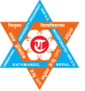
Tribhuvan University
Faculty of Humanities and Social Science
Ratna Rajya Laxmi Campus
Department of Bachelor in Computer Application
Pradarshani Marga, Kathmandu, Nepal
Lab report on
Disk Operating System (DOS) (CACS 101)
Computer Fundamental and Applications
Submitted By :  Name: Roben Thapa  Department: Bachelor of Computer  Application(BCA)  Roll Number: 27  Date:02/08/2026 | Submitted to :  Professor’s Name: Shree Maharjan  Subject: Computer Fundamental and Applications  Project Name: Disk Operating System (DOS)  Sign:

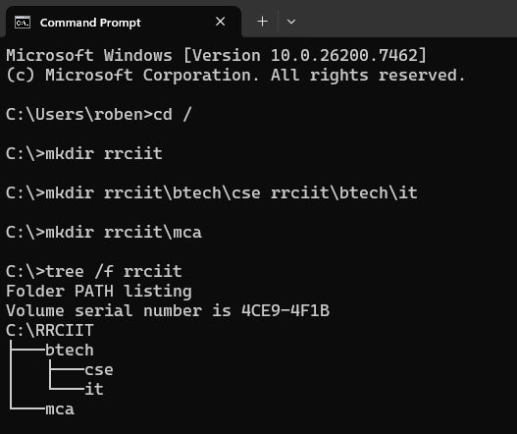

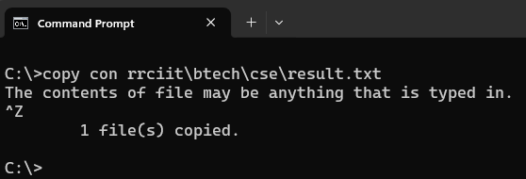

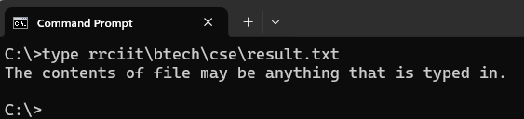

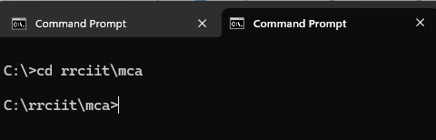

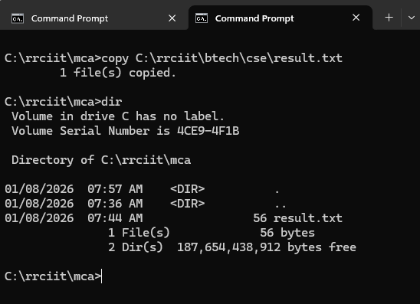

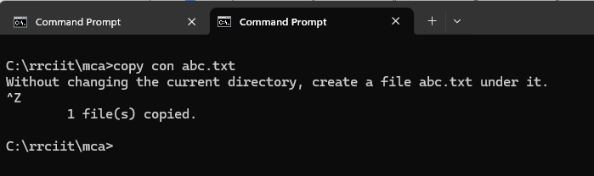

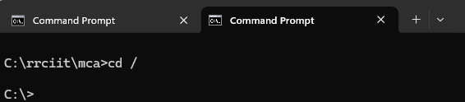

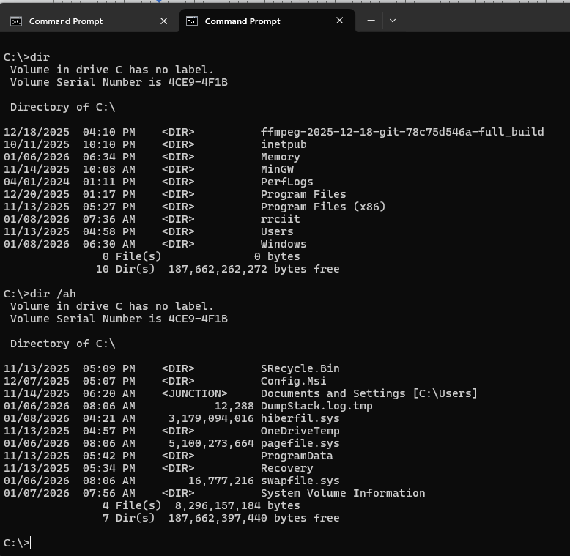

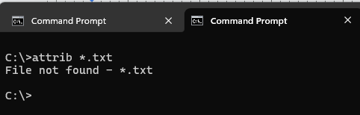

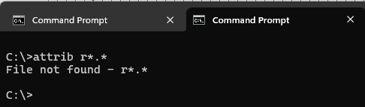

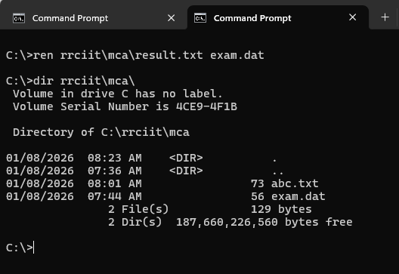

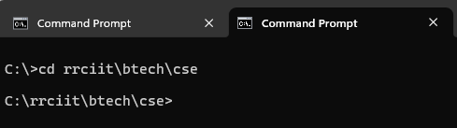

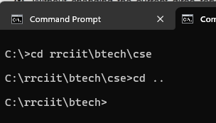

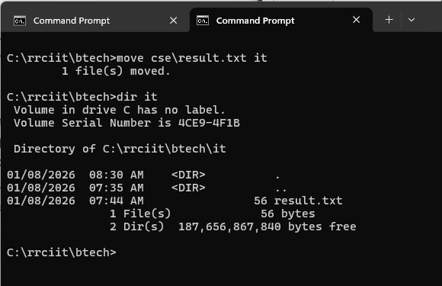

Hierarchical classification of Computer Memory
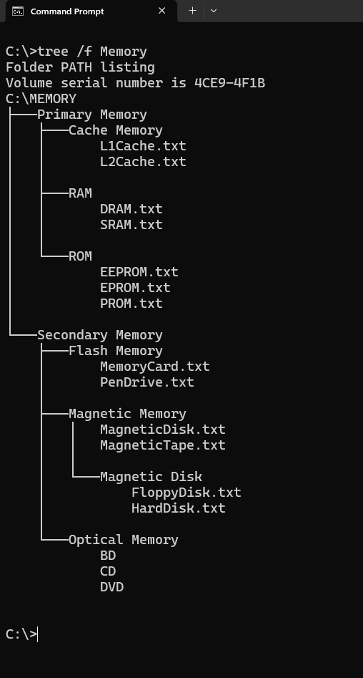
Primary Memory:
Cache Memory:
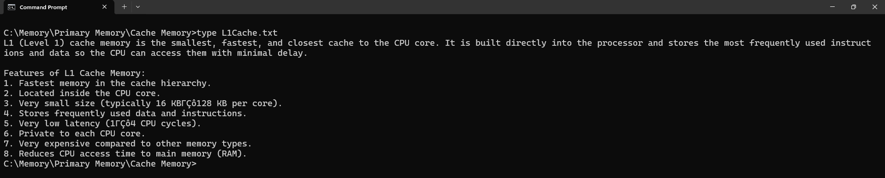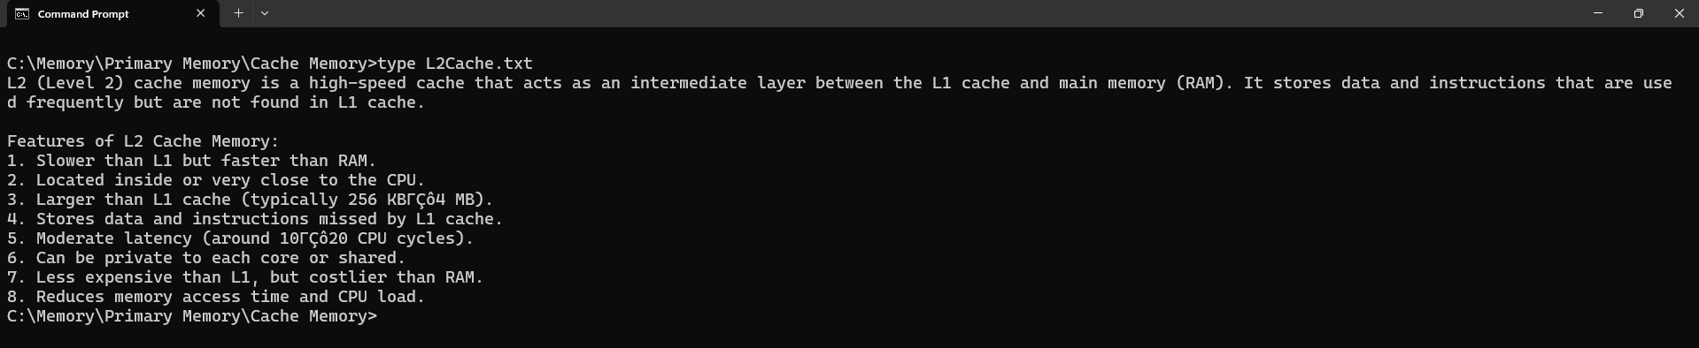

RAM
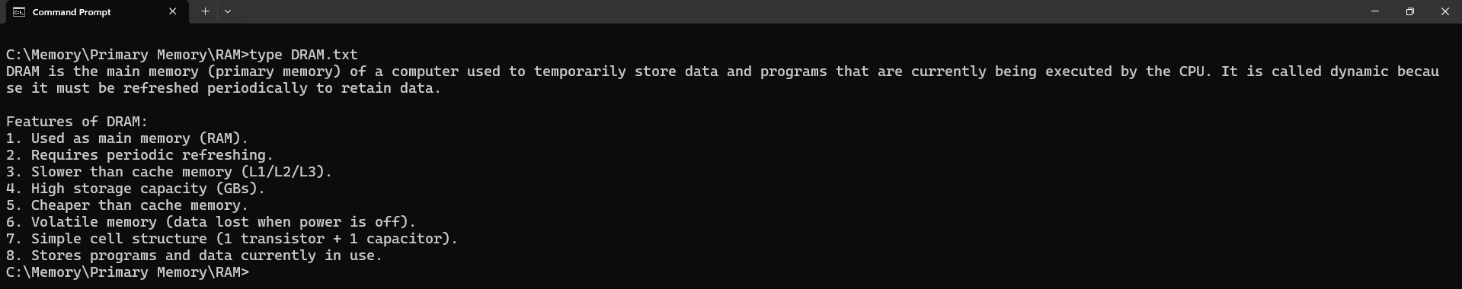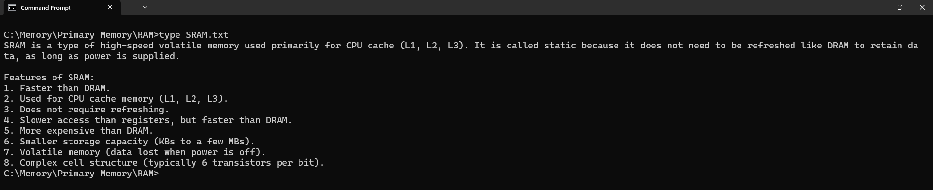

ROM
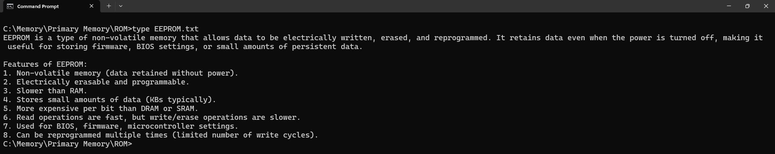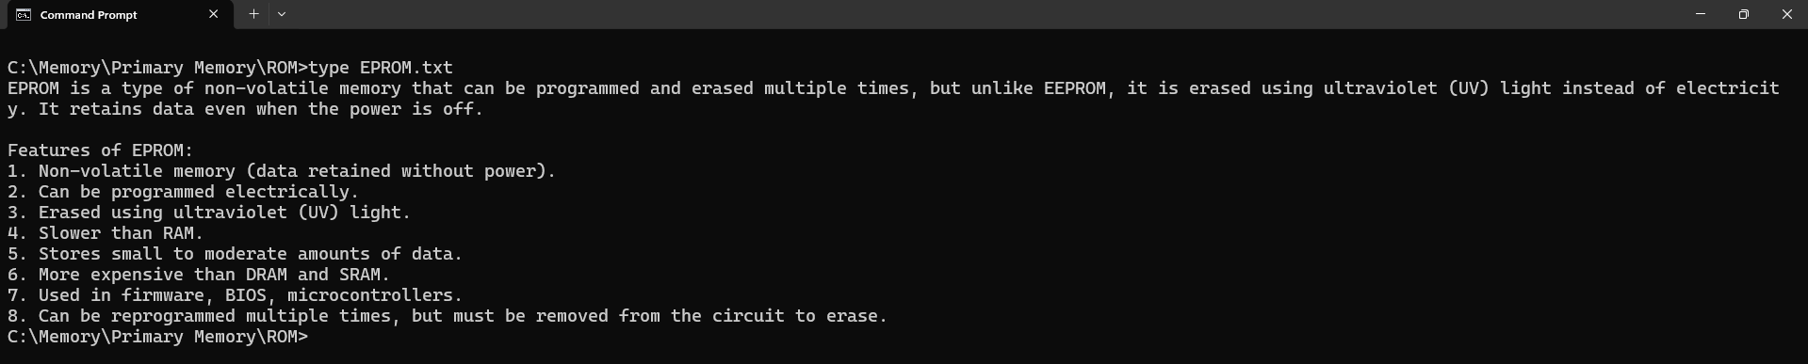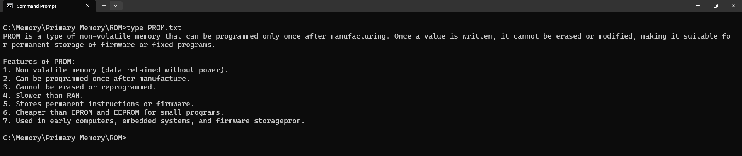

Secondary Memory
Flash Memory
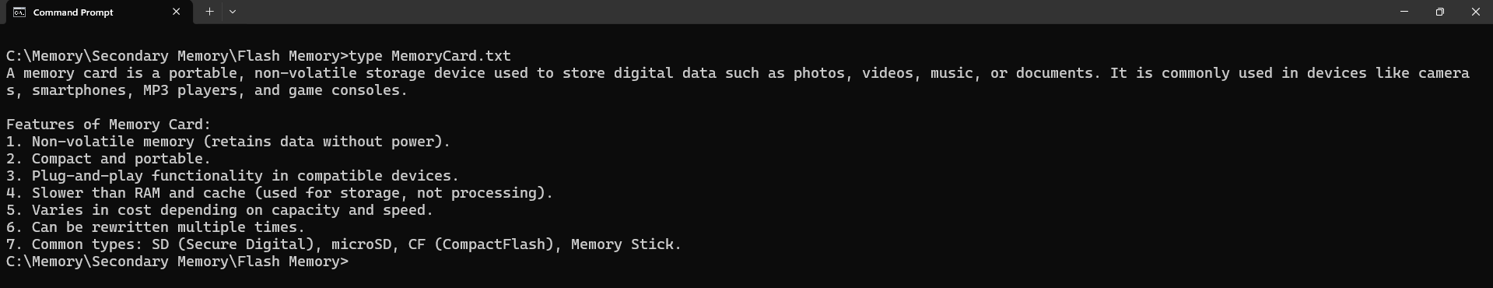
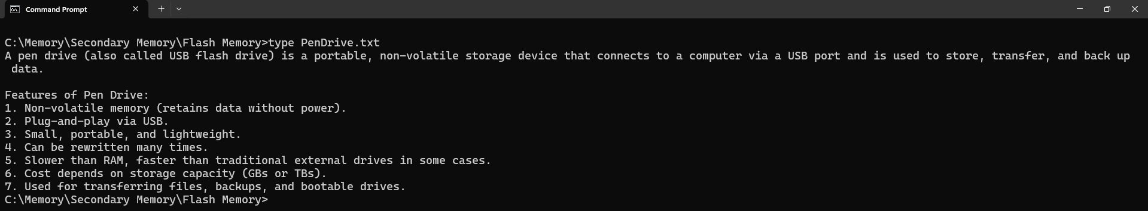

Magnetic Memory
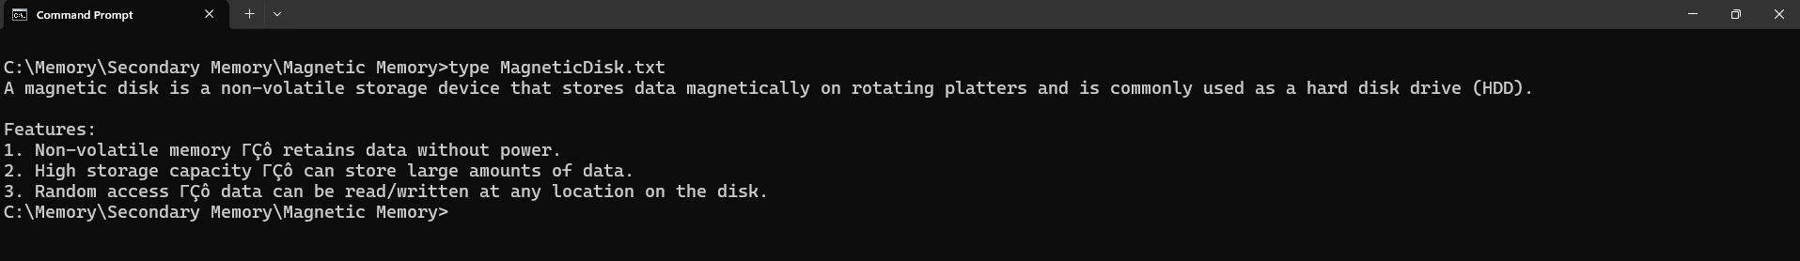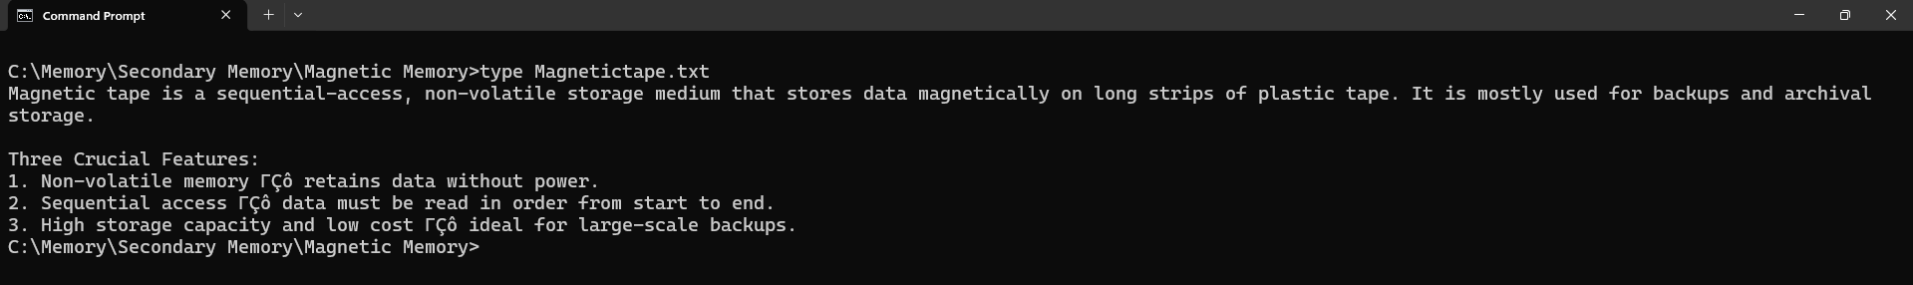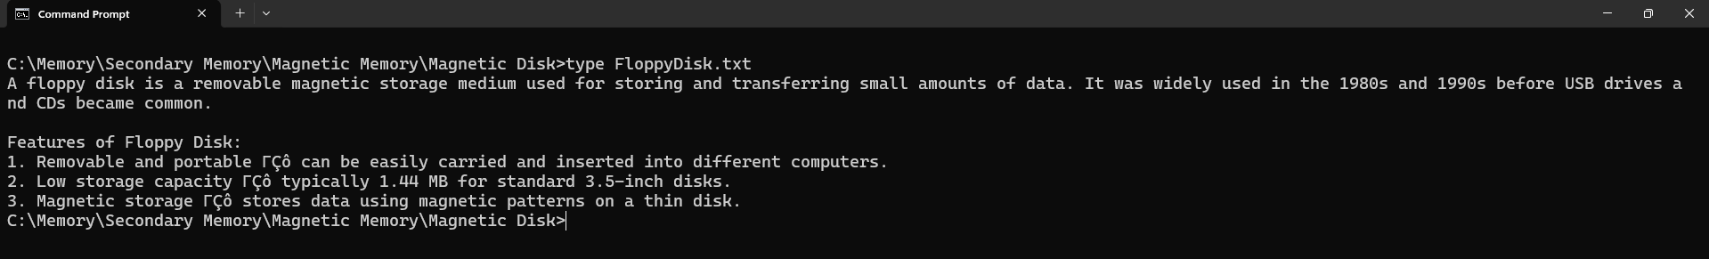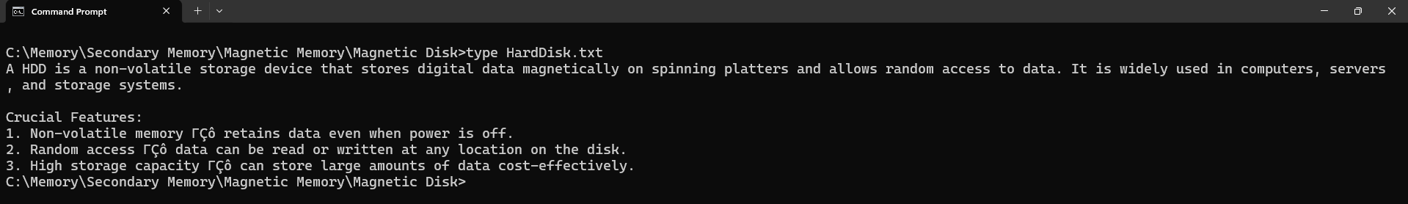

Optical Memory
