Consulta 1:

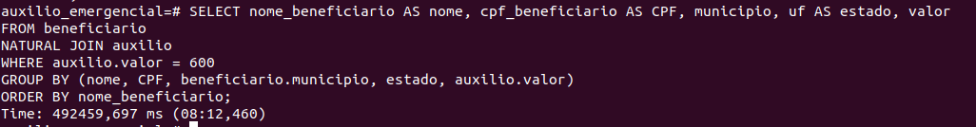

Consulta 2:
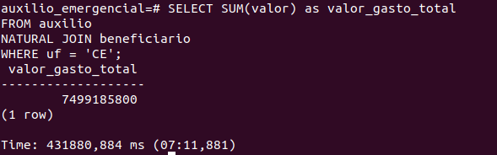

Consulta 3:

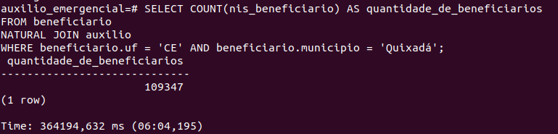

Consulta 4:

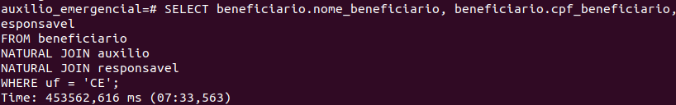

Consulta 5:

Consulta 6:

Consulta 7:

Consulta 8:

Consulta 9:

Consulta 10:

