Test name and objective | Endpoint & Method | Before treatment result | The result after treatment (Expected Status)
1. Register a new user | POST /api/auth/register | The path did not exist. | 201 Created with bcrypt password encryption
2. Prevent duplicate email registration | POST /api/auth/register | An internal error occurred in the database. | 409 Conflict with a clear message.
3. Valid login | POST /api/auth/login | unavailable. | 200 OK and return a valid JWT Token.
4. Incorrect password | POST /api/auth/login | unavailable. | 401 Unauthorized.
5. Protected path without a token | GET /api/auth/me | The route was open to the public. | 401 Unauthorized (No token provided).
6. Path protected by invalid token | GET /api/auth/me | The header is not validated. | 401 Unauthorized (Invalid/Expired token).
7. A customer is trying to add a product | POST /api/products | Anyone was allowed to add. | 403 Forbidden (Role customer rejected).
8. Admin adds product | POST /api/products | Allowed, but without identity checks. | 201 Created after verifying the Admin role.
9. Adding a product with a negative price | POST /api/products | It is accepted or results in a Database error. | 400 Bad Request via Input Validation.
10. Sending incorrect email addresses / blank fields | POST /api/auth/login | Uneven manual processing. | 400 Bad Request with a clear error matrix.
11. IDOR vulnerability scan | GET /api/users/:id | The customer reads the data of any other user. | 403 Forbidden to prevent unauthorized horizontal access.
12. Exceeding the limit of login attempts | POST /api/auth/login | Unrestricted guessing attacks. | 429 Too Many Requests after 5 incorrect attempts.
13. Request for a route that does not exist | GET /api/not-found | Disorganized response. | 404 Not Found via notFound wizard
14. Blocking the password_hash | GET /api/users | The entire hash_password field has been leaked. | 200 OK with the field permanently excluded from the response.
15. Protective Headings (Helmet) | GET / | The absence of security headings in the headers. | The appearance of headers such as X-Content-Type-Options and X-Frame-Options.

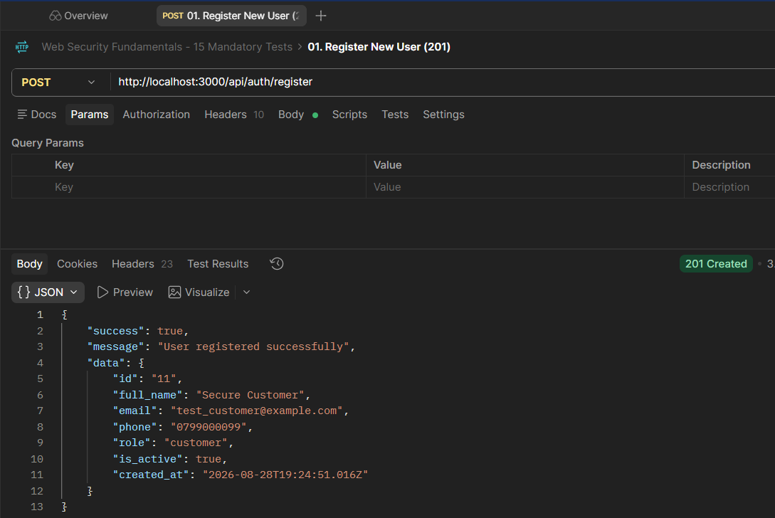
- Register New User (201)

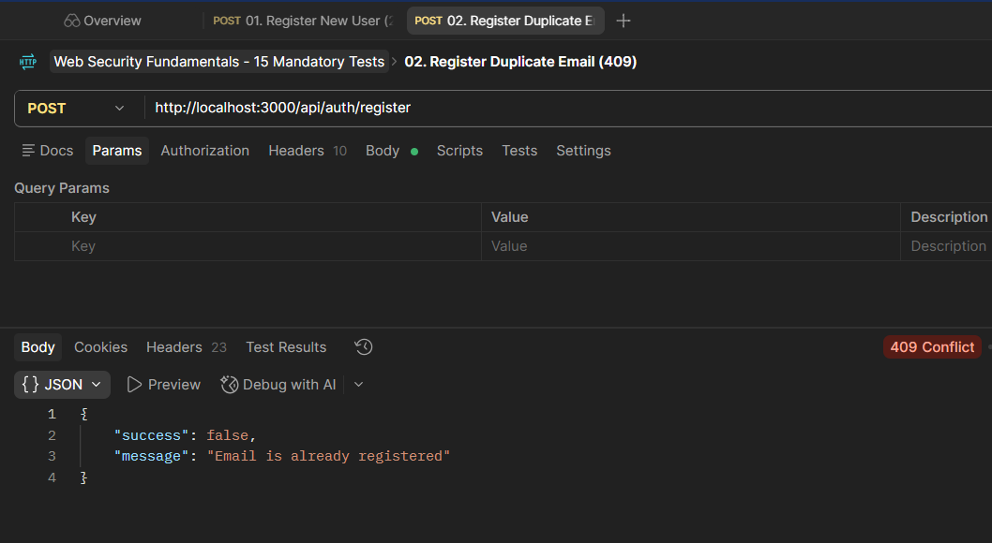
- Register Duplicate Email (409)

- Login Valid Credentials (200)
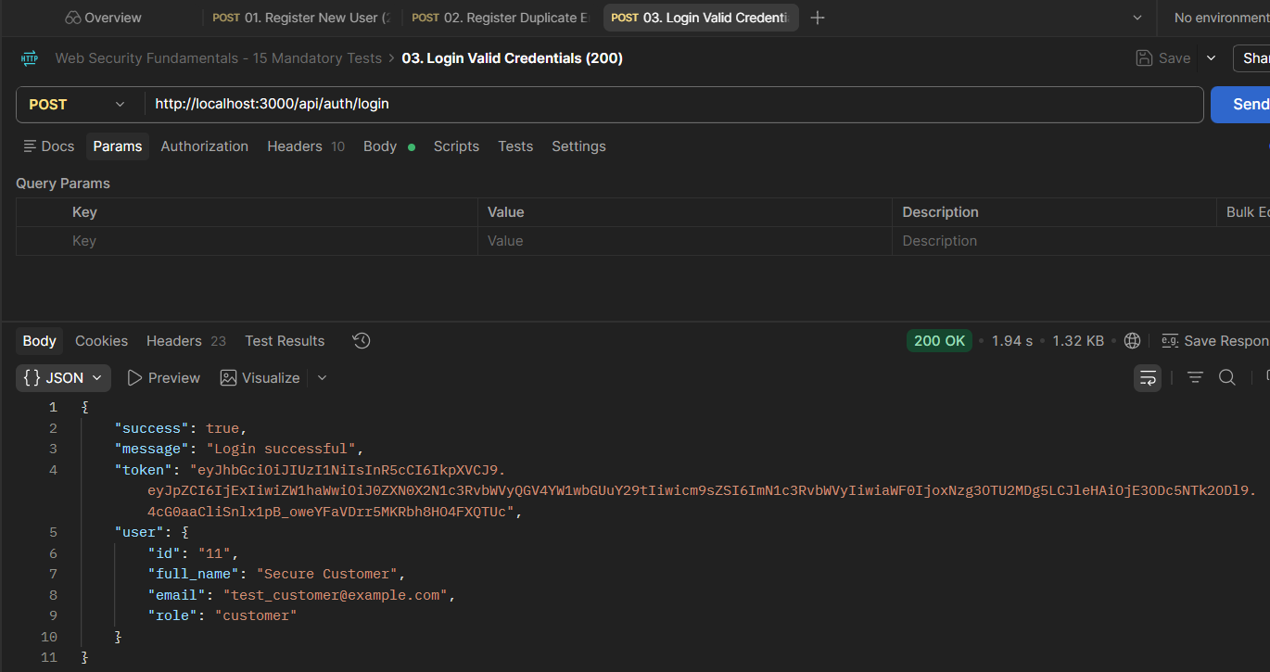

- Login Invalid Password (401)
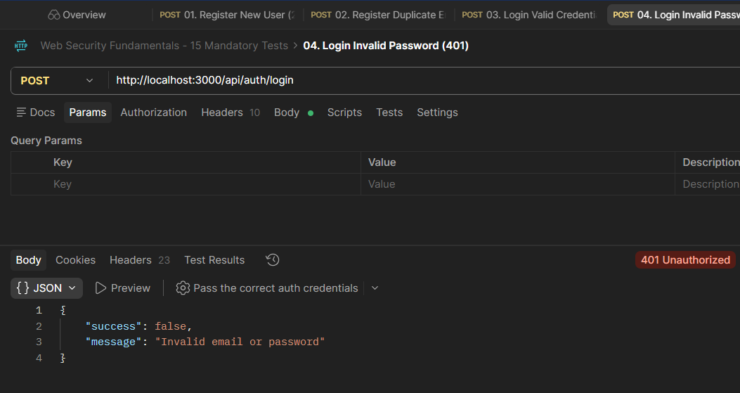

- Access Protected Route Without Token (401)
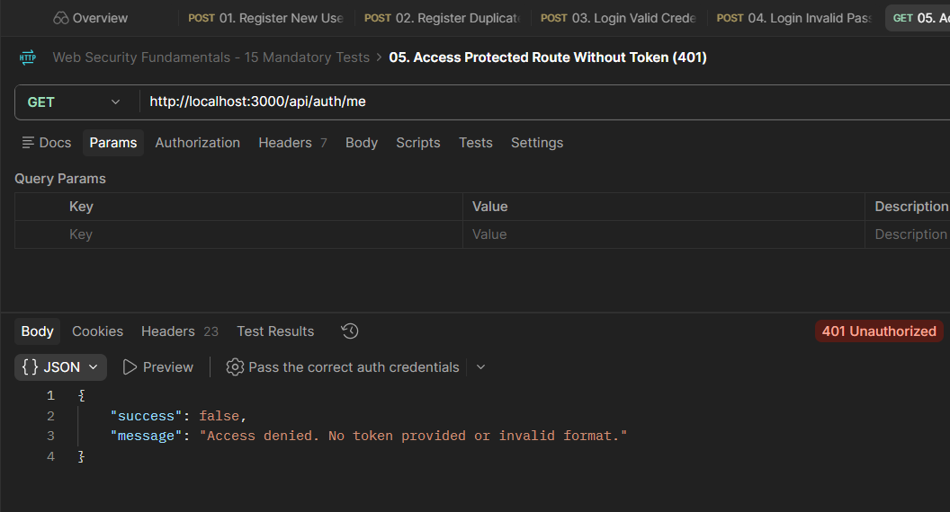

- Access Protected Route With Invalid Token (401)
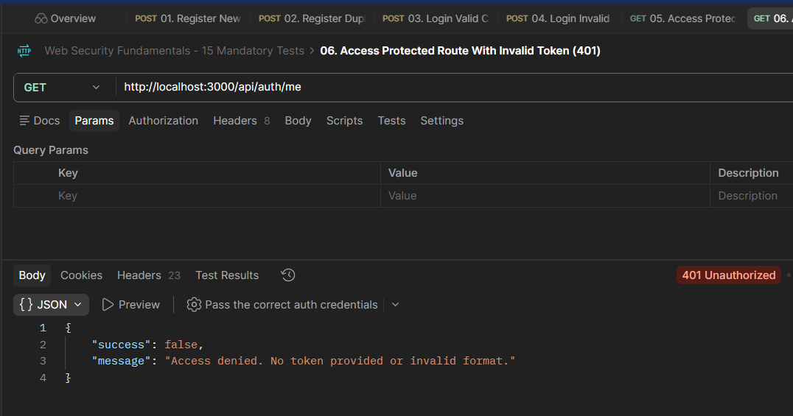

- Customer Creates Product (403)
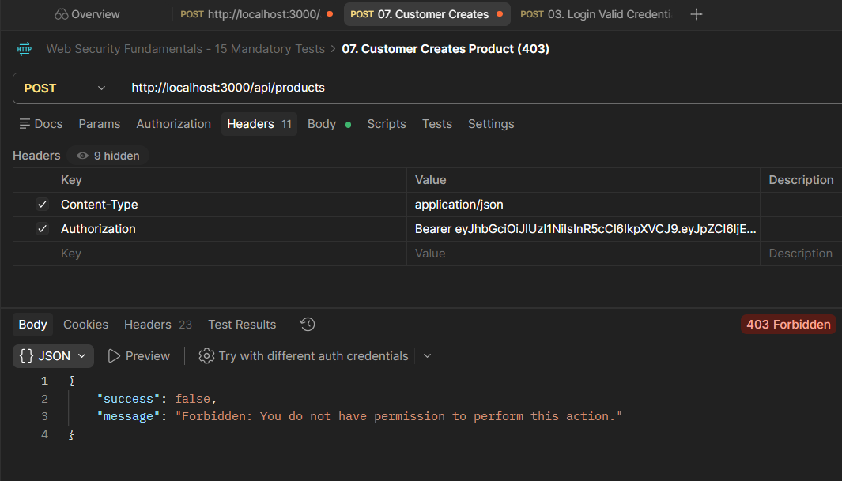

- Admin Creates Product (201)
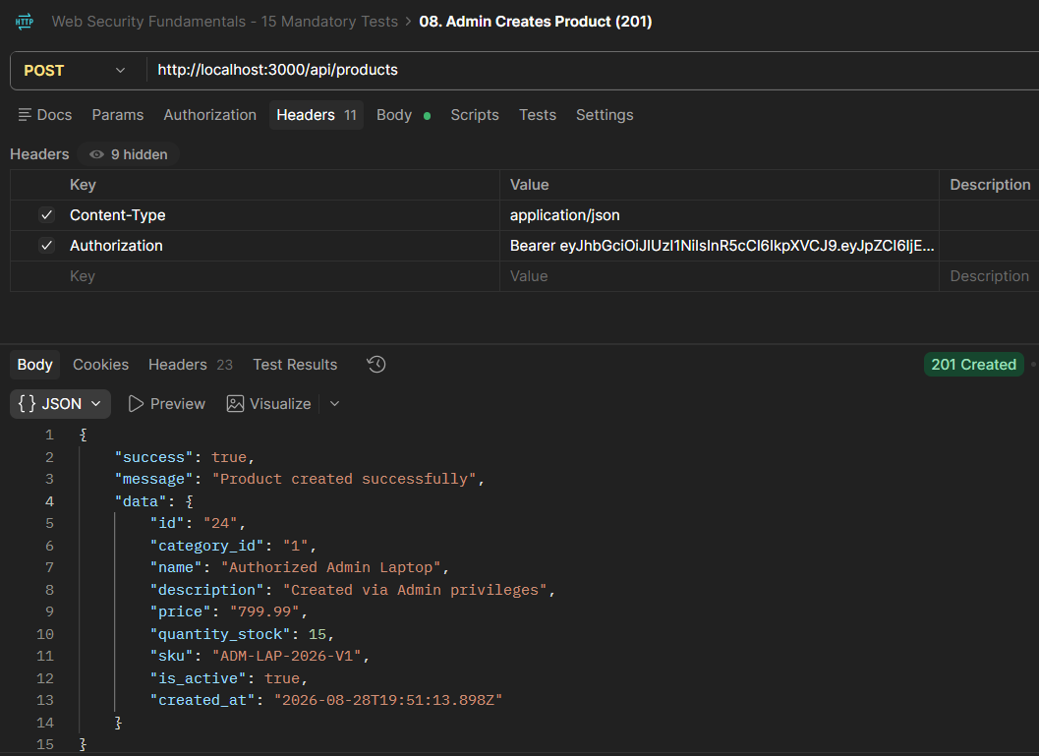

- Create Product Negative Price (400)
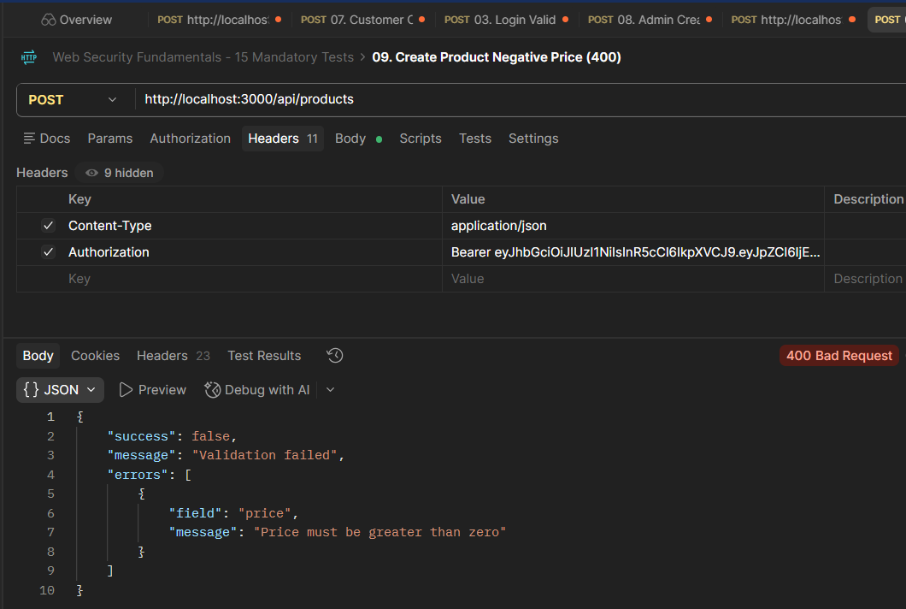

- Invalid Email or Missing Body (400)
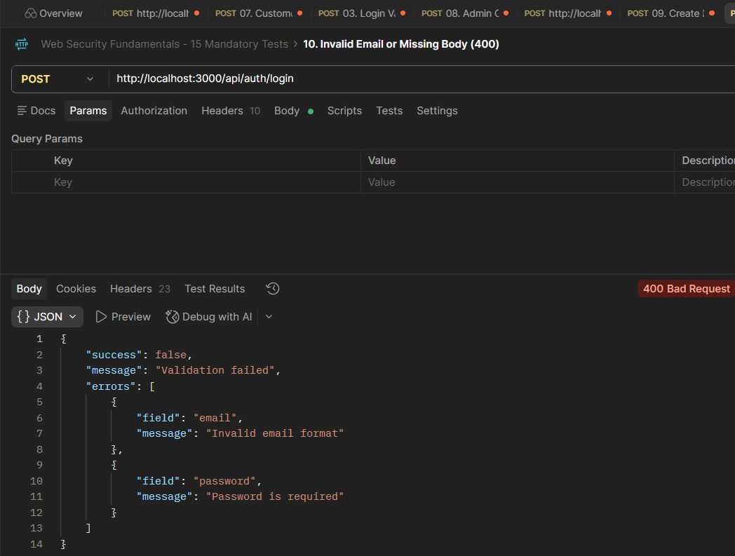

- IDOR - Customer Accessing Other User (403)
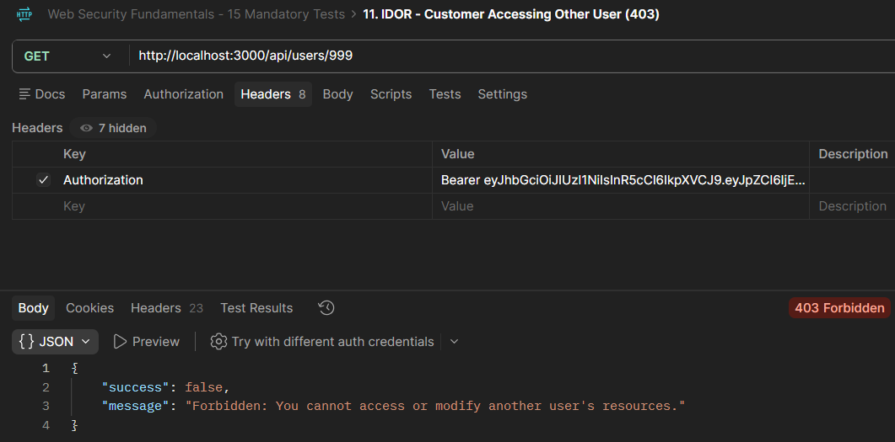

- Exceed Login Rate Limit (429)
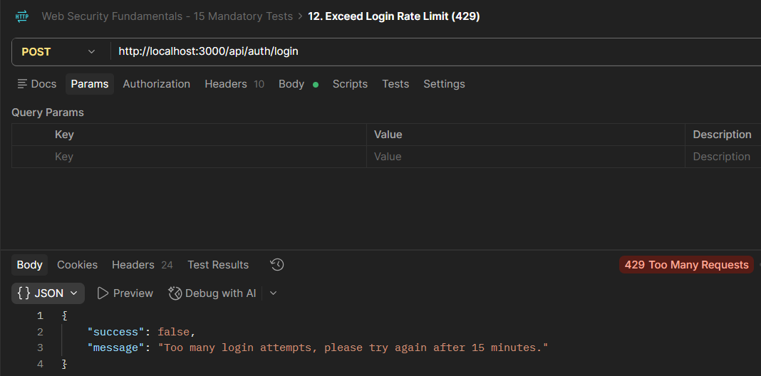

- Not Found Route (404)

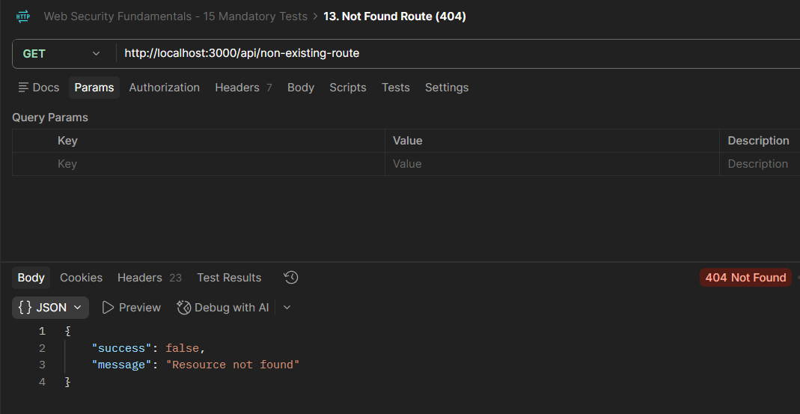

- Check No Password Hash Leaked (200)
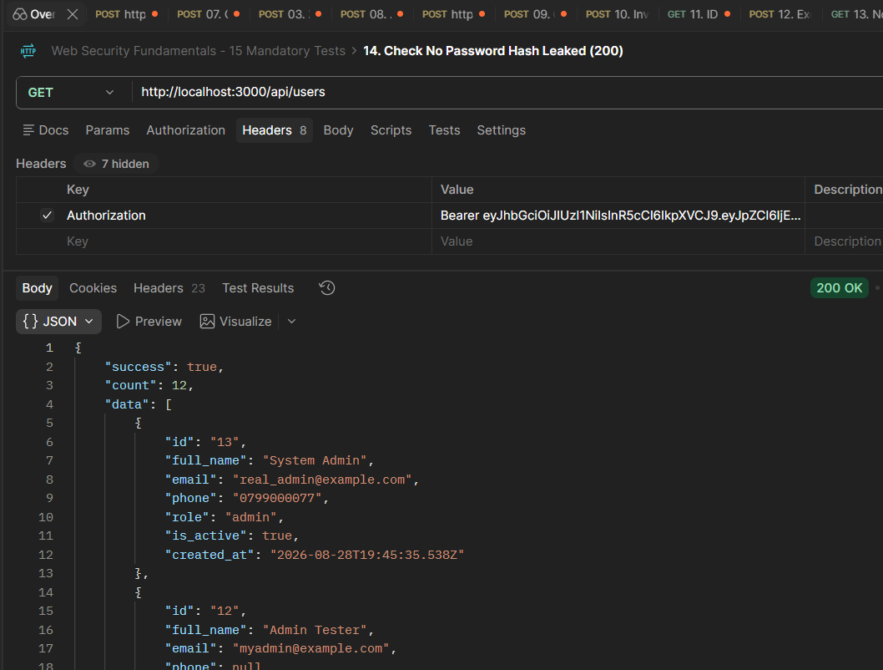

- Check Helmet Security Headers (200)
