Web Mining Project Winter-2025
Web Structure Mining
Student name :Ahmad Issa
Student ID:002230777
Group:FP I

  - 1-Data Preprocessing: Clean and structure raw data from social media platforms into a usable graph format. Students will need to handle data extraction, normalization, and transformation to prepare it for analysis.
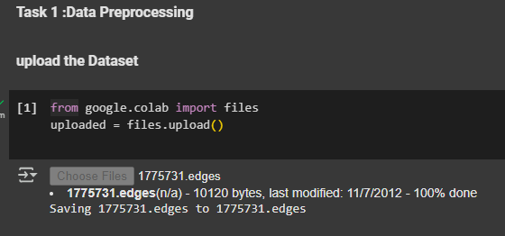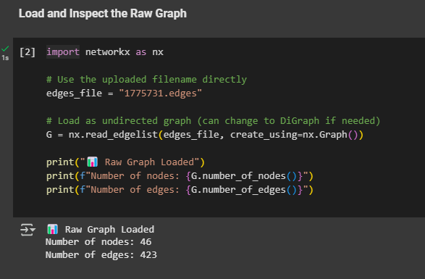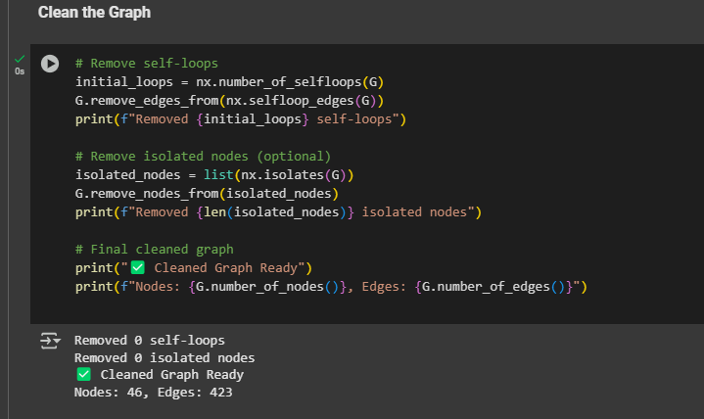

  - 2-Network Analysis: Apply graph theory concepts to identify central nodes (influencers) and clusters (communities) within the network. This may involve metrics like centrality, density, and modularity.

  - 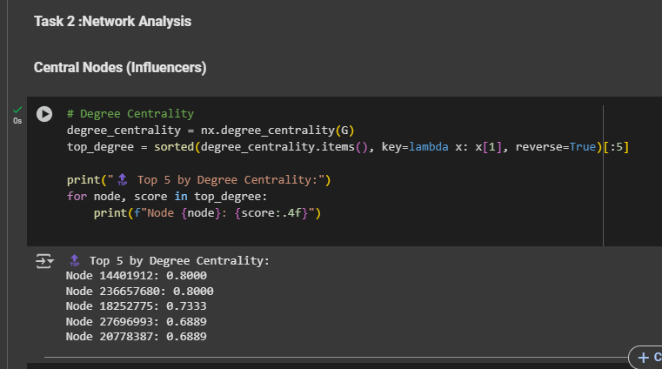

  - 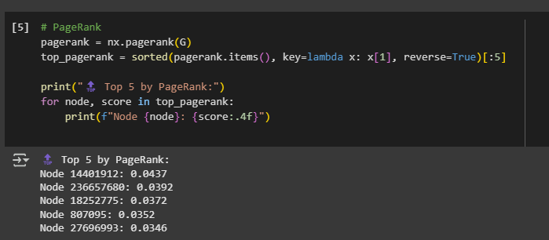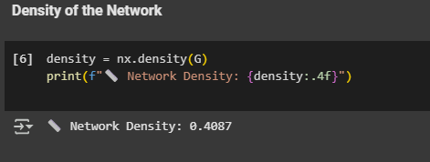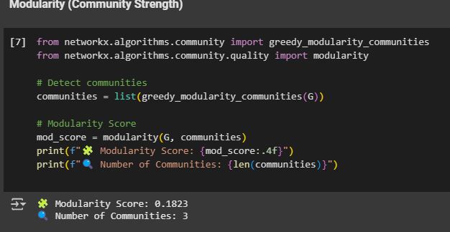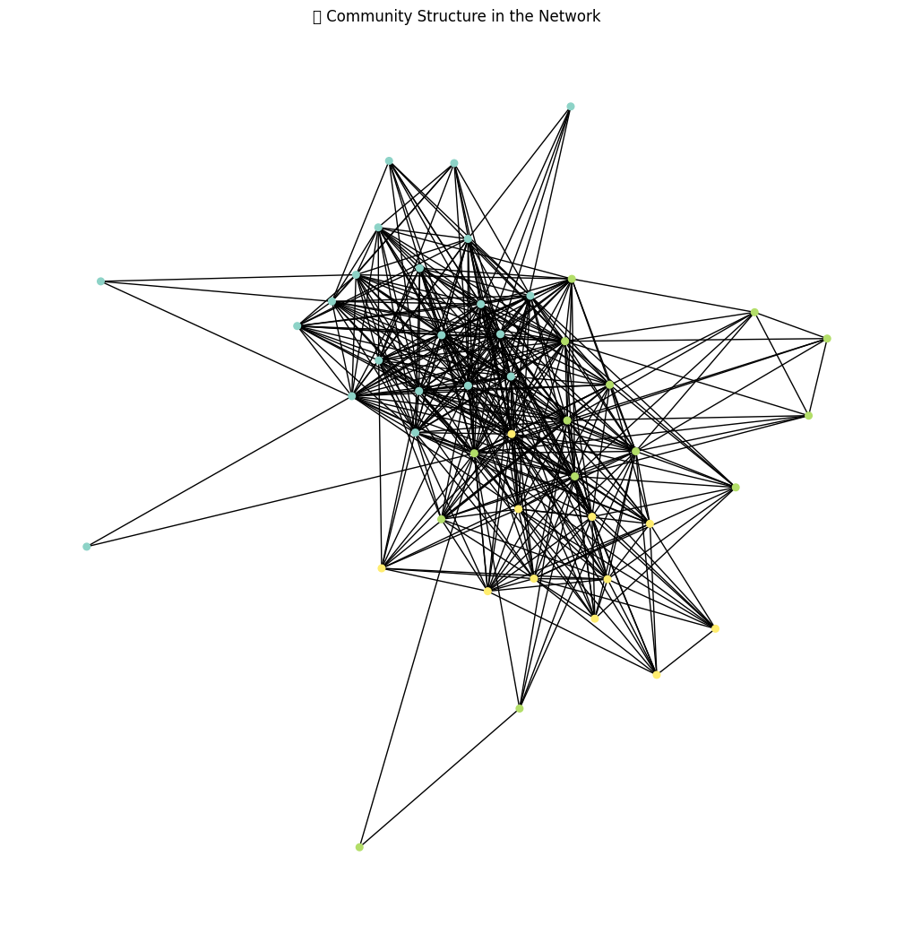
  - 3-Visualization: Create visual representations of the network that highlight community structures, influential users, and other relevant insights using libraries like NetworkX or igraph.
  - a-Visualize Community Structure:
  - 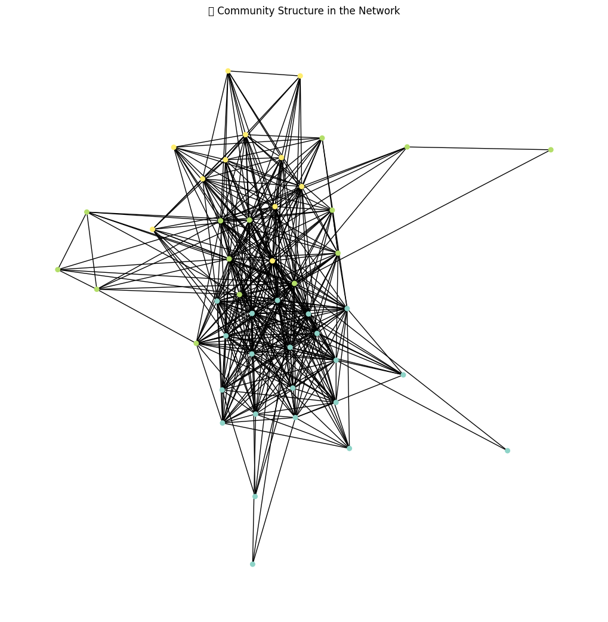
  - b-Visualize Influential Users High Centrality
  - 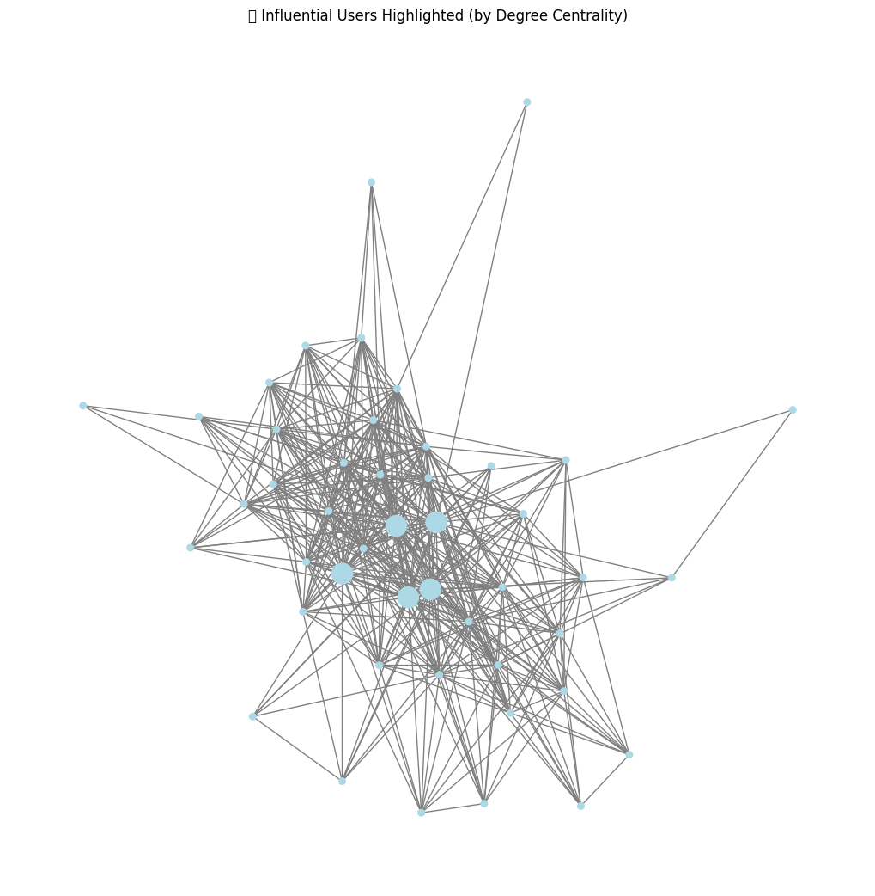c- Visualize the Entire Network with Labels for Top Users
  - 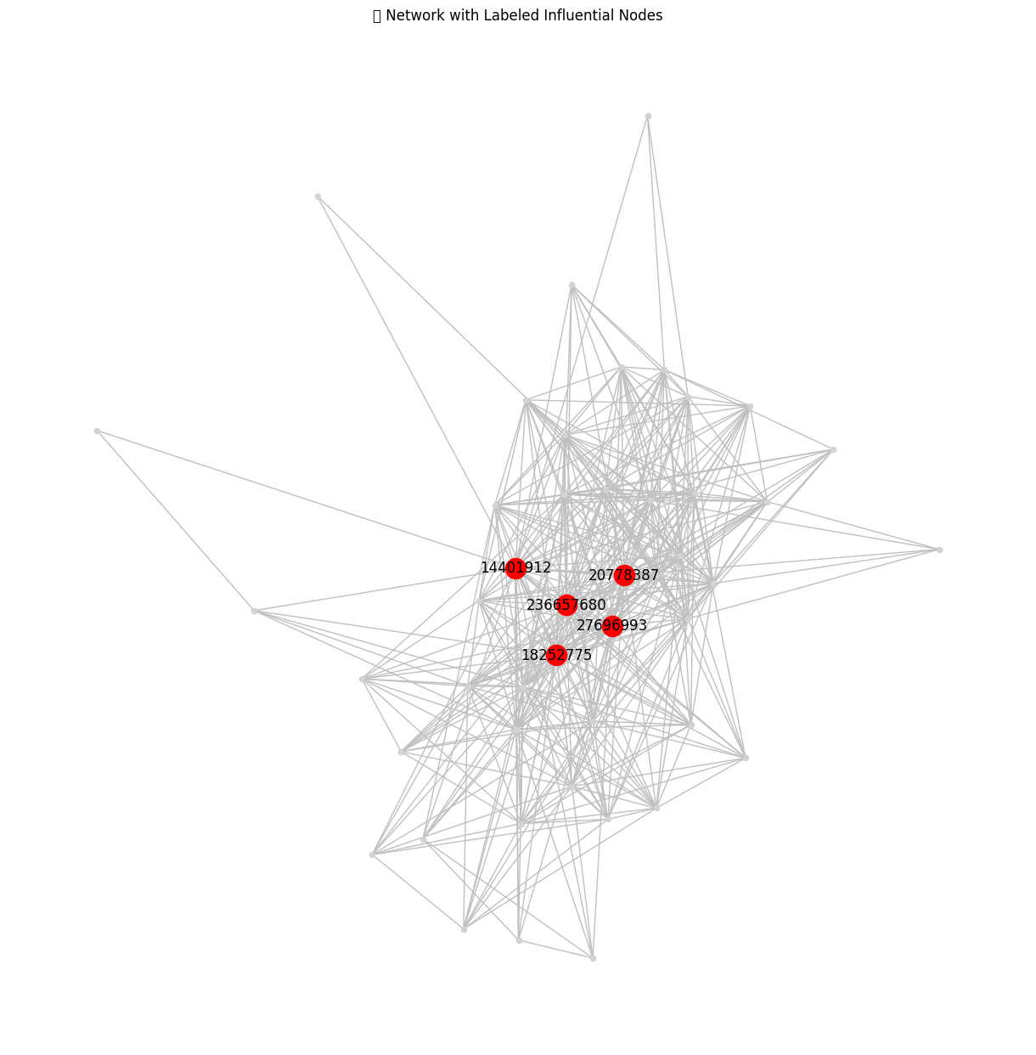
  - 4-Interpretation: Analyze the results to provide insights into the social structure of the network, discussing the roles of identified influencers and the characteristics of the communities.

Network Summary
- Total Nodes: 46
- Total Edges: 423
- Density: ~0.4087
➤ This indicates a moderately dense network, meaning many users are directly connected, suggesting strong interaction or interest overlap in the ego network.
Influential Users
Using degree centrality and PageRank, we identified the top influencers:
- Node 14401912 (Highest in both Degree Centrality and PageRank)
- Other top nodes: 236657680, 18252775, 27696993, 20778387
These nodes:
- Have the most connections (degree centrality)
- Are well-connected to other influential nodes (PageRank)
- Likely play key roles in information flow, possibly acting as hubs or bridges between user clusters.
In the labeled network plot, these nodes are highlighted and placed toward the center of the structure, indicating their central roles in the network.

Community Structure
- Number of Communities Detected: 3
- Modularity Score: 0.1823
➤ This shows moderate community structure — the network is not highly modular but still has visible clusters.
From the community visualization:
- Nodes are grouped by color.
- Each group is more densely connected internally, representing users with tighter mutual interactions.
- The graph also shows inter-community links, indicating that while users group into circles, there’s still interaction across boundaries.
Social Insights
- The network appears to reflect a core-periphery structure: a central set of highly connected influencers surrounded by moderately active users.
- The influencers act as bridges across different communities, suggesting they are important for cross-group communication or visibility.
- The structure likely reflects a real-world scenario of topic leaders or popular figures in a Twitter circle who connect distinct subgroups (e.g., professional vs. fan networks).
- Final Takeaway
- The analysis successfully reveals key influencers and community structures within the Twitter ego network. The moderate density and low modularity suggest the ego's followers interact frequently but are not strongly divided into separate groups. Influential users like node 14401912 play a vital role in connecting and potentially shaping the dynamics of the entire social structure.

