Contents

Introduction 3
1. Accessing the Web App and Logging In 3
2. Registering 4
3. Navigation 4
4. Using the Machine 6
5. Cart Management 8
6. Making a Payment 9
7. Viewing Your Receipt 12
8. Downloading Your Receipt 13
9. Automatic Stock Updates & Alerts 14
10. Card Payments 14
11. Transaction History Viewing 17
12. Smart Recommendations 19
13. Analytics 21
14. Admin Stock Controls 24
15. Troubleshooting & Common Issues 27
16. Future Enhancements 28
17. Contact & Support 28

Introduction

This guide explains how to use the Virtual Vending Machine Web App, covering everything from selecting items to making payments and viewing receipts. The system is designed to provide a smooth and intuitive vending experience with automatic stock management, real-time payment processing and more.

Accessing the Web App and Logging In

To access the vending machine system, open your browser and enter the following URL: http://localhost:8080/login
This will take you to the Following Login Page:
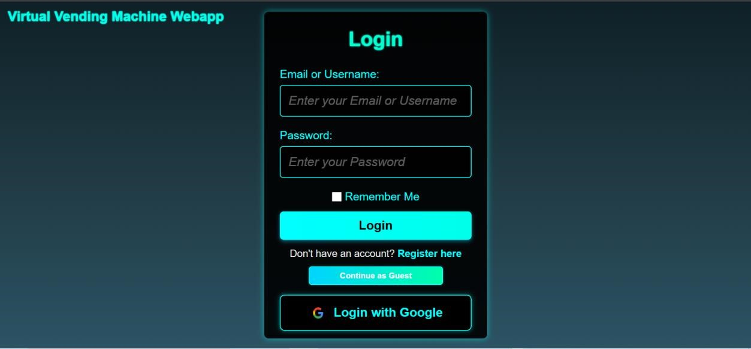

Now proceed to log in with your existing credentials. If you don’t have any credentials, you can easily register by clicking “Register Here”.
You may also prefer to log in securely through Google, if so click the “Login with Google” button.
If you wish to simply browse the basic features of the system without having to log in or register you can click “Continue as Guest” (Note: some advanced features aren’t available for guests).

Registering

If you have chosen to register, you will see a page like this:
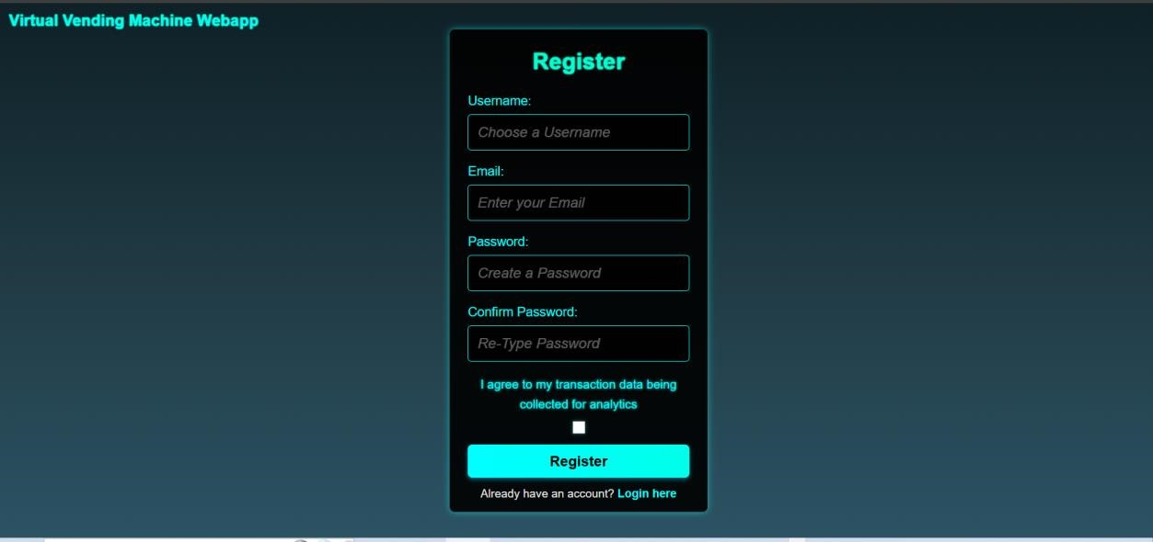
To register simply choose a username, enter your email address (ensure it’s a valid email) and create and confirm a password. You also need to tick the box before registering.

After successful registration you will be redirected to the Login page where you can now log in with your new account.

Navigation

After a successful login you will now be on the Home page.
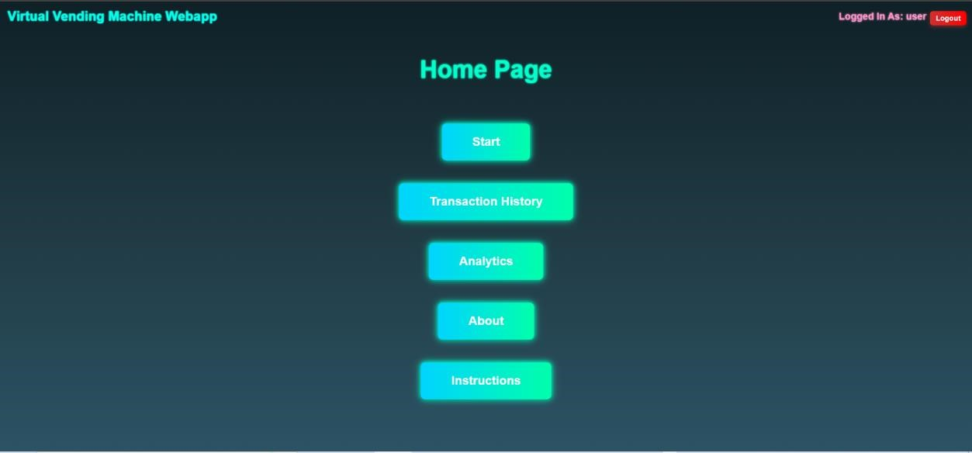

Select one of the buttons to choose what to do next. The About button takes you to a page with general information about the system. The instructions button will take you to a page where you can view an interactive version of this exact User Manual in case you need quick access to it. The Start button will take you to the main page for using the Vending Machine.

Guest users will not have access to the “Transaction History” or “Analytics” page.
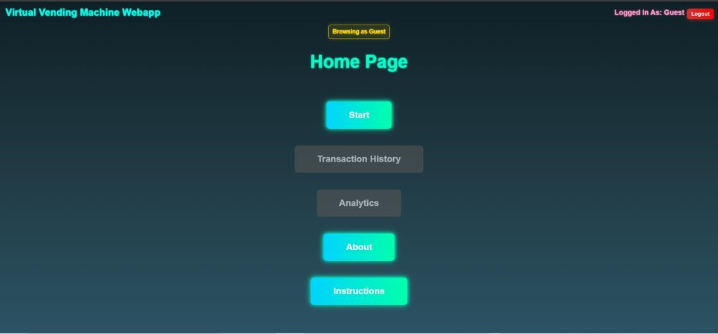

Using the Machine

When on the main page you are free to explore the products on offer inside the Vending Machine. Your Cart is displayed on the right side of the machine and there are instructions for using the machine on the left side of the page.
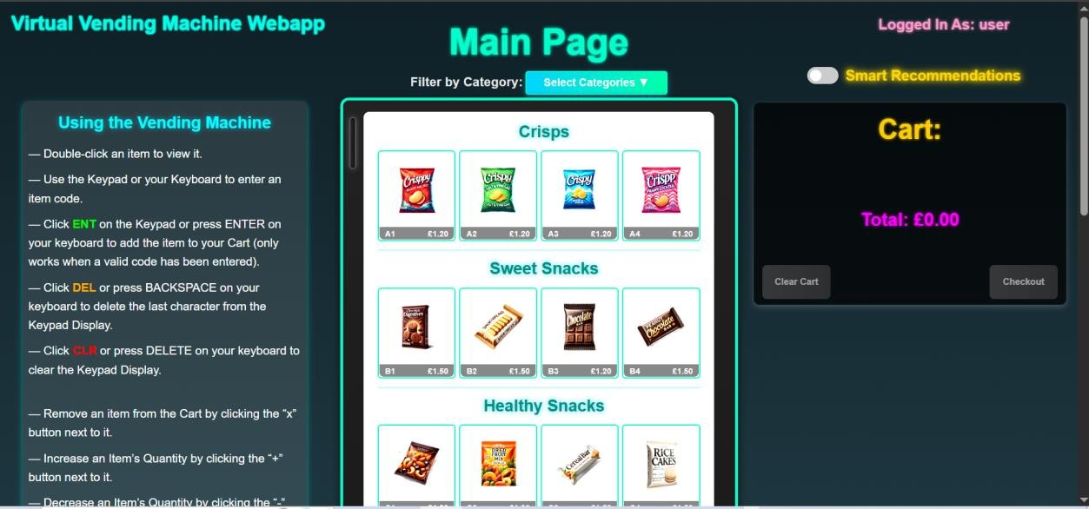

Use the category filtering dropdown menu to filter the vending machine view between categories.
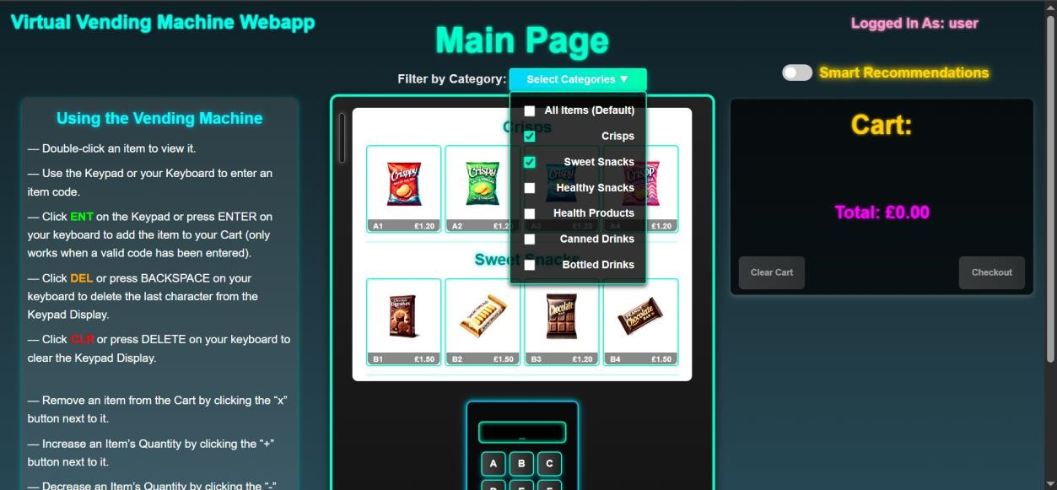

For an enhanced view of an item and all it’s details you can double click any item.
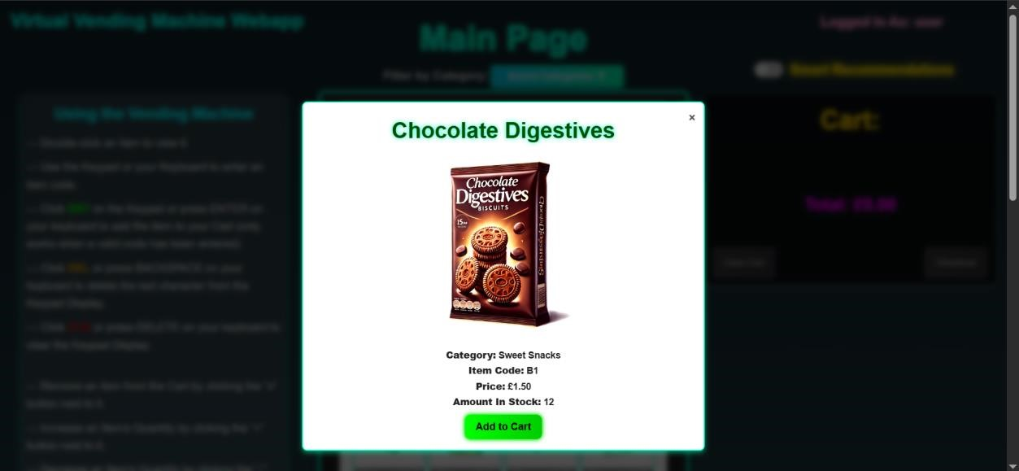

When you are ready to start purchasing items, you can either add items to the cart using the “Add to Cart” button inside the enhanced item views or use the Virtual Keypad at the bottom of the machine (click the buttons or enter the keys directly from your keyboard):
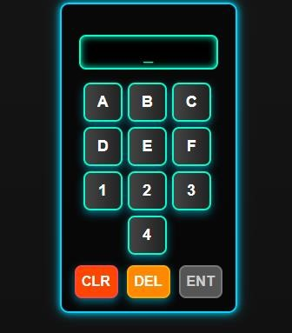

Enter the relevant Item Code of the Item(s) you want, using the Keypad keys. When a valid code has been entered, the ENT button will become active. Press this button or ENTER on your keyboard to add the chosen item to your cart. If you enter the wrong code, you can use the DEL button, or BACKSPACE on your keyboard to delete the last character in the display. Additionally, to clear the entire Keypad display, click the CLR button or use DELETE on your keyboard.
WARNING: The Keypad has been programmed to only accept a Letter entry followed by a Number entry; to help ensure you enter a valid Item code.

Cart Management

The cart is always visible on the page, displaying all selected items in real time. For each Item it displays the: Item Name, Item Code, Quantity and Price. It also displays the Total Cost of all Items in the Cart. All these automatically update with changes, e.g. the Total Price will dynamically increase/decrease when items are added/removed from the cart respectively.

Within the Cart, you can:
- See the Total Cost of all selected products.
- Remove an item from the Cart by clicking the “X” button next to it.
- Increase an Item’s Quantity by clicking the “+” button next to it.
- Decrease an Item’s Quantity by clicking the “-” button next to it.
- Clear the cart entirely before proceeding to payment by clicking the “Clear Cart” button at the bottom of the Cart.
WARNING: If you are trying to increase the Quantity of an Item to more than is available, an alert may appear at the top of the page, informing you that there is insufficient stock and you can’t add anymore to your Cart.
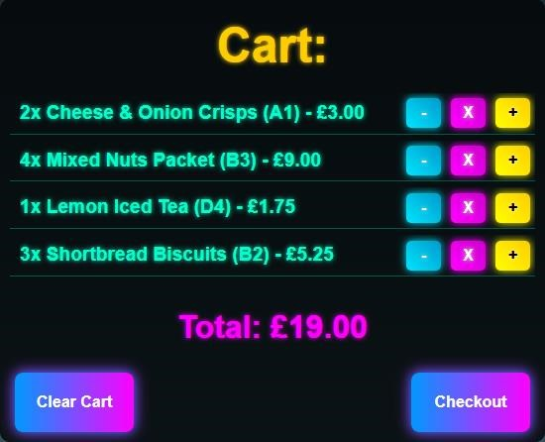

When you are happy with your Cart, and ready to pay, simply click the “Checkout” button to proceed to the Payment stage

Making a Payment

Once you enter the Checkout stage, your Cart will disappear and be replaced by the payment display:
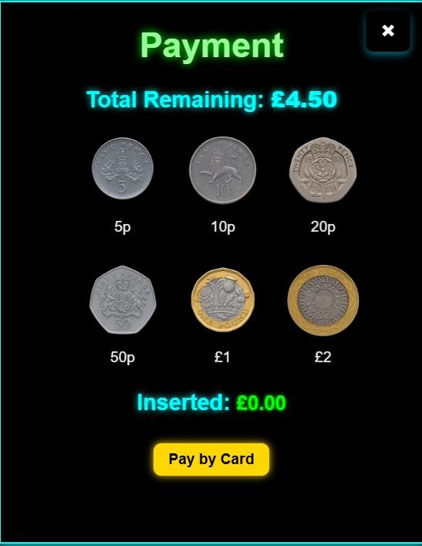

You are then free to use the coin buttons to make your payment. The system will track the amount inserted in real-time and automatically update the Total Remaining and Inserted amount as you enter coins. Coins will be visually animated into the machine
Once the payment matches or exceeds the total cost, the “Confirm Payment” button will become visible along with your change amount (if any):
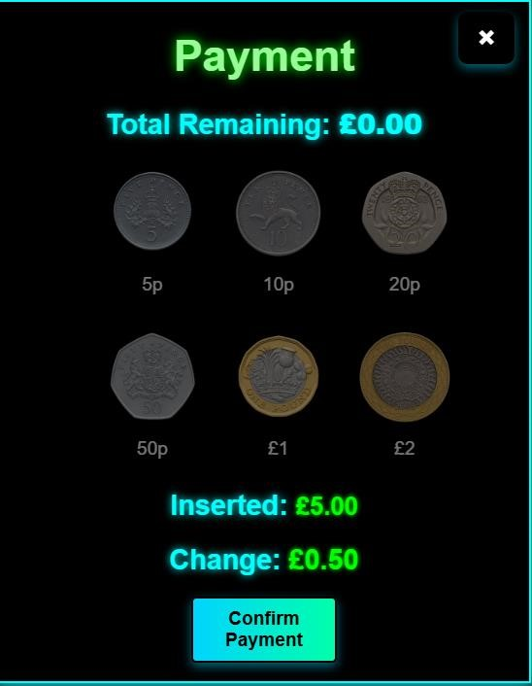

These will not appear until a sufficient payment has been made. When you are ready to pay, click the “Confirm Payment” button. You will be asked for confirmation through a popup alert and to complete the payment press ok.
This will display a popup on the screen confirming your payment and showing your items:

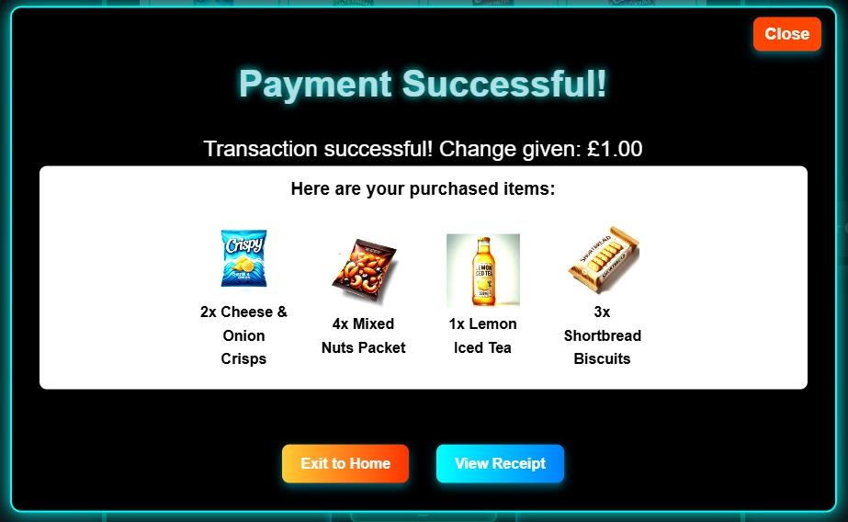

You may view this for as long as you require. When you are finished, if you wish to use the machine again immediately, press the “Close” button to remove the popup and the Vending Machine will be reset for you to use again. If you wish to exit to the Home Page instead, press the “Exit to Home” button. If you wish to claim your receipt first, see the next section.

Viewing Your Receipt

- After a successful transaction, the system generates a Transaction ID.
- If you wish to view your receipt: Click "View Receipt", or manually enter the transaction ID at: http://localhost:8080/receipts/{transactionID}
- The receipt includes:
  - Transaction details (ID, date, time).
  - Items purchased (name, quantity, price per unit, and total price).
  - Total Cost, Payment Received, and Change Given.

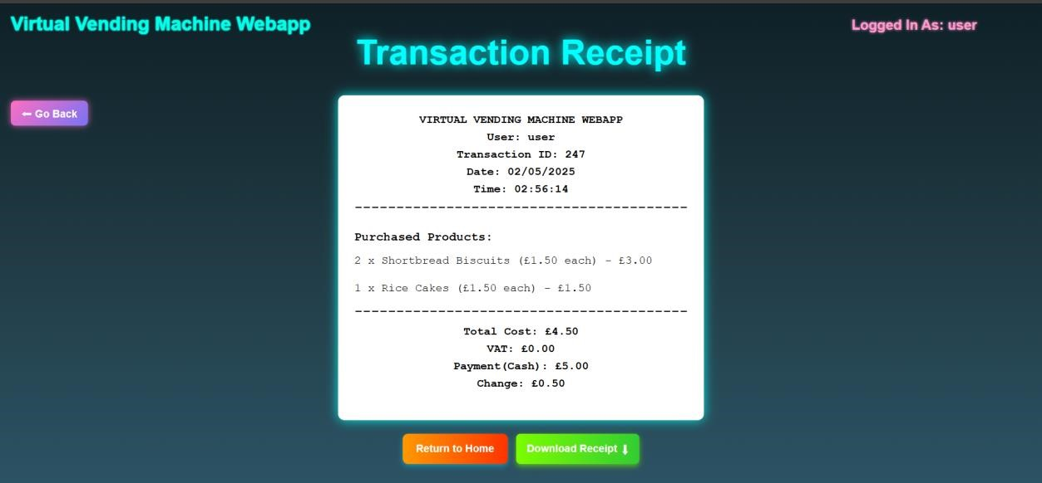

Downloading Your Receipt

If you are happy to view it then leave, click “Return to Home” when ready. If you wish to download a copy of the receipt, Click the "Download Receipt" button.
The receipt is downloaded as a .pdf file, formatted exactly like the on-screen receipt and is not editable.
The filename follows this format:
Transaction_{ID}_Receipt.pdf
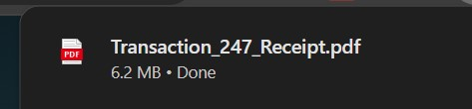

Open the file to view or print it.

Automatic Stock Updates & Alerts

If a product has auto restock turned on and goes below it’s threshold after a purchase is made:
A notification will appear saying:
Low stock for {Product Name(s)} has been detected and auto restocked!
This ensures that frequently purchased items always remain available.
The notification is logged in the console and immediately appears as an alert on the screen after a payment has been completed.
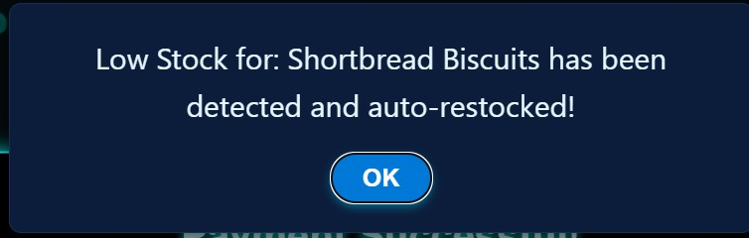
This will be explained further in the Admin Controls section.

Card Payments

In the payment menu, you may have noticed a “Pay by Card” button.

This is an alternative way to make a payment. Clicking it will redirect you to the Stripe Checkout page:
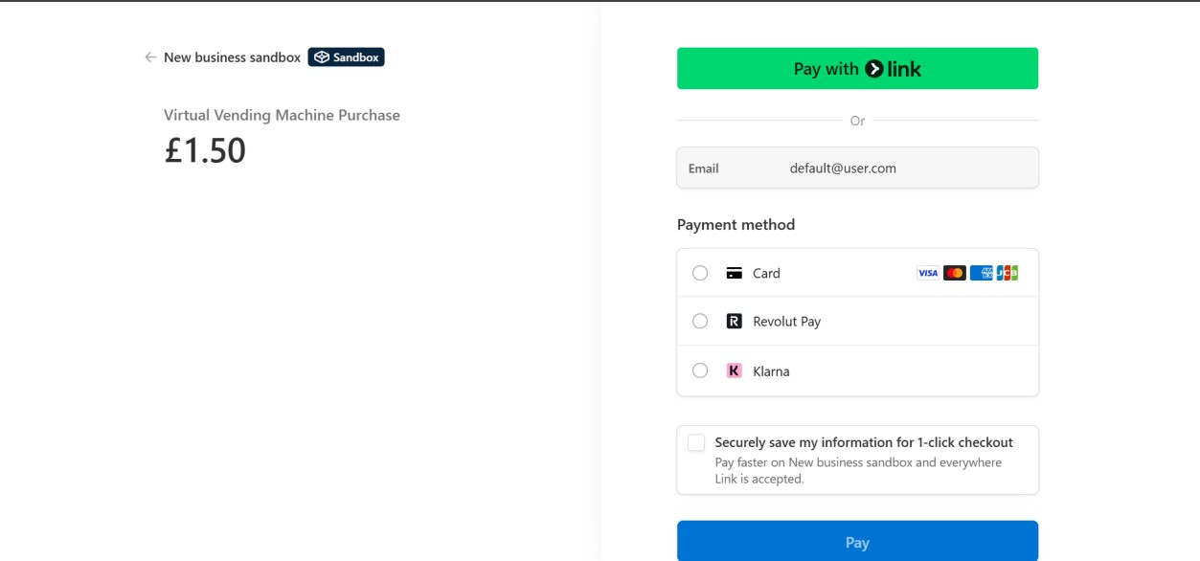
The required payment amount and your account email (or a default one for Guests) will automatically be filled in.
To complete the payment fill out the “Card” form:
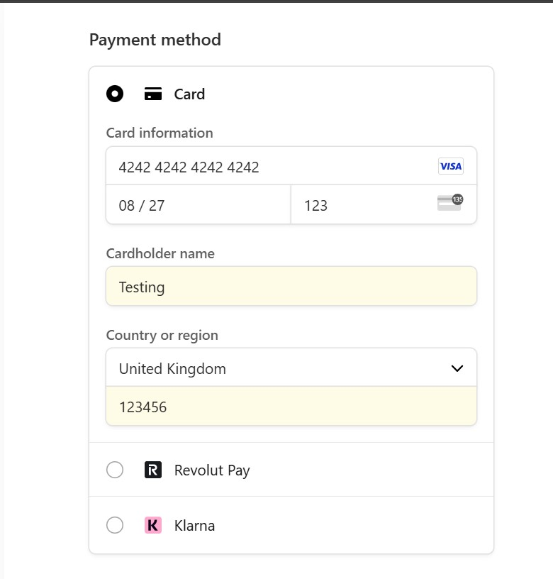
To fill it out you can use any random Name and Postcode. The CVC can be any 3-digit number, and the Expiry Date can be filled in with any valid date (any month and year AFTER the current date).
The Card Number MUST be: 4242 4242 4242 4242 (Stripe’s default test mode number)
After you have filled out the form if successful you will be redirected back to the main page and the payment will be completed as normal.
Note: this is Stripe test mode so payments aren’t real but the process accurately simulates a real payment.

Transaction History Viewing

(Guest Users can’t access this feature)
To view all of your previous transactions, you can visit the “Transaction History” page by clicking the button on the Home page. The page will look something like this:
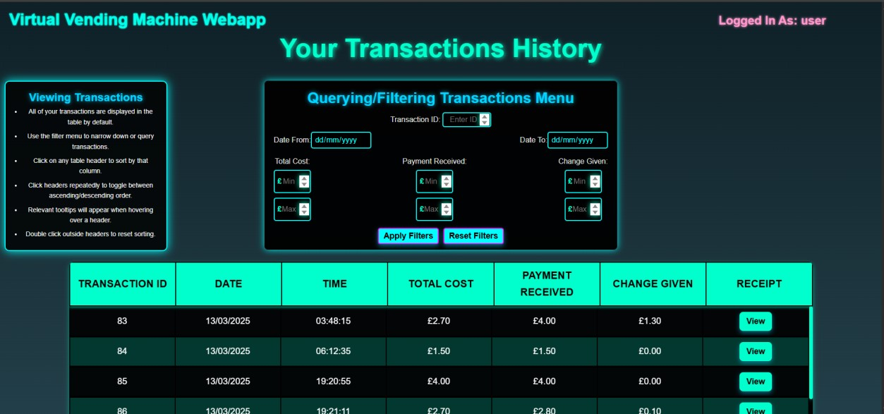
All of your transactions with their relevant details will appear in the scrollable, interactive table.

Sorting
Clicking any of the table headings will sort the table by that column ASCENDING:
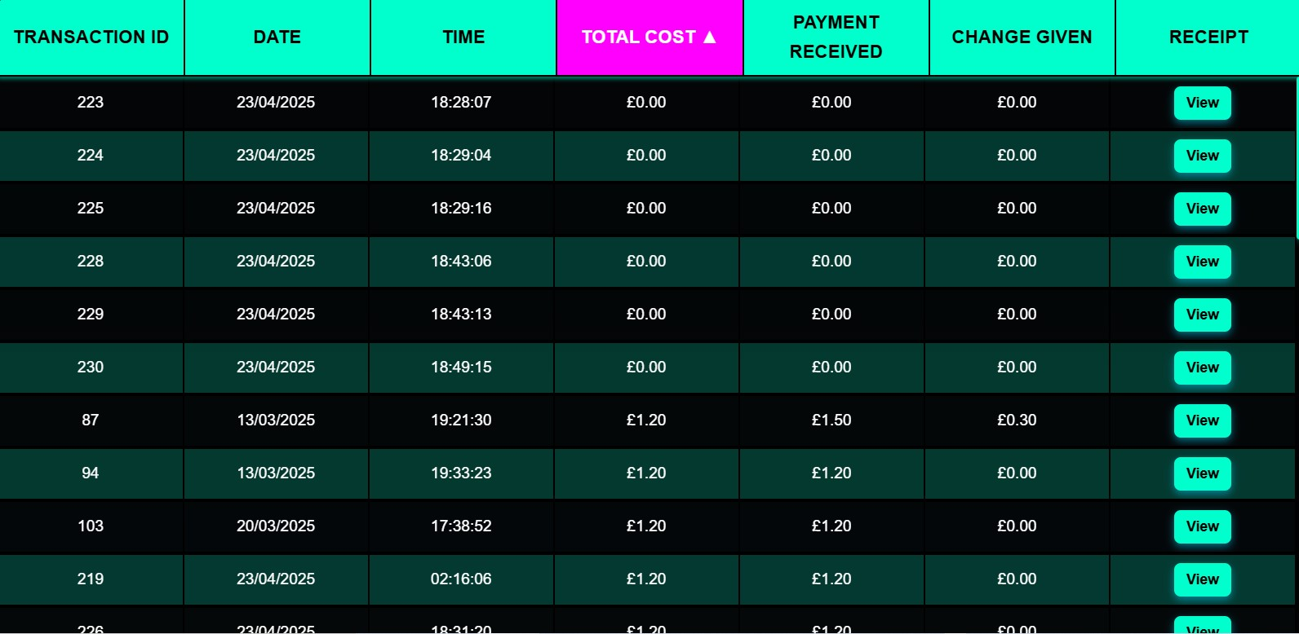
(For example: sorting by total cost ASCENDING)

Clicking the same heading will flip the sorting direction to DESCENDING:
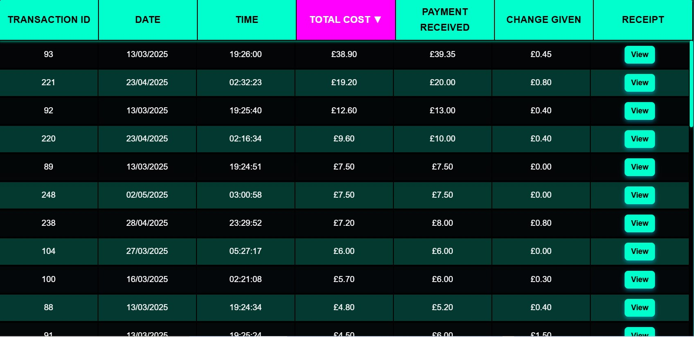

To remove the sort, double click anywhere outside of the table. By default, the table will be sorted by Transaction ID ASCENDING.

Filtering
You may have also noticed a filtering menu at the top of the page. You may use this to filter/query the table by various categories.
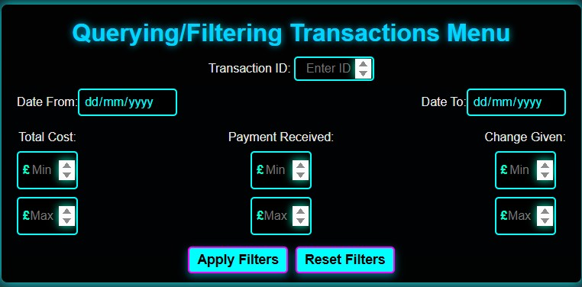

You may apply multiple filters at once. When you’re ready to submit your filters simply click “Apply Filters”. To reset all filters, click “Reset Filters”.

Note: Filtering and Sorting can be used together.

Receipt Viewing
To view a receipt for an old transaction, locate the transaction in the table (or filter by Transaction ID) then press the “View” button in the last column for that row. This will redirect you to the Receipt page, showing the correct receipt for that transaction.

Smart Recommendations

(Guest Users can’t access this feature)
On the main vending machine page there is a switch for Smart Recommendations.


Turning this switch on will generate some recommended items for you to purchase. These will be highlighted visually in the main vending machine display:
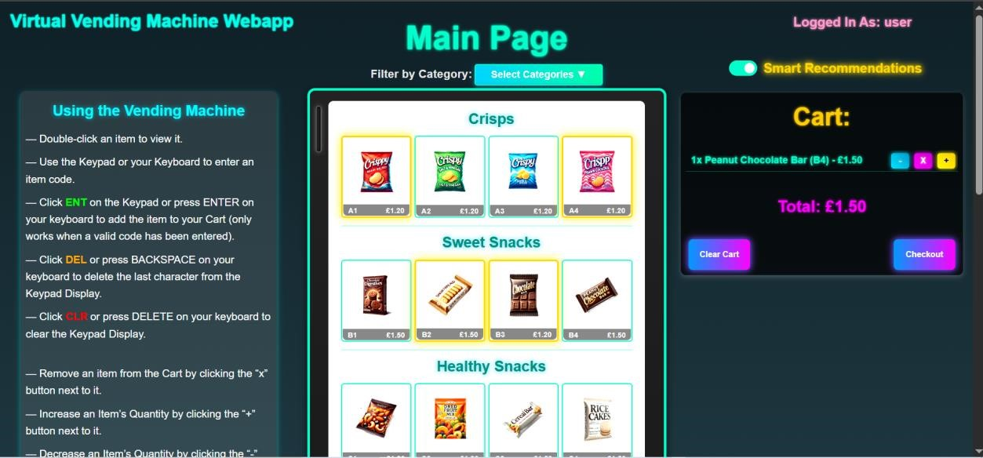
The recommendations are generated through a hybrid multi factor scoring intelligent algorithm in the backend code.

Hovering over each recommended item will give you a specific reason for recommending that item:
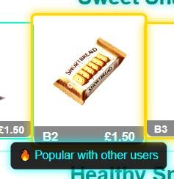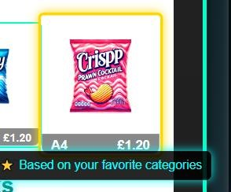

To turn the recommendations off, simply turn the switch off. Recommendations will change after every transaction you make since the algorithm learns from your purchase behaviour.

Analytics

(Guest Users can’t access this feature)
Clicking the “Analytics” button on the Home Page will direct you to the
Analytics page. This contains 5 visuals to help you analyse your purchase data:

Purchase Summary
These summary cards will show you an overall breakdown of your purchases history through picked out statistics.
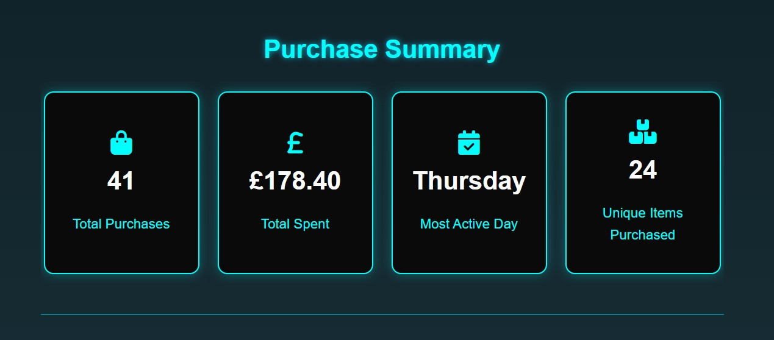

Purchase Frequency
This Bar Chart will show you how many purchases you have made over each month you have purchased in.
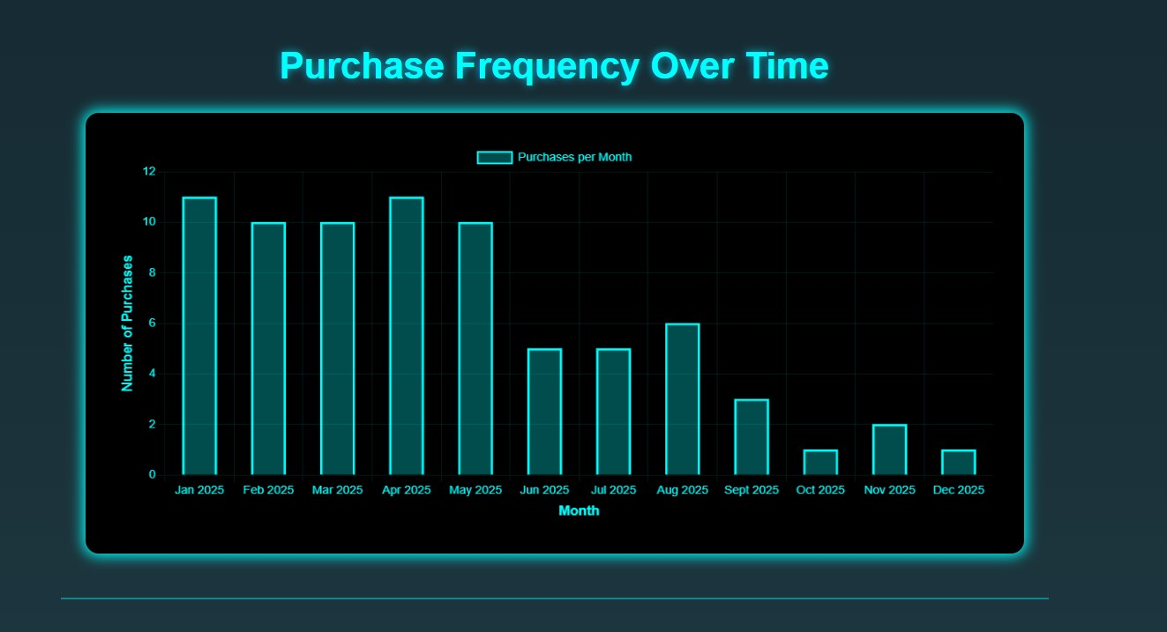

Spending Trend
This Line Graph will show you how your spending has evolved over time.
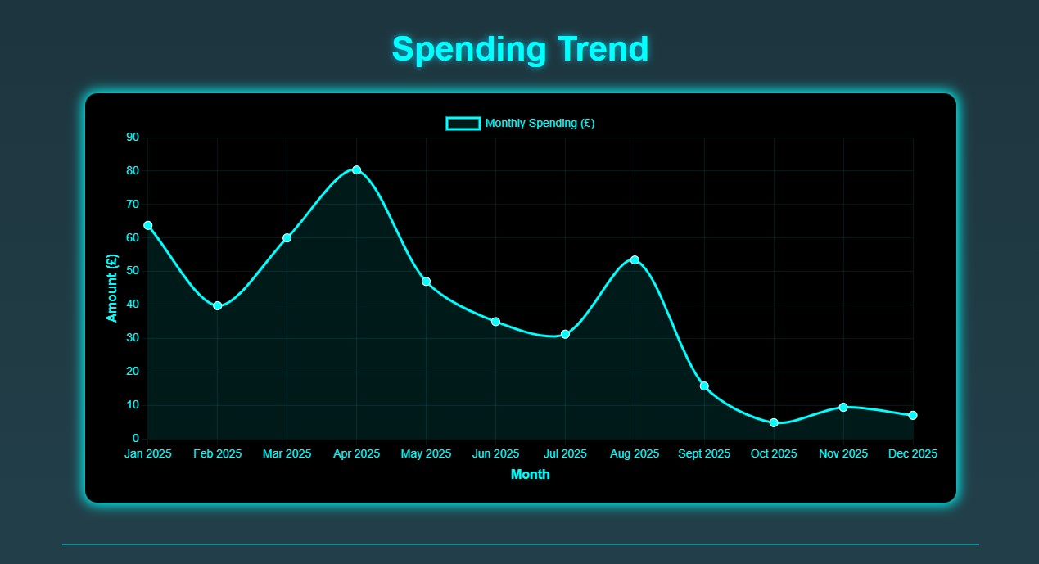

Item Quantity Breakdown
This Pie Chart will show you how much of each item you have purchased.
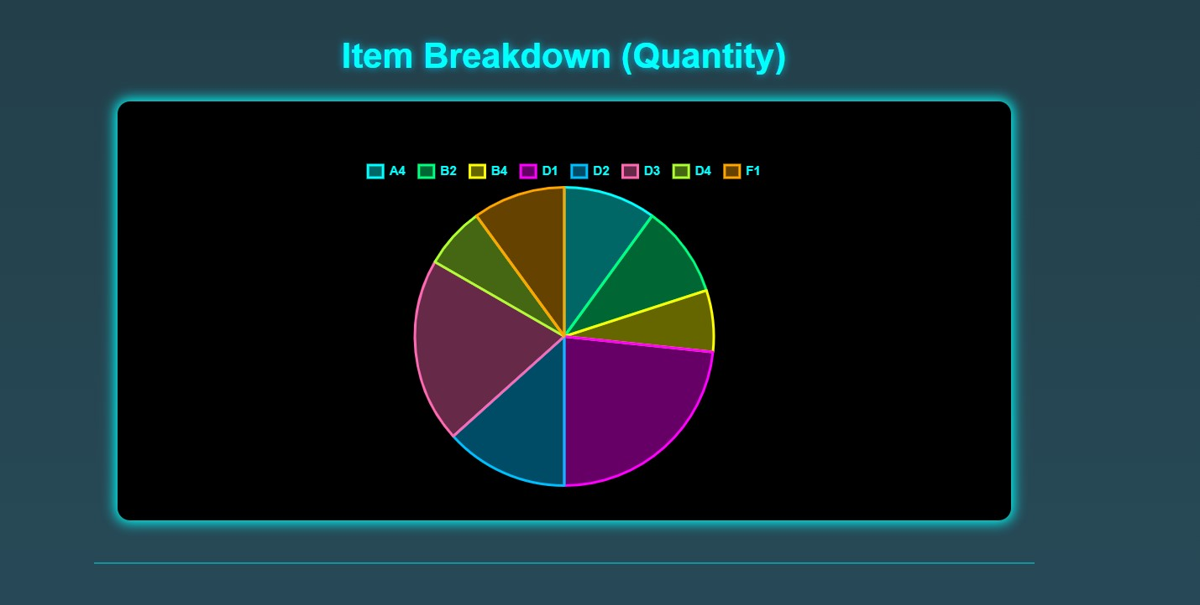

Smart Recommendation Insights
These flip cards give you an insight into which factors are used to generate your Smart Recommendations.
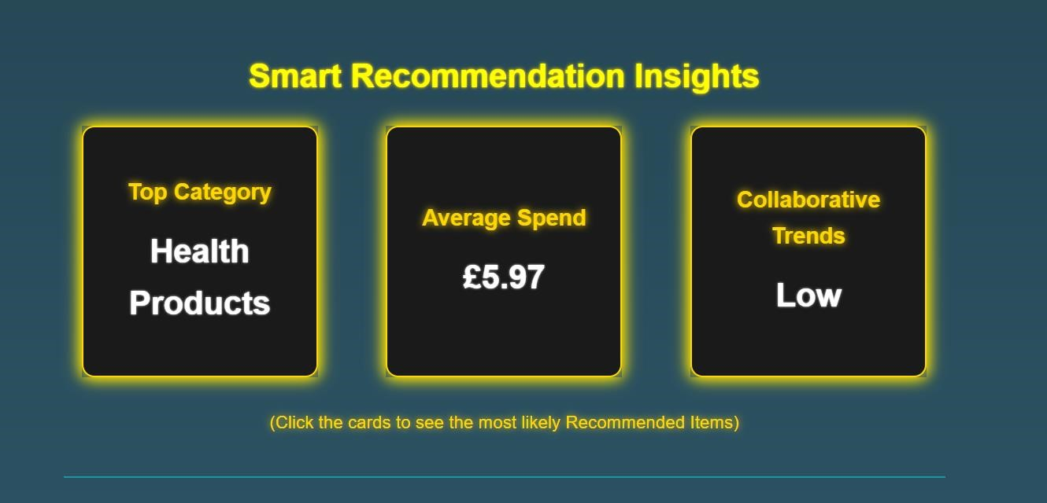
(The factors are shown on the front of the cards. Click them to flip them and see the most likely recommendations based on the factor insight.)

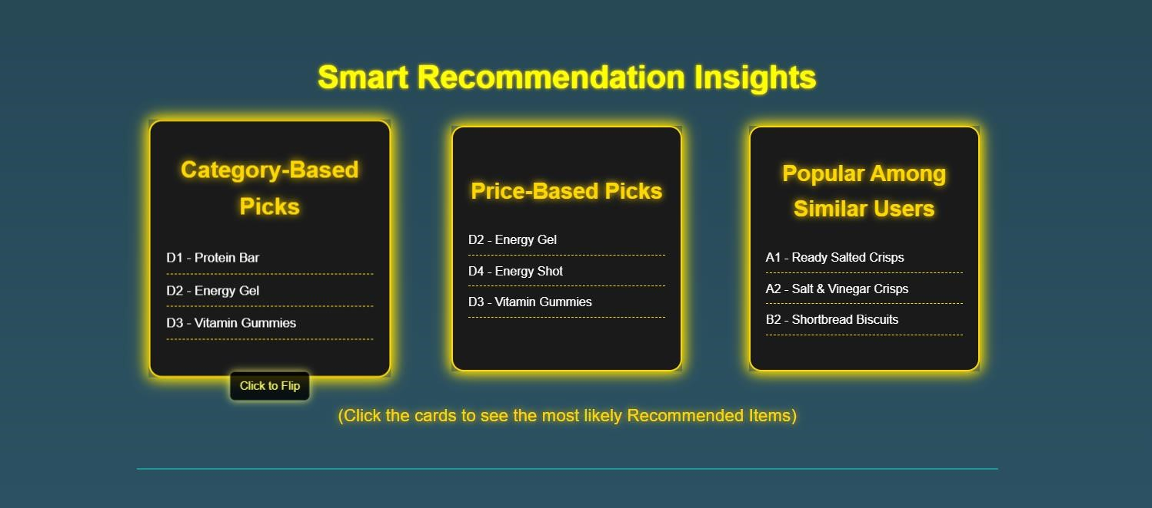

Admin Stock Controls

This feature is only accessible for admin users. To access the Admin Dashboard the authorised user must log in using the given admin credentials:
Username: admin
Password: admins

Once logged in you will be on the dashboard. Here you can modify stock levels and settings for every available product in the vending machine.
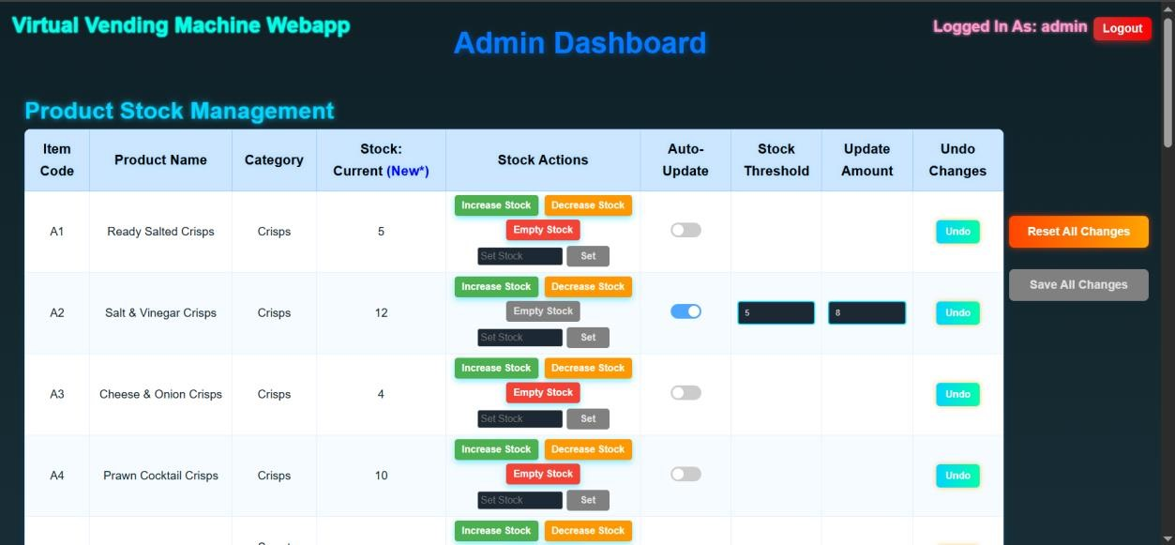

To modify stock levels, locate the “Stock Actions” column for the product you want to modify.
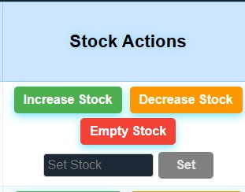
Use the “Increase” button to increase stock by 1, “Decrease” to reduce by 1, “Empty” to set the stock to 0 or you can manually type in the desired stock level to the input field and click “Set”.

After modifying a stock level, it’s new value will appear highlighted in blue next to the current stock value.
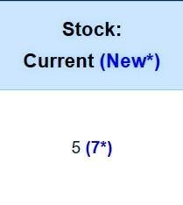
To commit the changes click the “Save All Changes” button on the right side of the page.

To modify the auto restock settings for a product you can turn the “AutoUpdate” switch on.
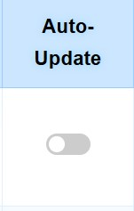

Then you can set a threshold value and update amount. The threshold value is the level of stock at which auto-restocking is triggered, and the update amount is how much stock it gets increased by. For example, if a product has current stock of 6, a threshold at 4 and an update amount of 5: if someone bought 2 of the item, there would be 4 left (the threshold value) so it will be automatically restocked by 5 units so there would be 9 left.
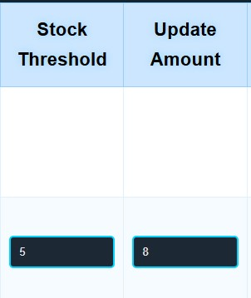
Once again when you have made your changes you can click “Save All Changes” to submit them. “Reset All Changes” will undo all of the changes made since the last submission. Each row also has an individual “Undo” button which removes all changes made to only that product row.
Extra Notes:
- This is a very powerful tool, ensure it is used properly and effectively
- Changes are submitted to the backend when saved and when the page is opened, it loads the current state from the backend.
- To turn on Auto-Update for a product you MUST set a threshold and update amount before saving.
- The threshold value must be set lower than the current stock value (if it isn’t the stock will automatically re-adjust)
- You can submit multiple changes to different products all at once

Troubleshooting & Common Issues

Issue | Possible Cause | Solution
Payment not processing | Not enough coins inserted. | Continue clicking coin buttons until the total cost is covered.
Wrong item added | Incorrect item code entered. | Clear the cart and re-enter the correct item code.
Restock alert not showing | Stock hasn't dropped below the threshold or auto restock for that product is not on. | This feature only triggers when stock drops below the threshold, which is only set when auto restock is turned on.
Item code not accepted | Entered code does not follow the valid format (e.g., A1, B2). | Make sure the code starts with a letter followed by a number.
“ENT” button not activating | Invalid item code entered or incomplete. | Ensure the item code is both valid and fully entered (e.g. two characters).
Coin buttons not responding | Browser issue or UI glitch. | Refresh the page and try again.
Cart not updating | JavaScript not fully loaded or browser cache issue. | Refresh the browser or clear cache and reload.
Checkout button disabled | Cart is empty. | Add at least one valid item to the cart before proceeding to checkout.
Smart  Recommendations not shown | Will always be shown for all nonguest users. | Double check you have logged in.
Admin page access denied | Incorrect password or no input. | Re-enter the correct admin password and try again.
Transaction history empty | No purchases have been made . | Complete at least one transaction before checking history.
Downloaded receipt unreadable | File opened with incompatible application. | Receipt should be downloaded as PDF. Check browser settings then try downloading again.
Payment confirmation missing | Page was refreshed or closed before confirming. | Repeat the transaction avoid refreshing during payment (your cart will still remain).

Future Enhancements

Upcoming updates may include:
- Emailing receipts for completed transactions.
- More advanced auto-restocking settings.
- Other admin controls (Product control/creation, discounts).
- Wider range of Items and Categories.
- More analytics
- Others (we are open to suggestions by email)

Contact & Support

For any issues, queries or support requests, reach out to the development team:
CREATOR: Issa Aboobaker, ia252@student.le.ac.uk, University of Leicester.

