Some theoretical approaches to stuff

Rita Felski, Context Stinks, New Literary History, 42.4 (Autumn 2011)
Latour, Bruno, Reassembling the social: an introduction to actor-network-theory. Oxford New York: Oxford University Press (2005)
Jane Bennett, Vibrant Matter: A Political Ecology of Things (Duke: London, 2005)
Paraphernalia! Victorian Objects, ed. Helen Kingstone, H, Lister (London; Routledge, 2018)

1). I went more than once to [Dickens’] celebrated readings . . . I “could not away with” the pathos of Little Nell and Paul Dombey … I fear I have not much sympathy with paper sorrows.
Jane Frith Panton, Leaves from a Life (London: 1908), pp. 150-151

2) Time of sunniest stillness;--shall we call it, what all men thought it, the new Age of God? Call it at least, of Paper … –beautiful art, not only of revealing Thought, but also of so beautifully hiding from us the want of Thought! Paper is made from the rags of things that did once exist; there are endless excellences in Paper.
Thomas Carlyle, ‘The Paper Age’, The French Revolution 1, 2 [1837] (London: 1867), pp. 28-9

3) Its rulers—solid and substantial as they appear to the eye—are made of paper. They ride in paper carriages; they marry paper wives, and unto them are born paper children; their food is paper, their thoughts are paper, and all they touch is transformed to paper.
James Hollingshead, ‘The City of Unlimited Paper’, Household Words 404, 19 December 1857.

,

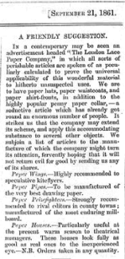

A FRIENDLY SUGGESTION: In a contemporary may be seen an advertisement headed “The London Lace Paper Company”, in which all sorts of perishable articles are spoken of as peculiarly calculated to prove the universal applicability of this wonderful material to hitherto unsuspected uses. We are to have paper hats, paper waistcoats, and paper shirt-fronts, in addition to the highly popular penny paper collar…
Fun magazine, September 21 1861

Mr Pickwick journeys to Ipswich, and meets with a romantic Adventure with a middle aged Lady in Yellow Curl Papers.

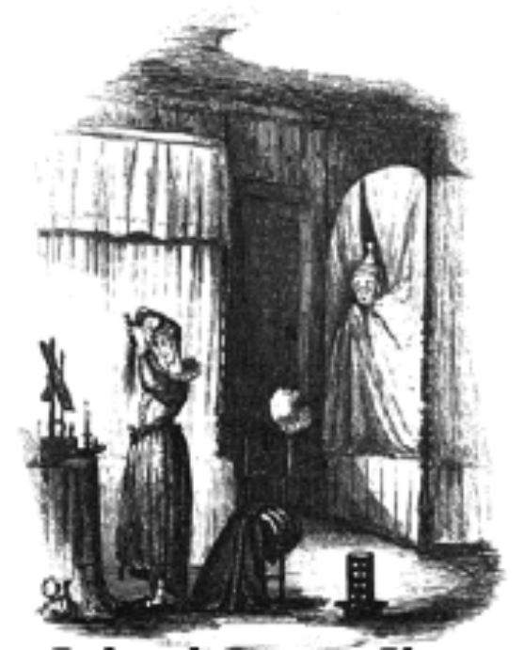

4)
[He] almost fainted with horror and dismay. Standing before the dressing-glass was a middle-aged lady, in yellow curl-papers, busily engaged in brushing what ladies call their 'back-hair.' However the unconscious middle-aged lady came into that room, it was quite clear that she contemplated remaining there for the night;
[…]
‘I never met with anything so awful as this,' thought poor Mr. Pickwick, the cold
perspiration starting in drops upon his nightcap. 'Never. This is fearful.' It was quite impossible to resist the urgent desire to see what was going forward. So out went Mr. Pickwick's head again. The prospect was worse than before. The middle-aged lady had finished arranging her hair; had carefully enveloped it in a muslin nightcap with a small plaited border; and was gazing pensively on the fire
[…]
Whatever grounds of self-congratulation Mr. Pickwick might have for having escaped so quietly from his late awkward situation, his present position was by no means enviable. He was alone, in an open passage, in a strange house in the middle of the night, half dressed; it was not to be supposed that he could find his way in perfect darkness to a room which he had been wholly unable to discover with a light, and if he made the slightest noise in his fruitless attempts to do so, he stood every chance of being shot at, and perhaps killed, by some wakeful traveller. He had no resource but to remain where he was until daylight appeared. So after groping his way a few paces down the passage, and, to his infinite alarm, stumbling over several pairs of boots in so doing, Mr. Pickwick crouched into a little recess in the wall, to wait for morning, as philosophically as he might.
Charles Dickens, Pickwick Papers [1836-7], Chapter 22

5) [Migg’s] nightcap had been knocked off in the scuffle, and she was on her knees making a strange revelation of blue and yellow curl papers, straggling locks of hair, tags of staylaces, and strings of it’s impossible to say what; panting for breath, clasping her hands, turning her eyes upwards, shedding an abundance of tears, and exhibiting various other symptoms of the acutest mental suffering.
Charles Dickens, Barnaby Rudge (1841)

6) Considering the multitude of mortals that handle the Pen in these days, and can mostly spell … [h]ow is it, then, that no Work proceeds from them, bearing any stamp of authenticity and permanence of worth for more than one day? Ship-loads of Fashionable Novels, Sentimental Rhymes, Tragedies, Farces, Daireis of Travel … are swallowed monthly into the bottomless Pool: Still does the Press toil; innumerable Paper-makers, Compositors, Printers’ Devils, Book-binders, and Hawkers… and still, in torrents rushes on the great array of Publications … How is it that no one can ..produce aught that shall endure longer than ‘snow-flake on the river’ or the foam of penny-beer? We answer: Because they are foam: because there is no Reality in them.
Thomas Carlyle, ‘Biography’, Fraser’s Magazine (1832)

7)
DO the subscribers to this journal, the customers at the eminent publishing-houses, …compose altogether the great bulk of the reading public of England? There was a time when, if anybody had put this question to me, I, for one, should certainly have answered, Yes…. I know better now. I know that the public just now mentioned, viewed as an audience for literature, is nothing more than a minority. This discovery (which I venture to consider equally new and surprising) dawned upon me gradually. I made my first approaches towards it, in walking about London, more especially in the

second and third rate neighbourhoods. At such times, whenever I passed a small stationer’s or small tobacconist’s-shop, I became conscious, mechanically as it were, of certain publications which invariably occupied the windows. These publications all appeared to be of the same small quarto size; they seemed to consist merely of a few unbound pages; each one of them had a picture on the upper half of the front leaf, and a quantity of small print on the under. …we have a sale of a Million weekly for five penny journals. Reckoning only three readers to each copy sold, the result is a public of three millions—a public unknown to the literary world
Wilkie Collins, ‘The Unknown Public’, Household Words (1858)

7b) ‘I have often felt cramped and confined…I have found this form of publication perplexing and difficult’
Dickens in 1841 on publishing in a weekly format in Master Humphrey’s Clock

8) This lack of complexity, intelligence, or ‘interiority’ undoubtedly goes some way towards explaining the barrage of hostile criticism Dickens’ Gothic villains have received in a post-Realist age
Juliet John, Dickens’s Villains: Melodrama, Character, Popular Culture (Oxford: OUP, 2001), p. 95.

9) characters [in Dickens] who evidence an abdication or enforced loss of the essential or inward self in favour of outward attributes
David Simpson, Fetishism and Imagination (John Hopkins University Press: Baltimore, 1982), p. 48.

10) We ordered something rather special for dinner, with a bottle of something similarly out of the common way, in order that our minds might be fortified for the occasion, and we might come well up to the mark. Dinner over, we produced a bundle of pens, a copious supply of ink, and a goodly show of writing and blotting paper. For, there was something very comfortable in having plenty of stationery.
Charles Dickens, Great Expectations [1861], chapter 34

11) On the eastern borders of Chancery Lane, that is to say, more particularly in Cook's Court, Cursitor Street, Mr. Snagsby, law-stationer, pursues his lawful calling. In the shade of Cook's Court, at most times a shady place, Mr. Snagsby has dealt in all sorts of blank forms of legal process; in skins and rolls of parchment; in paper—foolscap, brief, draft, brown, white, whitey-brown, and blotting; in stamps; in office-quills, pens, ink, India-rubber, pounce, pins, pencils, sealing-wax, and wafers; in red tape and green ferret; in pocket-books, almanacs, diaries, and law lists; in string boxes, rulers, inkstands—glass and leaden—pen-knives, scissors, bodkins, and other small office-cutlery; in short, in articles too numerous to mention; ever since he was out of his time, and went into partnership with Peffer.
Charles Dickens, Bleak House [1852-3], chapter 10

12) Mr Merdle’s right hand was filled with the evening paper and the evening paper was full of Mr Merdle.
Charles Dickens, Little Dorrit [1857] chapter 48

13) ‘I have looked well into the papers, Esther -- I have been deep in them for months’ … As his look wandered over the papers again, I noticed how sunken and how large his eyes appeared, how dry his lips were. . . the commentary upon it now indelibly written in his handsome face made it far more distressing than it used to be.”
Bleak House, Chapter 23, Chapter 51

14) he pushed the newspaper over to Robert Audley … with a face that had changed from its dark bronze to a sickly, chalky grayish white

it was at the sight of this third paragraph that Mr. Robert Audley's face changed from its natural hue to a sickly, leaden pallor
Mary Elizabeth Braddon, Lady Audley’s Secret [1861-2], Chapter 4, Chapter 19.

15) That night he was again playing at the Beargarden, and he lost a great part of Mr Melmotte's money. He did in fact lose much more than the £200; but when he found his ready money going from him he issued paper.
Anthony Trollope, The Way We Live Now [1875], Chapter XXXVII

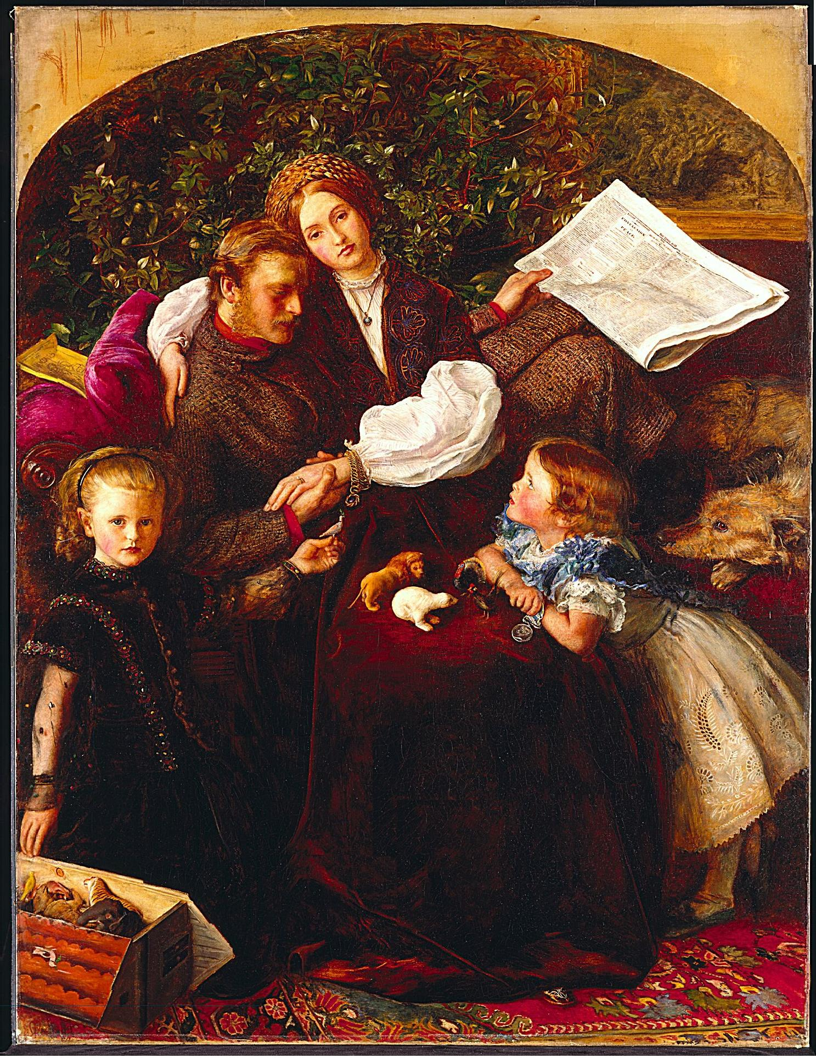
‘Peace Concluded’, John Everett Millais (1856)

16) As soon as Croll was gone he searched among various papers in his desk and drawers, and having found two signatures, those of his daughter and of this German clerk, set to work tracing them with some thin tissue paper.

17) Mr Melmotte on entering the room bolted the door, and then, sitting at his own table, took certain papers out of the drawers,—a bundle of letters and another of small documents. From these, with very little examination, he took three or four,—two or three perhaps from each. These he tore into very small fragments and burned the bits,—holding them over a gas-burner and letting the ashes fall into a large china plate. Then he blew the ashes into the yard through the open window. This he did to all these documents but one. This one he put bit by bit into his mouth, chewing the paper into a pulp till he swallowed it.
The Way We Live Now, LXXVII

18) Mr Tulkinghorn glances over his spectacles, and begins again lower down […] My Lady, changing her position, sees the papers on the table — looks at them nearer — looks at them nearer still — asks impulsively:
“Who copied that?”
Bleak House, Chapter 2.

19) The bell rang furiously and , when Miss Parker went to the tube, a furious voice called out in a piercing North of Ireland accent:
Send Farrington here! –
Miss Parker returned to her machine, saying to a man who was writing at a desk:
--Mr Alleyne wants you upstairs –
[…]
The man entered Mr Alleyne’s room. Simultaneously Mr Alleyne, a little man wearing gold-rimmed glasses on a clean-shaven face, shot his head up over a pile of documents. The head itself was so pink and hairless that it seemed like a large egg reposing on the papers.
Mr Alleyne bent his head again upon his pile of papers. The man stared fixedly at the polished skull which directed the affairs of Crosbie & Alleyne, gauging its fragility. A spasm of rage gripped his throat for a few moments and then passed, leaving after it a sharp sensation of thirst. The man recognised the sensation and felt that the must have a good night’s drinking. The middle of the month was passed and, if he could get the copy done in time, Mr Alleyne might give him an order on the cashier. He stood still, gazing fixedly at the head upon the pile of papers.
The man returned to the lower office and sat down again at his desk. He stared intently at the incomplete phrase: In no case shall the said Bernard Bodley be ... and thought how strange it was that the last three words began with the same letter. The chief clerk began to hurry Miss Parker, saying she would never have the letters typed in time for post. The man listened to the clicking of the machine for a few minutes and then set to work to finish his copy. But his head was not clear and his mind wandered away to the glare and rattle of the public-house. It was a night for hot punches. He struggled on with his copy, but when the clock struck five he had still fourteen pages to write. Blast it! He couldn't finish it in time. He longed to execrate aloud, to bring his fist down on something violently. He was so enraged that he wrote Bernard Bernard instead of Bernard Bodley and had to begin again on a clean sheet.
[…]
"What's for my dinner?"
"I'm going... to cook it, pa," said the little boy.
The man jumped up furiously and pointed to the fire.
"On that fire! You let the fire out! By God, I'll teach you to do that again!"
He took a step to the door and seized the walking-stick which was standing behind it.
"I'll teach you to let the fire out!" he said, rolling up his sleeve in order to give his arm free play.
The little boy cried "O, pa!" and ran whimpering round the table, but the man followed him and caught him by the coat. The little boy looked about him wildly but, seeing no way of escape, fell upon his knees.
"Now, you'll let the fire out the next time!" said the man striking at him vigorously with the stick. “Take that, you little whelp!”
The boy uttered a squeal of pain as the stick cut his thigh. He clasped his hands together in the air and his voice shook with fright.
“O, pa!" he cried. "Don't beat me, pa! And I'll... I'll say a Hail Mary for you.... I'll say a Hail Mary for you, pa, if you don't beat me.... I'll say a Hail Mary....”
James Joyce, ‘Counterparts’ [completed 1906], Dubliners (1914)

20) ellipsis
2. Grammar. The omission of one or more words in a sentence, which would be needed to complete the grammatical construction or fully to express the sense; concr. an instance of such omission. OED
21) From about 1850 three discrete points ‘…’, were being used to mark the crises that shake the most orderly of nineteenth-century worlds
Anne Henry, ‘The Remarkable Rise of the Ellipsis’ in Ma(r)king the Text, ed. Joe Bray, Miriam Handley and Anne Henry (Ashgate: Aldershot, 2000), p. 139.



Texts which might prompt further thoughts
George and Weedon Grossmith, The Diary of a Nobody [1888-9]
Anthony Trollope, An Editor’s Tales
Gissing would also lend himself well to these themes…New Grub Street especially
Dickens, ‘On Bill Sticking’, and Dickens with Mark Lemon, ‘A Paper Mill’, Household Words, 31 August 1850.

Selected Further Reading
Reading and the Victorians, ed. Juliet John and Matthew Bradley (2015)
Robert MacFarlane, Original Copy: Plagiarism and Originality in Nineteenth-Century Literature (Oxford: OUP, 2007) – excellent on Dickens and recycling
Matthew Rubery, The Novelty of Newspapers (OUP, 2009);
Leah Price, ‘Reader’s Block’, Victorian Studies 46, no. 2 (Winter 2004), 231 242 – about the way texts stop us engaging with each other and How to do Things With Books in Victorian Britain (Princeton, N.J.: Princeton UP, 2012).
Richard Altick, The English Common Reader: A Social History of the Mass Reading Public (Ohio University Press, 1957)
Anthony Nuttall, Dead from the Waist Down: Scholars and Scholarship in Literature and the Popular Imagination (Yale UP: New Haven & London, 2003) – a chapter on Casaubon helpful for thinking of other ways of getting lost in paper;
Richard Altick, “Education, Print, and Paper in Our Mutual Friend,” Nineteenth-Century Literary Perspectives. Ed. Claude de L. Ryals et al. Durham, N.C.: Duke UP, 1974. 237-54
Nicholson Baker, Double Fold: Libraries and the Assault on Paper (New York: Random House, 2001) – Baker campaigns against the microfiche culture
Patrick Brantlinger, The Reading Lesson: The Threat of Mass Literacy in Nineteenth-Century British Fiction (Bloomington: Indiana UP, 1998)
D.C. Coleman, The British Paper Industry, 1495-1860: A Study in Industrial Growth (Oxford: Oxford UP, 1958)
Ian Samson, Paper: An Elegy
Handbook – from my article

Online resources
Fun Magazine http://ufdc.ufl.edu/UF00078627
Project Boz http://dickens.wpi.edu/
Dickens Journals Online http://www.djo.org.uk/

‘No single objects cause his raptured starts,
For Mind is narrow’d, not inspired by parts’
(ELIZABETH BARRETT BROWNING)
Discuss the relationship between parts and wholes in any writing of the period.

‘The elusiveness or inscrutability of queer feelings or urges (even one’s own feelings,
illegible to oneself) are often registered’ (CHRISTOPHER LOOBY)’
Discuss in relation to any writing of the period

