Applicant: K.Ramakrishnan College of Technology No. of Sheets: 1

Application No: Sheet No: 1



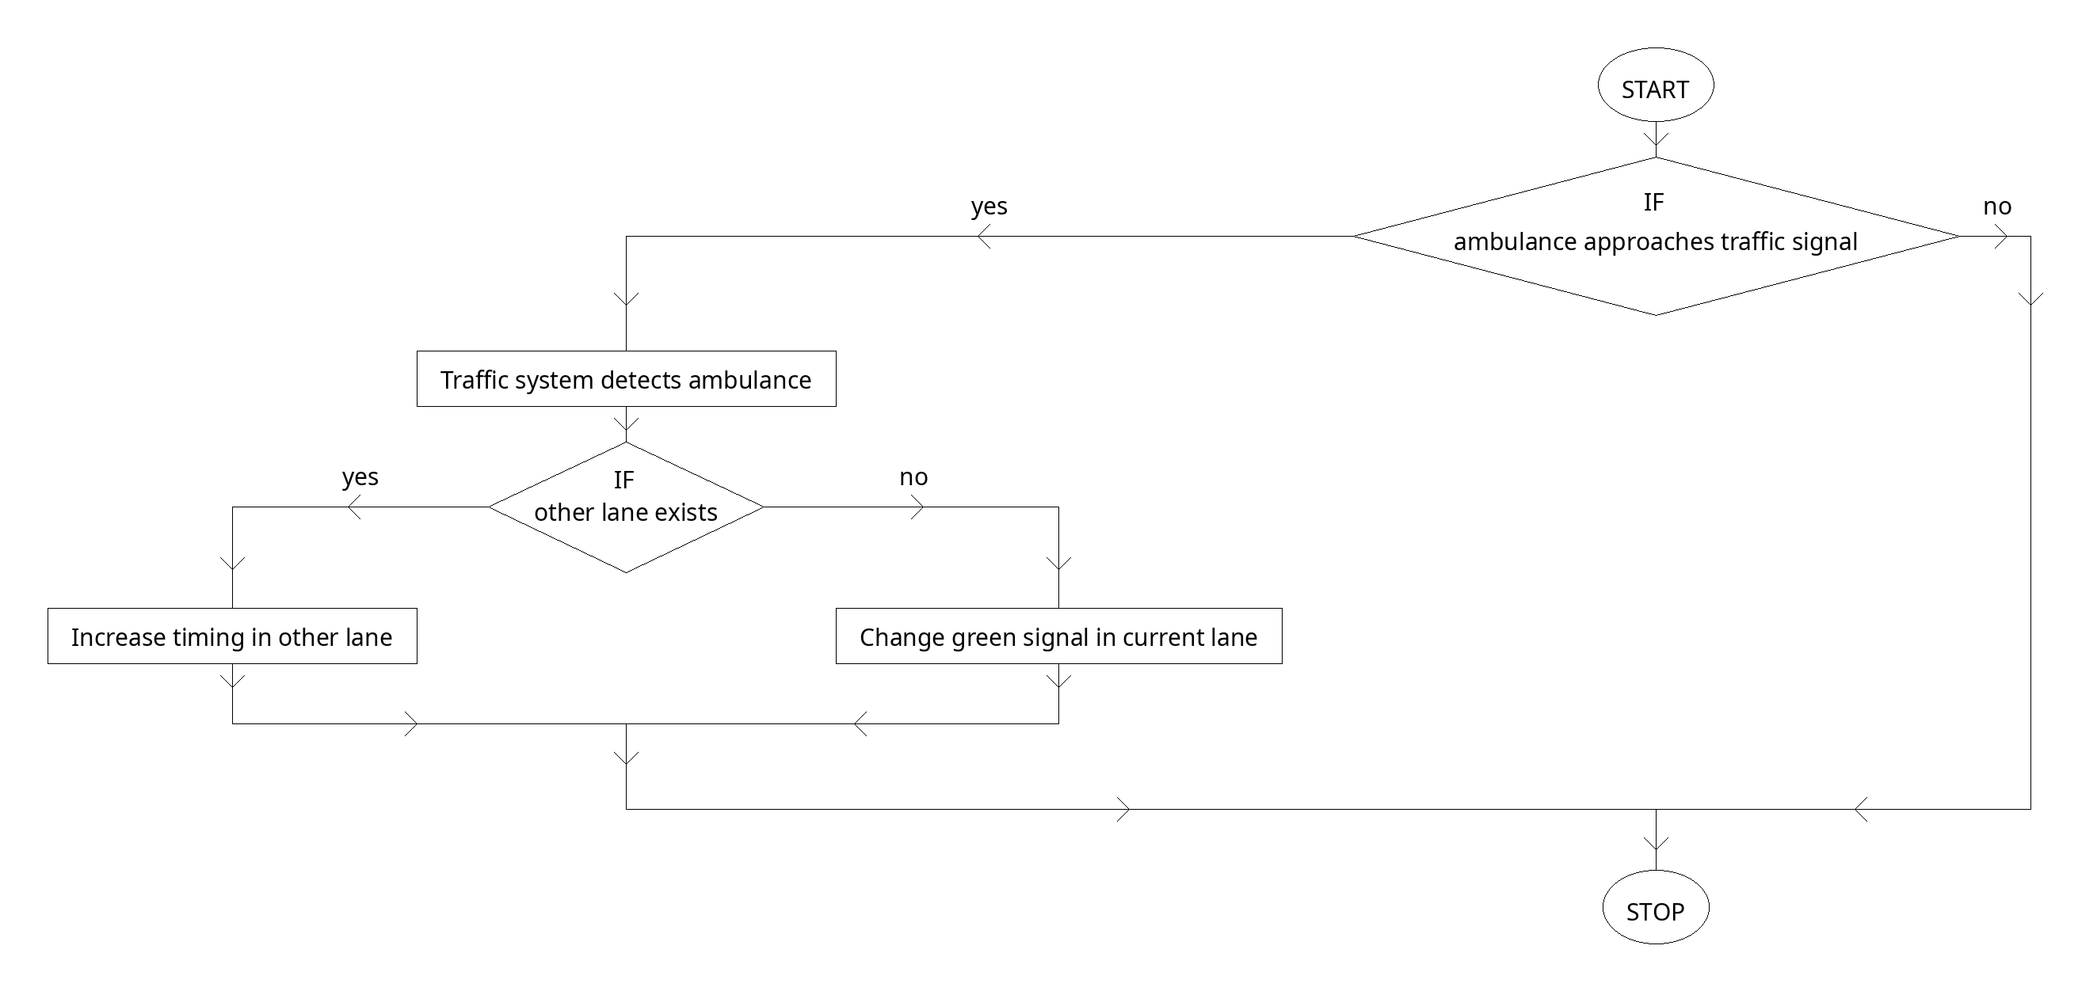

Fig 1