PathLab SPSS Extension Hub
submission materials
Version 0.2.2 beta | Prepared 28 October 2026
Developed by Dr. B. Issac Johny
Professor
Gnanam School of Business, Thanjavur
johnydurai@gmail.com
https://www.johny.uk
These materials support a request to review PathLab as a Community extension for the SPSS Extension Hub. They bring together the proposed catalog entry, submission letter, menu-based review procedures and validation evidence. The existing release and source are supplied for inspection and reproducibility.
Item | Current status
Software | PathLab for IBM SPSS Statistics 0.2.2 beta
Verified environment | Windows SPSS 27 with bundled Python 3.8.2
Public contact | johnydurai@gmail.com
Developer website | https://www.johny.uk supplied by the developer
License | MIT approved by the developer on 28 October 2026
Public source and releases | github.com/issacjohny/PathLab-SPSS  Release tag v0.2.2
Submission | GitHub beta release; IBM submission pending

Decisions before submission
The MIT license is approved and the repository and release URLs are assigned. Complete the recorded menu-to-results acceptance checks. A current SPSS release needs its own test before broad compatibility claims. Confirm the current IBM intake route before sending the letter.

Documents and review files
The drafts folder supplies copyable text for all main submission documents. The review archive includes the licensed 0.2.2 extension and Windows package, a standalone source archive, synthetic examples, evidence and SHA-256 checksums. START-HERE.txt identifies the remaining actions.

Proposed submission letter
To the SPSS Community manager and extension maintainers
Subject: Request to review PathLab for SPSS Extension Hub community listing
Dear SPSS Community manager,
I request review of PathLab for IBM SPSS Statistics for possible inclusion as a Community extension in the SPSS Extension Hub.
PathLab provides an Analyze-menu interface for observed-variable mediation, moderation and conditional process analysis. Users assign variables and choose model stages, inference settings and diagrams through a native dialog. The extension offers parallel, serial and combined mediator presets, paired-case percentile bootstrap intervals, conditional path inference, interaction diagrams and Johnson-Neyman diagrams for applicable continuous moderators. Results appear as native SPSS Viewer tables and diagrams, with optional local exports.
I am submitting version 0.2.2 beta under the developer credit Dr. B. Issac Johny, Professor, Gnanam School of Business, Thanjavur. The accompanying review package includes source code, the native extension bundle, installation and menu-use guidance, synthetic data, example diagrams, source provenance and validation evidence.
The automated extension suite has 101 passing tests. Windows SPSS 27 has been used for runtime, installation, native-command calculation and diagram insertion. The evidence records each check's version and scope. A complete calculation through the final main dialog OK button remains to be recorded, and later SPSS releases have not yet been executed. Please assess compatibility against the documented evidence.
Please confirm the current review procedure and any catalog, licensing or dependency-installation requirements. My public contact is johnydurai@gmail.com, and my website is https://www.johny.uk.
Public source repository: https://github.com/issacjohny/PathLab-SPSS
Release: https://github.com/issacjohny/PathLab-SPSS/releases/tag/v0.2.2
Distribution license: MIT, approved on 28 October 2026.
Thank you for considering the extension.
Dr. B. Issac Johny
Professor
Gnanam School of Business, Thanjavur
johnydurai@gmail.com

Proposed catalog entry
PathLab Mediation and Moderation
Menu-driven observed-variable mediation, moderation and conditional process analysis with bootstrap intervals, interaction diagrams and Johnson-Neyman path-slope diagrams.
Catalog field | Proposed value
Developer | Dr. B. Issac Johny, Professor
Affiliation | Gnanam School of Business, Thanjavur
Version and category | 0.2.2 beta; regression and conditional process analysis
Bundle minimum | SPSS Statistics 27
Verified platform | 64-bit Windows SPSS 27; Python 3.8.2
Other releases and platforms | Require separate execution and installation checks
Contact | johnydurai@gmail.com; https://www.johny.uk

Features
The native dialog offers parallel, serial and combined mediator presets, continuous outcomes and binary 0/1 logistic outcomes. Categorical predictors, moderators and covariates use explicit reference groups. Included moderated paths retain required lower-order terms. Indirect effects and contrasts use paired whole-case percentile bootstrap intervals. Coefficient inference can use HC3 or conventional covariance.
Interaction diagrams show fitted means or probabilities at labeled moderator values. Johnson-Neyman diagrams show a conditional path slope, its pointwise confidence band and analytic boundaries within the observed moderator range. Bootstrap indirect-effect intervals remain separately identified. Standard output presents the main results; Full adds detailed contrasts and diagnostic tables.

Installation and limits
Windows users install the calculation libraries with PathLab Setup using SPSS's bundled Python, install the SPE through Extensions > Install Local Extension Bundle, and restart SPSS. Libraries are NumPy, pandas, SciPy, statsmodels and Matplotlib. Analysis runs locally; the setup step downloads software dependencies.
All equations use one common complete-case sample. Active weights and split files are rejected. Latent-variable models, arbitrary graph editing and equation-specific covariates are outside the menu interface. Statistical associations do not establish causation; logistic indirect products are log-odds-scale associations.

Reviewer installation and first analyses

Prepare the review session
Save existing work and use a separate review session. Record SPSS version and build, operating system, bundled Python version and display resolution. Extract PathLab-SPSS-0.2.2.zip. Close SPSS, open PathLab-Setup.cmd, select SPSS's bundled Python and click Install calculation libraries. Open SPSS, install PathLab-0.2.2.spe through Extensions > Install Local Extension Bundle, then restart SPSS.
Open Analyze > PathLab: Mediation and Moderation. Confirm the credited dialog title and Help text. Import examples/pathlab-demo.csv using File > Import Data > CSV Data. Import the header as variable names. Its 180 artificial cases have numerical columns X, M1, M2, Y, W, Z, Q and C.
For these demonstrations use all cases, no weights and no split files. Start each model with cleared unused roles and moderation stages set to None; reopened dialogs can retain earlier selections. With these unfiltered complete data, the expected analysis sample is 180 cases.

Simple mediation
Choose Mediation. Assign X to Predictor, Y to Outcome and M1 to Mediators. Leave moderators and covariates empty. Under Model select Parallel and a continuous linear outcome. Under Options select 1,000 bootstrap samples, 95% confidence, seed 20261028, HC3 and Standard output. Click the main OK button.
Inspect model roles, sample size, equation coefficients and the M1 indirect-effect estimate with its bootstrap interval. If diagrams were requested, the output should explain their inapplicability because this model has no moderated path. The normal starting bootstrap count is 5,000; 1,000 is used here for a quicker demonstration.

Moderation with both diagrams
Start a fresh dialog and choose Moderation. Assign X, Y and W; leave Mediators blank. Under Moderators set Direct path X to Y to W and every other stage to None. Keep a continuous outcome. Under Diagrams select Show both diagrams and optionally a PNG export folder. Use the same review inference settings, then click OK.
Inspect the interaction coefficient, conditional direct associations, simple slopes and interaction test. Compare diagram conditions and threshold labels with the tables. An eligible continuous moderator may have no Johnson-Neyman boundary within its observed range. Check the developer credit, notices and exported PNGs.

Conditional process review and acceptance record

Serial conditional process
Start a fresh dialog and choose Conditional process. Assign X and Y, then mediators M1 and M2 in that order. Under Model choose Serial and a continuous outcome. Assign W, Z and Q to their matching moderator boxes and C to Covariates.
Under Moderators set First stage to W, Serial stage to Z, Final stage to Q and Direct path to None. Request both diagrams. Under Options select 1,000 bootstrap samples, 95% confidence, seed 20261028, HC3 and Full output. Click the main OK button.
Inspect mediator order, fitted equations, conditional indirect associations, indices or derivatives, contrasts and diagnostic tables. Three numerical moderators use the 16th and 84th percentile probes. Diagram panels should label the held conditions and retain them across pages. This model can take longer than the simpler examples.

Record each executed acceptance run
Record | Information to retain
Environment | SPSS version/build, OS, bundled Python and display size
Artifact | Version and SHA-256 of the exact SPE tested
Model and inference | Variable roles, stages, seed, confidence, bootstrap and covariance choices
Sample and bootstrap | Actual complete cases; requested, successful and failed replications
Results and diagrams | Synthetic Viewer output, optional JSON/PNGs, warnings and elapsed time
Reproducibility | Repeat the same settings and seed; record agreement or discrepancies

These are procedures to execute and record. The existing evidence does not yet document the final main-menu OK calculation. Completing the three examples addresses that gap. Later SPSS releases, smaller displays and other operating systems require separate checks.
The supplied preview PNGs and the historical 71-case result use a separate validation fixture. They are not numerical expected results for the 180-case demonstration CSV.

Validation evidence and compatibility scope
The evidence separates source tests, native execution, installation and menu interaction. Version 0.2.2 adds approved MIT licensing and contact information; its statistical code is unchanged from 0.2.1. Historical native checks retain their original versions.
Evidence | Recorded result | Scope
Automated suite | 101 passing tests | Independent numerical references; source fidelity; adapter, reports, plots and packaging
SPSS 27 runtime | Python 3.8.2 with tested numerical libraries | Windows 64-bit SPSS 27.0.0.0 and spss270 plug-in
0.2.0 native command | 71 complete cases; 200 of 200 bootstrap replications | Separate 90-case fixture with a filter and one user-missing case
0.2.0 Viewer diagrams | Both embedded; decoded pixels match; no Viewer notices | Johnson-Neyman boundary about -0.9124413470 on the validation fixture
Native forms | Main assignments and option forms inspected | 1920 by 1080 display; final main OK calculation not recorded
0.2.1 attribution | Installed files, title/help and isolated import checked | 24 Python files parsed; report calls captured; branded PNGs rendered and inspected

Reproduction and provenance
The standalone source archive includes the extension tests and builder. Numerical references use explicit matrix QR/Newton calculations and paired bootstrap checks. These tests do not establish equivalence to the PROCESS macro. source-provenance.json records the exact frozen statistical source snapshot and import adaptation.
VALIDATION.md and validation/*.json retain the original version and artifact hashes for every historical check. The review manifest identifies the unchanged SPE and Windows release ZIP. The archive checksum list covers the review materials.

Checks still needed
Record a final menu-to-results run, a clean-user dependency installation and a run on a current SPSS release. Requirements for later Python interpreters are installation targets rather than verified later-SPSS results. macOS, Linux, smaller displays and all future interpreters have not been validated.
Verified direct dependencies for SPSS 27 are NumPy 1.24.4, pandas 2.0.3, SciPy 1.10.1, statsmodels 0.14.1 and Matplotlib 3.7.5.

License and IBM submission steps

Approved MIT license
LICENSE contains the developer-approved MIT license with Copyright 2026 Dr. B. Issac Johny. It is included in the source, native extension and Windows release package. Preserve its copyright and permission notice and applicable third-party terms and notices.
THIRD-PARTY-NOTICES.txt describes the separately installed numerical libraries, observed versions, upstream sources and license-file locations. PathLab's supplied SPE and Windows ZIP do not redistribute those wheel binaries. A later binary redistribution needs the full notices for the exact distributions included.

Publication sequence
1. Review the dossier, proposed IBM letter and catalog wording. Public contact and the developer-approved MIT license are recorded with the release.
2. Use the dedicated PathLab-SPSS GitHub repository and versioned v0.2.2 beta release. Its source, documentation, synthetic examples and downloadable packages are organized for review.
3. Complete the recorded acceptance checks and retain the exact tested package hash. Update compatibility wording to match those results.
4. Confirm the current SPSS Community intake contact and procedure. Approve the final IBM submission message and send the review request through that route.
IBM's published contribution guide describes GitHub publication with a description and contact information followed by a note to the SPSS Community manager. It dates from 8 April 2020. The checklist is PathLab's preparation guidance; the current intake procedure and IBM's review requirements must be confirmed. No catalog acceptance or IBM product support is established by this package.

Primary references
IBM Community contribution guidance 8 April 2020
IBM SPSS Statistics Extension Hub documentation
Open Source Initiative MIT license text

Recommended citation
B. Issac Johny. (2026). PathLab for IBM SPSS Statistics (Version 0.2.2) [Computer software]. Gnanam School of Business, Thanjavur.

Example diagram styles
These developer-credited images use the separate deterministic validation fixture. They illustrate appearance and interpretation; the demonstration CSV has its own run results.
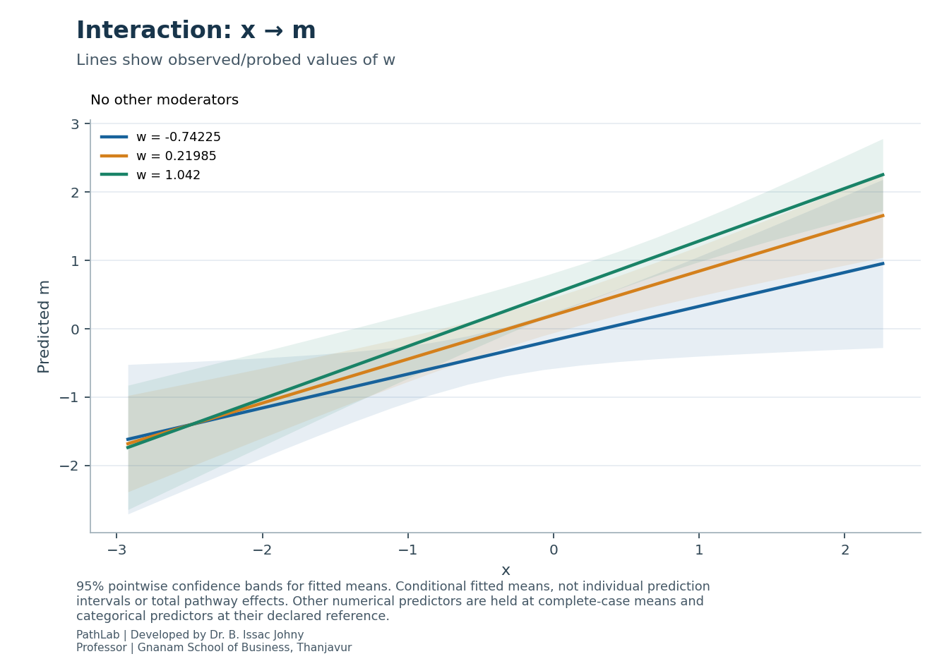
Interaction diagram with fitted-mean confidence bands
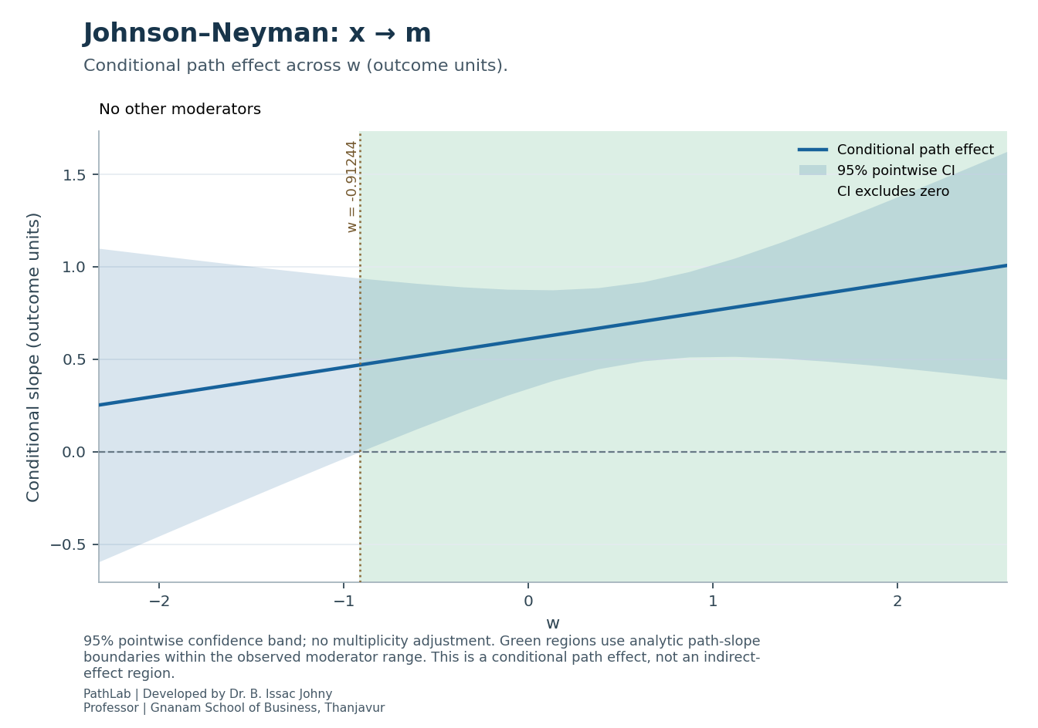
Johnson-Neyman diagram for a conditional path slope

