**Installing/Configuring X-windows**

The X Window System (X11, X, and sometimes informally X-Windows) is a windowing system for bitmap displays, common on UNIX-like computer operating systems. X provides the basic framework for a GUI environment: drawing and moving windows on the display device and interacting with a mouse and keyboard. Software must be installed on the PC to make this link work. The software for Windows are PuTTy and Xming, and for Mac is XQuartz.

**PuTTy and Xming for Windows**

**Step 1 Download and Install**

**PuTTy** SSH client can be downloaded from:

<http://www.putty.org/>

**Xming** can be downloaded from:

<http://sourceforge.net/projects/xming/>

Once PuTTy and Xming have been downloaded to the PC, install Xming:

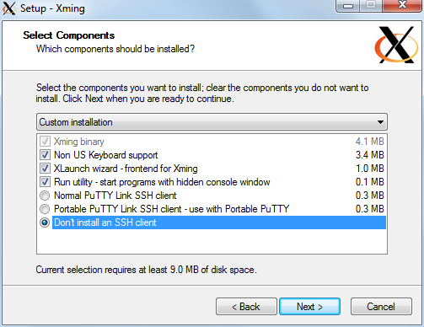

**Step 2 Configure Xming**

Once Xming is installed, run the application called 'XLaunch' and verify that the settings are as shown:

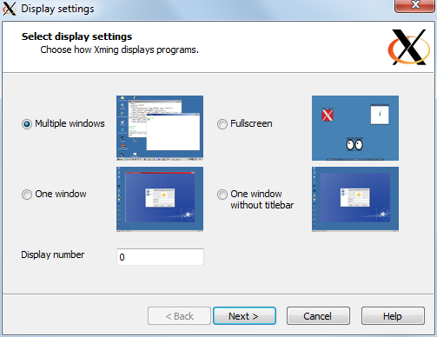

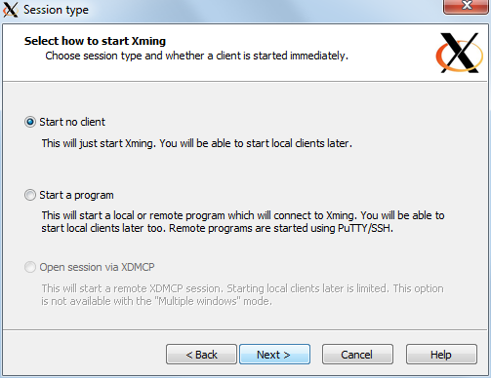

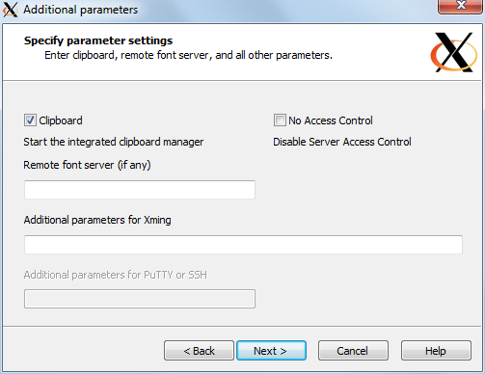

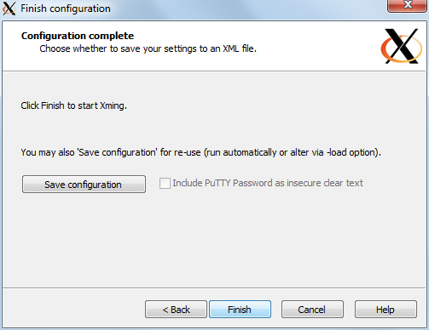

Save the configuration and close XLaunch.

**Step 3 Configure PuTTy**

Double-click on the PuTTy.exe and configure PuTTy:

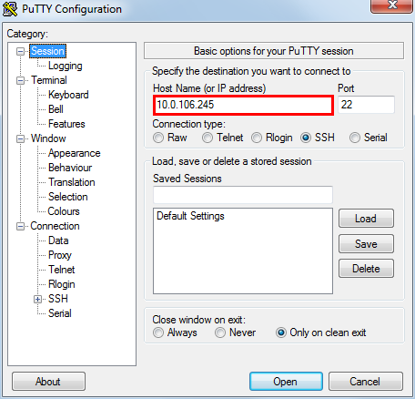

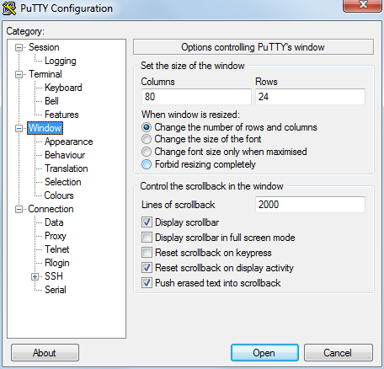

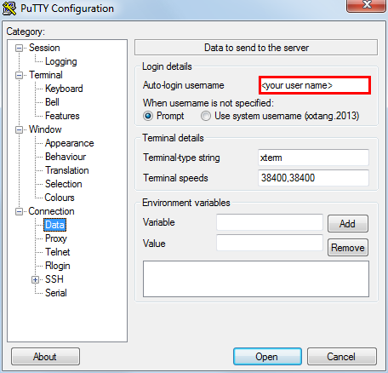

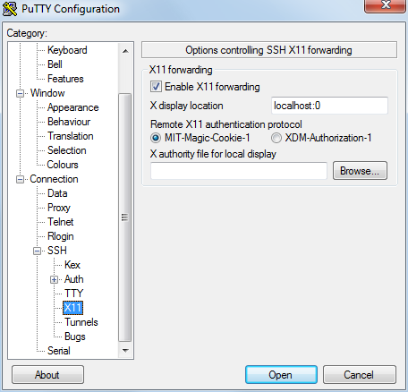

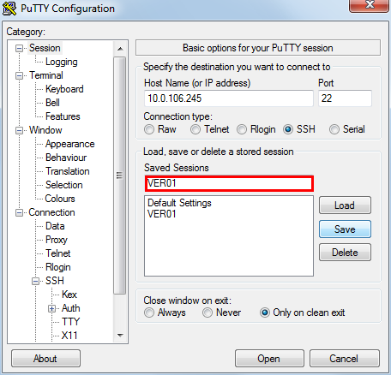

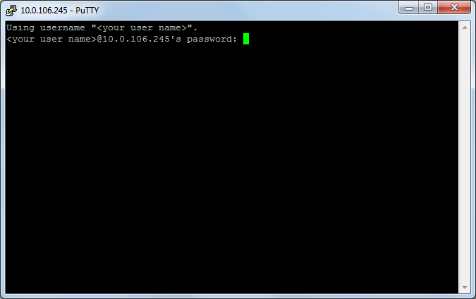

The most important setting is the X11 Forwarding. Without that set, the X-window system cannot find your PC for display. Save the configuration by typing a name (e.g. VER01) in the box under 'Saved Sessions' on the Sessions screen. Press the Save button to save the configuration. Click Open to open the terminal window or Cancel to close PuTTy.

The next time PuTTy is run, the session named VER01 will be shown. Select VER01 with the mouse and click Open to launch, or double click VER01.

**Step 4 Try X-window**

Enter “gedit” in the shell, open a text editor.

**Step 5 Logout**

Close all the graphics windows and enter “exit”.

**XQuartz for Mac**

**Step 1 Install and open XQuartz**

If you have not installed XQuartz yet:

Download XQuartz from <http://xquartz.macosforge.org/landing/>

Install XQuartz according to the instructions. Then, log out your account and log in again.

Open utilities (Shift+Command+U), find XQuartz and open it.

**Step 2 Change Preferences**

Open X11 -> Preferences of XQuartz, you can change the settings such as “Emulate three button mouse” and “Full-screen mode”. If you changed the preferences, you need to restart XQuartz.

Open Applications->Terminal.

**Step 3 Login to the server**

In the terminal “xterm”, type in “xhost +” and press enter. Then you can use ssh to access the server remotely:

Type in command: ssh –X username@10.0.106.245

Then, enter your password to login.

**Step 4 Try X-window**

Enter “gedit” in the shell, open a text editor.

**Step 5 Logout**

Close all the graphics windows and enter “exit”.

**Other applications start commands**

Firefox firefox

Clock xclock

Emacs emacs

… …