Assignment 4
Forms and Validation (HTML + Bootstrap)
Name: Islambek Saitov
Group:IT-2507
Date: 18 October 2026
GitHub repository:
https://github.com/issait1701-code/WebAssignment6
I made three forms using HTML and Bootstrap. Each task is on its own page. The home page links to all three tasks. The project does not need installation: open index.html in a browser.
Files
index.html — home page
task1.html — train ticket form
task2.html — hackathon registration
task3.html — fixed café form
styles.css — custom styles
success.html — demo page after a valid form submission
Checks
In Chrome, 41 validation checks passed. The train form had no horizontal overflow at 375px and 1280px. Clear reset the typed fields, and the phone layout showed Find trains above Clear. All controls have labels and unique IDs. The café form submitted with Enter from the Reserve button, including its seating value.
The official W3C Nu validator returned no errors or warnings for task3.html on 18 October 2026.
The forms are static demos, so they do not make real bookings.

Task 1 — Train ticket
I used floating labels for From and To, date inputs, a select for 1–6 adults, radio groups, a phone input group, a switch and an agreement checkbox. The Bootstrap grid makes the fields stack on a phone. My CSS adds the five given colors, Montserrat, rounded corners and a shadow.
The required fields use required. The city fields start empty so Clear can empty them without JavaScript. Clear is a reset button. On a phone, flex-direction: column-reverse puts Find trains first without changing the HTML order.
Reference — laptop  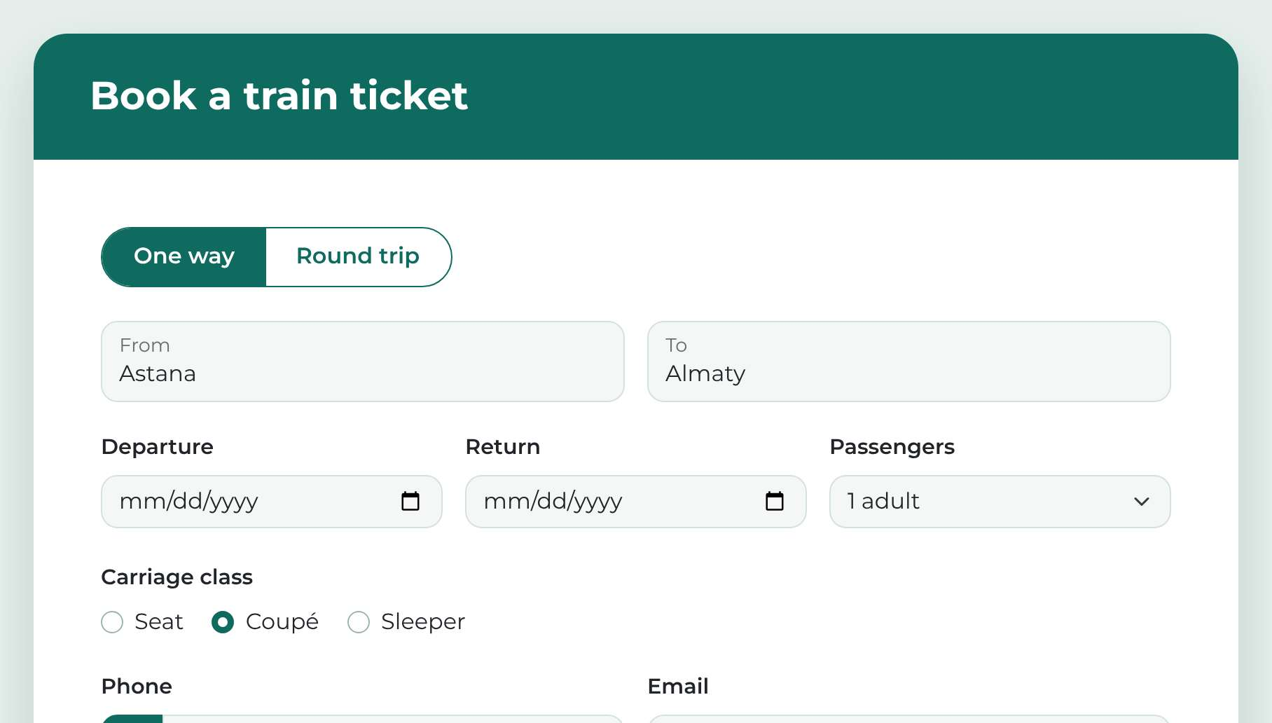  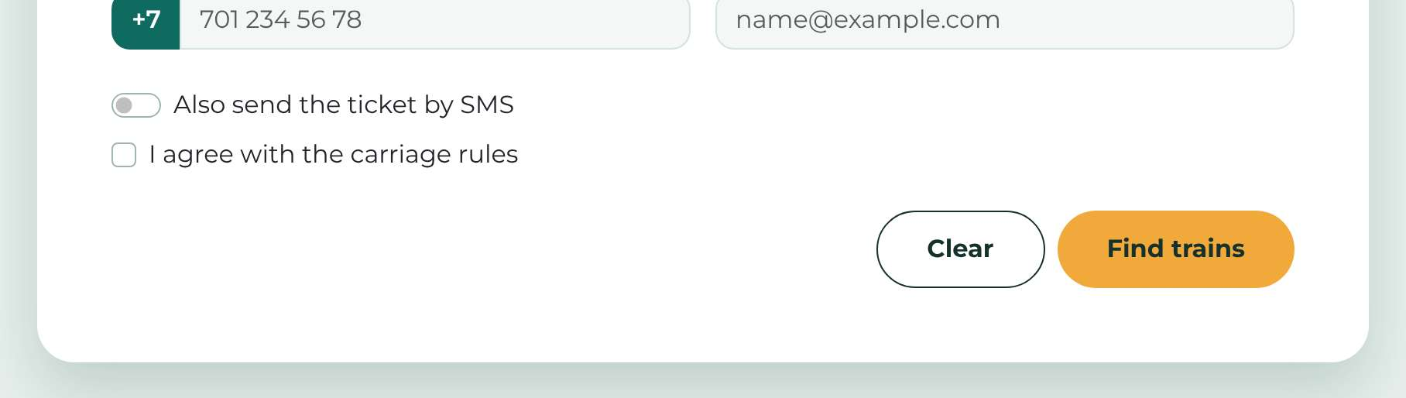 | My form — viewport 1280px  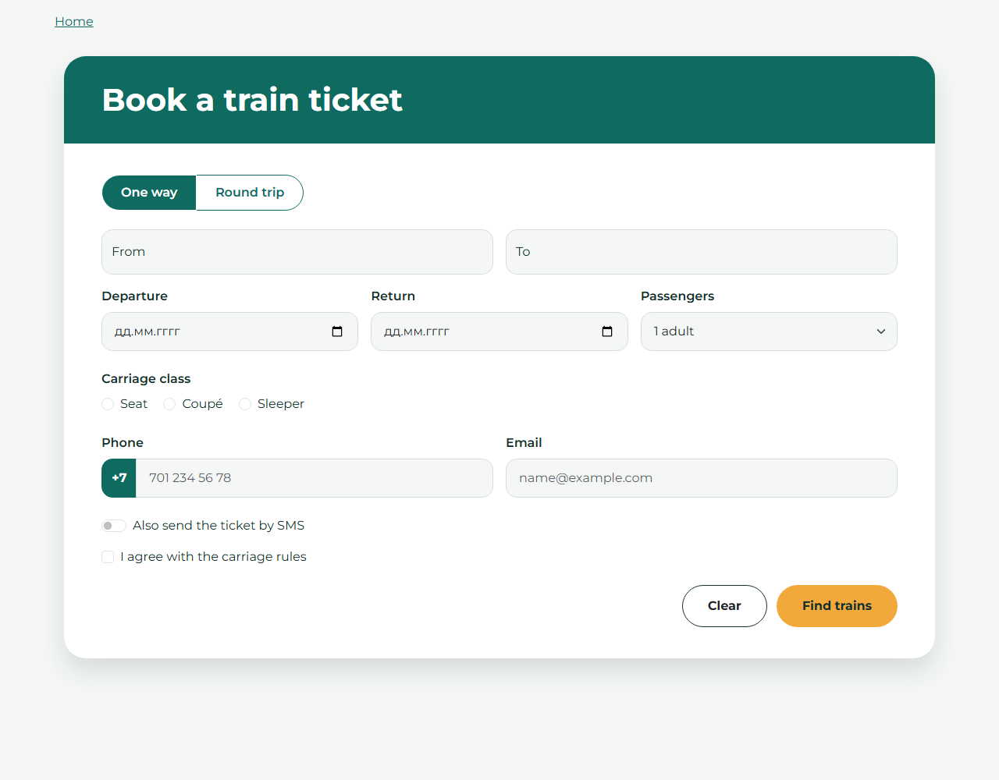

Task 1 — Phone view, 375px
Reference — phone  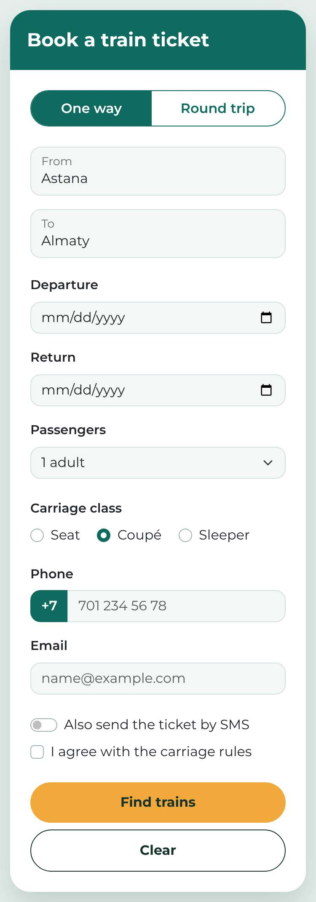 | My form — viewport 375px  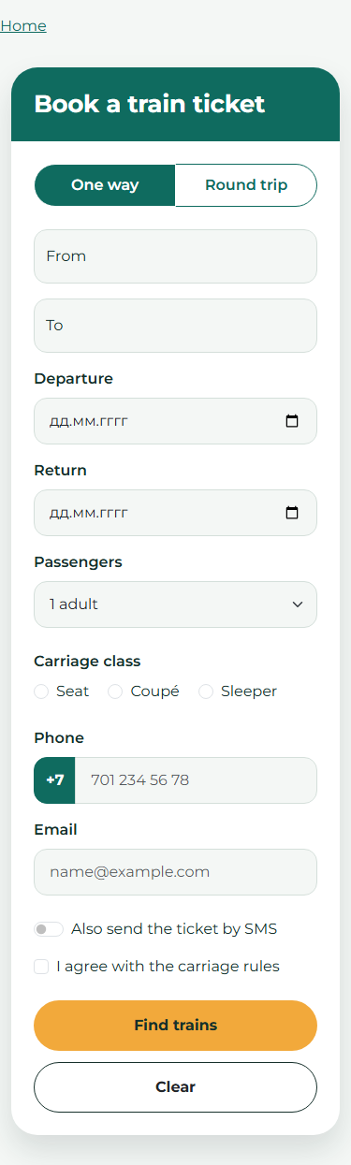

The inputs fit the screen. Find trains is above Clear.

Task 2 — AITU Hack 2026
I chose input types and HTML attributes for each rule. For example, age uses min="16", max="30" and step="1". Time uses step="1800", because time steps are in seconds. The first track option has an empty value, so required rejects it.
The CSS selector :user-invalid shows a red border and the invalid-feedback message after interaction. On the untouched page, all error messages are hidden. I used no JavaScript, pattern or novalidate. The email rule checks address format; it does not restrict the university domain because the assignment only asks for a valid email.
Test results
I tested these values in Chrome. All 41 checks passed, including extra boundary values.
Field | Accepted values | Rejected values | Observed result
Full name | Anna-Maria Lee | A | Accept / reject
University email | a.fedenko@astanait.edu.kz | a.fedenko; a.fedenko@ | Accept / reject both
Age | 16; 18; 30 | 15; 31; 18.5 | Accept / reject
Team size | 4 | 5; 2.5 | Accept / reject both
Track | Web | Choose… (empty value) | Accept / reject
Arrival day | 21.11.2026 | 25.11.2026 | Accept / reject
Check-in time | 09:00; 10:30; 18:00 | 10:15; 19:00 | Accept / reject
Entry fee | 0; 1500; 5000 | 1250; 6000 | Accept / reject
Experience | Beginner | Nothing chosen | Accept / reject
GitHub profile | Empty; https://github.com/yerassyl-dev | github.com/yerassyl-dev | Accept both / reject
Password | Astana2026 | short | Accept / reject
Motivation | 50; 120; 300 characters | 49 characters | Accept / reject
Rules agreement | Ticked | Not ticked | Accept / reject
minlength handles the lower text limit. maxlength prevents typing beyond the upper limit. Browser validation runs before the form goes to the demo completion page.

Task 2 — Screenshot
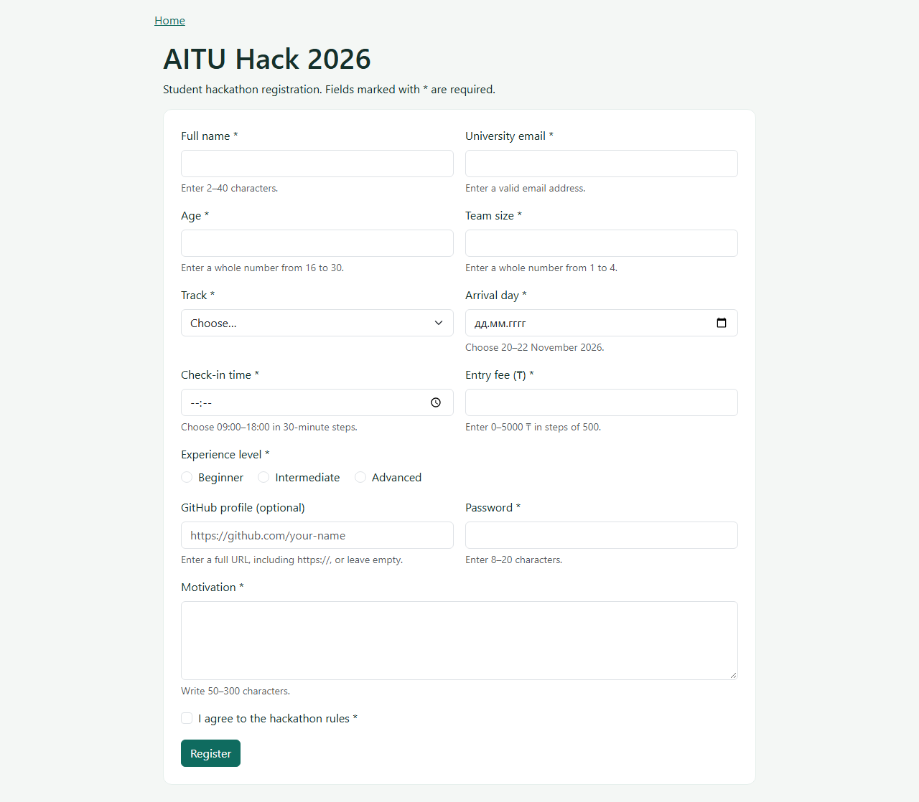

Task 3 — Problems in the original form
Line numbers refer to the original snippet transcribed in reference/bad-form.txt.
Original line | Problem for the user | My fix
3–4 | Name and email use only placeholders. They disappear while typing. | Added visible labels connected to unique input IDs.
4 | Email uses type="text", so incorrect addresses are accepted. | Changed it to type="email".
5–6 | The phone label is not connected. Clicking it does not focus the field. | Added for="phone".
6 | A text phone field does not request a phone keypad on mobile. | Used type="tel" and autocomplete="tel".
7–8 | The guests label points to a missing ID. | Used id="guests" to match the label.
8 | Guests accepts words, fractions and negative values. | Used type="number", min="1" and step="1".
10 | A text date accepts impossible or ambiguous dates. | Used type="date" so the browser supplies a date control.
10, 12 | id="date" is used twice. The date label may focus the wrong control. | Kept date for the date field and used inside for the radio.
12–13 | The seating radios have different names, so both can be selected. | Both use name="seating" and different values.
11–13 | Seating has no accessible group name or connected option labels. | Used fieldset, legend and a label for each radio.
14–17 | The meal select has no label. Its purpose is not announced clearly. | Added a Meal label and a unique ID.
18 | Comments has only a placeholder. | Added a visible Comments label.
19 | The agreement text is not a label; clicking it does not tick the box. | Connected a label to the checkbox ID.
3–10, 14, 18–19 | Most fields have no name, so their values are absent from submission. | Added name attributes to all fields.
20 | Reserve is a div. It cannot submit the form with normal keyboard controls. | Replaced it with button type="submit".
2–21 | Required information can be skipped because required is missing. | Marked booking fields and agreement as required; comments stays optional.
Whole snippet | The form has no responsive grid or spacing; fields can crowd on a phone. | Added Bootstrap row, col-md-6, col-12, g-3 and form classes.
Two alternative fixes
Missing labels (lines 3–4): aria-label could give the fields accessible names. I chose visible labels because they help both screen-reader users and people who need to see the field name while typing.
Seating choices (lines 12–13): a required select with Inside and Terrace could also work. I kept radios because there are only two options and both stay visible.

Task 3 — Fixed form
I kept all the original fields. Every value has a name for submission. Seating uses a shared radio name and separate values. The form uses Bootstrap columns on a laptop and one column on a phone. Labels and native controls support keyboard use.
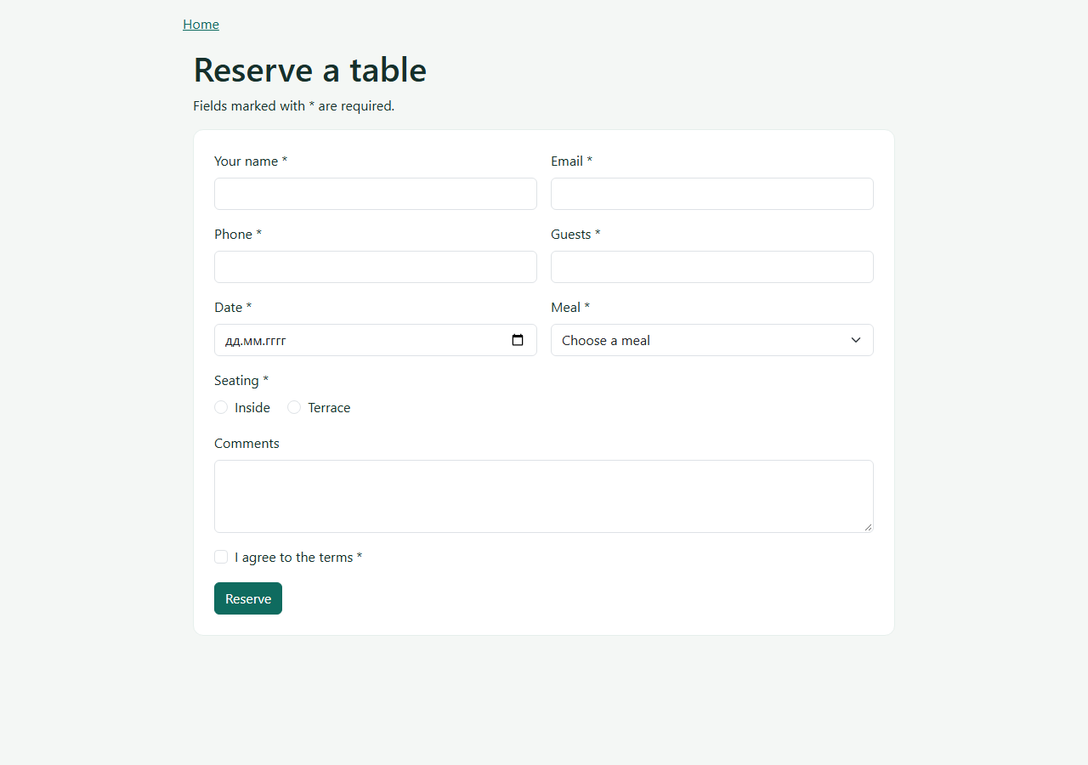
W3C result: messages: [] — no errors or warnings.

Conclusion
I learned how to lay out a form with Bootstrap and how to validate it with HTML attributes. I also learned that labels, field names and button types affect how a form works. CSS can show validation feedback after the user interacts with a field.
References
Bootstrap — Forms
MDN — Time input
MDN — :user-invalid
W3C Nu HTML Checker

