Assignment 5 JavaScript Basics
DOM Manipulation and Events
Name: Saitov Islambek
Group: [ENTER YOUR GROUP]
GitHub repository URL: [PASTE YOUR REPOSITORY URL]
Chosen options: Task 1 A, Task 2 A, Task 3 A.
I made a small Study Hub with three separate pages: a number game, a study board and an event ticket form. Each task has its own JavaScript file. The pages use plain HTML, CSS and JavaScript.
Task 1 Higher or Lower
I chose option A. The player guesses whether the next number is higher or lower. The game starts with 3 lives and shows the current streak and best streak. Equal numbers are correct. The minimum, maximum and life count are constants at the top of task1.js. Math.floor and Math.random generate integers from 1 to 20, including both endpoints.
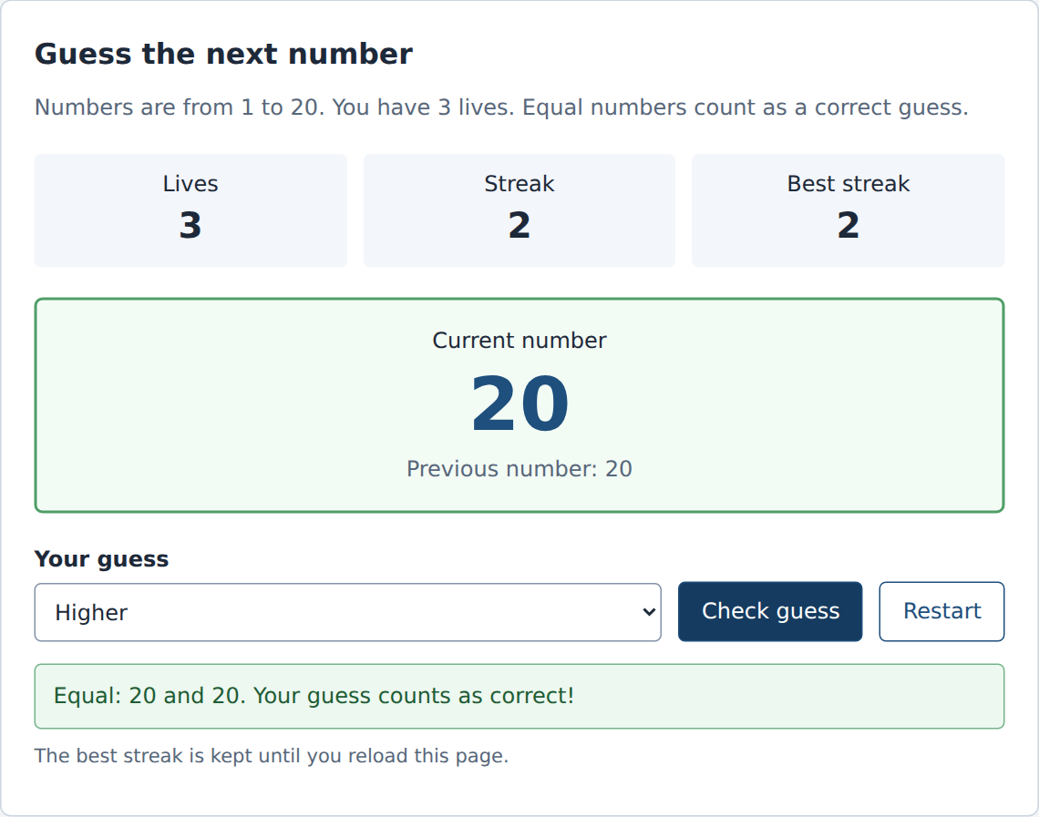
Figure 1. Equal numbers count as a correct guess and increase the streak.

Task 1 Game over and restart
The three outcomes are an equal number, a correct direction and a wrong direction. The conditions use ===, && and ||. An empty choice shows a message without changing the number, lives or streak. A wrong answer removes one life and resets the streak. At zero lives the guess controls are disabled.
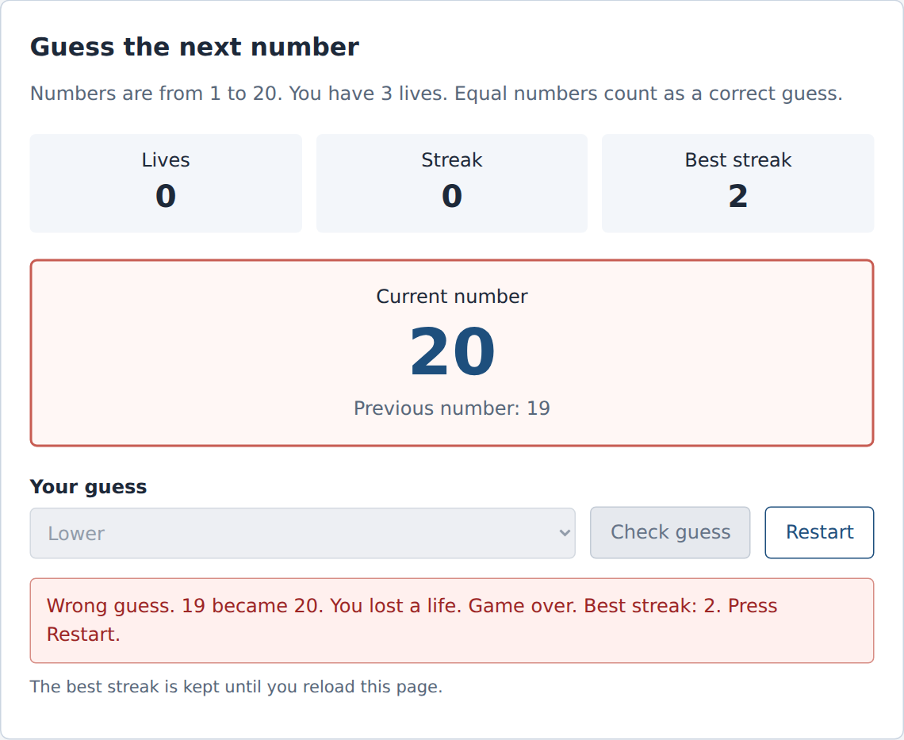
Figure 2. The game stops at zero lives. Restart remains available.
Restart sets a new random number, restores the lives and clears the current streak without reloading the page. The best streak remains for the current page session. Reloading starts a new session.
The checks also changed the range to 40-42 and the starting lives to 1. The range, game ending and restart still worked. Repeated restarts did not create extra event listeners.

Task 2 Study board
I chose option A. The tasks array contains 10 objects. Each object has a unique numeric id, a title, a numeric priority, an important boolean, an array of tags and a status. The HTML starts with an empty boardApp container. JavaScript creates the controls, columns and cards with createElement and textContent.
The render function removes the previous cards and creates the current view after a change. A for...of loop counts finished cards and calculates progress from the whole array. The user can filter by tag, search by title and sort by priority. No results produces a clear empty message.
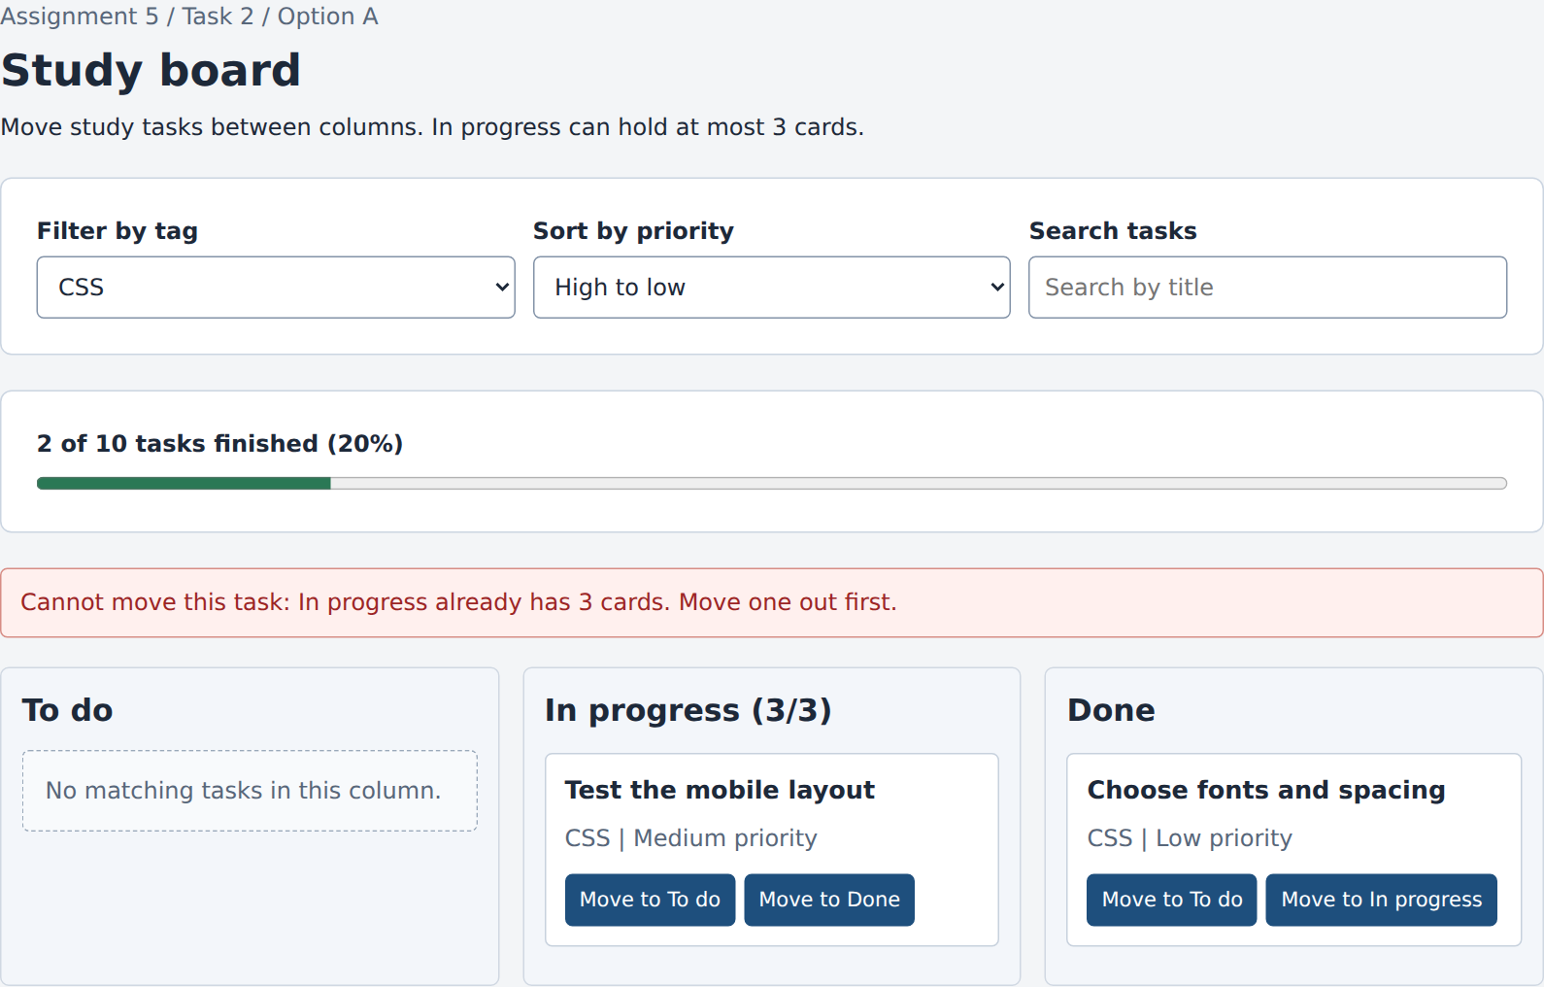
Figure 3. The CSS filter is active. A fourth In progress card is blocked with a reason.
There is one click listener on boardApp for all card buttons. It reads the task id and destination from dataset. Before changing the array, it checks the three-card In progress limit. The limit counts all tasks, including tasks hidden by the current filter.
Initially, 2 of 10 tasks are finished, so the progress is 20%. Moving one more task to Done changes it to 30%. A new object is included automatically when render is called.

Task 3 Ticket builder
I chose option A. The form has seven fields: event, date, ticket type, quantity, full name, email and an optional promo code. Ticket availability is stored in an array of objects. Each row contains the event, date, type, price and seats left. The preview updates on every input and change event.
The form uses form.noValidate = true to turn off browser popups. The HTML still has required, type, min, step and length attributes. JavaScript uses the Constraint Validation API and additional rules to show messages under the fields. Errors first appear on blur; after that, they update while typing.
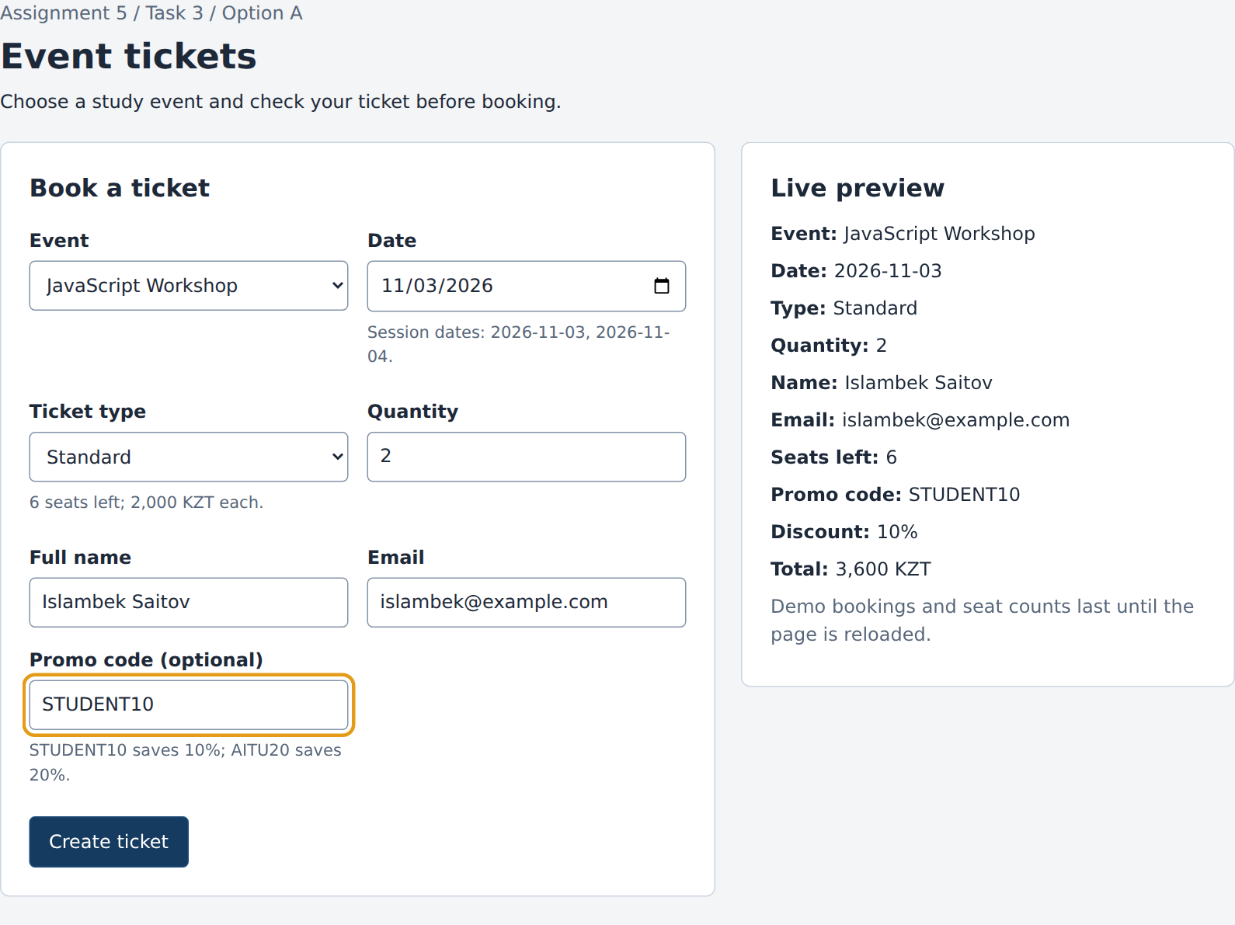
Figure 4. A valid live preview with two Standard tickets and the STUDENT10 discount.
For the JavaScript Workshop on 2026-11-03, a Standard ticket costs 2,000 KZT. Two tickets with STUDENT10 cost 2 x 2,000 x 0.90 = 3,600 KZT. Promo codes ignore surrounding spaces and letter case.

Task 3 Validation rules
The table shows the rules implemented in task3.js. Custom rules 1-5 depend on arrays or other fields, so fixed HTML attributes cannot express them. Examples use the initial availability before any booking. Dates are written as YYYY-MM-DD.
Field | Rule | Valid example | Invalid example
Event | An event must be selected. | JavaScript Workshop | Empty selection
Date | A valid date is required. | 2026-11-03 | Empty date
Date | Custom 1: the date must belong to the selected event. | Workshop on 2026-11-03 | Workshop on 2026-11-05
Date | Custom 2: the selected session must not be sold out. | Workshop on 2026-11-03 | Workshop on 2026-11-04
Ticket type | Custom 3: the type must be offered for that session and have seats left. | Game Night on 2026-11-05, Standard | Game Night on 2026-11-05, VIP
Quantity | Required whole number of at least 1. | 1 or 2 | Empty, 0 or 1.5
Quantity | Custom 4: quantity cannot exceed seats left for the chosen event, date and type. | Workshop on 2026-11-03, Standard, 2 tickets | Same session and type, 7 tickets when 6 remain
Full name | Required; at least 2 characters after trimming; maximum 60 characters. | Islambek Saitov | Empty, spaces, I, or more than 60 characters
Email | Required address accepted by the email input validity check. | islambek@example.com | Empty or islambek@
Promo code | Custom 5: empty or found in the promoCodes array; ignore case and surrounding spaces. | Empty, STUDENT10 or AITU20 | SAVE50
Changing an event, date or ticket type also rechecks dependent fields that have already been touched. For example, a quantity that was valid can become too large when a different ticket type has fewer seats.

Task 3 Invalid submission
On submit, the handler prevents the default action and validates every field. It counts the fields with errors, shows the count at the top and focuses the first invalid field. Each error has a message below its input and aria-invalid is set to true. Labels and aria-describedby connect fields with their help and error text.
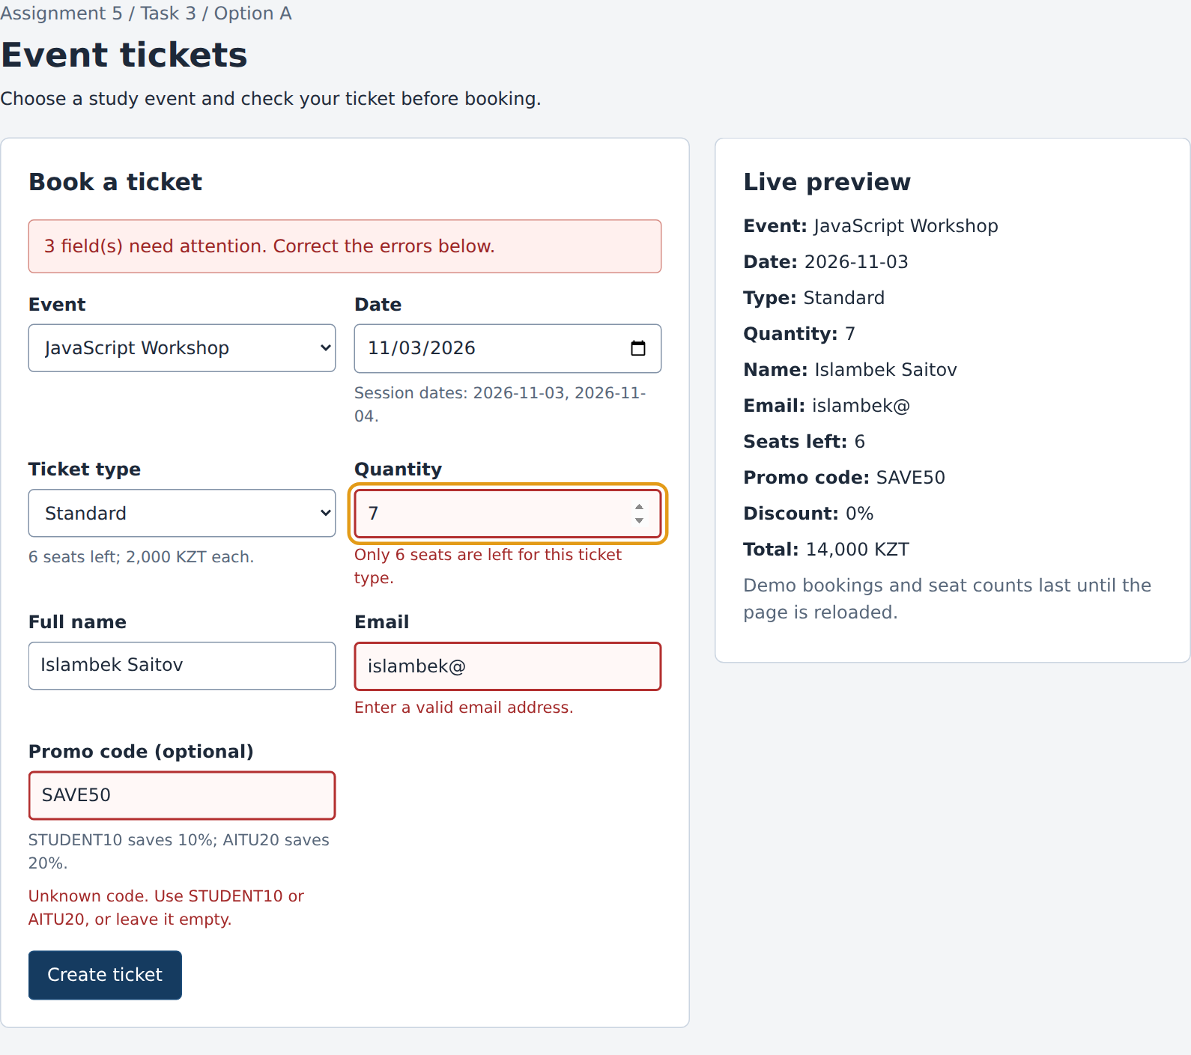
Figure 5. Three fields are invalid: quantity, email and promo code. Quantity receives focus.
There are no error messages when the page first opens. The form uses native inputs, selects and a submit button, so the user can complete it with the keyboard.

Task 3 Successful submission
After a valid submission, JavaScript creates the final ticket with DOM methods. It generates an AITU booking code with six random digits and subtracts the quantity from the selected availability row. The form, touched fields and errors are reset. The confirmed ticket remains visible and receives focus.
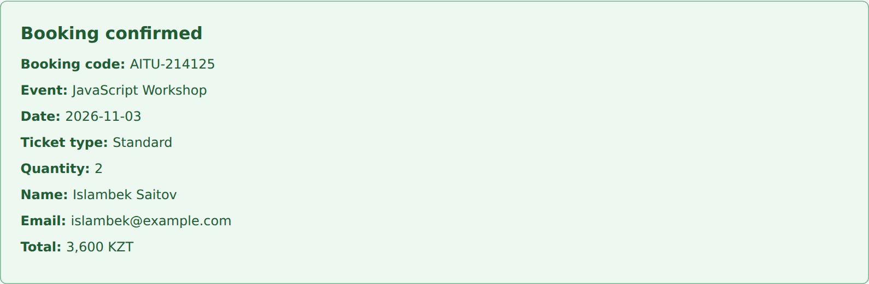
Figure 6. The completed ticket contains the booking code and the discounted total.
The data is kept only in memory. Reloading the page restores the original seat counts. This is a front-end assignment, so there is no server or payment system.
Verification
The browser checks covered game boundaries, equal values, wrong guesses, invalid moves and repeated restarts. They also covered the board limit, sorting, filters, empty results, moving cards and adding another data object.
For the form, the checks covered missing fields, validation after blur, live correction, event and date compatibility, sold-out sessions, ticket limits, invalid promo codes, successful submission and reset. A second booking cannot use seats that were already reserved in the current session.
The pages were checked at widths of 375 px and 1280 px. There was no horizontal scrolling and no JavaScript console error. Hover, focus, disabled, error, success, game win/loss and empty states are defined in styles.css.
Conclusion
I learned how to keep the program state in variables and arrays, then update the page from that state. I used conditions for the game, loops and event delegation for the board, and input, blur, change and submit events for the form. I also learned why dependent fields must be checked again when another field changes.
Project files and launch
Open index.html in a browser. The navigation opens task2.html and task3.html. Each page loads its matching task1.js, task2.js or task3.js file with defer. All pages share styles.css. The screenshots folder contains the images used in this report and additional examples.

