ASTANA IT UNIVERSITY
WEB Technologies 1 (Front End)

RentKit.
Midterm Project Report
Rent the kit. Make it happen.
Project team | Academic information
Islambek Saitov  Jomar Akylbek | Group: IT-2507  Report date: 6 October 2026

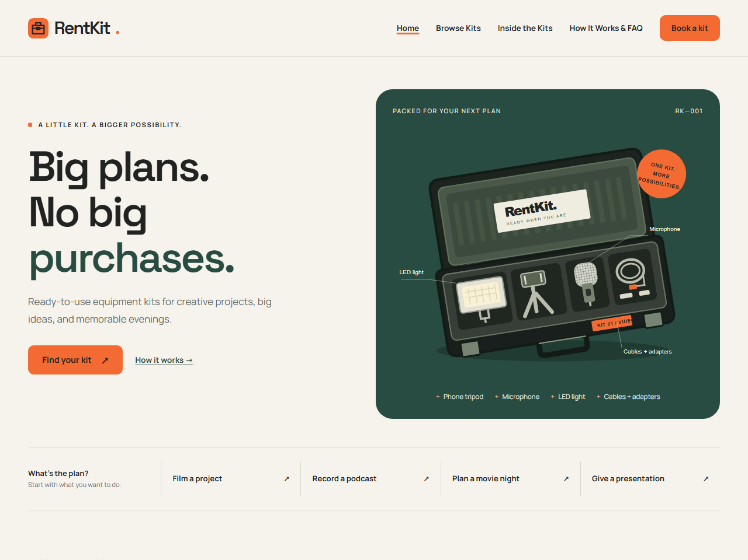
Current project version • Five HTML pages • Local browser screenshots
Equipment rental for creative projects, conversations, evenings and presentations.

1. Project idea and team contribution
RentKit is a frontend website for a business concept that rents complete equipment kits for a specific task. Visitors start with what they want to do, then compare the included equipment and review a rental package. The equipment belongs to RentKit; the concept is not a marketplace between private owners.
The intended visitors are students, beginning content creators, small teams and people who need equipment for a short period. The topic gives the project a clear purpose: reduce the effort of selecting several separate devices for one interview, recording session, evening or presentation. This is the rationale for the concept, rather than a claim based on market research.

Four tasks, four equipment kits
Kit | Task and included equipment
Video Project Kit | Film an interview or project: phone tripod, microphone, LED light, cables and adapters. The visitor supplies a compatible phone.
Podcast Kit | Record two participants: two microphones, stands, headphones, recorder and cables. The visitor provides a quiet room and a conversation plan.
Movie Night Kit | Arrange a movie evening: projector, portable screen, speaker and cables. The visitor supplies the video source and content.
Presentation Kit | Present slides: projector, clicker, HDMI cable and adapters. The visitor supplies a compatible laptop and slides.

Contribution reported by the team
Team member | Actual work described by the team
Islambek Saitov | HTML pages; home.css, kits.css and kit-details.css; finding and adding the project fonts.
Jomar Akylbek | Shared styles.css and the page styles rent.css and order.css; selecting and adding the projector photograph.

This allocation follows the team’s description. It does not claim a verified commit history or assign authorship of order.js to either student.

Current content changes
The visible educational labels were removed from the interface, while all four fictional testimonials were retained. The checkout button now reads “Review booking”, delivery is described as a fee per order, and the local result shows a rental summary. README.md and CREDITS.md still explain the project’s demonstration limits. This report describes the files currently saved in the repository.

2. Visual style and design decisions
The visual identity combines a warm background, dark typography, a bright action colour and a deep green equipment case. It presents rental as a practical way to carry out a plan. The main headline, “Big plans. No big purchases.”, connects directly to that idea.
CSS token | Colour and purpose
--paper | #F6F3EC — warm background across every page.
--ink | #202322 — headings, body text and dark text on orange buttons.
--orange | #F36B32 — primary actions, brand punctuation and small section markers.
--green | #294C42 — equipment case, information panels, links and focus outlines.
--surface / --line | #FFFDF8 / #D8D9CF — light cards and form sections with quiet borders.
--sage / --muted | #E3E8DD / #62665F — supporting panels and secondary text.

Typography and reusable components
Manrope is used for body text, navigation and forms. Space Grotesk is used for headings, the brand and prices. Both families are loaded from local font files through @font-face, with Arial and sans-serif fallbacks. font-display: swap lets the text appear while a custom font is loading.
styles.css defines colours, spacing, radii and the maximum page width as CSS custom properties. The same button, kit-card, tag, header and footer rules are reused on every page. Bootstrap is loaded first; the custom CSS then gives its components the RentKit appearance. Orange buttons use dark text, rather than small white lettering.

The memorable visual element
The homepage uses an asymmetric two-column Grid: a strong headline on the left and an open RentKit case on the right. The SVG shows a phone tripod, microphone, LED light, cables and adapters, with labels that explain the kit. It does not substitute a professional camera for the phone accessories actually listed.
The four kit SVGs follow the same illustration style and are reused in the catalogue, kit details and order preview. Equipment labels such as KIT 01 make the sets easy to identify. The projector photograph adds a relevant photographic element without promising a particular device model.

Testimonials and small interactions
The homepage keeps a static grid of four testimonial examples, with names, kit names and circular initials. No real person’s portrait is used. The examples are fictional content, as documented in CREDITS.md. Hover states, visible keyboard outlines and small button movements add feedback; reduced-motion preferences disable movement.

3. Structure and page implementation
The application uses five independent HTML documents and relative file paths. It has no build step, frontend framework, backend, login or payment integration. Shared styling is in css/styles.css; home.css, kits.css, kit-details.css, rent.css and order.css hold page-specific rules. The only custom JavaScript is js/order.js.

Home — index.html
The page introduces the brand and the open-case illustration, then offers task links to the relevant catalogue anchors. Featured kits use Bootstrap row, col-12, col-md-6 and col-lg-4 classes. Custom Grid lays out the hero, task strip, process and testimonials. Flexbox arranges the calls to action and testimonial captions.

Browse Kits — kits.html
The catalogue contains four article cards inside a two-column CSS Grid. Bootstrap card and button classes are restyled by RentKit CSS. Every card shows equipment, a one-day price and what the visitor supplies. Details links lead to the corresponding #video, #podcast, #movie or #presentation section. Booking links pass only the kit key in order.html?kit=video and equivalent URLs.

Inside the Kits — kit-details.html
Four named sections explain every included item using definition lists, distinguish “We provide” and “You bring”, and add ordered setup checklists. Grid pairs each illustration with its contents; Flexbox arranges headings and prices. A Bootstrap table compares 1-, 3- and 7-day package totals. It has a caption, column headers with scope="col" and kit headers with scope="row".

How It Works & FAQ — rent.html
A custom Grid pairs the process panel with a numbered ordered list. CSS counters display the four steps. Rental conditions use Bootstrap columns, while the FAQ uses native details and summary elements that work without a custom script. This page links to the booking page and contains no second order form.

Book Your Kit — order.html
The form is divided into fieldsets for the kit, rental details, contact information and final review. Labels connect to each input. Bootstrap form-control, form-select, form-check and row/col classes provide useful form structure. Named CSS Grid areas place the form on the left and the live summary on the right; on narrower screens the summary appears before confirmation.

Shared semantic structure
Each page has header, labelled nav, main and footer landmarks, one h1, a skip link and an aria-current marker for its active navigation link. The five menu links remain visible and wrap on a phone. Meaningful images have alt text and dimensions. Local images below the first screen use lazy loading; the hero image is prioritised.

4. Rental pricing and local order logic
All prices are in KZT. The amounts below cover the complete selected period; the three- and seven-day values are package prices, not the one-day rate multiplied by the number of days.
Equipment kit | 1 day | 3 days | 7 days
Video Project Kit | 5 000 ₸ | 13 000 ₸ | 26 000 ₸
Podcast Kit | 7 000 ₸ | 18 000 ₸ | 36 000 ₸
Movie Night Kit | 8 000 ₸ | 21 000 ₸ | 42 000 ₸
Presentation Kit | 6 000 ₸ | 15 000 ₸ | 30 000 ₸

Pickup adds 0 ₸; delivery adds 2 000 ₸ once per order. For example, Movie Night Kit for three days with delivery totals 21 000 + 2 000 = 23 000 ₸. The HTML price table and the prices object in order.js contain matching values.

Functions in js/order.js
Function | Purpose in the current code
todayInKazakhstan() | Builds today’s YYYY-MM-DD date using Asia/Qyzylorda, independently of the visitor’s timezone.
formatMoney(amount) | Adds grouped digits and the tenge symbol, for example 23 000 ₸.
formatPickupDate(value) | Displays the selected date in a readable English format, or asks the visitor to choose a date.
getRental() | Reads the allowed kit, duration and pickup method, selects the package price, and adds the pickup fee.
validateDate() | Sets the minimum date to today and marks a past date as invalid.
updateSummary() | Updates both kit images, contents, date, duration and totals; validates the name/date and clears an older result.
confirmDemo(event) | Prevents submission, checks native form validity, displays an error or a local rental summary, and focuses the status message.

URLSearchParams reads the kit parameter. Object.hasOwn restricts it to the four catalogue keys; unknown values leave the normal kit selection in place. Dynamic text is inserted with textContent. input and change events refresh the summary, while button click and submit events share the same validation handler.

Validation and demonstration limits
Required fields, type="email", date checks, a trimmed name check and the conditions checkbox prevent an incomplete review. The result is local: no reservation, payment or email is made. The form uses method="dialog", contact fields have no name attributes, and the button starts disabled. Without JavaScript the disabled control and noscript message remain. Contact data are not saved to a URL, storage or logs.

5. Responsiveness, accessibility and checks
The custom media queries adapt the layout beyond Bootstrap’s own column breakpoints. The page avoids global overflow-x: hidden; the grids and components are sized to fit the available space.
Breakpoint | Changes made by the project CSS
1000 px | The header can wrap; section spacing decreases. Home tasks and process steps use two columns.
850 px | Kit-detail sections become one column. Order areas become fields → summary → confirmation.
800 px | The process and FAQ layouts stack vertically.
700 / 650 px | The home hero, rental explanation and testimonials stack at 700 px; catalogue cards stack at 650 px.
600 / 400 px | Page gutters and panel padding decrease; menu links wrap; the price table and small task tiles use compact spacing.
Reduced motion | Smooth scrolling, transitions, animation and the button movement are disabled.

Checks performed on 6 October 2026
The current saved version was served locally and tested in Chrome/154.0.8037.93. Fresh full-page captures were saved for all five pages at 375, 768 and 1280 px. The report includes readable viewport screenshots from those browser sessions. 257 automated assertions passed.
Check | Observed result
Pages and images | All 15 page/width combinations loaded; no horizontal page overflow or broken images was detected.
Links and anchors | 144 local references resolved; fragment targets exist and page IDs are unique.
Pricing and selection | All four URL kit selections worked. All 24 kit × duration × pickup-method totals and images matched. Twelve table prices matched the order configuration.
Invalid input | Empty required fields, an invalid email, a past date, a whitespace-only name and missing consent produced no successful summary.
Local result and edge cases | A valid Movie Night / 3 days / delivery example returned 23 000 ₸. Editing cleared it. Unknown and malformed kit values were ignored.
Keyboard and privacy | The skip link was the first visible keyboard target; FAQ opened with Enter. The status received focus. Confirmation sent no HTTP request, changed no URL and used no local/session storage.
Without JavaScript | The noscript explanation appeared, confirmation stayed disabled and the form retained its non-network submission method.

Limits of these checks: desktop Chrome with emulated viewport sizes, not physical phones or a full screen-reader audit. Other browser engines and the deployed site were not tested. Website source files were unchanged while preparing the report.

6. Result, conclusion and project links
The result is a complete five-page frontend with one consistent visual identity and a clear path from choosing a task to reviewing a rental. It combines original equipment illustrations, semantic content, a useful comparison table, an accessible form and a small calculation script. The interface now uses the updated commercial wording while its real technical behaviour remains a local prototype.
The project brings together practical course topics: separating shared and page-specific CSS, choosing Grid for two-dimensional layouts, using Flexbox for rows of controls, adjusting Bootstrap components, creating custom breakpoints and validating a form with native browser rules. The price examples also show why a package must be looked up directly instead of calculated from a daily rate. These are technical learning outcomes demonstrated by the project; no personal reflection is attributed to a student without their input.

Repository and publication
GitHub repository: https://github.com/issait1701-code/RentKIT
Deployed website:

Sources, licences and AI assistance
The resource information is recorded in midterm/CREDITS.md. The projector photo is “A White Projector” by Jens Mahnke from Pexels. The six SVG assets were created specifically for RentKit with AI assistance, rather than downloaded as a website theme.
Projector original: https://www.pexels.com/photo/a-white-projector-6062806/
Photo conditions: https://www.pexels.com/license/
Manrope: https://fonts.google.com/specimen/Manrope
Space Grotesk: https://fonts.google.com/specimen/Space+Grotesk
Bootstrap 5.3: https://getbootstrap.com/docs/5.3/
Bootstrap 5.3.8 is included locally under its MIT licence. The fonts include SIL Open Font License 1.1 files. The report uses Arial, the website’s fallback font, for portable document text and follows the RentKit colour palette.
AI assistance supported the CSS and JavaScript, the SVG illustrations. The student changes listed in Section 1 follow the contribution description supplied by the team.
A1. Home — 375 px and 768 px
index.html • Fresh local browser captures • 6 October 2026
375 px  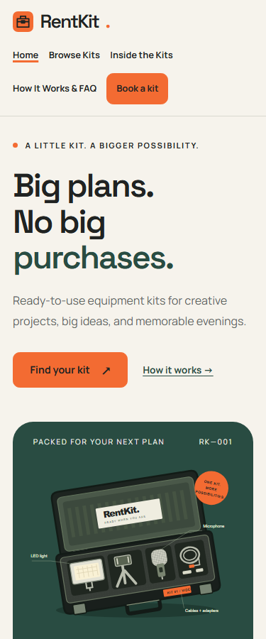 | 768 px  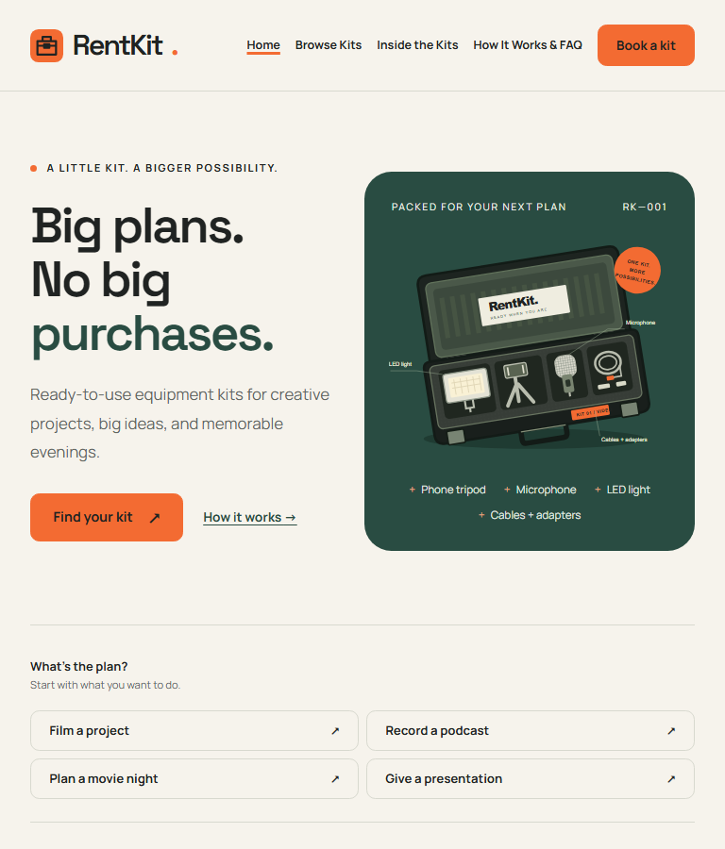
The headline and equipment case share a Grid on wide screens; the phone view stacks them.

A1. Home — 1280 px
index.html • Desktop viewport • 6 October 2026
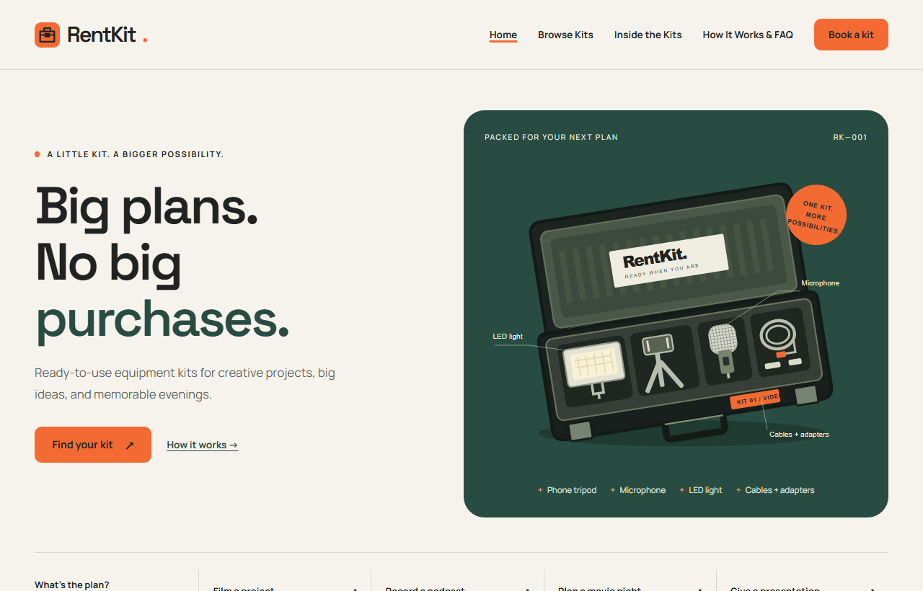
The headline and equipment case share a Grid on wide screens; the phone view stacks them.

A2. Browse Kits — 375 px and 768 px
kits.html • Fresh local browser captures • 6 October 2026
375 px  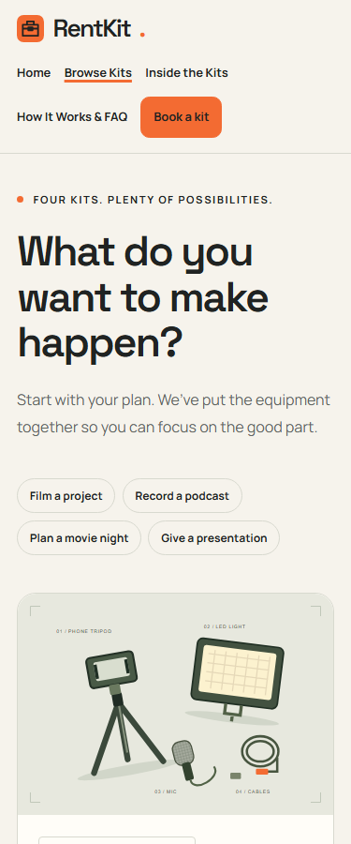 | 768 px  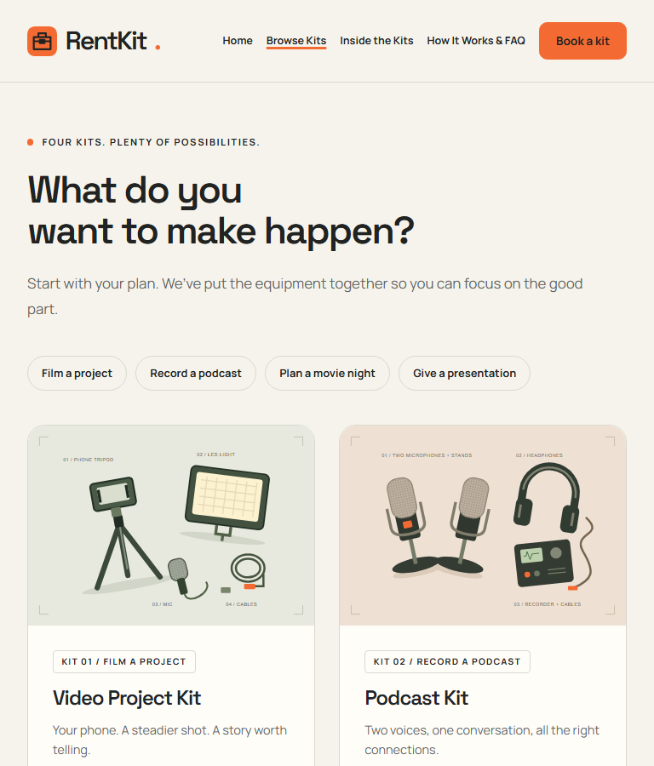
Task links wrap and the catalogue changes from two columns to one on a small screen.

A2. Browse Kits — 1280 px
kits.html • Desktop viewport • 6 October 2026
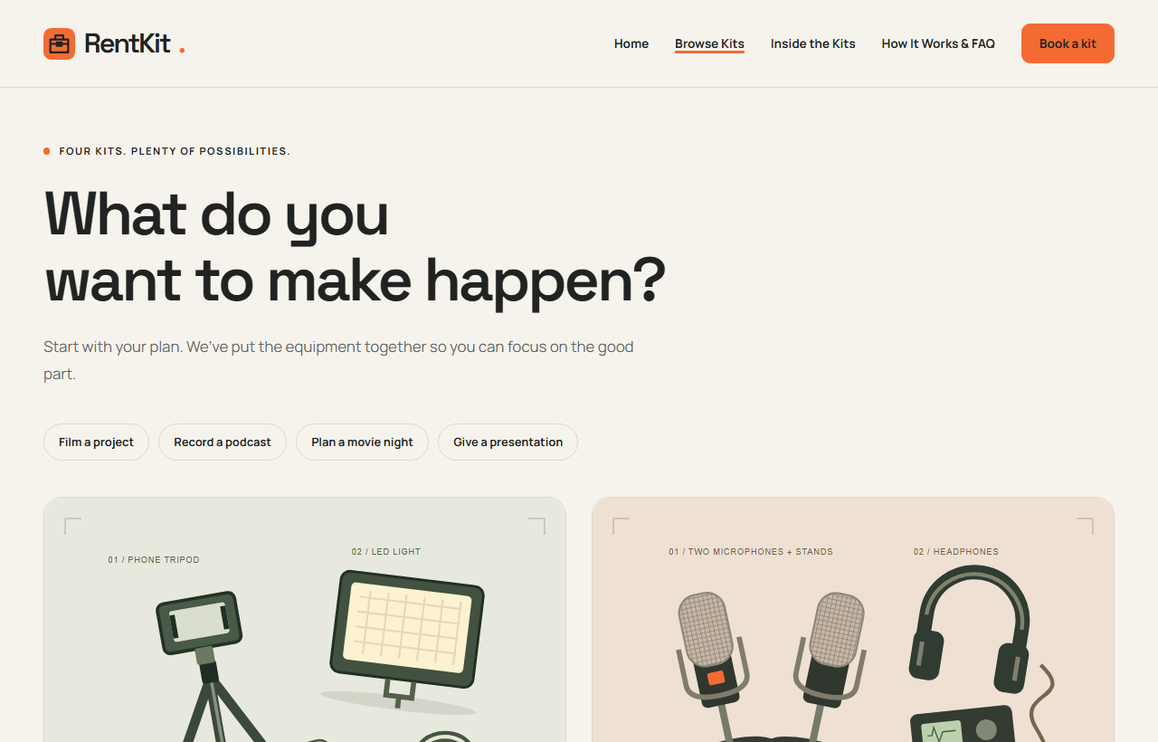
Task links wrap and the catalogue changes from two columns to one on a small screen.

A3. Inside the Kits — 375 px and 768 px
kit-details.html • Fresh local browser captures • 6 October 2026
375 px  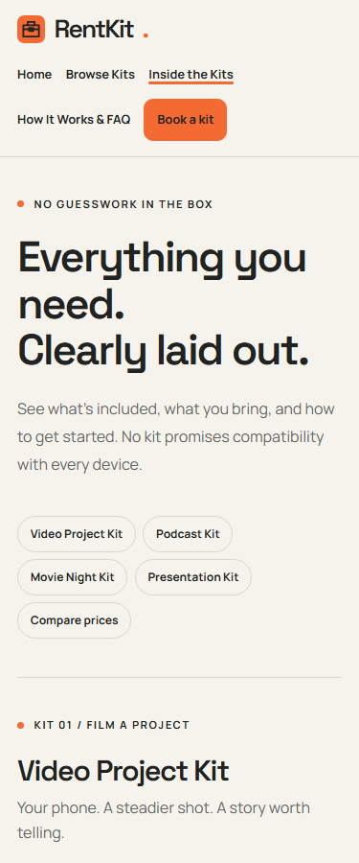 | 768 px  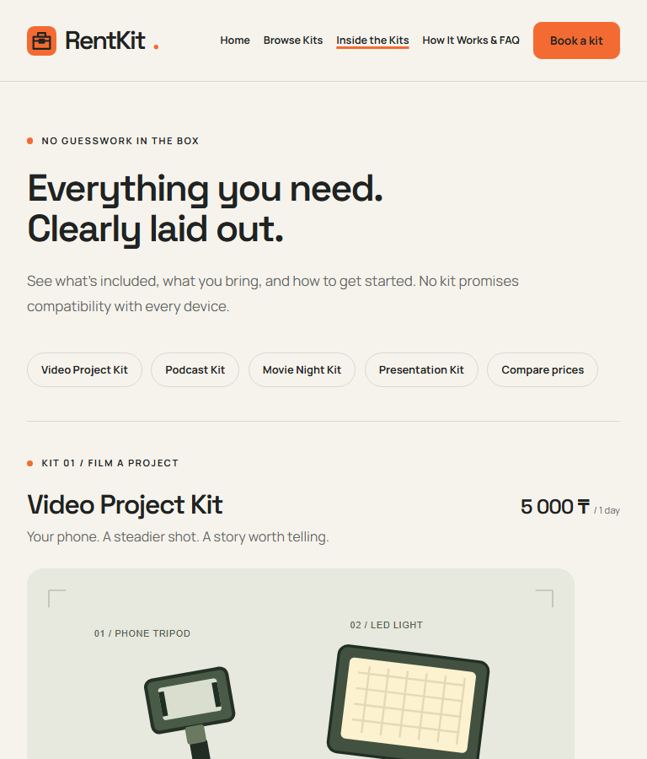
Anchor navigation wraps. The equipment illustration and descriptions stack below 850 px.

A3. Inside the Kits — 1280 px
kit-details.html • Desktop viewport • 6 October 2026
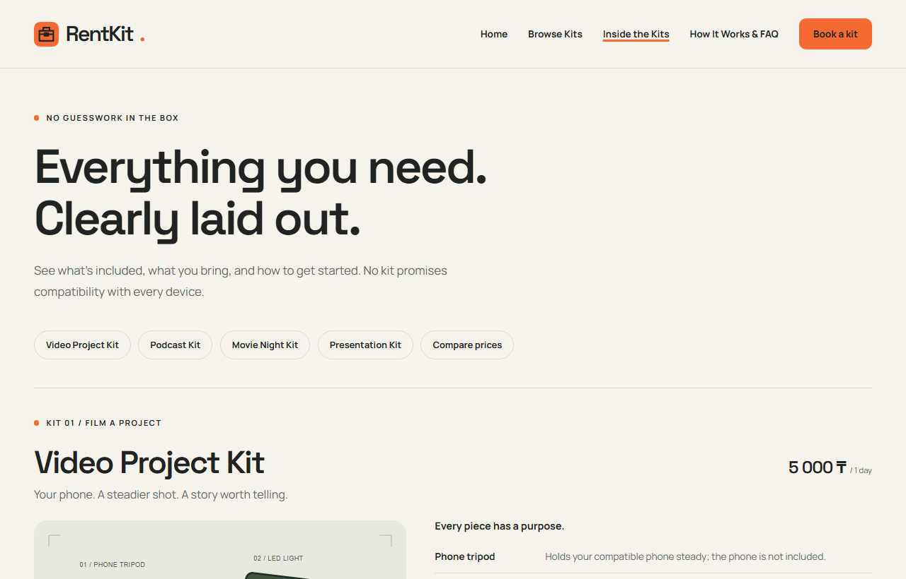
Anchor navigation wraps. The equipment illustration and descriptions stack below 850 px.

A4. How It Works & FAQ — 375 px and 768 px
rent.html • Fresh local browser captures • 6 October 2026
375 px  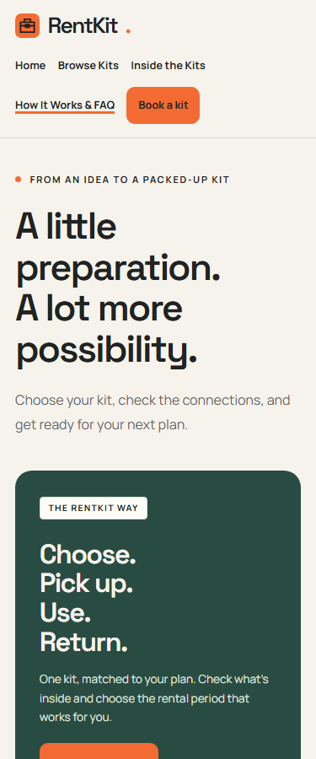 | 768 px  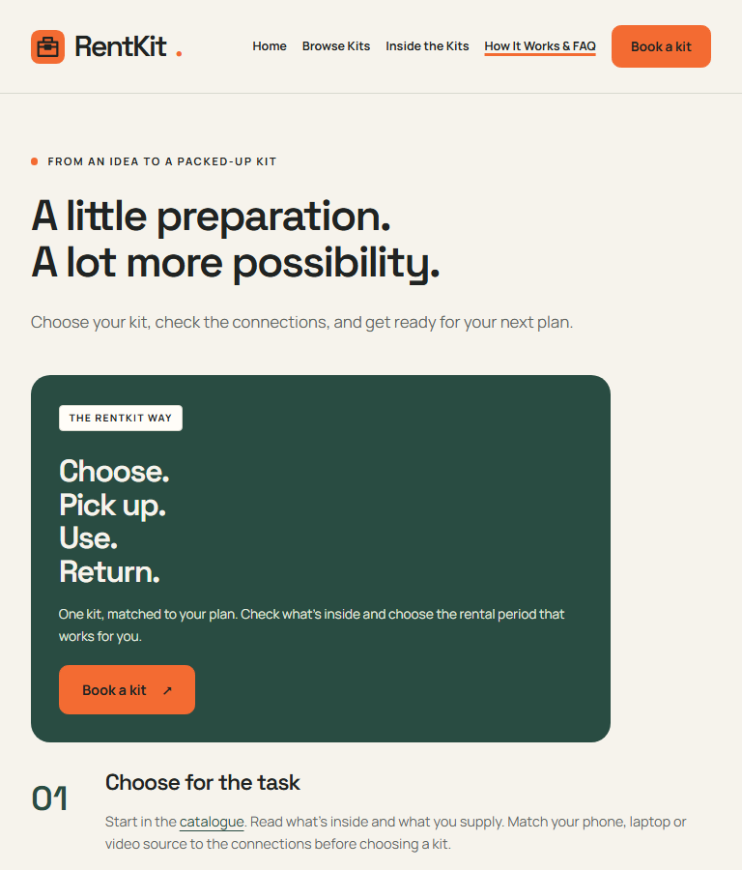
The process panel moves above the checklist. FAQ remains a native details/summary component.

A4. How It Works & FAQ — 1280 px
rent.html • Desktop viewport • 6 October 2026
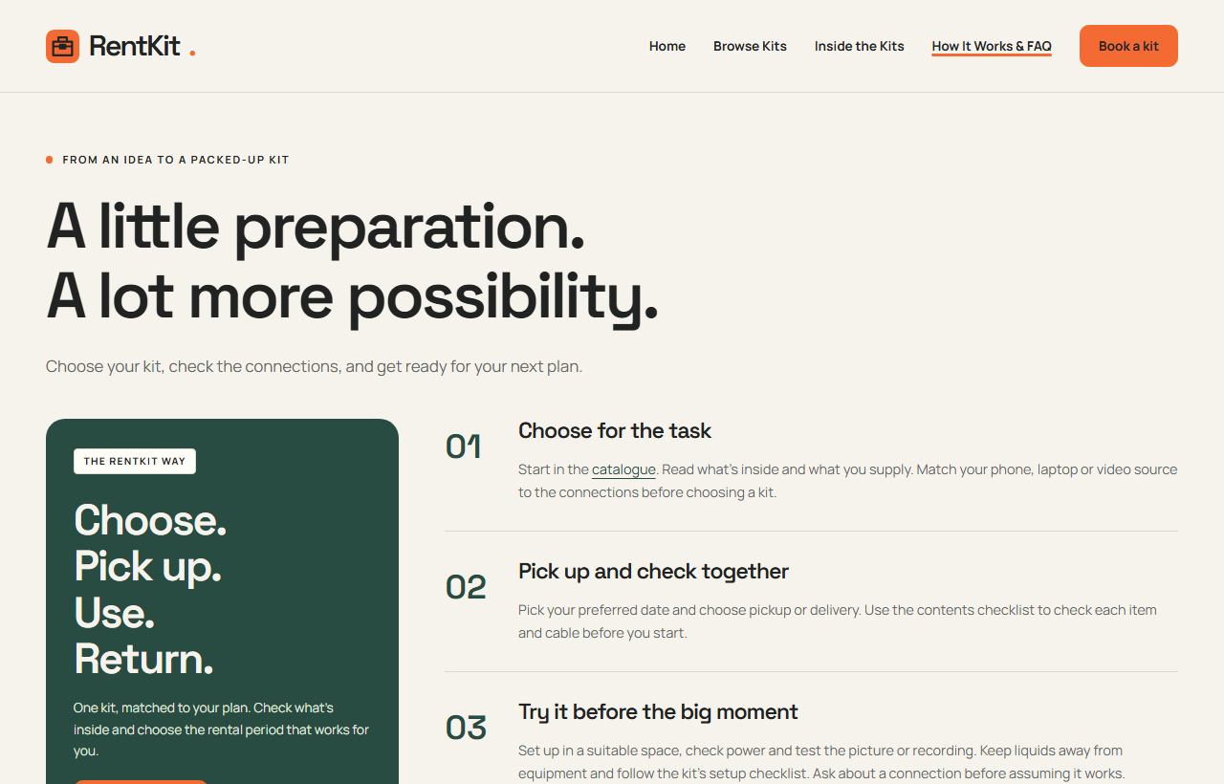
The process panel moves above the checklist. FAQ remains a native details/summary component.

A5. Book Your Kit — 375 px and 768 px
order.html • Fresh local browser captures • 6 October 2026
375 px  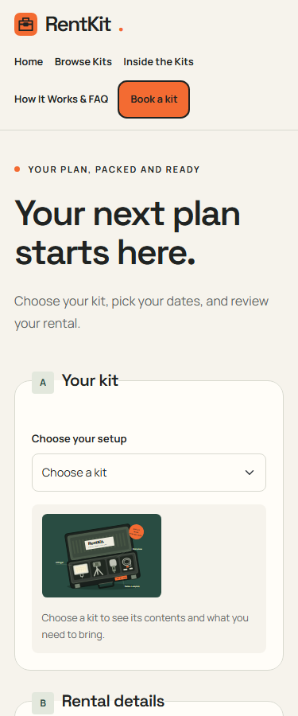 | 768 px  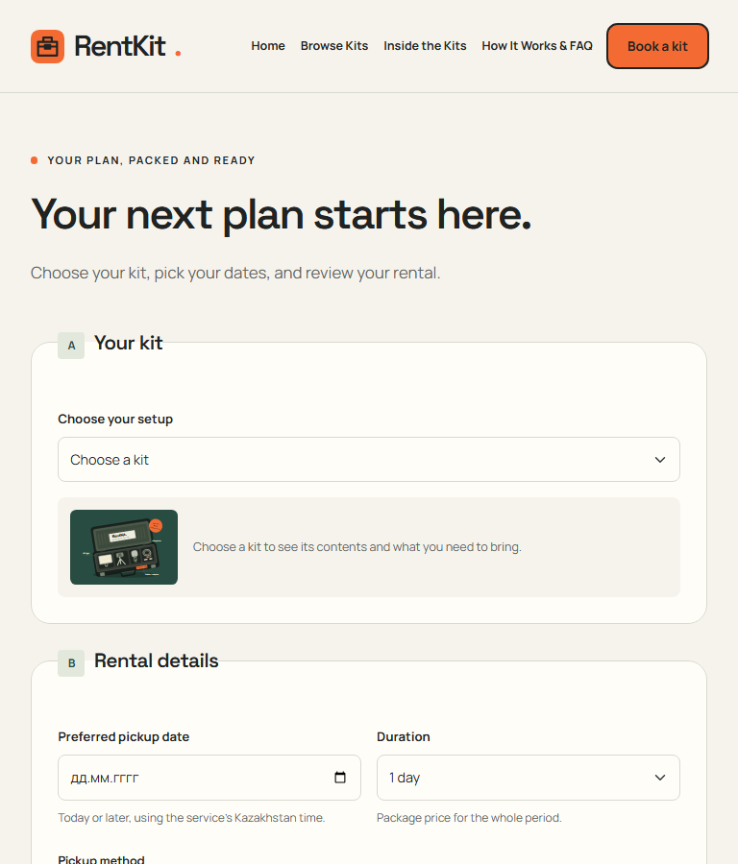
At 768 px and below the form, summary and confirmation use one column in reading order.

A5. Book Your Kit — 1280 px
order.html • Desktop viewport • 6 October 2026
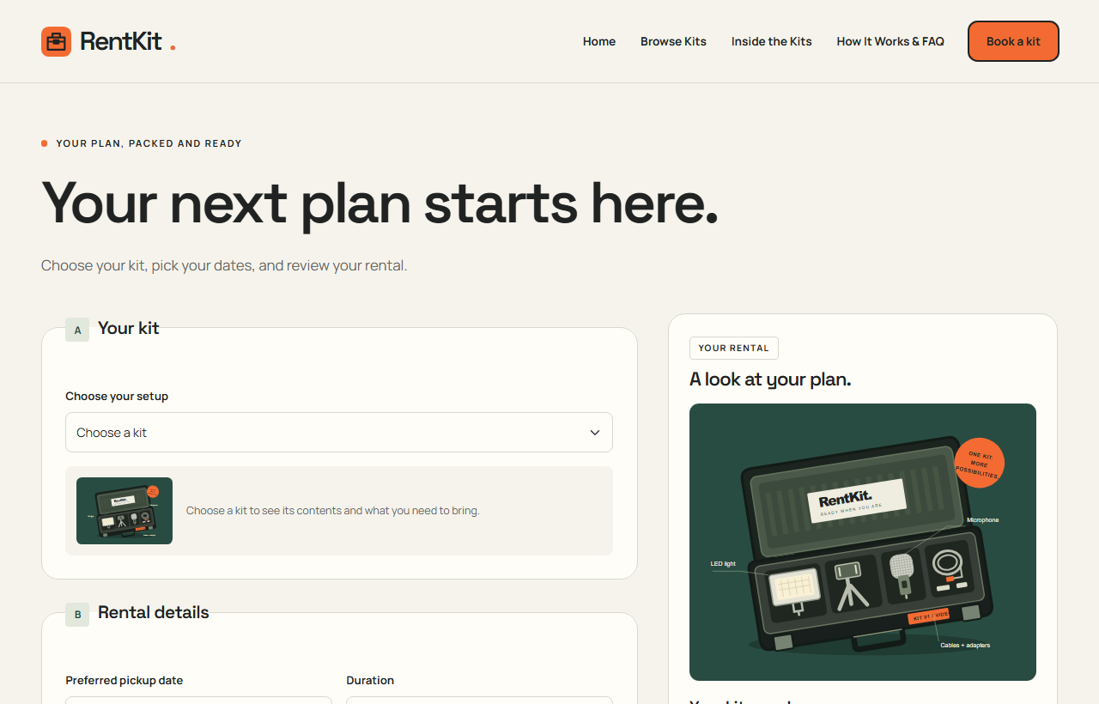
At 768 px and below the form, summary and confirmation use one column in reading order.

