Assignment 6
jQuery: Selectors, Effects and Animations
Name: Saitov Islambek
Group: IT-2507
GitHub repository URL: [ADD YOUR REPOSITORY LINK BEFORE SUBMISSION]
The repository has not been created yet. This field must be replaced with the real source-code repository URL before the report is submitted.

Project overview
This project rebuilds the birthday party from the assignment picture. Task 1 finds guests and rooms with jQuery selectors and traversal. Task 2 is a copy of Task 1 with spotlight, guest details, room transfers and animated sorting. The implementation uses plain HTML, CSS and jQuery 3.7.1. There are no other JavaScript libraries, inline onclick handlers, CSS transitions or CSS animations.
Part | Files | Purpose
Task 1 | index.html, task1.js | 21 original guests, 4 rooms, 20 cases
Task 2 | task2.html, task2-base.js, task2.js | Copy of Task 1 plus jQuery effects
Shared | styles.css, jquery.min.js, avatars/ | Layout and local assets; works offline

How to run
Open index.html in Chrome or Edge. Use the navigation link to open Task 2. Click a case number to see the result, its count and its jQuery chain. Hover over the number to read the condition. Clear / Reset returns the complete party to the original picture order.
Avatar source: DiceBear Open Peeps, CC0. Local SVGs were downloaded from https://api.dicebear.com/9.x/open-peeps/svg?seed=NAME. The avatar ring represents clothing color. Icons represent the objects in the picture, and the graduation badge marks AITU students.

Task 1 — Party data and page structure
The array contains each room’s name, floor and guests from left to right. A guest record has a name, clothing color, arrival time, AITU status and things. buildParty() creates both floors and all cards with jQuery. Each card stores searchable classes and data-name, data-time, data-minutes and data-things attributes.
Floor / room | Guests in picture order
2 / Balcony | Aigerim, Aliya, Madina, Ivan
2 / Hall | Arman, Sophia, Dias, Bekzat, Aruzhan, Saule
1 / Kitchen | Nurlan, Emma, Timur, Sergey, Yerlan, Kamila
1 / Living room | Daniel, Zarina, Natasha, Askar, Inkar

Data check
Room | Guest | Color | Time | AITU | Things
Balcony | Aigerim | Green | 20:45 | Yes | Cup, crumbs
Balcony | Aliya | Black | 21:15 | No | Phone, cup
Balcony | Madina | Green | 22:10 | No | Phone, bag, crumbs
Balcony | Ivan | Black | 20:10 | Yes | Cup
Hall | Arman | Yellow | 20:35 | No | Bag, glasses
Hall | Sophia | Purple | 21:20 | Yes | Phone
Hall | Dias | Green | 19:45 | Yes | Nothing
Hall | Bekzat | Purple | 20:55 | No | Bag, cup, crumbs
Hall | Aruzhan | Blue | 21:50 | Yes | Phone
Hall | Saule | Green | 21:25 | No | Glasses
Kitchen | Nurlan | Red | 19:40 | Yes | Phone, cup
Kitchen | Emma | Black | 20:15 | No | Bag
Kitchen | Timur | Green | 21:05 | Yes | Phone, bag, crumbs
Kitchen | Sergey | Yellow | 20:50 | No | Nothing
Kitchen | Yerlan | Red | 21:40 | Yes | Glasses, phone
Kitchen | Kamila | Green | 20:05 | No | Cup
Living room | Daniel | Blue | 19:55 | Yes | Glasses
Living room | Zarina | Green | 21:10 | No | Bag, phone, crumbs
Living room | Natasha | Yellow | 20:30 | Yes | Nothing
Living room | Askar | Black | 21:00 | Yes | Phone
Living room | Inkar | Purple | 20:20 | No | Bag

Task 1 — Case 1

Who is in the hall?
Result on the original party
Case 1: 6 found — Arman, Sophia, Dias, Bekzat, Aruzhan, Saule
jQuery chain
$('#hall .guest')
The room id limits the search to guest cards inside the hall.
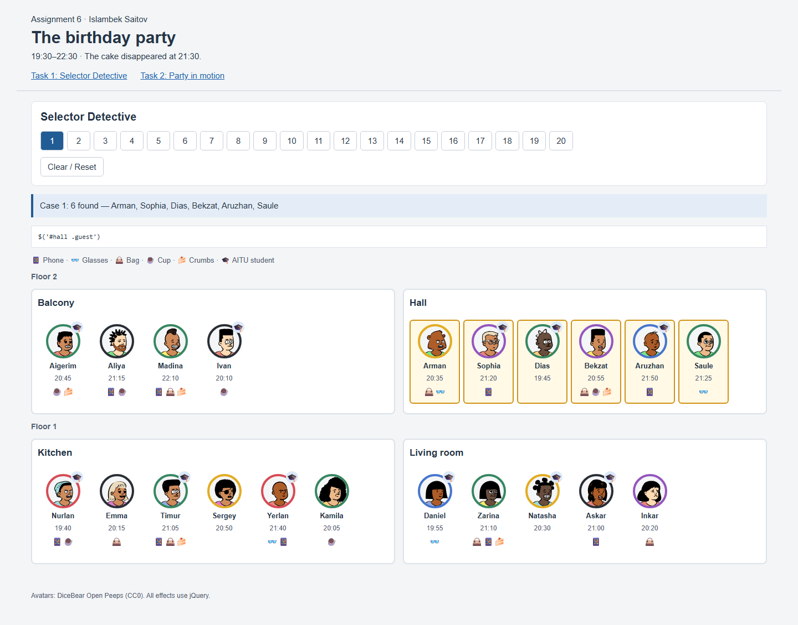
Figure 1. Actual browser result for case 1.

Task 1 — Case 2

Yellow or purple clothes
Result on the original party
Case 2: 6 found — Arman, Sophia, Bekzat, Sergey, Natasha, Inkar
jQuery chain
$('.guest.yellow, .guest.purple')
The two clothing classes are combined in one selector.
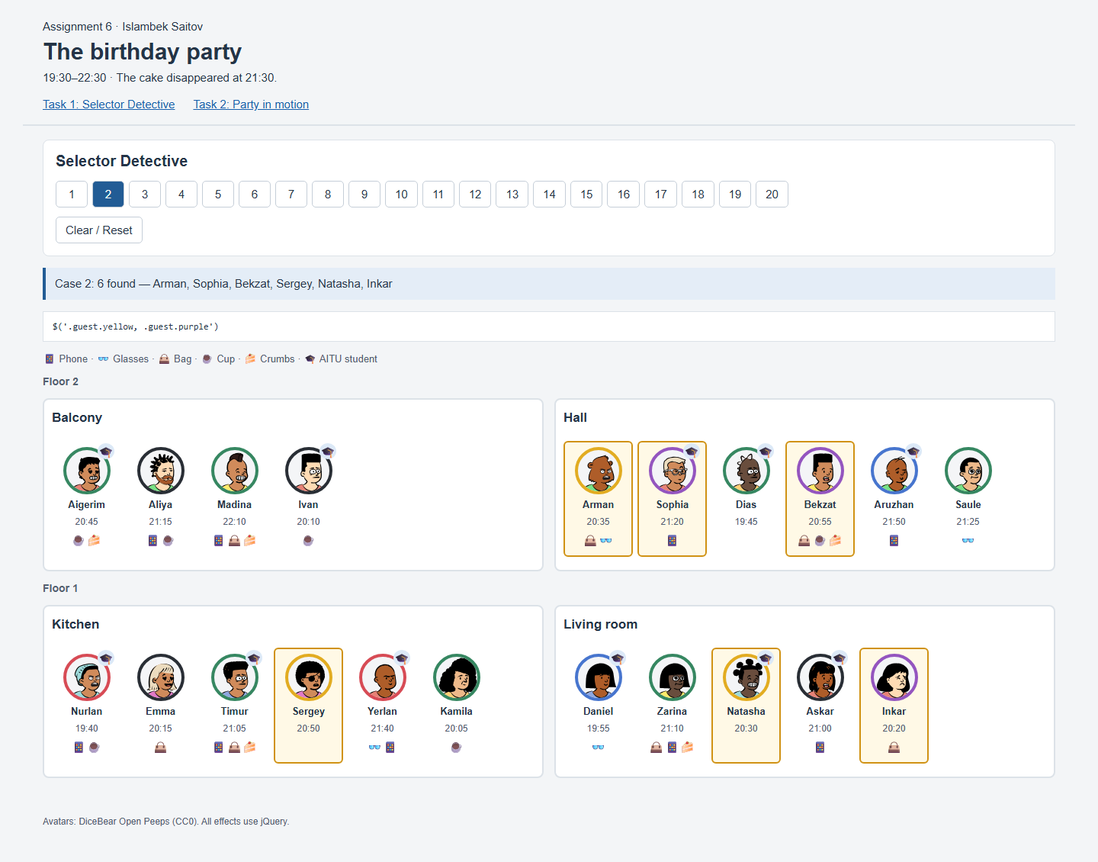
Figure 2. Actual browser result for case 2.

Task 1 — Case 3

AITU students upstairs
Result on the original party
Case 3: 5 found — Aigerim, Ivan, Sophia, Dias, Aruzhan
jQuery chain
$('.floor[data-floor="2"] .guest.aitu')
The floor attribute restricts the search to floor 2; the aitu class checks student status.
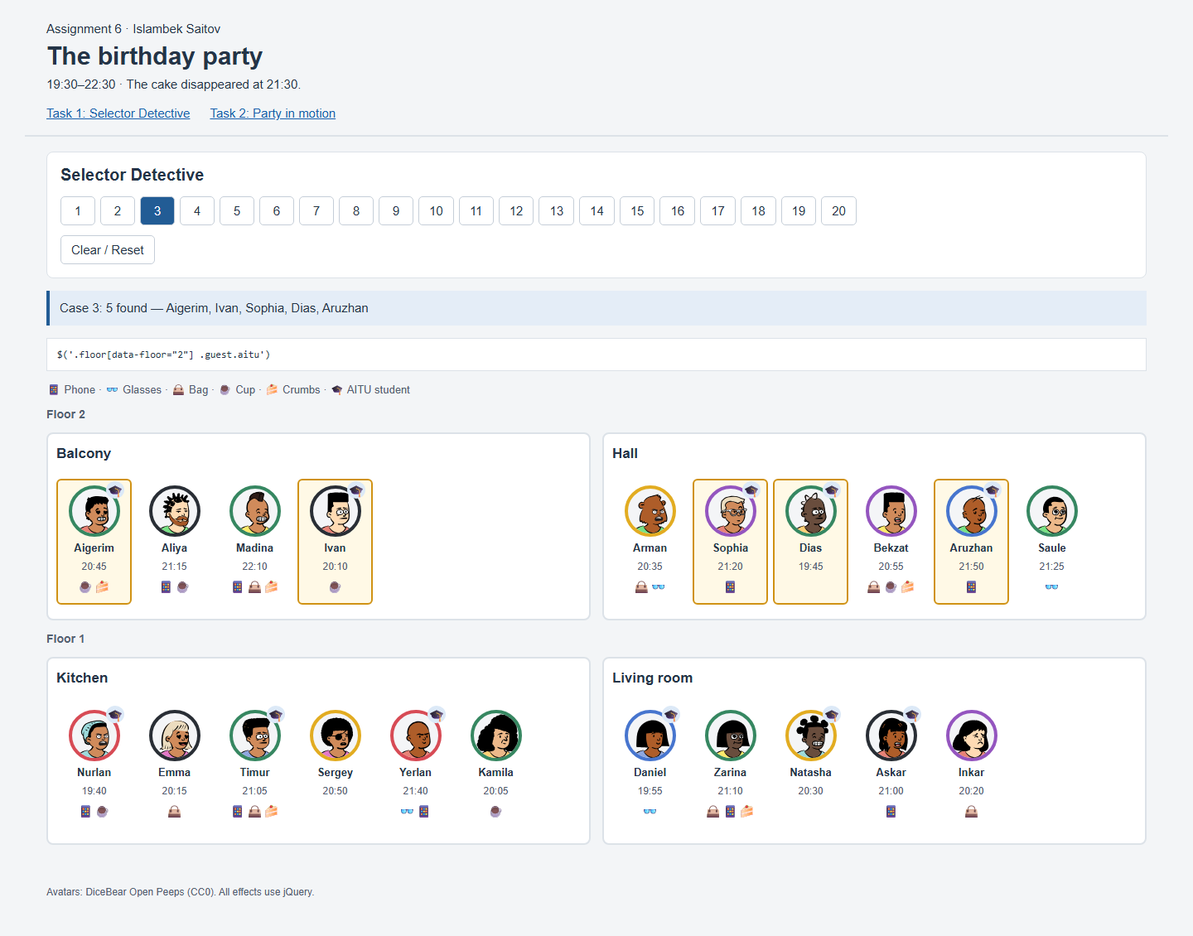
Figure 3. Actual browser result for case 3.

Task 1 — Case 4

Glasses or a bag
Result on the original party
Case 4: 10 found — Madina, Arman, Bekzat, Saule, Emma, Timur, Yerlan, Daniel, Zarina, Inkar
jQuery chain
$('.guest:has(.glasses), .guest:has(.bag)')
:has() checks the object icons inside the card. The comma combines both conditions.
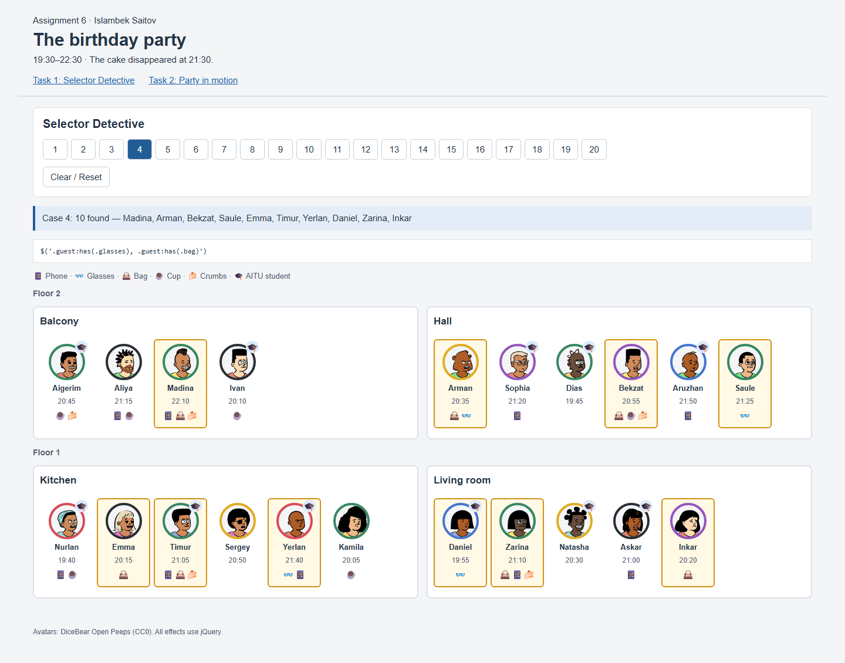
Figure 4. Actual browser result for case 4.

Task 1 — Case 5

Nothing at all
Result on the original party
Case 5: 3 found — Dias, Sergey, Natasha
jQuery chain
$('.guest[data-things=""]')
An empty data-things attribute means the guest brought nothing.
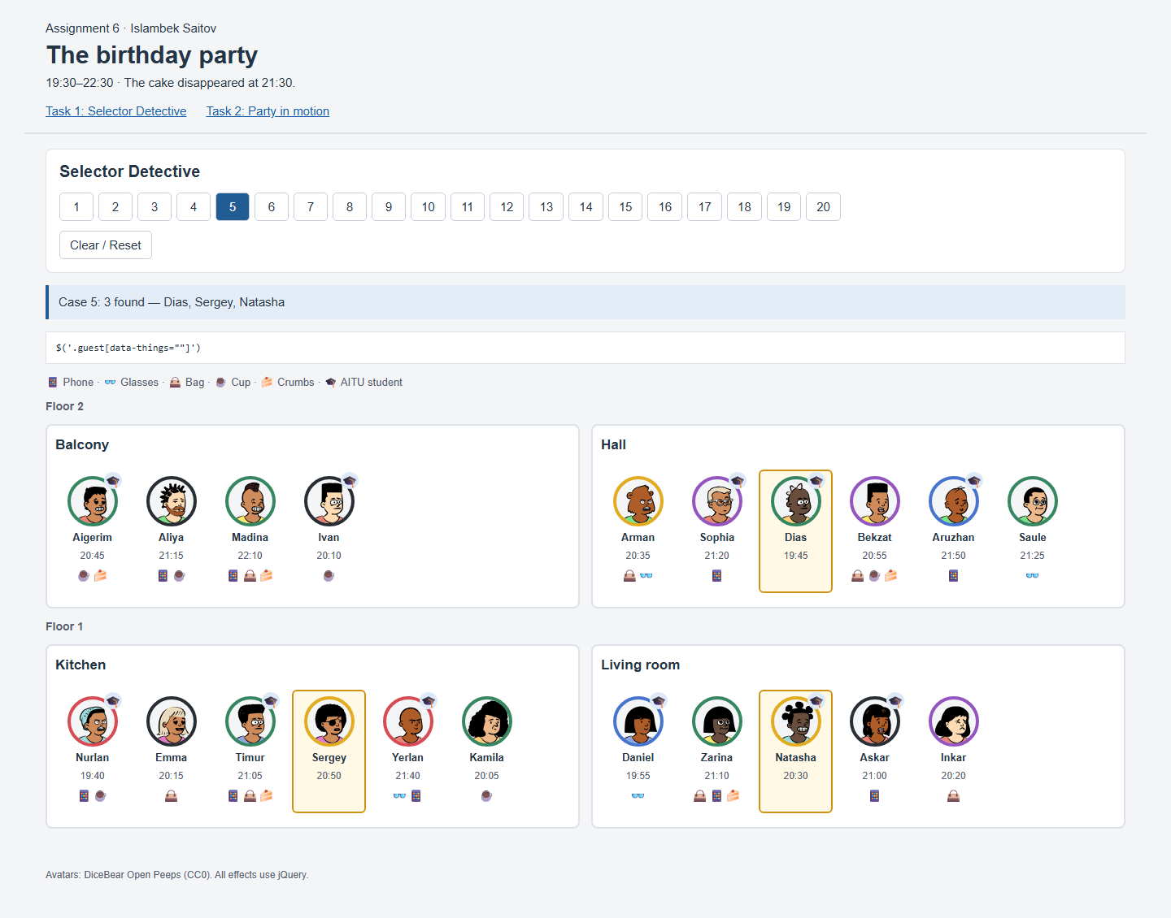
Figure 5. Actual browser result for case 5.

Task 1 — Case 6

Phone but no bag
Result on the original party
Case 6: 6 found — Aliya, Sophia, Aruzhan, Nurlan, Yerlan, Askar
jQuery chain
$('.guest:has(.phone):not(:has(.bag))')
:has(.phone) includes phone owners, and :not(:has(.bag)) excludes bag owners.
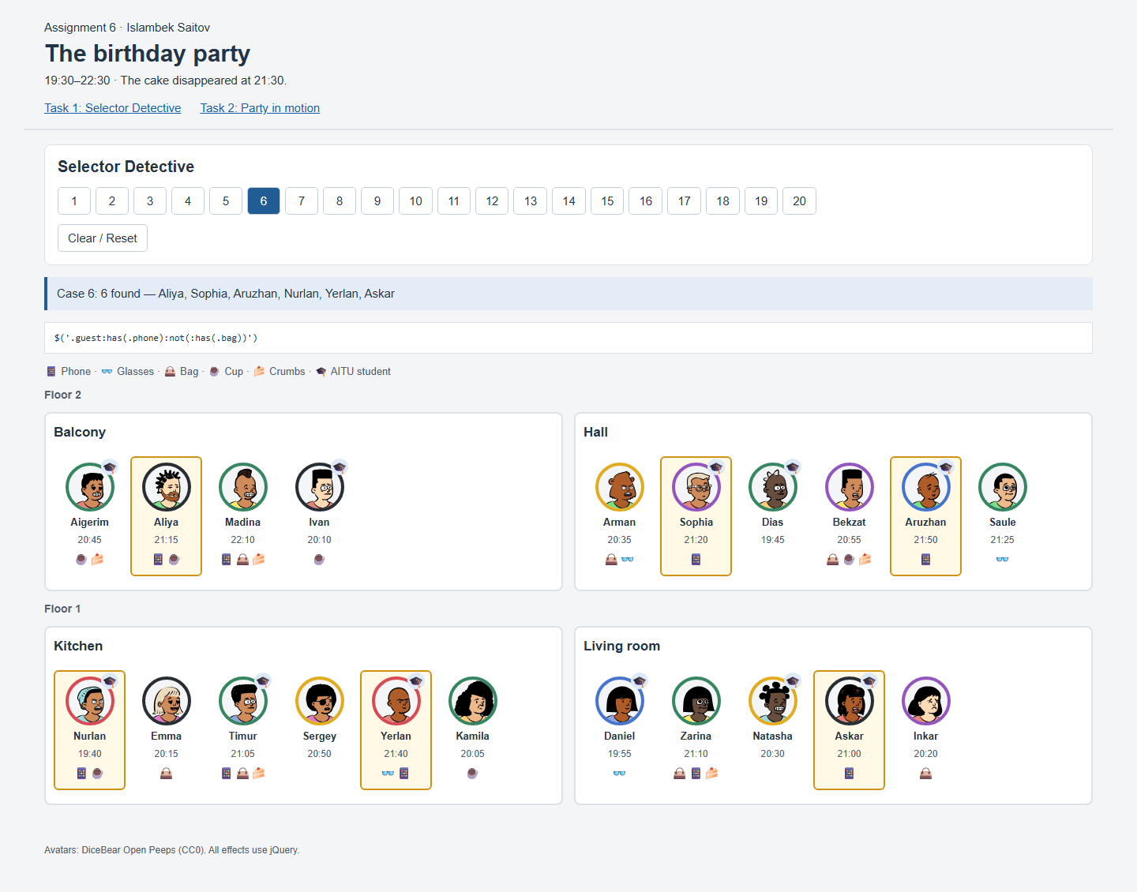
Figure 6. Actual browser result for case 6.

Task 1 — Case 7

Arrival 20:30–21:00 inclusive
Result on the original party
Case 7: 6 found — Aigerim, Arman, Bekzat, Sergey, Natasha, Askar
jQuery chain
$('.guest').filter(function () { return $(this).data('minutes') >= 1230 && $(this).data('minutes') <= 1260; })
Arrival times are stored as minutes. The inclusive range is 1230 through 1260.
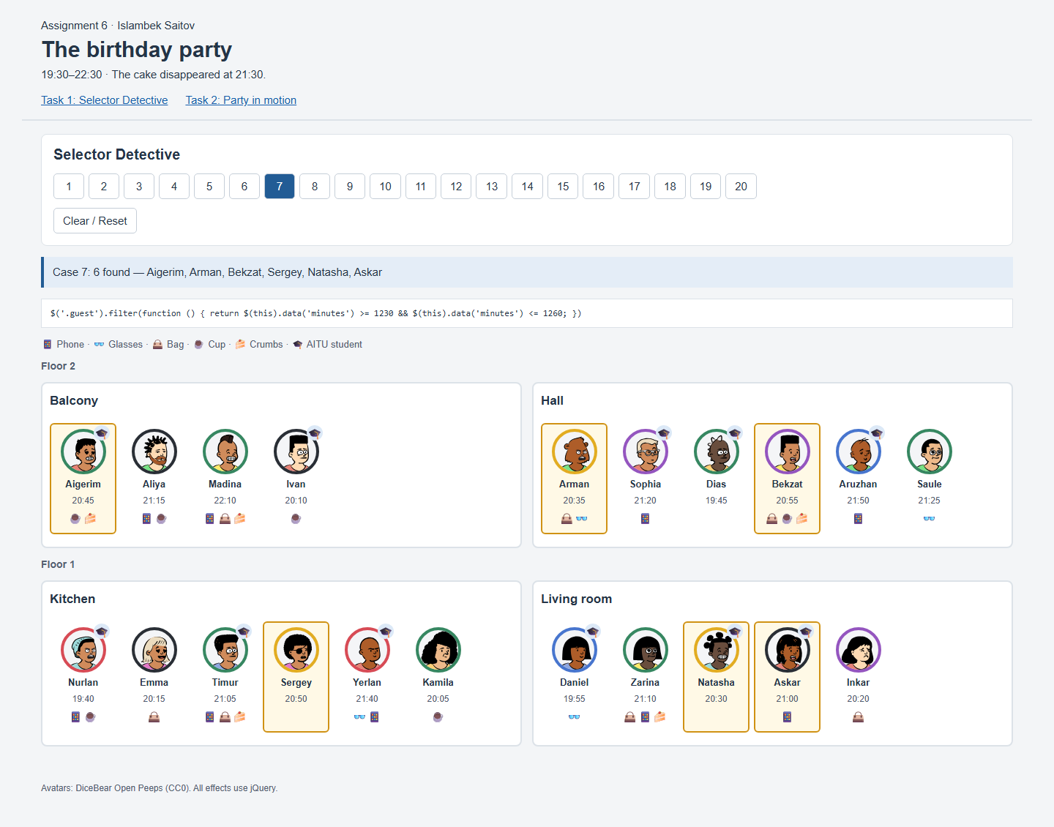
Figure 7. Actual browser result for case 7.

Task 1 — Case 8

After 21:00, not AITU
Result on the original party
Case 8: 4 found — Aliya, Madina, Saule, Zarina
jQuery chain
$('.guest:not(.aitu)').filter(function () { return $(this).data('minutes') > 1260; })
The selector excludes AITU students. filter() keeps arrivals later than 1260 minutes.
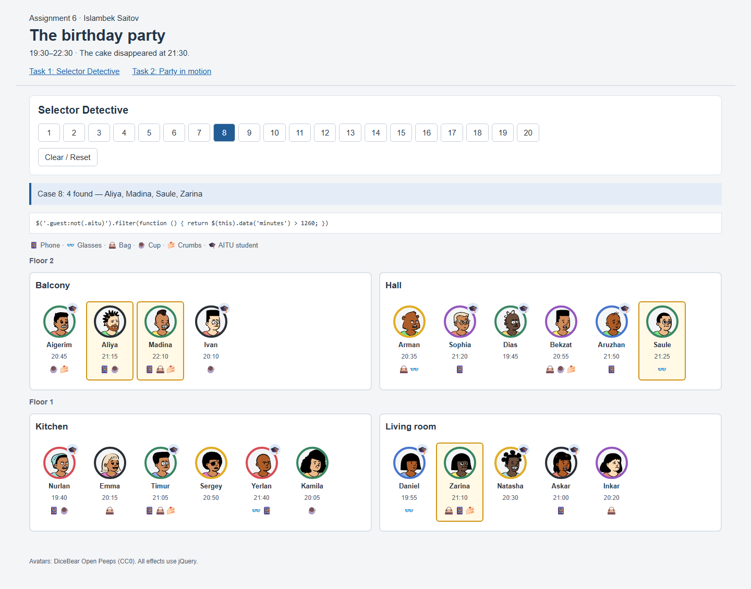
Figure 8. Actual browser result for case 8.

Task 1 — Case 9

Right next to Askar
Result on the original party
Case 9: 2 found — Natasha, Inkar
jQuery chain
$('.guest[data-name="Askar"]').prev('.guest').add($('.guest[data-name="Askar"]').next('.guest'))
prev() and next() find only the immediate neighbors of Askar in the same room.
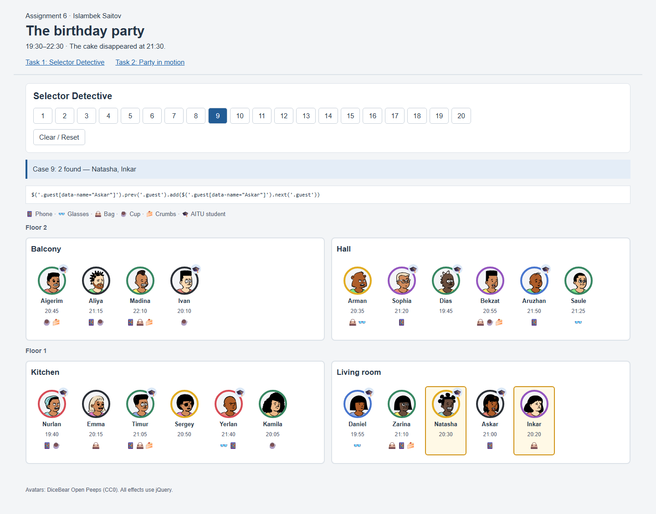
Figure 9. Actual browser result for case 9.

Task 1 — Case 10

Last in each room
Result on the original party
Case 10: 4 found — Ivan, Saule, Kamila, Inkar
jQuery chain
$('.guest:last-child')
:last-child finds the final guest in each room’s guests container.
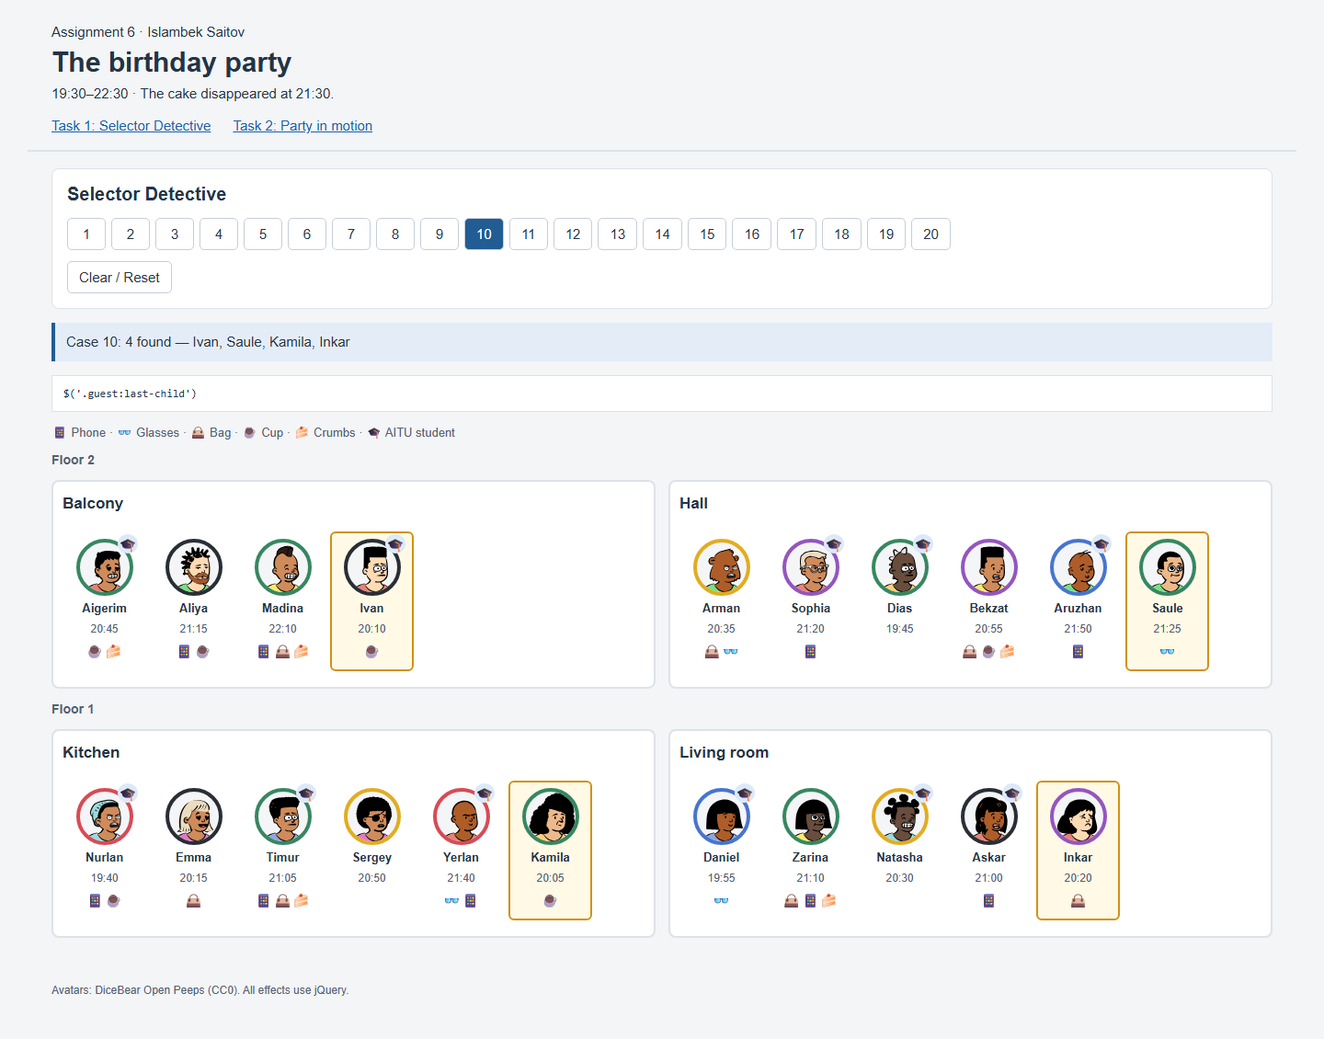
Figure 10. Actual browser result for case 10.

Task 1 — Case 11

Third in each room
Result on the original party
Case 11: 4 found — Madina, Dias, Timur, Natasha
jQuery chain
$('.guest:nth-child(3)')
:nth-child(3) finds the third guest in each room.
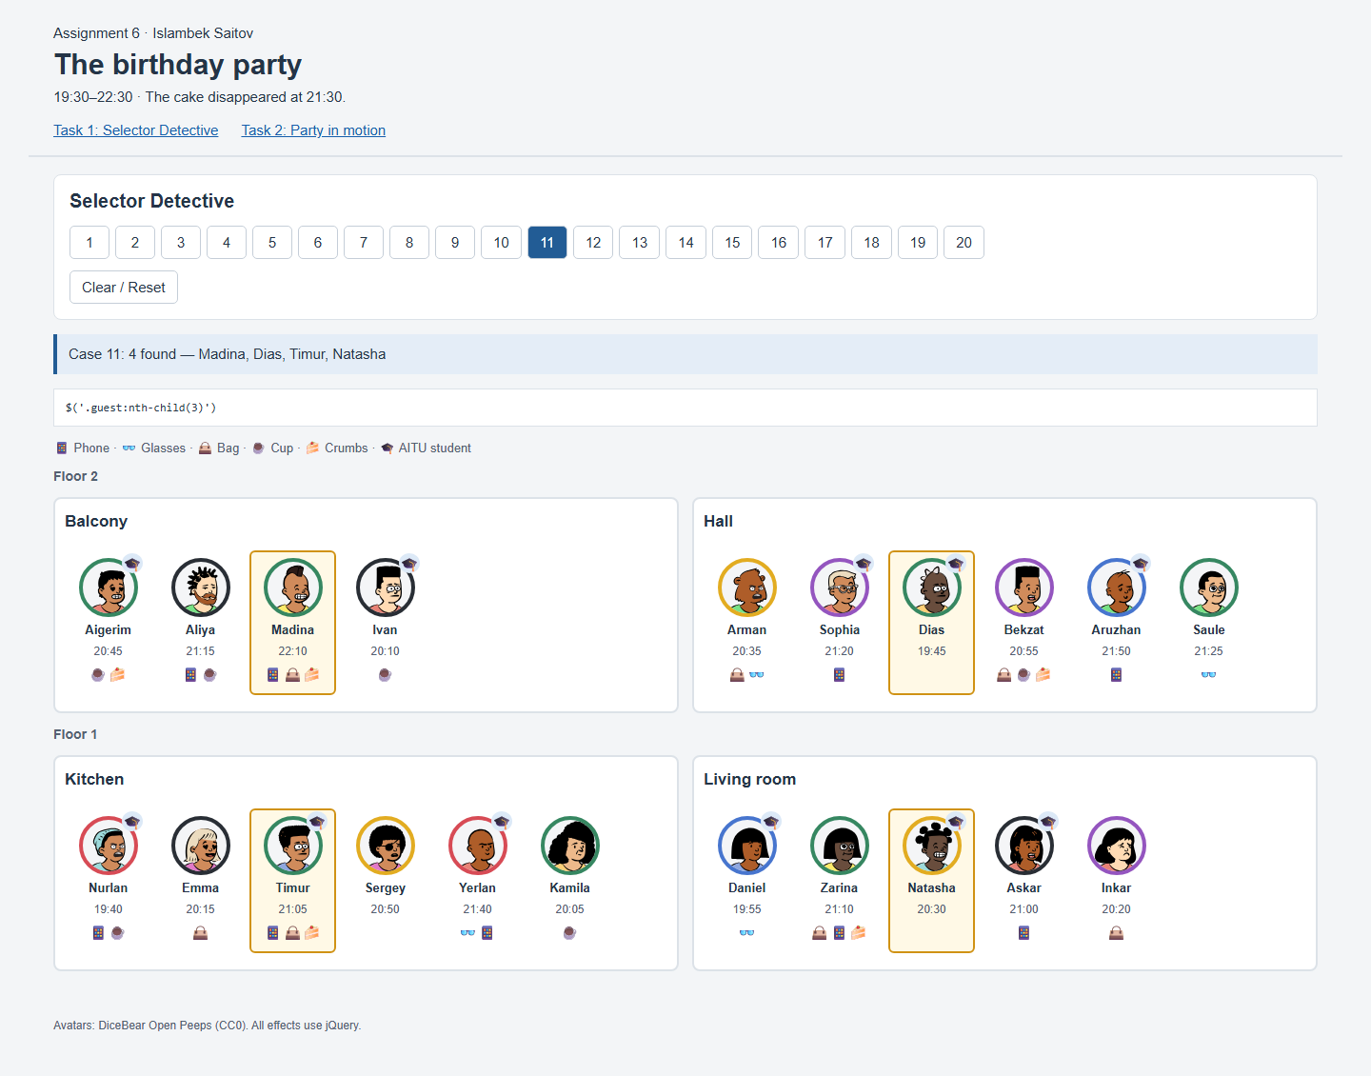
Figure 11. Actual browser result for case 11.

Task 1 — Case 12

After Timur
Result on the original party
Case 12: 3 found — Sergey, Yerlan, Kamila
jQuery chain
$('.guest[data-name="Timur"]').nextAll('.guest')
nextAll() returns everyone standing after Timur in his room.
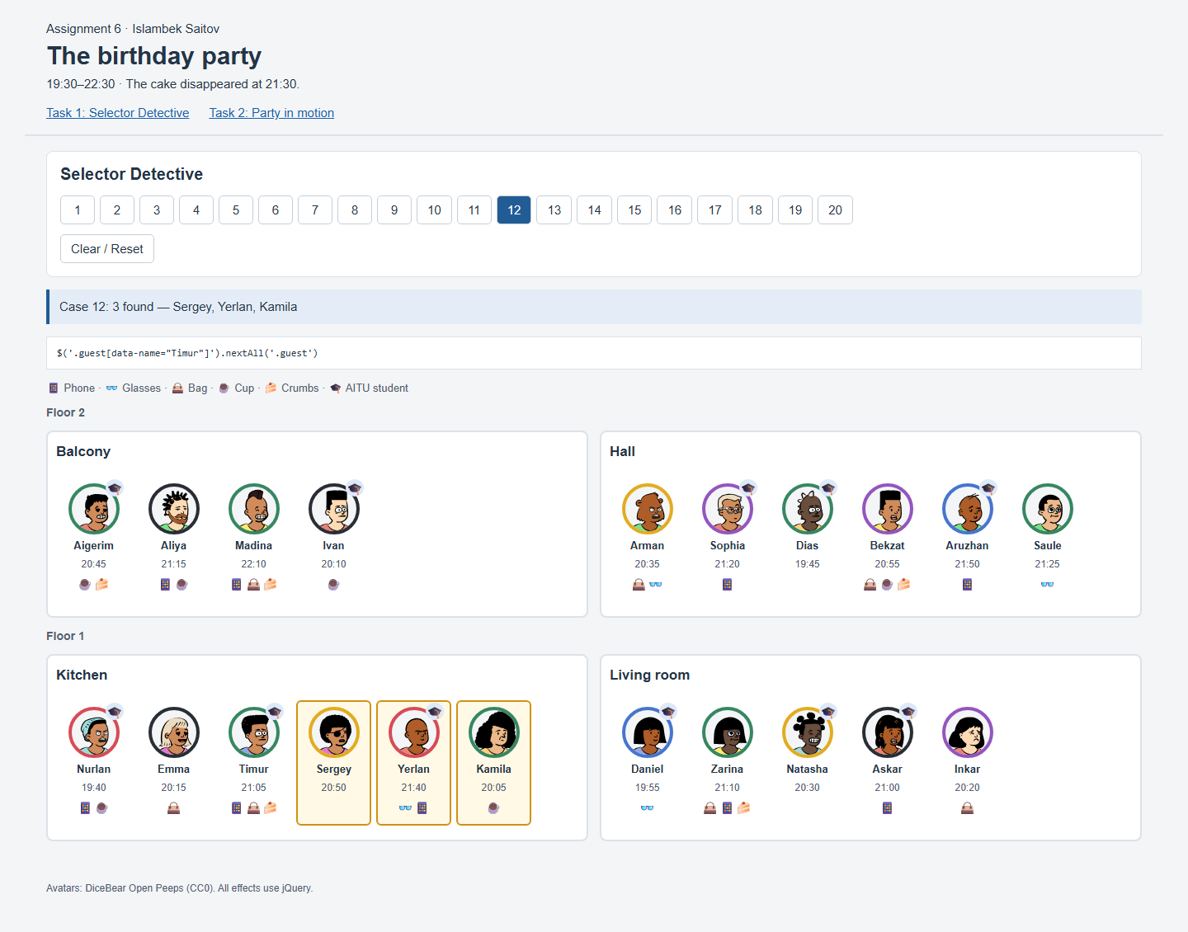
Figure 12. Actual browser result for case 12.

Task 1 — Case 13

Right before someone in black
Result on the original party
Case 13: 4 found — Aigerim, Madina, Nurlan, Natasha
jQuery chain
$('.guest.black').prev('.guest')
The search begins with black clothing and prev() returns each immediate predecessor.
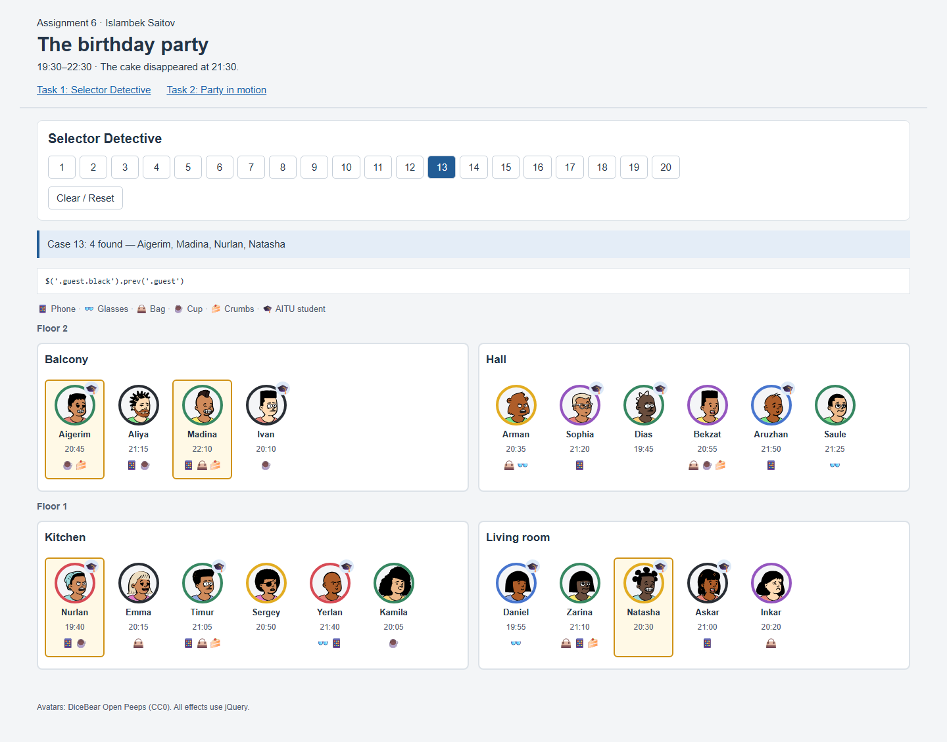
Figure 13. Actual browser result for case 13.

Task 1 — Case 14

Room with Aruzhan
Result on the original party
Case 14: 1 found — Hall
jQuery chain
$('.guest[data-name="Aruzhan"]').closest('.room')
closest() moves from Aruzhan’s guest card to its room section.
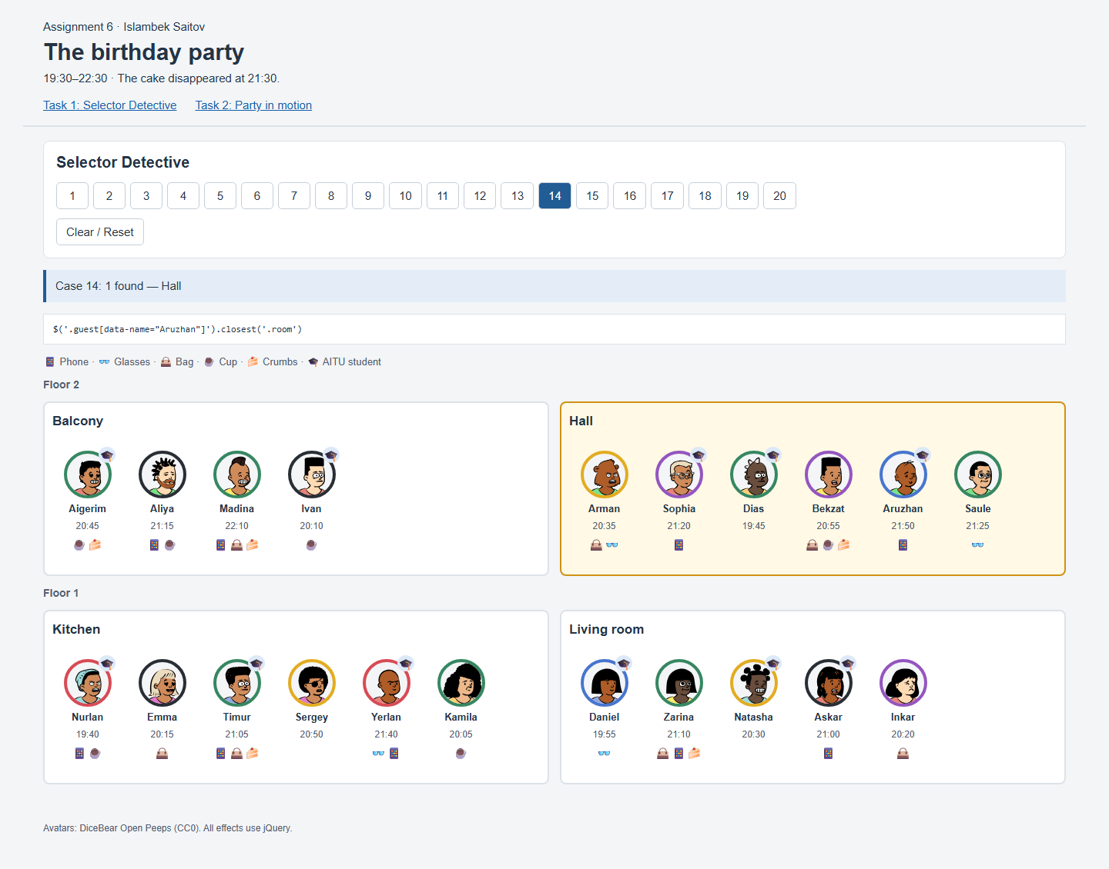
Figure 14. Actual browser result for case 14.

Task 1 — Case 15

Rooms with fewer than 6 guests
Result on the original party
Case 15: 2 found — Balcony, Living room
jQuery chain
$('.room').filter(function () { return $(this).find('.guest').length < 6; })
filter() counts the guest cards inside each room and keeps counts below six.
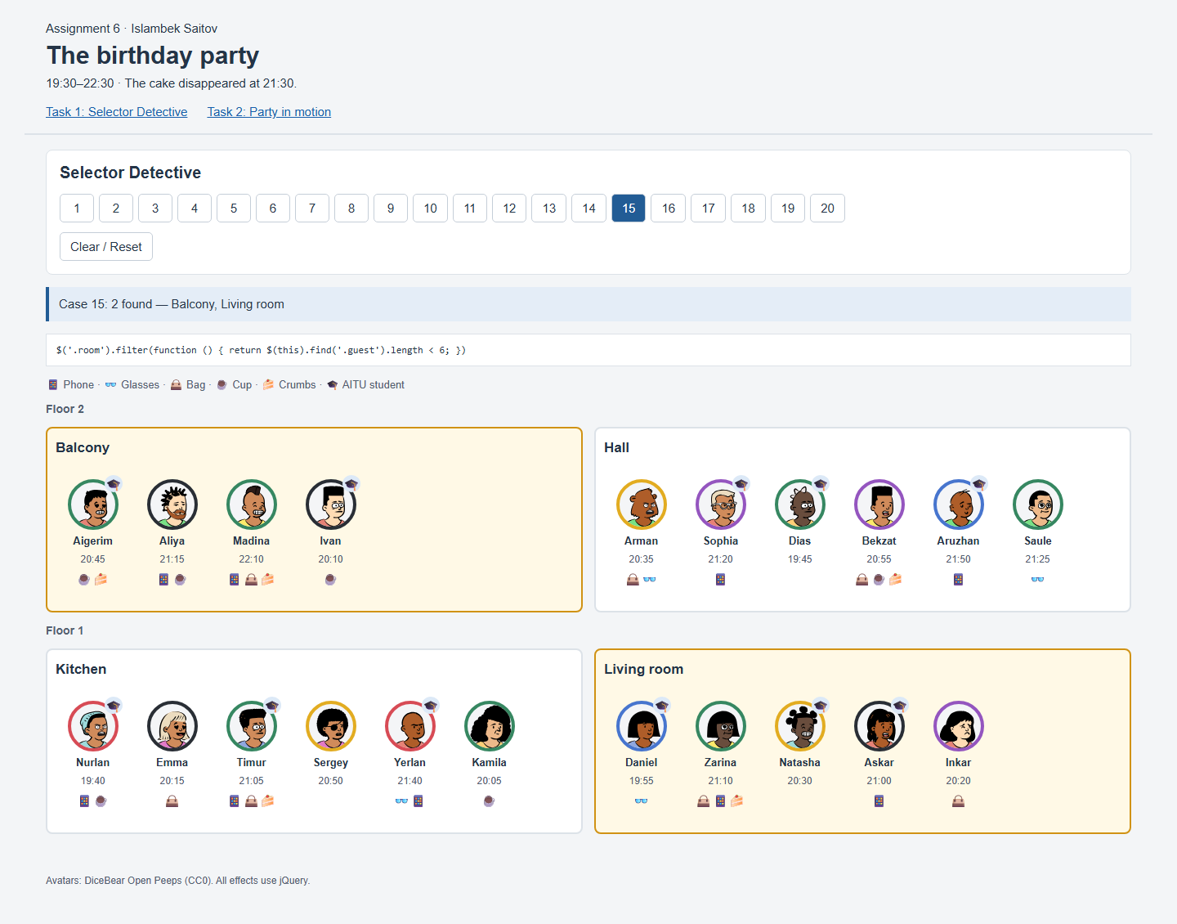
Figure 15. Actual browser result for case 15.

Task 1 — Case 16

Rooms with a cup but no glasses
Result on the original party
Case 16: 1 found — Balcony
jQuery chain
$('.room:has(.cup):not(:has(.glasses))')
The room must contain a cup icon and must not contain any glasses icons.
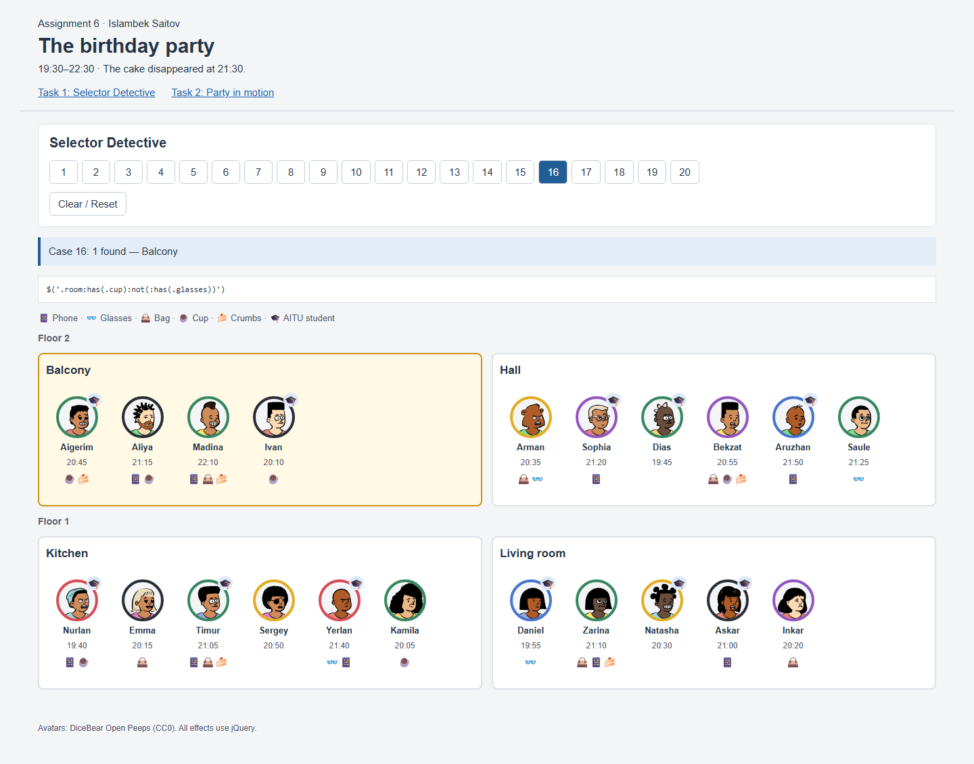
Figure 16. Actual browser result for case 16.

Task 1 — Case 17

First arrival in each room
Result on the original party
Case 17: 4 found — Ivan, Dias, Nurlan, Daniel
jQuery chain
$('.guest').filter(function () { return $(this).siblings('.guest').filter((i, other) =>
Number($(other).attr('data-minutes')) < Number($(this).attr('data-minutes'))).length === 0; })
A guest is selected when none of the siblings in the same room has an earlier arrival.
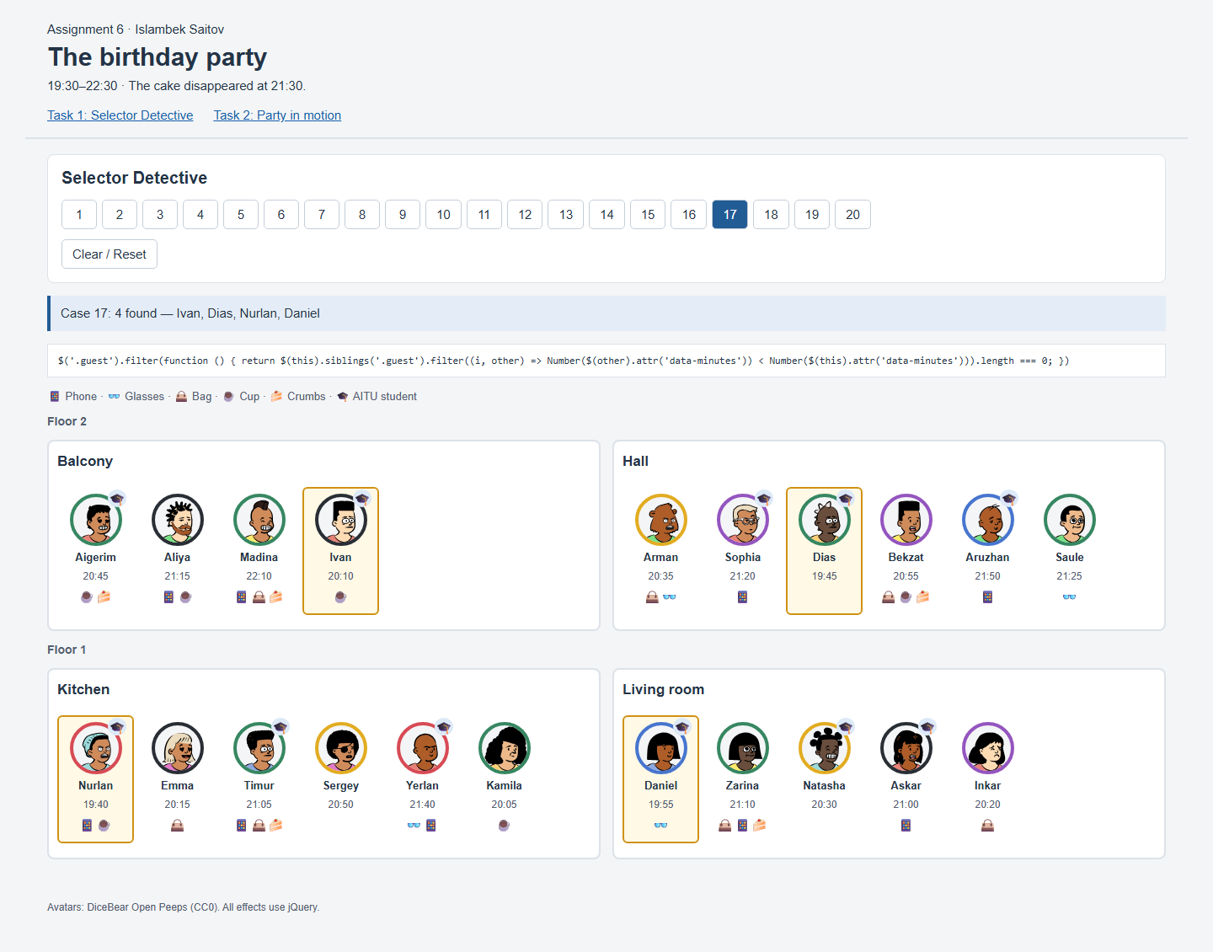
Figure 17. Actual browser result for case 17.

Task 1 — Case 18

Miras joins between Askar and Inkar
Result on the original party
Case 18: 1 found — Miras
jQuery chain
guestCard(['Miras', 'blue', '21:20', true,
['phone']]).hide().insertAfter($('.guest[data-name="Askar"]')).fadeIn(350)
A new card for Miras is inserted after Askar and fades in. In the picture, Inkar is next, so Miras stands between them.
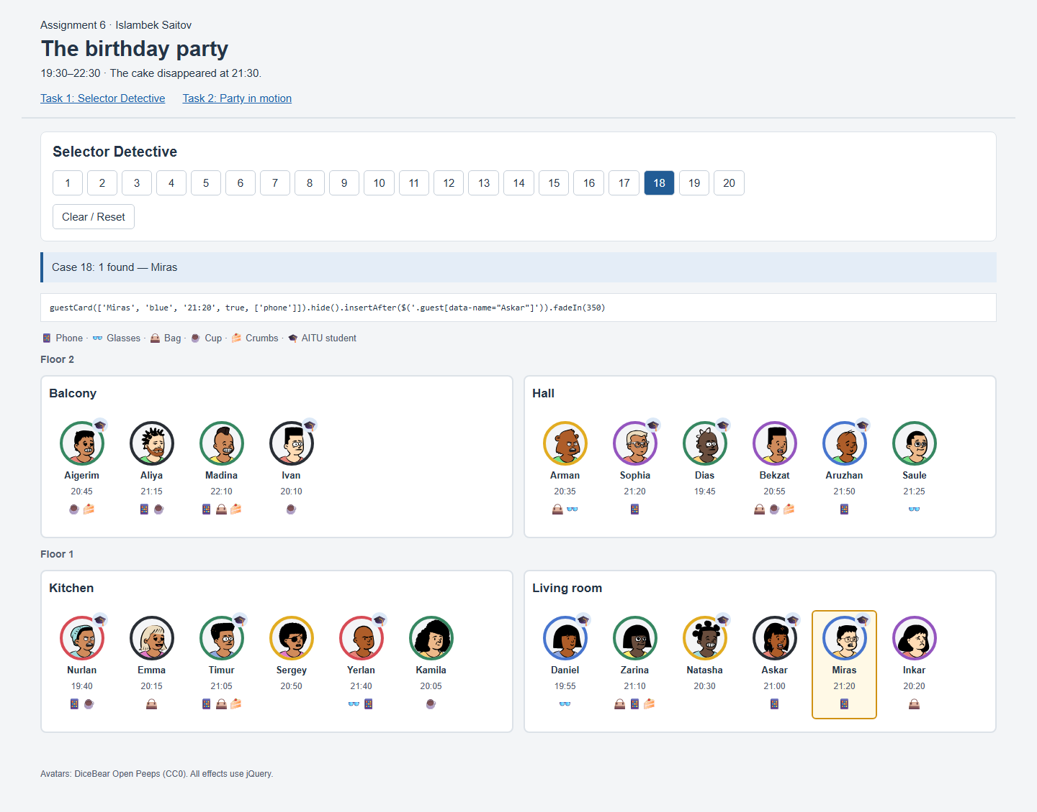
Figure 18. Actual browser result for case 18.

Task 1 — Case 19

Natasha goes home
Result on the original party
Case 19: 1 found — Natasha (left the party)
jQuery chain
$('.guest[data-name="Natasha"]').fadeOut(350, function () { $(this).remove(); })
Natasha fades out. The completion callback removes her card from the DOM.
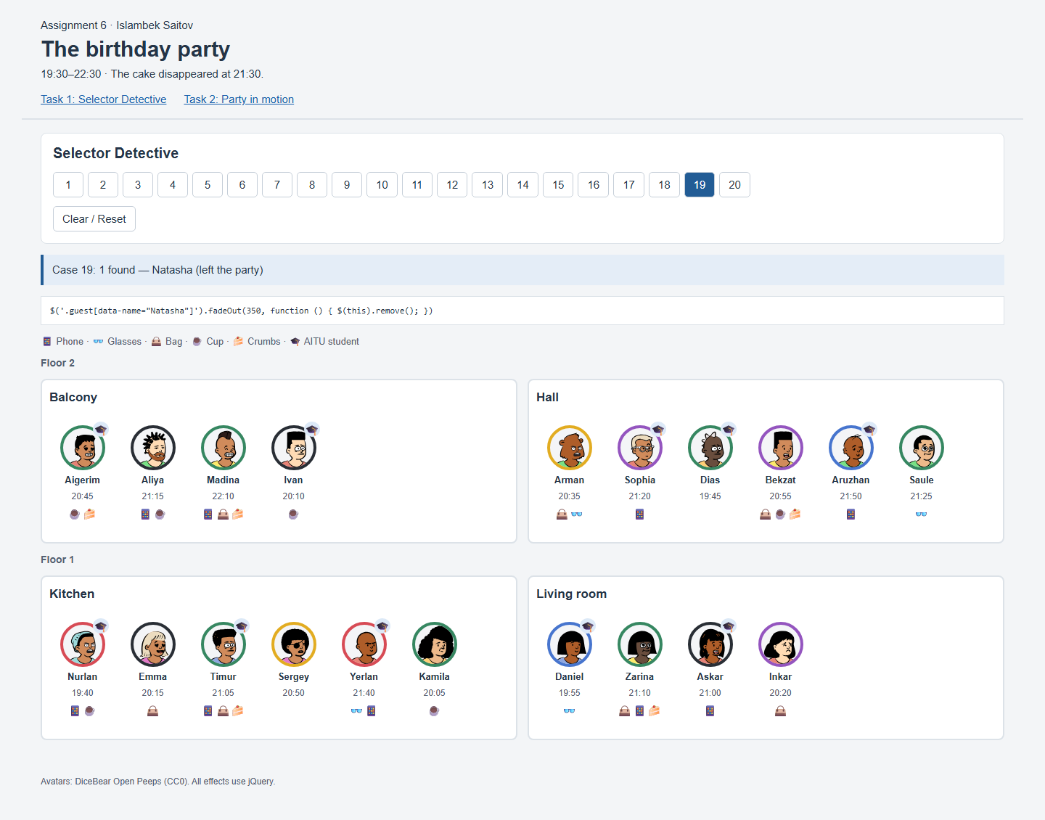
Figure 19. Actual browser result for case 19.

Task 1 — Case 20

Who took the cake?
Result on the original party
Case 20: 1 found — Zarina
jQuery chain
$('.floor[data-floor="1"] .guest:has(.crumbs):not(:has(.cup))').filter(function () { return
$(this).data('minutes') > 1260 && $(this).data('minutes') < 1290; }).filter(function () { return
$(this).prev('.guest').add($(this).next('.guest')).is('.aitu'); })
Zarina is downstairs and arrived at 21:10, after 21:00 and before 21:30. She has crumbs but no cup and stands next to Natasha, an AITU student. Timur has crumbs too, but neither immediate neighbor is an AITU student.
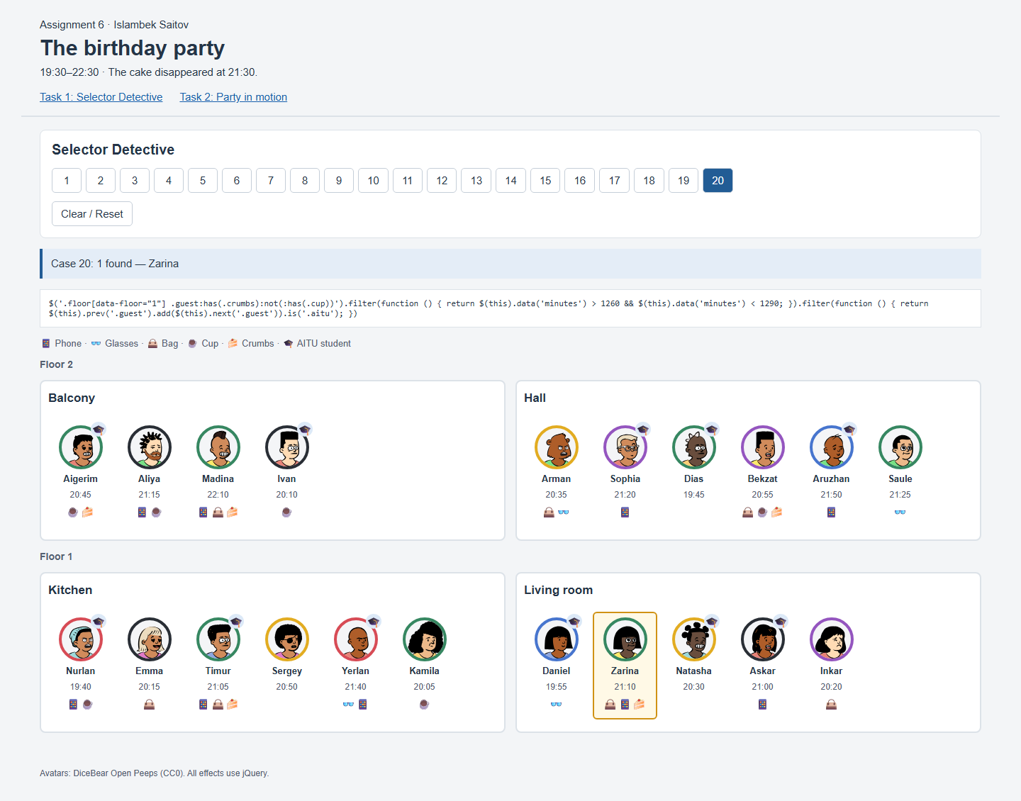
Figure 20. Actual browser result for case 20.

Task 2 — Effects and checks
task2.html and task2-base.js copy the first task. task2.js adds the animations. The four effects use jQuery: fadeTo() for spotlight and animate() for guest details, transfers and sorting. The handlers use delegated on() events so rebuilt guest cards continue to work.
Check from the assignment | Observed result | Status
Case 3, then Clear | 5 upstairs AITU guests bright, 16 pale; Clear restores 21. | Passed
Click a guest, then Esc | Details grow from the avatar and shrink back on Esc. | Passed
Move Arman to the balcony | Arman is last on the balcony and excluded by case 1. | Passed
Sort living room twice | 19:55, 20:20, 20:30, 21:00, 21:10; then picture order. | Passed
Sort 5 times fast | Final order is sorted; no animation queues remain. | Passed

1. Spotlight
The selected cards stay at opacity 1. Other guest cards fade to 0.2 in 300 ms. When a case selects rooms, the bright set includes the guests inside those rooms. Clear rebuilds the original party with full opacity.
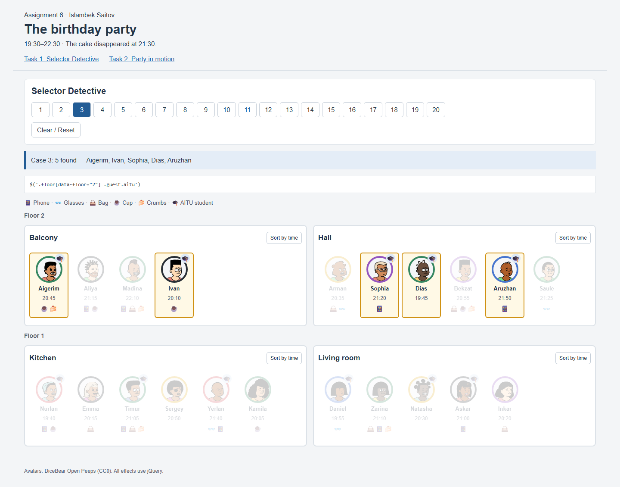
Figure 21. Case 3 keeps only upstairs AITU students bright.

Task 2 — Guest information card

2. Opening and closing
offset() locates the guest’s avatar. The information panel begins at that position with a size of 62 × 62 pixels. animate() grows it into a full panel. The text includes the clothing color, time, student status, things, room and floor. There is one move button for every other room.
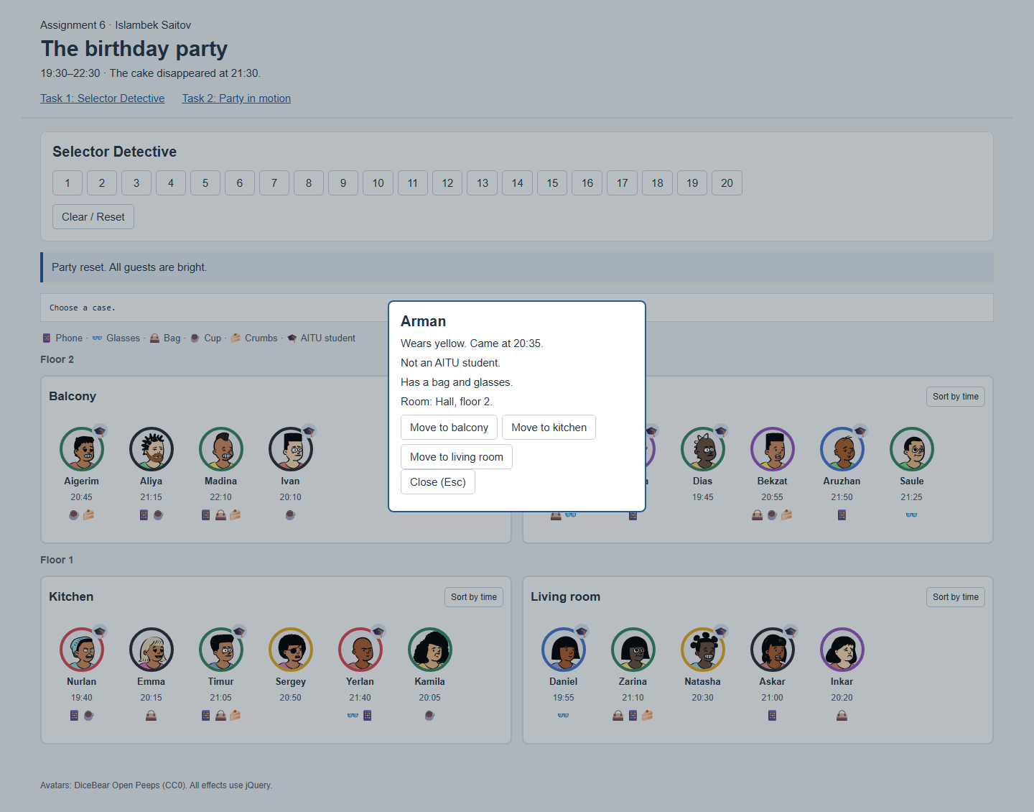
Figure 22. Arman’s full information and room transfer buttons.
Esc, Close or a click on the outside overlay shrinks the panel back to the avatar. Clicking another guest closes the first panel before opening the next one. Fast clicks were checked: only the last requested card remains open.

Task 2 — Moving a guest

3. Room transfer
moveGuest() removes the guest from the source room array and appends the same record to the destination room array. A clone flies between the two positions. The old placeholder shrinks, and a new placeholder opens at the end of the destination room. After the flight, the real card replaces the new placeholder and the clone is removed.
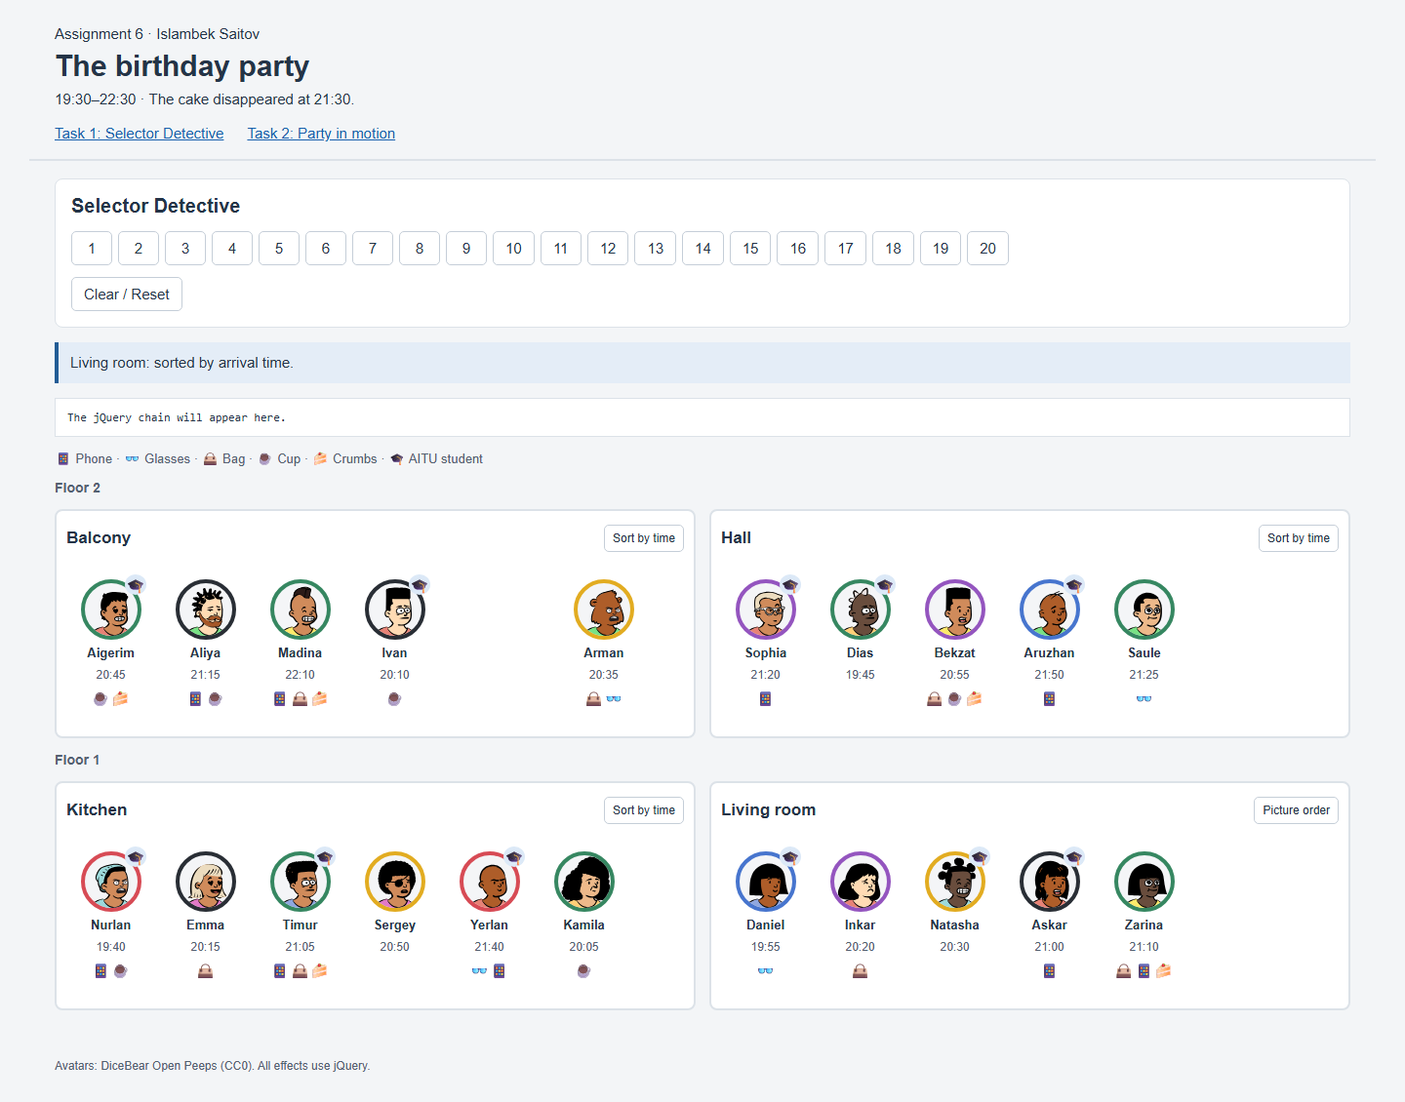
Figure 23. Arman during the animated flight to the balcony.
The card’s position is animated with jQuery rather than a CSS transition. Calls to the cases rebuild from the updated array, so the new room is used by the selectors.

Task 2 — Result after the transfer
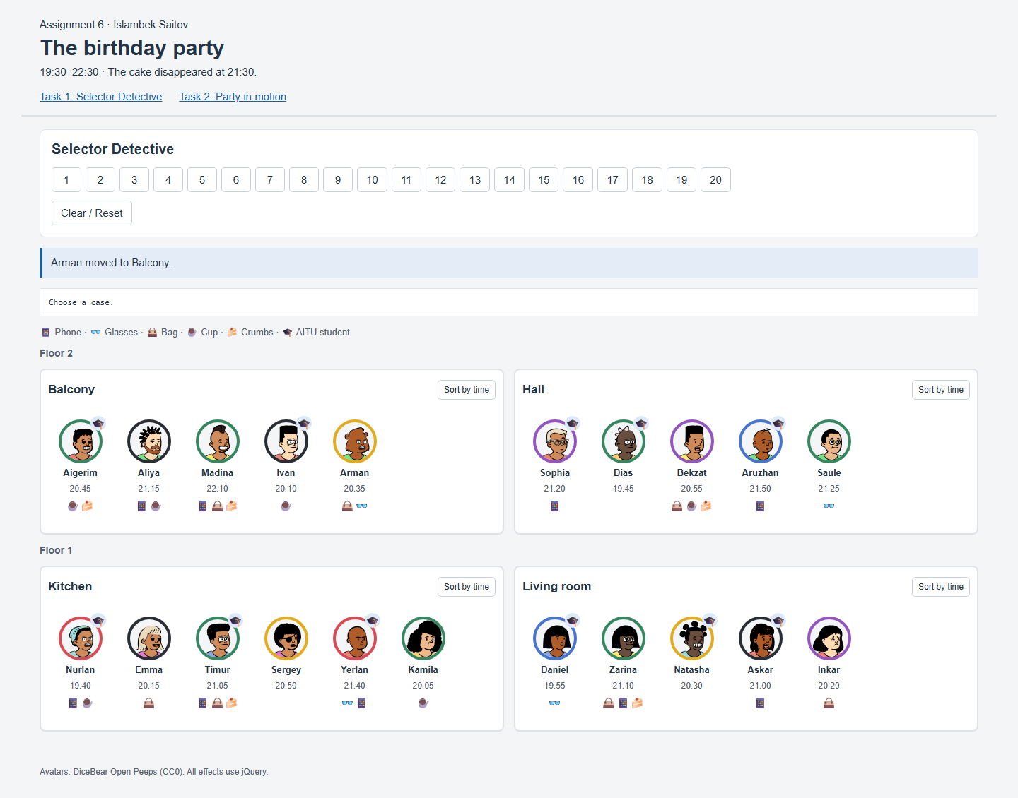
Figure 24. Arman stands at the end of the balcony; the hall has five guests.
Validation | Observed result
Destination DOM | Arman is the last guest in the balcony.
Source DOM | Arman is absent from the hall.
Array | The balcony array ends with Arman; the hall array no longer contains him.
Case 1 after move | Five hall guests are found; Arman is excluded.
Interrupt transfer with another action | The transfer finishes once; there are no duplicate cards or placeholders.

Task 2 — Sorting and fast clicks

4. Sort by arrival time
The code records each card’s coordinates, changes the DOM order, and uses the difference between the old and new positions as an animated offset. Cards slide to their new places over 450 ms. The array keeps picture order, so the next click restores it. Guests moved into a room are appended to that room’s baseline order.
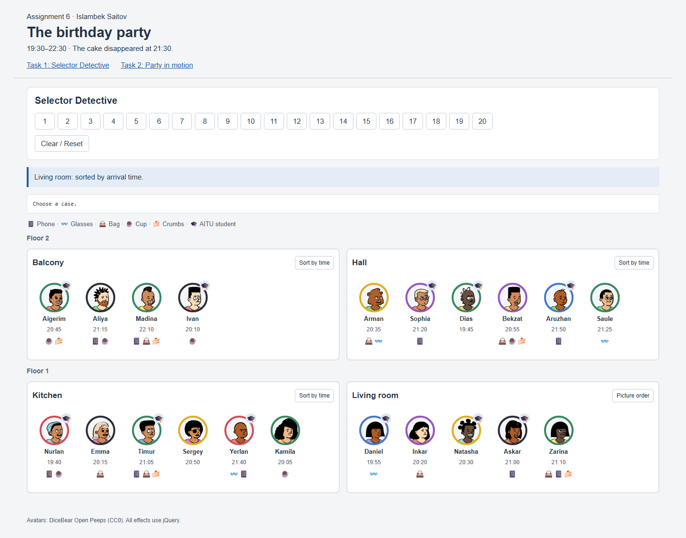
Figure 25. Living room sorted: Daniel, Inkar, Natasha, Askar, Zarina.

5. Repeated clicks
stop(true, true) clears pending effects and completes the current animation before another action begins. Transfer callbacks finish their placeholders and clone before the next operation. Five fast sort clicks end in sorted order. Rapid case clicks, rapid guest clicks and a transfer interrupted by another action also finished in the expected state without queued effects.

Verification and conclusion
The project was checked in local headless Google Chrome. Screenshots in this report were captured from the running pages. All 20 Task 1 results were compared with the expected guests or rooms. Task 2 checks covered the assignment’s five scenarios, local avatar loading, outside-click closing, rapid guest switching, rapid cases and an interrupted transfer.
Additional automated check | Status
4 rooms, 2 floors, 21 loaded local avatars | Passed
Case 19 removes Natasha | Passed
Task 1 cases 1–20 have expected results | Passed
Spotlight: 5 bright upstairs AITU, 16 pale guests | Passed
Clear restores all 21 guests | Passed
Guest details contain complete data and three move buttons | Passed
Escape closes guest card | Passed
Arman moves to balcony end and array matches | Passed
Case 1 excludes moved Arman | Passed
Living room sorted by time | Passed
Second sort restores picture order | Passed
Five fast sorts end sorted without animation queues | Passed
Fast case clicks leave Zarina highlighted and no queues | Passed
Fast guest clicks leave exactly the last card open | Passed
Outside click closes card | Passed
Interrupted move commits once without clones or gaps | Passed

Conclusion
The main skills practiced were selecting elements by classes and attributes, traversing between guests and rooms, and combining filters to solve the cases. The effects show how jQuery callbacks connect a visual animation with a DOM change. Updating the array after a transfer keeps the rebuilt page consistent. Finishing current effects and clearing queues makes repeated clicks predictable.

Before submission
Create a GitHub repository, upload the source files and replace the GitHub placeholder on the first page with its real URL. The assignment also requires a live defense. Review the selectors, callbacks and data updates so you can explain and modify the code independently.

References
Assignment 6.pdf — task requirements and original party picture.
jQuery 3.7.1 — https://code.jquery.com/jquery-3.7.1.min.js
DiceBear Open Peeps avatars, CC0 — https://www.dicebear.com/styles/open-peeps/

