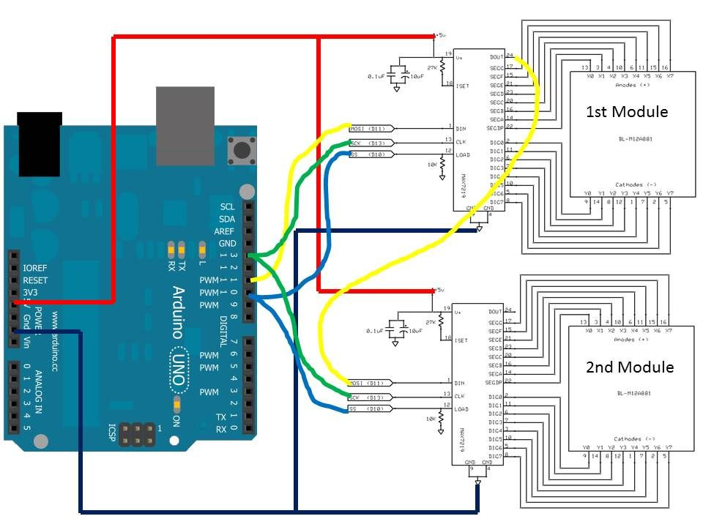
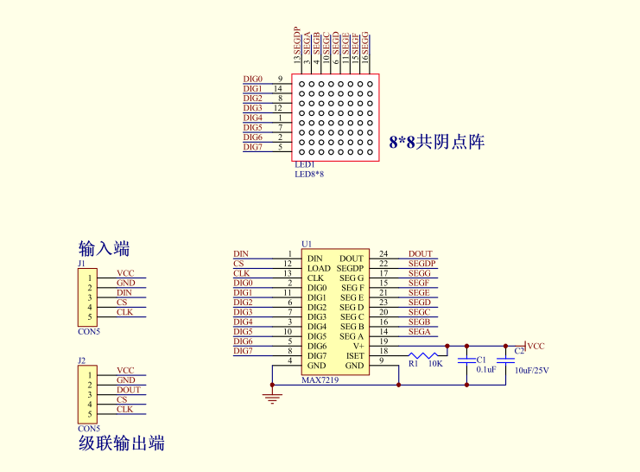

UVp-2088 Column Anode → Common cathode in row
Row Cathode
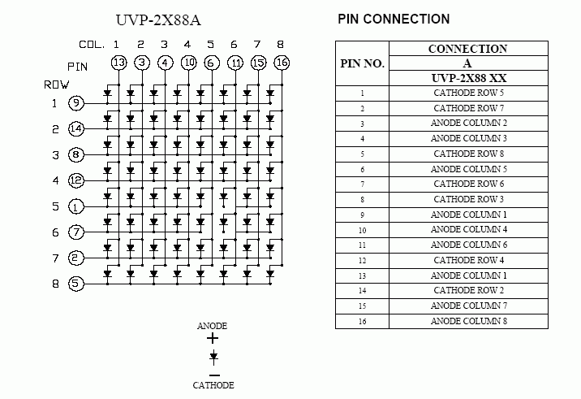

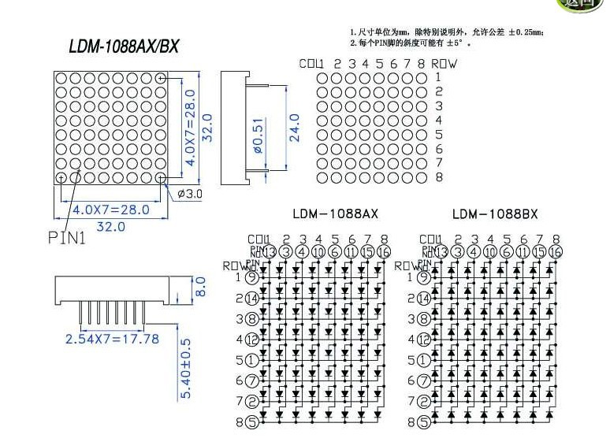

http://i0.wp.com/tronixstuff.com/wp-content/uploads/2013/09/max7219_resistor_table.jpg
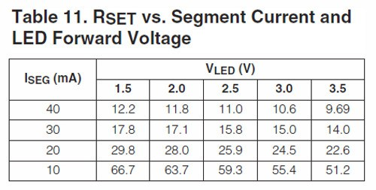
http://www.planetarduino.org/?cat=432
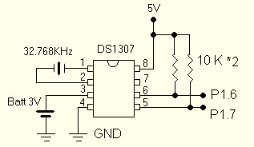

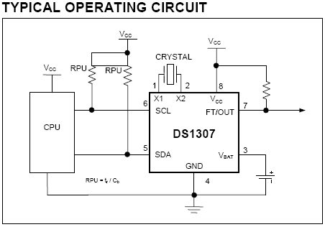
conect rtc to arduino.
conect SDA to Arduino A4.
conect SCL to Arduino A5.
conect vcc to +5v
conect gnd to gnd

http://www.instructables.com/id/Clock-with-termometer-using-Arduino-i2c-16x2-lcd-D/

http://www.sharatronica.com/cd4017.html

Sensor óptico

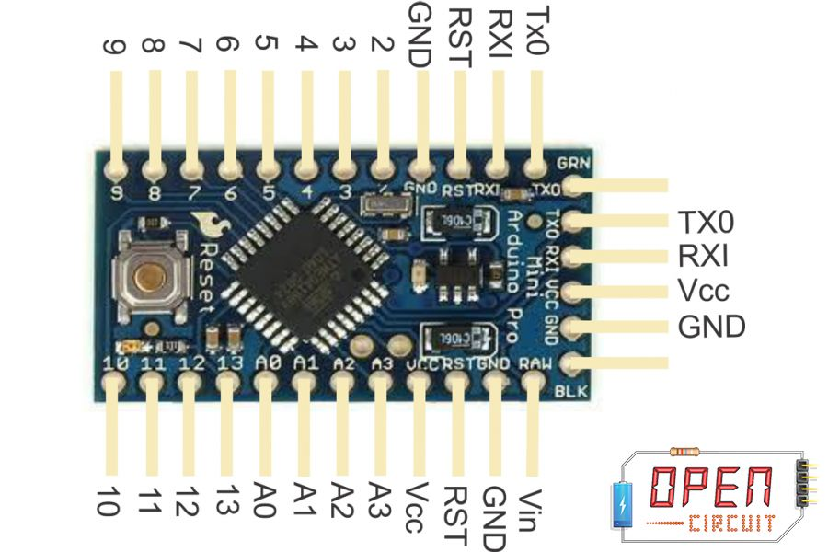

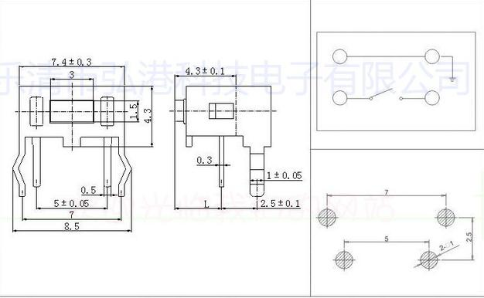

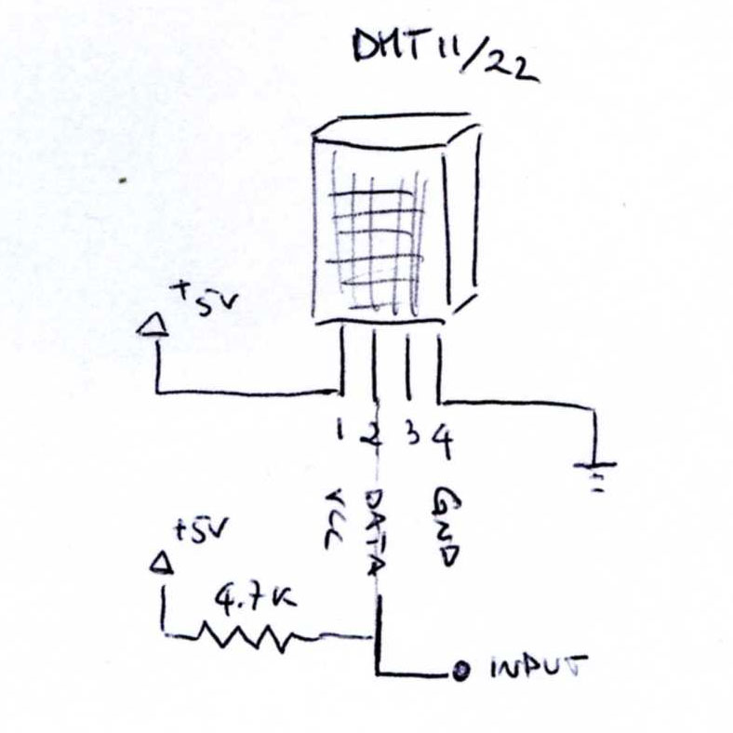
http://www.hobbytronics.co.uk/mosfet-voltage-level-converter
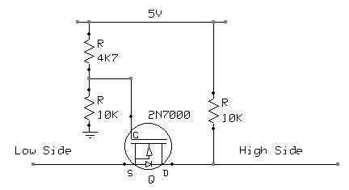
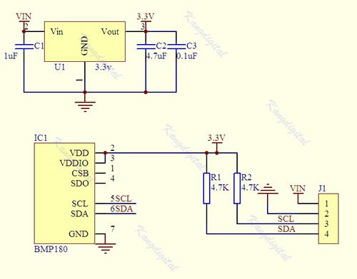
Placa
Main board
En v0.2 están A0, A1, A2, A3 para botones (en placa A0, A1, A2, A3)
El chip usa los pines 10, 11, 12
Se exportan 2-9 (en placa D2-D9)
13 libre
Botones → En v.0.1 K4 es A0, K3 es A1. http://arduino.cc/en/Tutorial/InputPullupSerial
pinMode(0, INPUT_PULLUP); analogRead(0); (se han cableado a analog)???

TODO
Arreglar conexión masas en V.0.3 para V.0.4. OK
Revisar agujeros batería, demasiado grandes. ELIMINAR
Revisar agujeros switch, demasiado pequeños. OK
Añadir TEA5767 / TDA7330 http://www.vwlowen.co.uk/arduino/bedside-clock/page2.htm
http://nicuflorica.blogspot.ro/2013/06/radio-fm-cu-tea5767-si-arduino-ii.html
http://blog.simtronyx.de/en/simple-fm-stereo-radio-with-a-tea5767-breakout-module-and-an-arduino/
http://nicuflorica.blogspot.ro/2014/11/modul-de-afisare-cu-8-cifre-led-din-7_11.html

Sensor-power
RTC se conecta por I2C SDA (A4) SCL (A5)
Scanning...
I2C device found at address 0x50 ! MEM
I2C device found at address 0x68 ! RTC
done

BMP180 SDA (A4) SCL (A5) (OK)
DHT11 conecta a D6 (OK)
BOOST (pendiente)

Es posible usar otros con SerialTWI
SPI: 10 (SS), 11 (MOSI), 12 (MISO), 13 (SCK).

Poner también batería?
Cargador? 2 AA

In addition, some pins have specialized functions:
- Serial: 0 (RX) and 1 (TX). Used to receive (RX) and transmit (TX) TTL serial data. These pins are connected to the TX-0 and RX-1 pins of the six pin header.
- External Interrupts: 2 and 3. These pins can be configured to trigger an interrupt on a low value, a rising or falling edge, or a change in value. See the attachInterrupt() function for details.
- PWM: 3, 5, 6, 9, 10, and 11. Provide 8-bit PWM output with the analogWrite() function.
- SPI: 10 (SS), 11 (MOSI), 12 (MISO), 13 (SCK). These pins support SPI communication, which, although provided by the underlying hardware, is not currently included in the Arduino language.
- LED: 13. There is a built-in LED connected to digital pin 13. When the pin is HIGH value, the LED is on, when the pin is LOW, it's off.
The Pro Mini has 8 analog inputs, each of which provide 10 bits of resolution (i.e. 1024 different values). Four of them are on the headers on the edge of the board; two (inputs 4 and 5) on holes in the interior of the board. The analog inputs measure from ground to VCC. Additionally, some pins have specialized functionality:
- I2C: A4 (SDA) and A5 (SCL). Support I2C (TWI) communication using the Wire library.
There is another pin on the board:
- Reset. Bring this line LOW to reset the microcontroller. Typically used to add a reset button to shields which block the one on the board.

Protel Gerber Layer Names
GTO - Gerber Top Overlay (silkscreen)
GBO - Gerber Bottom Overlay (silkscreen)
GTL - Gerber Top Signal
GBL - Gerber Bottom Signal
GTS - Gerber Top Solder Mask
GBS - Gerber Bottom Solder Mask
GTP - Gerber Top Paste Mask
GBP - Gerber Bottom Paste Mask
GM1 - Gerber Mechanical 1
GM2 - Gerber Mechanical 2
GM3 - Gerber Mechanical 3
GM4 - Gerber Mechanical 4
GDD - Gerber Drill Drawing
GD1 - Gerber Drill Drawing, Top To Mid 1
GD2 - Gerber Drill Drawing, Mid 1 To Mid 2
GDG - Gerber Drill Guide
GG1 - Gerber Drill Guide, Top To Mid 1
GG2 - Gerber Drill Guide, Mid 1 To Mid 2
GPT - Gerber Top Pad Master
GPB - Gerber Bottom Pad Master
GKO - Gerber Keepout
PO1 - Gerber Panels
REP - Report file
TXT - ASCII NC Drill
DRL - EIA NC Drill
DRR - NC Drill Report
APR - Aperature File

Coin cell holder
http://www.shogyo.com/pdf/ch224-2032lf.pdf

NOKIA LCD takes 4 digital lines
3.3V !!!
http://www.google.es/url?sa=i&rct=j&q=&esrc=s&source=images&cd=&cad=rja&uact=8&ved=0CAUQjhw&url=http%3A%2F%2Fnicuflorica.blogspot.com%2F2013%2F08%2Fafisajul-folosit-la-telefoanele-nokia.html&ei=s8ytVJyOHYStU5Skg4gI&bvm=bv.83134100,d.d24&psig=AFQjCNFrW_TDc2UuTrOCLbg6gxJRcV6MJQ&ust=1420762184205945

http://drianoxaman.blogspot.com.es/2013/03/arduino-usb-lipo-charger-5v-booster.html
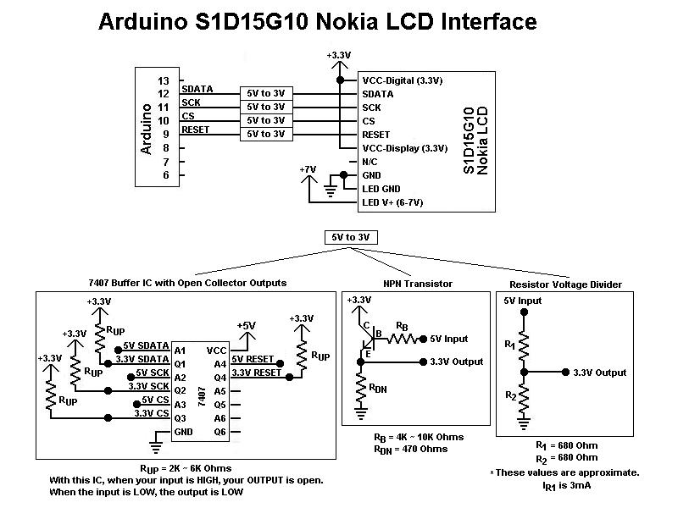

If you power display from 5 V, you should use 10K resistors on all pins, but either way with 5 V there could be problems with displaying and it will reduce it's life time.
There is 2 types of pinouts:
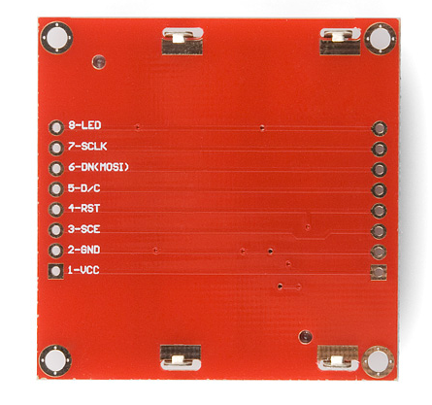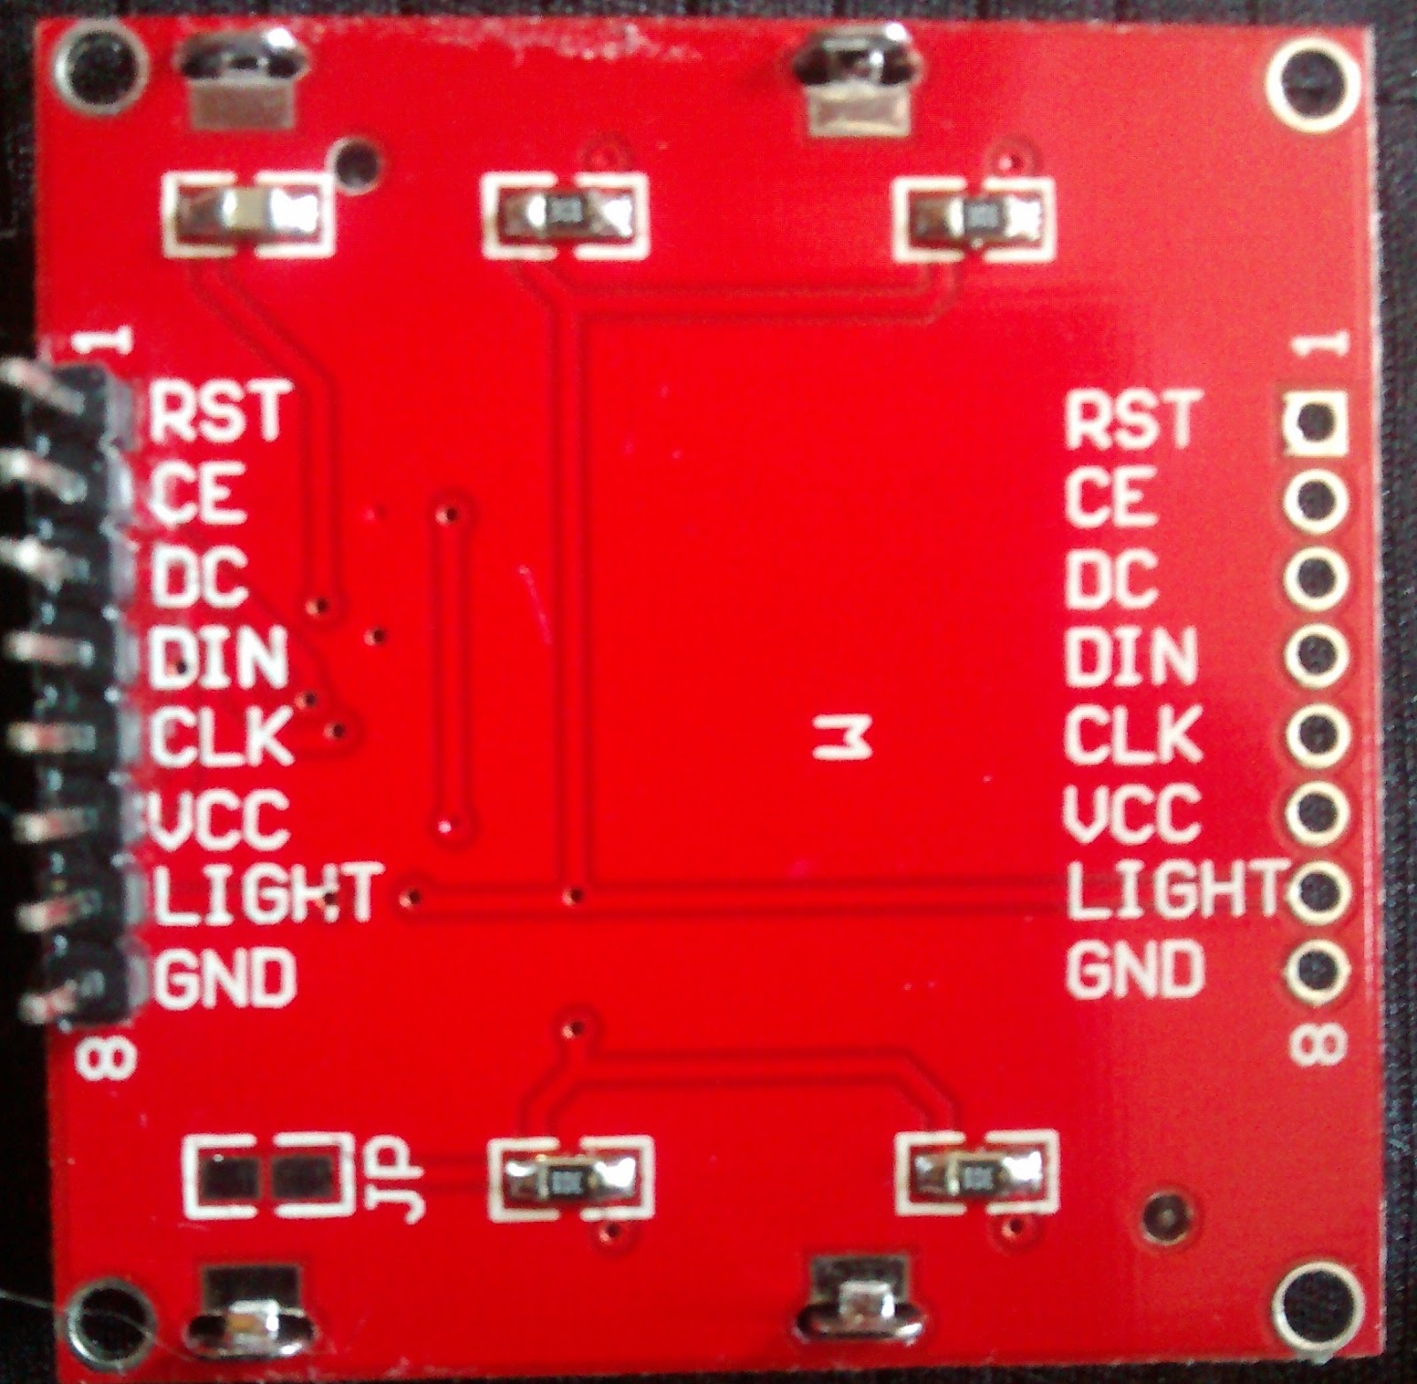

Pin number | Designator | Function | Notes
1 | VCC | power supply
2 | GND | ground
3 - 2 | SCE (CE) | chip select | usually grounded
4 - 1 | RST | RESET | Active with log. 0
5 - 3 | D/C (DC) | choose operating mode | Commands log. 0  Data log. 1
6 - 4 | DN (DIN) | Data | 1 byte of data
7 - 5 | SCLK (CLK) | Serial clock,  synchronization
8 | LED (LIGHT) | Backlight | 3.3V

1 | RST | Reset | Entrada
2 | CE | Chip Selection (Selección de chip) | Entrada
3 | DC | Data/Commands choice | Entrada
4 | DIN | Serial data in (D11) | Entrada
5 | CLK | Serial clock (D13) | Entrada
6 | VCC | Positive power supply (Alimentación positiva) | Entrada | 2.7V a 3.3V
7 | LIGHT | LED backlight supply | Entrada | Conectar a GND para max brillo
8 | GND | Ground (Tierra) | Entrada

Connections
RST – Reset
Connect this to any digital pin of Arduino or connect it permanently to high using a 10k ohm resistor if you do not care about the remote reset capability. To reset the screen automatically connect this pin to the Arduino reset. Does not require 10kΩ resistor for level shifting.
CE – Chip Select
Connect this to any digital pin of Arduino with a 1kΩ resistor in between. By connecting this pin to GND you can not reuse the LCD’s pins between screen updates and should be done only when no other SPI devices are being used.
DC – Mode Selection
Connect this to any digital pin of Arduino. Does not require 10kΩ resistor for level shifting.
DIN – Serial Data In (MOSI)
Connect this to Arduino pin 11. Does not require 10kΩ resistor for level shifting.
CLK – Serial Clock Line
Connect this to Arduino pin 13. Does not require 10kΩ resistor for level shifting.
VCC – Power input
Connect this pin to 3.3V pin of Arduino. Connecting it to 5V may decrease the LCD’s life.
BL – Back Light LED
Connect this pin to any PWM pin of Arduino with a 330Ω resistor in between to dim the back light as you please. You can also connect it to 3.3V.
GND – Ground
Connect this to the Arduino GND pin.
Connecting SCLK and DN(MOSI) to Arduino’s hardware SPI pins helps to achieve a faster data transfer. These pins do not require the resistors mentioned above but are mentioned here for the purpose of extra protection.

Images

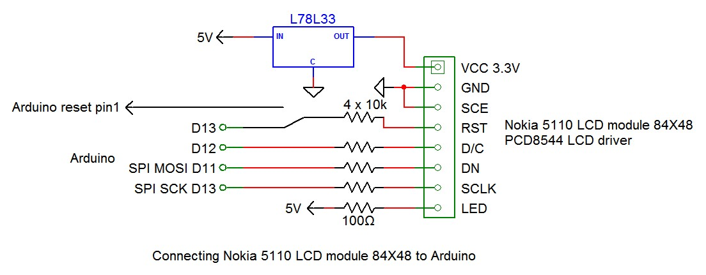

https://learn.sparkfun.com/tutorials/graphic-lcd-hookup-guide

LCD Pin | Arduino Pin | Notes
1 - VCC | 3.3V (VCC) | 3.3V only (not 5V!)
2 - GND | GND
3 - SCE | 7 | Can be any digital pin.
4 - RST | 6 | Can be any digital pin.
5 - D/C | 5 | Can be any digital pin.
6 - DN(MOSI) | 11 | Can't be moved.
SCLK | 13 | Can't be moved.
LED | 9 | Can be any PWM pin. 330Ω resistor in between the pins.

// Software SPI (slower updates, more flexible pin options):
// pin 7 - Serial clock out (SCLK)
// pin 6 - Serial data out (DIN)
// pin 5 - Data/Command select (D/C)
// pin 4 - LCD chip select (CS)
// pin 3 - LCD reset (RST)
Adafruit_PCD8544 display = Adafruit_PCD8544(7, 6, 5, 4, 3);

// Hardware SPI (faster, but must use certain hardware pins):
// SCK is LCD serial clock (SCLK) - this is pin 13 on Arduino Uno
// MOSI is LCD DIN - this is pin 11 on an Arduino Uno
// pin 5 - Data/Command select (D/C)
// pin 4 - LCD chip select (CS)
// pin 3 - LCD reset (RST)
// Adafruit_PCD8544 display = Adafruit_PCD8544(5, 4, 3);
// Note with hardware SPI MISO and SS pins aren't used but will still be read
// and written to during SPI transfer. Be careful sharing these pins!

RTC.
Not very accurate.

The two Sainsmart Tiny-RTC units I just received had CR2032 (non-rechargeable) lithium coin cells in them. THESE ARE NOT THE RIGHT BATTERY TYPE for Tiny-RTC circuits, and may leak or catch fire if the circuit is left powered from Vcc for long periods of time!
You *can* use the CR2032 battery and it should last 3 years or more in this application, but the Tiny-RTC module must have its battery charging circuit removed to do so safely. The modification is: Remove R5, D1, R4, R6, and replace R6 with a shorting wire. Or you can try to find the proper battery, which is a LIR2032 and can be ordered easily right here on Amazon but probably isn't available at your neighborhood Radio Shack.
Three stars because the circuits themselves work just fine, -2 for shady supplier putting cheap, incorrect batteries in.

If you need to reset the date and time look here http://forum.arduino.cc/index.php?topic=184908.0
the addresses are
x50 EEPROM
x68 RTC

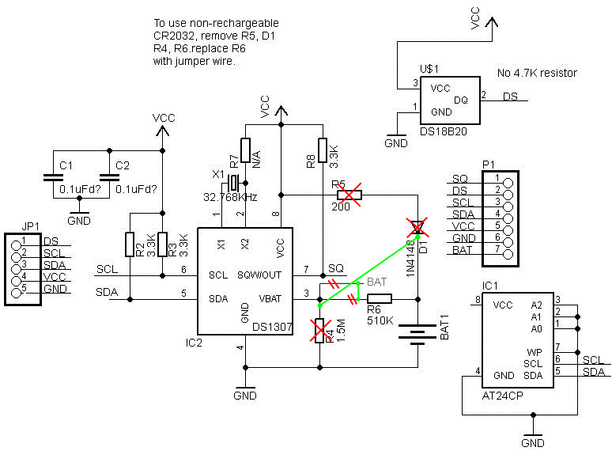
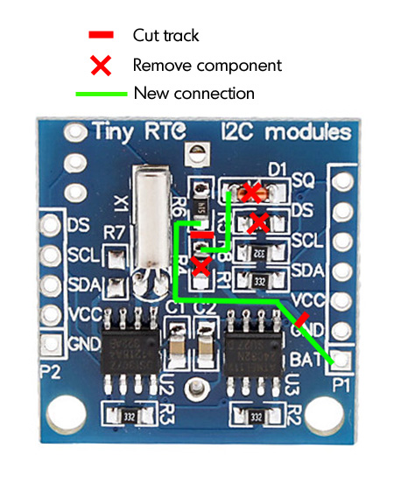

http://electronics.stackexchange.com/search?q=url%3Ahttp%3A%2F%2Farduino.stackexchange.comYou can always use the analog pins for digital writing.

digitalRead() works on all pins. It will just round the analog value received and present it to you. If analogRead(A0) is greater than or equal to 512, digitalRead(A0) will be 1, else 0.
digitalWrite() works on all pins, with allowed parameter 0 or 1. digitalWrite(A0,0) is the same as analogWrite(A0,0), and digitalWrite(A0,1) is the same as analogWrite(A0,255)
analogRead() works only on analog pins. It can take any value between 0 and 1023.
analogWrite() works on all analog pins and all digital PWM pins. You can supply it any value between 0 and 255.

The analog pins let you read/write analog values - basically, instead of giving out a voltage of 0 or 5 (as with digital), they can give a range of voltages between 0 and 5 (both as input and output). Note that the voltage during analog output is only the observed voltage with a multimeter. In reality, the analog pins send pulses of 0V and 5V signals to get an output that "looks" analog (this is PWM).

Regarding the number of pins: keep in mind that the PWM pins can be used for analog output. If you run out of pins, you can use multiplexing to make more. It is not necessary to get another Arduino.

LED RGB Common cathode

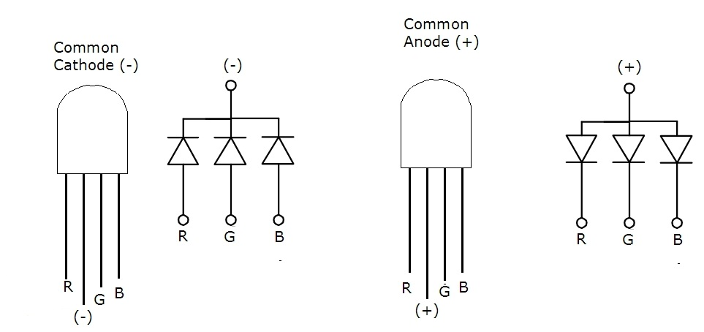

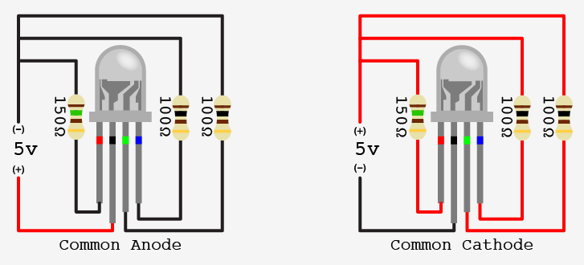

200mA is the maximum of all the combined pins, no one pin to exceed 40mA
3x 20mA → 60
without transistor
Max current 20mA, working at 10mA
RGB 160, 150, 1
http://talkingelectronics.com/projects/30%20LED%20Projects/30%20LED%20Projects.html
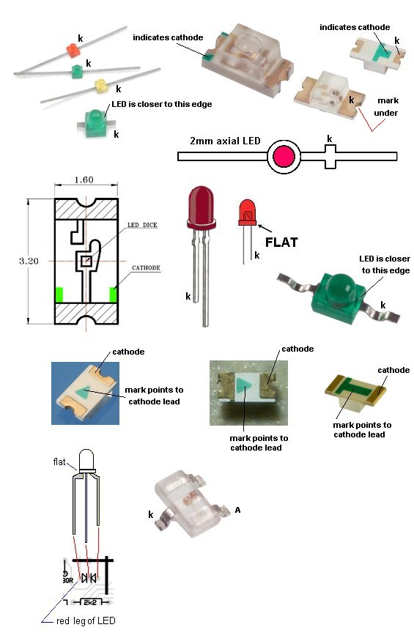
Night clock
http://www.instructables.com/id/LED-Dawn-Sunrise-Alarm-Clock-Nightlight-Secur/all/?lang=es

Level shifter
http://husstechlabs.com/support/tutorials/bi-directional-level-shifter/

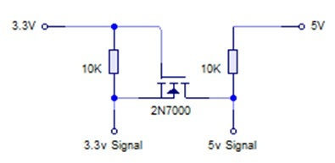
Level shifter
I used the general purpose 2N7000 MOSFET, but I had used some 3A power MOSFET’s while I was waiting for the 2N7000’s to arrive! Note that the Gate is always connected to the LOWER voltage.

http://www.hobbytronics.co.uk/mosfet-voltage-level-converter

Pegar un vistazo a esto
http://www.thefrankes.com/wp/index.php?cat=41&paged=7

https://learn.sparkfun.com/tutorials/using-the-logic-level-converter
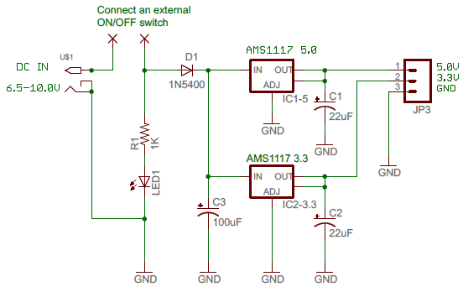

http://arduino-info.wikispaces.com/IR-RemoteControl
1.- Digital (PWM?) 2.- GND 3 VCC
http://arduino-info.wikispaces.com/file/view/IR-Receiver-AX-1838HS.pdf
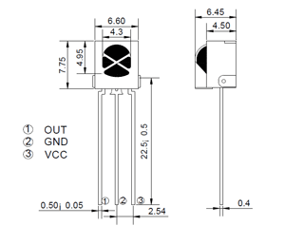

http://drianoxaman.blogspot.com.es/2013/03/arduino-usb-lipo-charger-5v-booster.html
https://medium.com/@tomsimon/lipo-charger-board-for-the-arduino-nano-39e709f459bc
https://www.tindie.com/products/onehorse/lipo-battery-charger-add-on-for-teensy-31/

TEA5767
http://blog.simtronyx.de/en/simple-fm-stereo-radio-with-a-tea5767-breakout-module-and-an-arduino/
http://www.vwlowen.co.uk/arduino/bedside-clock/bedside-clock.htm
https://www.electronicsblog.net/arduino-fm-receiver-with-tea5767/

Light encoding, no suele ir muy bien.
http://www.wayneandlayne.com/projects/blinky/design/

https://github.com/mossblaser/Clockie
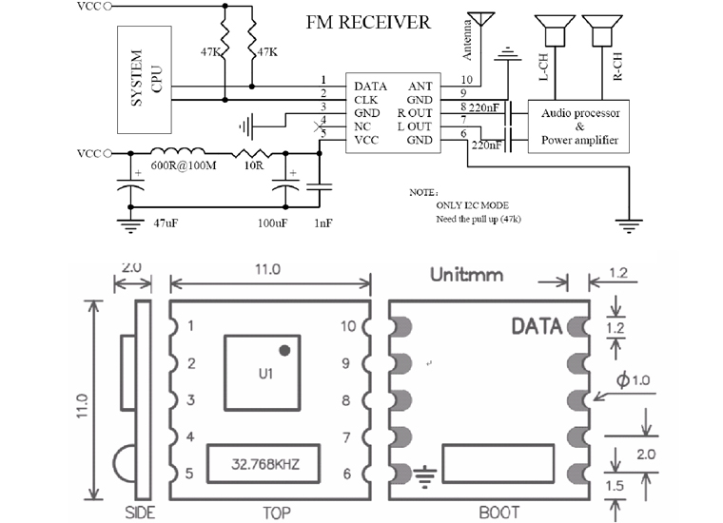

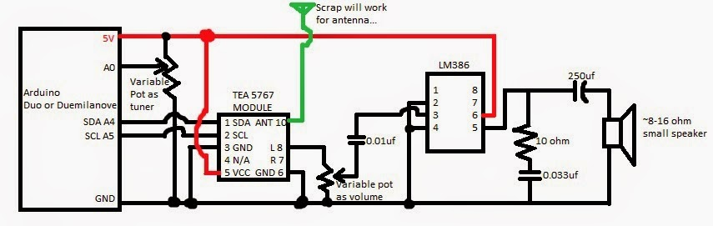

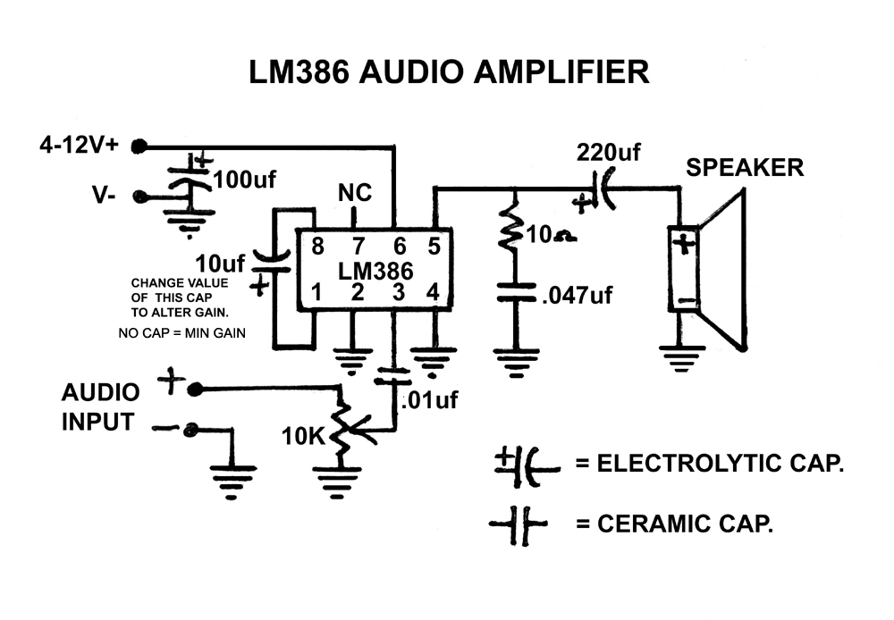

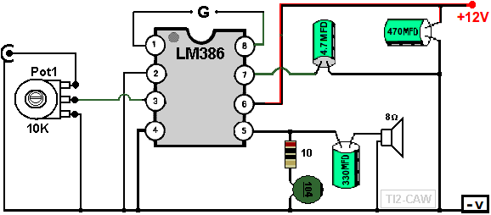

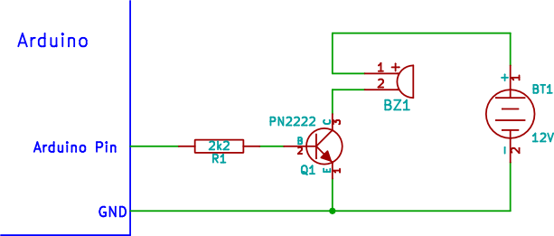

2n2222 OK, con 5v ok !!!

piezo al pin arduino 1Mohm, se oye suficiente para beep

http://hackaweek.com/hacks/?p=327

http://xronosclock.com/files/xronos_2.1_schematic.png

USB MICRO
https://www.sparkfun.com/datasheets/Prototyping/Micro-USB.pdf
http://portal.fciconnect.com/Comergent//fci/drawing/10118192.pdf

Shield y GND
http://pinouts.ru/Slots/usb_pinout.shtml
http://electronics.stackexchange.com/questions/4515/how-to-connect-usb-connector-shield

