1 - Backoffice fetch all events ; because of users integrations : just clic on the navbar File Manger and then Calendar

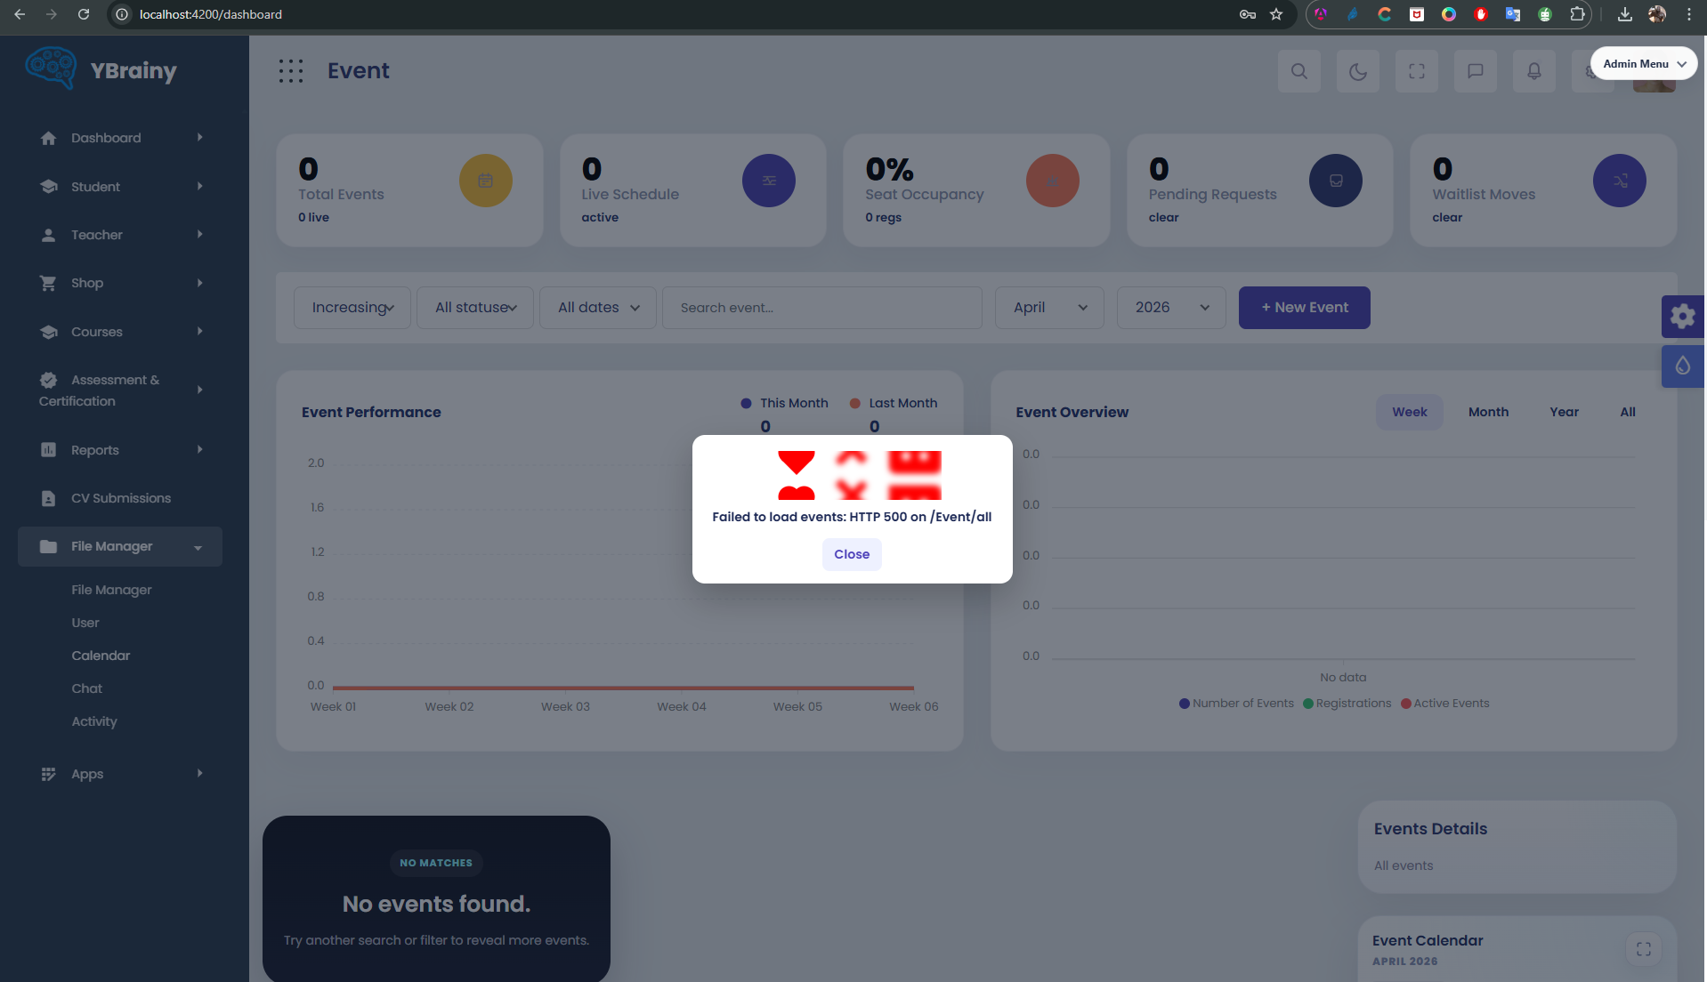
2 – click on New Event
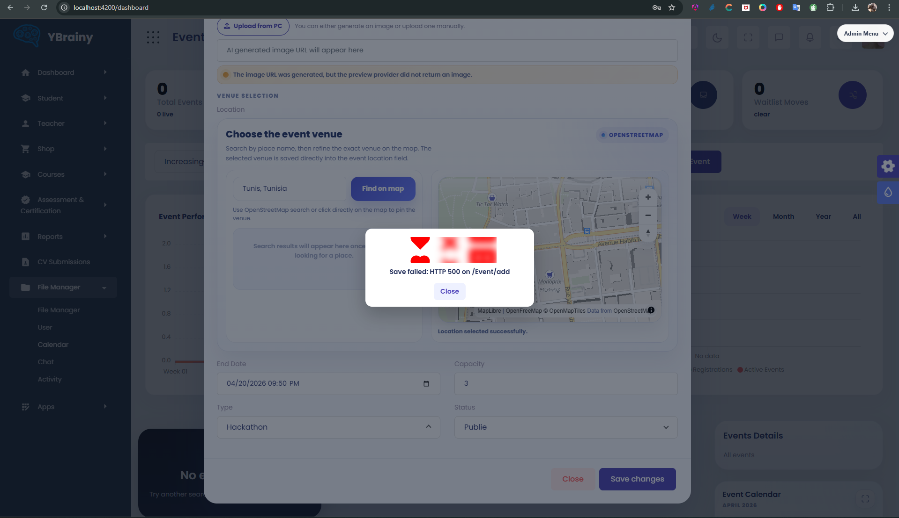
3 – it should appear all the Events in frontoffice
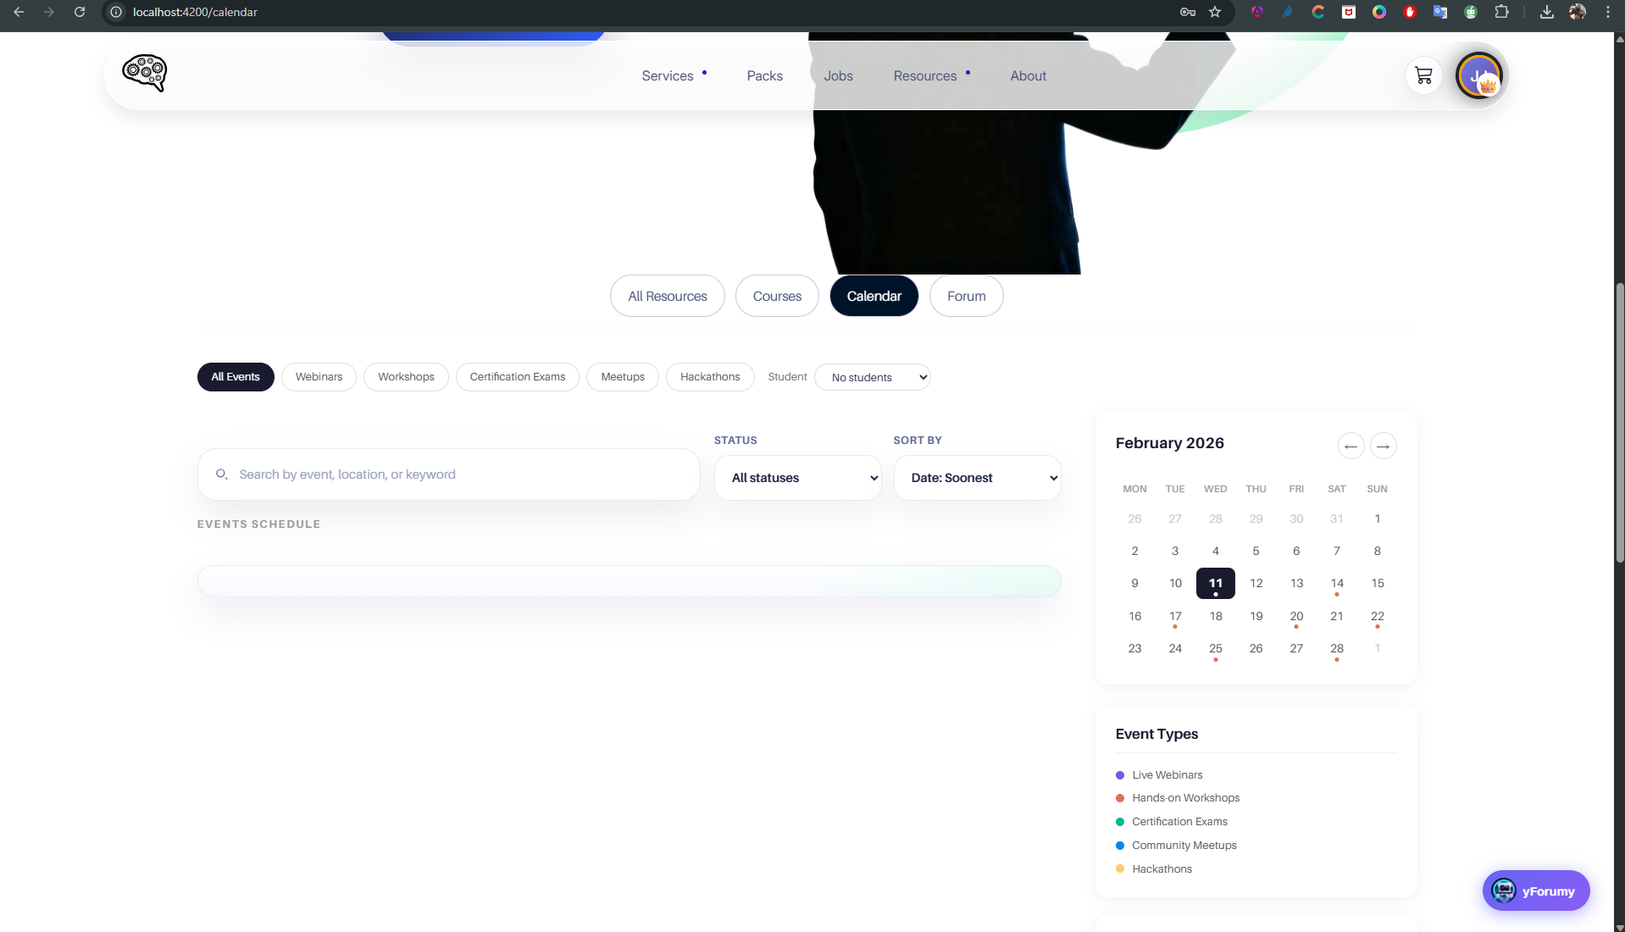

4- here for the dropdown Stuent IDs : after the integration of user it should disappear
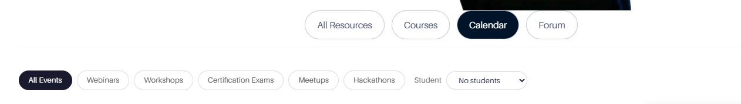

5 – in frontoffice in ressources in calender , when I click on the button “Open CodeLab Simulator” it should appear the codeLab
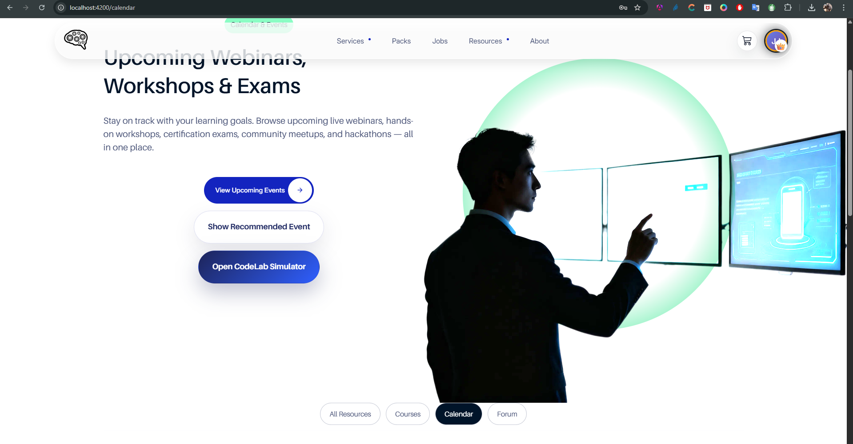

6 – in Ressources , change Calendar to Events& Calendar
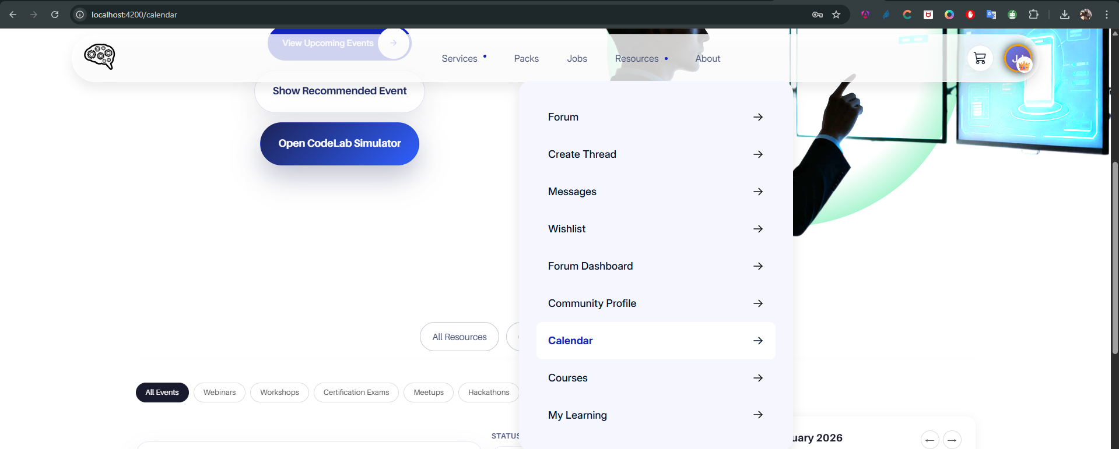

7 – in frontoffice , change with Hackathons , Ateliers, Formations and Webinaires

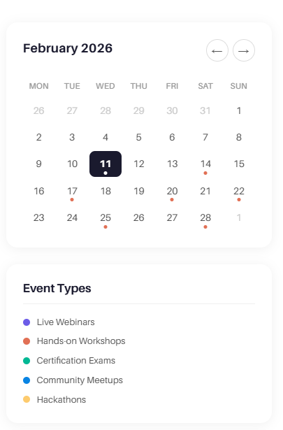

8 – for the statistics , it appear automatically j ust after the implement of the events
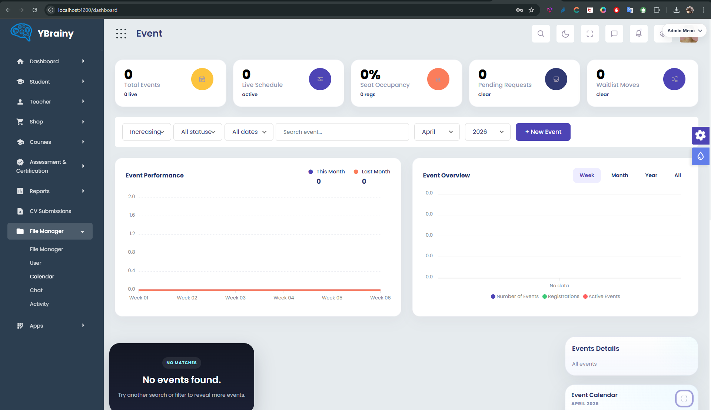

9 - after the register of a student, in the backoffice, it appear for the admin notifications for confirm.
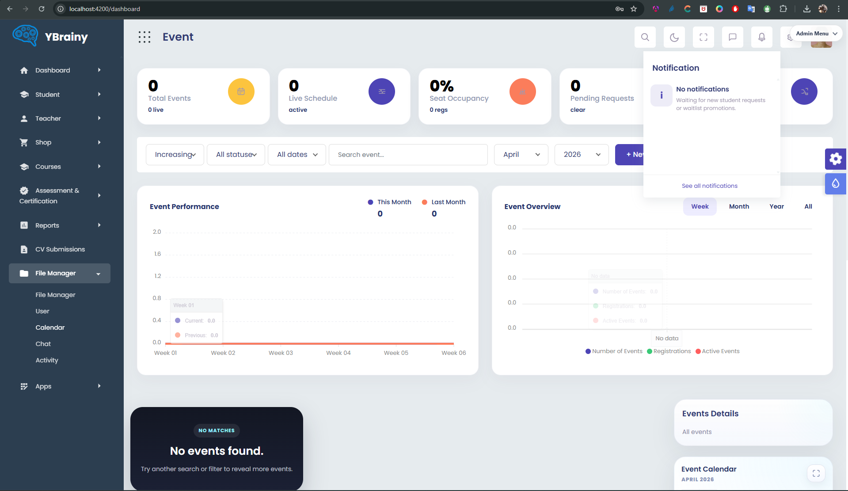

10 – change the button “ Open CodeLab Event “ with “Open CodeStudio”
