Forum error houssem
1 ) theres an ! mark and under it is : “Unable to load the dashboard. Please try again”

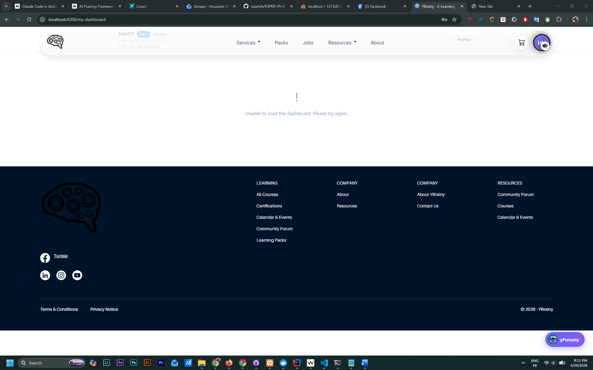

The dashboard don t work of the forum I think because the user

2 )

when I create a post this error appear : unsupported media type
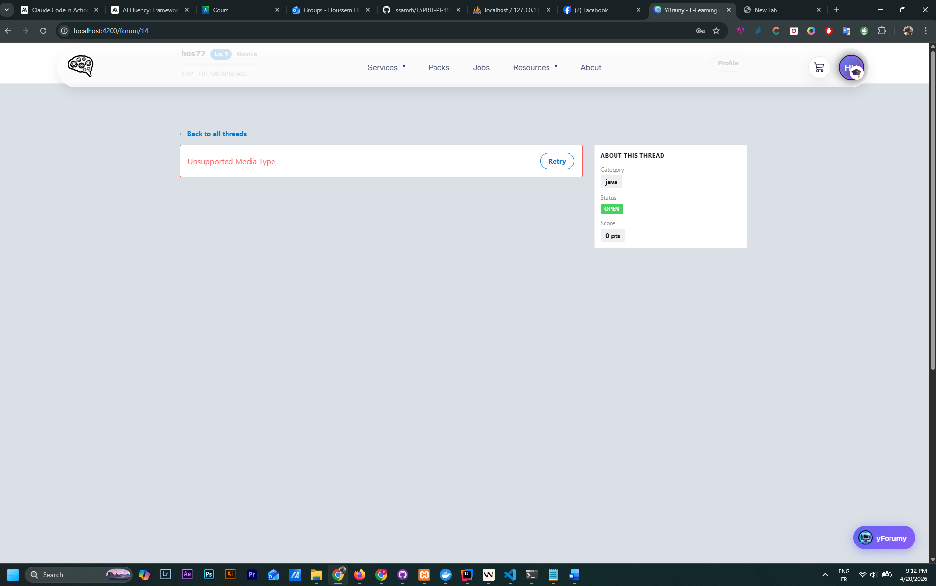

3 )
The users are hardcoded , it uses the default users in browser and doesn’t check for user what’s over

4 )
Cannot GET /uploads/threads/efbf94bd-1660-4e6b-9f39-506f67d70b20.jpg
I think the error is because the route /upload/thread is not integrated in the user api gateway
Search it in forum and integrate it in the user api gateway to make the images work

5 ) please see all error and try to fix it and integrate the forum with the user in keyclock and add the attribute of leveling system in forum to make all the work perfect

