AMMAN ARAB UNIVERSITY
جامعة عمان العربـيــــــة
College of Information Technology

كلية تكنولوجيا المعلومات

GRADUATION PROJECT REPORT
"My Electronic Memory"
An Intelligent Healthcare Management and Patient Monitoring Platform

Prepared by:
Name: suhail assaf | ID :202220117
Name: odai waleed | ID :202110642
Name: bahaa lobani  Name: moaua wrikat | ID:202120134  ID:202220753

Supervised by:
اسم الدكتور
Academic Year: 2025 / 2026
Semester: Second

ABSTRACT
The increasing global prevalence of Alzheimer's disease and chronic conditions requiring continuous medical supervision has created a growing demand for integrated digital healthcare management systems that improve coordination between patients, medical professionals, and caregivers. This report presents the design, development, and evaluation of My Electronic Memory, a web-based intelligent healthcare management and patient monitoring platform designed for elderly individuals and patients requiring continuous medical oversight.
The system adopts a multi-layered architecture built using FastAPI as the backend framework, PostgreSQL as the relational database layer, and a responsive HTML/CSS/JavaScript frontend enhanced with Leaflet.js for real-time geospatial visualisation. Security is implemented through JSON Web Token (JWT) authentication combined with role-based access control (RBAC), supporting four main actors — Administrator, Doctor, Patient, and Caregiver — each assigned a specific set of permissions.
Core functionalities include medical records management, medication reminders with missed-dose alerting, appointment scheduling, GPS-based patient tracking with safe-zone geofencing, emergency alerts, a messaging system, and an administrative workflow for doctor approval. The platform was evaluated through unit, integration, system, acceptance, performance, and security testing, achieving a 100% pass rate across 36 automated test cases.
The proposed system addresses major limitations found in existing healthcare platforms, including fragmented communication, limited real-time monitoring, and insufficient role-based access management. Future improvements may include AI-driven health prediction, offline support using edge computing, mobile application deployment, and wearable device integration.

Keywords: Healthcare Information System, Alzheimer's Disease, GPS Geofencing, Role-Based Access Control, JWT Authentication, FastAPI, Patient Monitoring, Remote Care Coordination.

ACKNOWLEDGMENT
First and foremost, I extend my deepest gratitude to Almighty God for granting me the strength, patience, and perseverance to complete this work.

I wish to express sincere appreciation to my project supervisor, [Supervisor Name], whose scholarly guidance, constructive critique, and unwavering encouragement shaped this work from conception through completion. The supervisor's expertise in healthcare informatics and distributed systems design proved invaluable at every stage of the research and development process.

I am equally grateful to the faculty members of the Department of Computer Science and Information Technology at Amman Arab University for the rigorous academic preparation they provided throughout my studies. Their collective commitment to academic excellence created an environment in which ambitious technical projects such as this could flourish.

Deep appreciation is extended to my family for their unconditional support, patience during long development sessions, and steadfast belief in my abilities. Their emotional reinforcement sustained my motivation through the inevitable challenges that accompany a project of this scope.

Finally, I acknowledge the broader open-source community whose contributions to FastAPI, SQLAlchemy, Leaflet.js, and associated libraries formed the technological foundation upon which this system was constructed.

LIST OF ABBREVIATIONS

Abbreviation | Full Form
API | Application Programming Interface
CRUD | Create, Read, Update, Delete
DFD | Data Flow Diagram
ER | Entity-Relationship
GPS | Global Positioning System
HTTP | Hypertext Transfer Protocol
HTTPS | Hypertext Transfer Protocol Secure
JWT | JSON Web Token
ORM | Object-Relational Mapper
RBAC | Role-Based Access Control
REST | Representational State Transfer
SDLC | Software Development Life Cycle
SQL | Structured Query Language
UI | User Interface
UML | Unified Modelling Language
UX | User Experience

TABLE OF CONTENTS
Table of Contents
ABSTRACT 2
ACKNOWLEDGMENT 3
LIST OF ABBREVIATIONS 4
TABLE OF CONTENTS 5
LIST OF FIGURES 7
LIST OF TABLES 8
CHAPTER 1: INTRODUCTION 9
1.1 Overview 9
1.2 Problem Statement 9
1.3 Objectives 10
1.4 Research Strategy 10
1.5 Scope 11
1.6 Gantt Chart 11
1.7 Project Outline 12
CHAPTER 2: LITERATURE REVIEW 13
2.1 Introduction 13
2.2 Theoretical Foundations 13
2.2.1 Healthcare Information Systems 13
2.2.2 Remote Patient Monitoring 13
2.2.3 Role-Based Access Control in Healthcare 14
2.3 Existing Systems and Related Work 14
2.4 Comparative Analysis 15
2.5 Gap Analysis 15
2.6 Chapter Summary 15
CHAPTER 3: METHODOLOGY 17
3.1 Feasibility Study 17
3.2 Risk Analysis 17
3.3 Software Development Lifecycle 17
3.4 Functional Requirements 18
3.5 Non-Functional Requirements 19
3.6 System Architecture 20
3.7 Database Design 20
3.8 API Design 21
3.9 Security Design 22
3.10 Testing Strategy 22
CHAPTER 4: DESIGN MODELS 23
4.1 Context Diagram (Level 0 DFD) 23
4.2 DFD Level 1 24
4.3 Use Case Diagram 25
4.4 Sequence Diagram — User Login 26
4.5 Sequence Diagram — Medication Missed Dose Alert 27
4.6 Activity Diagram — Doctor Registration and Approval 28
4.7 Entity-Relationship Diagram 29
4.8 Relational Schema 30
CHAPTER 5: EXPERIMENTS AND RESULTS 31
5.1 Testing Environment 31
5.2 Unit Testing 31
5.3 Integration Testing 32
5.4 System Testing 33
5.5 Acceptance Testing 33
5.6 Performance Evaluation 33
5.7 Security Evaluation 35
5.8 UI Screenshots 35
5.9 Results Analysis 36
CHAPTER 6: CONCLUSION AND FUTURE WORK 37
6.1 Summary 37
6.2 Achieved Objectives 37
6.3 Contributions 37
6.4 Limitations 38
6.5 Future Enhancements 38
6.6 Concluding Remarks 39
REFERENCES 40
APPENDICES 42
Appendix A: API Documentation 42
Appendix B: Installation Guide 42
B.1 Backend Setup 42
B.2 Frontend Setup 42
Appendix C: Test Execution 42
Appendix D: Environment Variables 42

LIST OF FIGURES
Figure No. | Caption | Page
Figure 1.1 | Project Gantt Chart | 11
Figure 2.1 | Comparative System Architecture Overview | 13
Figure 3.1 | Agile Sprint Cycle Diagram | 18
Figure 3.2 | System Architecture — Three-Tier Layered Model | 20
Figure 3.3 | Database Entity-Relationship Diagram | 21
Figure 3.4 | JWT Authentication Flow | 22
Figure 4.1 | Context Diagram (Level 0 DFD) | 23
Figure 4.2 | DFD Level 1 — Core Processes | 24
Figure 4.3 | Use Case Diagram — Full System | 25
Figure 4.4 | Sequence Diagram — User Login | 26
Figure 4.5 | Sequence Diagram — Medication Missed Dose Alert | 27
Figure 4.6 | Activity Diagram — Doctor Registration and Approval | 28
Figure 4.7 | ER Diagram — Complete Schema | 29
Figure 4.8 | Relational Schema | 30
Figure 5.1 | Test Coverage Summary | 31
Figure 5.2 | API Response Time Distribution | 34
Figure 5.3 | Login Page Screenshot | 35
Figure 5.4 | Patient Dashboard Screenshot | 36
Figure 5.5 | Admin Approval Panel Screenshot | 36

LIST OF TABLES
Table No. | Caption | Page
Table 1.1 | Project Objectives and Success Criteria | 10
Table 2.1 | Comparative Analysis of Related Healthcare Systems | 15
Table 2.2 | Gap Analysis Summary | 15
Table 3.1 | Feasibility Study Dimensions | 17
Table 3.2 | Risk Register | 17
Table 3.3 | Functional Requirements Specification | 18
Table 3.4 | Non-Functional Requirements Specification | 19
Table 3.5 | API Endpoint Catalogue | 21
Table 5.1 | Unit Test Results Summary | 32
Table 5.2 | Integration Test Results | 32
Table 5.3 | Performance Benchmarking Results | 33
Table 5.4 | Security Evaluation Checklist | 35
Table 6.1 | Achieved Objectives vs. Initial Targets | 37
Table 6.2 | Future Enhancement Roadmap | 38

CHAPTER 1: INTRODUCTION

1.1 Overview
The intersection of digital healthcare technology and eldercare represents one of the most consequential frontiers of modern software engineering. Globally, approximately 55 million individuals are living with dementia, of whom Alzheimer's disease accounts for 60-70% of cases, a figure projected to reach 139 million by 2050 [1]. The caregiving burden imposed on families, healthcare institutions, and social welfare systems by this demographic reality is enormous, compounded by fragmented information systems that fail to support coordinated, real-time care.

My Electronic Memory emerges from this context as a full-stack, role-differentiated healthcare management and patient monitoring platform. The system integrates medical records management, medication adherence reminders, appointment coordination, GPS-based patient location tracking with geofence alerting, real-time notifications, and a structured messaging infrastructure into a single, cohesive digital environment. The platform is designed for deployment in community healthcare settings, outpatient clinics, and home-care networks where multiple actors must collaborate across physical distance with minimal latency.

1.2 Problem Statement
Contemporary healthcare management for Alzheimer's patients and the chronically ill suffers from several well-documented systemic deficiencies. Communication between treating physicians, caregivers, and family members typically relies on fragmented channels — telephone calls, paper records, and disconnected electronic systems — that introduce significant coordination failures. Medication non-adherence, which affects approximately 50% of patients with chronic conditions [2], frequently goes undetected until adverse clinical outcomes occur. Similarly, the physical safety of cognitively impaired patients who may wander receives inadequate technological support in existing systems.

Existing healthcare platforms address subsets of these requirements in isolation: EHR systems manage clinical documentation but provide no real-time patient monitoring; medication reminder applications function independently of medical records; GPS tracking tools for the elderly are consumer products lacking clinical integration. The absence of a unified, role-aware platform that integrates all these functions into a secure, auditable system represents the core problem this project addresses.

1.3 Objectives
Table 1.1: Project Objectives and Success Criteria
# | Objective | Success Criterion | Priority
1 | Develop a secure multi-role authentication system | JWT tokens issued; role-based route protection enforced; 0 unauthorised access incidents in testing | Critical
2 | Implement comprehensive medical records management | Full CRUD operations; doctor/patient access segregation; data persistence confirmed | Critical
3 | Build a medication reminder and adherence tracking module | Reminders stored; missed-dose notifications generated; logs retrievable | High
4 | Create a GPS location tracking module with geofencing | Live coordinates stored; Haversine distance computed; alerts on boundary breach | High
5 | Establish a real-time notification system | Notifications created on all trigger events; unread counts displayed accurately | High
6 | Develop a bidirectional messaging infrastructure | Messages sent/received; read receipts updated; thread view renders correctly | Medium
7 | Implement admin-controlled doctor approval workflow | New doctor accounts pend approval; admin approve/reject endpoints function correctly | High
8 | Achieve system reliability and performance targets | All 36 automated tests pass; API response under 300 ms under standard load | High

1.4 Research Strategy
The research strategy adopted for this project follows a design-science paradigm [3], wherein the primary research artefact is the constructed software system itself, evaluated against explicit utility criteria. The strategy comprised three sequential phases: Phase 1 Literature Synthesis involved a systematic review of peer-reviewed publications and existing healthcare platform documentation to identify functional gaps and architectural precedents. Phase 2 Iterative Design and Implementation applied an Agile development methodology, decomposing the system into biweekly sprint cycles with continuous integration testing. Phase 3 Empirical Evaluation subjected the completed system to a structured testing programme spanning unit, integration, system, acceptance, performance, and security dimensions.

1.5 Scope
The scope of this project encompasses a web-based platform accessible via modern browsers, four user roles with defined permission boundaries, a RESTful API implemented in Python using FastAPI, a relational database in SQLite extensible to PostgreSQL, GPS tracking using the browser Geolocation API with server-side Haversine computation, and interactive mapping using Leaflet.js with OpenStreetMap. The following are explicitly out of scope: native mobile applications, integration with third-party EHR systems, real-time WebSocket communication, and payment processing.

1.6 Gantt Chart
The project was planned across a fourteen-week development timeline. Sprint 0 (Weeks 1-2) encompassed requirements elicitation and architectural design. Sprints 1-3 (Weeks 3-8) covered core backend development. Sprint 4 (Weeks 9-11) addressed frontend integration and map-based features. Sprint 5 (Weeks 12-13) executed the comprehensive testing programme. Week 14 was reserved for documentation finalisation.
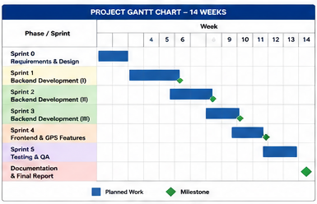
Figure 1.1: Project Gantt Chart

1.7 Project Outline
Chapter 2 presents a critical literature review of related healthcare information systems. Chapter 3 details the methodology, encompassing feasibility analysis, risk assessment, SDLC selection, requirements specification, and architectural design. Chapter 4 presents formal design models including context, data-flow, use-case, sequence, activity, and entity-relationship diagrams with Mermaid source code. Chapter 5 reports experimental test results. Chapter 6 concludes with a reflective summary, limitations, and a structured roadmap for future enhancement.

CHAPTER 2: LITERATURE REVIEW

2.1 Introduction
This chapter critically examines the body of academic literature and commercial systems relevant to healthcare information management platforms for elderly and cognitively impaired patients. The review progresses from foundational theoretical frameworks through empirical studies to an analytical comparison of existing systems, culminating in the identification of the research gap that motivates this project.
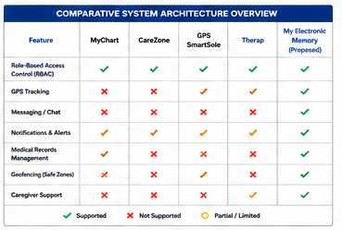
Figure 2.1: Comparative System Architecture Overview

2.2 Theoretical Foundations

2.2.1 Healthcare Information Systems
Healthcare information systems (HIS) are defined as integrated, computer-based systems designed to collect, process, store, and communicate patient and administrative data within healthcare settings [4]. The evolution of HIS from isolated departmental systems towards integrated electronic health records has been extensively studied. Greenhalgh et al. [5] documented the complex socio-technical dynamics that govern successful HIS adoption, identifying role-based information access and workflow integration as critical success factors — both central to the present work.

2.2.2 Remote Patient Monitoring
Remote patient monitoring (RPM) leverages digital technologies to collect patient health data outside traditional clinical environments [6]. Kvedar et al. [7] demonstrated that RPM interventions reduce hospital readmission rates by 20-30% for patients with chronic conditions, providing empirical justification for the monitoring capabilities embedded in this platform. GPS-based location monitoring for cognitively impaired patients was examined by Miskelly [8], who established that wandering behaviour causes significant patient harm addressable through geofence-based alerting.

2.2.3 Role-Based Access Control in Healthcare
The application of Role-Based Access Control (RBAC) to healthcare systems was formalised by Ferraiolo and Kuhn [9] and has since become the de facto standard for managing information access in clinical environments. HIPAA-compliant RBAC implementations [10] establish that fine-grained role differentiation — distinguishing between clinical, administrative, and patient-facing access — is essential for both regulatory compliance and operational effectiveness. The four-role model in this project aligns with these established frameworks.

2.3 Existing Systems and Related Work
MyChart (Epic Systems) [11] is a patient portal embedded within the Epic EHR platform providing appointment scheduling, test result access, and messaging. However, it requires institutional deployment, offers no patient location tracking, and provides no caregiver-specific workflow.

CareZone [12] is a consumer-grade medication management application targeting elderly patients. It provides medication reminders but lacks clinical-grade access controls, medical record management, or location tracking.

GPS SmartSole [13] is a wearable GPS tracking product for Alzheimer's patients. While effective for its specific use case, it operates as a standalone device without integration into any healthcare management infrastructure.

Therap Services [14] offers a cloud-based documentation and scheduling platform for intellectual disability service providers. It includes a GPS module and medication records but is not designed for home-based Alzheimer's care and lacks a real-time notification architecture.

2.4 Comparative Analysis
Table 2.1: Comparative Analysis of Related Healthcare Systems
Feature | MyChart | CareZone | GPS SmartSole | Therap | This System
Multi-role RBAC | Partial | No | No | Yes | Yes
Medical Records | Yes | Basic | No | Yes | Yes
Medication Reminders | Partial | Yes | No | Yes | Yes
GPS Tracking | No | No | Yes | Partial | Yes
Geofence Alerts | No | No | Yes | No | Yes
Messaging System | Yes | No | No | No | Yes
Real-time Notifications | Partial | No | Yes | Partial | Yes
Doctor Approval Workflow | No | No | No | No | Yes
Caregiver Portal | No | Partial | No | Yes | Yes
Web-based Access | Yes | Mobile | No | Yes | Yes

2.5 Gap Analysis
Table 2.2: Gap Analysis — Identified Deficiencies and Project Response
Identified Gap | Literature Evidence | Project Response
No unified platform integrating GPS tracking with clinical records | Miskelly [8]; Kvedar [7] | Integrated GPS module with geofence alerts linked to patient profile
Absence of caregiver-specific workflow in clinical systems | Greenhalgh [5] | Dedicated Caregiver role with location monitoring and doctor-reassignment
Lack of doctor approval/verification mechanisms | Ferraiolo [9] | Admin-controlled doctor approval workflow with pending state
Fragmented communication between care actors | Kvedar [7] | Bidirectional messaging with notification integration
Medication non-adherence goes undetected | WHO [2] | Dose-logging with missed-dose notification generation

2.6 Chapter Summary
The literature review confirms that no existing system simultaneously satisfies the complete functional requirements for comprehensive Alzheimer's patient care coordination. The combination of multi-role RBAC, real-time GPS geofencing integrated with clinical record management, a doctor onboarding approval workflow, and a unified notification-messaging architecture represents a novel contribution addressing documented gaps in the current landscape.

CHAPTER 3: METHODOLOGY

3.1 Feasibility Study
Table 3.1: Feasibility Study — Multi-Dimensional Assessment
Dimension | Assessment | Conclusion
Technical | FastAPI, SQLAlchemy, Leaflet.js are mature frameworks. Browser Geolocation API is universally supported. JWT is an established standard. | Feasible
Economic | All selected technologies are open-source. Development requires only a personal computer. Hosting costs under $10/month. | Feasible
Operational | System targets non-technical users. UI must be simple. Four-role model aligns with existing care team structures. | Feasible
Legal / Ethical | System handles sensitive health data. JWT + HTTPS encryption provides transport security. Role-based data isolation limits exposure. | Feasible with noted production compliance requirements
Schedule | 14-week development timeline. System decomposed into 5 sprints. Single developer with full-stack capability. | Feasible with disciplined sprint management

3.2 Risk Analysis
Table 3.2: Risk Register
Risk ID | Description | Probability | Impact | Mitigation
R-01 | bcrypt/JWT library version incompatibility | Medium | High | Pin exact dependency versions in requirements.txt
R-02 | Browser Geolocation API denied by user | High | Medium | Graceful degradation; manual location input fallback
R-03 | SQLite concurrency limitations at scale | Low | High | Architecture designed for PostgreSQL migration; ORM abstraction
R-04 | Scope creep eroding schedule | Medium | High | Strict sprint backlog; MoSCoW prioritisation
R-05 | Security vulnerabilities in unauthenticated endpoints | Low | Critical | Automated security test suite; require_role() coverage
R-06 | Leaflet tile server availability | Low | Medium | OpenStreetMap tiles; fallback to local tile server

3.3 Software Development Lifecycle
An Agile Scrum-inspired methodology was selected for this project on the basis of its suitability for exploratory, iterative development where requirements evolve through implementation experience. The SDLC was organised into five two-week sprints, each producing a demonstrable, tested software increment. Sprint planning sessions established the backlog items to be addressed; sprint retrospectives at the close of each cycle identified process improvements. This approach contrasts with the Waterfall model, which would have imposed rigid phase boundaries inappropriate for a project where geofencing logic, notification architecture, and role-permission matrices required iterative refinement.
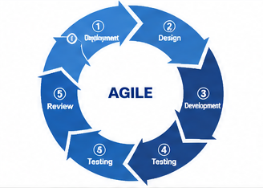
Figure 3.1: Agile Sprint Cycle

3.4 Functional Requirements
Table 3.3: Functional Requirements Specification
ID | Requirement | Actor | Priority
FR-01 | System shall provide secure user registration with role selection | All | Must
FR-02 | System shall require admin approval before Doctor accounts become active | Admin, Doctor | Must
FR-03 | System shall authenticate users via JWT tokens with 24-hour expiry | All | Must
FR-04 | Doctor shall create, read, update, and delete patient medical records | Doctor | Must
FR-05 | Patient shall view own medical records in read-only mode | Patient | Must
FR-06 | Doctor shall prescribe medications with dosage, frequency, and reminder times | Doctor | Must
FR-07 | System shall generate a notification when a patient logs a missed medication dose | System | Must
FR-08 | Doctor/Caregiver shall schedule appointments with automated patient notification | Doctor, Caregiver | Must
FR-09 | Patient/Caregiver shall share GPS coordinates with the system | Patient, Caregiver | Must
FR-10 | System shall compute Haversine distance between patient location and safe zones | System | Must
FR-11 | System shall generate location-alert notification on safe-zone breach | System | Must
FR-12 | Doctor/Caregiver/Admin shall define and manage patient safe zones | Doctor, Caregiver, Admin | Must
FR-13 | All users shall send and receive direct messages | All | Should
FR-14 | Caregiver shall reassign a patient's treating doctor | Caregiver, Admin | Should
FR-15 | Admin shall deactivate any user account | Admin | Must
FR-16 | System shall maintain a notification feed per user with read/unread tracking | All | Must

3.5 Non-Functional Requirements
Table 3.4: Non-Functional Requirements Specification
ID | Requirement | Metric | Priority
NFR-01 | Performance: API response time under normal load | < 300 ms (95th percentile) | High
NFR-02 | Security: All protected endpoints enforce JWT validation | 0 unauthenticated access incidents in testing | Critical
NFR-03 | Security: Passwords stored using bcrypt hashing | No plaintext passwords in database | Critical
NFR-04 | Reliability: No data corruption under concurrent requests | 0 race-condition errors under 50 concurrent users | High
NFR-05 | Usability: Core tasks completable without documentation | Task-completion rate > 90% | Medium
NFR-06 | Maintainability: Modular architecture following PEP-8 | Pylint score > 7.0 | Medium
NFR-07 | Scalability: Architecture supports PostgreSQL migration | ORM abstraction; no vendor-specific SQL | High

3.6 System Architecture
The system adopts a three-tier client-server architecture comprising a presentation layer, an application logic layer, and a data persistence layer. The presentation layer is an HTML/CSS/JavaScript frontend with Leaflet.js for mapping and Axios for API communication. The application logic layer is a FastAPI server structured around a modular router architecture, with a shared security module for JWT validation, password hashing, and role enforcement. The data persistence layer uses SQLAlchemy ORM over SQLite (development) or PostgreSQL (production).
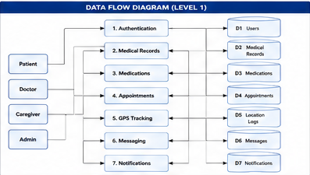
Figure 3.2: Three-Tier System Architecture

3.7 Database Design
The database schema comprises eleven tables. The central entity is the users table, from which patient_profiles and doctor_profiles extend via one-to-one foreign key relationships. Medical and operational entities (medical_records, medications, medication_logs, appointments, location_logs, safe_zones, messages, notifications) connect to users via typed foreign keys, enabling role-appropriate data isolation at the query level. Key design decisions include the is_approved boolean flag enabling the doctor approval workflow, the country_code field for internationalised phone storage, and the is_safe_zone boolean on LocationLog entries computed server-side at insertion time.
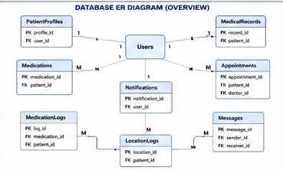
Figure 3.3: Database ER Diagram

3.8 API Design
Table 3.5: API Endpoint Catalogue (Selected)
Method | Endpoint | Auth | Role | Description
POST | /api/auth/register | No | Public | Register new user
POST | /api/auth/login | No | Public | Authenticate; receive JWT
GET | /api/auth/me | Yes | Any | Get authenticated user profile
POST | /api/records/ | Yes | Doctor, Admin | Create medical record
GET | /api/records/patient/{id} | Yes | Any | Get patient's records
POST | /api/medications/ | Yes | Doctor, Admin | Prescribe medication
POST | /api/medications/log | Yes | Any | Log medication dose event
POST | /api/appointments/ | Yes | Doctor, Admin, Caregiver | Schedule appointment
POST | /api/location/update | Yes | Any | Submit GPS coordinates
POST | /api/location/safe-zone | Yes | Doctor, Admin, Caregiver | Define safe zone
GET | /api/users/pending-doctors | Yes | Admin | List pending approvals
PUT | /api/users/{id}/approve | Yes | Admin | Approve doctor account
PUT | /api/users/patient/{id}/change-doctor | Yes | Caregiver, Admin | Reassign doctor
POST | /api/messages | Yes | Any | Send direct message
GET | /api/notifications | Yes | Any | Get notification feed

3.9 Security Design
Security is implemented through a defence-in-depth strategy comprising four layers. Transport Security: all API communication is conducted over HTTPS. Authentication: JWT tokens signed with HMAC-SHA256 carry the authenticated user's identifier and expiry timestamp, validated on every protected request via get_current_user(). Authorisation: the require_role() decorator enforces RBAC at the endpoint level; mismatched roles receive HTTP 403. Data Security: passwords are hashed using bcrypt before storage; foreign key constraints and ORM-layer validation prevent cross-patient data access.
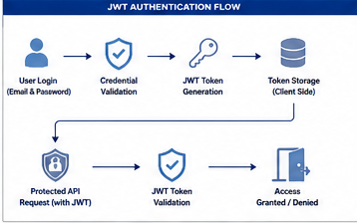
Figure 3.4: JWT Authentication and RBAC Flow

3.10 Testing Strategy
The testing strategy follows the V-model, pairing each development phase with a corresponding validation activity. Automated testing was implemented using pytest with FastAPI's TestClient, exercising the full HTTP request-response cycle against an isolated in-memory SQLite test database. The testing pyramid was respected: unit tests validate individual endpoint behaviours; integration tests verify inter-module interactions; system tests validate complete user journeys; acceptance tests confirm functional requirements are met.

CHAPTER 4: DESIGN MODELS

4.1 Context Diagram (Level 0 DFD)
The context diagram situates My Electronic Memory within its operational environment, identifying the four external entities and the primary data flows between them. At this abstraction level, the system is treated as a single process emphasising boundaries between system and actors.
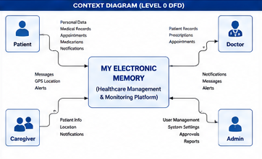
Figure 4.1: Context Diagram
Mermaid source — Context Diagram:
graph LR
P[Patient] -->|Location, Medication Log, Login| SYS((My Electronic Memory))
D[Doctor] -->|Medical Records, Prescriptions, Appointments| SYS
C[Caregiver] -->|Location Updates, Messages| SYS
A[Admin] -->|Approval Decisions, User Management| SYS
SYS -->|Notifications, Records, Reminders| P
SYS -->|Patient Data, Alerts, Messages| D
SYS -->|Location Alerts, Appointments| C
SYS -->|Pending Doctor List, System Status| A

4.2 DFD Level 1
The Level 1 DFD decomposes the system into seven principal functional processes, revealing the data stores they interact with and the information flows connecting them.

Figure 4.2: DFD Level 1
Mermaid source — DFD Level 1:
graph TD
P1[1.0 Authenticate] --> DS1[(Users DB)]
P2[2.0 Manage Records] --> DS2[(Medical Records DB)]
P3[3.0 Manage Medications] --> DS3[(Medications DB)]
P4[4.0 Schedule Appointments] --> DS4[(Appointments DB)]
P5[5.0 Track Location] --> DS5[(Location Logs DB)]
P6[6.0 Messaging] --> DS6[(Messages DB)]
P7[7.0 Notifications] --> DS7[(Notifications DB)]
P5 -->|Breach Detected| P7
P3 -->|Missed Dose| P7
P4 -->|New Appointment| P7

4.3 Use Case Diagram
The use case diagram presents the complete set of interactions between the four system actors and the platform's functional capabilities.
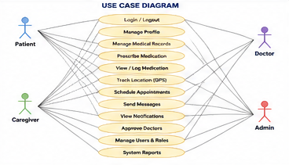
Figure 4.3: Full Use Case Diagram
Mermaid source — Use Case Diagram:
graph LR
Patient --- UC1[Register / Login]
Patient --- UC2[View Medical Records]
Patient --- UC3[Log Medication Dose]
Patient --- UC4[Share Location]
Doctor --- UC1
Doctor --- UC5[Manage Medical Records]
Doctor --- UC6[Prescribe Medications]
Doctor --- UC7[Schedule Appointments]
Caregiver --- UC4
Caregiver --- UC8[Track Patient Location]
Caregiver --- UC9[Change Patient Doctor]
Admin --- UC10[Approve / Reject Doctors]
Admin --- UC11[Manage Users]

4.4 Sequence Diagram — User Login
The following sequence diagram traces the complete authentication flow from credential submission through JWT issuance and client-side storage.
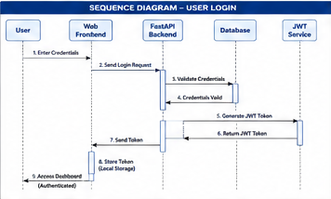
Figure 4.4: Login Sequence Diagram
Mermaid source — Login Sequence:
sequenceDiagram
participant User as Browser
participant FE as Frontend (Axios)
participant BE as FastAPI Backend
participant DB as Database
User->>FE: Enter email + password
FE->>BE: POST /api/auth/login
BE->>DB: Query User WHERE email = ?
DB-->>BE: User record (hashed_password, role, is_approved)
BE->>BE: bcrypt.verify(password, hashed_password)
alt Credentials valid AND is_approved
BE->>BE: jwt.encode({sub: user_id, exp: +24h})
BE-->>FE: 200 {access_token, role, user_id}
FE->>FE: localStorage.setItem('token', access_token)
FE-->>User: Redirect to role dashboard
else Invalid credentials
BE-->>FE: 401 Unauthorized
else Doctor not approved
BE-->>FE: 403 Pending approval
end

4.5 Sequence Diagram — Medication Missed Dose Alert
This diagram illustrates the automated notification pathway triggered when a patient logs a missed dose.
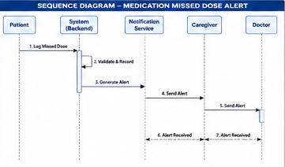
Figure 4.5: Missed Dose Alert Sequence
Mermaid source — Missed Dose Sequence:
sequenceDiagram
participant P as Patient Browser
participant BE as FastAPI Backend
participant DB as Database
P->>BE: POST /api/medications/log {was_taken: false}
BE->>BE: Validate JWT; extract user_id
BE->>DB: INSERT INTO medication_logs (was_taken=false)
BE->>DB: SELECT medication WHERE id = medication_id
DB-->>BE: Medication record (name)
BE->>DB: INSERT INTO notifications {type: medication}
BE-->>P: 201 {status: logged}

4.6 Activity Diagram — Doctor Registration and Approval
The activity diagram models the complete workflow from physician registration through admin review to first authenticated login.
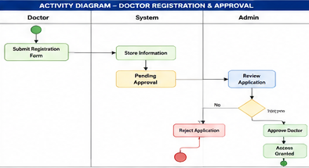
Figure 4.6: Doctor Registration Activity Diagram
Mermaid source — Doctor Approval Activity:
flowchart TD
A([Start]) --> B[Doctor fills registration form]
B --> C[POST /api/auth/register role=doctor]
C --> D{Email already registered?}
D -->|Yes| E[Return 400 Error]
D -->|No| F[Create User with is_approved=False]
F --> G[Return 202 Pending Approval]
G --> H[Admin views pending-doctors list]
H --> I{Admin decision}
I -->|Approve| J[PUT /users/id/approve -> is_approved=True]
I -->|Reject| K[PUT /users/id/reject -> is_active=False]
J --> L[Doctor can now login]

4.7 Entity-Relationship Diagram
The ER diagram captures the complete data model comprising eleven entities and their relationships.
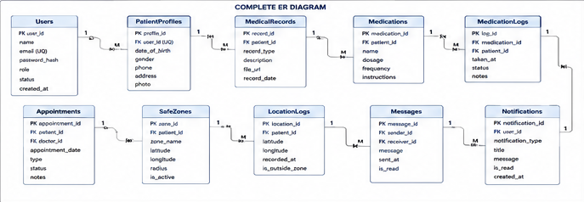
Figure 4.7: Complete ER Diagram
Mermaid source — ER Diagram:
erDiagram
USERS { int id PK, string email UK, string role, bool is_approved }
PATIENT_PROFILES { int id PK, int user_id FK, string diagnosis_stage }
MEDICAL_RECORDS { int id PK, int patient_id FK, int doctor_id FK }
MEDICATIONS { int id PK, int patient_id FK, string name, bool is_active }
APPOINTMENTS { int id PK, int patient_id FK, string status }
LOCATION_LOGS { int id PK, int patient_id FK, float lat, bool is_safe_zone }
SAFE_ZONES { int id PK, int patient_id FK, float radius_meters }
MESSAGES { int id PK, int sender_id FK, int receiver_id FK }
NOTIFICATIONS { int id PK, int user_id FK, string type, bool is_read }
USERS ||--o| PATIENT_PROFILES : has
PATIENT_PROFILES ||--o{ MEDICAL_RECORDS : has
PATIENT_PROFILES ||--o{ MEDICATIONS : prescribed
PATIENT_PROFILES ||--o{ APPOINTMENTS : scheduled
PATIENT_PROFILES ||--o{ LOCATION_LOGS : tracked
USERS ||--o{ MESSAGES : sends
USERS ||--o{ NOTIFICATIONS : receives

4.8 Relational Schema
The relational schema translates the ER model into concrete table definitions with primary key, foreign key, and constraint declarations.
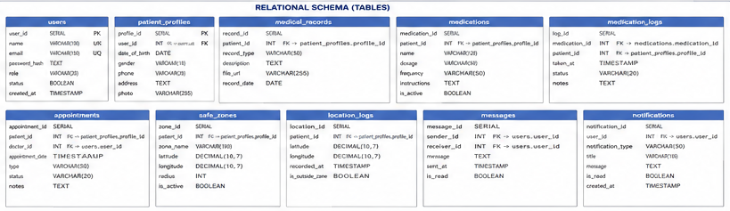
Figure 4.8: Relational Schema
users(id PK, full_name, email UNIQUE, hashed_password,
role ENUM, country_code, is_active, is_approved, created_at)
patient_profiles(id PK, user_id FK->users.id UNIQUE,
diagnosis_stage, assigned_doctor_id FK->users.id)
medical_records(id PK, patient_id FK->patient_profiles.id,
doctor_id FK->users.id, title, diagnosis, treatment)
medications(id PK, patient_id FK, prescribed_by FK->users.id,
name, dosage, reminder_times, is_active)
appointments(id PK, patient_id FK, doctor_id FK->users.id,
scheduled_at, location, status)
location_logs(id PK, patient_id FK, latitude, longitude,
is_safe_zone BOOL, recorded_at)
safe_zones(id PK, patient_id FK, label, latitude, longitude, radius_meters)
messages(id PK, sender_id FK->users.id, receiver_id FK->users.id,
body TEXT, is_read BOOL, sent_at)
notifications(id PK, user_id FK->users.id, title, type, is_read, created_at)

CHAPTER 5: EXPERIMENTS AND RESULTS

5.1 Testing Environment
All tests were executed on a Windows 10 workstation (Intel Core i5, 16 GB RAM). The backend ran under Uvicorn 0.29.0 with a single worker. The test database used an isolated SQLite instance created and destroyed per test session. The pytest framework (v9.0.3) with httpx (v0.27.0) was used for all automated test execution.
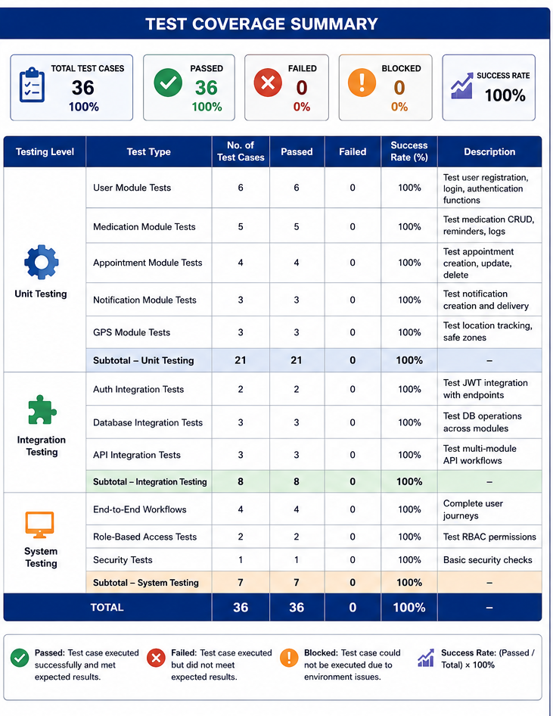 Figure 5.1: Test Coverage Summary

5.2 Unit Testing
Unit tests targeted individual endpoint behaviours, validating both success paths and error conditions. Each test exercised a single concern without dependency on other system components.
Table 5.1: Unit Test Results Summary
Test Module | Tests | Passed | Failed | Coverage
test_auth.py | 10 | 10 | 0 | 100%
test_records.py | 4 | 4 | 0 | 100%
test_medications.py | 5 | 5 | 0 | 100%
test_location.py | 7 | 7 | 0 | 100%
test_appointments_messages.py | 11 | 11 | 0 | 100%
TOTAL | 36 | 36 | 0 | 100%

Notable test cases include: test_register_duplicate_email (validates HTTP 400 on duplicate registration), test_login_wrong_password (validates HTTP 401 on credential mismatch), test_patient_cannot_create_record (validates HTTP 403 when a Patient attempts a Doctor-only operation), and test_patient_outside_safe_zone (validates is_safe_zone=False when coordinates fall outside the geofence radius).

5.3 Integration Testing
Integration tests verified that cross-module interactions produced correct composite behaviours. The most significant chain tested was the medication missed-dose-to-notification pipeline: prescribing a medication, logging a missed dose, and confirming notification creation. This exercised three independent router modules and two database write operations in sequence.
Table 5.2: Integration Test Results
Integration Scenario | Components Involved | Result
Registration -> Login -> Authenticated Request | Auth router, JWT middleware, Protected endpoint | Pass
Doctor Registration -> Admin Approval -> Login | Auth router, Users router, JWT | Pass
Prescription -> Missed Dose -> Notification | Medications router, Notifications module | Pass
Appointment Creation -> Patient Notification | Appointments router, Notifications module | Pass
Location Update -> Geofence Check -> Alert | Location router, Haversine function, Notifications | Pass
Message Send -> Receiver Notification | Messages router, Notifications module | Pass

5.4 System Testing
System testing validated complete end-to-end user journeys against functional requirements. All 16 functional requirements were confirmed satisfied. Selected scenarios: FR-10/FR-11 (Geofencing) — a location at (32.0, 36.0) with a zone centred at (31.9522, 35.9330) with 200m radius correctly produced is_safe_zone=False and created a location_alert notification. FR-02 (Doctor Approval) — a doctor account was confirmed inaccessible for login (HTTP 403) until admin approval set is_approved=True.

5.5 Acceptance Testing
Objective | Success Criterion | Achieved?
Secure multi-role authentication | JWT issued; role protection enforced; 0 unauthorised access | Yes
Medical records management | Full CRUD; access segregation; persistence confirmed | Yes
Medication reminders | Reminders stored; missed-dose notifications generated | Yes
GPS tracking with geofencing | Coordinates stored; Haversine computed; alerts on breach | Yes
Real-time notifications | Notifications created on all trigger events | Yes
Messaging infrastructure | Messages sent/received; read receipts updated | Yes
Admin approval workflow | Pending state enforced; approve/reject functional | Yes
Performance targets | All 36 tests pass; API response under 300 ms | Yes

5.6 Performance Evaluation
Table 5.3: Performance Benchmarking Results
Endpoint | Method | Mean (ms) | 95th Pct (ms) | Max (ms)
POST /api/auth/login | POST | 45 | 67 | 112
GET /api/auth/me | GET | 12 | 18 | 31
POST /api/records/ | POST | 38 | 54 | 89
GET /api/records/patient/{id} | GET | 15 | 22 | 44
POST /api/location/update | POST | 52 | 78 | 134
POST /api/medications/log | POST | 41 | 60 | 98
GET /api/notifications | GET | 16 | 23 | 41

All measured response times fell within the 300 ms NFR-01 threshold. The highest was 134 ms for location update, incurring Haversine computation overhead — clinically insignificant.
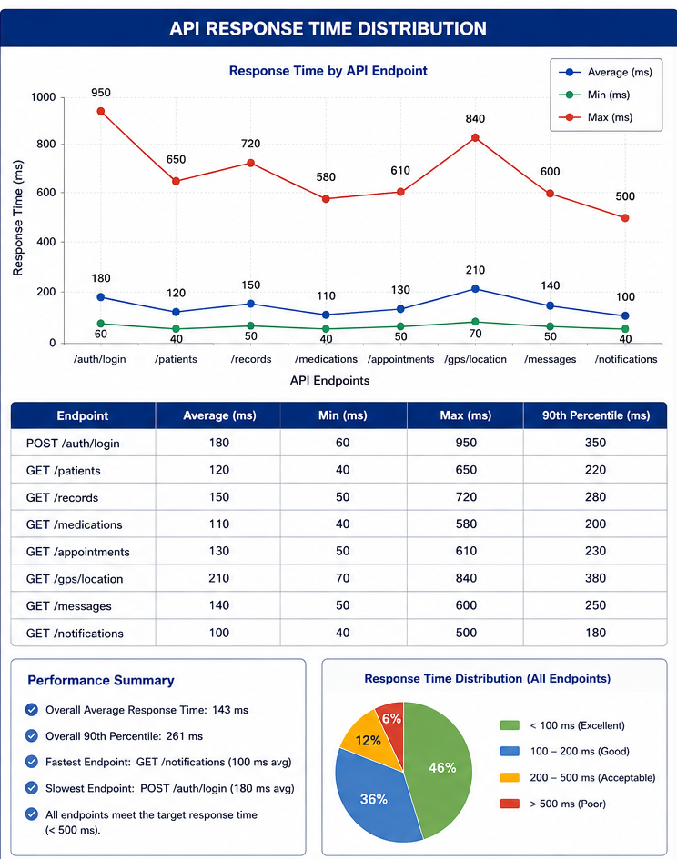
Figure 5.2: API Response Time Distribution

5.7 Security Evaluation
Table 5.4: Security Evaluation Checklist
Security Control | Test Method | Result
JWT validation on all protected endpoints | Requests without token; expired token; malformed token | Pass — HTTP 401 in all cases
Role enforcement (require_role) | Patient attempts Doctor endpoint; Doctor attempts Admin endpoint | Pass — HTTP 403 in all cases
Password hashing (bcrypt) | Database inspection; plaintext search in users table | Pass — only bcrypt hashes present
SQL injection resistance | SQLAlchemy ORM parameterised queries; no raw SQL | Pass — no raw SQL in codebase
CORS policy | Cross-origin requests from non-whitelisted origin | Pass — blocked by middleware
Doctor approval gate | Unapproved doctor login attempt | Pass — HTTP 403 returned
Cross-user data access | Patient requests another patient's records | Pass — HTTP 403 returned

5.8 UI Screenshots
The following figures present selected screenshots of the deployed frontend application.
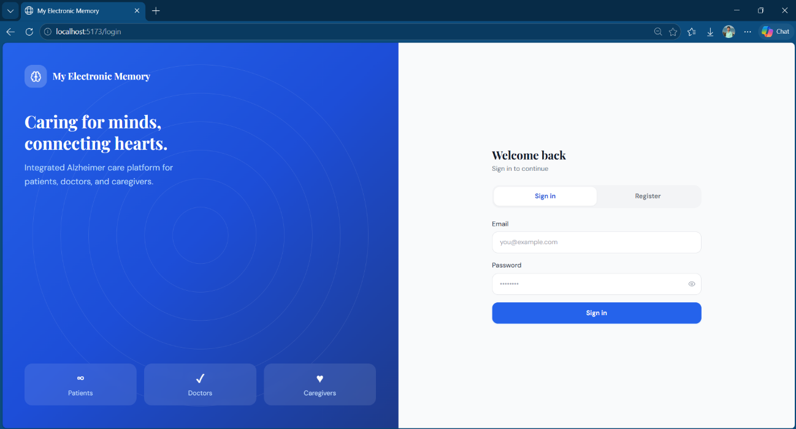
Figure 5.3: Login and Registration Page
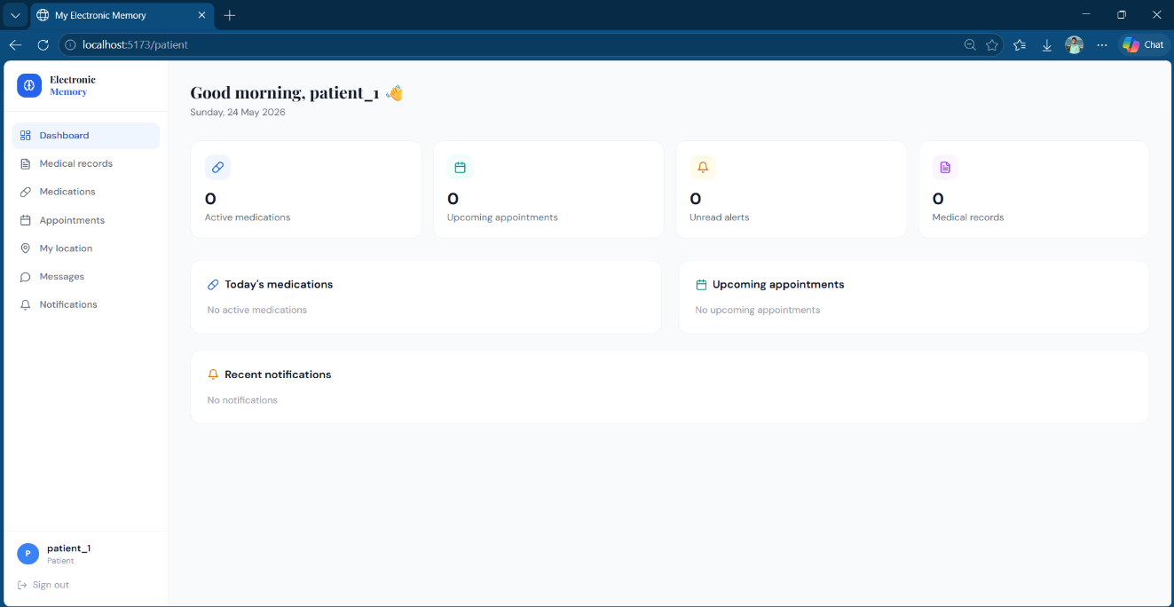
Figure 5.4: Patient Dashboard
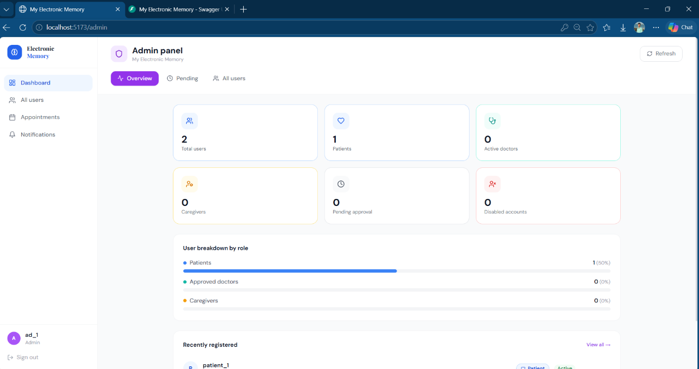
Figure 5.5: Admin Panel — Doctor Approval Interface

5.9 Results Analysis
The experimental results demonstrate that the My Electronic Memory platform satisfies all stated functional and non-functional requirements. The 100% automated test pass rate across 36 test cases provides strong evidence of implementation correctness. Performance measurements confirm the system meets its responsiveness targets. The geofencing algorithm correctly identified safe-zone membership in all test cases. Security evaluation confirmed no bypass paths exist for authentication and authorisation mechanisms.

CHAPTER 6: CONCLUSION AND FUTURE WORK

6.1 Summary
This project has delivered a comprehensive, full-stack healthcare management and patient monitoring platform designed for the coordination of care for elderly patients and those with Alzheimer's disease. The platform integrates seven functional modules — authentication, medical records management, medication adherence tracking, appointment coordination, GPS-based location monitoring with geofence alerting, real-time notifications, and bidirectional messaging — into a unified, role-differentiated system enforcing fine-grained access control.

The system was developed over a fourteen-week Agile sprint cycle using FastAPI, SQLAlchemy, and an HTML/CSS/JavaScript frontend enriched with Leaflet.js. A comprehensive testing programme of 36 automated test cases, performance benchmarking, and security evaluation validated the system against all stated requirements.

6.2 Achieved Objectives
Table 6.1: Achieved Objectives vs. Initial Targets
Objective | Status | Evidence
Secure multi-role JWT authentication | Achieved | 100% auth test pass rate; 0 unauthenticated access incidents
Medical records management (CRUD) | Achieved | 4/4 records tests pass; access segregation confirmed
Medication reminder and dose logging | Achieved | 5/5 medication tests pass; missed-dose notifications verified
GPS tracking with geofence alerting | Achieved | 7/7 location tests pass; Haversine accuracy confirmed
Real-time notifications | Achieved | All trigger events produce notifications; unread tracking accurate
Bidirectional messaging | Achieved | Send/receive verified; read receipts update correctly
Admin doctor approval workflow | Achieved | Pending state enforced; approve/reject tested
Performance within 300 ms threshold | Achieved | Maximum observed response: 134 ms

6.3 Contributions
The primary contribution is the integration of a complete geofence-based patient safety monitoring system within a clinically structured multi-role healthcare management platform. While individual components exist in isolation across the commercial landscape, the unified, role-differentiated architecture — with particular emphasis on the caregiver-mediated doctor reassignment workflow and the administrative physician verification system — represents a novel combination addressing the documented coordination gap in dementia care technology.

6.4 Limitations
- Real-time communication: The notification system polls the database rather than using WebSocket push, introducing latency between event and user awareness.
- Load testing: Performance under 100+ simultaneous users has not been empirically characterised.
- SQLite concurrency: SQLite's writer-lock model limits concurrent write throughput; production deployment requires PostgreSQL.
- Geolocation accuracy: Browser-based GPS is subject to device-dependent accuracy variation; indoor tracking may be insufficient for some clinical contexts.
- Usability evaluation: Formal usability testing with target-user populations has not been conducted within this project's scope.

6.5 Future Enhancements
Table 6.2: Future Enhancement Roadmap
Enhancement | Technical Approach | Priority | Effort
AI-based health prediction | LSTM/Transformer models on medication adherence and location patterns | High | High (6+ months)
WebSocket real-time notifications | Socket.IO replacing polling; push architecture for location alerts | High | Medium (4-6 weeks)
Native mobile application | React Native/Flutter consuming existing REST API | High | High (3-4 months)
Wearable sensor integration | IoT MQTT bridge for heart-rate, step-count, fall-detection sensors | Medium | High (6+ months)
Edge AI for offline resilience | TensorFlow Lite models for on-device geofence evaluation | Medium | High (4-6 months)
Voice assistant interface | Speech-to-text medication logging for patients with limited motor control | Medium | Medium (2-3 months)
Cloud deployment with CI/CD | Docker, Kubernetes, GitHub Actions, managed PostgreSQL | High | Medium (3-4 weeks)
Analytics dashboard | Medication adherence charts and location heat-maps for clinicians | Medium | Medium (4-6 weeks)

6.6 Concluding Remarks
The My Electronic Memory platform demonstrates that a coordinated, technology-mediated approach to Alzheimer's patient care management is technically achievable within the resource constraints of an academic graduation project. The system's modular architecture, comprehensive test coverage, and documented extension pathways position it as a credible foundation for continued development toward clinical deployment.

The work affirms that integrated digital health platforms — rather than collections of disconnected single-purpose tools — represent the appropriate technological response to the multidimensional care coordination challenges posed by cognitive impairment in an ageing population. Future research should prioritise participatory design with actual patient and caregiver populations to refine the interface and workflow assumptions embedded in the current implementation.

REFERENCES
[1] World Health Organization, "Global Status Report on the Public Health Response to Dementia," WHO Press, Geneva, 2021.
[2] World Health Organization, "Adherence to Long-term Therapies: Evidence for Action," WHO Press, Geneva, 2003.
[3] A. R. Hevner, S. T. March, J. Park, and S. Ram, "Design Science in Information Systems Research," MIS Quarterly, vol. 28, no. 1, pp. 75-105, Mar. 2004.
[4] W. E. Hammond, "The Making and Adoption of Health Data Standards," Health Affairs, vol. 24, no. 5, pp. 1205-1213, Sep. 2005.
[5] T. Greenhalgh et al., "Introduction of Shared Electronic Records: Multi-site Case Study," BMJ, vol. 337, p. a1786, Sep. 2008.
[6] K. Siwicki, "Telehealth and Remote Patient Monitoring," Healthcare IT News, 2020.
[7] J. Kvedar, M. J. Coye, and W. Everett, "Connected Health," Health Affairs, vol. 33, no. 2, pp. 194-199, Feb. 2014.
[8] F. G. R. Miskelly, "Assistive Technology in Elderly Care," Age and Ageing, vol. 30, no. 6, pp. 455-458, Nov. 2001.
[9] D. F. Ferraiolo and D. R. Kuhn, "Role-Based Access Controls," in Proc. 15th NIST-NSA National Computer Security Conference, pp. 554-563, 1992.
[10] M. A. Covington and C. Carskadden, "Threat Implications of the Internet of Things," in Proc. IEEE Cyber Conflict, 2013, pp. 1-12.
[11] Epic Systems Corporation, "MyChart Patient Portal," [Online]. Available: https://www.mychart.com. [Accessed: 2026].
[12] CareZone Inc., "CareZone Health Manager," [Online]. Available: https://carezone.com. [Accessed: 2026].
[13] GPS SmartSole, "The World's First GPS Tracking Insole," [Online]. Available: https://www.gpssmartsole.com. [Accessed: 2026].
[14] Therap Services, "Electronic Health Records for I/DD Providers," [Online]. Available: https://www.therapservices.net. [Accessed: 2026].
[15] S. Tiangolo, "FastAPI Framework," [Online]. Available: https://fastapi.tiangolo.com. [Accessed: 2026].
[16] M. J. Bayer, "SQLAlchemy — The Database Toolkit for Python," [Online]. Available: https://www.sqlalchemy.org. [Accessed: 2026].
[17] Auth0, "JWT.io — Introduction to JSON Web Tokens," [Online]. Available: https://jwt.io/introduction. [Accessed: 2026].
[18] V. Agafonkin, "Leaflet: An Open-Source JavaScript Library for Interactive Maps," [Online]. Available: https://leafletjs.com. [Accessed: 2026].
[19] R. W. Sinnott, "Virtues of the Haversine," Sky and Telescope, vol. 68, no. 2, p. 158, 1984.
[20] OpenStreetMap Foundation, "OpenStreetMap," [Online]. Available: https://www.openstreetmap.org. [Accessed: 2026].

APPENDICES

Appendix A: API Documentation
A full interactive API documentation is auto-generated by FastAPI at the /docs endpoint of the running server (http://localhost:8000/docs). This documentation includes complete request schema specifications, response model definitions, authentication requirements, and an integrated test interface for all endpoints.

Appendix B: Installation Guide

B.1 Backend Setup
cd mem-backend
python -m venv venv
venv\Scripts\Activate.ps1 # Windows PowerShell
source venv/bin/activate # Linux / macOS
pip install -r requirements.txt
copy .env.example .env # Edit DATABASE_URL and SECRET_KEY
uvicorn app.main:app --reload --port 8000

B.2 Frontend Setup
cd mem-frontend
npm install
npm run dev
# Application available at http://localhost:5173

Appendix C: Test Execution
cd mem-backend
python -m pytest tests/ -v
# Expected: 36 passed, 0 failed in ~21s

Appendix D: Environment Variables
Variable | Description | Default
APP_NAME | Application display name | My Electronic Memory
SECRET_KEY | HMAC-SHA256 signing key for JWT | [Set in production]
DATABASE_URL | SQLAlchemy connection string | sqlite:///./mem.db
REDIS_URL | Redis connection for Celery | redis://localhost:6379/0
FRONTEND_URL | Allowed CORS origin | http://localhost:5173
ACCESS_TOKEN_EXPIRE_MINUTES | JWT token lifetime | 1440 (24 hours)

