# Barcode

Encoding:

|  |  |  |  |
| --- | --- | --- | --- |
| Number | L | M | R |
| 0 | 1 | 1 | 1 |
| 1 | 1 | 1 | 0 |
| 2 | 0 | 1 | 1 |
| 3 | 1 | 0 | 1 |

Must end with black

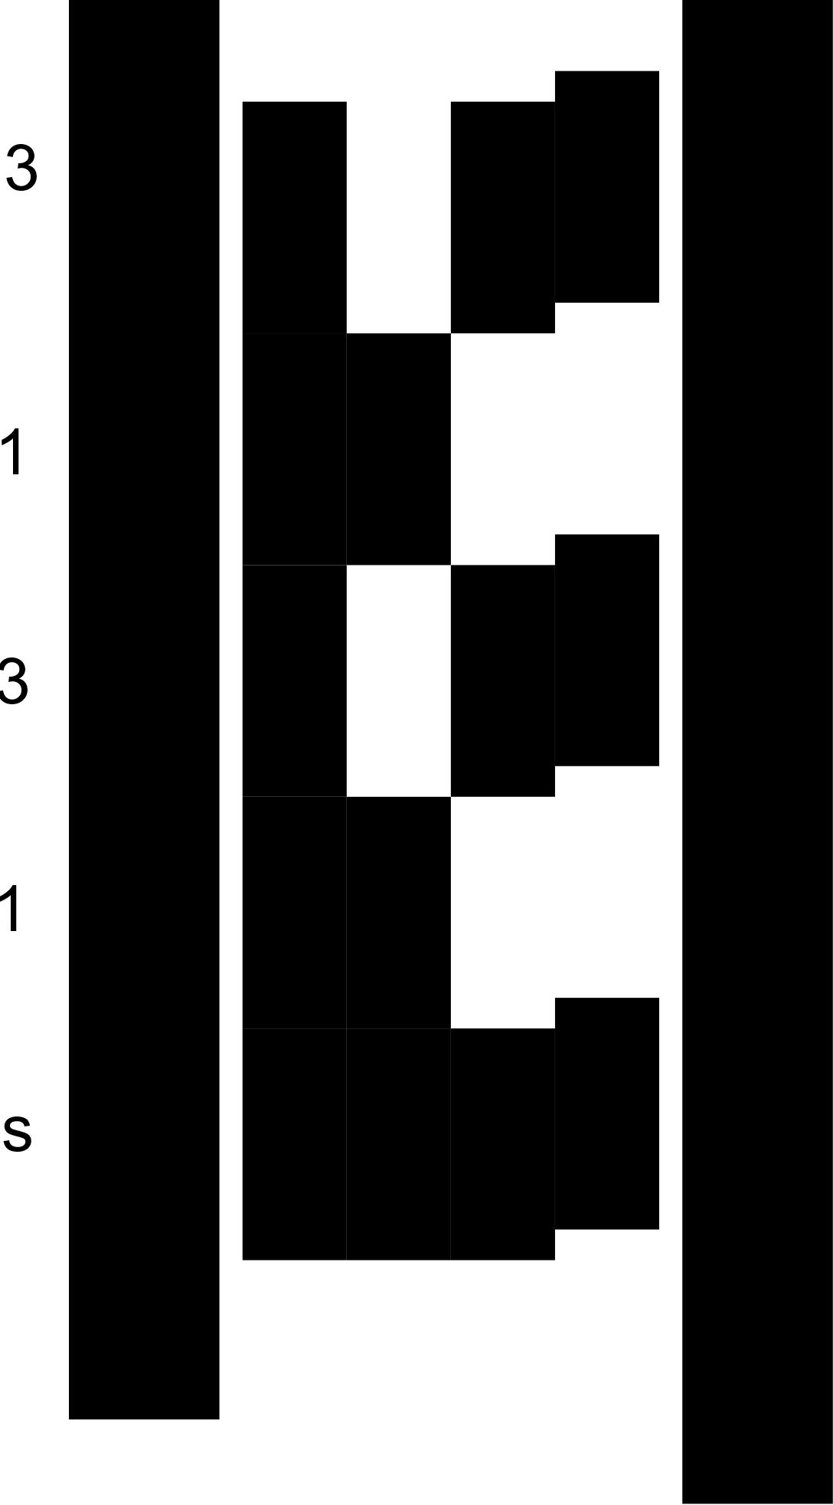2 mm

13 mm

Offset by X mm

Begins with pure black

# 

Min. 24,5mm

Min. 24,5mm

66mm

# Line Data

Width of a Line: 13mm

# Bot

Width of an ActivityBot: 115mm

# Two Lanes

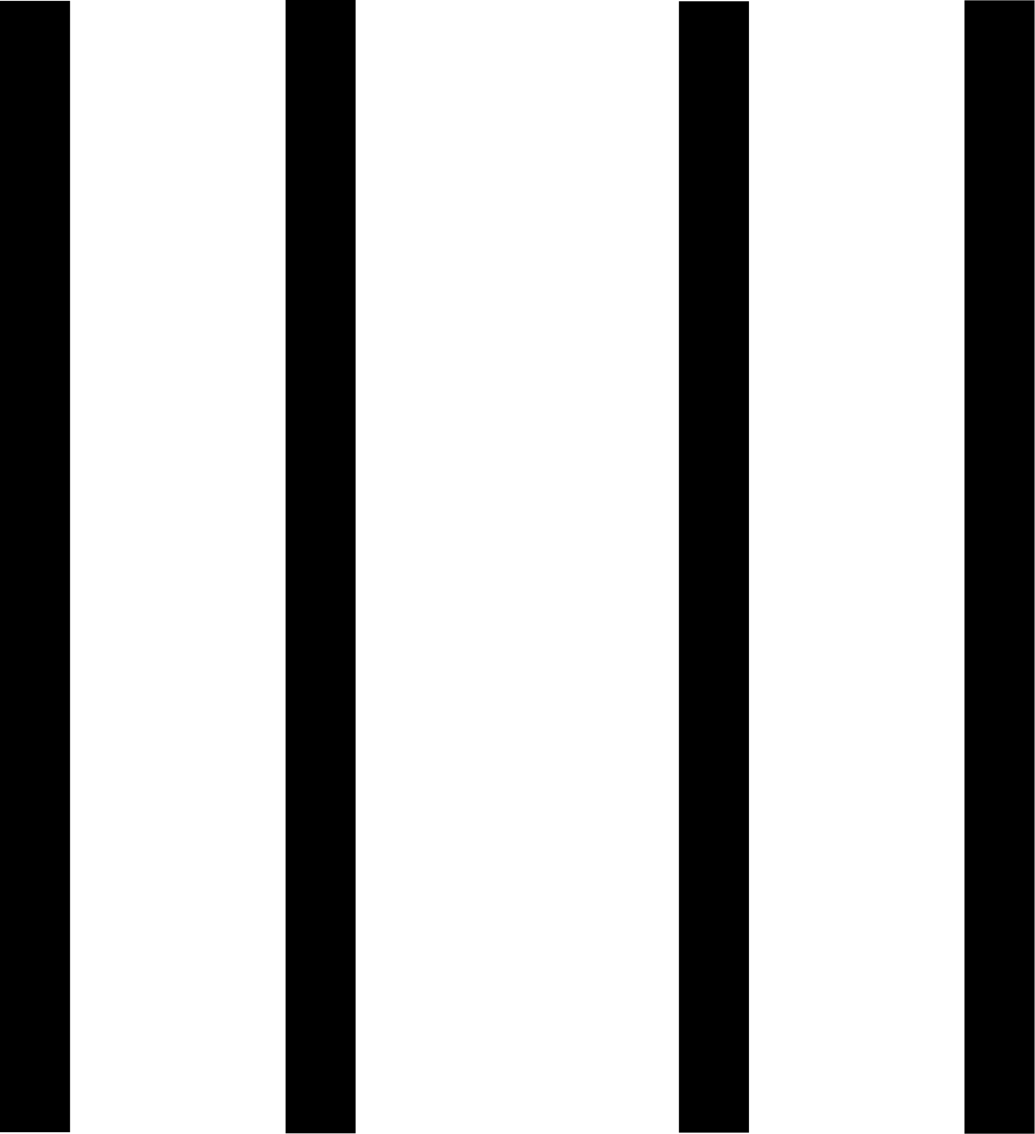

11mm between Bots

9mm 66mm 30mm 30mm 66mm 9mm