SQL – DAY1 TASK

# 1. SQL Lesson 1: SQL Select queries

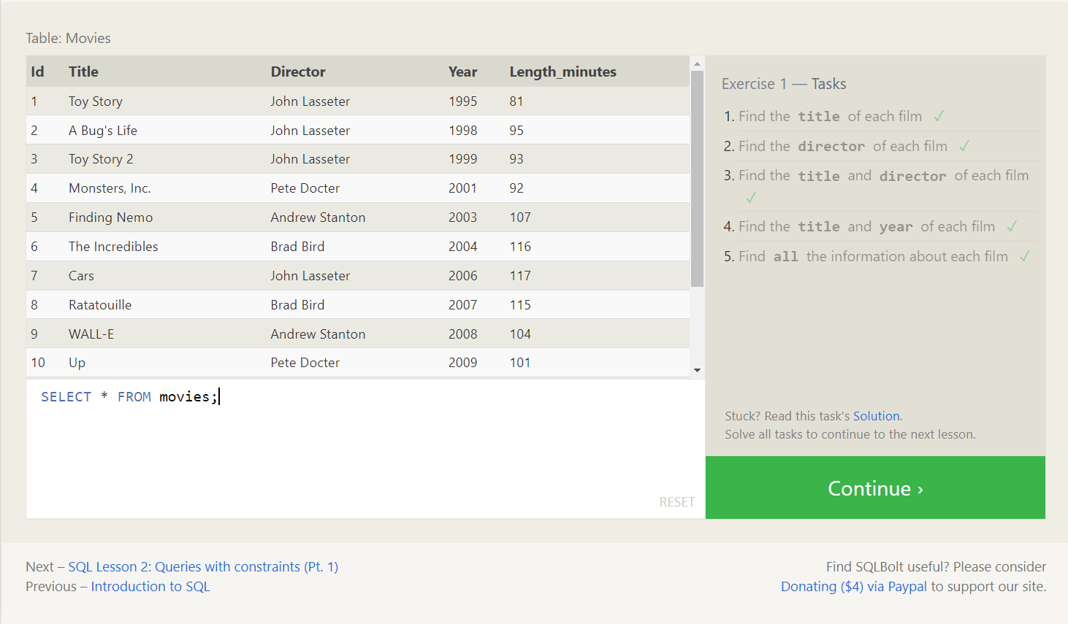

# 2. SQL Lesson 4: Queries with Constraints – pt.1

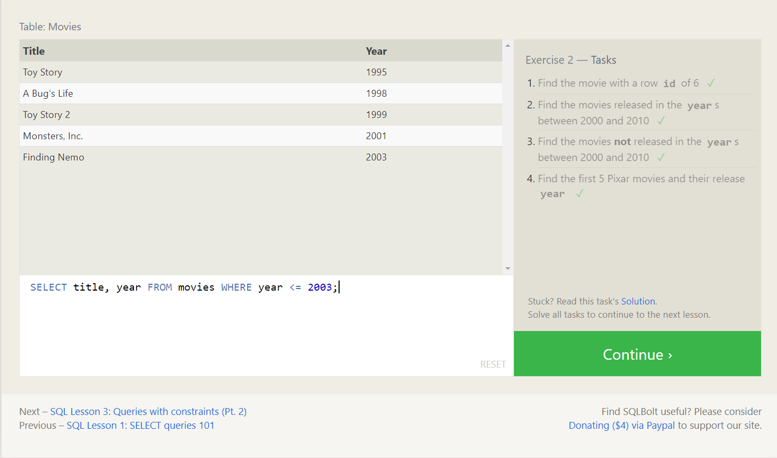

# 3. SQL Lesson 3: Queries with constraints (Pt. 2)

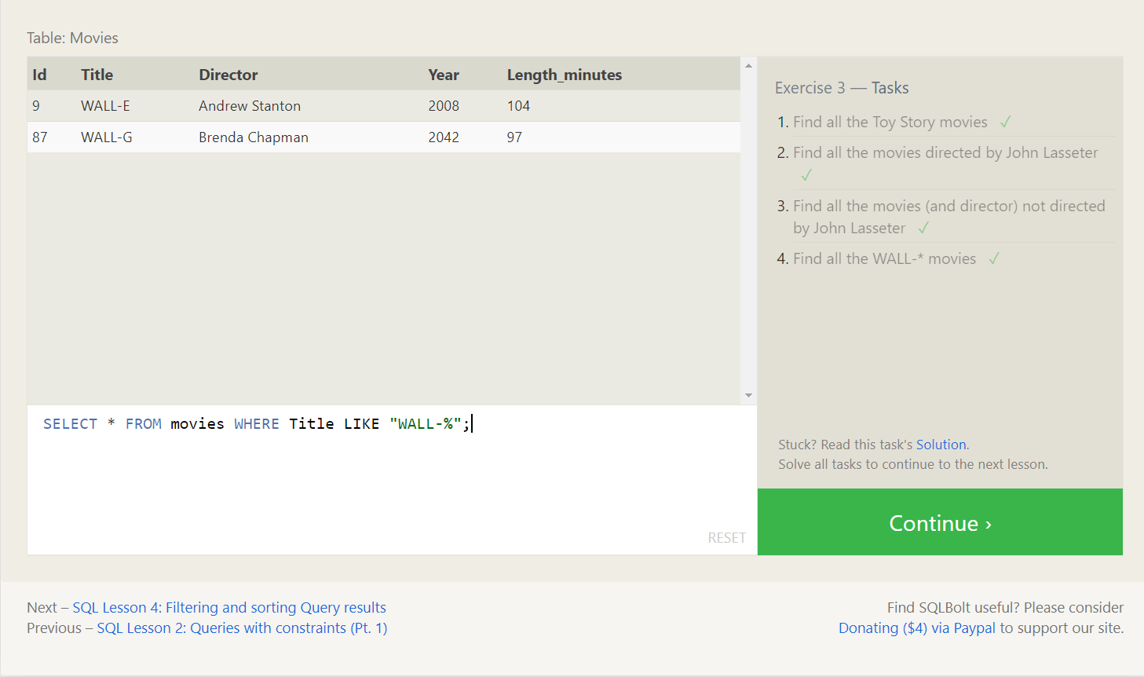

# 4. SQL Lesson 4: Filtering and sorting Query results

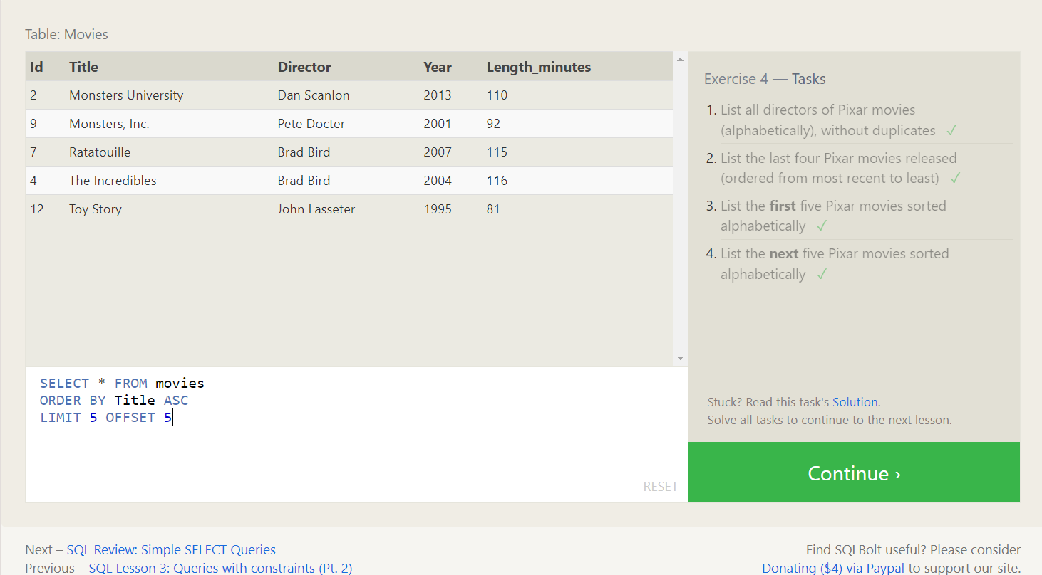

# 5. SQL Review: Simple SELECT Queries

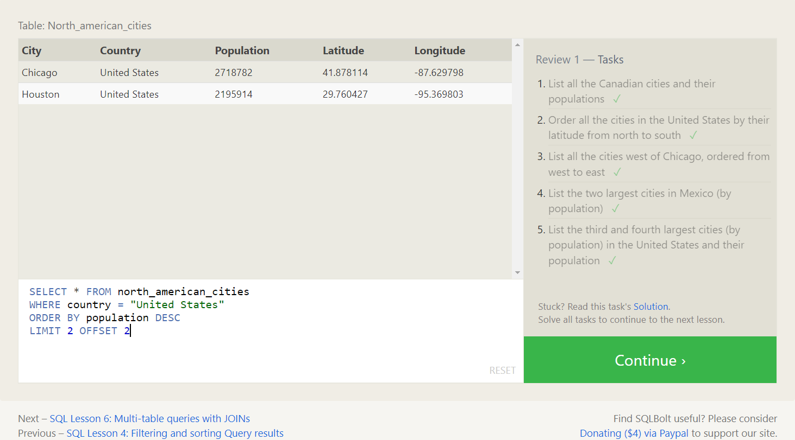

# 6. SQL Lesson 6: Multi-table queries with JOINs

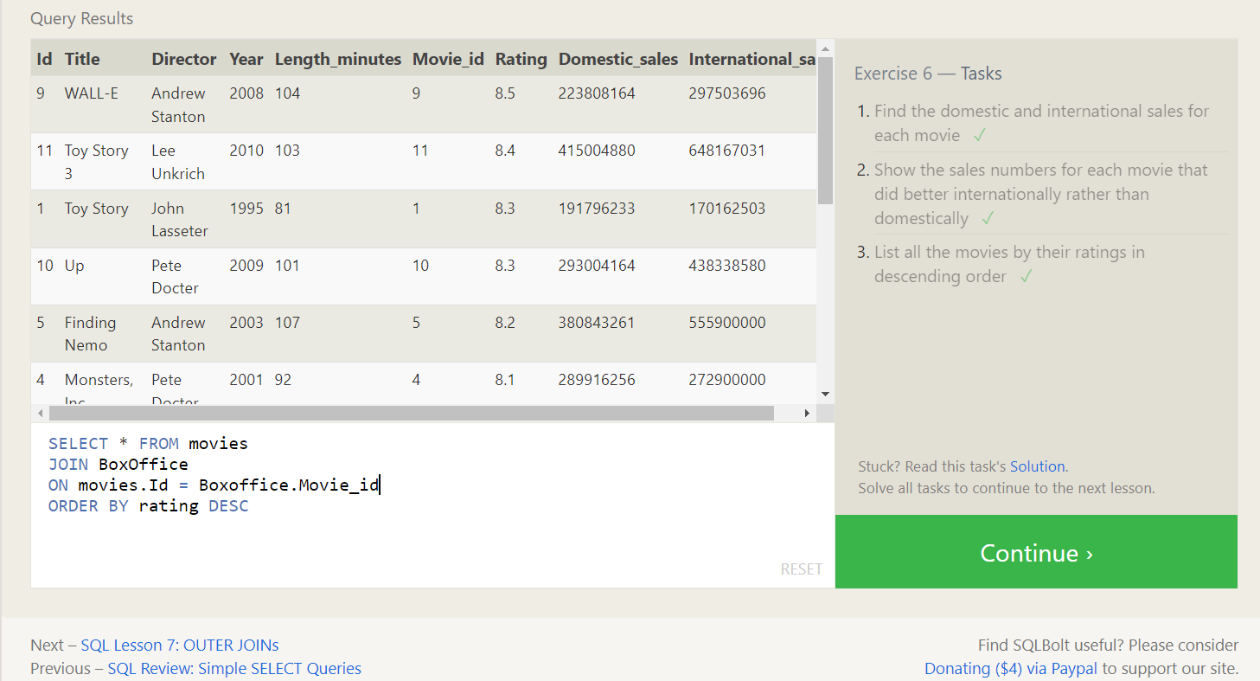

# 7. SQL Lesson 7: OUTER JOINs

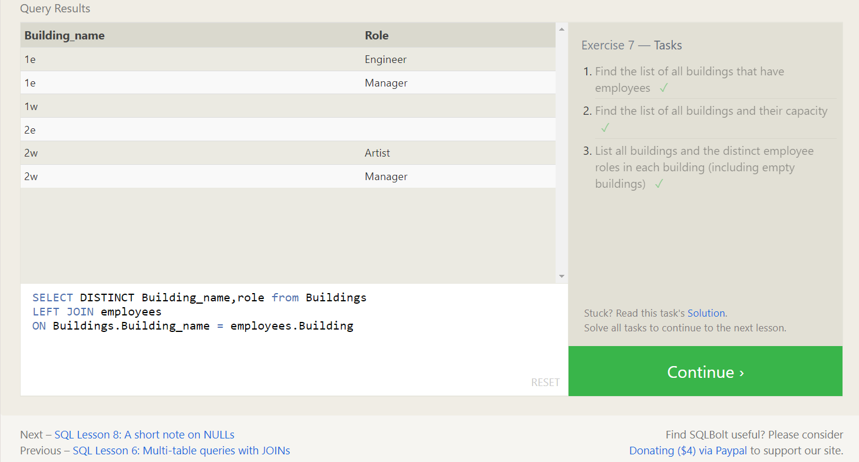

# 8. SQL Lesson 8: A short note on NULLs

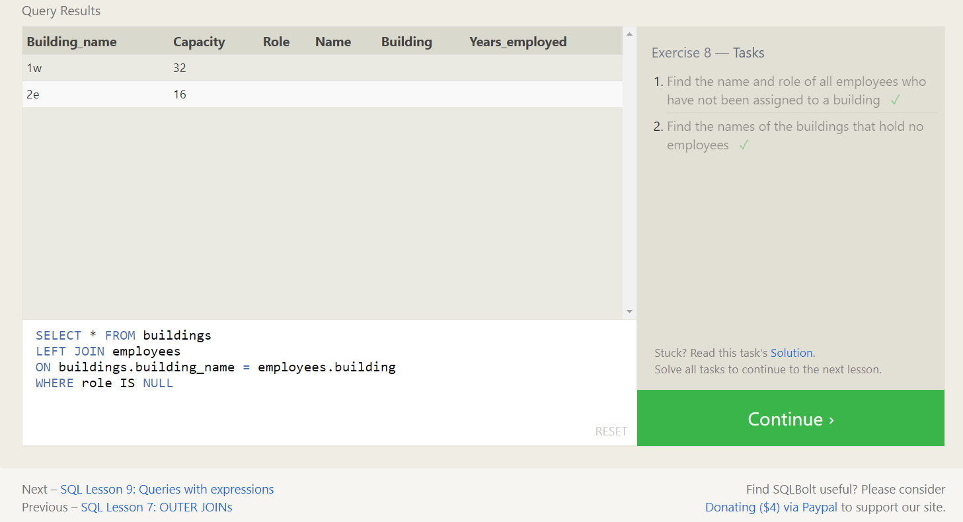

# 9. SQL Lesson 9: Queries with expressions

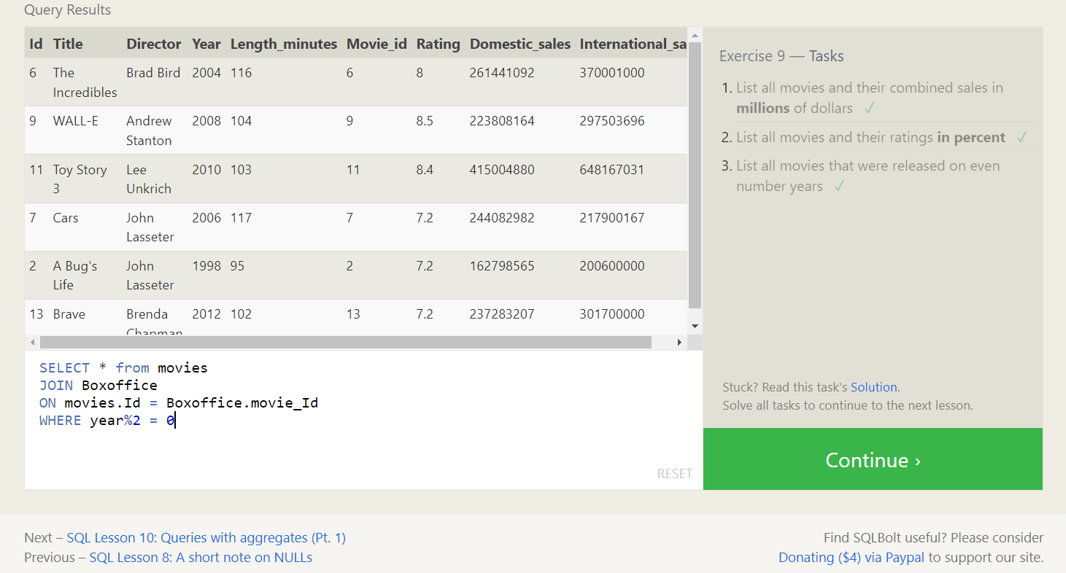

# 10. SQL Lesson 10: Queries with aggregates (Pt. 1)

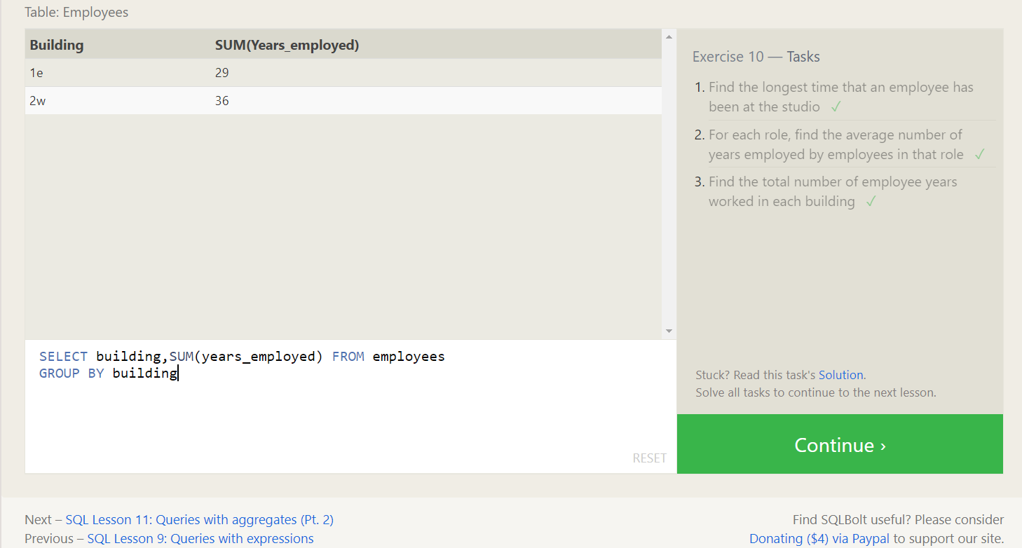

# 11. SQL Lesson 11: Queries with aggregates (Pt. 2)

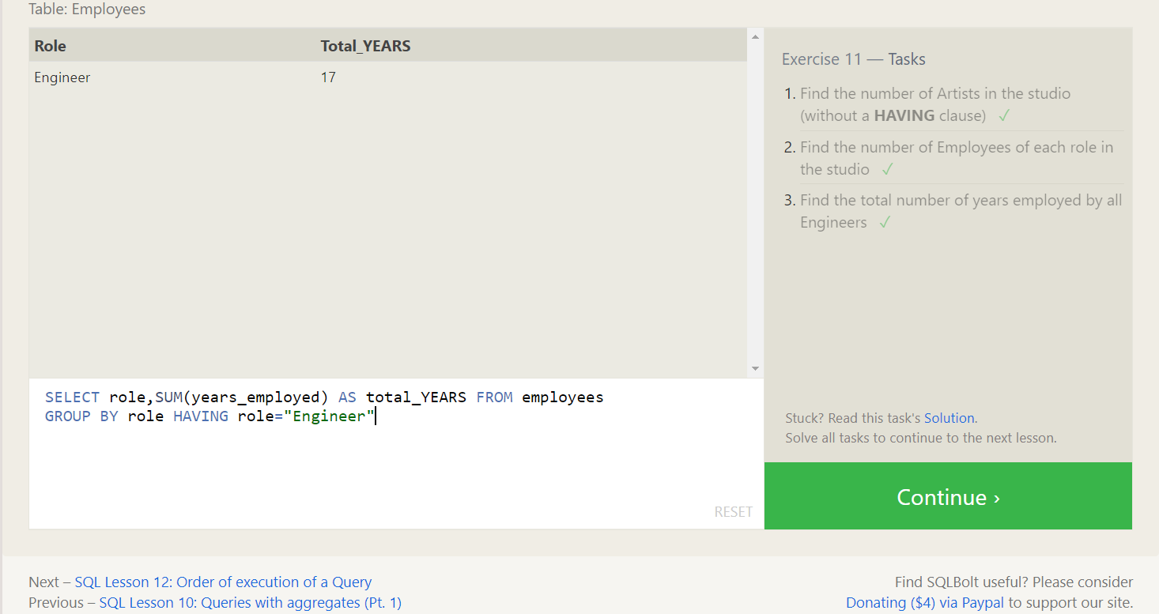

# 12. SQL Lesson 12: Order of execution of a Query

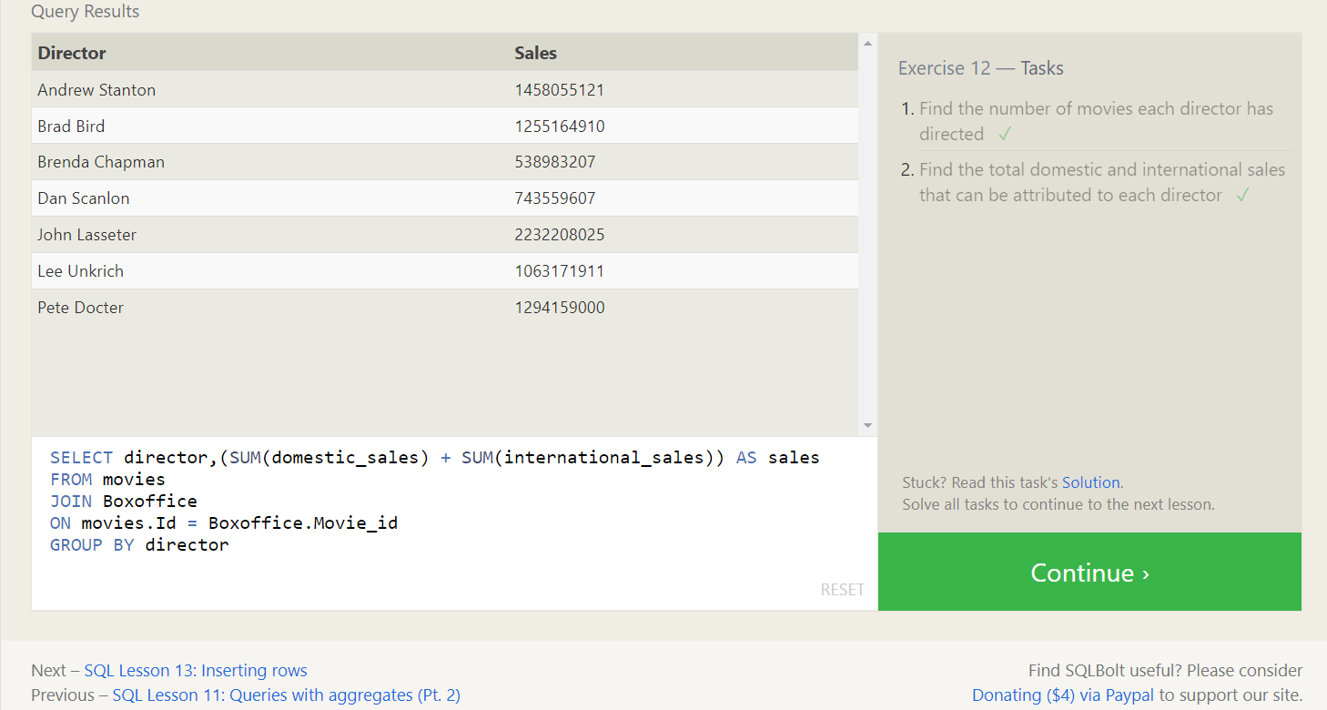

# 13. SQL Lesson 13: Inserting rows

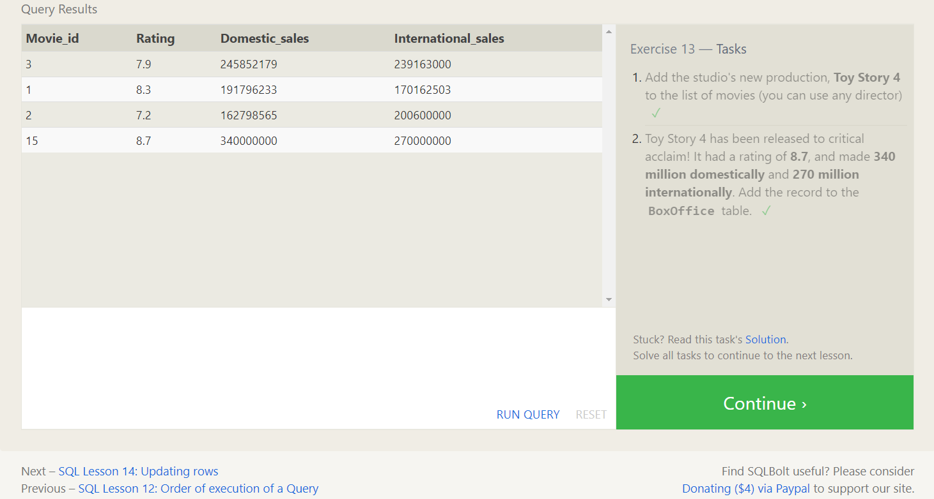

# 14. SQL Lesson 14: Updating rows

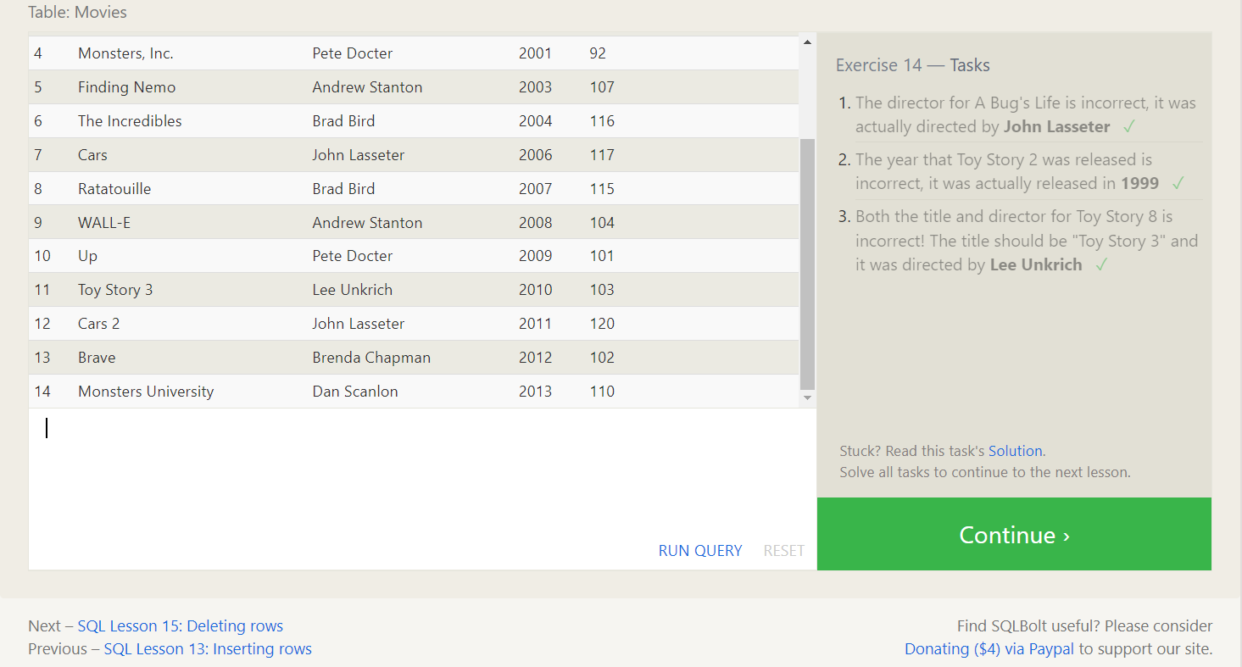

# 15. SQL Lesson 15: Deleting rows

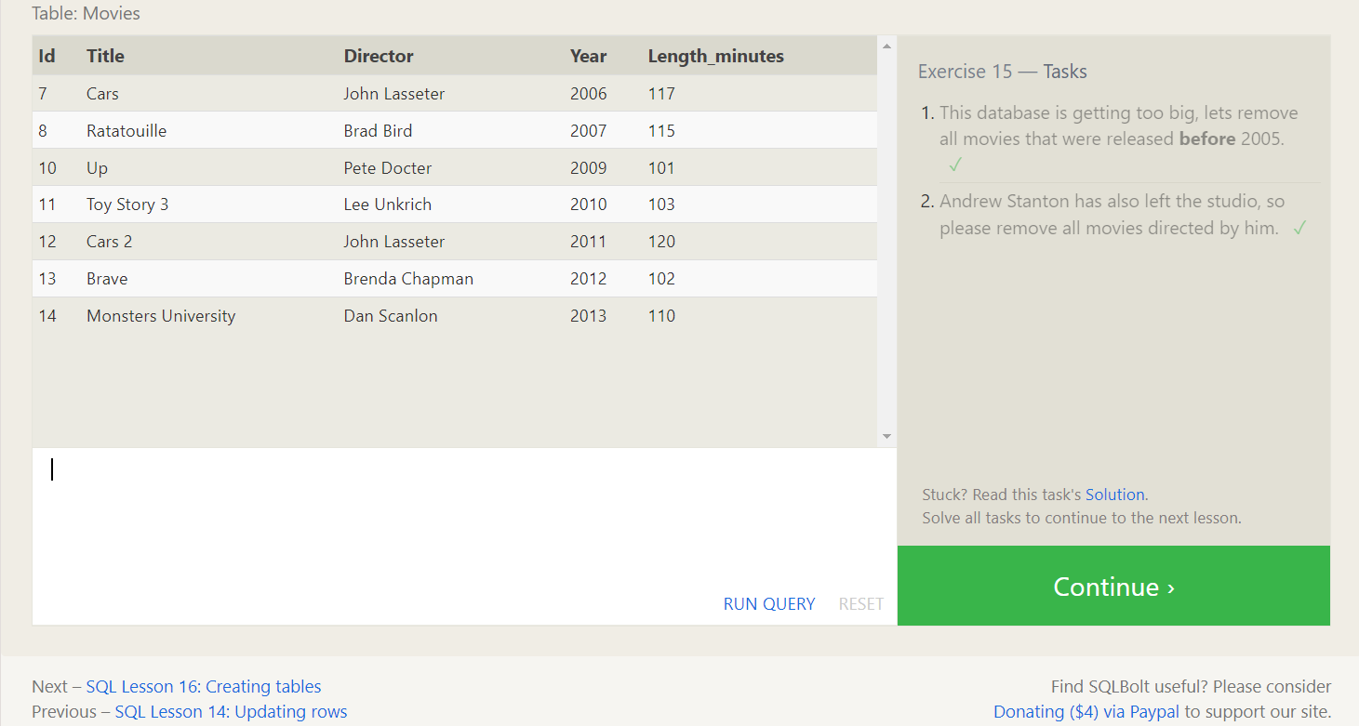

# 16. SQL Lesson 16: Creating tables

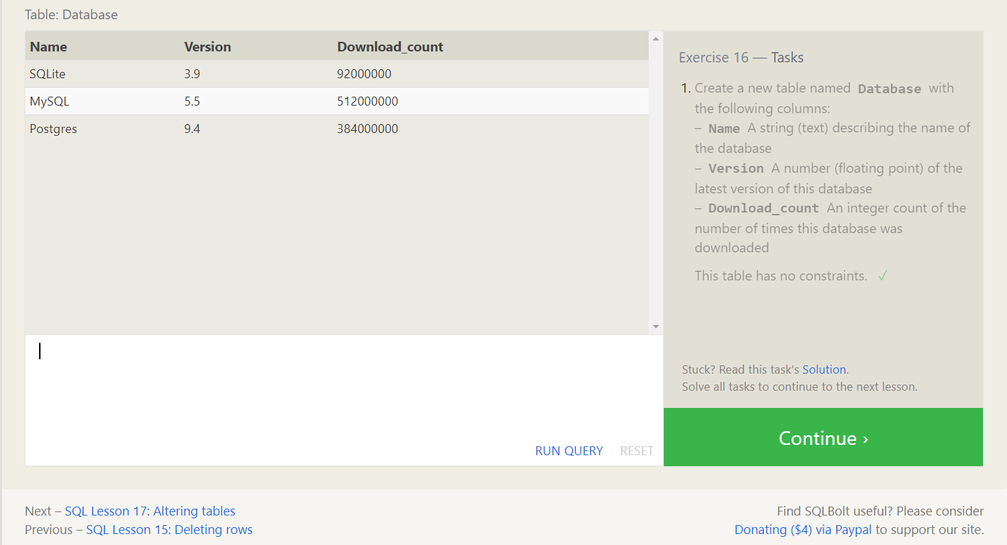

# 17. SQL Lesson 17: Altering tables

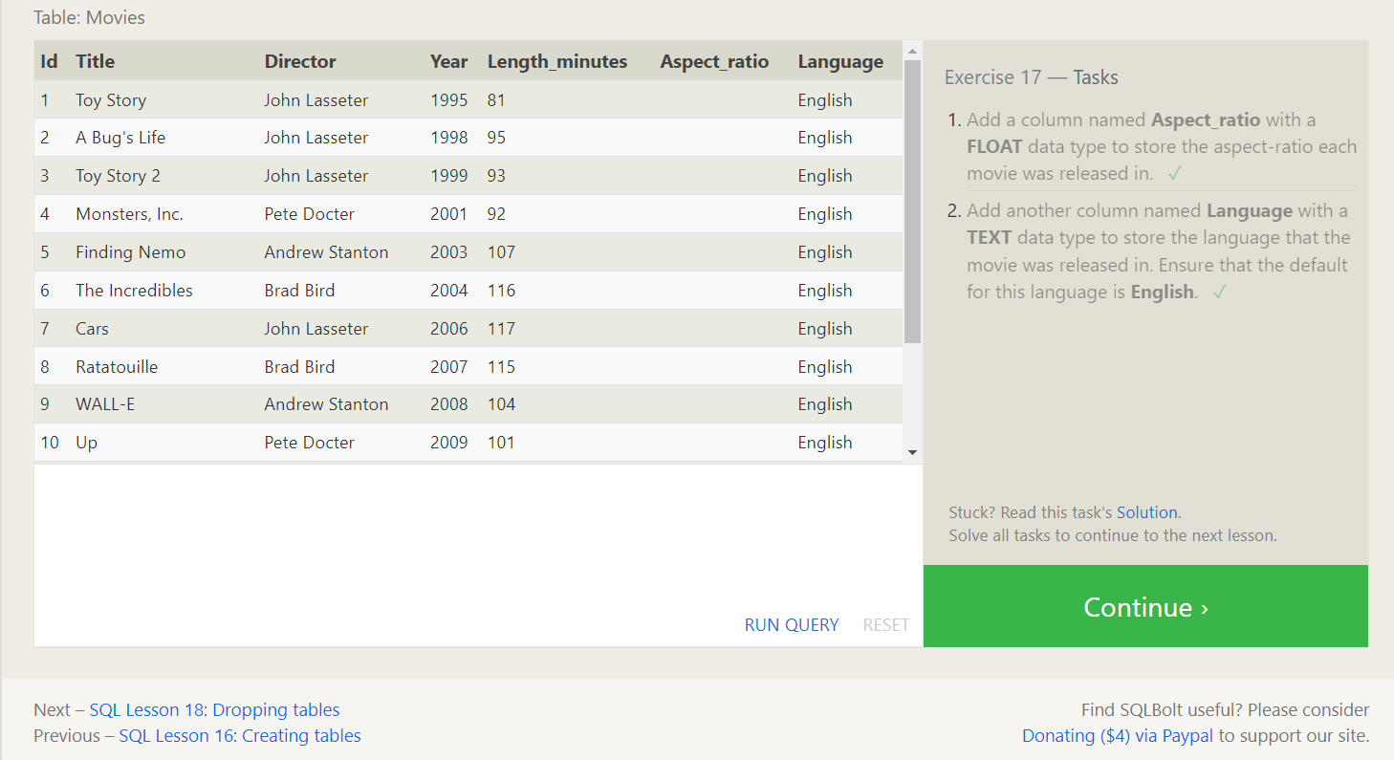

# 18. SQL Lesson 18: Dropping tables

