ICS 340 Programming Project, Deliverable D (100 pts)
Specification:
Start with your Java program “prog340” which implements Deliverables A and B and C (although you really don’t need to successfully implement previous deliverables to do this program, but Deliverable A should still work!).
Recall the definition of the Traveling Salesperson Problem (the TSP): Given a set of cities, you want to find the shortest route that visits every city and ends up back at the original starting city. For the purposes of this problem, every city will be directly reachable from every other city (think flying from city to city).
Your goal is to solve the TSP by creating the optimal (shortest total distance) bitonic tour. A bitonic tour is a TSP tour that starts at the southernmost city, goes north to the northernmost city (stopping zero or more times along the way, with every stop being north of the previous one), then goes back to the southernmost city, stopping at every remaining city, from north to south. There are a variety of bitonic tour specifications, I choose to use this one from stackexchange. It has a nice description that lends itself to outputting specified intermediate results. The description in this assignment is a close paraphrasing of the description.
Note that I will also use the term bitonic path. A bitonic path is a path from a northernmost city that visits a set of other cities that goes strictly south through zero or more of the cities to the southernmost city, then goes strictly north through the remaining cities, but does not return to the starting (northernmost) city.
Revision
There was an error in the equations. This does mess things up a bit. The corrected equations are highlighted in yellow. Because I wrote them with an equation tool, I can’t highlight only the part that is wrong.
In the formula for z(k), d(c_{n},c_{k}) should have been d(c_{n},c_{k-1}).
In the formula for z(p), d(c_{n},c_{k}) should have been d(c_{n},c_{i-1}).
The Input Files
The input files will look very similar to the input files for Deliverable C. The only difference is that the Labels (Values) of the Nodes have real meaning here. The Label of any node (city) will be a floating point number indicating its latitude, in degrees.minutes format. This way you can sort the Nodes by latitude as part of the algorithm. For instance, here is the file for the 5-city problem (D5.txt). The Labels (“Val”) are non-negative floating point numbers. The input files are symmetrical; the distance from city A to city B always is the same as the distance from city B to city A.
~ Val C H K M P
Cleveland 41.28 ~ 1114 700 630 360
Houston 29.45 1114 ~ 644 1056 1341
KansasCity 39.05 700 644 ~ 413 1039
Minneapolis 44.58 630 1056 413 ~ 985
Philadelphia 39.57 360 1341 1039 985 ~
The Algorithm
Denote the cities c₁, c₂, …, c_{n} from south to north. This is a dynamic programming algorithm, so it’s really a recursive algorithm with optimal substructure and overlapping subproblems. But what are these subproblems? Note there will be two optimal bitonic tours which are mirror images of each other (e.g., the tour Houston → Kansas City → Minneapolis → Cleveland → Philadelphia → Houston is the same as the tour Houston → Philadelphia → Cleveland → Minneapolis → Kansas City → Houston for our purposes.)
We know that somewhere during this tour the next-to-northernmost city, c_{n-1} will be visited. It must be visited either just before, or just after, the northernmost city. Thus the edge (c_{n-1}, c_{n}) [either c_{n-1} → c_{n} or c_{n} → c_{n-1}] will be in the tour. So the optimal bitonic tour contains within it the optimal bitonic path starting at c_{n}, going south to c₁ while visiting some cities along the way and then going from c₁ north to c_{n-1} and stopping at every unvisited city on the way back.
Any such bitonic path from c_{n} to c_{n-1} must first visit some city c_{k}, k < n-1, which could be c₁. That is, edge (c_{n}, c_{k}) is in the optimal bitonic path/tour for some city c_{k}.
This is a bitonic path – it goes north to south then back north – so if k ≠ n-2, every city north of c_{k} must be visited on the northbound return trip. So the bitonic path from c_{n} to c_{n-1} must end with c_{k+1}, c_{k+2,} …, c_{n-1}. (Note if k = n-2, this path is empty.) So the bitonic path from c_{n} to c_{n-1}, for some k, must look like:
C_{n} → c_{k} → … 0 or more cities going south … → c₁ → … 0 or more cities going north … → c_{k+1} → c_{k+2} → … → c_{n-1}.
So c_{k} → … 0 or more cities going south … → c₁ → … 0 or more cities going north … → c_{k+1} is itself a bitonic path, and the bitonic path (and hence bitonic tour) will contain the optimal bitonic path from c_{k} → c_{k+1}. This shows optimal substructure and overlapping subproblems.
So, to recap, we want to find the shortest total distance bitonic tour from the southernmost city c₁ back to itself, going first north to the northernmost city (c_{n}) then back south. To do this, we argued that we need to find the shortest bitonic path from the northernmost city c_{n} down to the southernmost city c₁ then back up to the next-to-northernmost city c_{n-1}. And to do this, for some city c_{k}, we need to find the shortest bitonic path from city c_{k} to city c_{k+1}, or equivalently from city c_{k+1} to city c_{k}.
For any i > 1, let z(i) denote the length of the shortest-distance bitonic path from c_{i} to c_{i-1}. Let d(c_{i}, c_{j}) denote the length of the edge from city c_{i} to city c_{j}. So, there must be some city c_{k} that gives us the shortest bitonic path, and for this k < n-1, the shortest bitonic path is
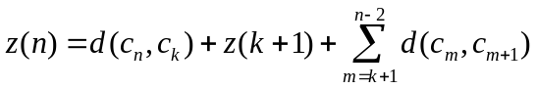 . The shortest bitonic path overall is the shortest of these:
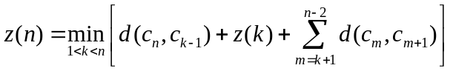. The same reasoning applies for all p < n, so:
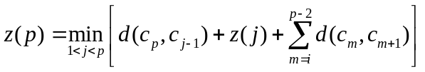, for all p.
Note that z(2) = d(c₂, c₁). We can use this recursion to successively calculate z(p) for p = 3, .., n, and then the length of the bitonic tour starting at southernmost city c_{n} = z(n) + d(c_{n-1}, c_{n}).
The Assignment
For each input file, for each value of p, print the value of z(p) and the bitonic path from c_{p} to c₁.
Example: D7.txt
Here’s the file, augmented with a city number, and a map of the cities and distances that might be helpful.
~ Val C D d N L P W
c5 Chicago 41.50 ~ 967 1004 473 296 398 863
c1 Dallas 32.26 967 ~ 794 663 631 944 1297
c4 Denver 39.45 1004 794 ~ 1158 850 924 1097
c2 Nashville 36.10 473 663 1158 ~ 309 875 1338
c3 StLouis 38.37 296 631 850 309 ~ 557 1013
c6 StPaul 44.56 398 944 924 875 557 ~ 458
c7 Winnipeg 49.53 863 1297 1097 1338 1013 458 ~
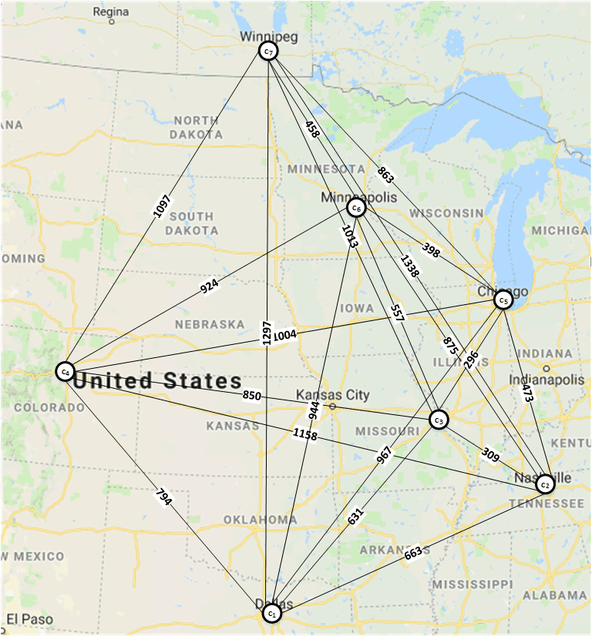
Calculation of z-values
z(2): It is immediate that z(2) = d(Nashville,Dallas) = 663. So the shortest bitonic path is c₁ (Dallas) ←→ c₂ (Nashville). It’s trivially a bitonic path.

z(3) contains the 3 southernmost cities. It is the shortest bitonic path from c₃ south to c₁ then north to c₂. There’s only one way to do this (if mirror images are identical): c₃ (St. Louis) ←→ c₁ (Dallas) ←→ c₂ (Nashville). So z(3) = 631 + 663 = 1294. In equations, p = 3, so the only legal j with 1<j<p is j = 2.
z(3) = d(c₃,c₁) + z(2) = 631 + 663 = 1293. Note p-2 < j, so the final summation is never done.

z(4) contains the 4 southernmost cities. It is the shortest bitonic path from c₄ south to c₁ then north to c₃. In equations, j = 2 or 3, so
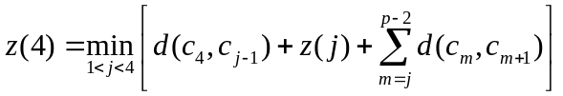= min of:
(j=2): d(c₄,c₁) + z(2) + d(c₂,c₃) = 794 + 663 + 309 = 1766
(j=3): d(c₄,c₂) + z(3) = 1158 + 1293 = 2451 (final summation never done, j > p-2)
So z(4) =1766. To find the shortest bitonic path, note that it starts c₄ ←→ c₁, ends c₂ ←→ c₃, and has z(2) in the middle. So the shortest bitonic path is: c₄ (Denver) ←→ c₁ (Dallas) ←→ c₂ (Nashville) ←→ c₃ (St. Louis).

z(5) contains the 5 southernmost cities. It is the shortest bitonic path from c₅ south to c₁ then north to c₄. In equations, j = 2, 3, or 4, so
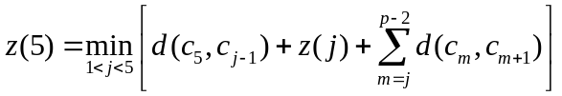= min of:
(j=2): d(c₅,c₁) + z(2) + d(c₂,c₃) + d(c₃,c₄) = 976 + 663 + 309 + 850 = 2798
(j=3): d(c₅,c₂) + z(3) + d(c₃,c₄) = 473 + 1294 + 850 = 2617
(j=4): d(c₅,c₃) + z(4) = 296 + 1766 = 2062 (final summation never done, j > p-2)
So z(5) =2062. To find the shortest bitonic path, note that it starts c₅ ←→ c₃ with path z(4) concatenated to it. So the shortest bitonic path is: c₅ (Chicago) ←→ c₃ (St. Louis) ←→ c₂ (Nashville) ←→ c₁ (Dallas) ←→ c₄ (Denver).

z(6) contains the 6 southernmost cities. It is the shortest bitonic path from c₆ south to c₁ then north to c₅. In equations, j = 2, 3,4, or 5, so:
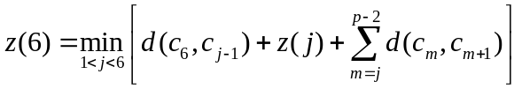= min of:
(j=2): d(c₆,c₁) + z(2) + d(c₂,c₃) + d(c₃,c₄) + d(c₄,c₅) = 944 + 663 + 309 + 850 + 1004 = 3770
(j=3): d(c₆,c₂) + z(3) + d(c₃,c₄) + d(c₄,c₅) = 875 + 1293 + 850 + 1004 = 4022
(j=4): d(c₆,c₃) + z(4) + d(c₄,c₅) = 557 + 2451 + 1004 = 4012
(j=5): d(c₆,c₄) + z(5) = 924 + 2062 = 2986 (final summation never done, j > p-2)
So z(6) = 2986. To find the shortest bitonic path, note that it starts c₆ ←→ c₄ with path z(5) concatenated to it. So the shortest bitonic path is: c₆ (St. Paul) → c₄ (Denver) → c₁ (Dallas) → c₂ (Nashville) → c₃ (St. Louis)→ c₅ (Chicago).

z(7) contains all 7 cities. It is the shortest bitonic path from c₇ south to c₁ then north to c₆. In equations, j = 2, 3,4, 5, or 6, so:
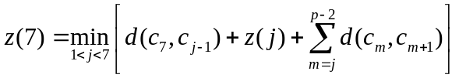
(j=2): d(c₇,c₁) + z(2) + d(c₂,c₃) + d(c₃,c₄) + d(c₄,c₅) + d(c₅,c₆) = 1297 + 663 + 309 + 850 + 1004 + 398 = 4521
(j=3): d(c₇,c₂) + z(3) + d(c₃,c₄) + d(c₄,c₅) + d(c₅,c₆) = 1338 + 1293 + 850 + 1004 + 398 = 4883
(j=4): d(c₇,c₃) + z(4) + d(c₄,c₅) + d(c₅,c₆) = 1013 + 1766 + 1004 + 398 = 4181
(j=5): d(c₇,c₄) + z(5) + d(c₅,c₆) = 1097 + 2062 + 398 = 3557
(j=6): d(c₇,c₅) + z(6) = 863 + 2986 = 3849 (final summation never done, j > p-2)
So z(7) = 3557. To find the shortest bitonic path, note that it starts c₇ ←→ c₄ with path z(5) concatenated to it, and ends with c₅ ←→ c₆. So the shortest bitonic path is: c₇ (Winnipeg) → c₄ (Denver) → c₁ (Dallas) → c₂ (Nashville) → c₃ (St. Louis)→ c₅ (Chicago) → c₆ (St. Paul).

Then the shortest tour will “close the loop” by going from St. Paul to Winnipeg by going 458 miles. Then, since I asked for the tour from south to north and back, the final tour is:
c₁ (Dallas) → c₂ (Nashville) → c₃ (St. Louis)→ c₅ (Chicago) → c₆ (St. Paul) → c₇ (Winnipeg) → c₄ (Denver) → c₁ (Dallas) for 4015 miles. If you want to write it from north to south and back north again, that’s OK, too.

z2 z3
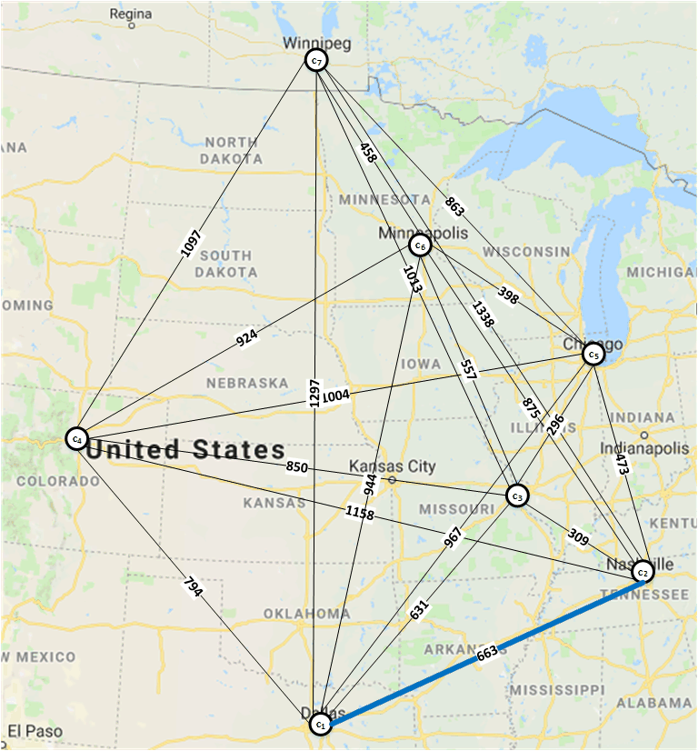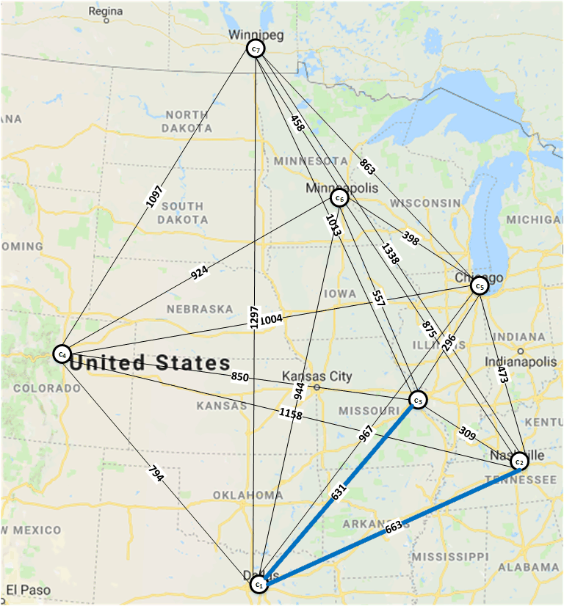
z4 z5
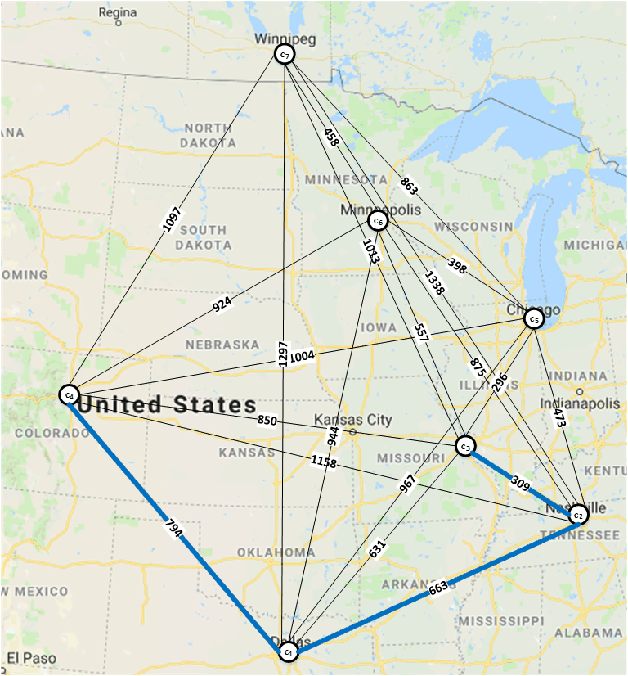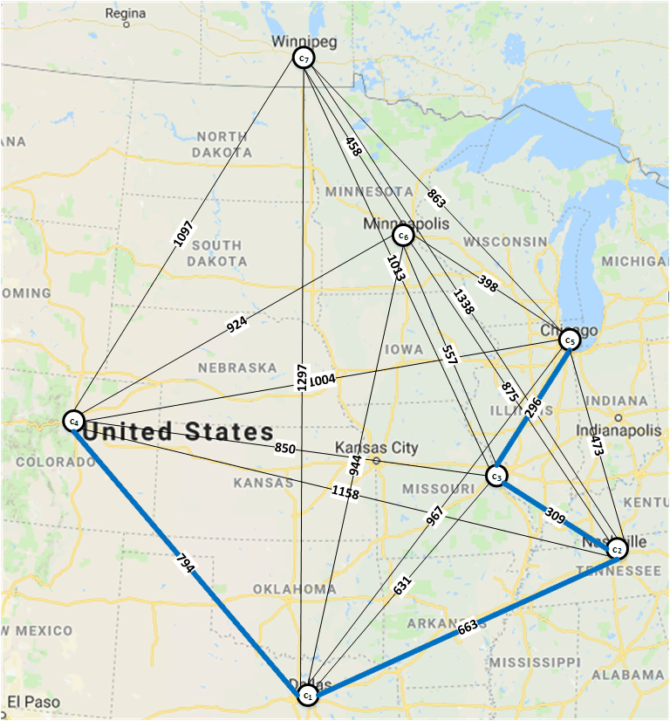
z6 z7
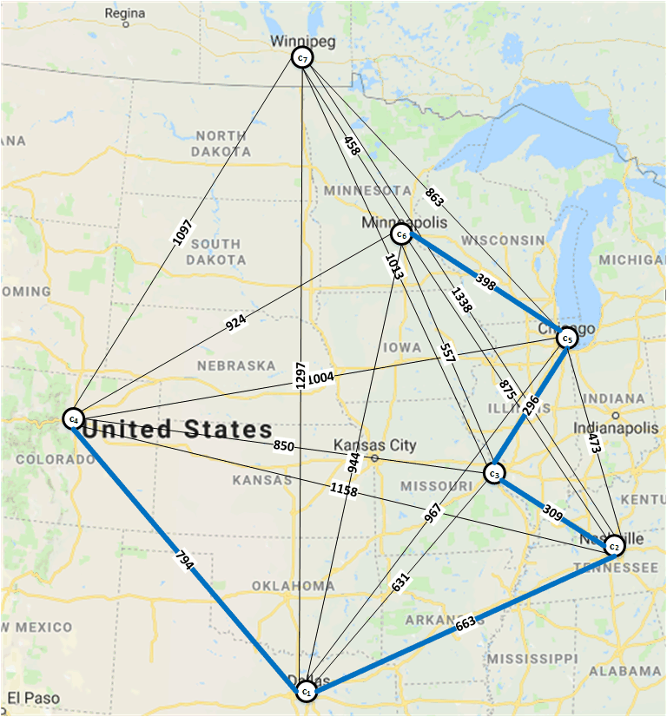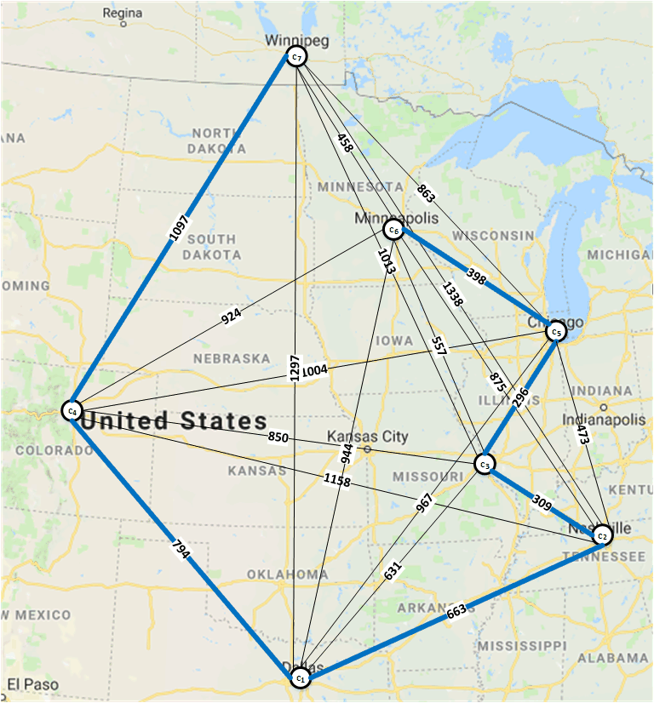
tour
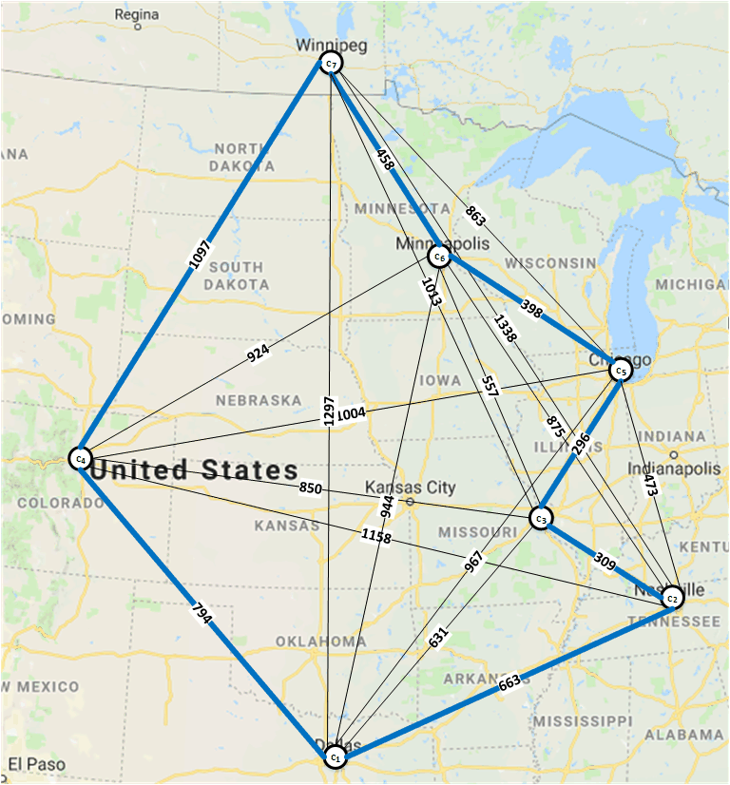
The Desired Output
File D7.txt

P = 2
z(2) = 663
Nashville
Dallas

P = 3
z(3) = 1293
StLouis
Dallas
Nashville

P = 4
z(4) = 1766
Denver
Dallas
Nashville
StLouis

P = 5
z(5) = 2062
Chicago
StLouis
Nashville
Dallas
Denver

P = 6
z(6) = 2986
StPaul
Denver
Dallas
Nashville
StLouis
Chicago

P = 7
z(7) = 3557
Winnipeg
Denver
Dallas
Nashville
StLouis
Chicago
StPaul

BITONIC TOUR
Distance = 4015
Dallas
Nashville
StLouis
Chicago
StPaul
Winnipeg
Denver
Dallas

Suggestions
You should be able to “eyeball” a solution to the 5-city case (using Google maps or something if you wish), and I’ve given you a solution to the 7-city case. This should give you enough information to go on.
One way to do this would be to get the distances right first, and then to worry about the cities later.
Administrative Details
The “prog340” handout describes the format of the input file for this and all program deliverables.
As will always be the case in this class, the program must be written in Java and must run on the University Windows computer systems. To ensure this I strongly recommend that you:
- Use only Oracle Java 8 SE and earlier constructs, and
- Test it on the University systems before submission if you have any doubts about its ability to run on the University Windows.
- As before, minimize disruption to the existing codebase. I realize that you will have to do some machinations to deal with Graphs having Edges with positive integral values differently from more general edges.
Submit:
Submit the Java source code to the open Deliverable D submission folder. You may submit either the source code or a full Eclipse package, as with Deliverable A.
Test Files:
There are five test files that will be used for grading: D5.txt, D7.txt, D10.txt, D15.txt, and D49.txt.
Grading:
60 points for passing the tests correctly. There are five files at 10 points each, plus 5 points for Deliverable A functionality not being broken; it will be tested on one of the files. 10 points each for design and documentation. This is an extra credit assignment. Your total points will be added to the points of Deliverables A, B, and C. Note that you cannot end up with more than 200 points (out of 175) for all the programs together.
Due Dates:
The program is due on Friday, May 3rd. The time of submission is the time that D2L lists the file as submitted.

Obviously, a bitonic tour could go east → west → east or any other back-and-forth way rather than south → north → south, but I chose to write the assignment more specifically to keep it shorter and less confusing.
There are no ties, I made sure of that. Geographically, when computing latitude to the nearest minute, there were two ties in the large file of Minnesota Cities, but I added one minute to the latitudes of Litchfield and St. Paul to break two separate ties, so these two cities are slightly farther south than my file indicates.
This is suggestive of optimal substructure, but it’s not quite what we need.
It turns out this will be easier to work with.

