Homework W3 (15 pts)
- [5 pts]: Suppose that you are searching the graph below to find a path from the source node S to the goal node G. This contains parts of a large graph that is basically a tree with some cross-connections back up the tree.
All the nodes have a forward branching factor of 3 or 4, and a backward branching factor of 2 or 3. You can’t come up with a good heuristic, so you can’t use A* search. Assume this pattern shown continues on for many levels, so you have over 1,000,000 nodes.
Qualitatively speaking, how would you approach searching this graph? What search strategy/strategies would you use, and why? (Yes, this is a very open-ended question. And the explanation is the most important part.)

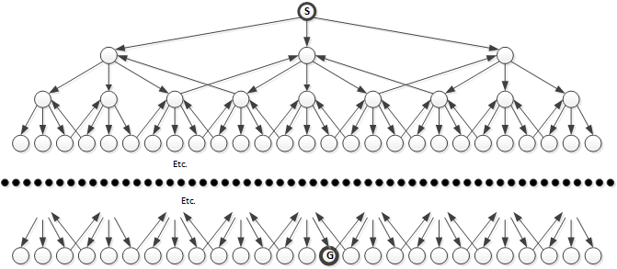
Solution:
A*Search because it does path pruning that means it will avoid loops since this graph is a DAG. Also it is depth first search and the goal node appears to be located in the furthest depth level.

- [6 pts]: Here is a map of a skyway system (like the ones in downtown Minneapolis). You want to use A* search to tell you the best route from block S to block G. Each block has a single-letter name, and a heuristic distance given in parentheses. Fill out the following table, as for the in class exercise, showing the final route to goal node G, and showing all the items in the queue at each stage of the algorithm. The distance of each edge (skyway) is 1.
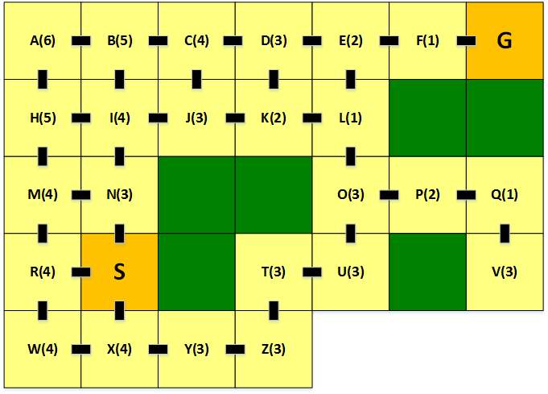Solution:
ver. | Priority Queue After Expanding Node
ver. | n | f | via | n | f | via | n | f | via | n | f | via | n | f | via | n | f | via | n | f | via | n | f | via
S | N | 4 | S | R | 4 | S | X | 5 | S
N | I | 6 | SN | M | 6 | SN
I | J | 6 | SNI | B | 8 | SNI | H | 8 | SNI
J | K | 6 | SNIJ | C | 8 | SNIJ
K | L | 6 | SNIJK
L | E | 8 | SNIJKL
E | F | 8 | SNIJKLE
F | G | 8 | SNIJKLEF
G
- [4 pts] What is the worst-case “big-O” time complexity of A* search? Explain.
Solution:
Let b = the average length of all paths on the graph.
Let d = that average children of each node.
The Worst Case for A*Search would be 0(b^{d} ) which means it will have visited all the nodesbefore finding the Goal Node. This is highly unlikely though
- [10 pts, 2 per part]: Use Kosaraju’s algorithm to find the strongly connected components of the graph below. Do it according to the following steps.
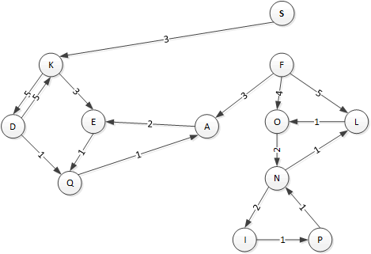
  - Do a depth-first search of this graph starting with node S. When you have the choice of two or more edges to unexplored nodes to traverse, take the shortest edge first. List the discovery and finishing times of each node in the table below. If your depth first search from S ends without exploring all nodes of the graph (it will), continue the search from the unexplored node with the earliest letter of the alphabet.
Vertex | A | D | E | F | I | K | L | N | O | P | Q | S
Discovery Time | 5 | 9 | 3 | 13 | 18 | 2 | 16 | 15 | 14 | 19 | 4 | 1
Finishing Time | 6 | 10 | 8 | 24 | 21 | 11 | 17 | 22 | 23 | 20 | 7 | 12

  - List the type of each edge in the above graph using the table below.
Edge | AE | DK | DQ | EQ | FA | FL | FO | IP | KD | KE | LO | NI | NL | ON | PN | QA | SK
Type (BCFT) | B | B | C | T | C | F | T | T | T | T | B | T | T | T | B | T | T

  - Create the stack of nodes in reverse order of finishing time, with the latest finish time at the top. List that in the table below.
Top of Stack → | F | O | N | I | P | L | S | K | D | E | Q | A
  - Here is the complement of the graph above – the graph with all its edges reversed. Do DFS on this graph following Kosaraju’s algorithm as shown in the notes, the text, or geeksforgeeks.org (same result). Show the start and finish times in the table below.
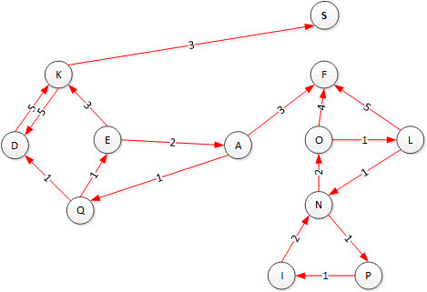
Vertex | A | D | E | F | I | K | L | N | O | P | Q | S
Discovery Time | 20 | 16 | 19 | 1 | 7 | 15 | 4 | 5 | 3 | 6 | 21 | 13
Finishing Time | 23 | 18 | 24 | 2 | 9 | 17 | 11 | 8 | 12 | 10 | 22 | 14

  - Based on the results of the algorithm, list the SCCs of this graph, one per line below (you may not need all the lines)
F______________________
OLNPI_________________
S______________________
KD_____________________
EAQ___________________
_______________________

