Programming Project
There will be one multi-deliverable Java programming project this semester, which will be divided into four separately-graded program deliverables (DelivA through DelivD). A specification for each deliverable will be uploaded on or before the date listed for “Pr<x> out” in the syllabus. Each deliverable will build on past deliverables.
Start from a Working Program
Some Java programs work on student computers but not on University lab (Windows) computers or grading computer. So this semester, you are given an initial codebase, “Prog340”, that seems to compile and run on all platforms.
- It opens a menu for you to select an action. It has a number of predefined menu items describing the various actions (which you will implement during the semester).
  - When you start the program the first action you will want to take will be to read a file. The input files for all deliverables have the same, specified format.
- It allows you to continuously select actions as long as you wish
  - Including read another file.
- It allows you to exit the program.
Each Deliverable will involve your modifying your existing program (DelivA involves modifying the initial program given to you). This minimizes any duplicate effort. But it means that if you screw up a deliverable, you may have screwed up another deliverable later in the course.
Grading
Deliverable A is worth 25 points. It is pretty simple if you understand OO programming in Java.
For each of Deliverables B (90 pts), C (100 pts), and D (100 pts):
- Correct functioning of the program is worth 80 points. You will receive a set of test files which will be used to evaluate the program. Some other test files may also be used that are not given to you (in real life, you design to the specification, you can’t test everything). You will receive the desired output for at least one test file (maybe more). Part of learning the material in the class is figuring out the correct answer to the test files yourself. The correctness points are divided among the tests. For instance, if there are 8 tests, each test is worth 10 points. Normally, a test is either all or nothing, 0 or max points, but you can get substantial partial credit for output whose content is correct, but whose formatting is off.
- Design is worth 5 points.
- Documentation is worth 5 points.
For Deliverables C and D, there will be a report worth 10 points.
Program Architecture
The initial program reads a text file and interprets it as a graph.
Input File
All the input files in this course will look something like this, file A0.txt. Note that all columns of data are separated by 1 or more spaces (not tabs):
~ val AAA BB C DDD E
Alfa x ~ > ~ 99 fig
Bravo 67 999 -42 3 x ==
Charlie ~ ~ 4 ~ yz 9
Delta 4e 3 22 x ~ !=2
Echo yes ~ ~ ~ d>e 33
- The first row is a header row.
- The first “~” is merely a placeholder. All files will have this at the beginning of the header row.
- “val” is a column label for the column of node values.
- The rest of the strings are mnemonics for the nodes of the graph. They are alphanumeric and do not contain spaces.
- Each subsequent row describes one node and its outgoing edges.
- The first column contains the name of the node (e.g., “Alfa”)
- The string in the “val” column is the value of the node, which may be numeric, but which will certainly always consist of a string of printable characters. The character “~“ by itself stands for “no value”. (e.g., node “Charlie” has no value.)
- For the rest of the columns, if there is no edge going from the node to another node, there is a “~“ in the appropriate column. (e.g., there is no edge from node “Charlie” to node “Alfa”.)
- If there is anything else in that column, that is the label of the edge. For some deliverables, this will be numeric, for others it may not be. Note that self edges are allowed. (e.g., the edge from “Delta” to “Echo” has label “!=2”.)
If you like a picture of what this is, here’s what the above table looks like in graphical form:
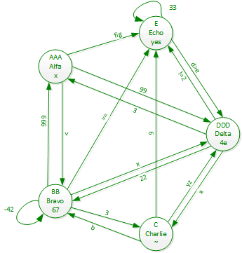
Program Classes and Methods
There are 4 classes in the program given to you (in addition to a stub class for each deliverable, A-D):
Prog340 is the main class, which handles the I/O.
Graph is a class whose objects represent graphs.
Node is a class whose objects represent nodes (a.k.a., vertices) in the graph.
Edge is a class whose objects represent edges (a.k.a., arcs) between nodes of the graph. Note that each edge has a direction. It goes from one specific node to another specific node.
Here is a basic UML class diagram for these four classes. All methods and attributes are listed explicitly rather than using composition connectors, to be easily understood by people with little UML background.
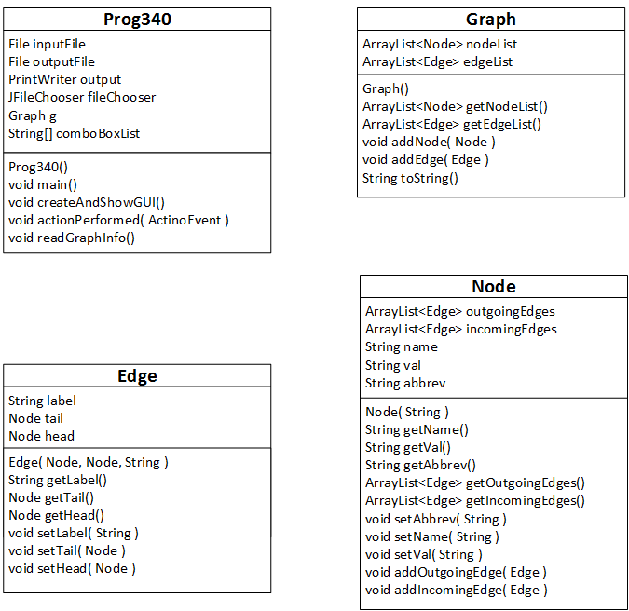
Rules
These rules will apply to all the program deliverables for this course:
- You may use any code you can find on the publicly accessible internet (or any other published source) as part of your program. If you take code from the internet or published source, you must acknowledge your source. You may not use code from your classmates or other unpublished sources. Two programs or program fragments that are unduly similar and are not acknowledged as having come from a published source will be considered as being incidences of plagiarism, with a 0 for the assignment and a report sent to the Academic Integrity committee. A “published source” is not somebody else’s program unless it’s on a publicly accessible, free site (thus, for instance, stackoverflow.com is fine, but Chegg or CourseHero (which require signup) are not).
- Do not publish any of your solutions to GitHub or any other public place before the end of the semester. If you do, and if someone uses your code, this will be considered academic misconduct and result in your getting a 0 for that deliverable.
- Your program must run on the university’s Windows computers “as is” – without having to import any packages that are not part of the Java 8 SE installed on the university systems. If it does so, it should run on both instructors’ systems. In case of dispute, we will run it on a university computer with the standard image. The results of running it on that platform will be final.
Two common problems in the past have been:
- People who write their programs on Macs sometimes have trouble, especially with I/O. This should not be a problem because we are giving you working I/O code. If your Deliverable A runs properly on the grading computers, it’s very likely all the other deliverables will, too, as long as you don’t violate rule (b) below.
- People who import other packages, most commonly imports from eclipse.org or netbeans.org. Do not import anything outside of the Java 8 SE to do problems in this class, and if you do so, this may make your program not compile and/or run properly on the university system. This will severely impact your grade, since 80-90% of the program grade is based on test results from a running program. There is no reason for you to make the mistake of importing any package not in the Java 8 SE. If you want to use code from the internet that uses such packages, you’ll need to strip out those imports and rewrite the equivalent functionality yourself. (Remember to reference your source, please.)
Deliverable Submissions
Notice that there are two dates listed in the syllabus for each program deliverable (deliv A shown):
14 | Pr A Out | 15 |  | 16 |  | 17 |  | 18 |  | 19 |  | 20
In-Class W0 |  | Quiz W1 Out
Quiz W0 Out |  | HW W0 Out |  |  |  |  |  | Quiz W0 Due
21 |  | 22 |  | 23 |  | 24 |  | 25 |  | 26 |  | 27
NO Class W1 |  | Quiz W2 Out |  |  |  |  |  | Pr A Due (A)
Quiz W1 Due |  | HW W1 Out |  |  |  |  |  |  |  | HW W0 Due
28 |  | 29 |  | 30 |  | 31 |  | 1 |  | 2 |  | 3
In-Class W2 |  | Quiz W3 Out |  |  |  |  |  |  |  | Pr B Out
Quiz W2 Due |  | HW W2 Out |  |  |  |  |  |  |  | HW W1 Due
4 |  | 5 |  | 6 |  | 7 |  | 8 |  | 9 |  | 10
In-Class W3 |  | Quiz W4 Out |  |  |  |  |  | Pr A Due (B)
Quiz W3 Due |  | HW W3 Out |  |  |  |  |  |  |  | HW W2 Due

Submissions before the “(A)” deadline are worth full credit. Submissions before the “(B)” deliverable are worth 80% of the credit earned. That way, if you don’t get most of the points the first time through, you can resubmit it two weeks later, at least one week after receiving the grade, for significant credit.
Note that all deliverables are due at noon on the due date. Since you get two chances to submit the program, late programs are not accepted.
Test Files:
The program correctness will be tested with various test files. Some test files are specific to a given deliverable, others may be used to test multiple deliverables. The test file naming convention is: XXXnnn.txt. XXX denotes the set of deliverables that this file pertains to, nnn is a unique number for the file. For instance, file A0.txt is a test file for deliverable A, while file ABD2.txt is a test file for deliverables A, B, and D.
Note that a file may be modified for a given deliverable. For instance, consider file ABD6.txt:
~ val Atl Bos Chi Dal Den LA Mia Min NY SF Sea Was
Atlanta ~ 0 957 581 725 1220 1942 608 898 752 2155 2201 538
Boston G 957 0 859 1571 1783 2594 1285 1127 207 2719 2505 420
Chicago ~ 581 859 0 803 928 1736 1185 354 718 1876 1758 601
Dallas ~ 725 1571 803 0 667 1248 1116 851 1384 1494 1698 1190
Denver ~ 1220 1783 928 667 0 812 1736 697 1645 957 1033 1507
LosAngeles S 1942 2594 1736 1248 812 0 2357 1500 2451 313 923 2301
Miami ~ 608 1285 1185 1116 1736 2357 0 1505 1097 2611 2755 917
Minneapolis ~ 898 1127 354 851 697 1500 1505 0 1024 1597 1415 940
NewYork ~ 752 207 718 1384 1645 2451 1097 1024 0 2594 2430 213
SanFrancisco ~ 2155 2719 1876 1494 957 313 2611 1597 2594 0 691 2464
Seattle ~ 2201 2505 1758 1698 1033 923 2755 1415 2430 691 0 2354
Washington ~ 538 420 601 1190 1507 2301 917 940 213 2464 2354 0

This file lists distances between cities. For deliverables B and D you will want to start from a given city (with value “S”) and search for a given city (value “G”). For testing purposes, we may use different starting and finishing cities (and you should do so, too, while testing your program).

Sometimes this is because programs written from scratch on a Mac have I/O problems on Windows machines, even though Java is an allegedly platform-independent language.
This will be demonstrated in the first class.

