Short Credit Card V iFrame Details

מתאריך: 22/06/2020

לקבלת התוקן כניסה למסך (TokenLogin) – יש לפנות לWS :
https://ws.comax.co.il/WS_WRK/Work_Comax_WS/Credit_GetTokenLogin.asmx

דוגמא להפעלה:
https://ws.comax.co.il/WS_WRK/Work_Comax_WS/Credit_GetTokenLogin.asmx/getLoginDetails?LoginName=aaa&Password=aaa&Scm=2&SwEncode=1&returnPage=https://www.example.com/Registration/CreditCardChecking.aspx

:WSהפרמטרים שיש לשלוח ל
LoginName
Password
+ הפרמטרים לצורך שימוש באייפרם. (איפיון בדף Credit_GetTokenLogin.docx)
תשובה:
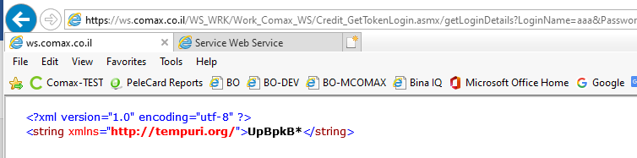
דוגמא נוספת:
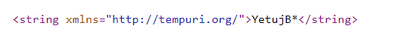

דוגמה להפעלת IFRAME:
https://ws.comax.co.il/comax_webservices/Credit/ShortCreditInput_V.aspx?LoginID=aaa&LoginPassword=aaa&AutoCreditCompany=1&CreditTransactionTypeList=1&TokenLogin=YetujB*

Mandatory Parameters:

Parameter | Description
LoginID | Login ID - Needs to be setup in Comax
LoginPassword | Password - Needs to be setup in Comax
TokenLogin | Token get from Credit_WS - GetTokenLogin.asmx and can use until 5 minutes

Optional Parameters:

Parameter | Description
MaxPaymentsNumber | Maximum number of payments (0 if you don’t want it displayed)
FixedPaymentsNumber | number of payments and there won't possibility to change it.
AutoCreditCompany | Automatically inserts the CC company when this is set to 1
CreditCompanyList | List of Credit Companies - Leave Blank in most cases. Comax identifies it automatically.
CreditTransactionTypeList | Type of transaction (1 - Regular, 2 - Break into Payments, 3 - Credit, 4 - Prefered + 30, 5 - Deffered + 30)  If a parameter is sent then the drop down window doesn’t show.  Most of the time 1 will be used.
OrderID | If you want to add this to a certain order that already exists in the Comax system.
NoValidateIDCard | When this parameter is set to 1 then the ID field will not be appear.
ViewTotal | When this parameter is set to 1 and Total not 0 then the Total field will be appear
SwEng | כשהפרמטר מסומן ב1 – השפה תהיה אנגלית
SwTranslate | מציג אפשרות בחירה של שפה לתרגום הכיתוב
getErrMsg | This is a parameter for testing. If it is set to 1 then the Result parameter will have the error message. If it isn’t set then error messages will come to the screen (user) - this is the proper way to work outside of testing.
fixedMessage | When this parameter is set to 1 then the Result will be  : "שגיאה בהקלדת הנתונים, אנא בדוק שוב"
NotFocus | לא להשתמש במסך בפוקוס אוטומטי

Return Parameters:

A webpage (ReturnPage Parameter) needs to be created that knows how to receive these parameters. From here, you need to active the WebService that creates an order in Comax.

Parameter | Description
Ref | This is the same number that is send in the request in order to know which order this is associated with
Success | If the J5 check was successful
Result | Confirmation number or Error Message (If GetErrMsg is set to 1)
Token | Identifier that needs to be sent when generating the order or invoice. That way the credit card actually gets charged.
cardId | ת"ז של בעל הכרטיס
credit | מספר כרטיס אשראי (6 ספרות אחרונות)
creditType | חברת אשראי
creditExpiry | תוקף כרטיס

