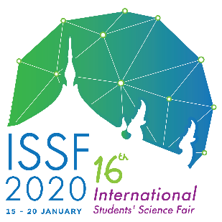

**Consent to the Use of Images**

I, _________________________________________

(name) PLEASE PRINT

of ____________________________________________________

(school’s name) PLEASE PRINT

hereby give consent to and authorize the use of images of me photographed or video recorded at the International Students’ Science Fair (ISSF2020) hosted by Kamnoetvidya Science Academy, Thailand for the school’s publication and promotional purposes such as on websites, Facebook, newsletters, official reports and any other promotional materials during the period of the fair and thereafter.

Signature : _____________________________________

Date : _____________________________________

Parent/Guardian Signature : _____________________________________

Date : _____________________________________

**Confirmation of Overseas Travel Insurance**

I have an overseas travel insurance

I will get an overseas travel insurance before my departure

Note: Please email a scanned copy of the signed document of every student to [issf2020@kvis.ac.th](mailto:issf2020@kvis.ac.th) at your earliest convenience**.**